Bash 01 — Task Report
Executing Bash Scripts & Capturing Results
Submitted by: Wasif

Overview
This document presents the completed Bash scripting task. It covers connecting to a remote machine via SSH, writing and executing automation scripts, and running a series of provided scripts from the DevOps Cloud channel. Each step is accompanied by a screenshot demonstrating successful execution.

Task Objective
• Connect to a remote instance via Git Bash over SSH
• Verify Bash installation and create an automation script
• Execute all scripts shared in the devops-cloud-documents-20 channel
• Capture and document screenshots for each step

Step 1 — SSH Connection & Bash Verification

1.1 Starting the Instance & Connecting via SSH
The EC2 instance was started and Git Bash was used to connect to the remote machine using SSH. The connection was verified and the user was switched to root.

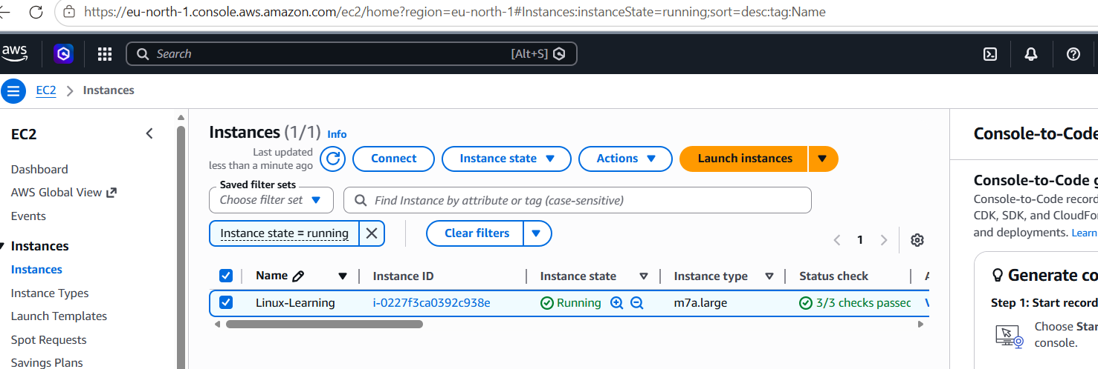
Figure 1.1 — SSH connection established to remote machine

1.2 Verifying Bash Shell
The following command was used to confirm that Bash is the active shell:
echo $0

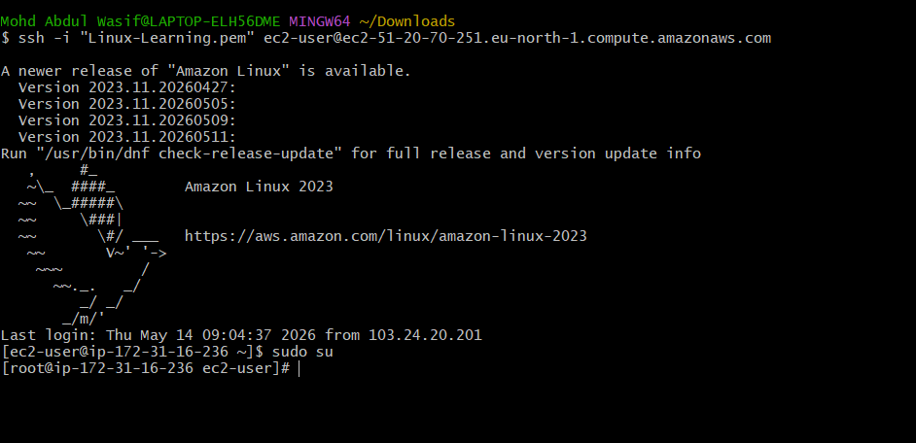
Figure 1.2 — Bash shell confirmed via echo $0

Step 2 — Creating an Automation Script
A daily automation script was created to run frequently used system commands. The script file was created and edited using the vi editor.

2.1 Writing the Script
The following commands were included in the script (test.bash):
#!/bin/bash
free -m
ps -ef
df
du -sk *

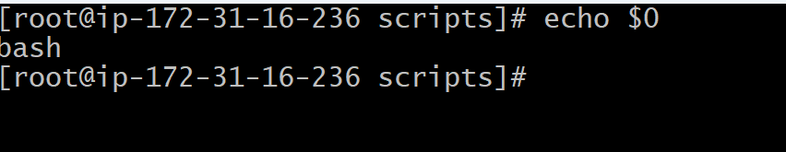
Figure 2.1 — Script file created using vi editor

2.2 Fixing the du Error & Running the Script
An initial error occurred with the du -sk* command (missing space). After correction, the script ran successfully. The ll command was used to list the file and ./filename was used to execute it.

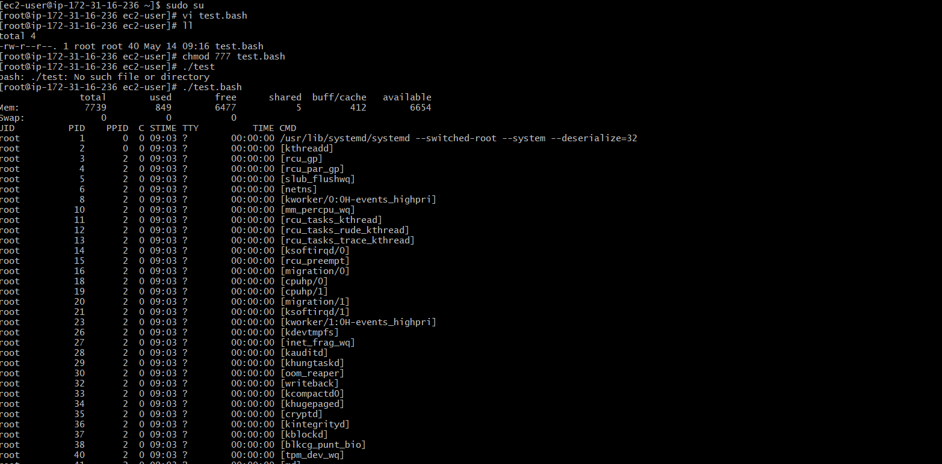
Figure 2.2 — Corrected script running successfully

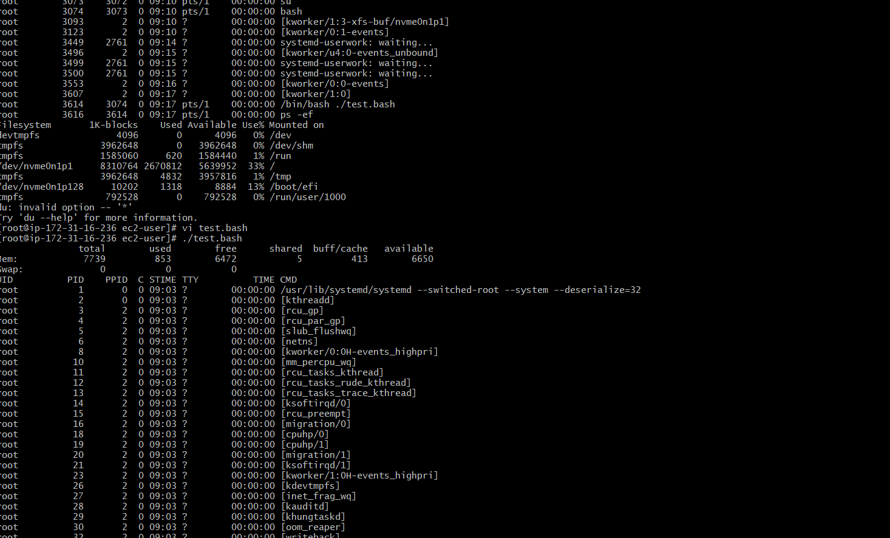
Figure 2.3 — All automation commands executing as expected

Step 3 — Executing Channel Scripts
All scripts shared in the devops-cloud-documents-20 Slack channel were executed. Each is documented below.

Script 1 — Basic Practice
A directory was created and the script was tested. Initially, execution failed because execute permission had not been granted.
Fix Applied:
chmod 777 <filename>
After granting permissions, the script executed and displayed its content correctly.

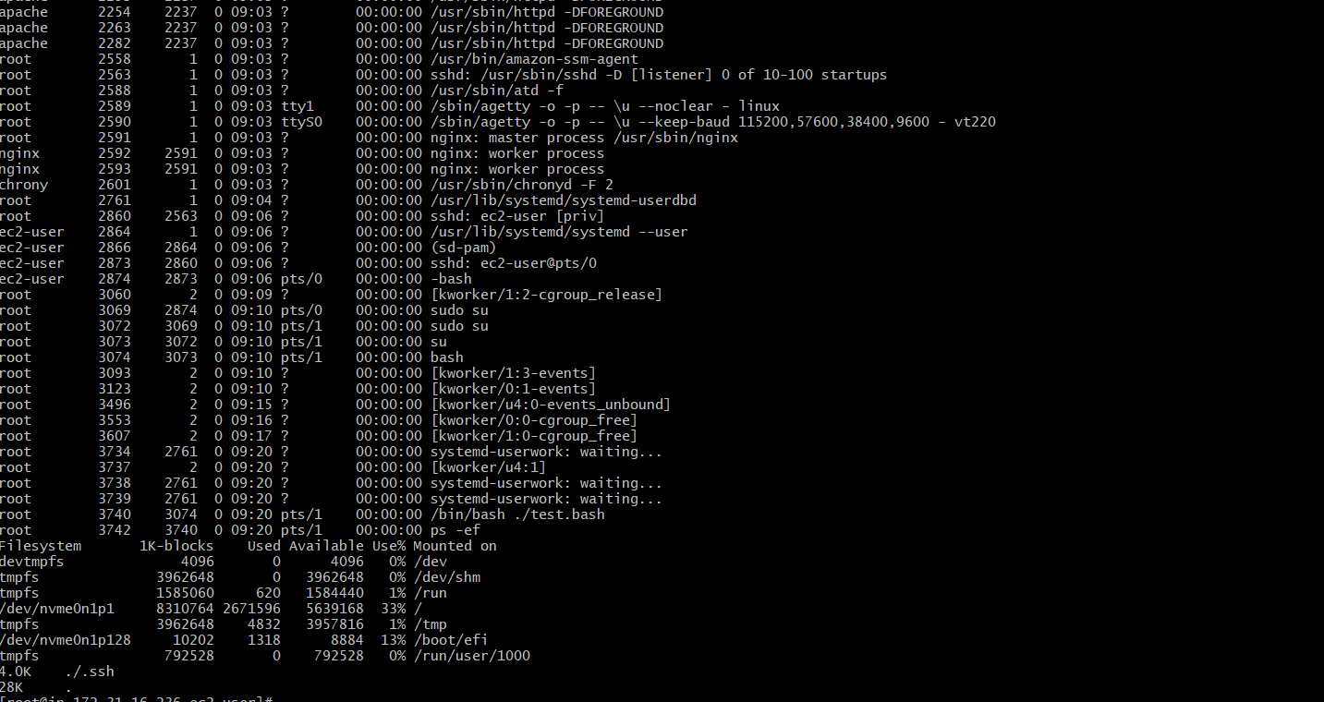
Figure 3.1 — Permission granted with chmod 777; script executed

Script 2 — Basic Practice (Extended)
The second practice script also required chmod 777 before it could be executed. After setting permissions, ./filename displayed the script output correctly.

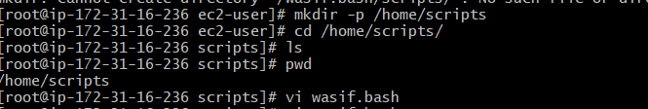
Figure 3.2 — Script 2 executed successfully after chmod

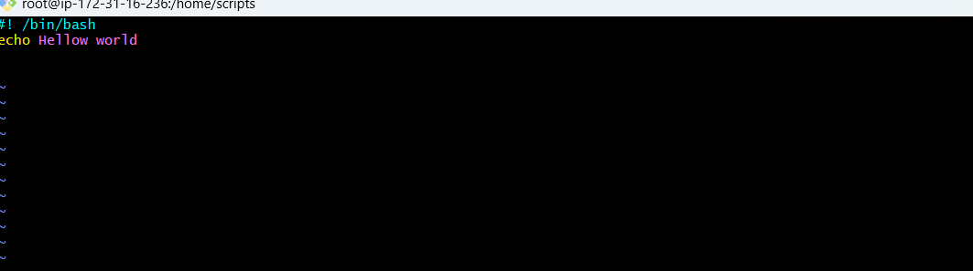
Figure 3.3 — Script 2 output confirmed

Script 3 — Sequence of Commands
This script runs a sequence of common system commands in order:
#!/bin/bash
pwd
ls
whoami
date
cal
touch a b c
The cat and ls commands were also used to verify file creation. All commands executed in the correct sequence.

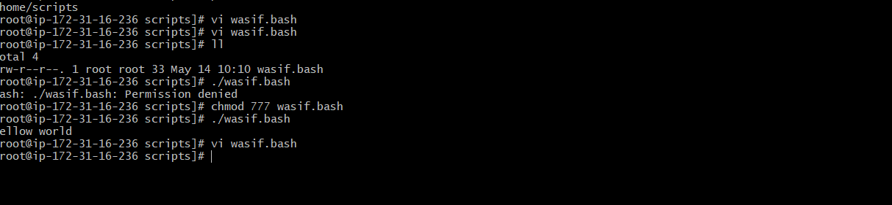
Figure 3.4 — Sequence of commands running in order

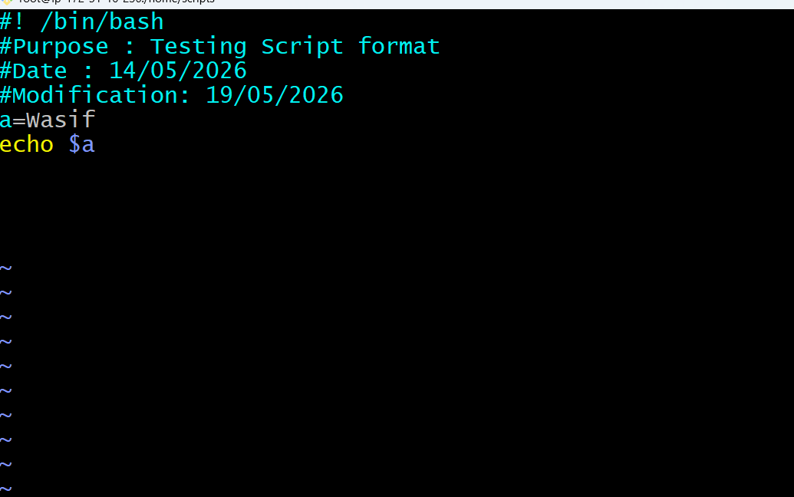
Figure 3.5 — Output of pwd, ls, whoami, date, cal, touch

Script 4 — Basic Administration Tasks
This script runs system administration commands to monitor resource usage:
top
df -h
free -m
uptime
iostat
The top command initially filled the entire screen. To make the output manageable, it was piped through head:
top | head -10
This made all command output clearly visible.

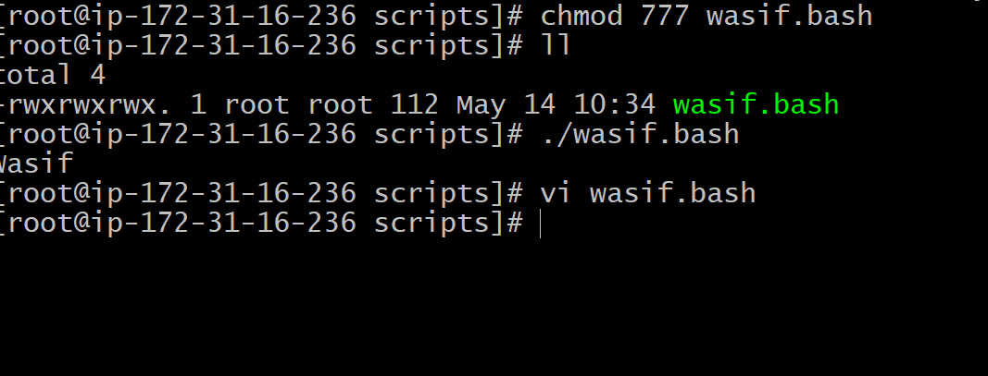
Figure 3.6 — Administration commands executed (df -h, free -m, uptime, iostat)

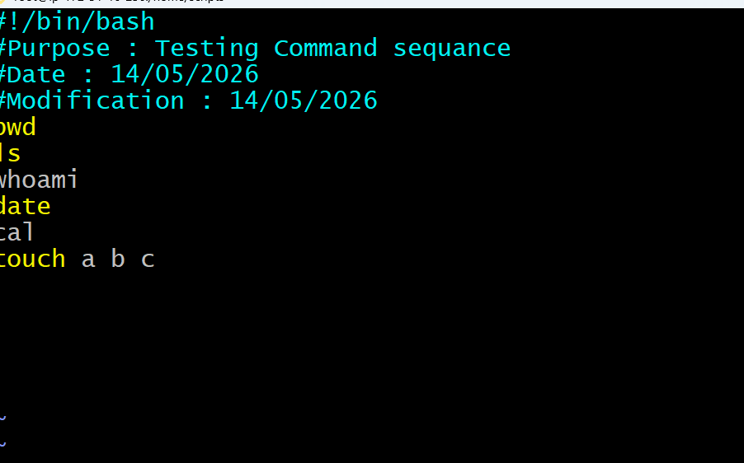
Figure 3.7 — top | head -10 output clearly visible

Script 5 — Defining Variables
In Bash scripting, a variable is a named value that can change depending on conditions or inputs. This script demonstrates defining and using variables:
#!/bin/bash
#Define Variables
p=pwd
l=ls
wi=whoami
d=date
c='cal 2026'
echo Run Variables tasks
echo
$p
$l
$wi
$d
$c
Each variable stores a command name, and the script expands them in sequence.

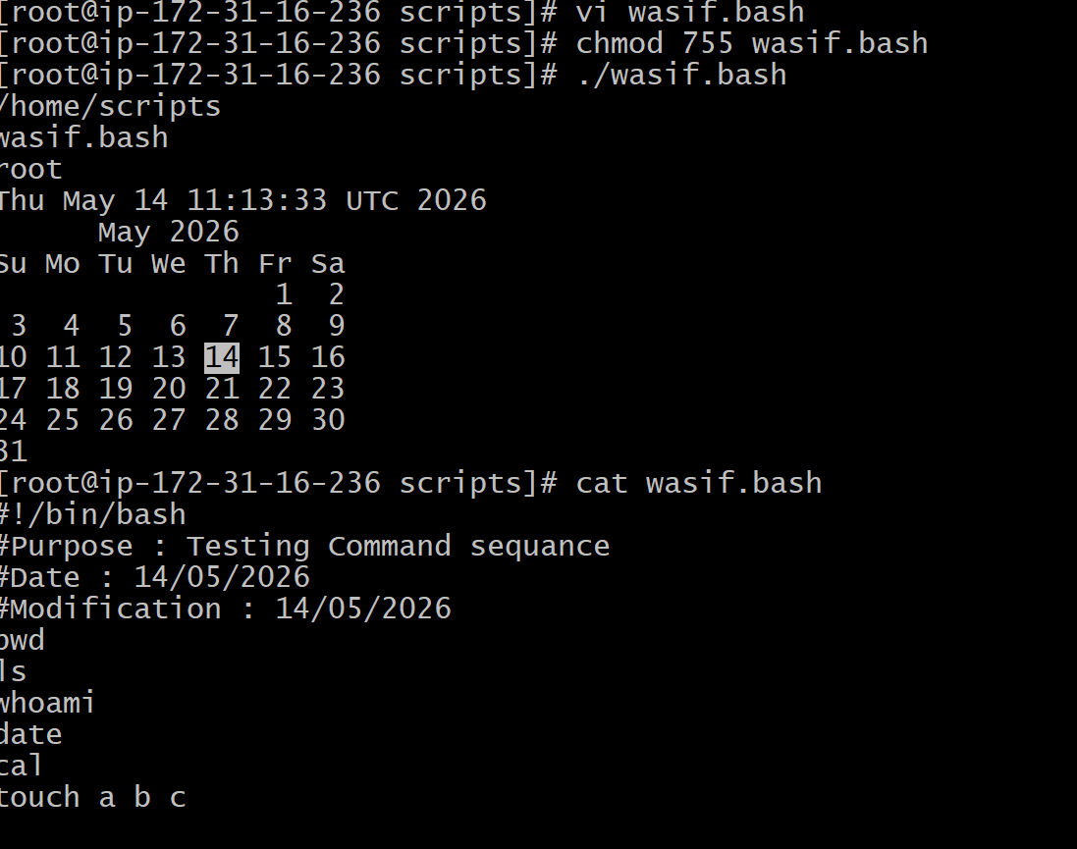
Figure 3.8 — Variables defined and executed in script

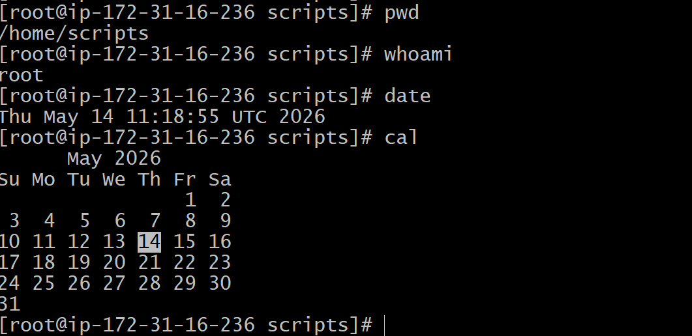
Figure 3.9 — Variable output results confirmed

Script 6 — Input / Output Script
This script demonstrates interactive user input (read) and output (echo):
Key Commands:
- read — accepts input from the user
- echo — prints output to the terminal

Example 1: Name Input/Output
#!/bin/bash
echo Hello, my name is Wasif
echo
echo What is your name?
read name
echo
echo Hello $name
echo
The script file was renamed to input-output and edited with vi. The script ran and prompted the user for their name.

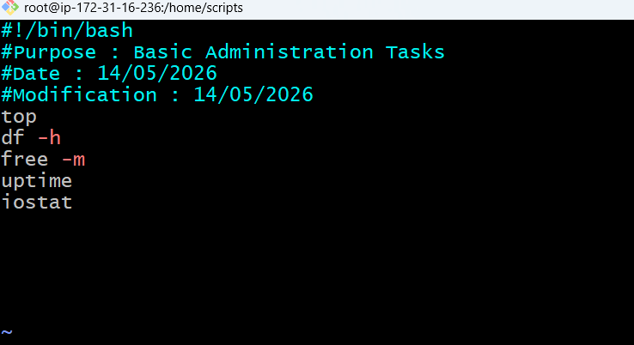
Figure 3.10 — Example 1: Input/Output script executed

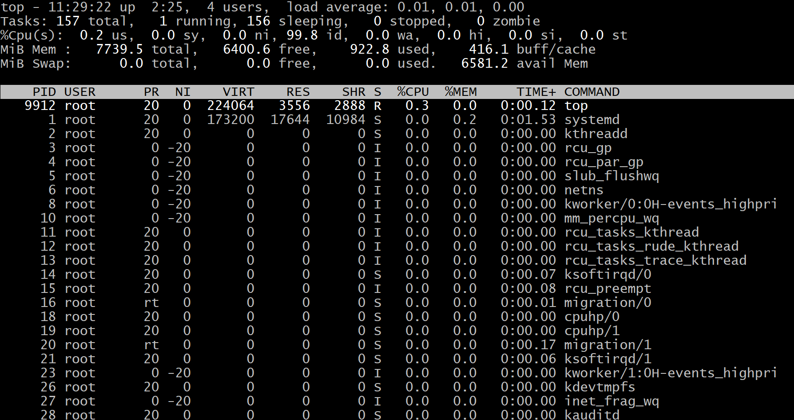
Figure 3.11 — User prompted and name echoed back

Example 2: Hostname Variable
#!/bin/bash
#use backticks to capture command output into a variable
a=`hostname`
echo Hello, my name is $a
echo
echo What is your name?
read b
echo
echo Hello $b
echo
Note: An initial error occurred because Hostname was capitalised. Bash commands are case-sensitive; the correct command is hostname (all lowercase). After fixing this, the script ran correctly.

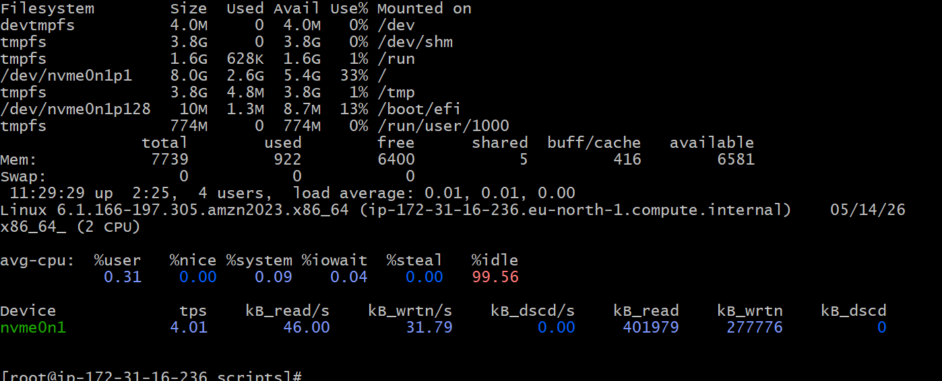
Figure 3.12 — Error due to capital H in Hostname

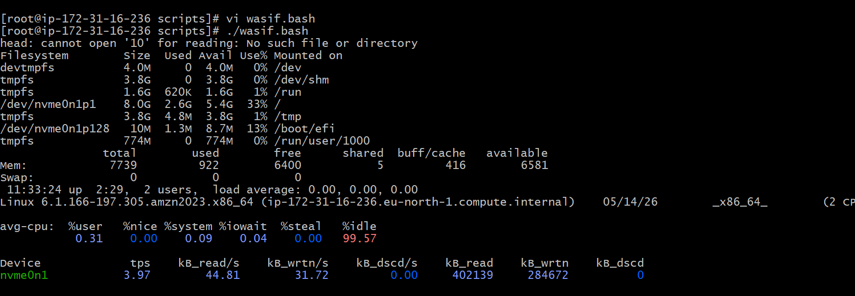
Figure 3.13 — Corrected hostname variable script running successfully

Additional Screenshots
The following screenshots capture additional steps and verifications performed during the task.

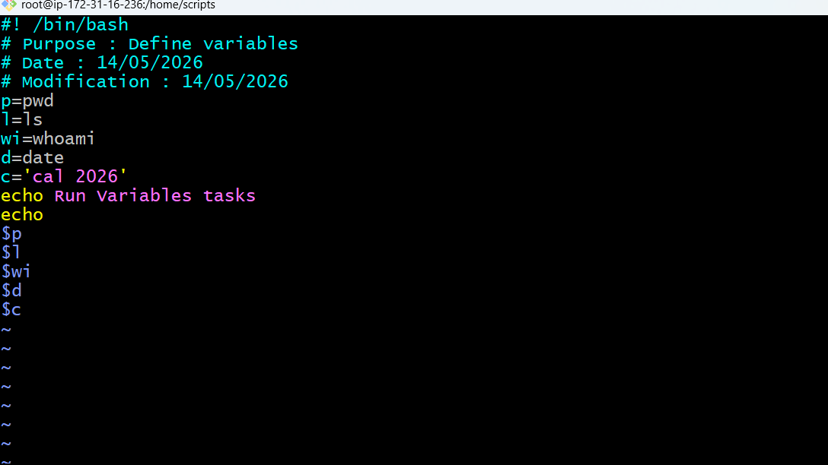
Figure 4.1 — Additional step verification

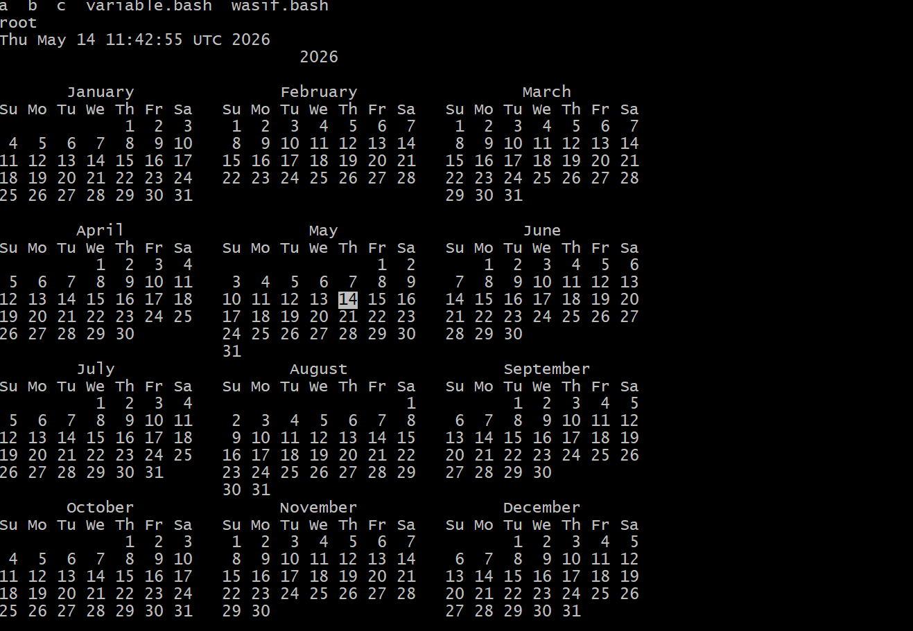
Figure 4.2 — Script output review

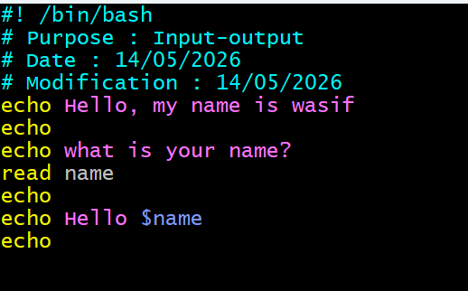
Figure 4.3 — Terminal session details

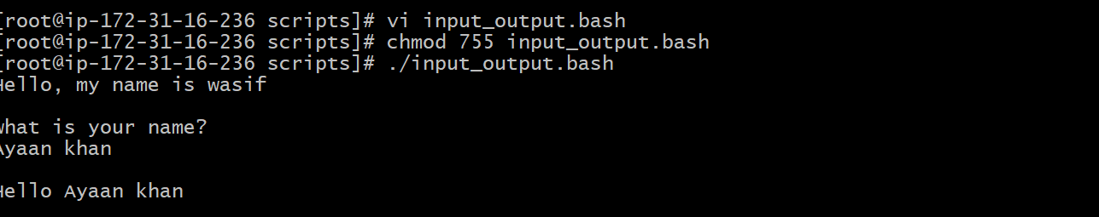
Figure 4.4 — Command listing verification

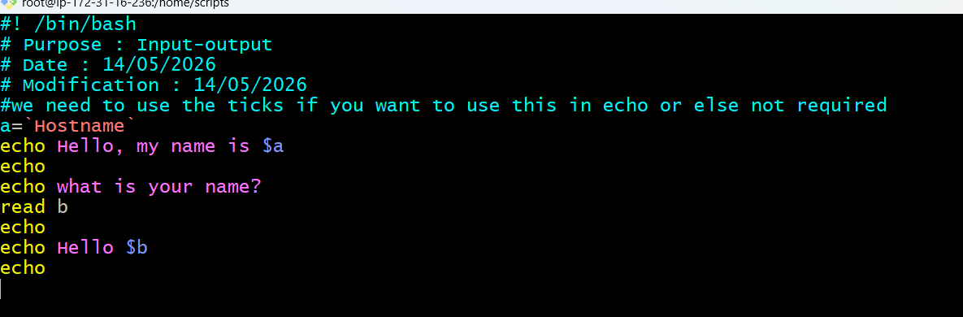
Figure 4.5 — Script permissions and execution

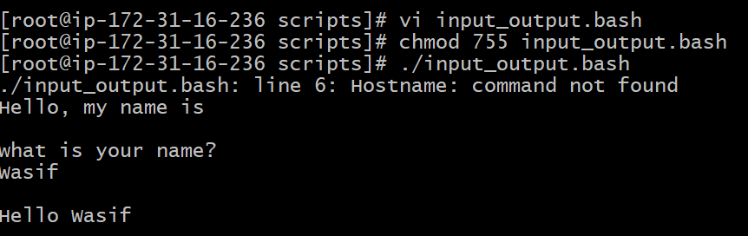
Figure 4.6 — Final command confirmation

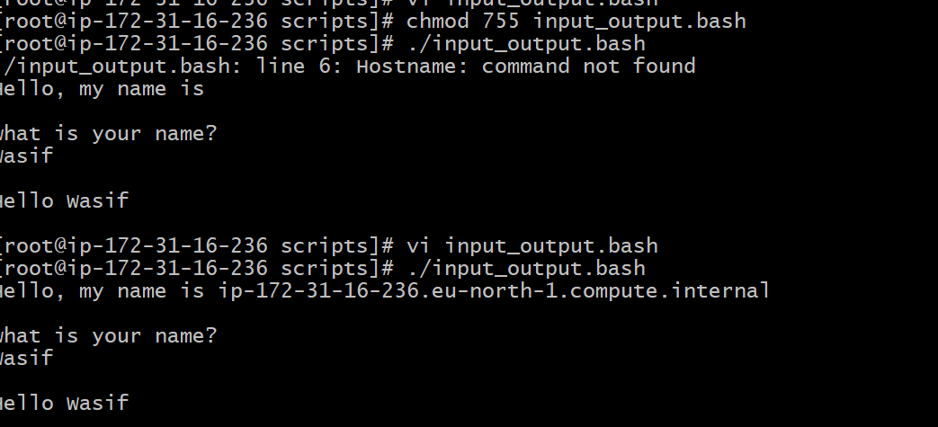
Figure 4.7 — Task completion screenshot

Conclusion

This task provided practical, hands-on experience with Bash scripting fundamentals in a real Linux environment. The following key skills were demonstrated and reinforced:

Key Learning Outcomes
1. SSH Connectivity — Successfully connected to a remote EC2 instance using Git Bash and switched to the root user.
2. Shell Verification — Confirmed active shell using echo $0 and understood its significance.
3. Automation Scripting — Created a daily automation script to run system monitoring commands (free, ps, df, du), and debugged a spacing error in du -sk *.
4. File Permissions — Learned the importance of chmod 777 when executing scripts. Without execute permission, scripts cannot run.
5. Command Sequencing — Demonstrated that Bash scripts execute commands in the exact order they are written.
6. System Administration — Used top, df -h, free -m, uptime, and iostat. Resolved the top overflow issue by piping to head -10.
7. Variables — Understood that variables store values or command references, and learned how to define and call them correctly.
8. Input/Output — Used read and echo for interactive scripts, and learned that Bash is strictly case-sensitive (hostname vs Hostname).

Overall, all six scripts from the DevOps Cloud channel were successfully executed, errors were identified and corrected, and every step was captured with screenshots. This exercise builds a solid foundation for more advanced Bash scripting and DevOps automation workflows.

— End of Report —

