Challenge-06
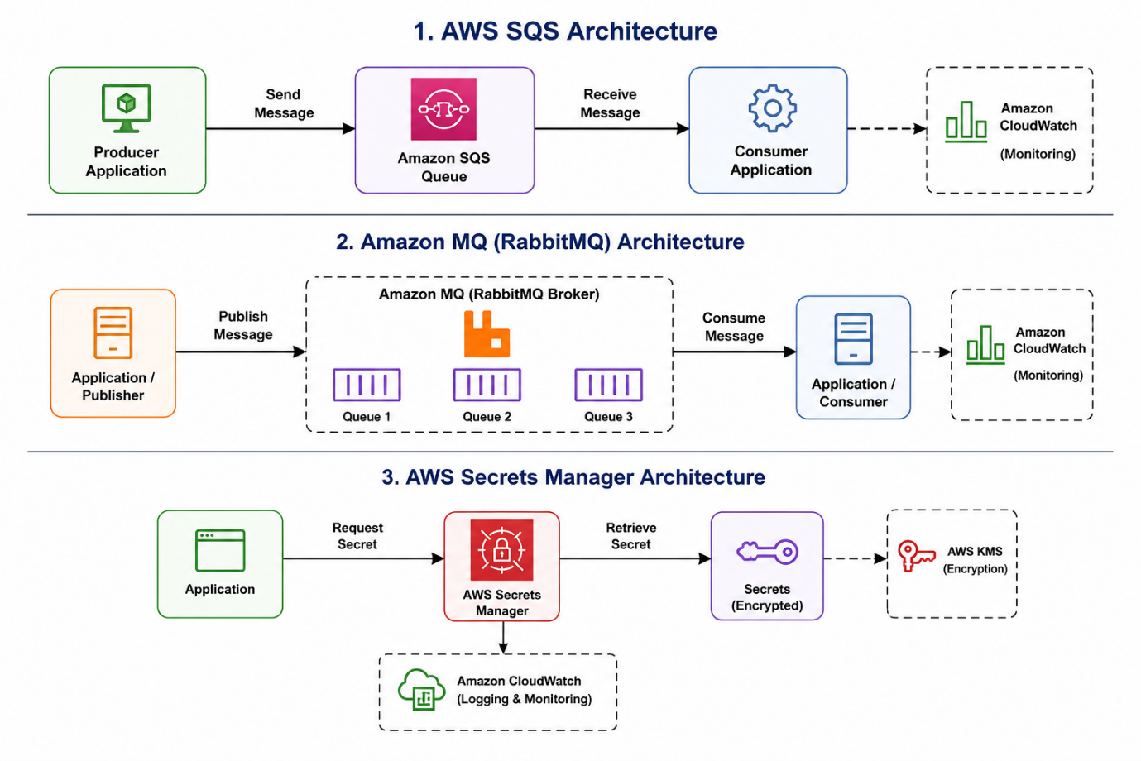
WS SQS (Simple Queue Service)
Objective
Implement a message queuing service to decouple applications and enable asynchronous communication.
What is AWS SQS?
AWS SQS is a fully managed message queue service that allows applications to communicate without being tightly connected.
Use Cases
- Order processing systems
- Background job processing
- Microservices communication
- Decoupling application components
Architecture
Producer Application
|
v
SQS Queue
|
v
Consumer Application
Hands-on Implementation
Step 1: Create SQS Queue
- Login to AWS Console.
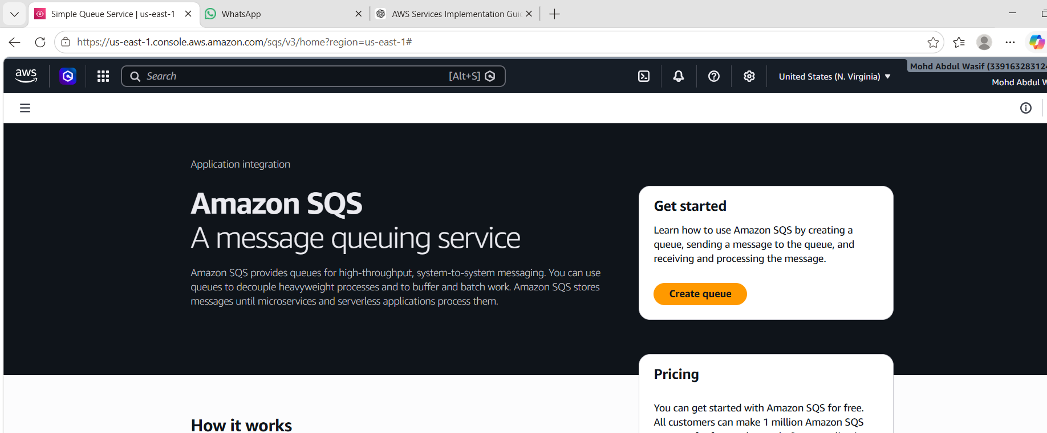
- Navigate to SQS.
- Click Create Queue.
- Select Standard Queue.
- Name: demo-queue.
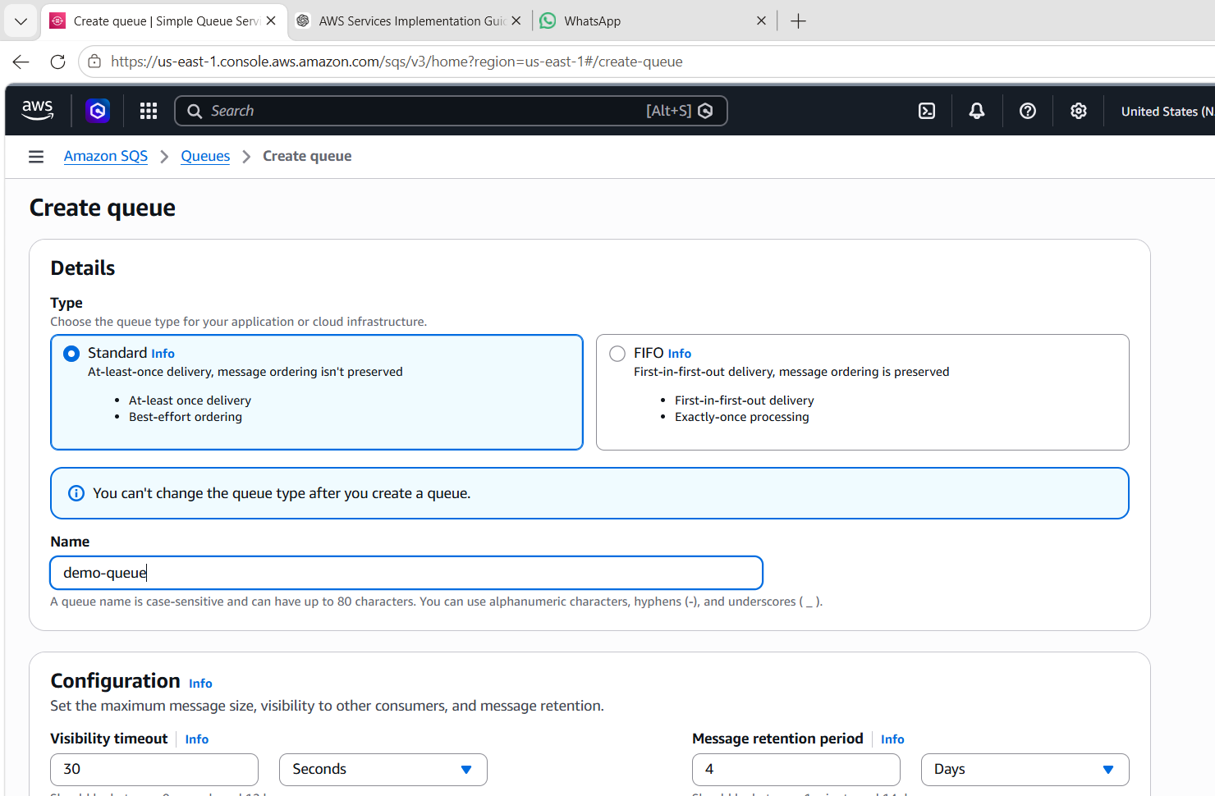
- Create Queue.
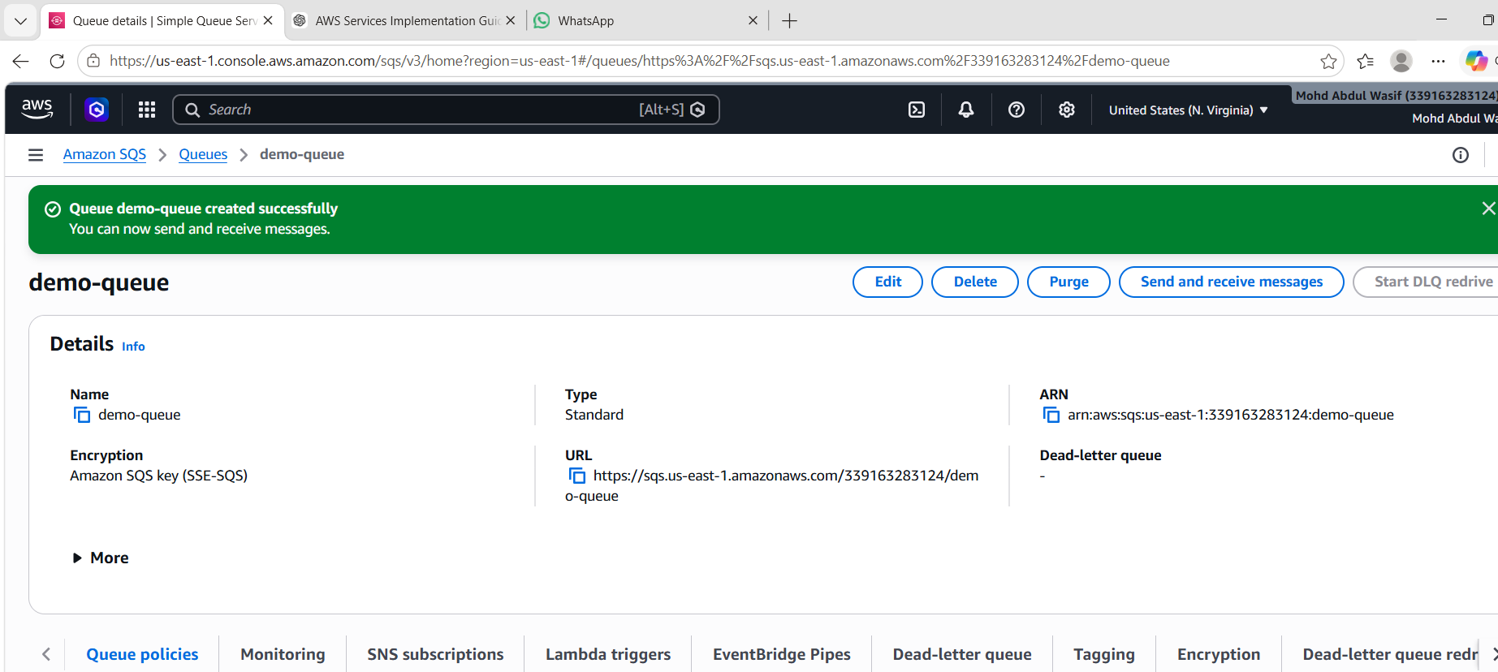
Step 2: Send Messages
- Open queue.
- Click Send and Receive Messages.
- Enter message:
Hello Wasif
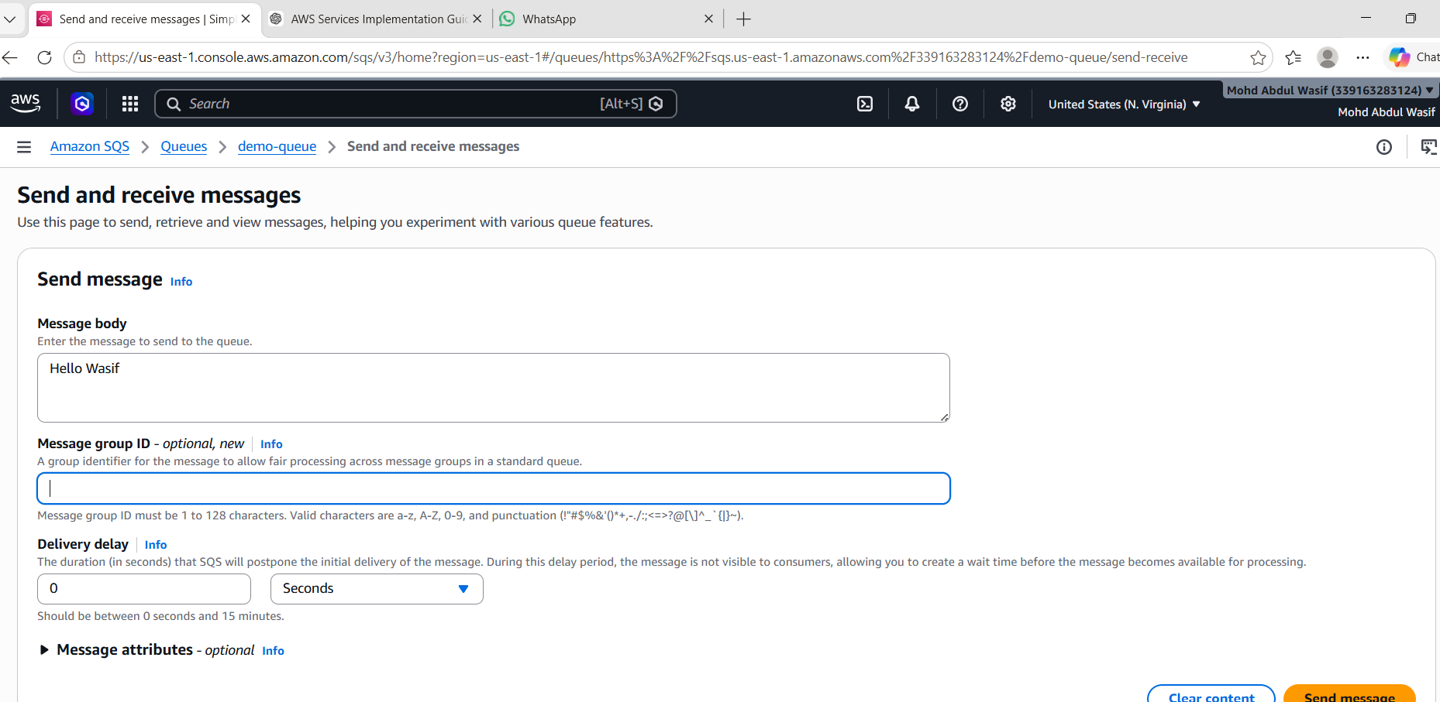
- Send message.
Step 3: Receive Messages
- Click Poll for Messages.
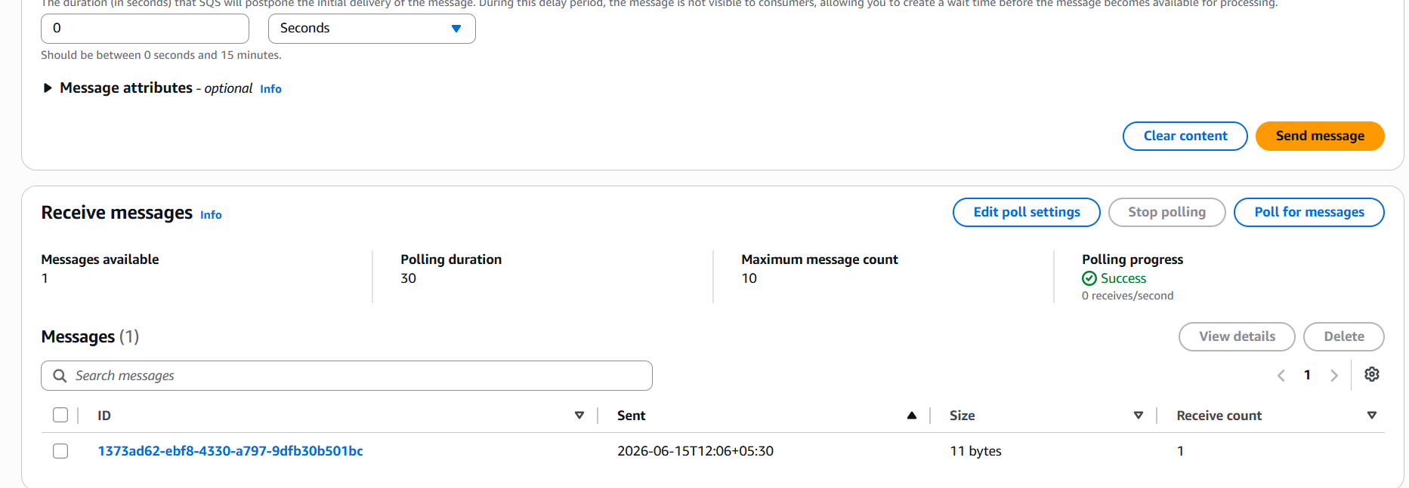
- View received message.
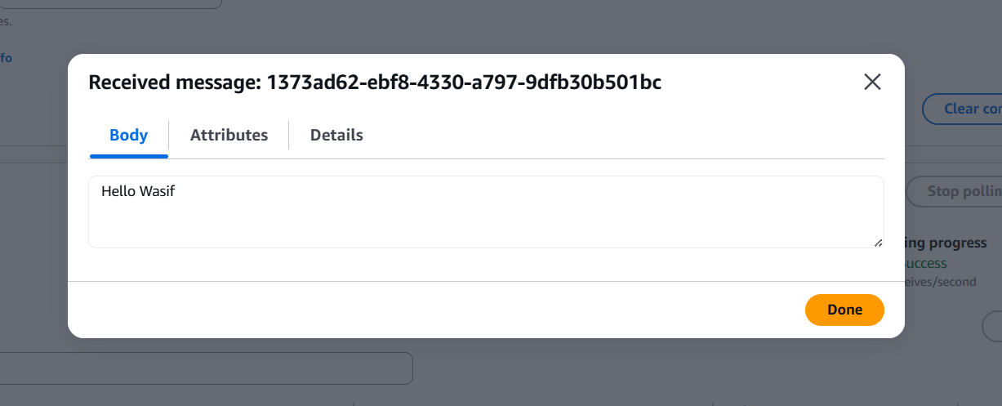
- Delete message after processing.
Observations
- Messages are stored reliably.
- Applications can communicate asynchronously.
- Queue handles traffic spikes efficiently.
What I Learned
- Difference between synchronous and asynchronous communication.
- Queue-based architecture.
- Message retention and visibility timeout concepts.

Amazon MQ
Objective
Deploy a managed message broker using Amazon MQ.
What is Amazon MQ?
Amazon MQ is a managed message broker service that supports:
- ActiveMQ
- RabbitMQ
It helps migrate existing messaging applications to AWS without changing application code.
Use Cases
- Enterprise messaging systems
- Legacy applications
- Banking applications
- Event-driven architectures
Architecture
Application A
|
v
Amazon MQ
|
v
Application B
Hands-on Implementation
Step 1: Create Broker
- Open Amazon MQ Console.
- Click Create Broker.
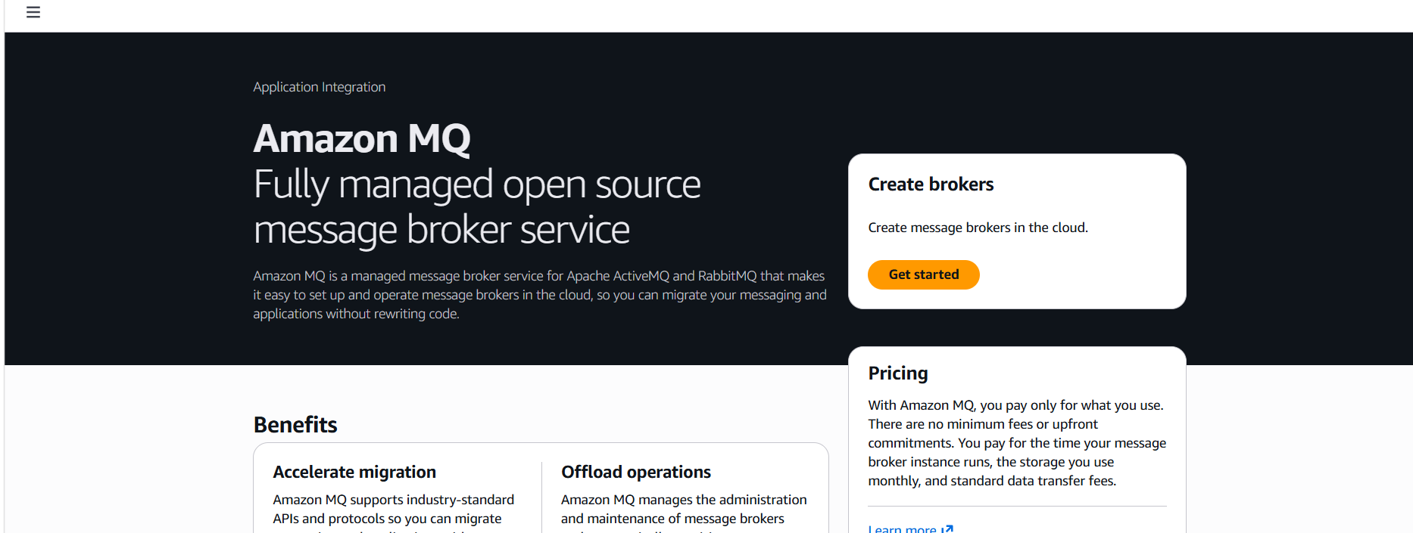
- Select RabbitMQ.
- Broker Name:
demo-rabbitmq
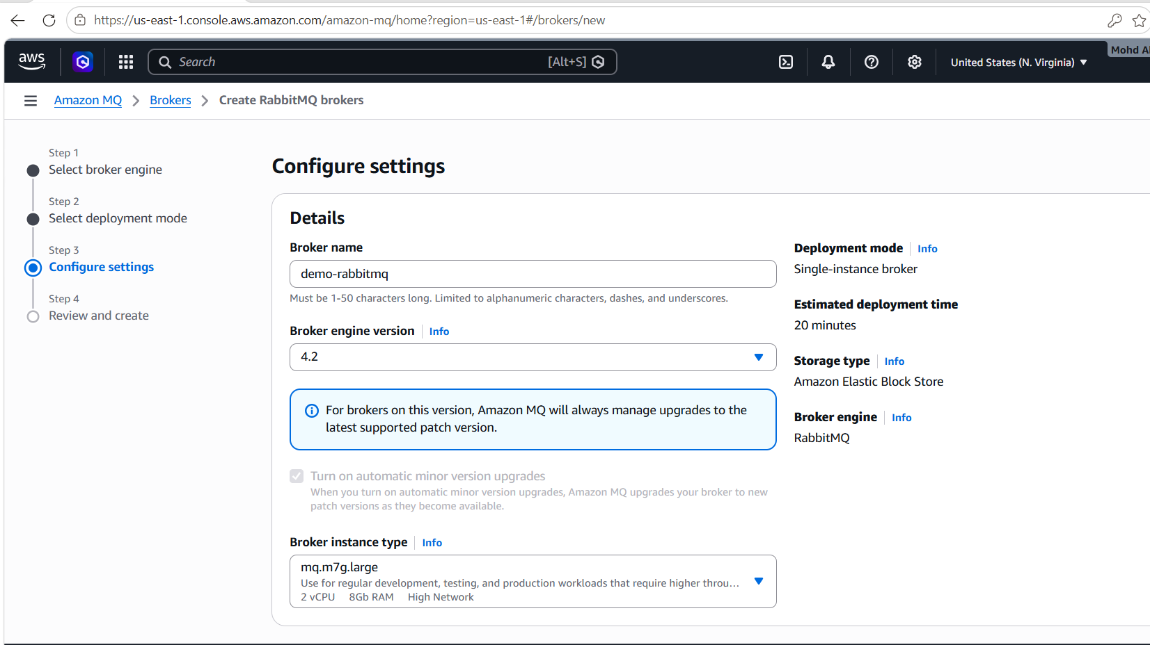
- Deployment Mode:
Single Instance
- Create username/password.
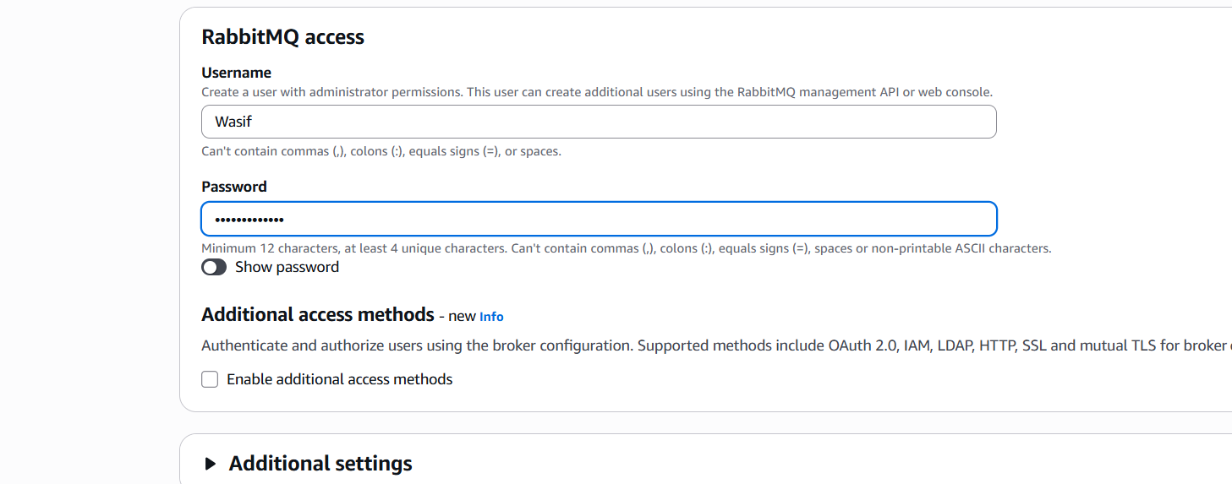
- Launch broker.
Step 2: Access Broker
- Wait until status becomes Running.
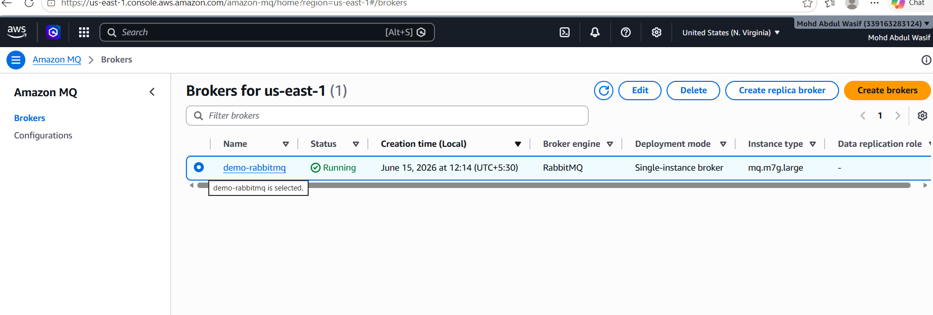
- Open RabbitMQ Web Console.
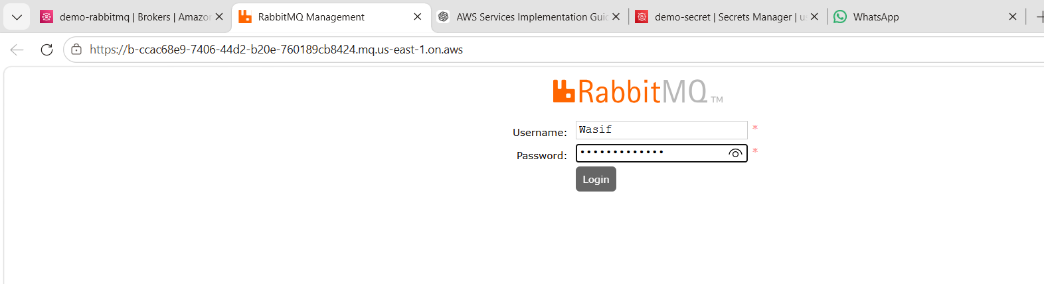
- Login with configured credentials.
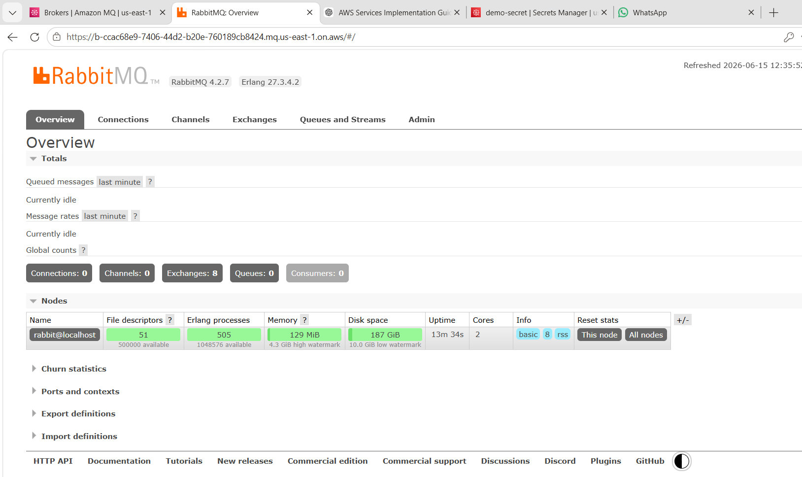
Step 3: Create Queue
- Navigate to Queues.
- Create queue:
test-queue
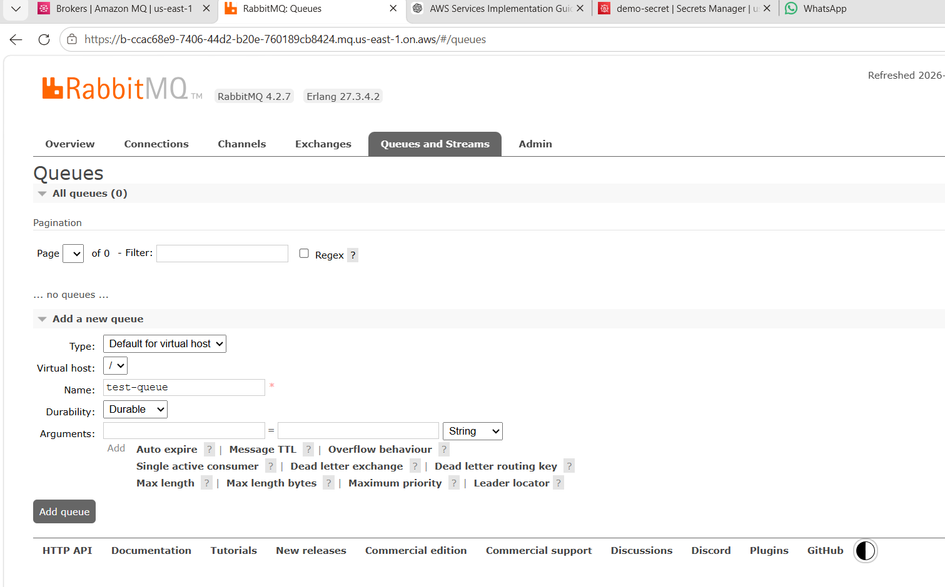
Use these settings:
- Type: Default for virtual host
- Virtual host: /
- Name: test-queue
- Durability: Durable
- Arguments: Leave empty
Then click Add queue.

- Publish test messages.
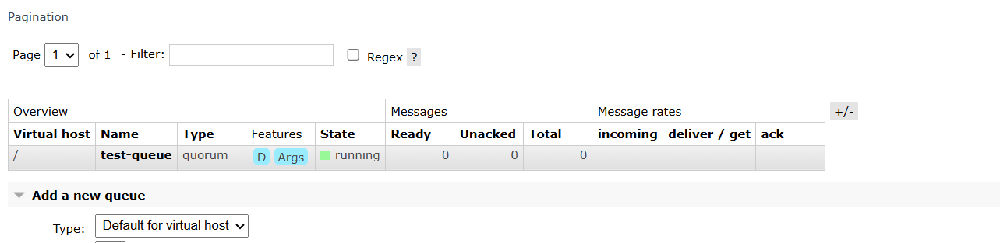
Send a Test Message
- Click test-queue.
- Scroll down to Publish message.
- Enter:
Payload
{
"message":"Hello Amazon MQ"
}

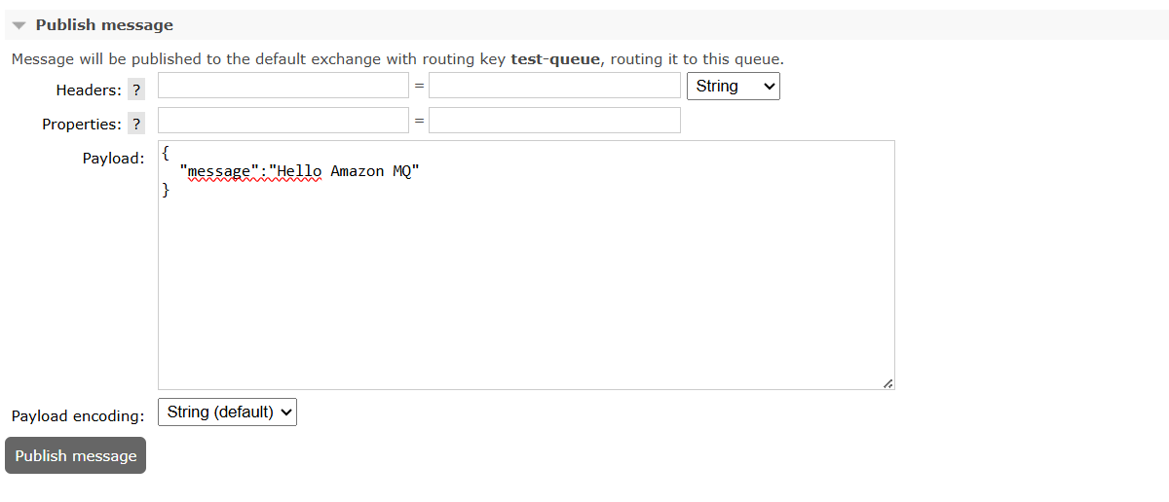
- Click Publish Message.
Verify Message
After publishing, you should see:
Ready: 1
Total: 1
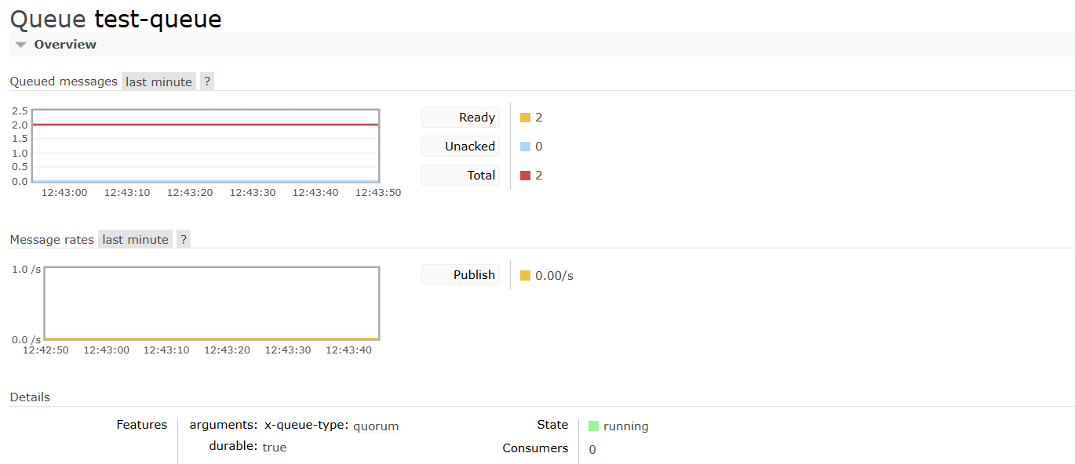
Consume Message
- In the same queue page, find Get messages.
- Message count:
1
- Click Get Message(s).
The message should appear below.

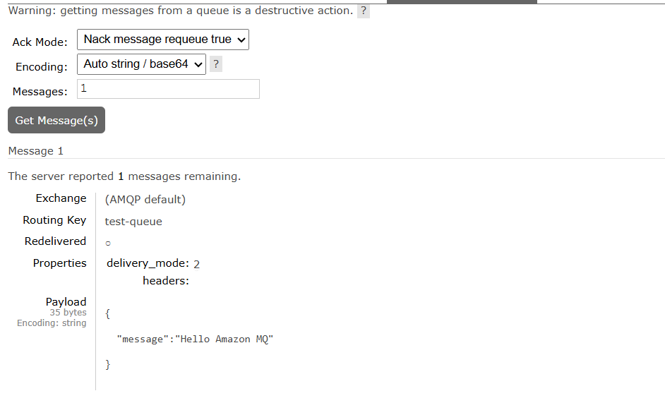
Observations
- Managed RabbitMQ administration.
- Easy broker setup.
- Built-in monitoring and security.
What I Learned
- Message broker concepts.
- Difference between Queue and Broker.
- RabbitMQ management in AWS.

AWS Secrets Manager
Objective
Securely store and retrieve application secrets.
What is AWS Secrets Manager?
AWS Secrets Manager helps store and manage sensitive information such as:
- Database passwords
- API Keys
- Tokens
- Application credentials
Use Cases
- RDS database credentials
- Third-party API keys
- Application secrets
- Automated secret rotation
Architecture
Application
|
v
AWS Secrets Manager
|
v
Encrypted Secret
Hands-on Implementation
Step 1: Create Secret
- Open Secrets Manager.
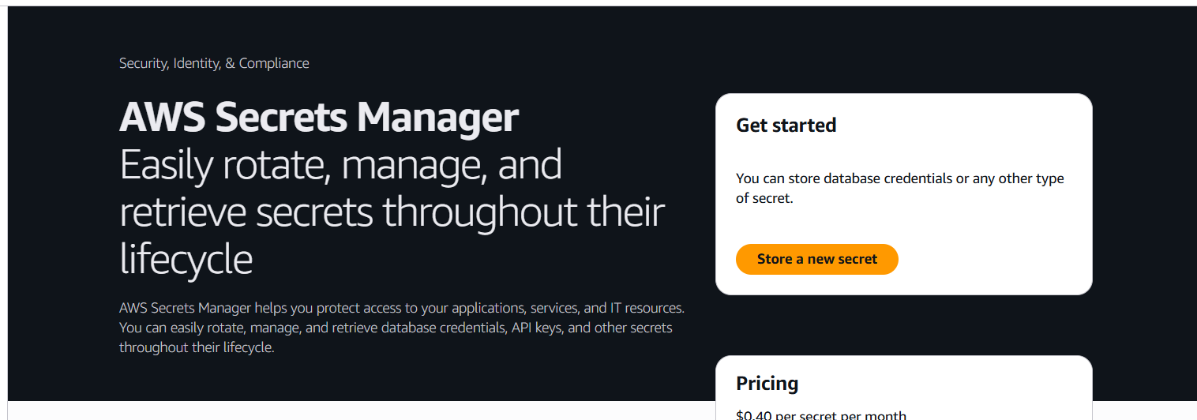
- Click Store a New Secret.
- Select:
Other type of secret
- Add key-value pair:
Key | Value  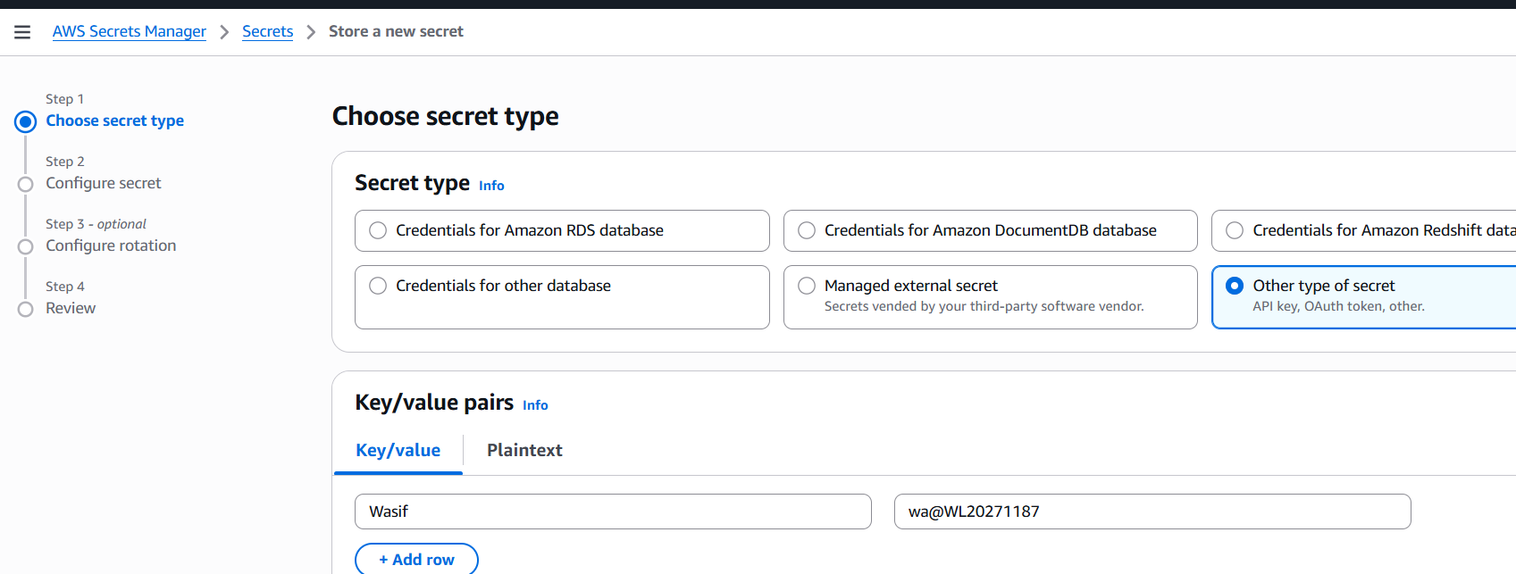
username | Wasif
password | wa@WL20271187
- Secret Name:
demo-secret
- Save secret.
Step 2: Retrieve Secret
- Open secret.
- Click Retrieve Secret Value.
- View stored credentials.
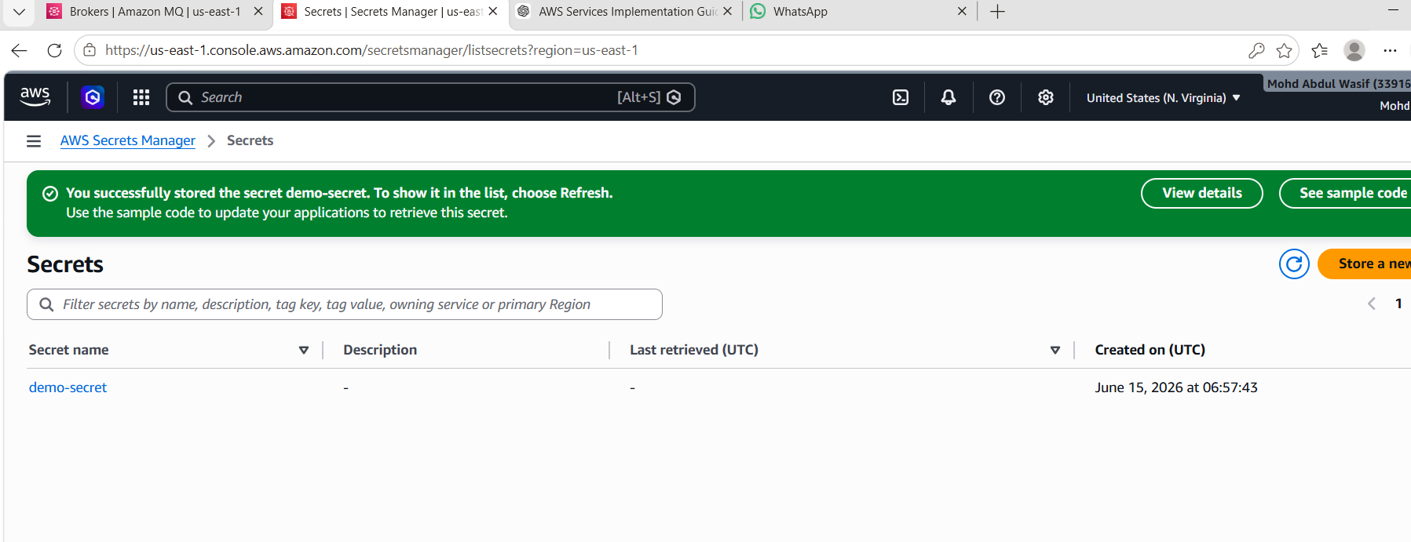
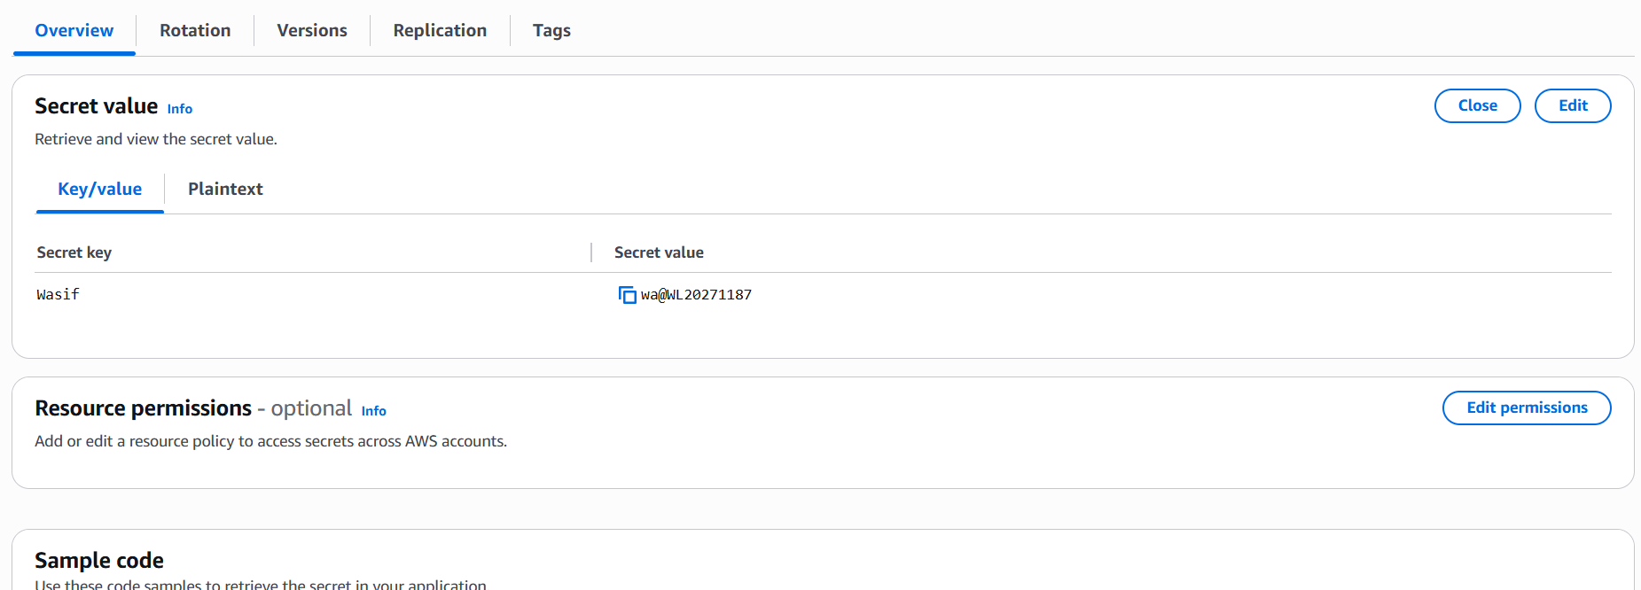
Observations
- Secrets are encrypted automatically.
- Secure alternative to storing passwords in code.
- Centralized secret management.
What I Learned
- Secret lifecycle management.
- Encryption using KMS.
- Secure credential storage.

Difference Between SQS, Amazon MQ, and Secrets Manager
Feature | SQS | Amazon MQ | Secrets Manager
Purpose | Message Queue | Message Broker | Secret Storage
Managed Service | Yes | Yes | Yes
Stores Messages | Yes | Yes | No
Stores Passwords | No | No | Yes
Supports Protocols | AWS API | AMQP, MQTT, STOMP, JMS | AWS API
Primary Use | Decoupling Apps | Enterprise Messaging | Credential Management
Conclusion
Through this hands-on exercise, I gained practical experience with AWS messaging and security services. I successfully created and tested AWS SQS queues, deployed an Amazon MQ RabbitMQ broker, and securely stored credentials using AWS Secrets Manager. These services improve application scalability, reliability, security, and maintainability in cloud environments.

