Terraform-Final-Task
Objective
To provision a complete public AWS network using Terraform, launch an Ubuntu EC2 instance with a manually created network interface, assign a static Elastic IP and automatically install and enable Apache2.
Prerequisites
- AWS account
- IAM user with EC2, VPC and SSM read permissions
- AWS CLI installed and configured
- Terraform installed
- Existing EC2 key pair
- VS Code or another code editor
- SSH client

Terraform Final Task: VPC + EC2 + Apache2
This Terraform project creates:
VPC
└── Internet Gateway
└── Public Route Table
└── Public Subnet
└── Network Interface
├── Security Group
├── Elastic IP
└── Ubuntu EC2
└── Apache2 Web Server
The configuration uses separate security-group rule resources because the current AWS provider documentation recommends them instead of inline rules. It also obtains the current Ubuntu 24.04 LTS AMI through Canonical’s AWS Systems Manager parameter, avoiding a region-specific hard-coded AMI.

1. Create the project folder
mkdir terraform-final-task
cd terraform-final-task
Create these files:
terraform-final-task/
├── main.tf
├── variables.tf
├── outputs.tf
└── terraform.tfvars
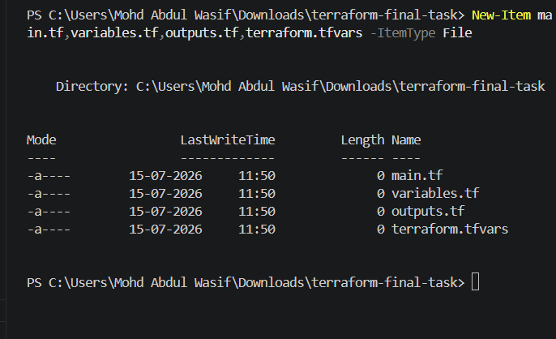

2. main.tf
terraform {
required_version = ">= 1.5.0"

required_providers {
aws = {
source = "hashicorp/aws"
version = "~> 6.0"
}
}
}

provider "aws" {
region = var.aws_region
}

data "aws_ssm_parameter" "ubuntu_ami" {
name = "/aws/service/canonical/ubuntu/server/24.04/stable/current/amd64/hvm/ebs-gp3/ami-id"
}

# 1. Create VPC
resource "aws_vpc" "final_vpc" {
cidr_block = var.vpc_cidr
enable_dns_support = true
enable_dns_hostnames = true

tags = {
Name = "${var.project_name}-vpc"
}
}

# 2. Create Internet Gateway
resource "aws_internet_gateway" "final_igw" {
vpc_id = aws_vpc.final_vpc.id

tags = {
Name = "${var.project_name}-igw"
}
}

# 3. Create Custom Route Table
resource "aws_route_table" "public_route_table" {
vpc_id = aws_vpc.final_vpc.id

route {
cidr_block = "0.0.0.0/0"
gateway_id = aws_internet_gateway.final_igw.id
}

tags = {
Name = "${var.project_name}-public-rt"
}
}

# 4. Create Public Subnet
resource "aws_subnet" "public_subnet" {
vpc_id = aws_vpc.final_vpc.id
cidr_block = var.subnet_cidr
availability_zone = var.availability_zone

tags = {
Name = "${var.project_name}-public-subnet"
}
}

# 5. Associate Subnet with Route Table
resource "aws_route_table_association" "public_association" {
subnet_id = aws_subnet.public_subnet.id
route_table_id = aws_route_table.public_route_table.id
}

# 6. Create Security Group
resource "aws_security_group" "web_sg" {
name = "${var.project_name}-web-sg"
description = "Allow SSH, HTTP and HTTPS"
vpc_id = aws_vpc.final_vpc.id

tags = {
Name = "${var.project_name}-web-sg"
}
}

resource "aws_vpc_security_group_ingress_rule" "ssh" {
security_group_id = aws_security_group.web_sg.id
from_port = 22
to_port = 22
ip_protocol = "tcp"
cidr_ipv4 = var.ssh_allowed_cidr
}

resource "aws_vpc_security_group_ingress_rule" "http" {
security_group_id = aws_security_group.web_sg.id
from_port = 80
to_port = 80
ip_protocol = "tcp"
cidr_ipv4 = "0.0.0.0/0"
}

resource "aws_vpc_security_group_ingress_rule" "https" {
security_group_id = aws_security_group.web_sg.id
from_port = 443
to_port = 443
ip_protocol = "tcp"
cidr_ipv4 = "0.0.0.0/0"
}

resource "aws_vpc_security_group_egress_rule" "all_outbound" {
security_group_id = aws_security_group.web_sg.id
ip_protocol = "-1"
cidr_ipv4 = "0.0.0.0/0"
}

# 7. Create Network Interface
resource "aws_network_interface" "web_eni" {
subnet_id = aws_subnet.public_subnet.id
private_ips = [var.private_ip]
security_groups = [aws_security_group.web_sg.id]

tags = {
Name = "${var.project_name}-eni"
}
}

# 8. Create Elastic IP
resource "aws_eip" "web_eip" {
domain = "vpc"

tags = {
Name = "${var.project_name}-eip"
}
}

resource "aws_eip_association" "web_eip_association" {
allocation_id = aws_eip.web_eip.id
network_interface_id = aws_network_interface.web_eni.id

depends_on = [
aws_internet_gateway.final_igw
]
}

# 9. Create Ubuntu EC2 and install Apache2
resource "aws_instance" "ubuntu_server" {
ami = data.aws_ssm_parameter.ubuntu_ami.value
instance_type = var.instance_type
key_name = var.key_name

network_interface {
network_interface_id = aws_network_interface.web_eni.id
device_index = 0
}

user_data = <<-EOF
#!/bin/bash
apt-get update -y
apt-get install apache2 -y
systemctl start apache2
systemctl enable apache2

cat > /var/www/html/index.html <<'HTML'
<html>
<head>
<title>Terraform Final Task</title>
</head>
<body>
<h1>Terraform Final Task Completed</h1>
<h2>Apache2 is running successfully!</h2>
</body>
</html>
HTML

systemctl restart apache2
EOF

tags = {
Name = "${var.project_name}-ubuntu-server"
}

depends_on = [
aws_route_table_association.public_association,
aws_eip_association.web_eip_association
]
}
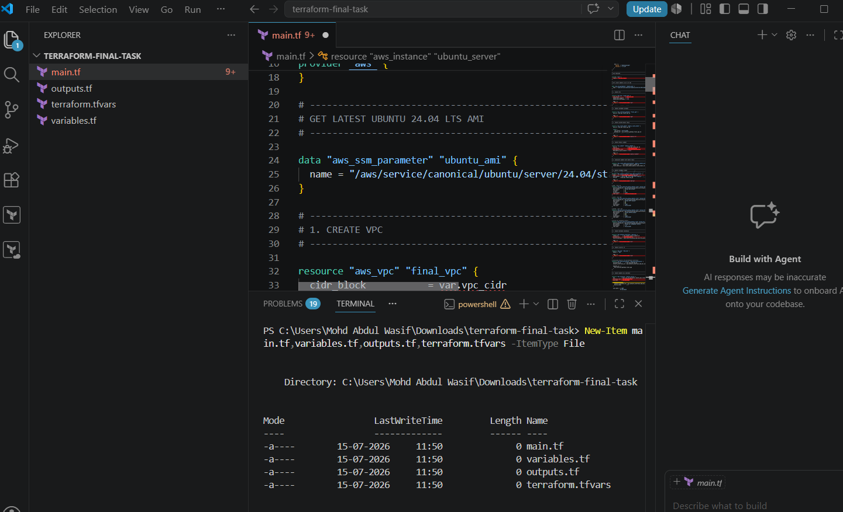
An Internet Gateway can be directly attached to a VPC using vpc_id, and a route-table association connects the custom route table to the subnet.

3. variables.tf
variable "aws_region" {
description = "AWS region"
type = string
default = "us-east-1"
}

variable "availability_zone" {
description = "Availability Zone"
type = string
default = "us-east-1a"
}

variable "project_name" {
description = "Project name"
type = string
default = "terraform-final-task"
}

variable "vpc_cidr" {
description = "VPC CIDR block"
type = string
default = "10.0.0.0/16"
}

variable "subnet_cidr" {
description = "Subnet CIDR block"
type = string
default = "10.0.1.0/24"
}

variable "private_ip" {
description = "Private IP for ENI"
type = string
default = "10.0.1.50"
}

variable "instance_type" {
description = "EC2 instance type"
type = string
default = "t2.micro"
}

variable "key_name" {
description = "Existing AWS key pair name"
type = string
}

variable "ssh_allowed_cidr" {
description = "CIDR allowed for SSH"
type = string
default = "0.0.0.0/0"
}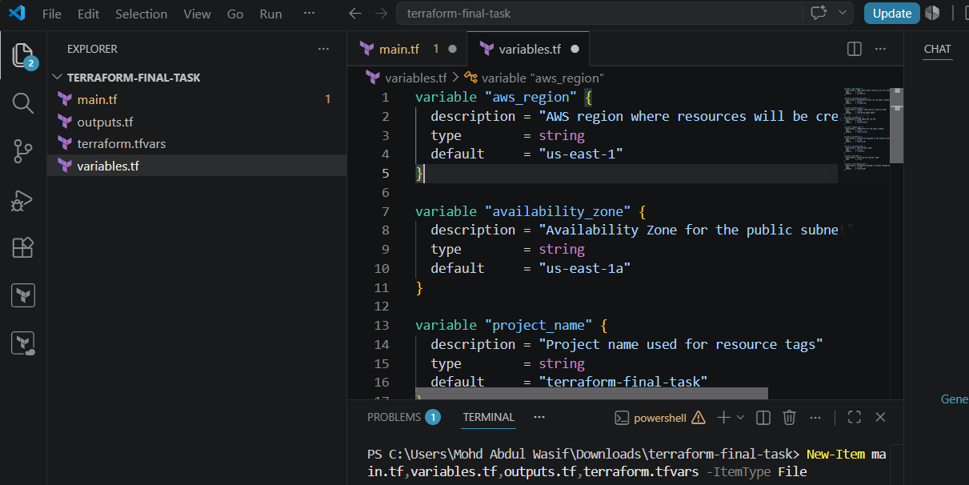

4. outputs.tf
output "vpc_id" {
description = "ID of the created VPC"
value = aws_vpc.final_vpc.id
}

output "internet_gateway_id" {
description = "ID of the Internet Gateway"
value = aws_internet_gateway.final_igw.id
}

output "public_subnet_id" {
description = "ID of the public subnet"
value = aws_subnet.public_subnet.id
}

output "route_table_id" {
description = "ID of the custom route table"
value = aws_route_table.public_route_table.id
}

output "security_group_id" {
description = "ID of the web security group"
value = aws_security_group.web_security_group.id
}

output "network_interface_id" {
description = "ID of the Elastic Network Interface"
value = aws_network_interface.web_eni.id
}

output "private_ip" {
description = "Private IP of the server"
value = aws_network_interface.web_eni.private_ip
}

output "elastic_ip" {
description = "Elastic IP assigned to the server"
value = aws_eip.web_eip.public_ip
}

output "instance_id" {
description = "Ubuntu EC2 instance ID"
value = aws_instance.ubuntu_server.id
}

output "website_url" {
description = "Apache2 website URL"
value = "http://${aws_eip.web_eip.public_ip}"
}

output "ssh_command" {
description = "Command to connect to Ubuntu EC2"
value = "ssh -i your-key.pem ubuntu@${aws_eip.web_eip.public_ip}"
}
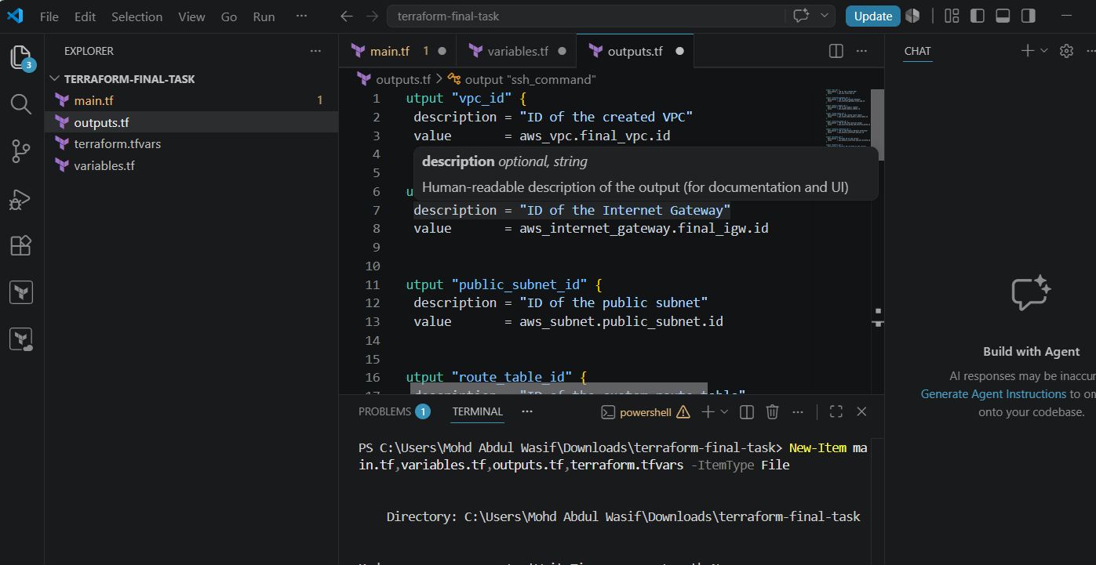

5. terraform.tfvars
Replace Virginia with the exact name of your existing AWS key pair.
aws_region = "us-east-1"
availability_zone = "us-east-1a"
project_name = "terraform-final-task"

vpc_cidr = "10.0.0.0/16"
subnet_cidr = "10.0.1.0/24"
private_ip = "10.0.1.50"

instance_type = "t3.micro"
key_name = "Virginia"

ssh_allowed_cidr = "0.0.0.0/0"
Opening SSH to 0.0.0.0/0 allows everyone on the internet to attempt an SSH connection. For real environments, replace it with your own public IP followed by /32.
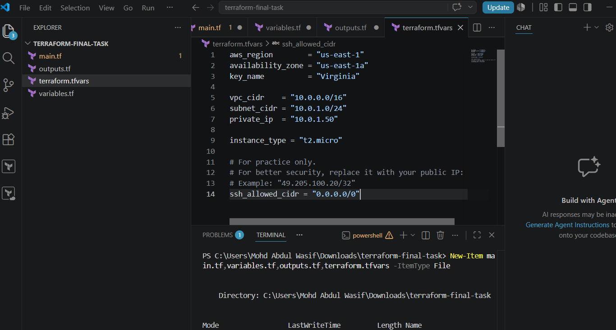

6. Configure AWS credentials
Check whether AWS CLI is already configured:
aws sts get-caller-identity
Expected output:
{
"UserId": "ABCDEFGHIJK",
"Account": "123456789012",
"Arn": "arn:aws:iam::123456789012:user/terraform-user"
}
If it is not configured:
aws configure
Enter:
AWS Access Key ID: Your access key
AWS Secret Access Key: Your secret key
Default region name: us-east-1
Default output format: json
Do not put AWS access keys inside Terraform files.
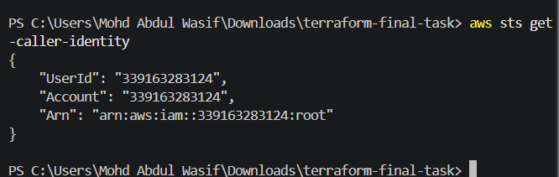

7. Run Terraform commands
Initialize
terraform init
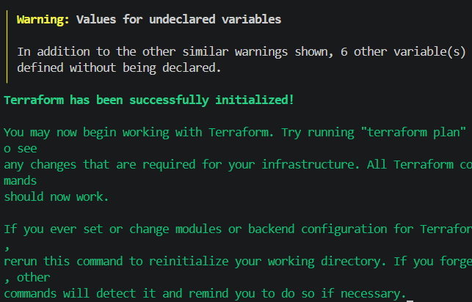
Downloads the required AWS provider.
Format the code
terraform fmt
Formats all .tf files.
Validate
terraform validate
Expected:
Success! The configuration is valid.
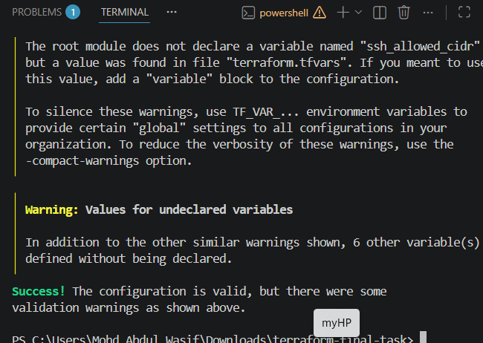
Review the plan
terraform plan
Or save the plan:
terraform plan -out=tfplan
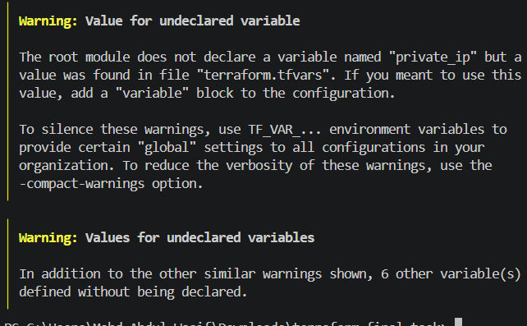
Create the infrastructure
terraform apply tfplan
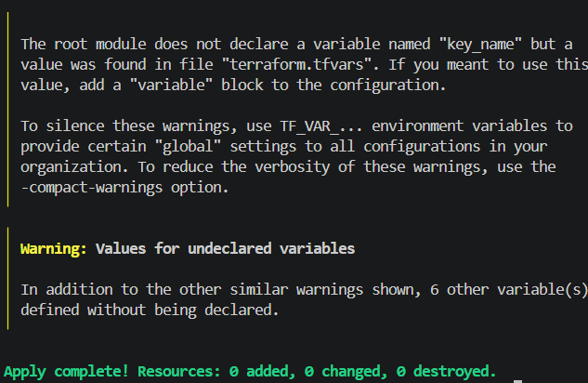
Or directly:
terraform apply
Enter:
Yes
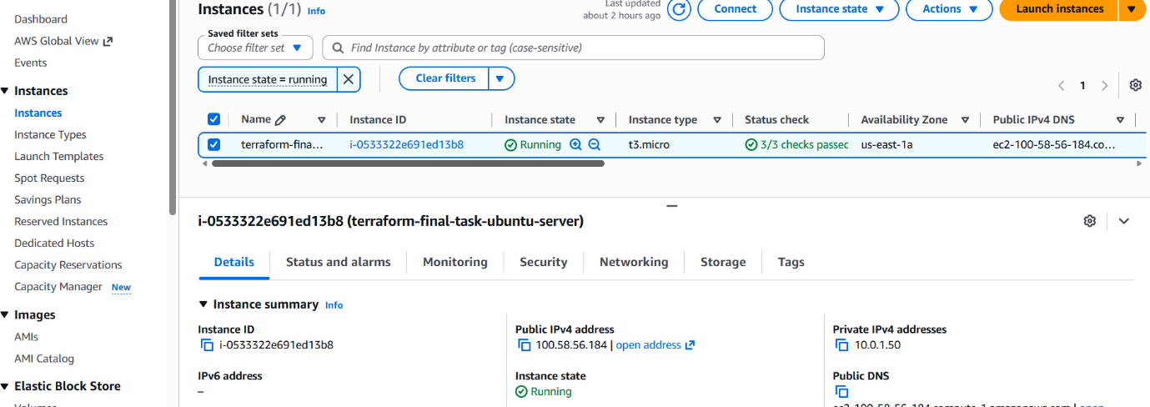
VPC & Subnet Ids
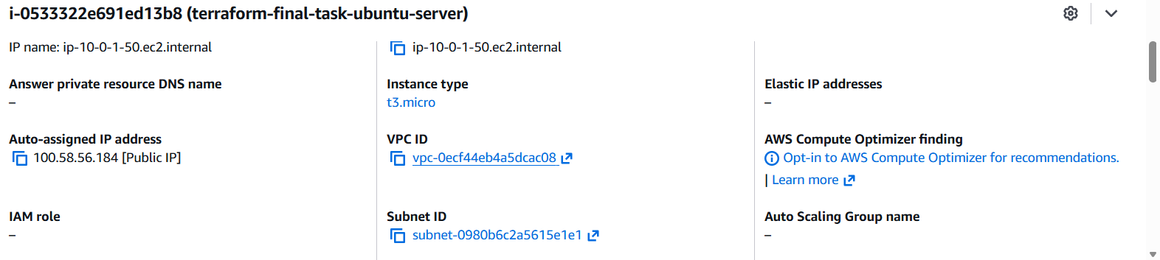

8. Check Terraform output
terraform output
Example:
elastic_ip = "54.210.10.20"
instance_id = "i-0123456789abcdef0"
private_ip = "10.0.1.50"
website_url = http://54.210.10.20
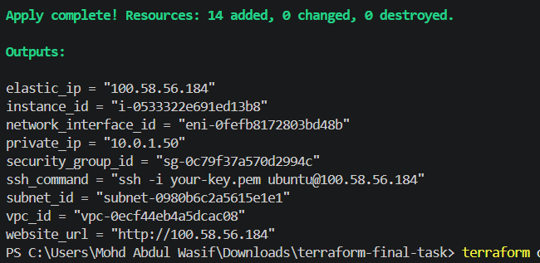
Open the displayed website URL:
http://<Elastic-IP>
Expected page:
Terraform Final Task Completed!
Apache2 is running on Ubuntu EC2
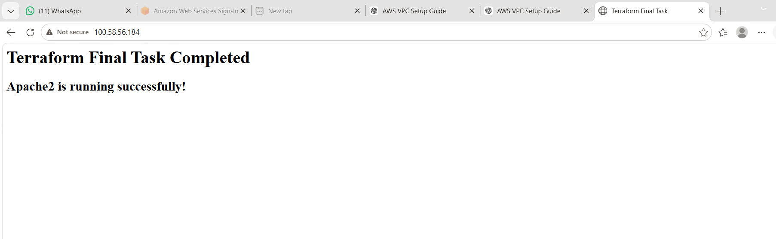

9. Connect through SSH
For PowerShell:
ssh -i "C:\path\Virginia.pem" ubuntu@<Elastic-IP>
Example:
ssh -i "C:\Users\Mohd Abdul Wasif\Downloads\Virginia.pem" ubuntu@54.210.10.20
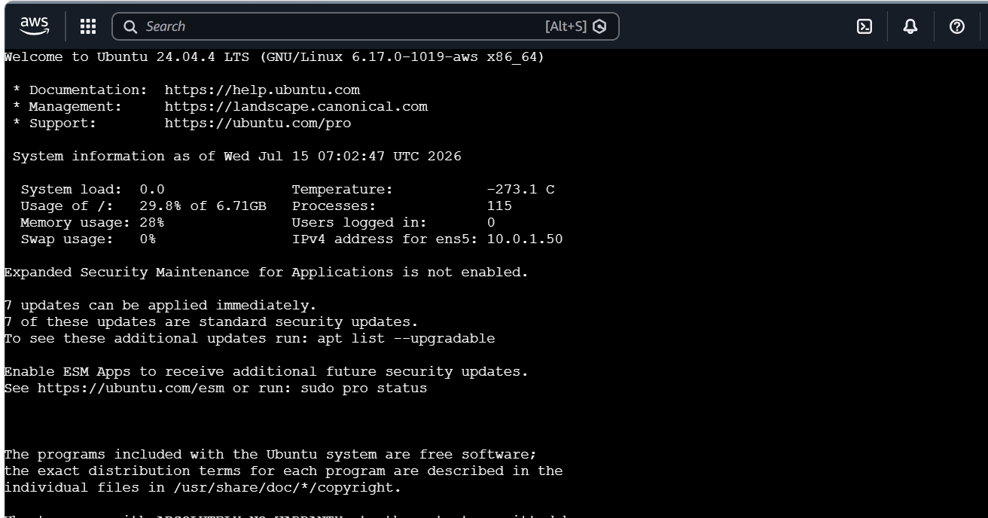
Verify Apache:
sudo systemctl status apache2
Verify Apache is enabled:
sudo systemctl is-enabled apache2
Expected:
enabled
Check the webpage locally:
curl http://localhost
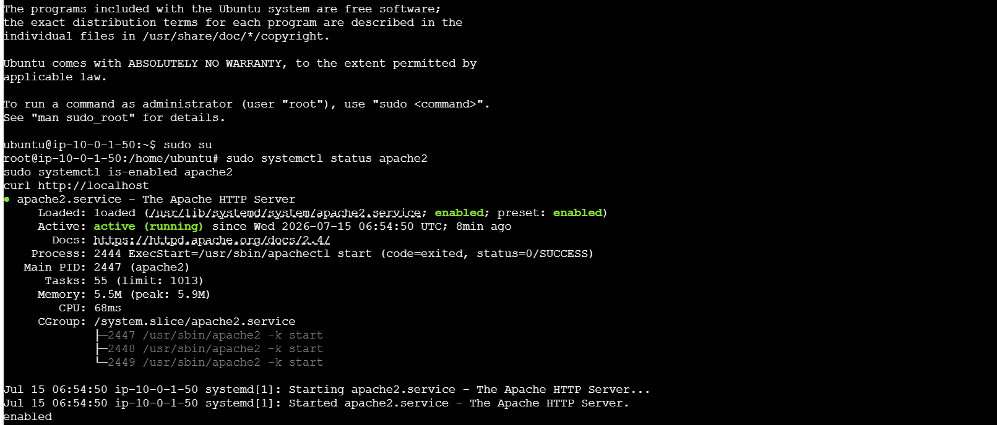
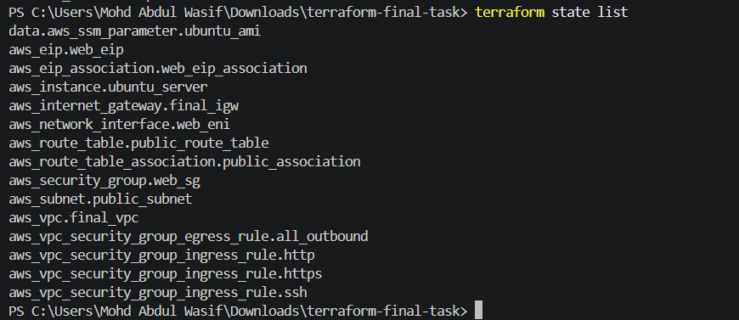

10. Destroy the infrastructure
After completing the task:
terraform destroy
Enter:
Yes
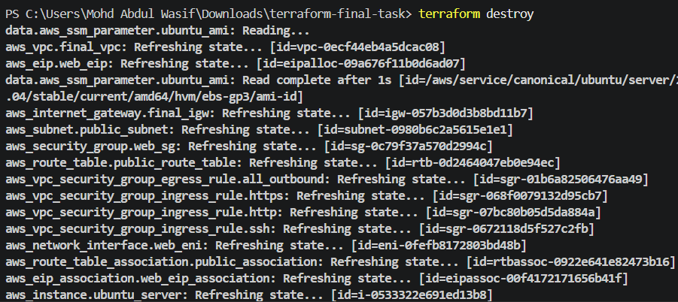
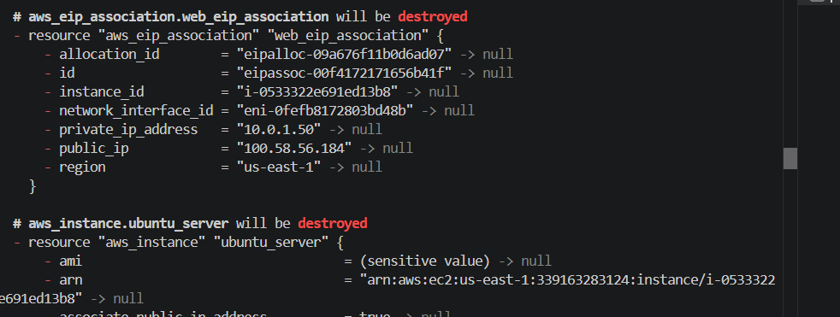
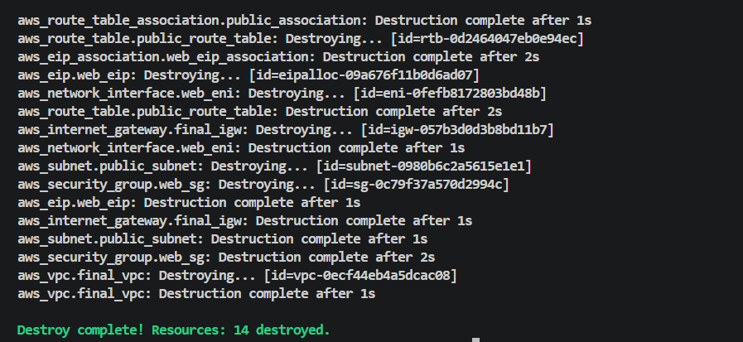
Terraform will delete the EC2 instance, Elastic IP, ENI, security group, subnet, route table, Internet Gateway and VPC.

What we learned
- Creating a custom VPC and public subnet using Terraform.
- Attaching an Internet Gateway to a VPC.
- Creating a public route through 0.0.0.0/0.
- Associating a route table with a subnet.
- Allowing ports 22, 80 and 443 through a security group.
- Creating an Elastic Network Interface with a fixed private IP.
- Associating an Elastic IP with the network interface.
- Launching Ubuntu using a current AMI obtained from SSM.
- Installing and enabling Apache2 automatically through user_data.
- Using Terraform outputs to retrieve the website URL and server details.
Conclusion
The final Terraform task provisions a complete AWS network and web-server environment automatically. Terraform creates the VPC, Internet Gateway, custom route table, public subnet, security group, network interface, Elastic IP and Ubuntu EC2 instance. Apache2 is installed and enabled during instance startup, and the website is accessible through the assigned Elastic IP.

