Terraform-Task-05

Task: Create an EC2 Instance with Apache Using Terraform
Terraform will create an EC2 instance, configure a security group, install Apache automatically through User Data, and display the website URL. EC2 Linux instances support shell scripts through user data, and Terraform’s user_data argument passes this startup script during instance creation.
Architecture
VS Code
│
▼
Terraform
│
├── AWS Provider
├── Default VPC
├── Security Group
│ ├── Port 22: SSH
│ └── Port 80: HTTP
│
└── EC2 Amazon Linux 2023
│
└── User Data installs Apache
│
▼
Website on Port 80

Prerequisites
1. Check Terraform
Open Git Bash or the VS Code terminal:
terraform -version
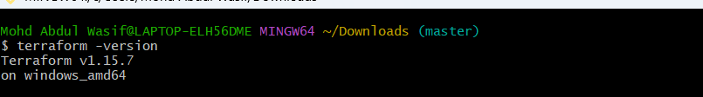
2. Check AWS CLI
Use two normal hyphens:
aws --version
The second command contains the wrong dash character.
3. Configure AWS credentials
Run:
aws configure
Enter:
AWS Access Key ID: your-access-key
AWS Secret Access Key: your-secret-key
Default region name: us-east-1
Default output format: json
Verify the AWS connection:
aws sts get-caller-identity
Never place your access key or secret key directly inside a Terraform file.

Step 1: Create the project folder
Open Git Bash:
mkdir terraform-ec2-httpd
cd terraform-ec2-httpd
code .
This opens the folder in Visual Studio Code.
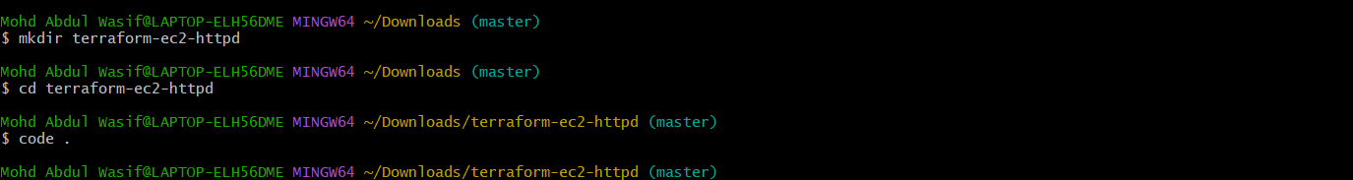

Step 2: Create Terraform files
Create these files inside VS Code:
terraform-ec2-httpd/
├── main.tf
├── variables.tf
└── outputs.tf
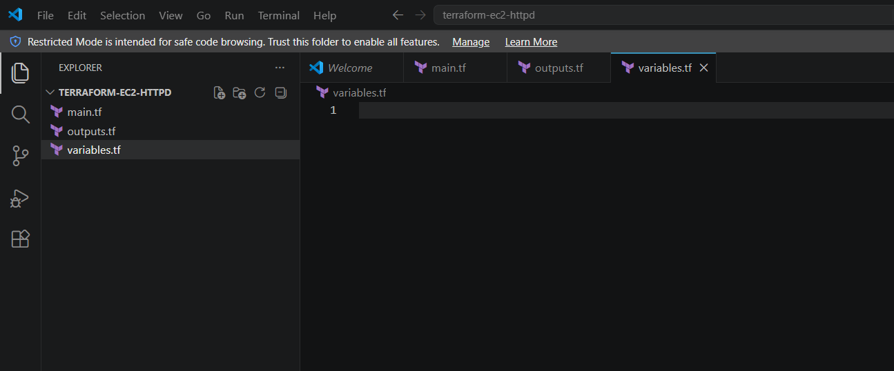

Step 3: Configure variables.tf
Paste:
variable "aws_region" {
description = "AWS region where resources will be created"
type = string
default = "us-east-1"
}

variable "instance_type" {
description = "EC2 instance type"
type = string
default = "t3.micro"
}

variable "ssh_cidr" {
description = "IP address allowed to connect through SSH"
type = string
default = "0.0.0.0/0"
}
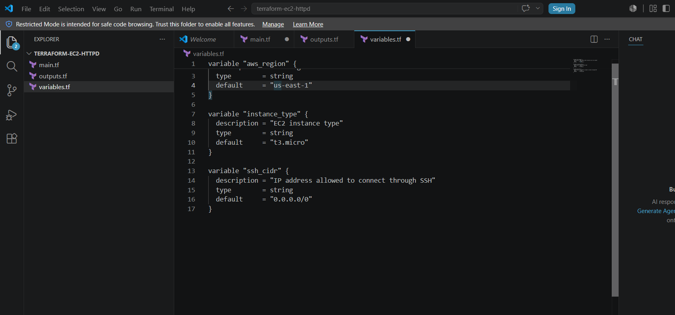
Explanation
- aws_region: AWS region where EC2 will be created.
- instance_type: Size of the EC2 instance.
- ssh_cidr: IP range allowed to access port 22.
For practice, 0.0.0.0/0 works, but it allows SSH attempts from anywhere. For better security, replace it with your public IP in this format:
default = "YOUR_PUBLIC_IP/32"

Step 4: Configure main.tf
Paste:
terraform {
required_providers {
aws = {
source = "hashicorp/aws"
version = "~> 6.0"
}
}
}

provider "aws" {
region = "us-east-1"
}

data "aws_vpc" "default" {
default = true
}

data "aws_ssm_parameter" "amazon_linux" {
name = "/aws/service/ami-amazon-linux-latest/al2023-ami-kernel-default-x86_64"
}

resource "aws_security_group" "web_sg" {
name = "terraform-httpd-sg"
description = "Allow SSH and HTTP"
vpc_id = data.aws_vpc.default.id

ingress {
description = "Allow SSH"
from_port = 22
to_port = 22
protocol = "tcp"
cidr_blocks = ["0.0.0.0/0"]
}

ingress {
description = "Allow HTTP"
from_port = 80
to_port = 80
protocol = "tcp"
cidr_blocks = ["0.0.0.0/0"]
}

egress {
description = "Allow all outgoing traffic"
from_port = 0
to_port = 0
protocol = "-1"
cidr_blocks = ["0.0.0.0/0"]
}

tags = {
Name = "Terraform-HTTPD-SG"
}
}

resource "aws_instance" "web_server" {
ami = data.aws_ssm_parameter.amazon_linux.value
instance_type = "t3.micro"
vpc_security_group_ids = [aws_security_group.web_sg.id]
associate_public_ip_address = true

user_data = <<-EOF
#!/bin/bash
dnf install -y httpd
systemctl enable httpd
systemctl start httpd
echo "<h1>Apache Installed Using Terraform</h1>" > /var/www/html/index.html
EOF

tags = {
Name = "Terraform-HTTPD-Server"
}
}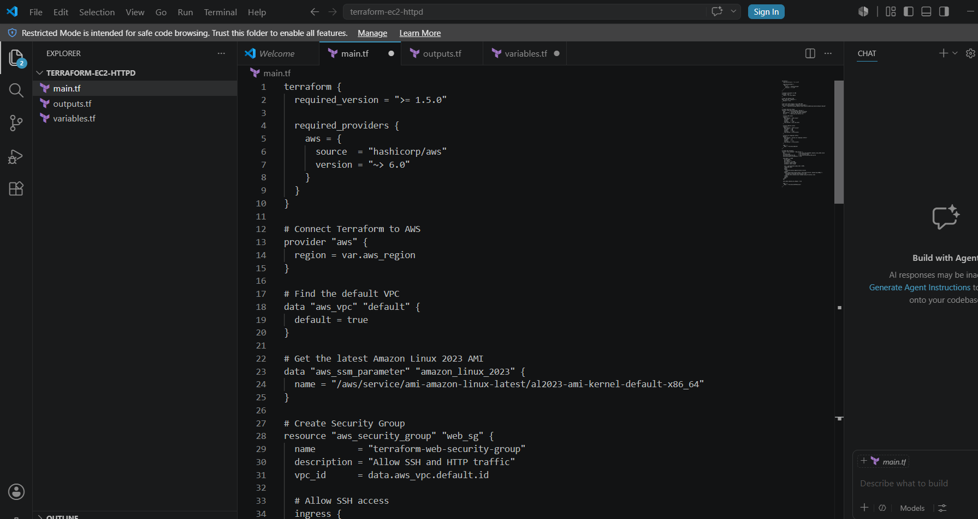
For EC2 instances running inside a VPC, Terraform recommends associating security groups using vpc_security_group_ids rather than security-group names.

Step 5: Configure outputs.tf
Paste:
output "instance_id" {
value = aws_instance.web_server.id
}

output "public_ip" {
value = aws_instance.web_server.public_ip
}

output "public_dns" {
value = aws_instance.web_server.public_dns
}

output "website_url" {
value = "http://${aws_instance.web_server.public_ip}"
}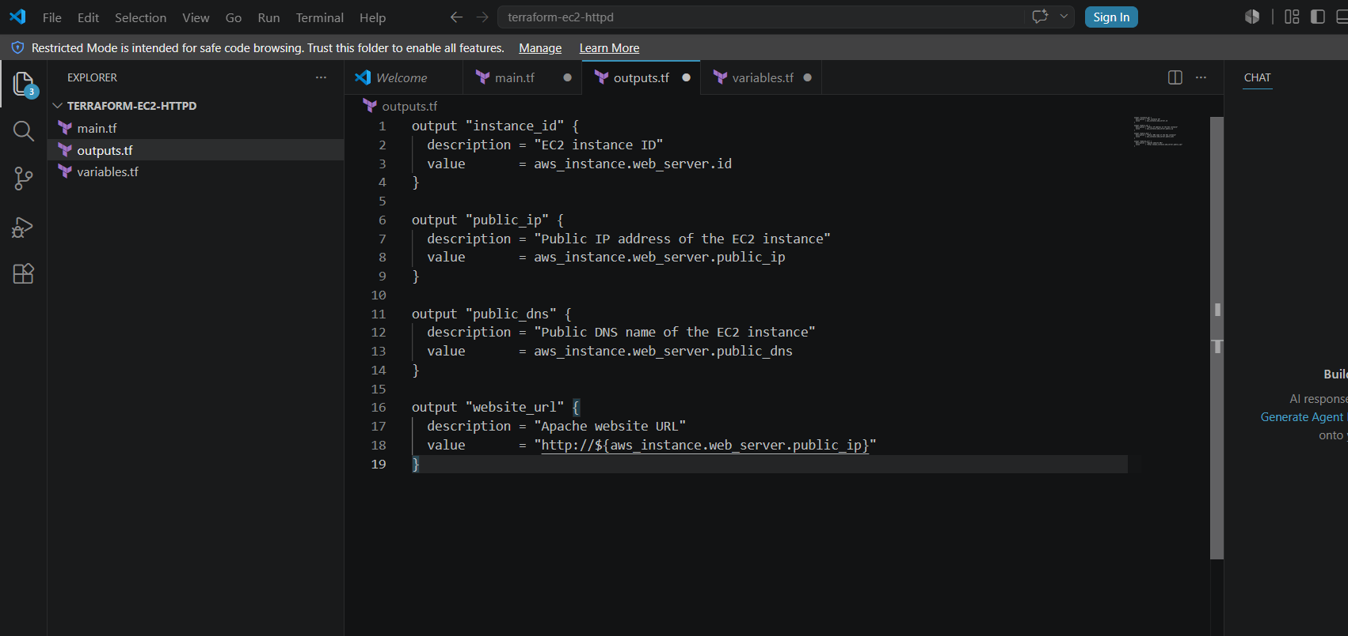

Step 6: Format the Terraform files
Open the VS Code terminal and run:
terraform fmt
This formats the Terraform code properly.

Step 7: Initialize Terraform
Run:
terraform init
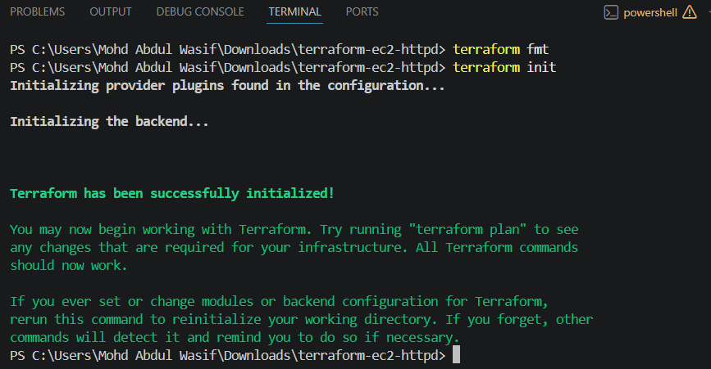
This downloads the AWS provider and initializes the working directory.
Expected result:
Terraform has been successfully initialized!

Step 8: Validate the configuration
Run:
terraform validate
Expected result:
Success! The configuration is valid.

Step 9: View the execution plan
Run:
terraform plan
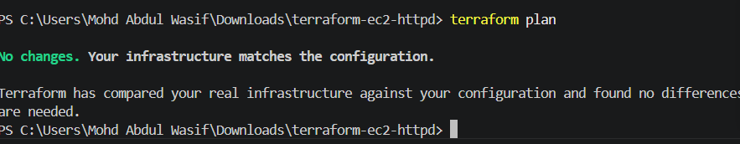
Terraform should show resources similar to:
Plan: 2 to add, 0 to change, 0 to destroy.
The two resources are:
1. Security Group
2. EC2 Instance
The VPC, AMI parameter and other data blocks only read existing information; they do not create resources.

Step 10: Create the AWS resources
Run:
terraform apply
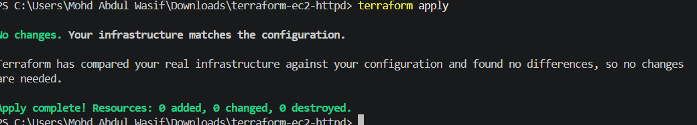
Terraform will ask:
Do you want to perform these actions?
Enter:
yes
After completion, Terraform displays:
Apply complete! Resources: 2 added, 0 changed, 0 destroyed.

Outputs:

instance_id = "i-xxxxxxxxxxxxxxxxx"
public_ip = "xx.xx.xx.xx"
website_url = http://xx.xx.xx.xx
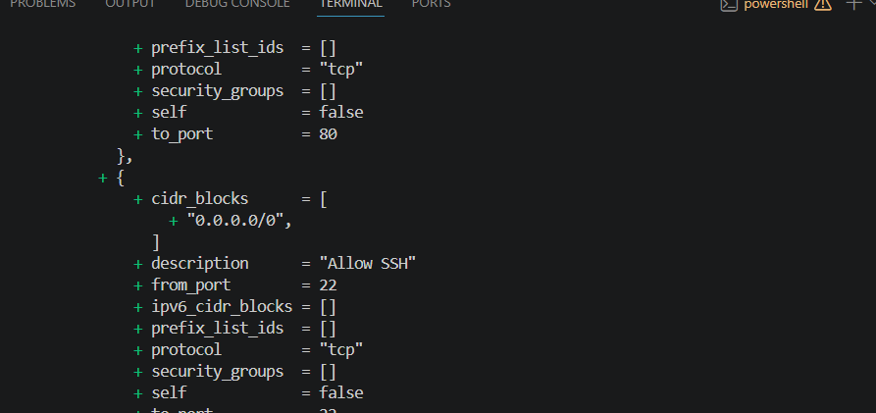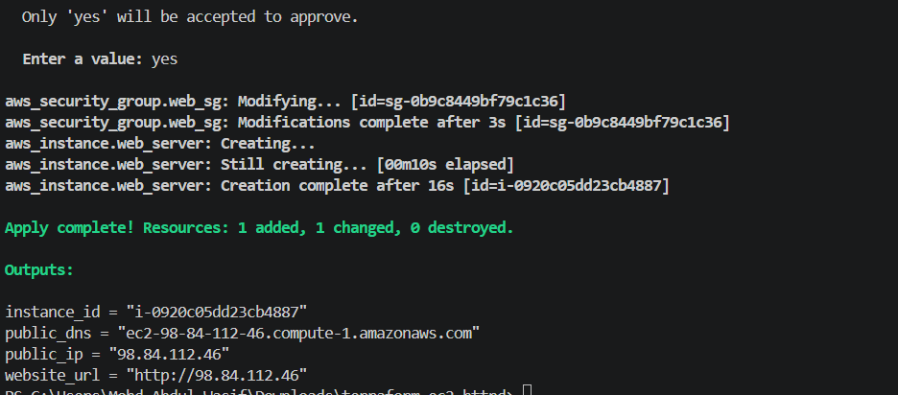

Step 11: Open the Apache website
Copy the value shown under:
website_url
Example:
http://13.233.100.25
Open it in your browser.
The page should display:
Apache Installed Successfully!
This EC2 instance was created using Terraform.
Apache installation may take a minute after the EC2 instance enters the Running state because the user-data script runs during startup.
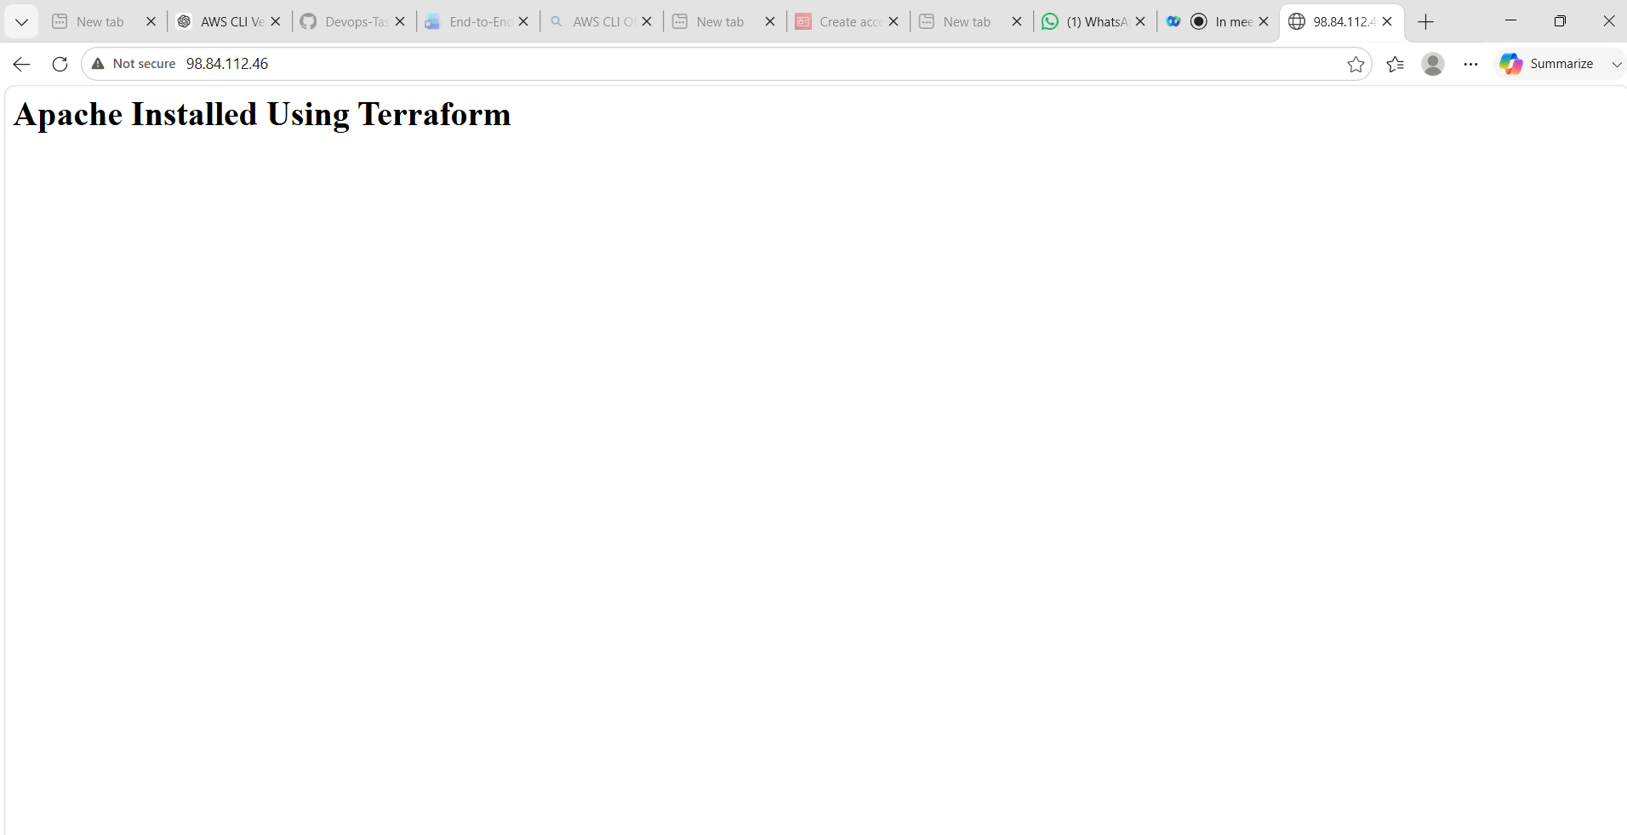

Step 12: Verify from AWS Console
Open the AWS Console and check:
EC2 → Instances
You should see:
Name: Terraform-HTTPD-Server
State: Running
Instance type: t3.micro
Check the security group:
EC2 → Security Groups → Terraform-Web-SG
Inbound rules should contain:
SSH TCP 22
HTTP TCP 80
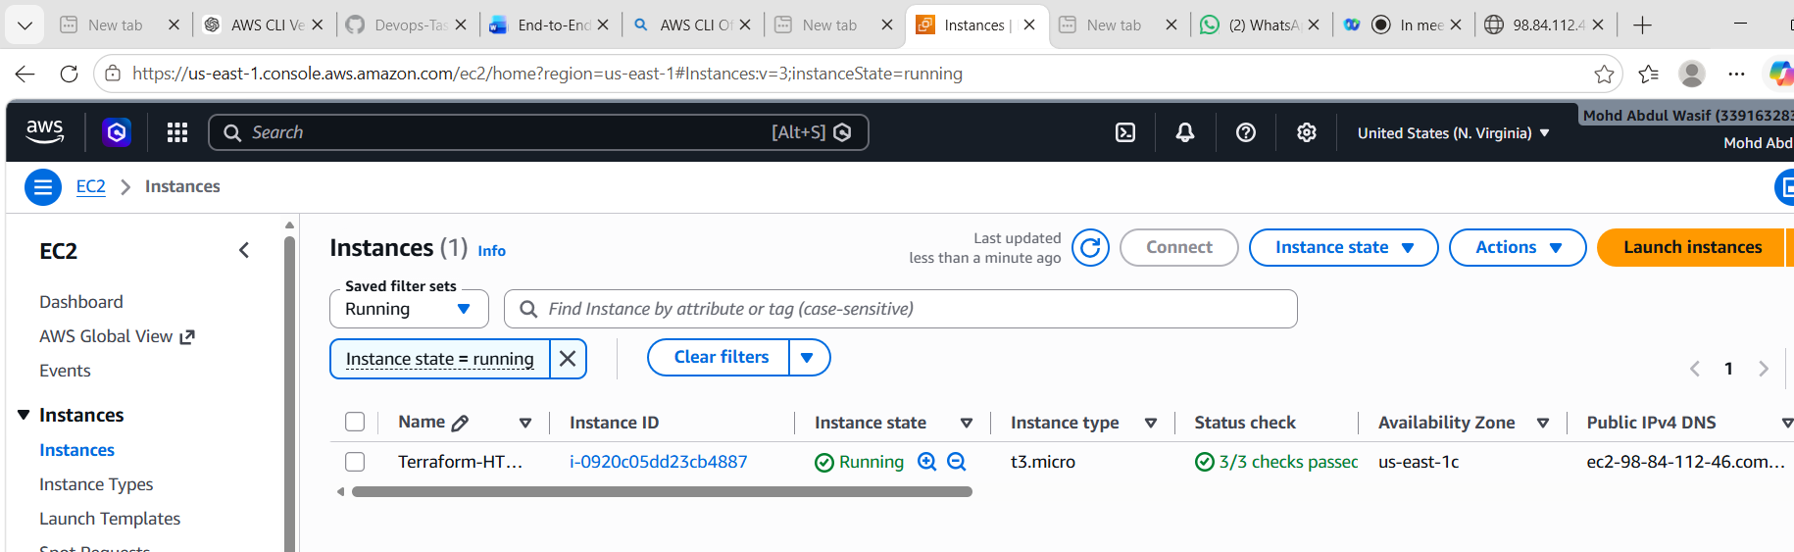

Step 13: Check Terraform state
Run:
terraform state list
Expected output:
data.aws_ssm_parameter.amazon_linux_2023
data.aws_vpc.default
aws_instance.web_server
aws_security_group.web_sg
You can display outputs again using:
terraform output
To display only the website URL:
terraform output -raw website_url


Step 14: Destroy the resources
After testing, delete the EC2 instance and security group to avoid unnecessary AWS charges:
terraform destroy
Enter:
yes
Expected result:
Destroy complete! Resources: 2 destroyed.
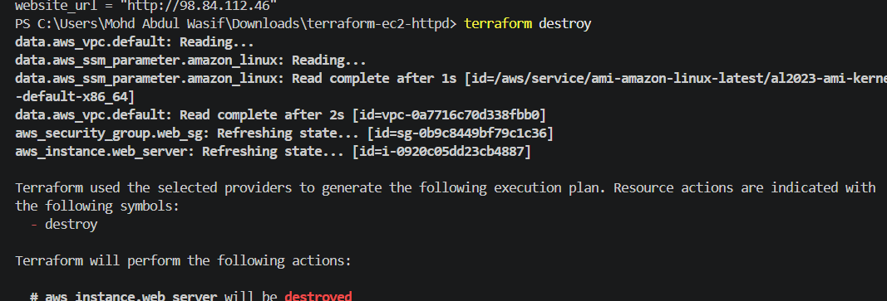
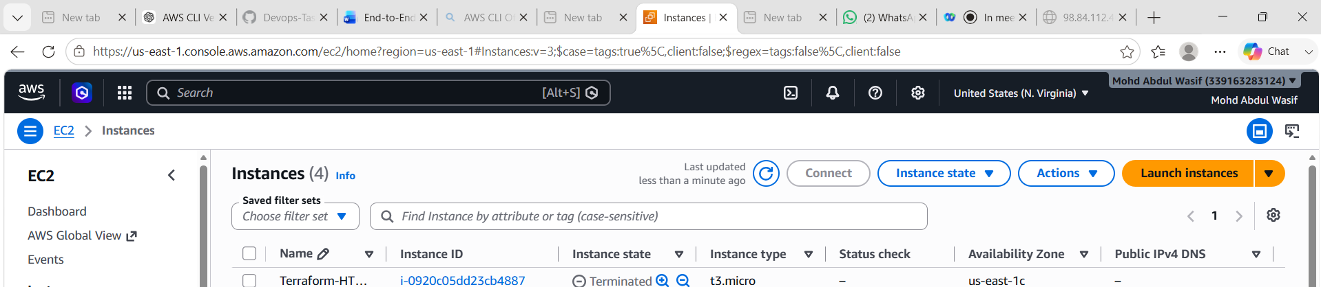

Commands summary
mkdir terraform-ec2-httpd
cd terraform-ec2-httpd
code .

aws --version
aws configure
aws sts get-caller-identity

terraform fmt
terraform init
terraform validate
terraform plan
terraform apply
terraform output
terraform destroy
What we learned
- Terraform connects to AWS using the AWS provider.
- A security group acts like a firewall for the EC2 instance.
- Port 80 allows users to open the Apache website.
- User Data automatically installs and starts Apache during EC2 startup.
- Terraform commands create, verify, manage and destroy AWS infrastructure.
Conclusion
We used Terraform in Visual Studio Code to create an AWS security group and EC2 instance. Terraform automatically installed Apache using a user-data shell script and hosted a webpage on port 80. Finally, we tested the website and used terraform destroy to remove the AWS resources.
Task 4: Set up S3 as Terraform backend
Step 1: Create a unique S3 bucket name
S3 bucket names must be globally unique.
Example:
wasif-terraform-state-339163283124
Use your own unique name in all commands below.
Step 2: Create the S3 bucket
Run in PowerShell:
aws s3api create-bucket `
--bucket wasif-terraform-state-339163283124 `
--region us-east-1
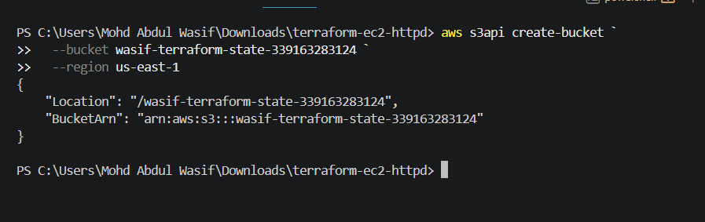
Because you are using us-east-1, you do not need to specify a location constraint.
Verify:
aws s3 ls
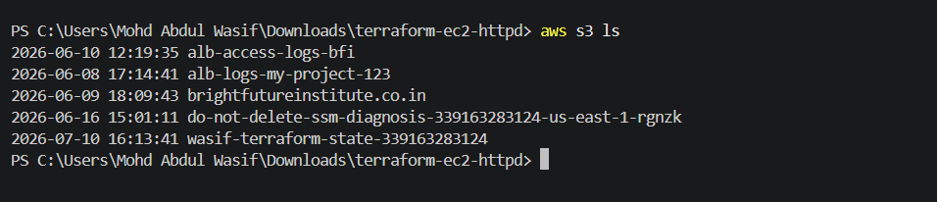
Step 3: Enable S3 bucket versioning
Versioning helps recover an older Terraform state if the current state is accidentally changed or deleted.
aws s3api put-bucket-versioning `
--bucket wasif-terraform-state-339163283124 `
--versioning-configuration Status=Enabled
Verify:
aws s3api get-bucket-versioning `
--bucket wasif-terraform-state-339163283124
Expected result:
{
"Status": "Enabled"
}
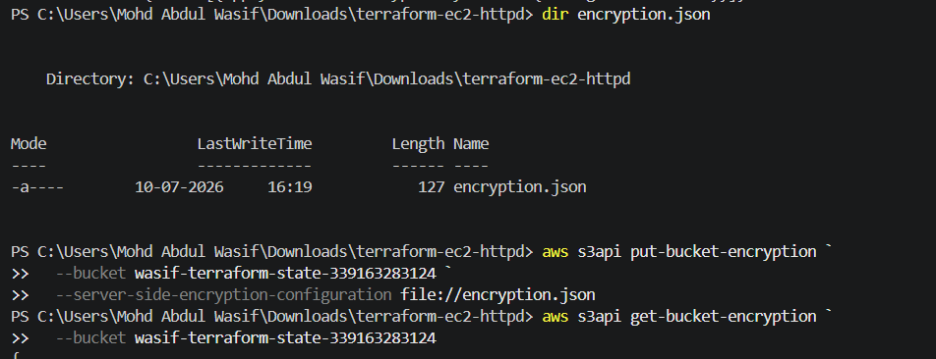
{
"Rules": [
{
"ApplyServerSideEncryptionByDefault": {
"SSEAlgorithm": "AES256"
}
}
]
}
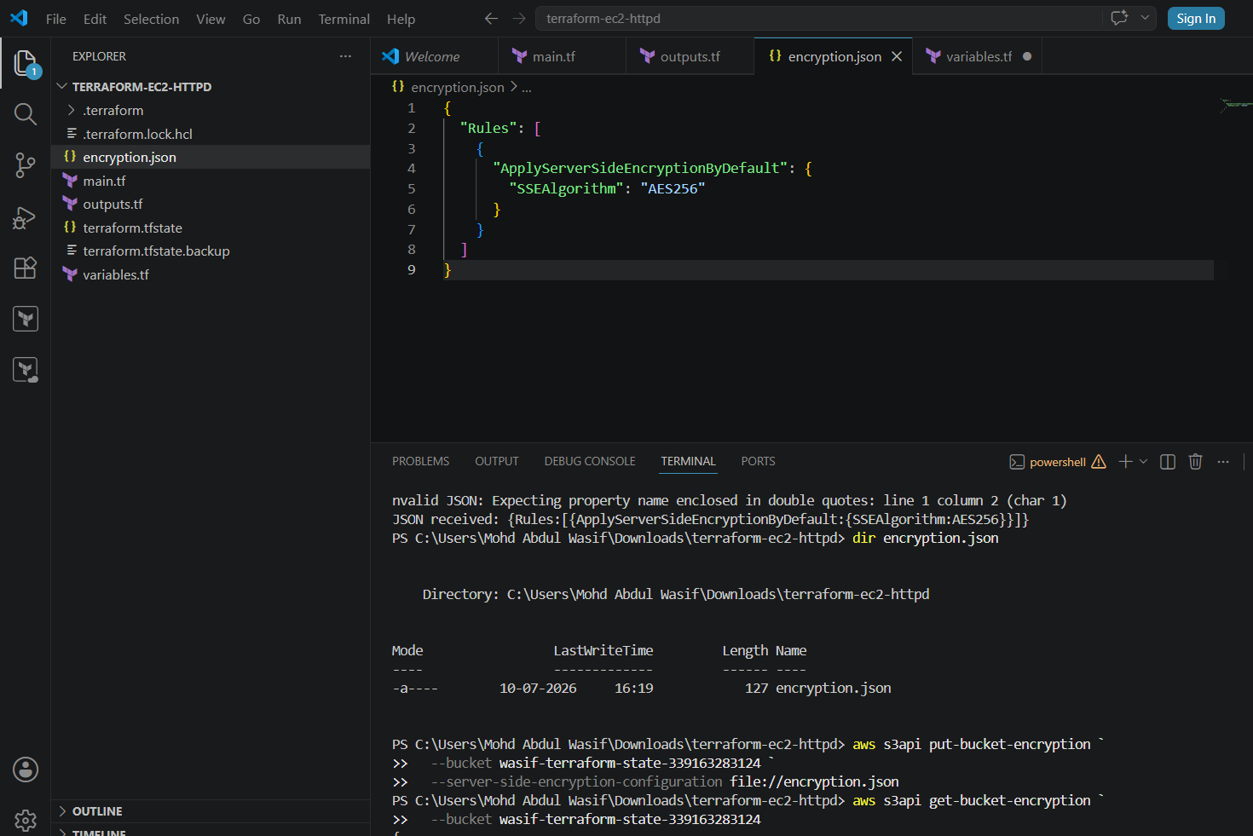
Step 4: Enable encryption
aws s3api put-bucket-encryption `
--bucket wasif-terraform-state-339163283124 `
--server-side-encryption-configuration '{"Rules":[{"ApplyServerSideEncryptionByDefault":{"SSEAlgorithm":"AES256"}}]}'
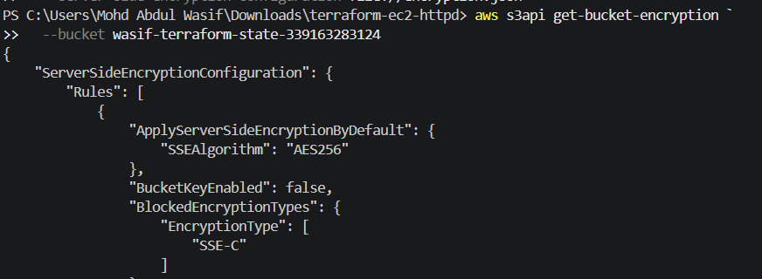
Step 5: Block public access
aws s3api put-public-access-block `
--bucket wasif-terraform-state-339163283124 `
--public-access-block-configuration
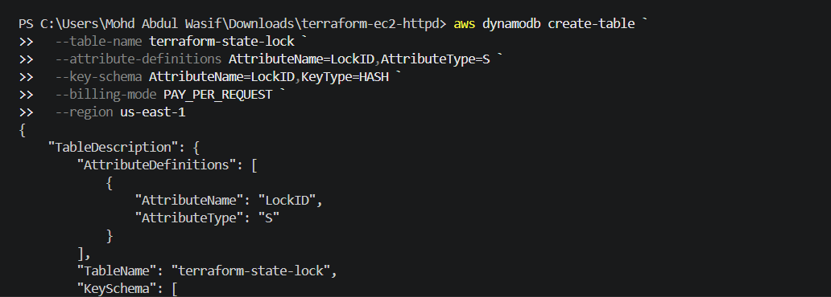
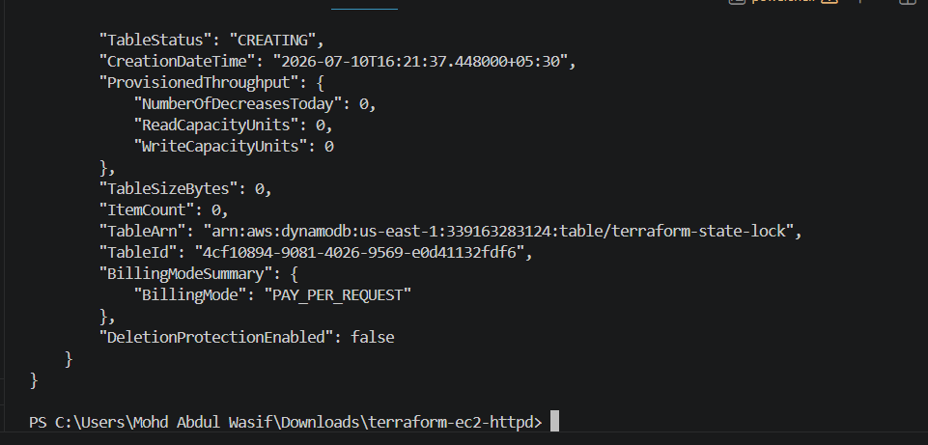
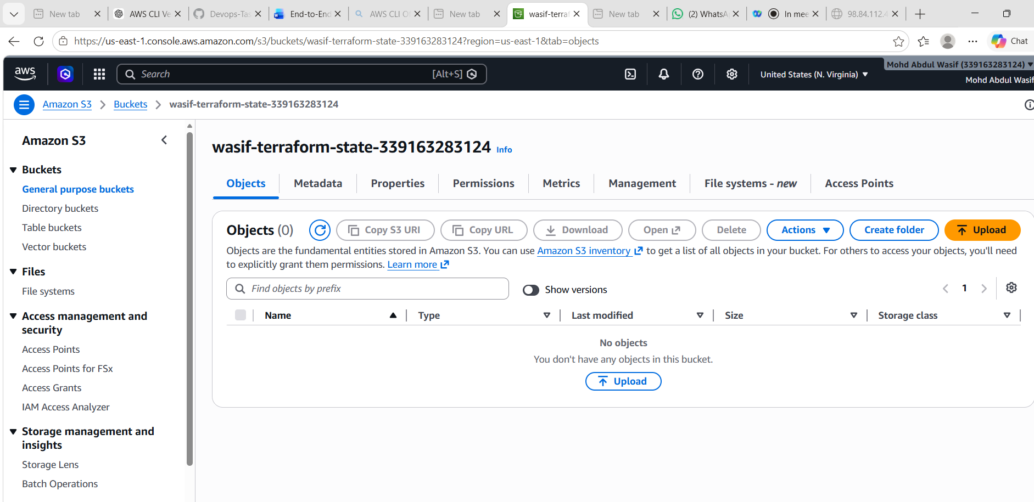
BlockPublicAcls=true,IgnorePublicAcls=true,BlockPublicPolicy=true,RestrictPublicBuckets=true
Terraform state may contain sensitive infrastructure information, so the bucket should not be public.

Task 5: Configure S3 Backend and DynamoDB State Locking for Terraform
Objective
Configure Amazon S3 as a remote backend to store the Terraform state file and configure DynamoDB for state locking to prevent simultaneous updates.

Prerequisites
- AWS Account
- AWS CLI installed and configured
- Terraform installed
- Existing Terraform project (Task 3)
- S3 Bucket
- DynamoDB Table

Step 1: Create an S3 Bucket
Create a unique S3 bucket to store the Terraform state file.
Example:
aws s3api create-bucket --bucket wasif-terraform-state-339163283124 --region us-east-1
Verify:
aws s3 ls


Step 2: Enable Versioning on S3 Bucket
Enable bucket versioning to maintain different versions of the Terraform state file.
aws s3api put-bucket-versioning `
--bucket wasif-terraform-state-339163283124 `
--versioning-configuration Status=Enabled
Verify:
aws s3api get-bucket-versioning `
--bucket wasif-terraform-state-339163283124
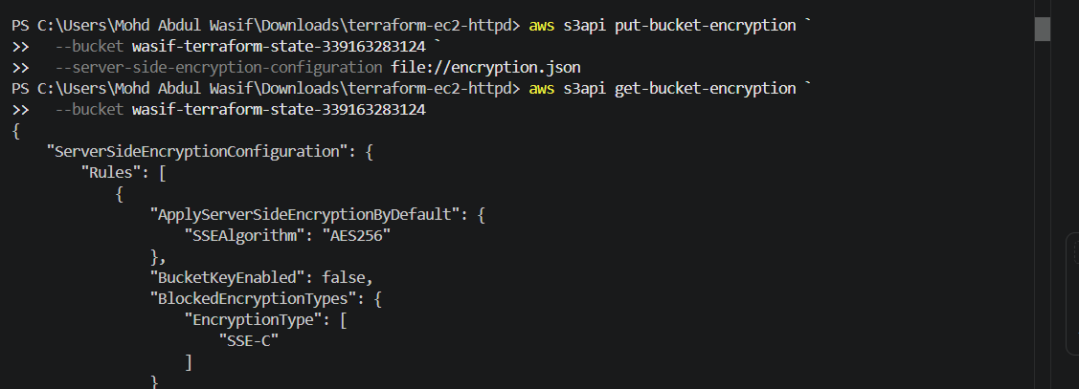

Step 3: Create DynamoDB Table
Create a DynamoDB table for Terraform state locking.
aws dynamodb create-table `
--table-name terraform-state-lock `
--attribute-definitions AttributeName=LockID,AttributeType=S `
--key-schema AttributeName=LockID,KeyType=HASH `
--billing-mode PAY_PER_REQUEST `
--region us-east-1
Verify:
aws dynamodb describe-table `
--table-name terraform-state-lock `
--region us-east-1
Status should be:
ACTIVE
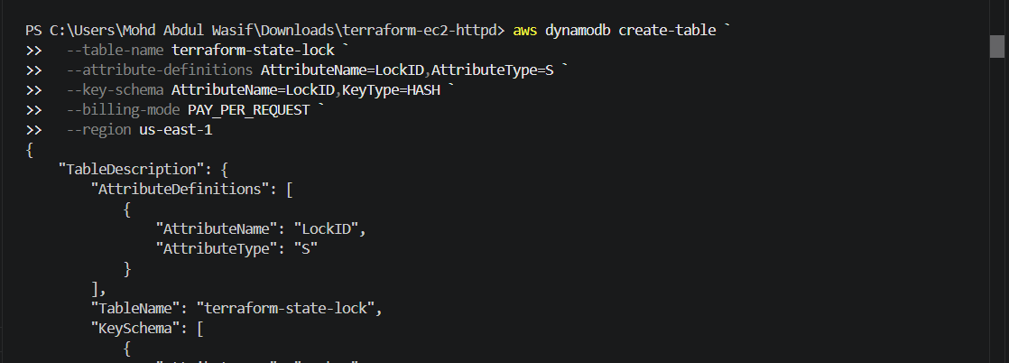

Step 4: Configure Terraform Backend
Create a file named backend.tf
terraform {
backend "s3" {
bucket = "wasif-terraform-state-339163283124"
key = "terraform.tfstate"
region = "us-east-1"
encrypt = true
use_lockfile = true
}
}
Initialize the backend:
terraform init -reconfigure
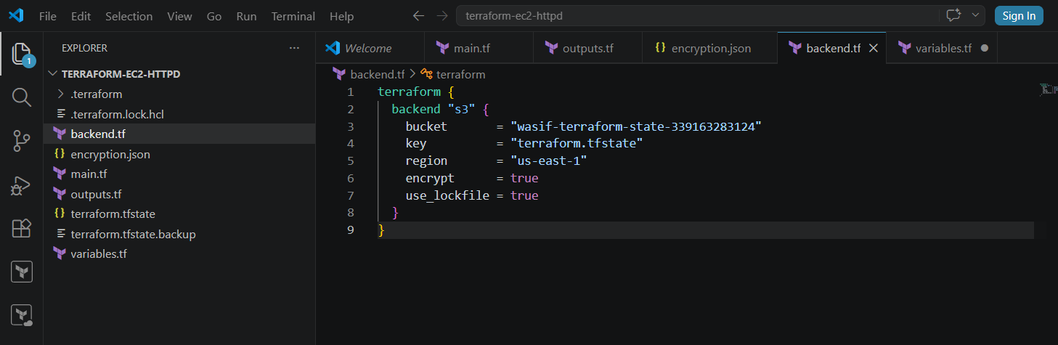

Step 5: Verify Backend Configuration
Check Terraform state:
terraform plan
Verify the state file is stored in S3:
aws s3 ls s3://wasif-terraform-state-339163283124 --recursive
Expected Output:
terraform.tfstate
Verify the DynamoDB table:
aws dynamodb describe-table `
--table-name terraform-state-lock `
--region us-east-1 `
--query "Table.TableStatus"
Expected:
ACTIVE
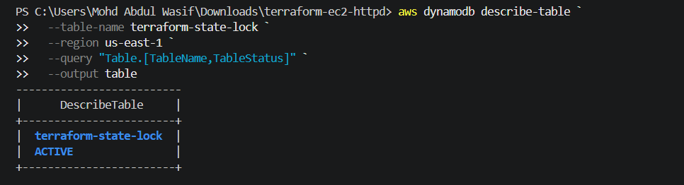

Commands Used
aws s3api create-bucket

aws s3api put-bucket-versioning

aws dynamodb create-table

terraform init -reconfigure

terraform plan

terraform apply

terraform output

aws s3 ls

terraform destroy

What We Learned
- Configured Amazon S3 as a remote backend for Terraform.
- Stored the Terraform state file securely in S3.
- Enabled versioning to protect state file changes.
- Configured DynamoDB state locking to avoid concurrent Terraform operations.
- Managed infrastructure using a centralized remote state.

Conclusion
Successfully configured Amazon S3 as the Terraform remote backend and DynamoDB for state locking. The Terraform state file is stored securely in S3, while state locking prevents multiple users from modifying the infrastructure simultaneously, ensuring safe and reliable infrastructure management.

