Terraform-06
Provision EC2, S3, and VPC Infrastructure Using Terraform Modules with Multi-Environment Deployment via Terraform Workspaces (Dev, Staging, Prod)

Task 1: Provision EC2, S3 and VPC Using Terraform Modules
Objective
Create reusable Terraform modules to provision:
- One custom VPC
- One public subnet
- Internet Gateway and route table
- One EC2 instance
- One S3 bucket
A Terraform module is a directory containing Terraform files that manage a related set of resources.
Prerequisites
Before starting, make sure you have:
- AWS account
- AWS IAM user with required permissions
- AWS CLI installed
- Terraform installed
- VS Code installed
- AWS credentials configured
- An existing EC2 key pair in the selected AWS region
Check the installations:
terraform version
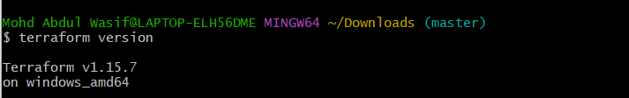
aws –version
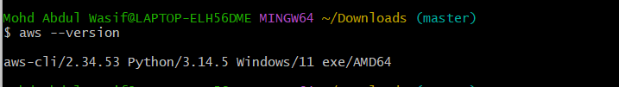
Configure AWS:
aws configure
Enter:
AWS Access Key ID: Your access key
AWS Secret Access Key: Your secret key
Default region name: us-east-1
Default output format: json
Verify AWS login:
aws sts get-caller-identity
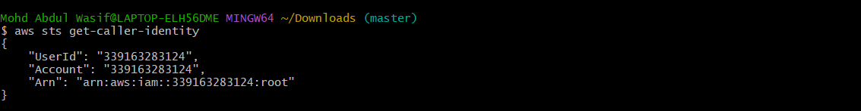

Step 1: Create the project folder
Open PowerShell:
mkdir terraform-modules-task
cd terraform-modules-task
code.
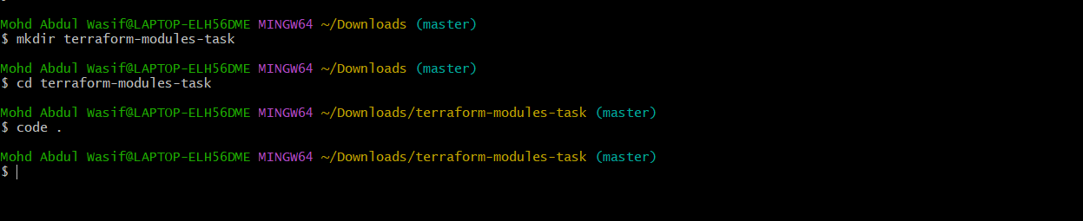
Create this folder structure:
terraform-modules-task/
│
├── main.tf
├── provider.tf
├── variables.tf
├── outputs.tf
├── terraform.tfvars
│
└── modules/
├── vpc/
│ ├── main.tf
│ ├── variables.tf
│ └── outputs.tf
│
├── ec2/
│ ├── main.tf
│ ├── variables.tf
│ └── outputs.tf
│
└── s3/
├── main.tf
├── variables.tf
└── outputs.tf
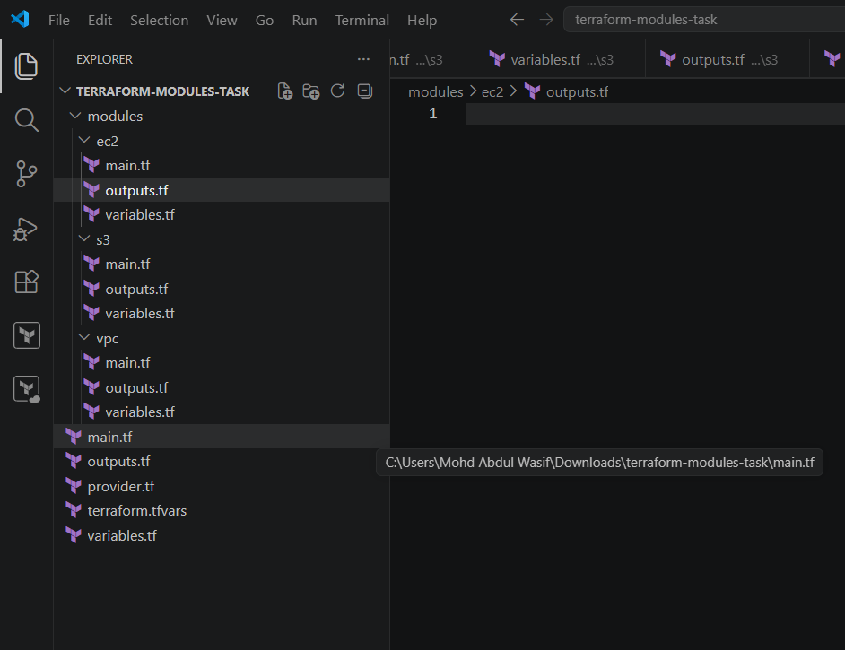

Step 2: Create the VPC module
modules/vpc/variables.tf
variable "vpc_cidr" {
description = "CIDR block for the VPC"
type = string
}

variable "subnet_cidr" {
description = "CIDR block for the public subnet"
type = string
}

variable "availability_zone" {
description = "Availability zone for the subnet"
type = string
}

variable "project_name" {
description = "Name used for resource tags"
type = string
}
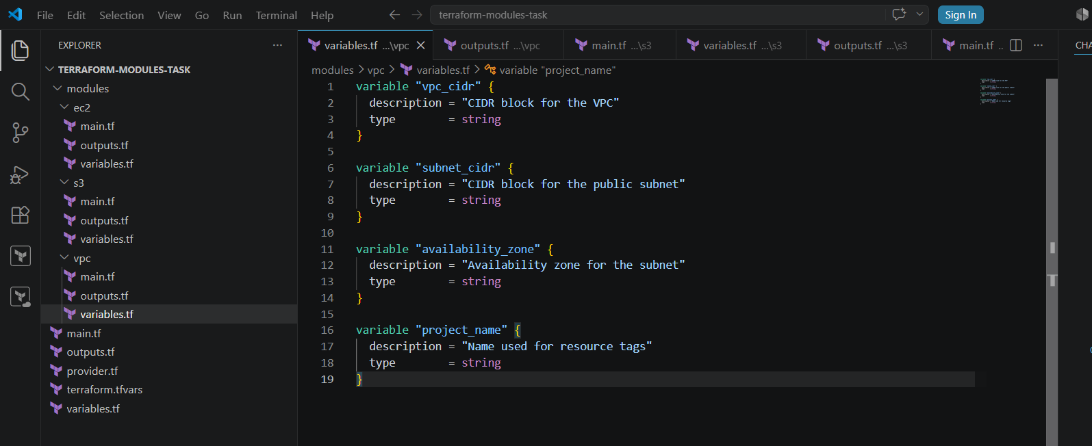
modules/vpc/main.tf
resource "aws_vpc" "main" {
cidr_block = var.vpc_cidr
enable_dns_support = true
enable_dns_hostnames = true

tags = {
Name = "${var.project_name}-vpc"
}
}

resource "aws_subnet" "public" {
vpc_id = aws_vpc.main.id
cidr_block = var.subnet_cidr
availability_zone = var.availability_zone
map_public_ip_on_launch = true

tags = {
Name = "${var.project_name}-public-subnet"
}
}

resource "aws_internet_gateway" "main" {
vpc_id = aws_vpc.main.id

tags = {
Name = "${var.project_name}-igw"
}
}

resource "aws_route_table" "public" {
vpc_id = aws_vpc.main.id

route {
cidr_block = "0.0.0.0/0"
gateway_id = aws_internet_gateway.main.id
}

tags = {
Name = "${var.project_name}-public-rt"
}
}

resource "aws_route_table_association" "public" {
subnet_id = aws_subnet.public.id
route_table_id = aws_route_table.public.id
}
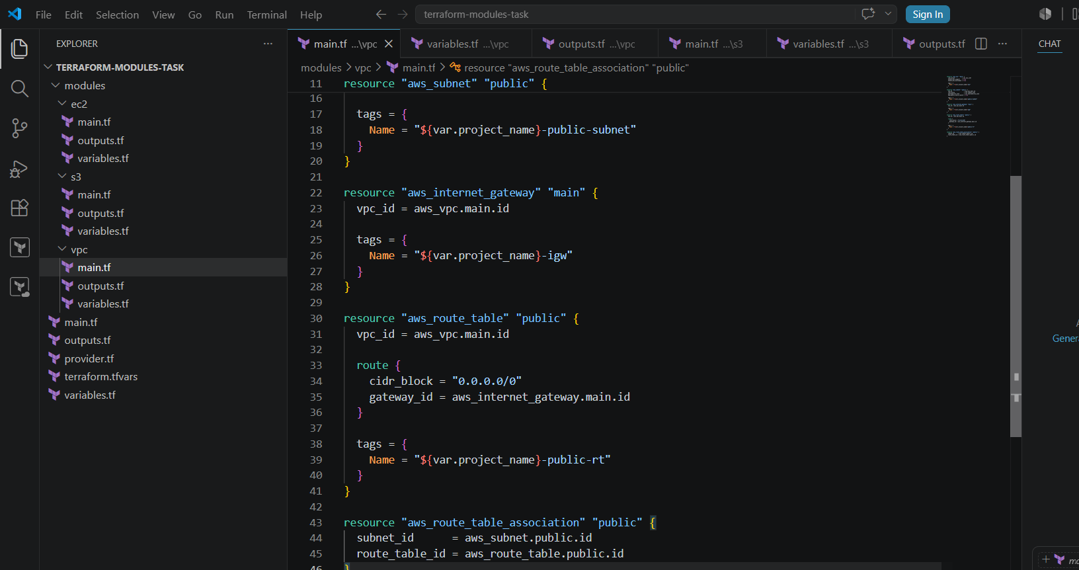
modules/vpc/outputs.tf
output "vpc_id" {
description = "ID of the created VPC"
value = aws_vpc.main.id
}

output "public_subnet_id" {
description = "ID of the public subnet"
value = aws_subnet.public.id
}
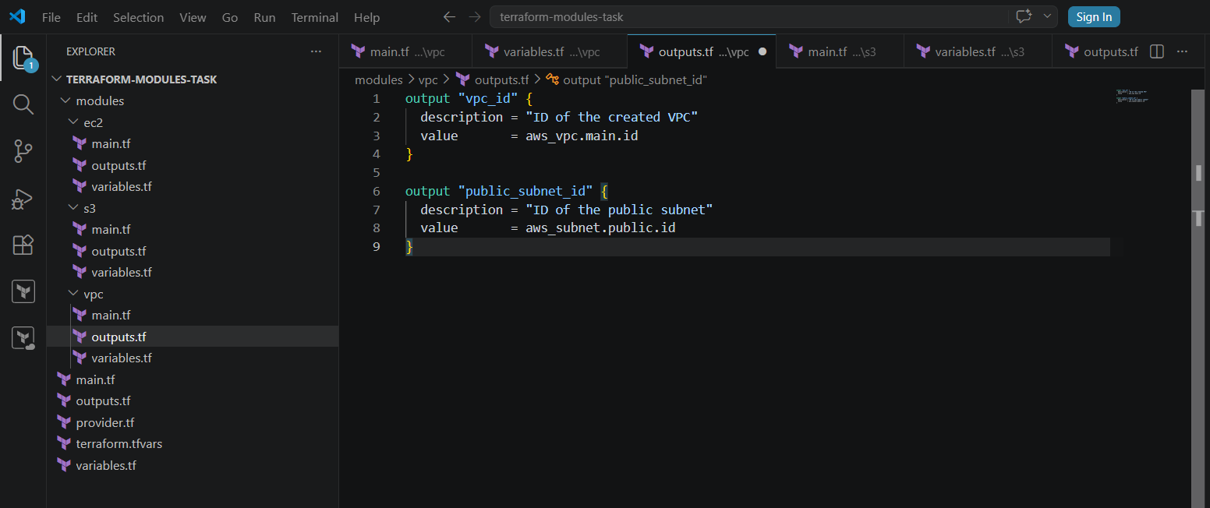

Step 3: Create the EC2 module
The aws_instance resource creates, updates and deletes EC2 instances through Terraform.
modules/ec2/variables.tf
variable "project_name" {
description = "Project name"
type = string
}

variable "vpc_id" {
description = "VPC ID"
type = string
}

variable "subnet_id" {
description = "Subnet ID"
type = string
}

variable "instance_type" {
description = "EC2 instance type"
type = string
}

variable "key_name" {
description = "Existing AWS EC2 key-pair name"
type = string
}
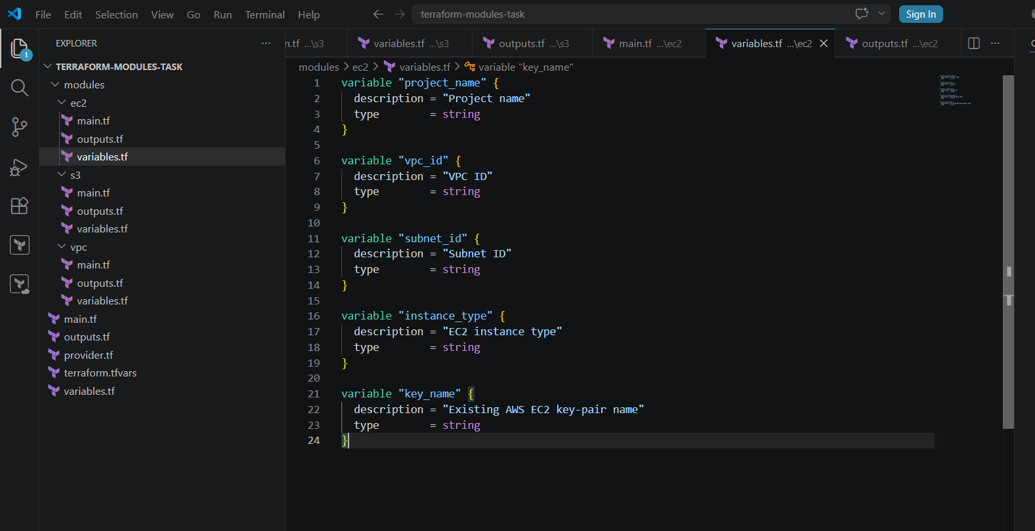
modules/ec2/main.tf
data "aws_ssm_parameter" "amazon_linux" {
name = "/aws/service/ami-amazon-linux-latest/al2023-ami-kernel-default-x86_64"
}

resource "aws_security_group" "web_sg" {
name = "${var.project_name}-web-sg"
description = "Allow SSH and HTTP traffic"
vpc_id = var.vpc_id

ingress {
description = "SSH access"
from_port = 22
to_port = 22
protocol = "tcp"
cidr_blocks = ["0.0.0.0/0"]
}

ingress {
description = "HTTP access"
from_port = 80
to_port = 80
protocol = "tcp"
cidr_blocks = ["0.0.0.0/0"]
}

egress {
description = "Allow all outbound traffic"
from_port = 0
to_port = 0
protocol = "-1"
cidr_blocks = ["0.0.0.0/0"]
}

tags = {
Name = "${var.project_name}-web-sg"
}
}

resource "aws_instance" "web_server" {
ami = data.aws_ssm_parameter.amazon_linux.value
instance_type = var.instance_type
subnet_id = var.subnet_id
vpc_security_group_ids = [aws_security_group.web_sg.id]
associate_public_ip_address = true
key_name = var.key_name

user_data = <<-EOF
#!/bin/bash
dnf install -y httpd
systemctl enable httpd
systemctl start httpd
echo "<h1>Terraform Module EC2 Server</h1>" > /var/www/html/index.html
EOF

tags = {
Name = "${var.project_name}-ec2"
}
}
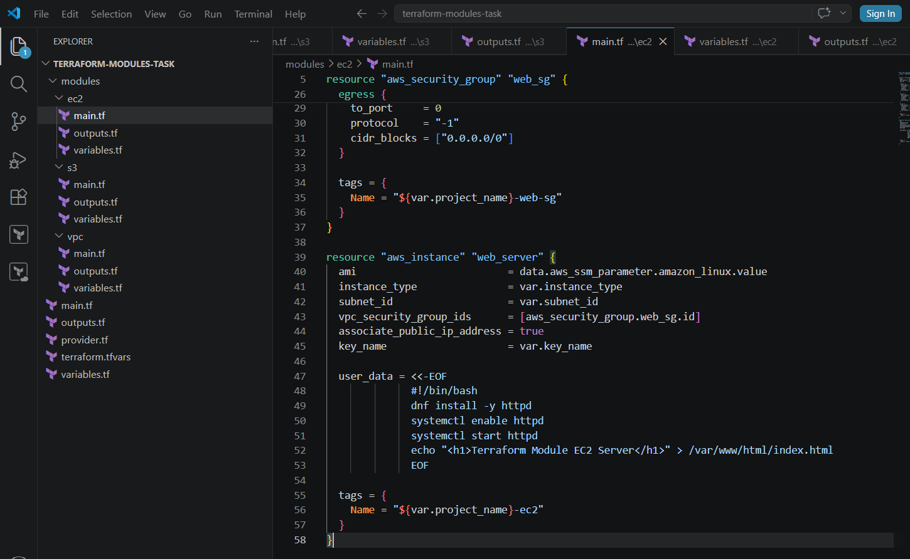
modules/ec2/outputs.tf
output "instance_id" {
description = "EC2 instance ID"
value = aws_instance.web_server.id
}

output "public_ip" {
description = "EC2 public IP address"
value = aws_instance.web_server.public_ip
}

output "website_url" {
description = "Website URL"
value = "http://${aws_instance.web_server.public_ip}"
}
For a real production server, restrict port 22 to your own IP address instead of using 0.0.0.0/0
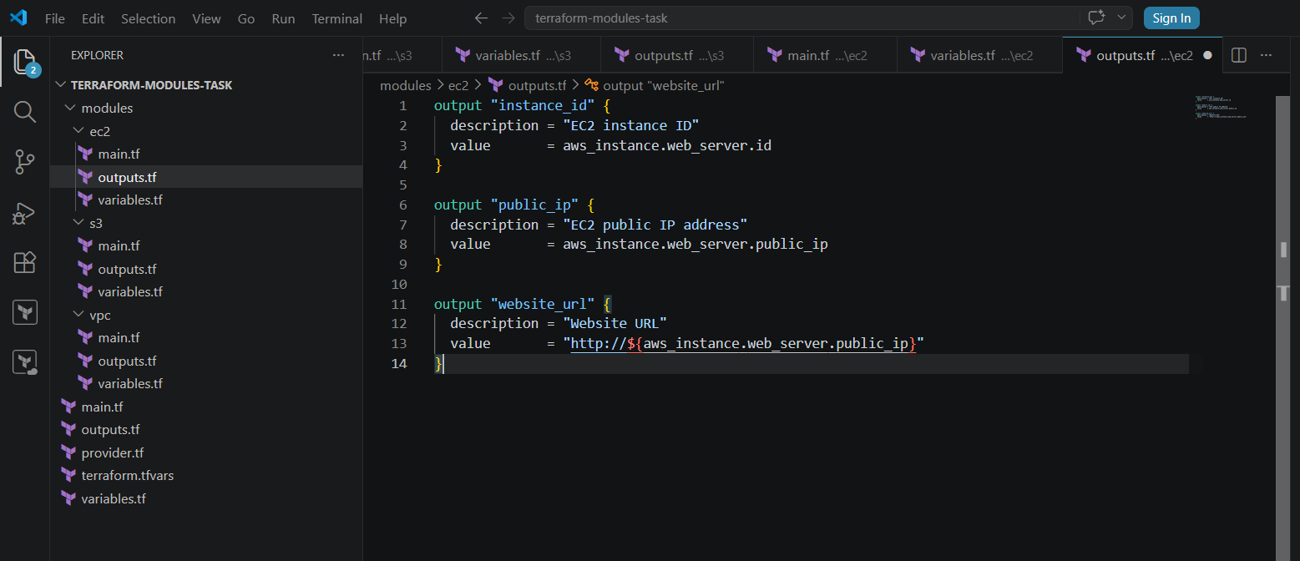

Step 4: Create the S3 module
Terraform provides the aws_s3_bucket resource for managing standard S3 buckets.
modules/s3/variables.tf
variable "bucket_name" {
description = "Globally unique S3 bucket name"
type = string
}

variable "project_name" {
description = "Project name"
type = string
}
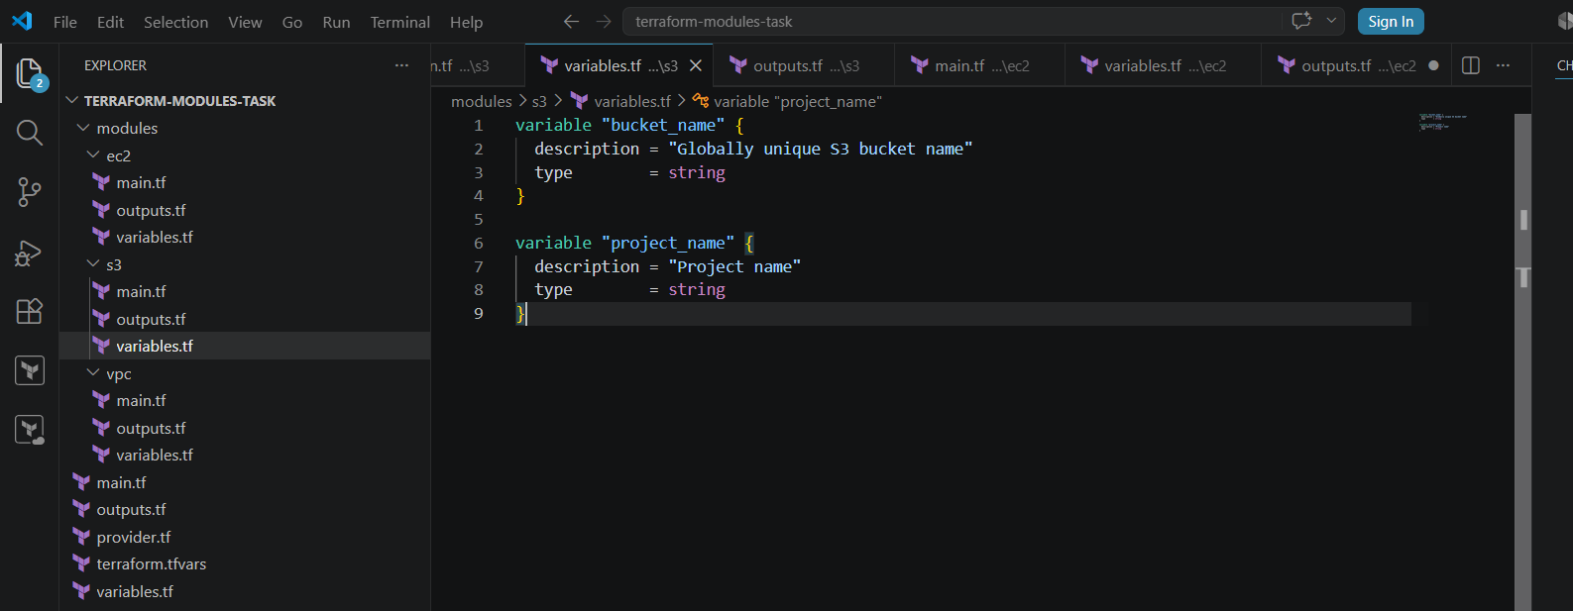
modules/s3/main.tf
resource "aws_s3_bucket" "project_bucket" {
bucket = var.bucket_name

tags = {
Name = var.bucket_name
Project = var.project_name
}
}

resource "aws_s3_bucket_public_access_block" "project_bucket" {
bucket = aws_s3_bucket.project_bucket.id

block_public_acls = true
block_public_policy = true
ignore_public_acls = true
restrict_public_buckets = true
}

resource "aws_s3_bucket_versioning" "project_bucket" {
bucket = aws_s3_bucket.project_bucket.id

versioning_configuration {
status = "Enabled"
}
}
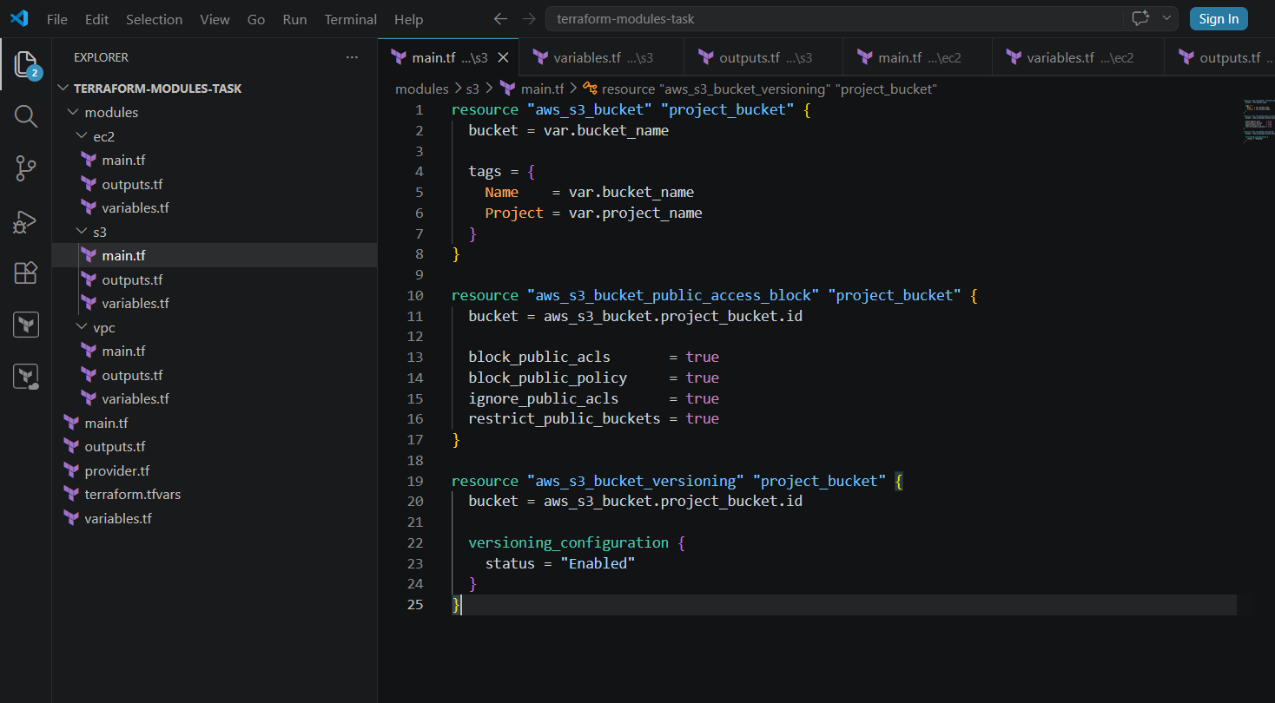
modules/s3/outputs.tf
output "bucket_name" {
description = "S3 bucket name"
value = aws_s3_bucket.project_bucket.bucket
}

output "bucket_arn" {
description = "S3 bucket ARN"
value = aws_s3_bucket.project_bucket.arn
}
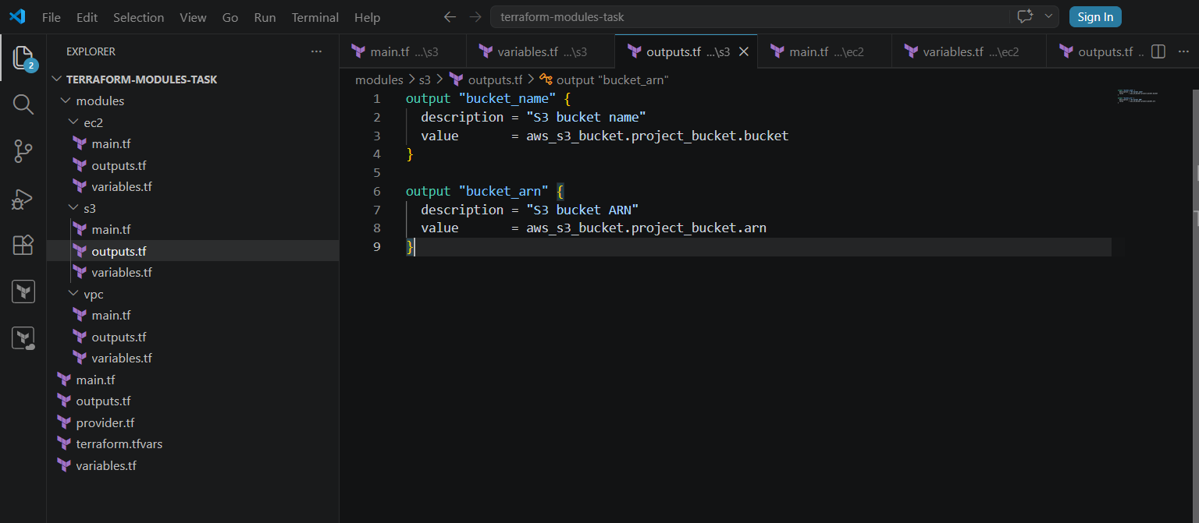

Step 5: Configure the root module
The root module calls the three child modules using module blocks.
provider.tf
terraform {
required_version = ">= 1.5.0"

required_providers {
aws = {
source = "hashicorp/aws"
version = "~> 6.0"
}
}
}

provider "aws" {
region = var.aws_region
}
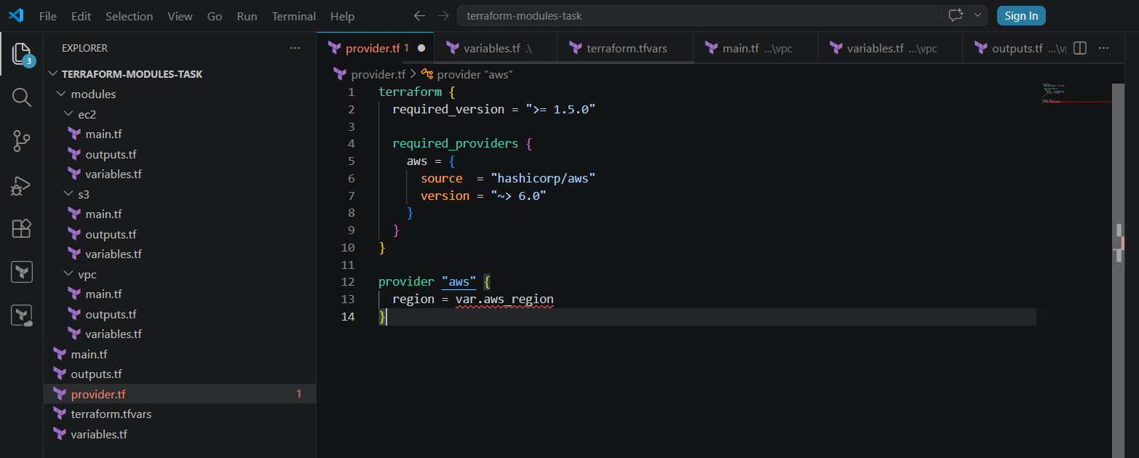
variables.tf
variable "aws_region" {
description = "AWS region"
type = string
default = "us-east-1"
}

variable "project_name" {
description = "Project name"
type = string
default = "terraform-module-task"
}

variable "vpc_cidr" {
description = "VPC CIDR block"
type = string
default = "10.0.0.0/16"
}

variable "subnet_cidr" {
description = "Public subnet CIDR block"
type = string
default = "10.0.1.0/24"
}

variable "availability_zone" {
description = "Availability zone"
type = string
default = "us-east-1a"
}

variable "instance_type" {
description = "EC2 instance type"
type = string
default = "t2.micro"
}

variable "key_name" {
description = "Existing EC2 key-pair name"
type = string
}

variable "bucket_name" {
description = "Globally unique S3 bucket name"
type = string
}
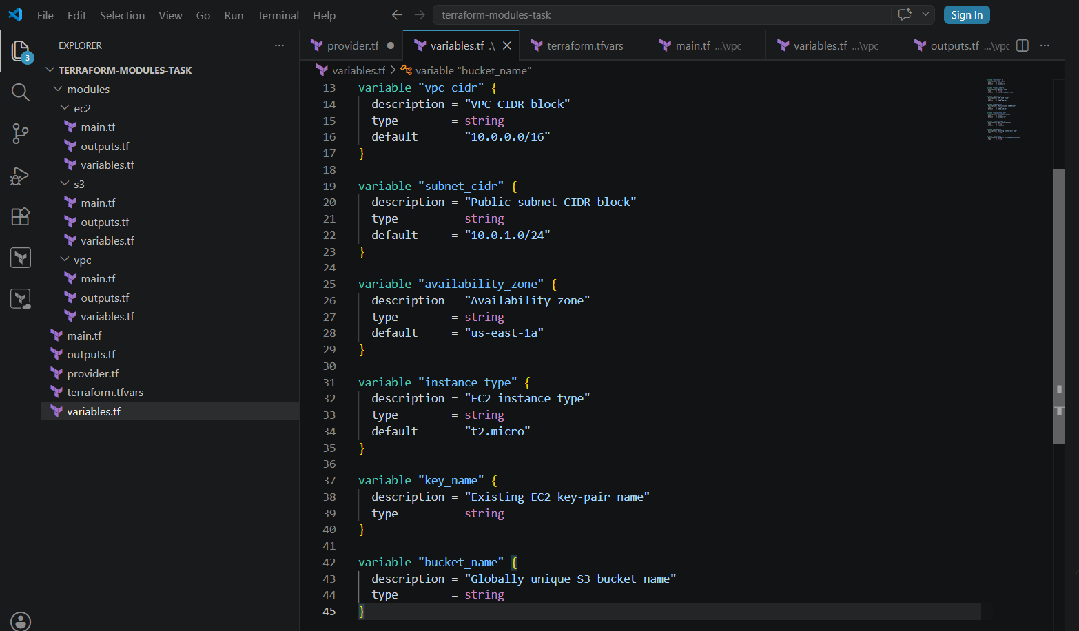
main.tf
module "vpc" {
source = "./modules/vpc"

project_name = var.project_name
vpc_cidr = var.vpc_cidr
subnet_cidr = var.subnet_cidr
availability_zone = var.availability_zone
}

module "ec2" {
source = "./modules/ec2"

project_name = var.project_name
vpc_id = module.vpc.vpc_id
subnet_id = module.vpc.public_subnet_id
instance_type = var.instance_type
key_name = var.key_name
}

module "s3" {
source = "./modules/s3"

project_name = var.project_name
bucket_name = var.bucket_name
}
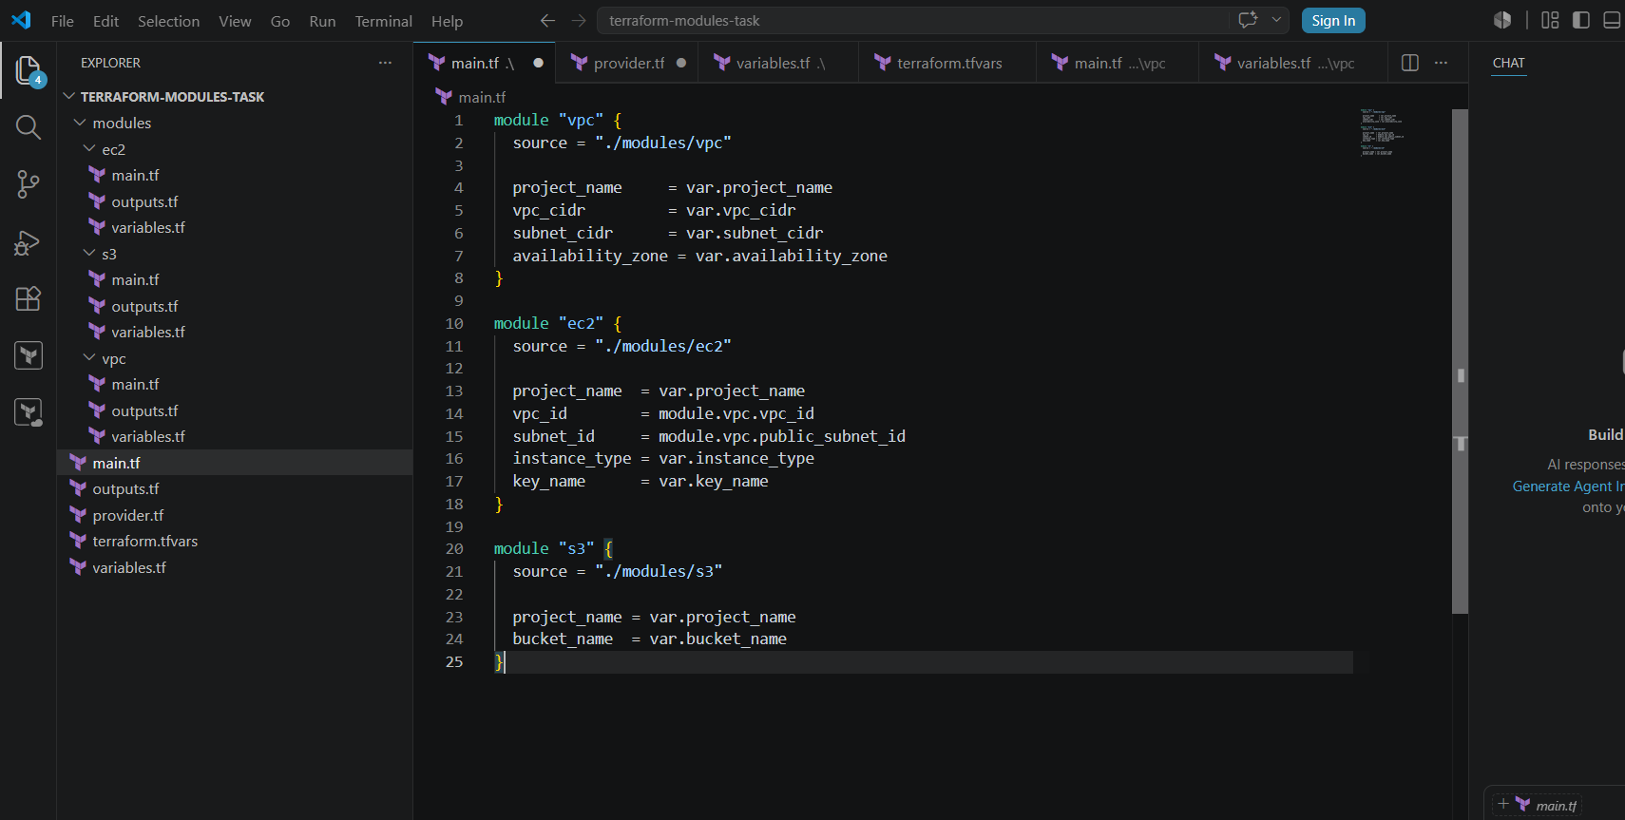
terraform.tfvars
Replace the values with your details:
aws_region = "us-east-1"
project_name = "wasif-module-task"
instance_type = "t3.micro"
key_name = "Virginia"
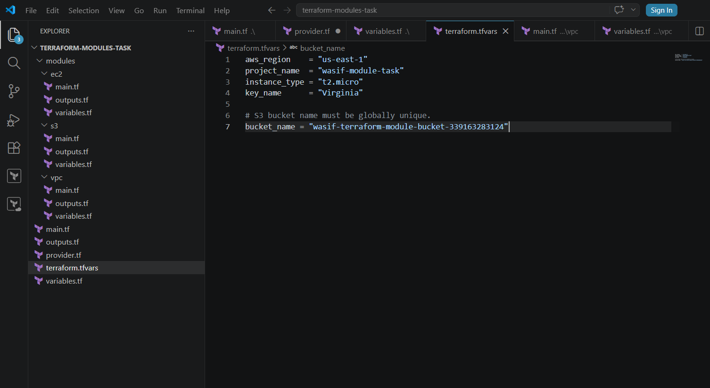

# S3 bucket name must be globally unique.
bucket_name = "wasif-terraform-module-bucket-339163283124"
outputs.tf
output "vpc_id" {
value = module.vpc.vpc_id
}

output "public_subnet_id" {
value = module.vpc.public_subnet_id
}

output "ec2_instance_id" {
value = module.ec2.instance_id
}

output "ec2_public_ip" {
value = module.ec2.public_ip
}

output "website_url" {
value = module.ec2.website_url
}

output "s3_bucket_name" {
value = module.s3.bucket_name
}
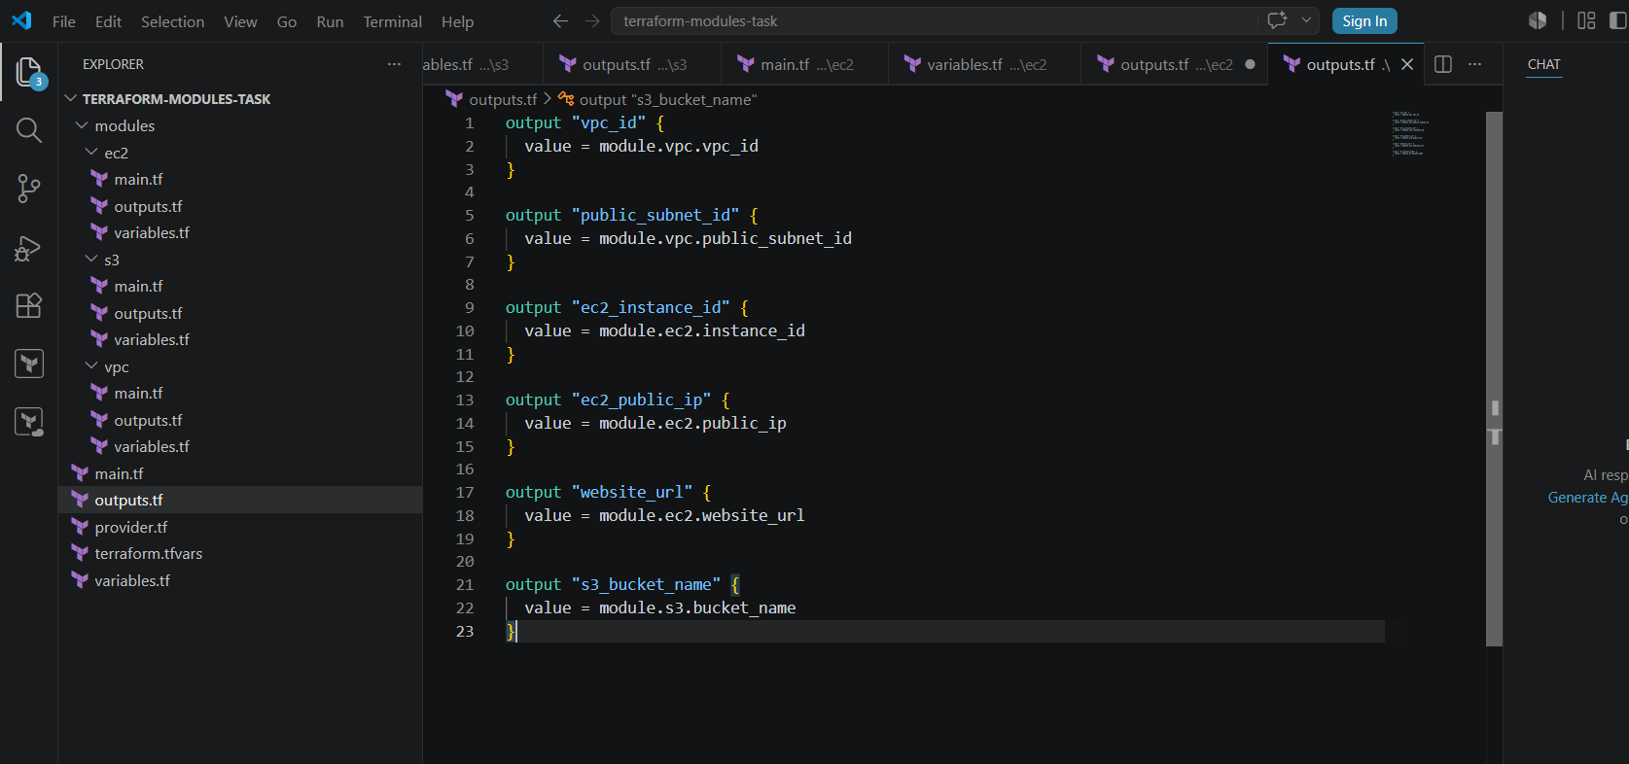

Step 6: Run Terraform commands
Initialize Terraform
terraform init
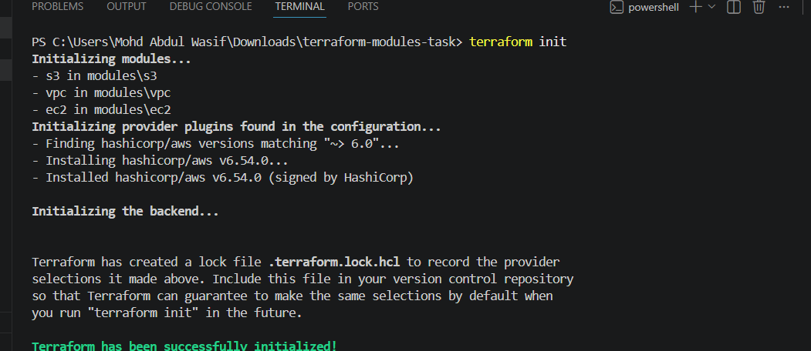
This downloads the AWS provider and loads the local modules.
Format the files
terraform fmt -recursive
Validate the configuration
terraform validate
Expected result:
Success! The configuration is valid.
Preview the resources
terraform plan
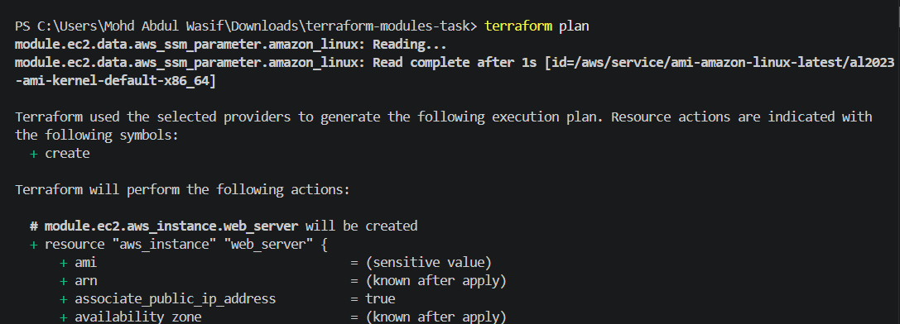
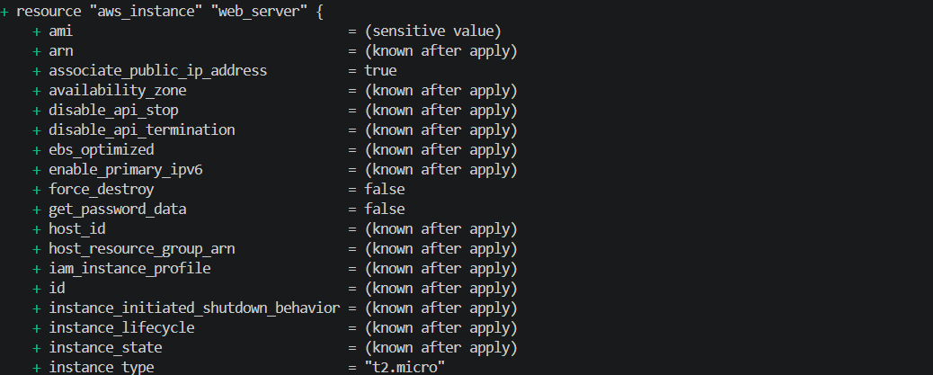
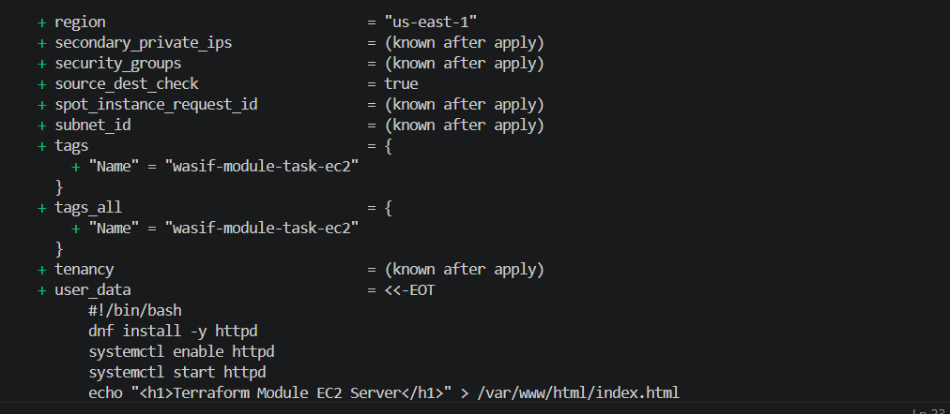
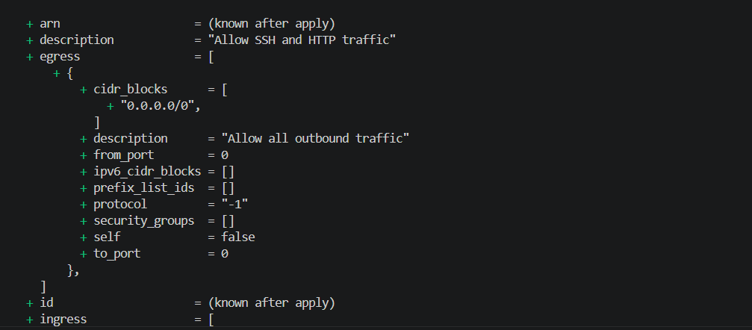
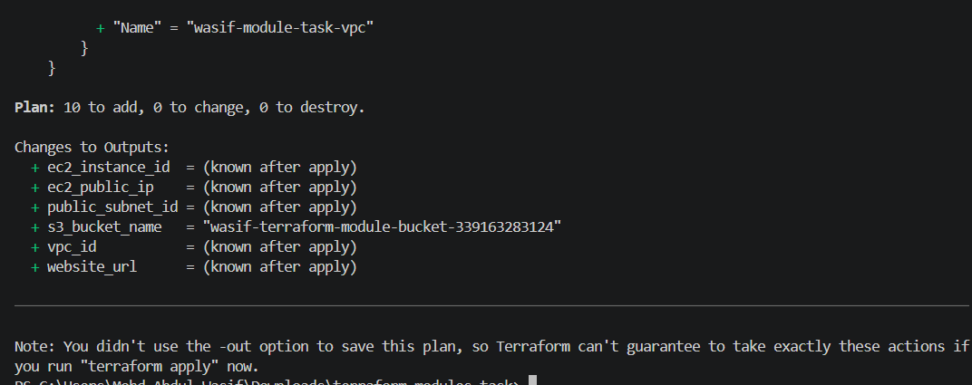
Terraform should show resources for:
VPC
Subnet
Internet Gateway
Route table
EC2
Security group
S3 bucket
S3 public access block
S3 versioning
Create the resources
terraform apply
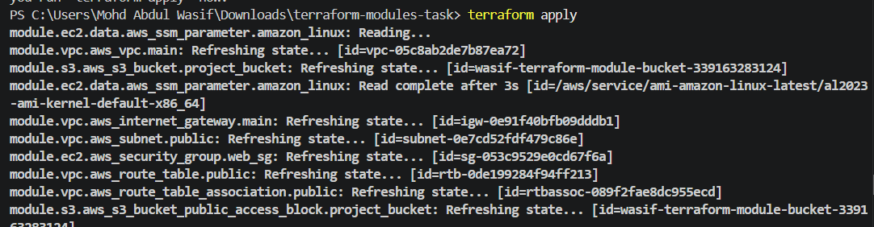
Enter:
Yes
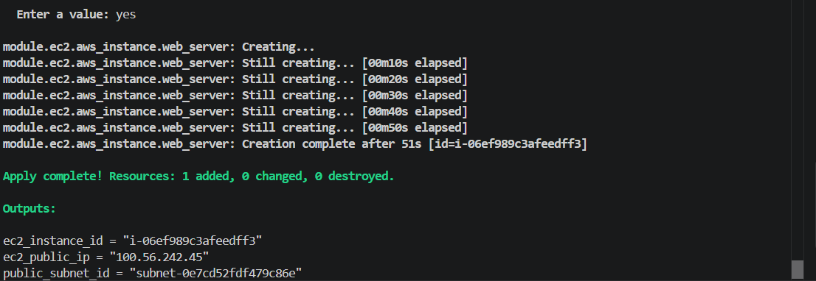
View outputs
terraform output
Open the website URL shown in the output:
http://EC2-PUBLIC-IP
Expected webpage:
Terraform Module EC2 Server
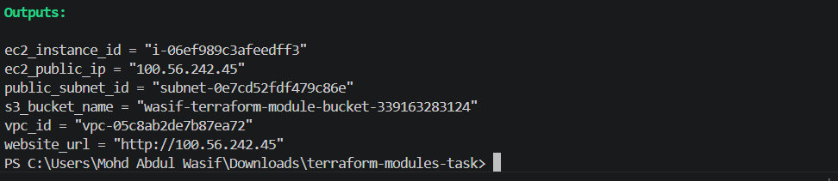
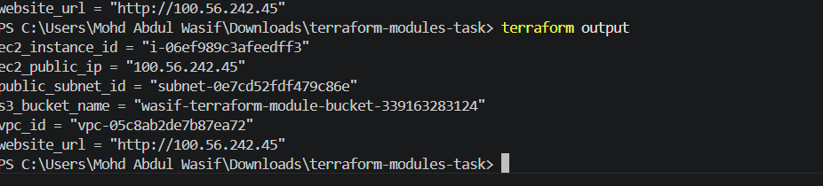

Step 7: Verify resources
Verify EC2
aws ec2 describe-instances `
--filters "Name=tag:Name,Values=wasif-module-task-ec2" `
--region us-east-1
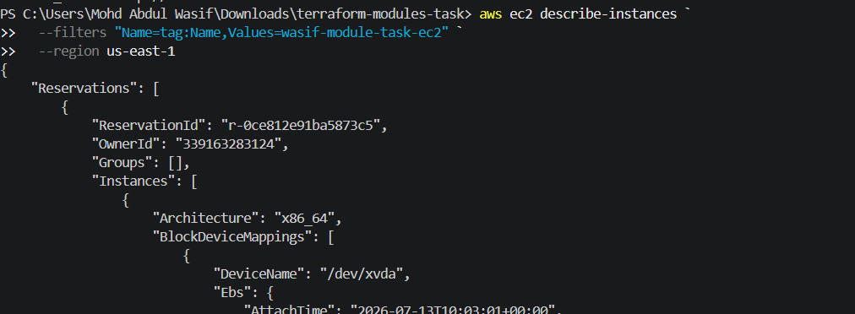
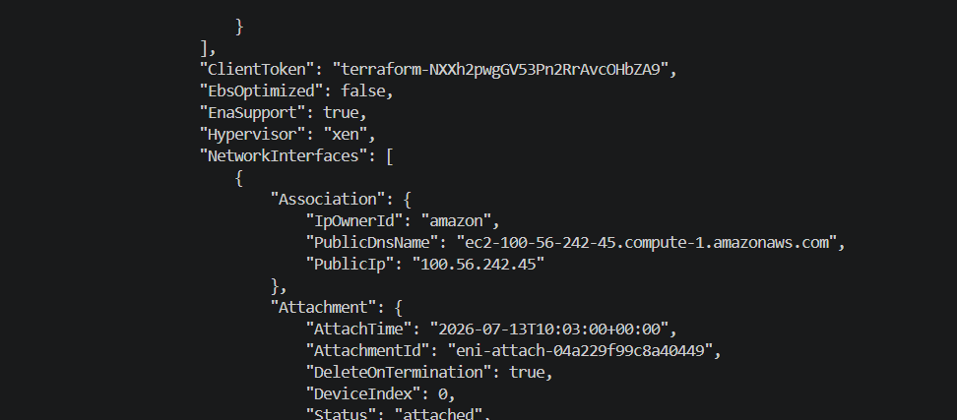
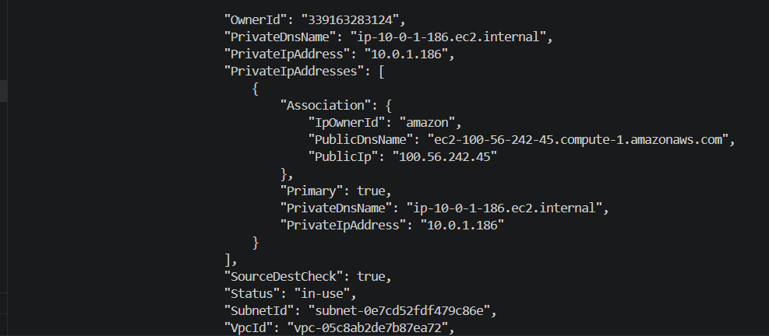
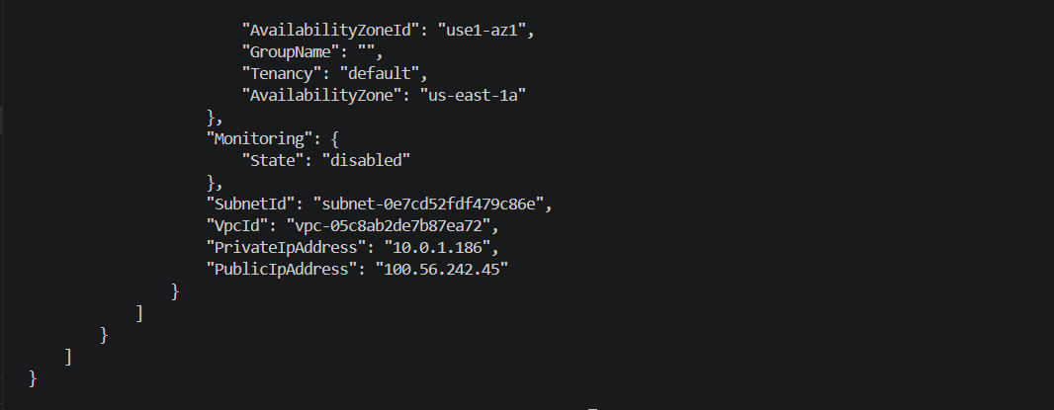
Verify S3
aws s3 ls
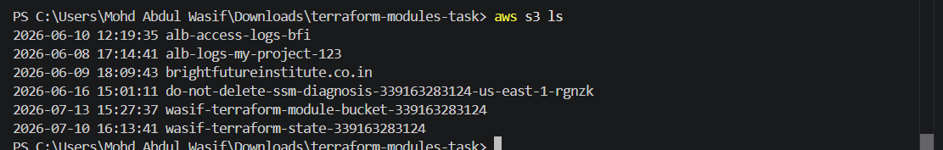
Verify VPC
aws ec2 describe-vpcs `
--filters "Name=tag:Name,Values=wasif-module-task-vpc" `
--region us-east-1
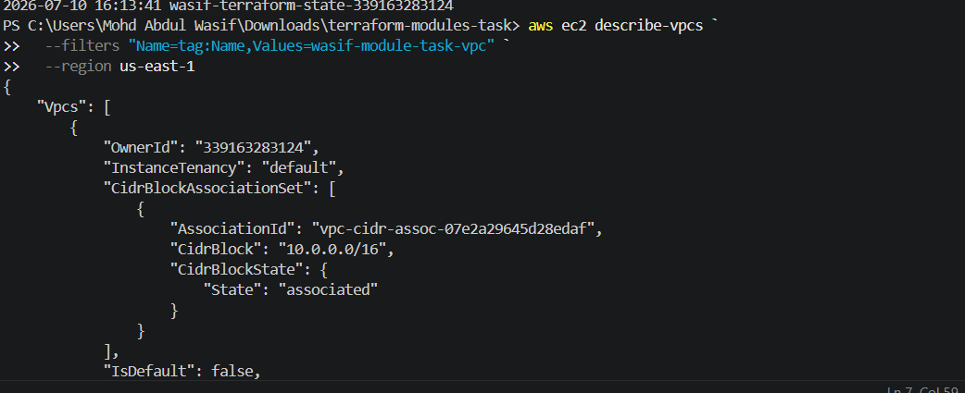
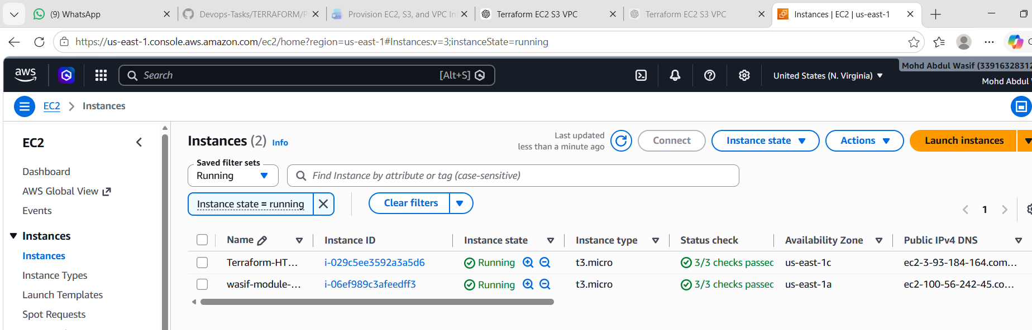

Step 8: Destroy the resources
terraform destroy
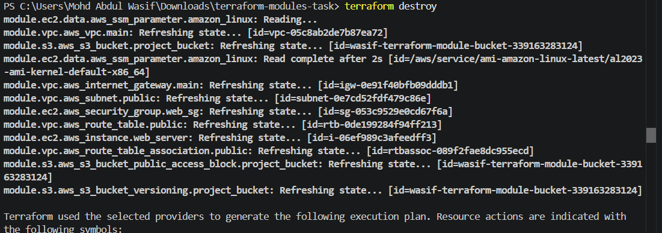
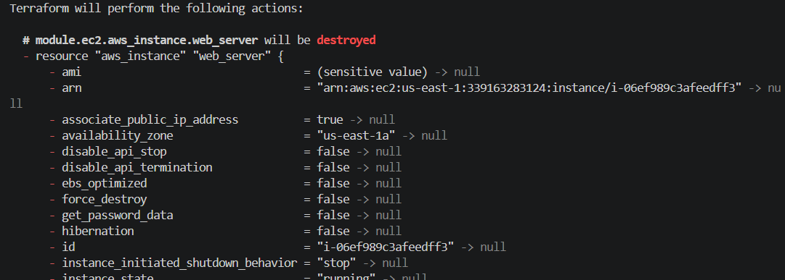
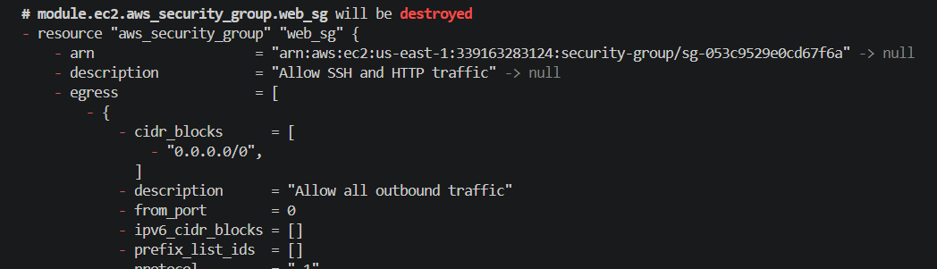
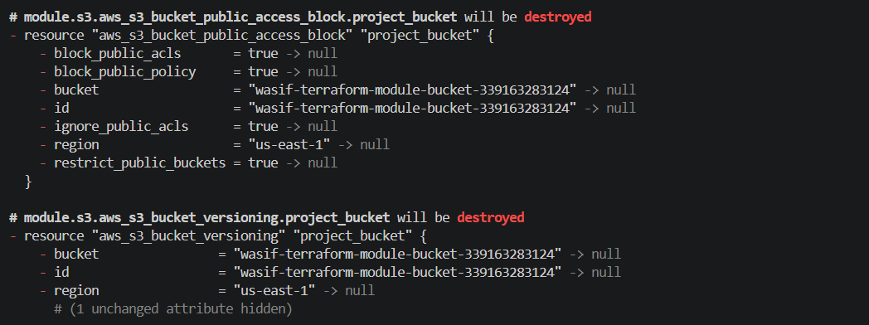
Enter:
Yes
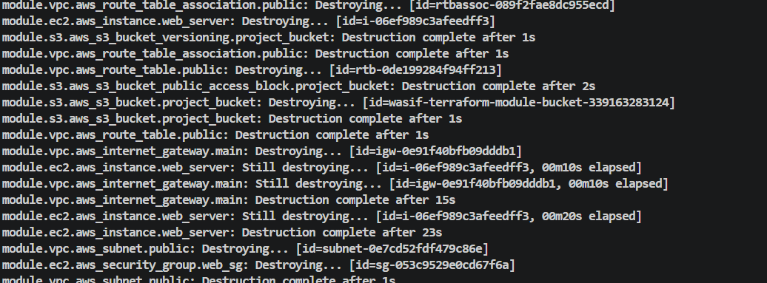
Check:
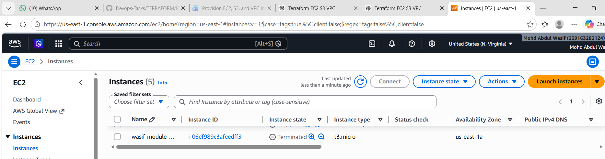
terraform state list
After a successful destroy, no managed resources should remain in the current state.

What We Learned – Task 1
- A module is reusable Terraform infrastructure code.
- The root module calls child modules using the module block.
- Module variables receive input values.
- Module outputs return resource information.
- One module can use outputs from another module.
- Terraform automatically handles resource dependencies.
- Modules make code easier to maintain, understand and reuse.
Task 1 Conclusion
We created separate VPC, EC2 and S3 Terraform modules. The VPC module provided networking, the EC2 module created a web server, and the S3 module created secured storage. The root module connected all three modules and provisioned the infrastructure using one Terraform workflow.

Task 2: Provision EC2 for Dev, Staging and Prod Using Workspaces
Objective
Use Terraform workspaces to provision separate EC2 instances for:
- Dev
- Staging
- Prod
Each workspace keeps a separate Terraform state. Most Terraform commands only affect the currently selected workspace.

Simple Workspace Concept
Same Terraform code
|
├── Dev workspace → Dev EC2 and Dev state
├── Staging workspace → Staging EC2 and Staging state
└── Prod workspace → Prod EC2 and Prod state
Memory trick:
Workspace = Separate room
State = Items inside that room

Prerequisites
- Terraform installed
- AWS CLI installed
- AWS credentials configured
- AWS account
- Default VPC available in the selected region
- EC2 key pair available
- Permission to create EC2 instances and security groups
Check whether a default VPC exists:
aws ec2 describe-vpcs `
--filters "Name=is-default,Values=true" `
--region us-east-1
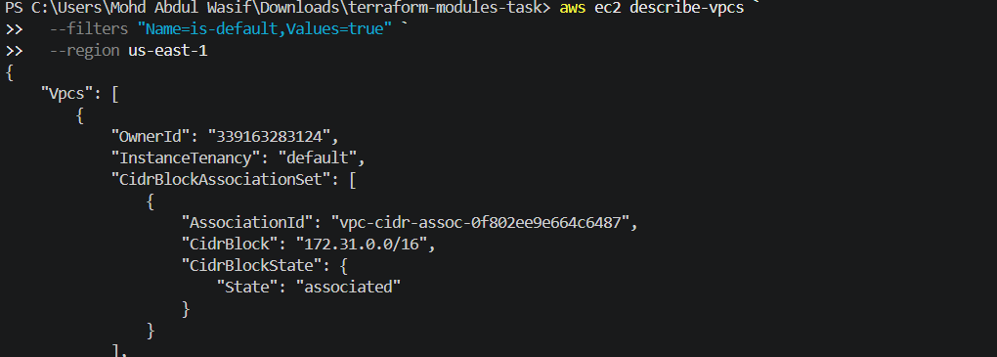

Step 1: Create the workspace project
mkdir terraform-workspaces-task
cd terraform-workspaces-task
code .
Create:
terraform-workspaces-task/
├── provider.tf
├── variables.tf
├── main.tf
└── outputs.tf
(with directory=mkdir terraform-workspaces-task; cd terraform-workspaces-task; New-Item provider.tf,variables.tf,main.tf,outputs.tf -ItemType File)
(only files multiple=New-Item provider.tf,variables.tf,main.tf,outputs.tf -ItemType File)
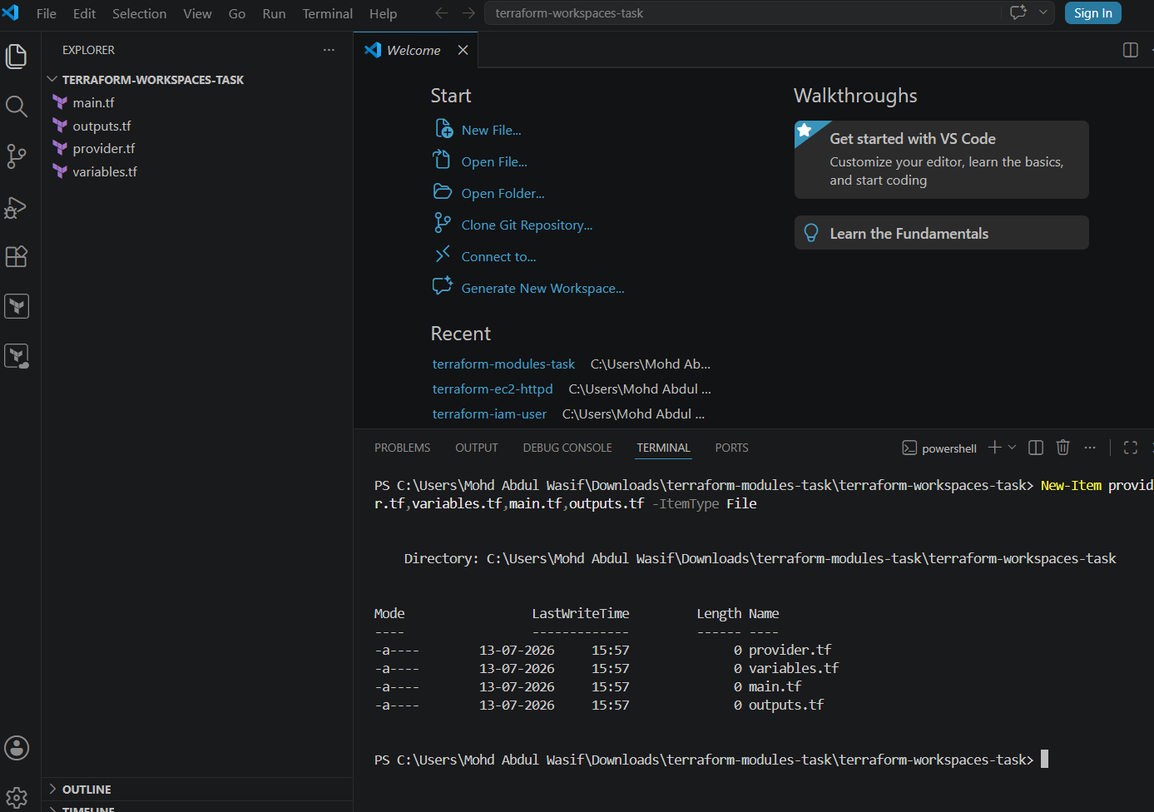

Step 2: Create the provider configuration
provider.tf
terraform {
required_version = ">= 1.5.0"

required_providers {
aws = {
source = "hashicorp/aws"
version = "~> 6.0"
}
}
}

provider "aws" {
region = var.aws_region
}
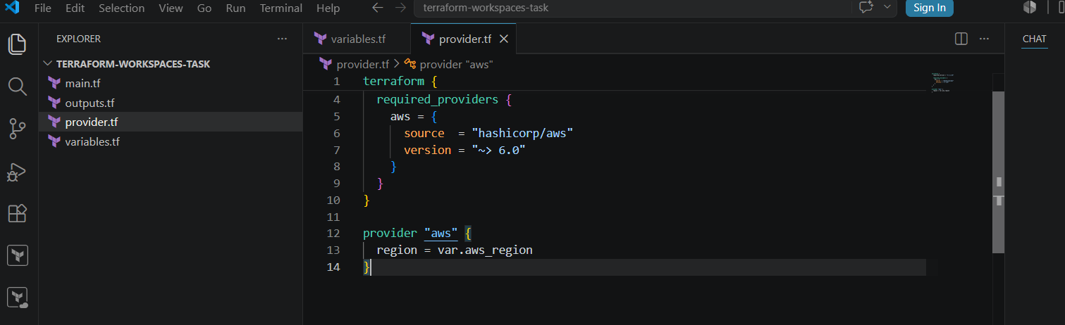

Step 3: Create variables
variables.tf
variable "aws_region" {
description = "AWS region"
type = string
default = "us-east-1"
}

variable "key_name" {
description = "Existing AWS key-pair name"
type = string
default = "Virginia"
}
Change Virginia to your existing EC2 key-pair name.
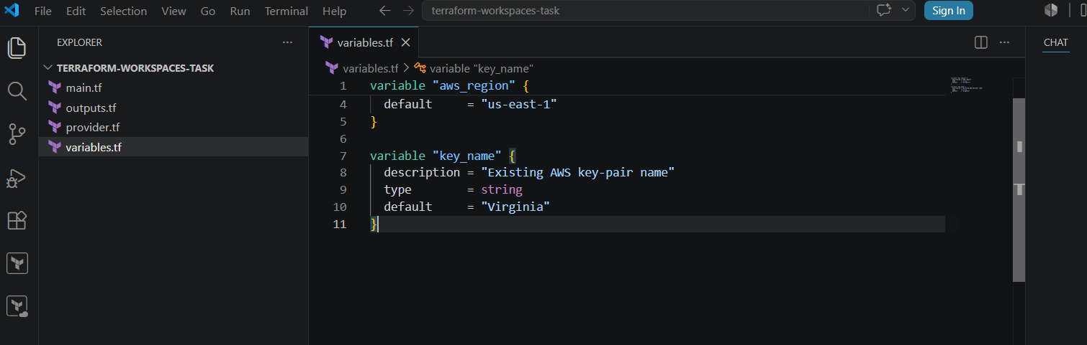

Step 4: Create the EC2 workspace configuration
main.tf
data "aws_vpc" "default" {
default = true
}

data "aws_subnets" "default" {
filter {
name = "vpc-id"
values = [data.aws_vpc.default.id]
}
}

data "aws_ssm_parameter" "amazon_linux" {
name = "/aws/service/ami-amazon-linux-latest/al2023-ami-kernel-default-x86_64"
}

locals {
environment_config = {
dev = {
instance_type = "t2.micro"
server_message = "Development Environment"
}

staging = {
instance_type = "t2.micro"
server_message = "Staging Environment"
}

prod = {
instance_type = "t2.micro"
server_message = "Production Environment"
}
}

current_environment = lookup(
local.environment_config,
terraform.workspace,
local.environment_config["dev"]
)
}

resource "aws_security_group" "web_sg" {
name = "${terraform.workspace}-web-sg"
description = "Security group for ${terraform.workspace}"
vpc_id = data.aws_vpc.default.id

ingress {
description = "SSH access"
from_port = 22
to_port = 22
protocol = "tcp"
cidr_blocks = ["0.0.0.0/0"]
}

ingress {
description = "HTTP access"
from_port = 80
to_port = 80
protocol = "tcp"
cidr_blocks = ["0.0.0.0/0"]
}

egress {
description = "Allow outbound traffic"
from_port = 0
to_port = 0
protocol = "-1"
cidr_blocks = ["0.0.0.0/0"]
}

tags = {
Name = "${terraform.workspace}-web-sg"
Environment = terraform.workspace
}
}

resource "aws_instance" "environment_server" {
ami = data.aws_ssm_parameter.amazon_linux.value
instance_type = local.current_environment.instance_type
subnet_id = data.aws_subnets.default.ids[0]
vpc_security_group_ids = [aws_security_group.web_sg.id]
associate_public_ip_address = true
key_name = var.key_name

user_data = <<-EOF
#!/bin/bash
dnf install -y httpd
systemctl enable httpd
systemctl start httpd
echo "<h1>${local.current_environment.server_message}</h1>" > /var/www/html/index.html
EOF

tags = {
Name = "${terraform.workspace}-server"
Environment = terraform.workspace
ManagedBy = "Terraform"
}
}
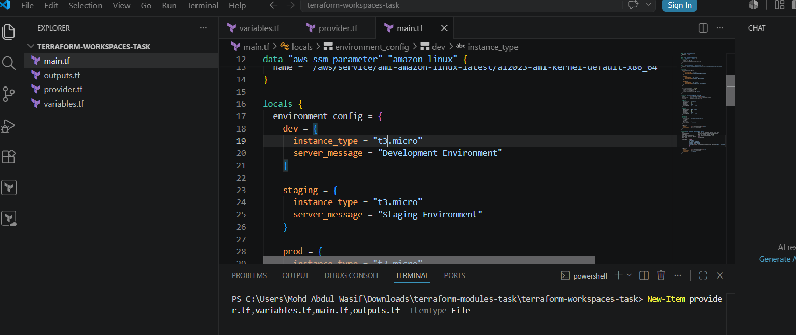
Important line
terraform.workspace
This automatically returns the currently selected workspace:
dev
staging
prod

Step 5: Create outputs
outputs.tf
output "current_workspace" {
description = "Currently selected workspace"
value = terraform.workspace
}

output "environment" {
description = "Current environment"
value = terraform.workspace
}

output "instance_id" {
description = "EC2 instance ID"
value = aws_instance.environment_server.id
}

output "instance_type" {
description = "EC2 instance type"
value = aws_instance.environment_server.instance_type
}

output "public_ip" {
description = "EC2 public IP"
value = aws_instance.environment_server.public_ip
}

output "website_url" {
description = "Environment website"
value = "http://${aws_instance.environment_server.public_ip}"
}
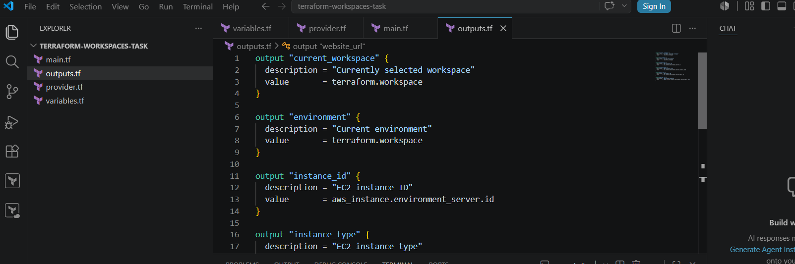

Step 6: Initialize Terraform
terraform init
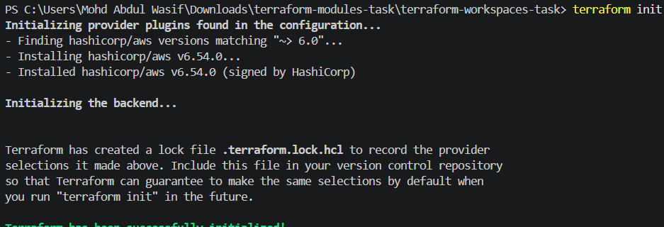
terraform fmt
terraform validate
Expected validation output:
Success! The configuration is valid.
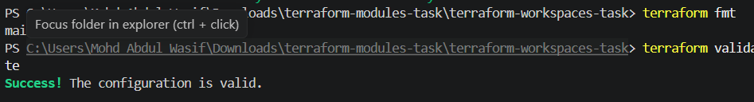

Step 7: Check the default workspace
terraform workspace list
Initially, the output will normally contain:
* default
The * shows the currently selected workspace.

Step 8: Create the Dev workspace
The terraform workspace new command creates and selects a new workspace.
terraform workspace new dev
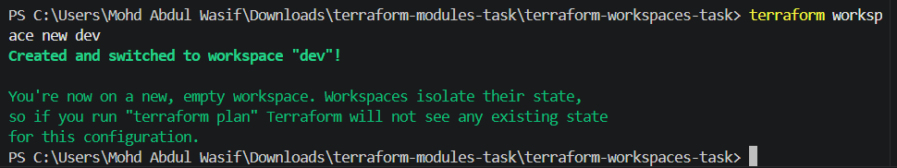
Check:
terraform workspace show
Expected:
Dev
The workspace show command displays the currently selected workspace.
Run:
terraform plan
terraform apply -auto-approve
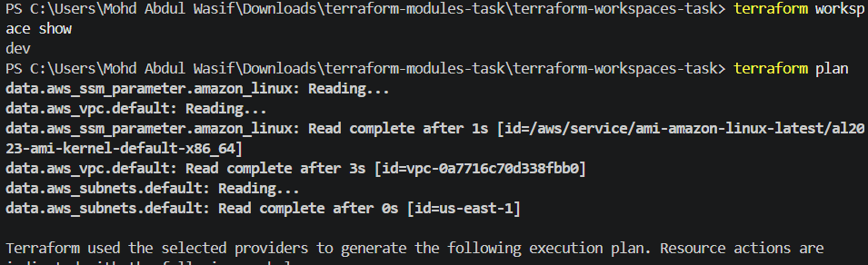
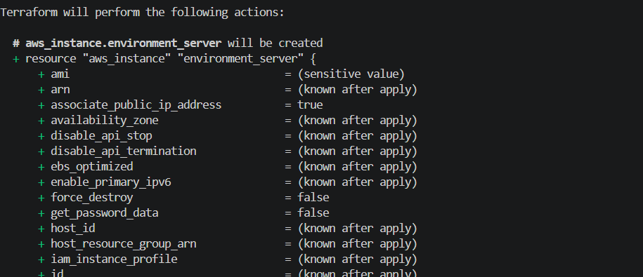
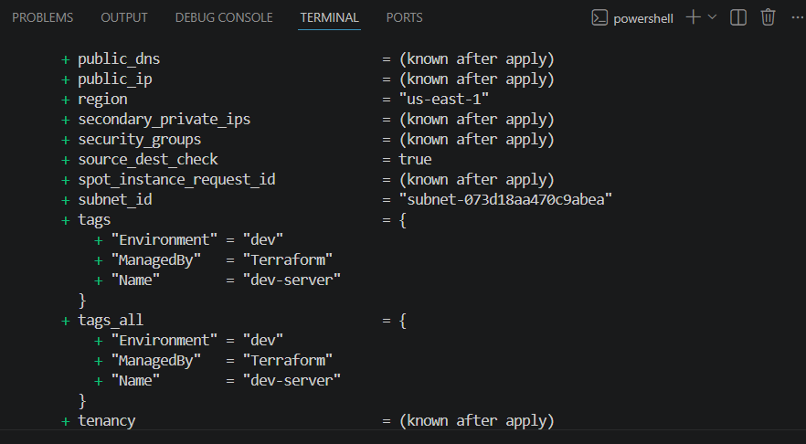
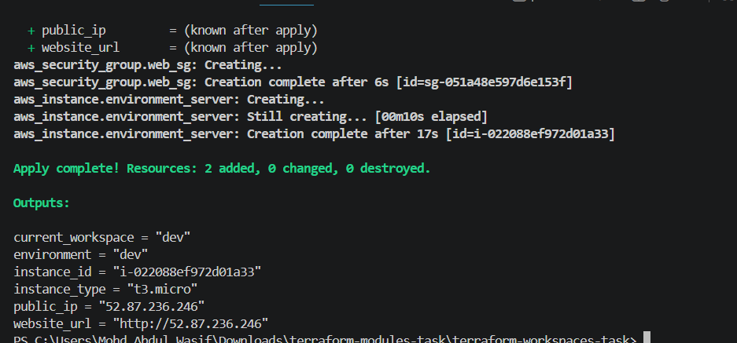
View output:
terraform output
This creates:
Name: dev-server
Environment: dev
Open:
http://DEV-PUBLIC-IP
Expected page:
Development Environment
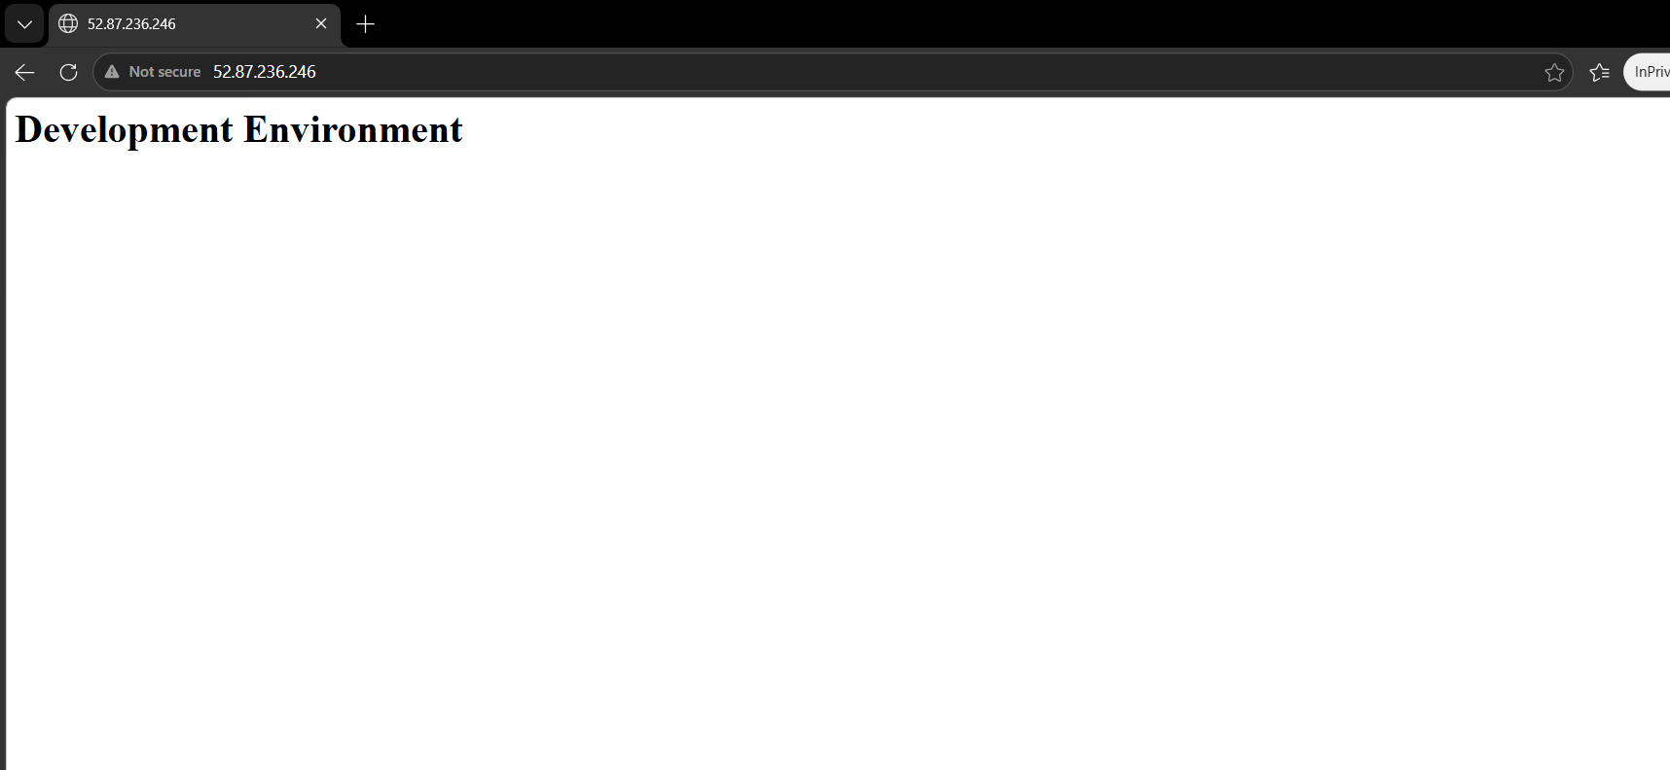

Step 9: Create the Staging workspace
terraform workspace new staging
terraform workspace show
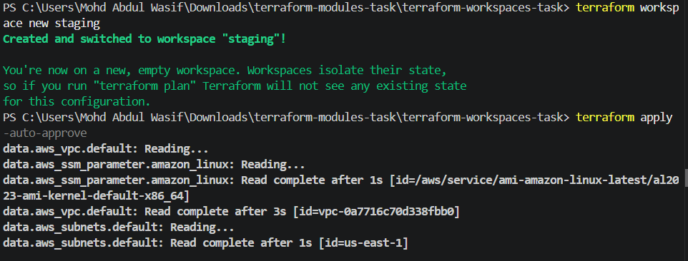
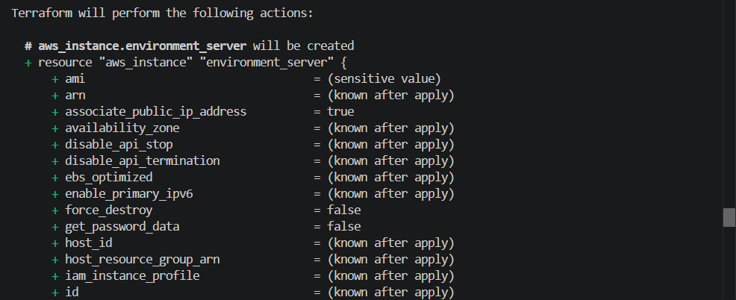
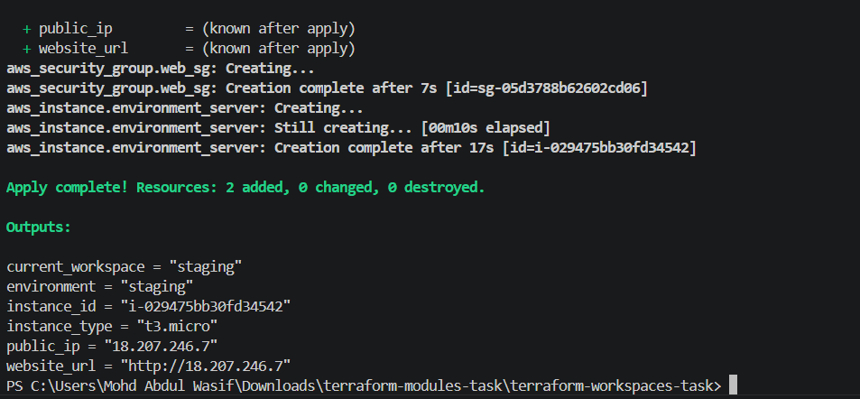
terraform plan
terraform apply -auto-approve
This creates:
Name: staging-server
Environment: staging
Expected webpage:
Staging Environment
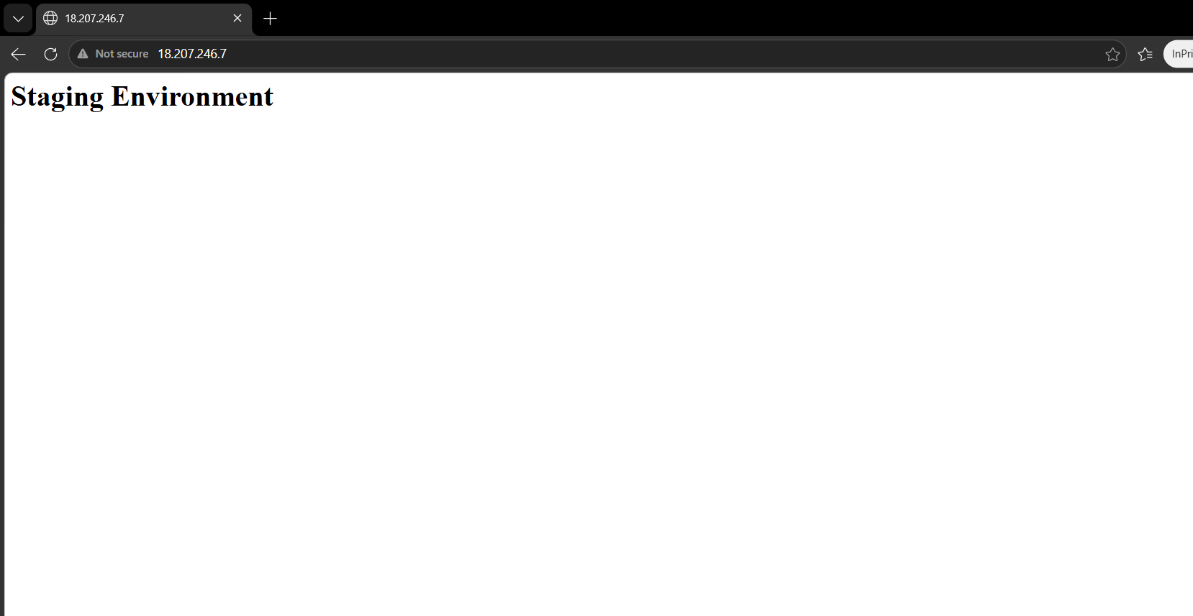

Step 10: Create the Prod workspace
terraform workspace new prod
terraform workspace show
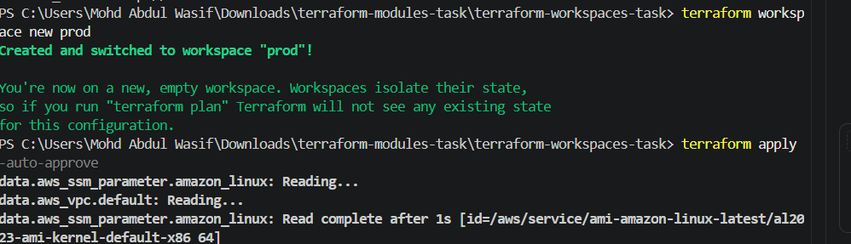
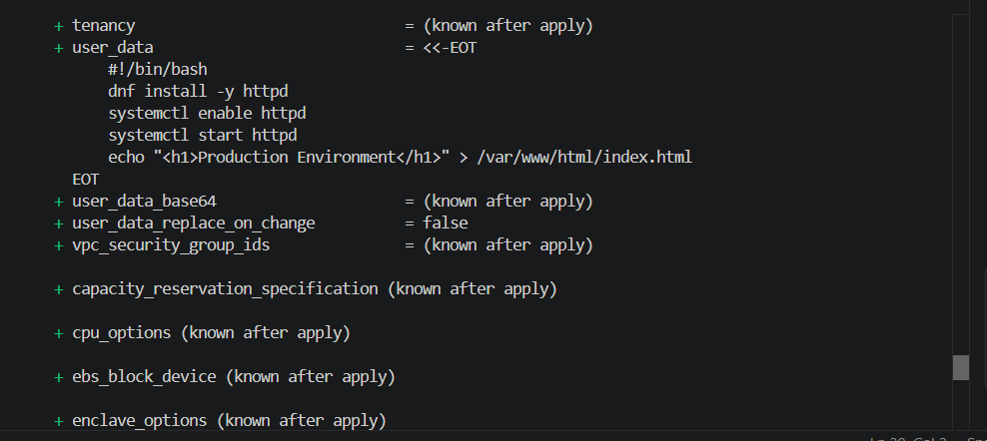
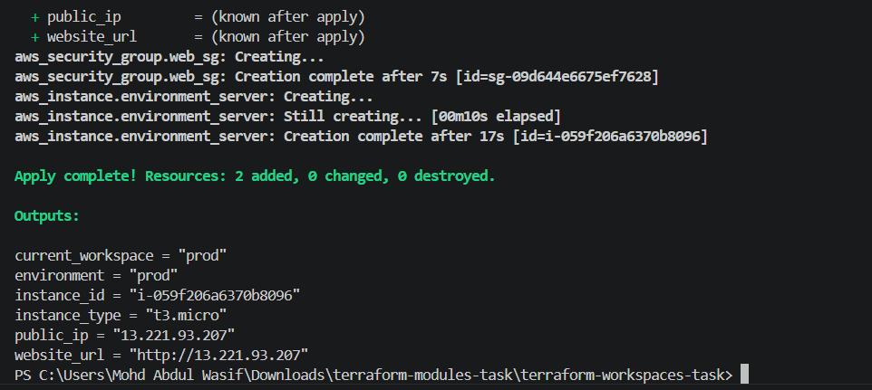
terraform plan
terraform apply -auto-approve
This creates:
Name: prod-server
Environment: prod
Expected webpage:
Production Environment
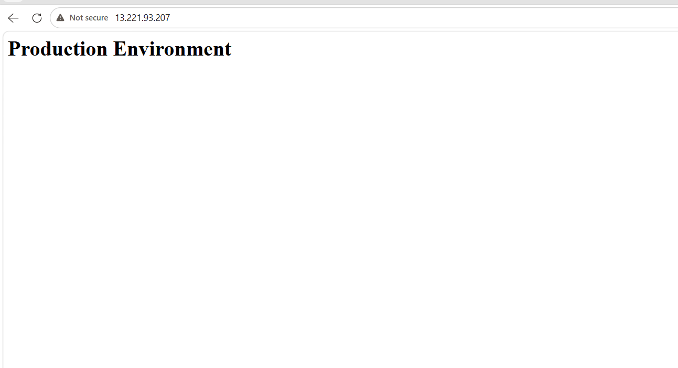

Step 11: List all workspaces
terraform workspace list
Expected:
default
dev
staging
* prod
The star indicates that prod is currently selected.
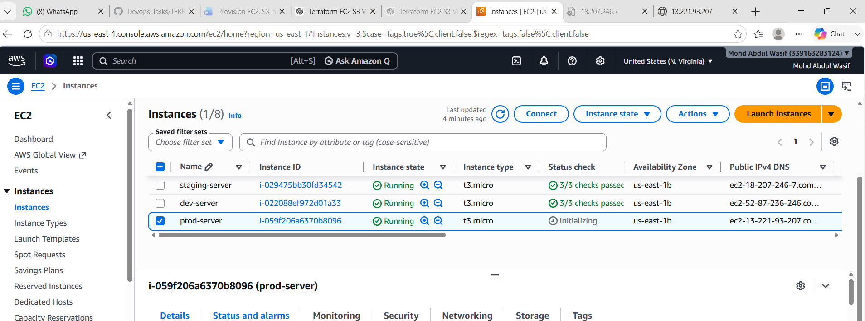

Step 12: Switch between environments
Use terraform workspace select to change the active workspace.
Switch to Dev
terraform workspace select dev
terraform output
Switch to Staging
terraform workspace select staging
terraform output
Switch to Prod
terraform workspace select prod
terraform output
Each workspace displays a different EC2 instance ID and public IP because each workspace has separate state.

Step 13: Verify all three EC2 instances
Run:
aws ec2 describe-instances `
--filters "Name=tag:ManagedBy,Values=Terraform" `
--query "Reservations[*].Instances[*].[Tags[?Key=='Name']|[0].Value,InstanceId,InstanceType,PublicIpAddress,State.Name]" `
--output table `
--region us-east-1
Expected concept:
-----------------------------------------------------------
| dev-server | i-xxxxx | t2.micro | public-ip | running |
| staging-server | i-yyyyy | t2.micro | public-ip | running |
| prod-server | i-zzzzz | t2.micro | public-ip | running |

-----------------------------------------------------------

Destroying Workspace Resources
Each workspace must be selected and destroyed separately.
Destroy Dev
terraform workspace select dev
terraform destroy -auto-approve
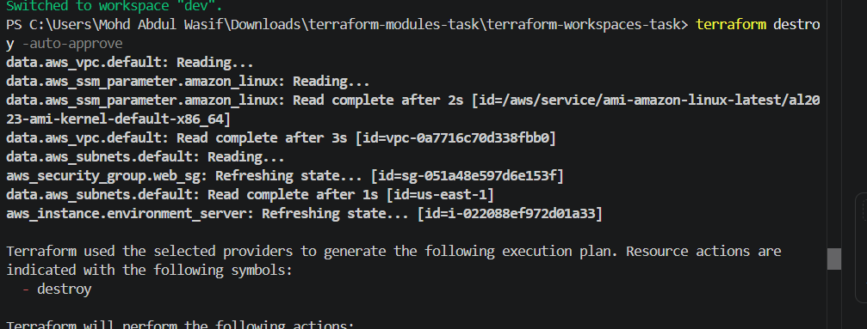
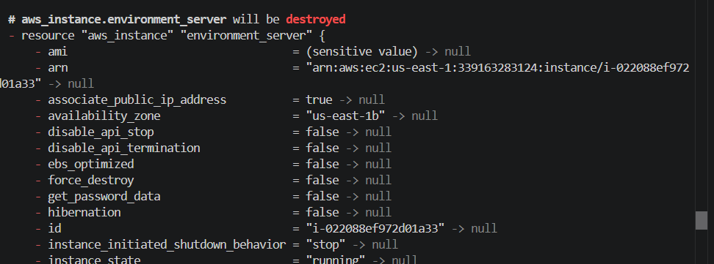
Destroy Staging
terraform workspace select staging
terraform destroy -auto-approve
Destroy Prod
terraform workspace select prod
terraform destroy -auto-approve
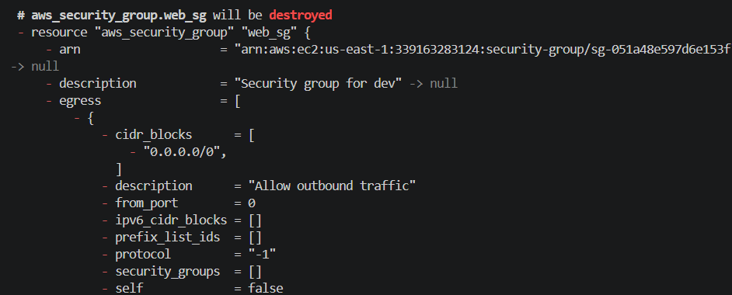
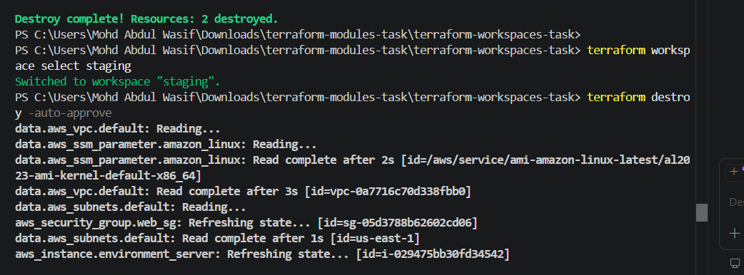

Delete the workspaces
You cannot delete the currently selected workspace. First switch to default:
terraform workspace select default
Delete the empty workspaces:
terraform workspace delete dev
terraform workspace delete staging
terraform workspace delete prod
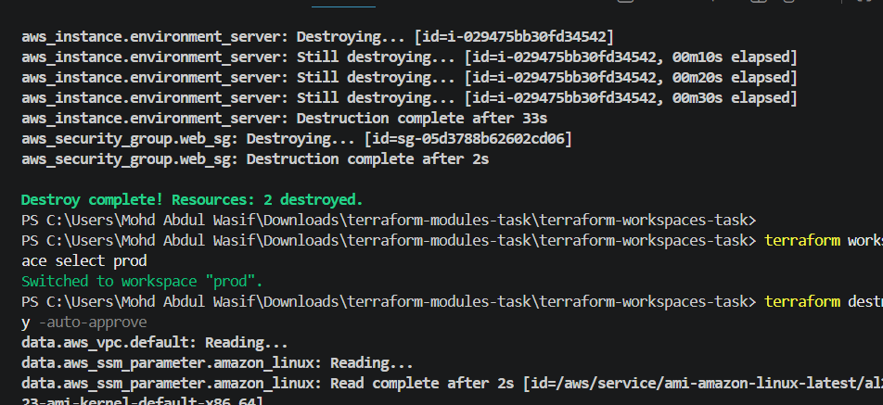
Check:
terraform workspace list
Expected:
* default
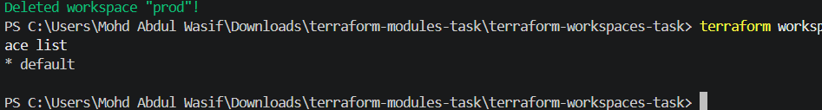

Common Errors and Solutions
1. No default VPC found
Error:
no matching EC2 VPC found
Reason:
The selected region does not have a default VPC.
Solution:
- Select a region containing a default VPC, or
- Use the custom VPC module from Task 2.
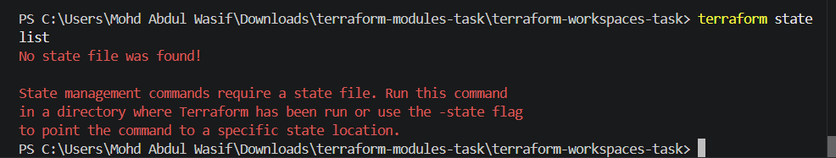

2. Invalid key-pair name
Error:
InvalidKeyPair.NotFound
Solution:
Check key pairs:
aws ec2 describe-key-pairs `
--region us-east-1 `
--query "KeyPairs[*].KeyName" `
--output table
Update key_name with the correct name.

3. Workspace resource already exists
Error:
InvalidGroup.Duplicate
Reason:
Two resources are trying to use the same security-group name.
Solution:
Include the workspace in the name:
name = "${terraform.workspace}-web-sg"

4. Wrong workspace selected
Check:
terraform workspace show
Select the correct one:
terraform workspace select dev

5. S3 bucket already exists
Error:
BucketAlreadyExists
Solution:
Use a globally unique bucket name, for example:
bucket_name = "wasif-module-bucket-339163283124"
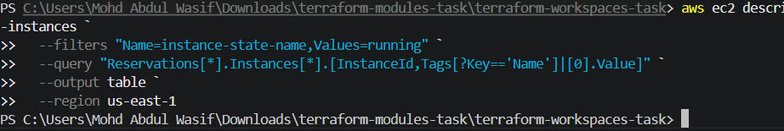
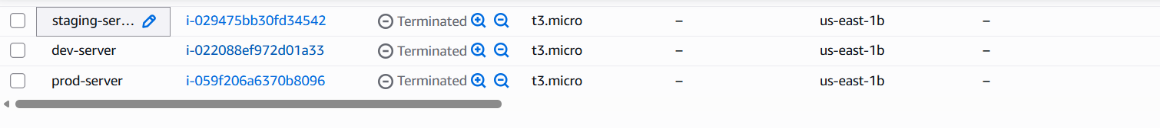

What We Learned – Task 4
- Workspaces allow the same Terraform code to manage multiple environments.
- Every workspace keeps separate Terraform state.
- terraform.workspace returns the active workspace name.
- Environment-specific values can be stored in a local map.
- Selecting one workspace does not automatically modify another workspace.
- Each environment must be applied and destroyed separately.
- Resource names should contain the workspace name to prevent naming conflicts.
Task 4 Conclusion
We used one Terraform configuration to provision separate EC2 instances for Development, Staging and Production. Terraform workspaces maintained separate state for each environment, while terraform.workspace helped assign environment-specific names, tags and webpage content.
Final Combined Conclusion
In these tasks, we learned two important Terraform concepts:
Modules = Reuse and organize Terraform code
Workspaces = Separate environments and state
Modules were used to divide VPC, EC2 and S3 resources into reusable components. Workspaces were used to create isolated Dev, Staging and Prod EC2 environments using the same Terraform configuration. Remember to destroy all practice resources after verification to avoid unexpected AWS charges.

