Ansible-Task-01
Ansible Lab — Master & Two Worker Nodes

Task 1: Setup One Master and Two Worker Nodes
Objective
To install and configure Ansible with:
- 1 Ansible Master/Control Node
- 2 Ansible Worker/Managed Nodes
- SSH key-based authentication
- Ansible inventory
- Connectivity testing using the ping module
Architecture
Ansible Master
Ubuntu EC2 Instance
Private IP: 10.0.0.10
|
SSH / Ansible Commands
/ \
/ \
↓ ↓
Worker Node 1 Worker Node 2
10.0.0.11 10.0.0.12
Ubuntu EC2 Ubuntu EC2
The IP addresses above are examples. Use the actual private IP addresses of your EC2 instances.

Step 1: Create 3 EC2 Instances
Create three Amazon EC2 instances in the same VPC/subnet if possible.
Instance | Role | Example Private IP
ansible-master | Ansible Master | 10.0.0.10
ansible-worker1 | Worker 1 | 10.0.0.11
ansible-worker2 | Worker 2 | 10.0.0.12
You can use a small instance type suitable for your lab.
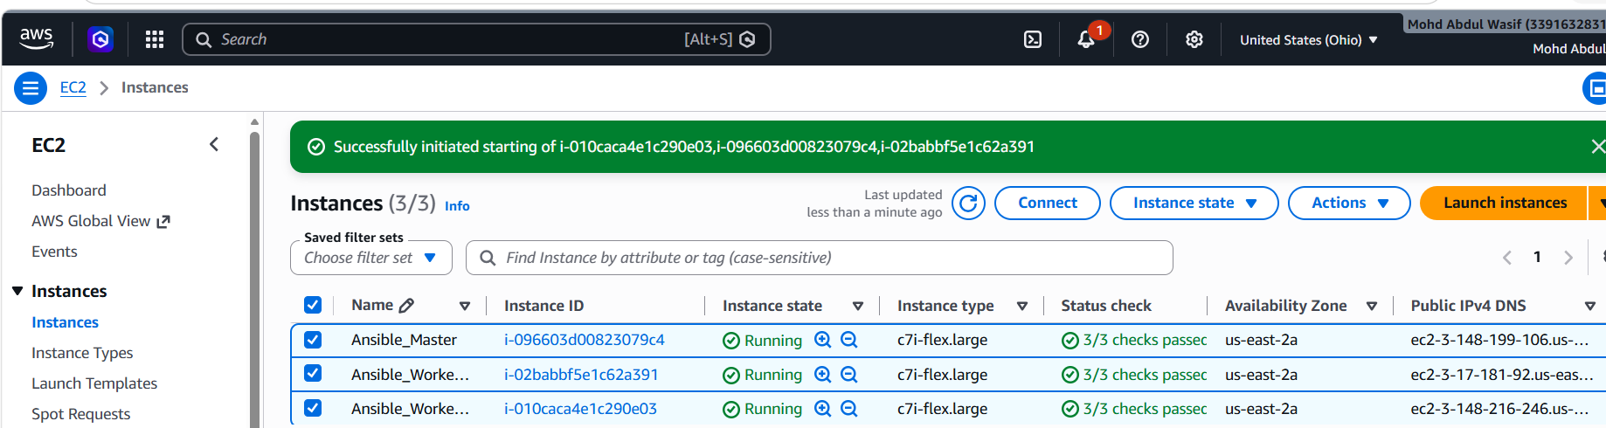
Security Group
Allow at least:
SSH
TCP
22
Your IP
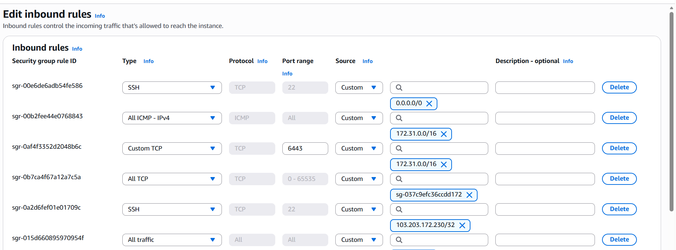
For easier lab testing, the three instances should be able to communicate with each other over SSH.

Step 2: Connect to the Master
From your Windows machine:
ssh -i "your-key.pem" amazon@<MASTER-PUBLIC-IP>
Check the OS:
cat /etc/os-release
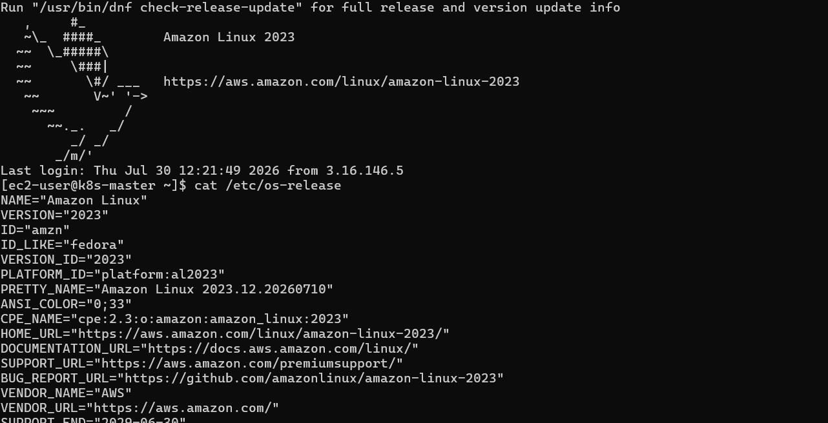
Update packages:
sudo yum update
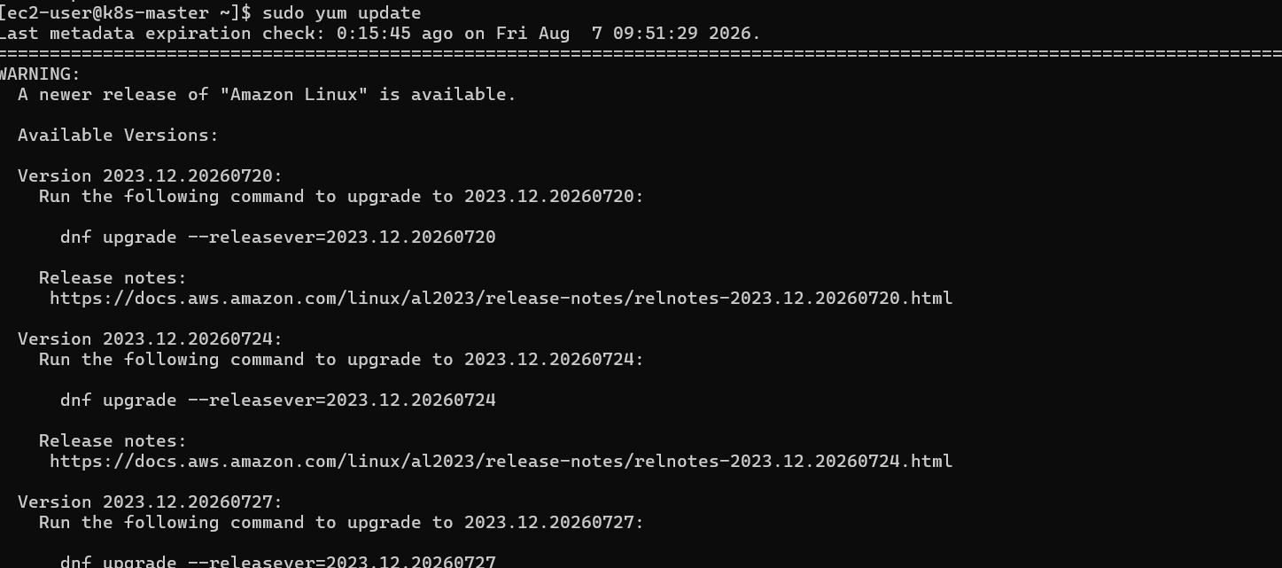
Install Python pip
Run:
sudo dnf install python3-pip -y
Check:
pip3 --version
Example:
pip 21.x.x from /usr/lib/python3...
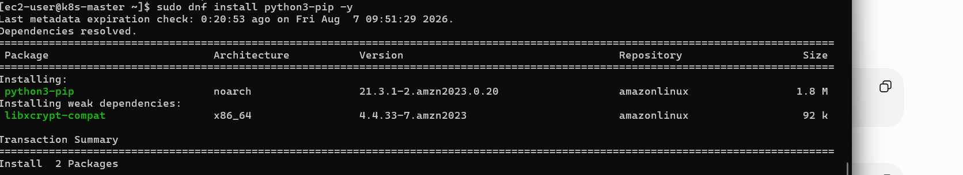
Step 3: Install Ansible using pip
Run:
pip3 install ansible --user
Wait until installation completes.
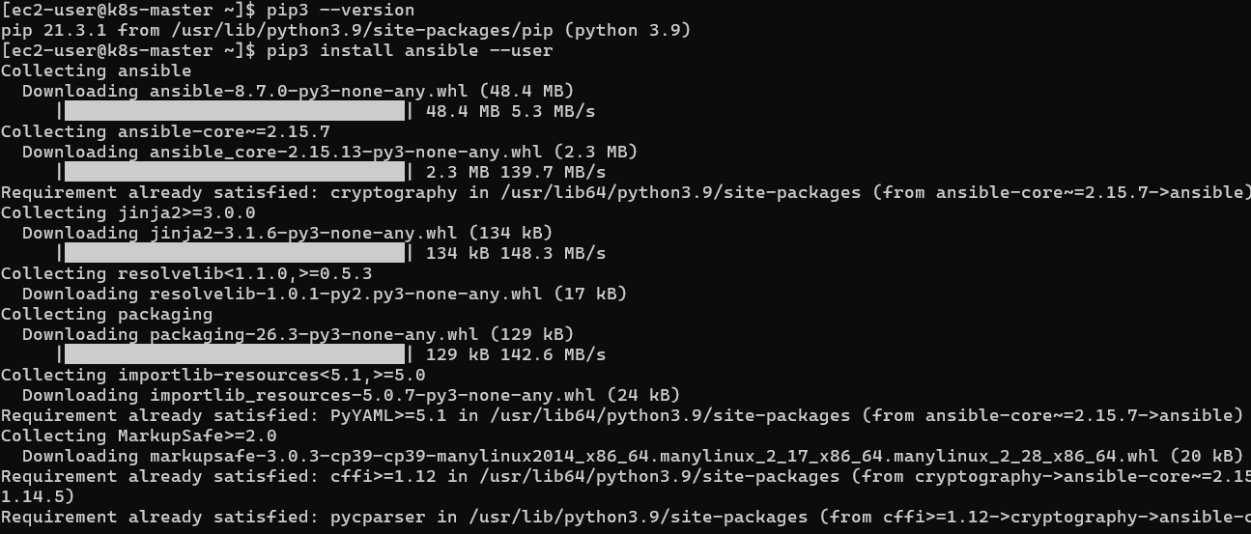
Step 4: Add Ansible to PATH
The installation usually places Ansible binaries here:
/home/ec2-user/.local/bin
Add it:
echo 'export PATH=$PATH:$HOME/.local/bin' >> ~/.bash_profile
Reload:
source ~/.bash_profile

Step 5: Verify Installation
Run:
ansible --version
Expected:
ansible [core 2.x.x]
python version = 3.x.x
Example:
ansible [core 2.19.x]
python version = 3.9.x
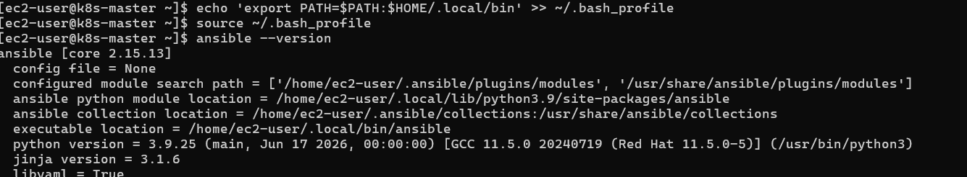

3.4 Verify Ansible Installation
Run:
ansible --version
Expected output:
ansible [core 2.x.x]
python version = 3.x.x
Example:
ansible [core 2.15.3]
python version = 3.9
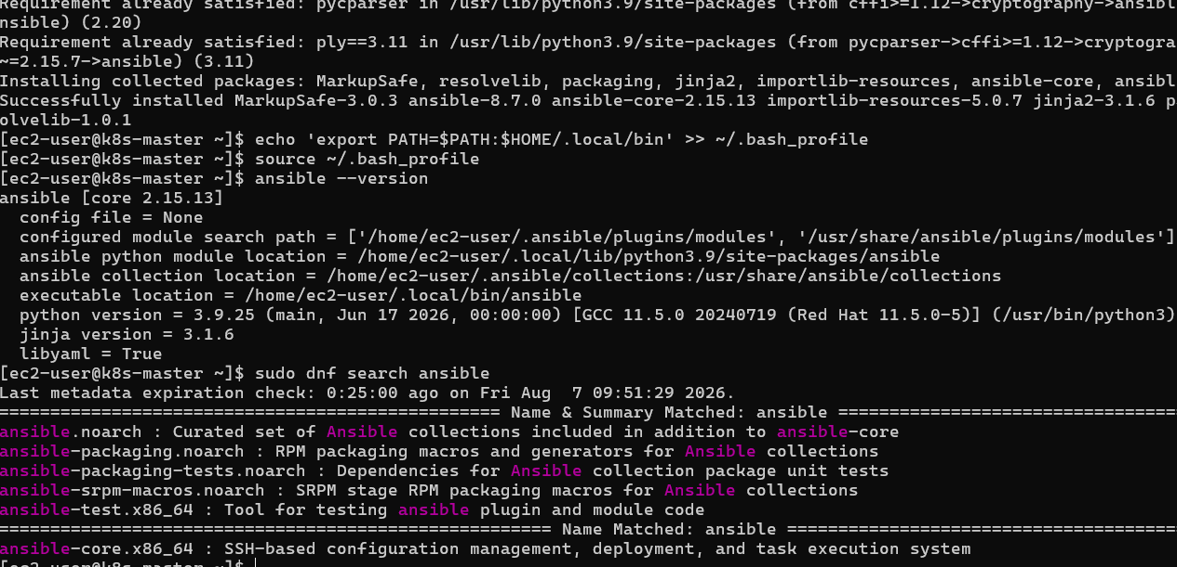
Your Master node is now ready.
Now run only the command after the prompt.
Execute:
ls -la ~/.ssh
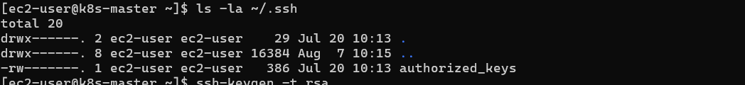
Step 5: Generate SSH Key on Ansible Master
Run only this command:
ssh-keygen -t rsa
You will see:
Generating public/private rsa key pair.
Enter file in which to save the key (/home/ec2-user/.ssh/id_rsa):
Press:
ENTER
Then:
Enter passphrase:
Press:
ENTER
Again:
Enter same passphrase again:
Press:
ENTER

After completion, check:
ls -la ~/.ssh
Expected output:
id_rsa
id_rsa.pub
authorized_keys
Example:
-rw------- id_rsa
-rw-r--r-- id_rsa.pub
-rw------- authorized_keys
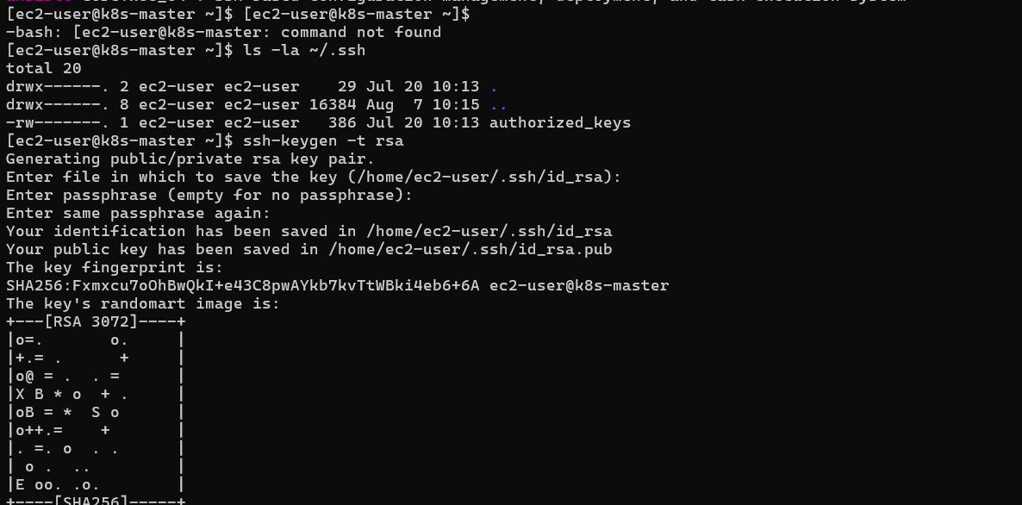
Step 6: Get Worker Private IP Addresses
Go to AWS Console:
EC2 → Instances
Copy the Private IPv4 address of:
- k8s_Worker01
- k8s_Worker02
Example:
Worker01 Private IP: 10.0.1.25
Worker02 Private IP: 10.0.1.50
Step 7: Copy SSH Key to Worker01
From your current Master terminal run:
ssh-copy-id ec2-user@<WORKER01_PRIVATE_IP>
Example:
ssh-copy-id ec2-user@10.0.1.25
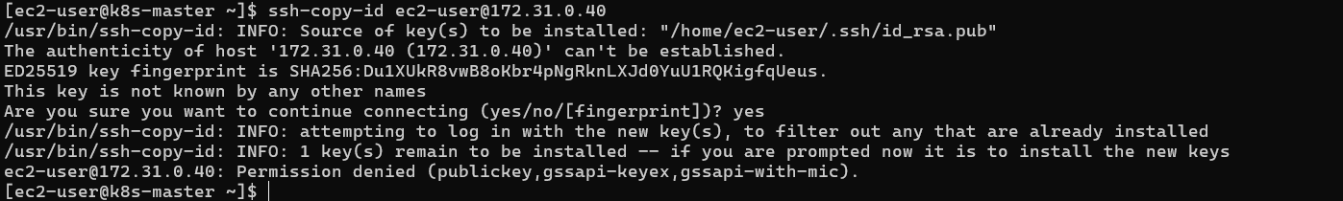
You may see:
The authenticity of host '10.0.1.25' can't be established.
Are you sure you want to continue connecting?
Type:
yes
Then it may ask:
ec2-user@10.0.1.25's password:
Enter the worker instance password if configured.

Step 8: Copy SSH Key to Worker02
Run:
ssh-copy-id ec2-user@<WORKER02_PRIVATE_IP>
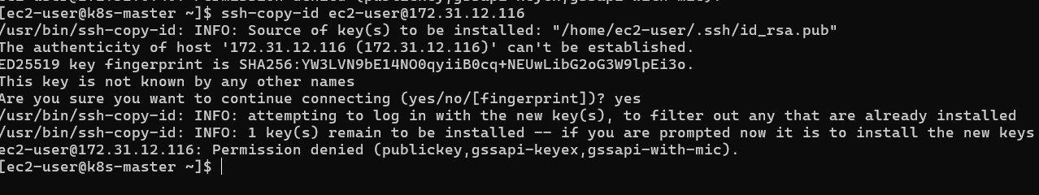
Example:
ssh-copy-id ec2-user@10.0.1.50

Step 9: Test Passwordless SSH
After copying keys:
Worker01
ssh ec2-user@<WORKER01_PRIVATE_IP>
Example:
ssh ec2-user@10.0.1.25
You should enter directly without a password.
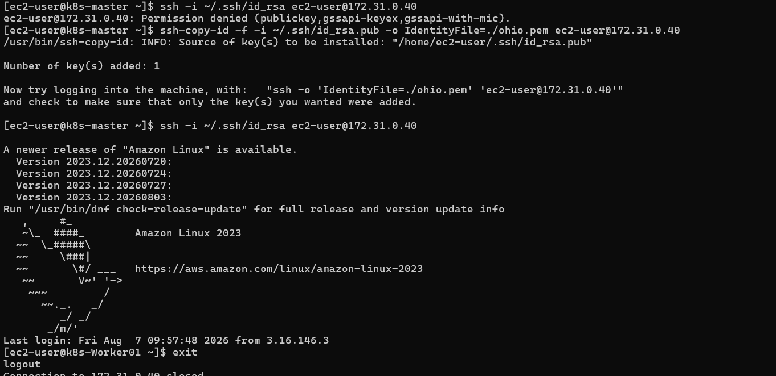
Exit:
exit

Worker02
ssh ec2-user@<WORKER02_PRIVATE_IP>
Example:
ssh ec2-user@10.0.1.50
Exit:
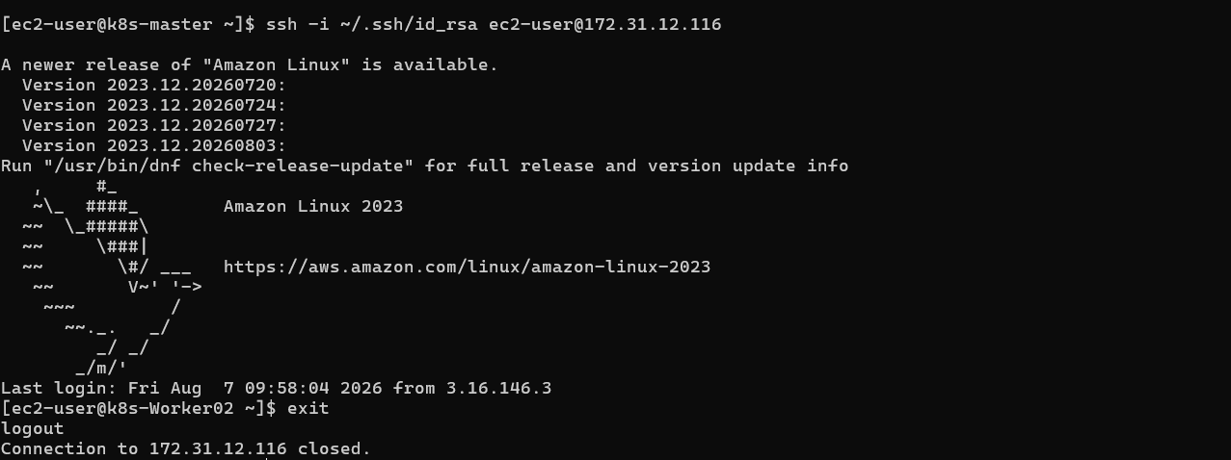
Exit
Step 2: Create Ansible Working Directory
Run:
mkdir ~/ansible-lab
cd ~/ansible-lab
Check:
Pwd
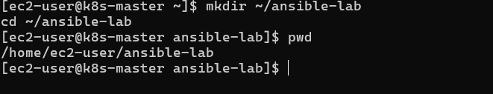
Expected:
/home/ec2-user/ansible-lab

Step 3: Create Inventory File
Create:
vi ansible_hosts
Press:
i
Enter insert mode.
Add this:
[workers]
worker01 ansible_host=172.31.0.40
worker02 ansible_host=172.31.12.116

[all:vars]
ansible_user=ec2-user
private_key_file=/home/ec2-user/.ssh/id_rsa
Save:
Press:
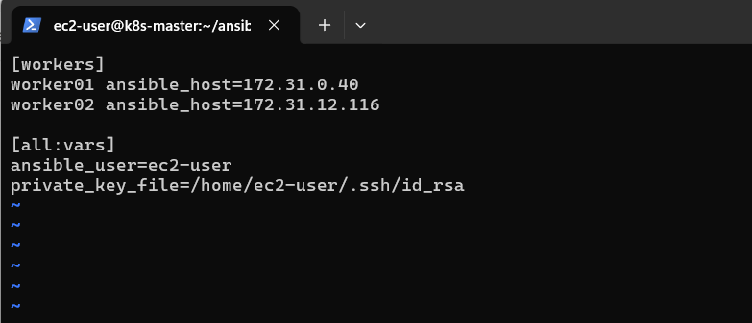
ESC
:wq
ENTER

Step 4: Verify Inventory
Run:
ansible all -i ansible_hosts --list-hosts
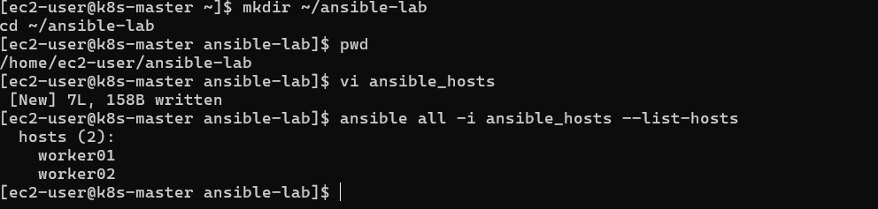
Expected:
hosts (2):

worker01
worker02

Step 5: Test Ansible Connectivity
Run:
ansible all -m ping -i ansible_hosts
Expected:
worker01 | SUCCESS => {
"changed": false,
"ping": "pong"
}

worker02 | SUCCESS => {
"changed": false,
"ping": "pong"
}
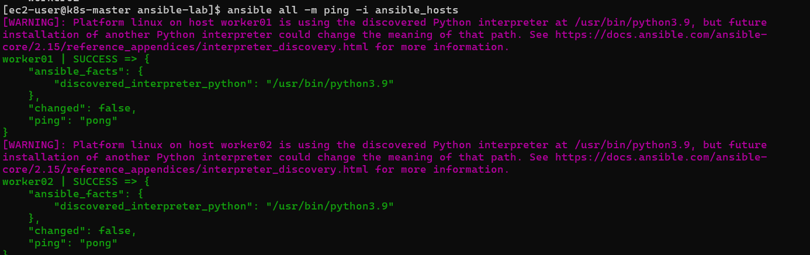

Step 6: Execute Your First Ad-hoc Commands
After ping works, test:
Check hostname
ansible all -a "hostname" -i ansible_hosts
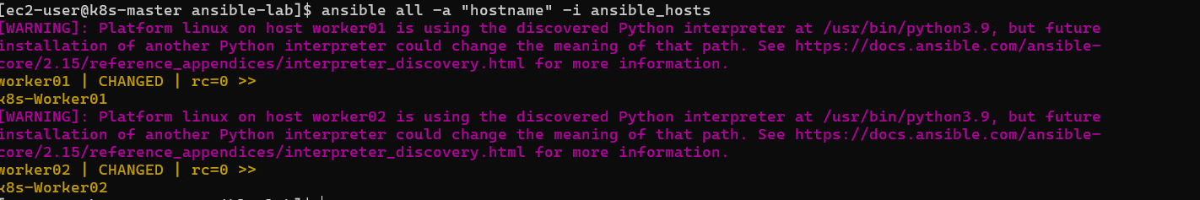
Expected:
worker01 | CHANGED | rc=0 >>
k8s-worker01

worker02 | CHANGED | rc=0 >>
k8s-worker02

Check uptime
ansible all -a "uptime" -i ansible_hosts
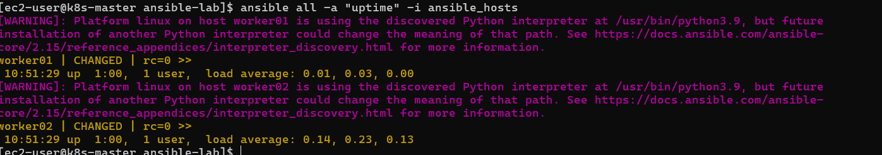

Check memory
ansible all -a "free -m" -i ansible_hosts

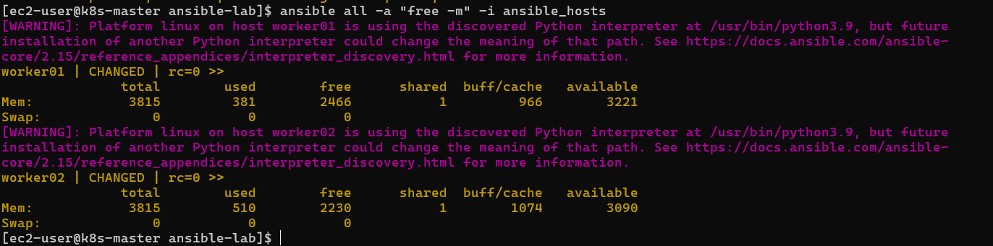

Your EC2-specific Checklist
Task | Status
Launch 3 EC2 Amazon Linux instances | ✅
Connect Master using Ohio.pem | Next
Install Ansible on Master | Next
Verify SSH on Workers | Next
Generate SSH key on Master | Next
Copy key to Workers | Next
Create inventory file | Next
Run ansible all -m ping | Final test
For the next step, send me the private IP addresses of Ansible_Master, Worker01, and Worker02 from EC2 console. Then I will prepare your exact ansible_hosts file.

Task 2: Execute Ansible Ad-hoc Commands from your DevOps document.
You are already in:
[ec2-user@k8s-master ansible-lab]$
Your inventory file is working, so use:
-i ansible_hosts
with every command.

1. Gather facts of worker machines
Command:
ansible all -m setup -i ansible_hosts
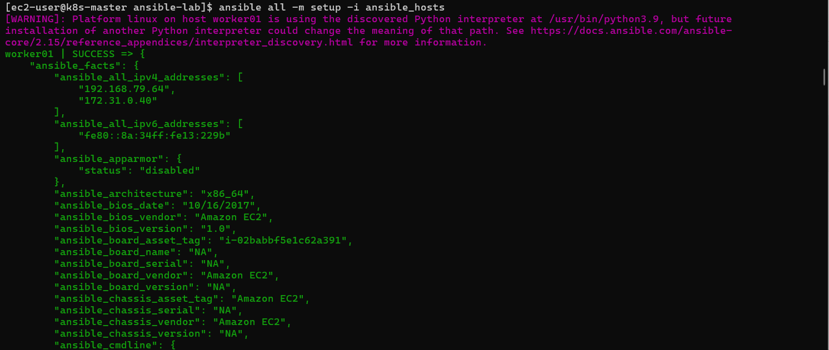
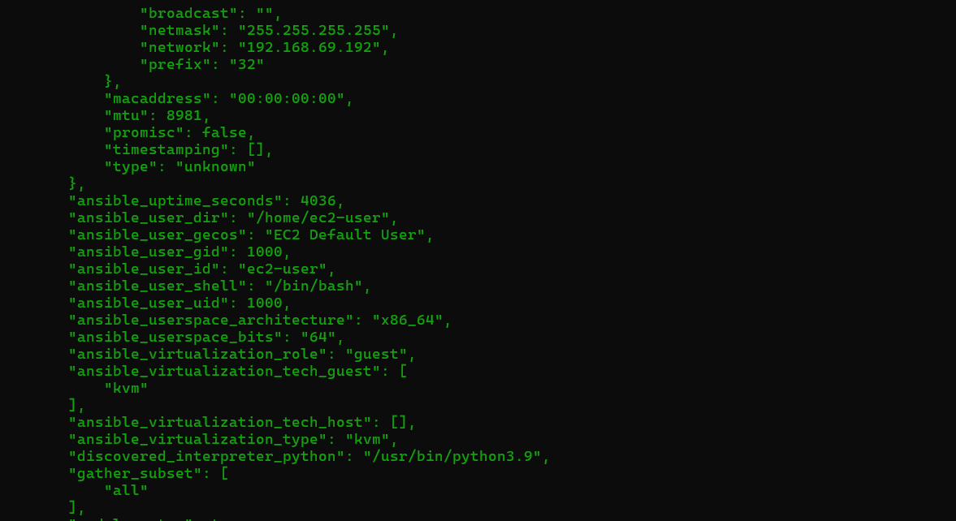
This collects:
- OS information
- CPU details
- Memory
- Network details
- IP addresses
- Hostname
(large output is expected)

2. Check free memory
Command:
ansible all -a "free -m" -i ansible_hosts
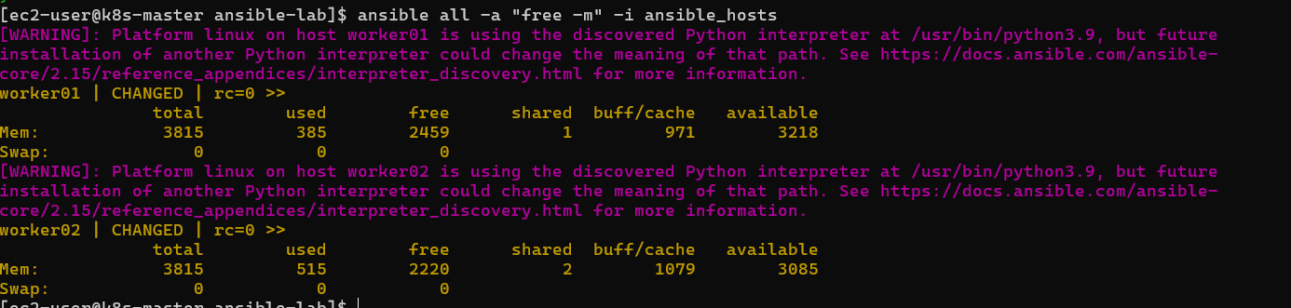
Expected:
worker01 | CHANGED >>
total used free

worker02 | CHANGED >>
total used free

3. Create Linux user group
Your document:
ansible all -s -m group -a "name=test state=present"
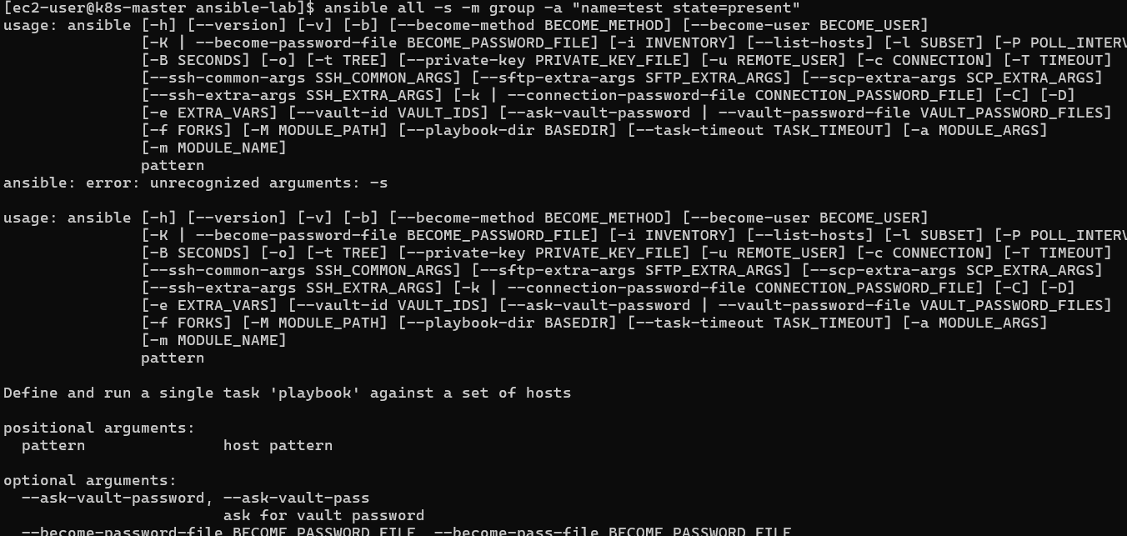
For your environment use:
ansible all -m group -a "name=test state=present" -b -i ansible_hosts
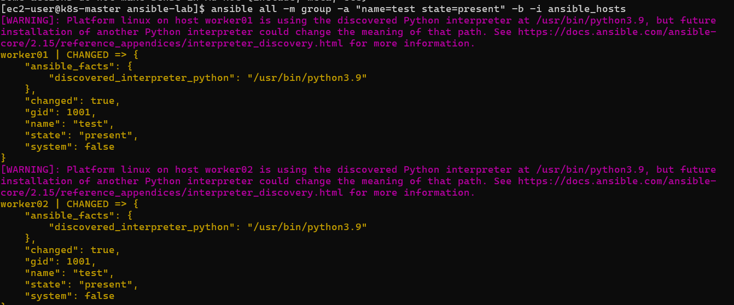
Verify:
ansible all -a "cat /etc/group | grep test" -i ansible_hosts
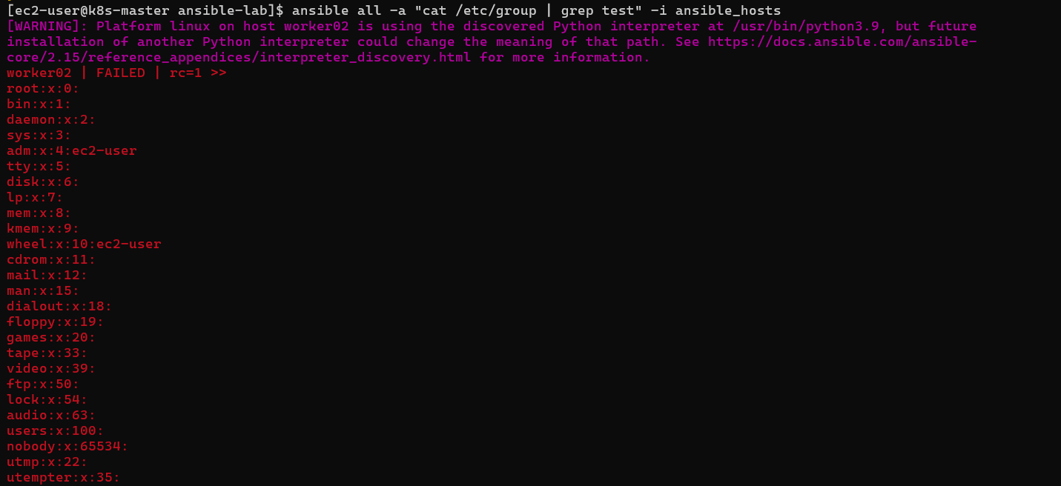

4. Create file with 755 permission
Run:
ansible all -m file -a "path=/home/ec2-user/testfile state=touch mode=0755" -i ansible_hosts
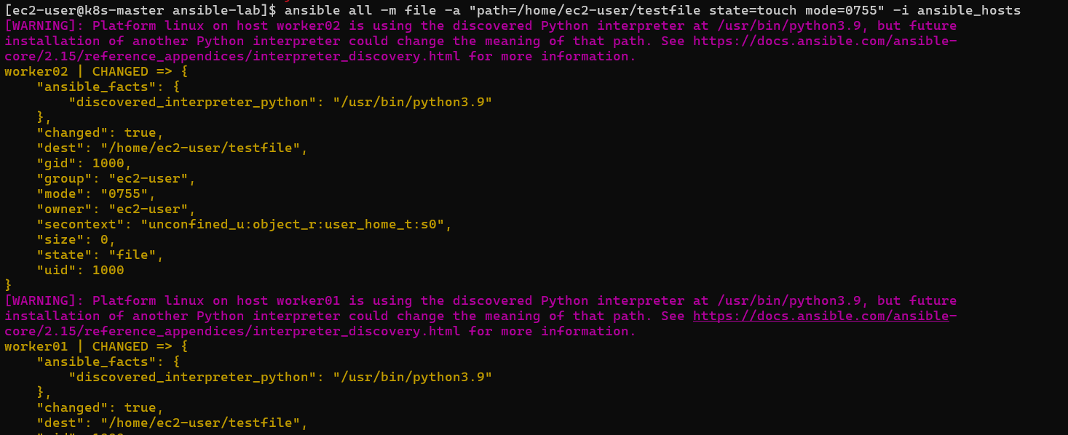
Verify:
ansible all -a "ls -l /home/ec2-user/testfile" -i ansible_hosts
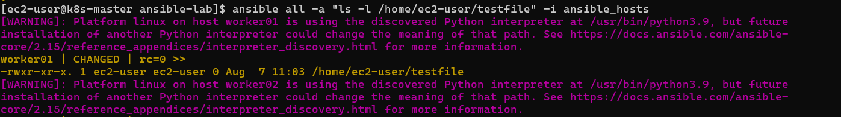
Expected:
-rwxr-xr-x

5. Create directory as another user (become example)
Create directory:
ansible all -m file -a "path=/home/ec2-user/testdir state=directory mode=0755" -b -i ansible_hosts
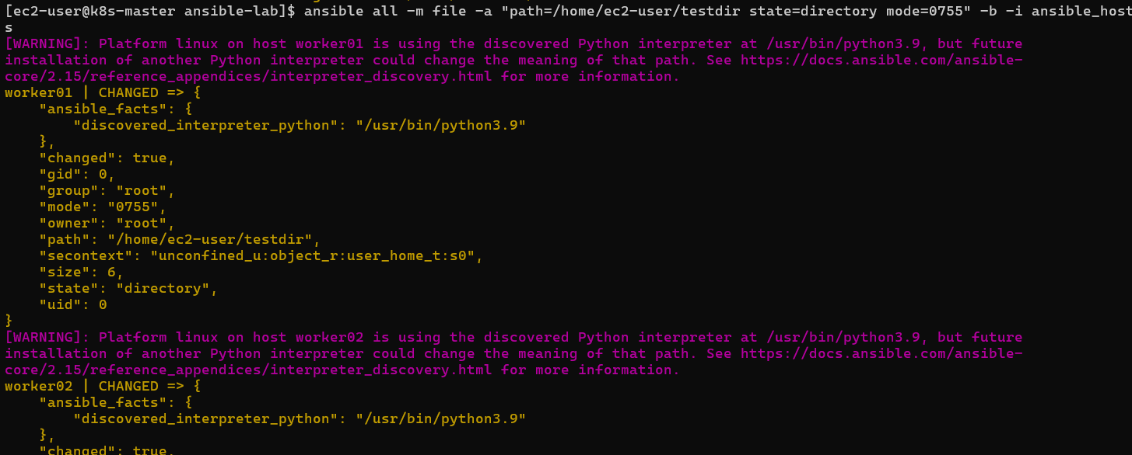

6. Install HTTPD package
Your workers are Amazon Linux 2023, so use dnf instead of yum.
Run:
ansible all -m dnf -a "name=httpd state=present" -b -i ansible_hosts
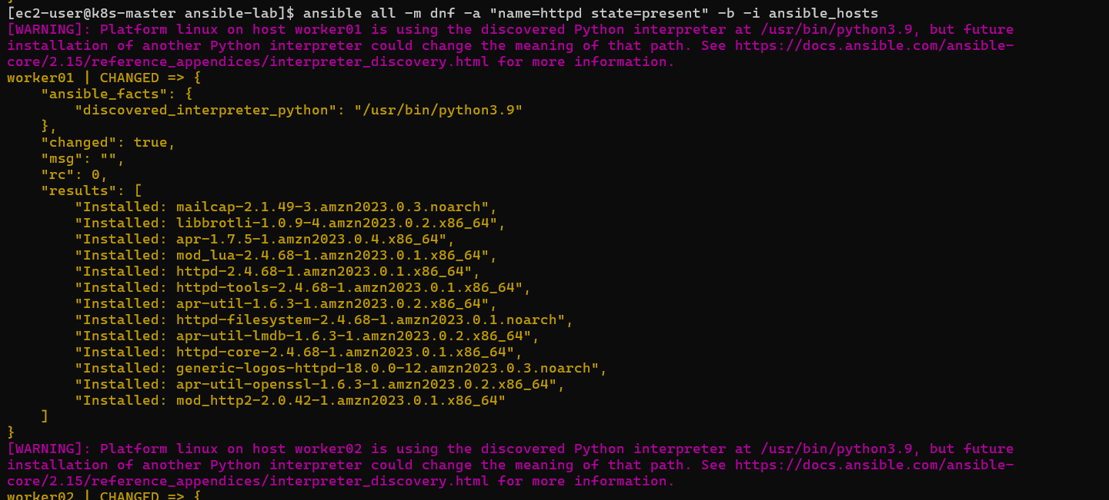

7. Start HTTPD service
Run:
ansible all -m service -a "name=httpd state=started enabled=yes" -b -i ansible_hosts
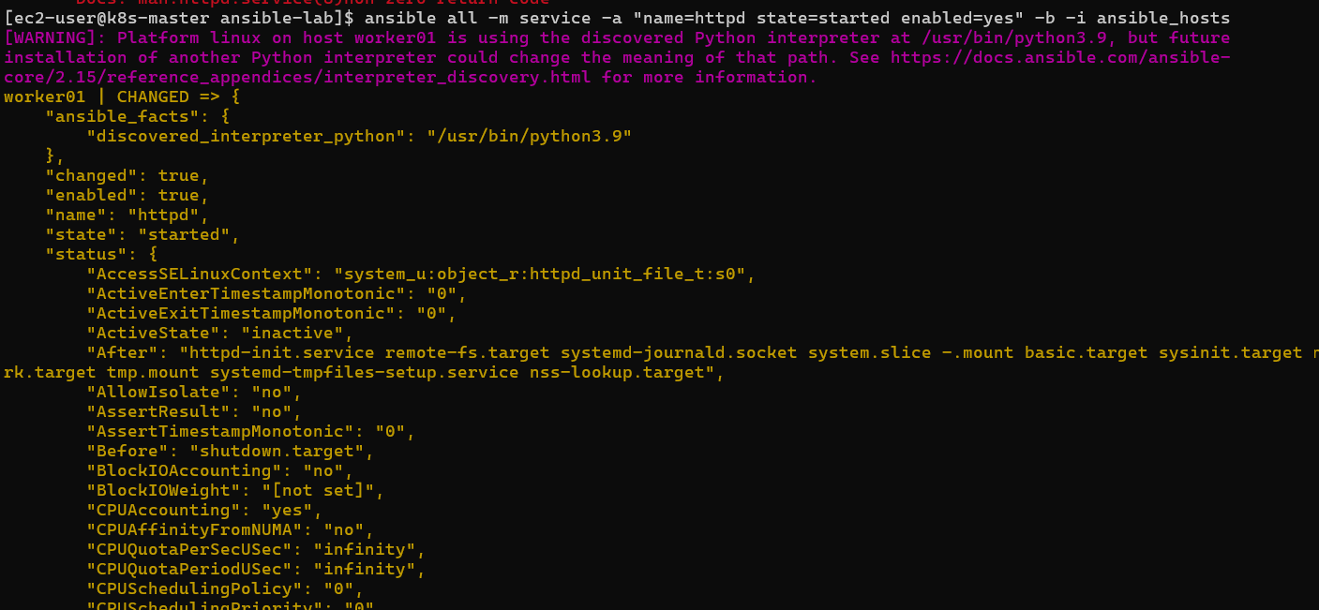
Check:
ansible all -a "systemctl status httpd --no-pager" -b -i ansible_hosts
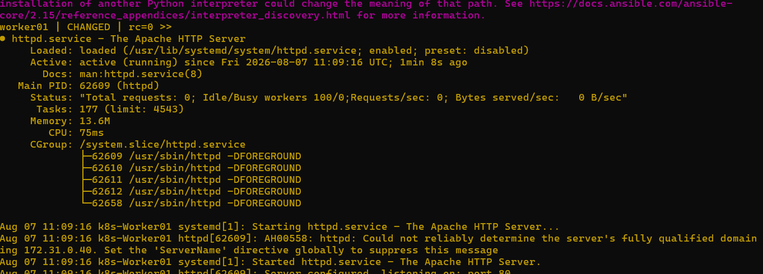

8. Check /etc/passwd user
Create user first:
ansible all -m user -a "name=ansadm state=present" -b -i ansible_hosts

Then:
ansible all -m shell -a "cat /etc/passwd | grep -i ansadm" -b -i ansible_hosts
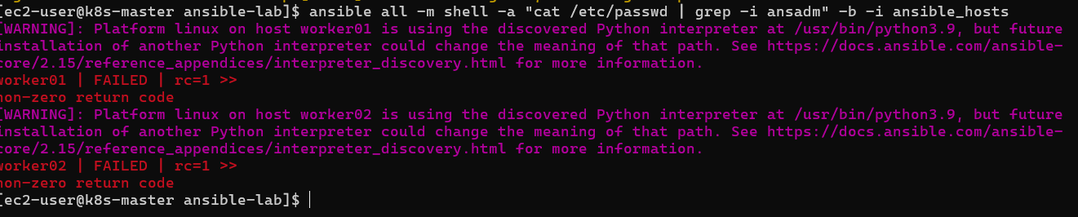
Fix: Create ansadm user first
Run:
ansible all -m user -a "name=ansadm state=present" -b -i ansible_hosts
Expected:
worker01 | CHANGED
worker02 | CHANGED

Now run your original command again
ansible all -m shell -a "cat /etc/passwd | grep -i ansadm" -b -i ansible_hosts
Expected:
worker01 | CHANGED >>
ansadm:x:1001:1001::/home/ansadm:/bin/bash

worker02 | CHANGED >>
ansadm:x:1001:1001::/home/ansadm:/bin/bash

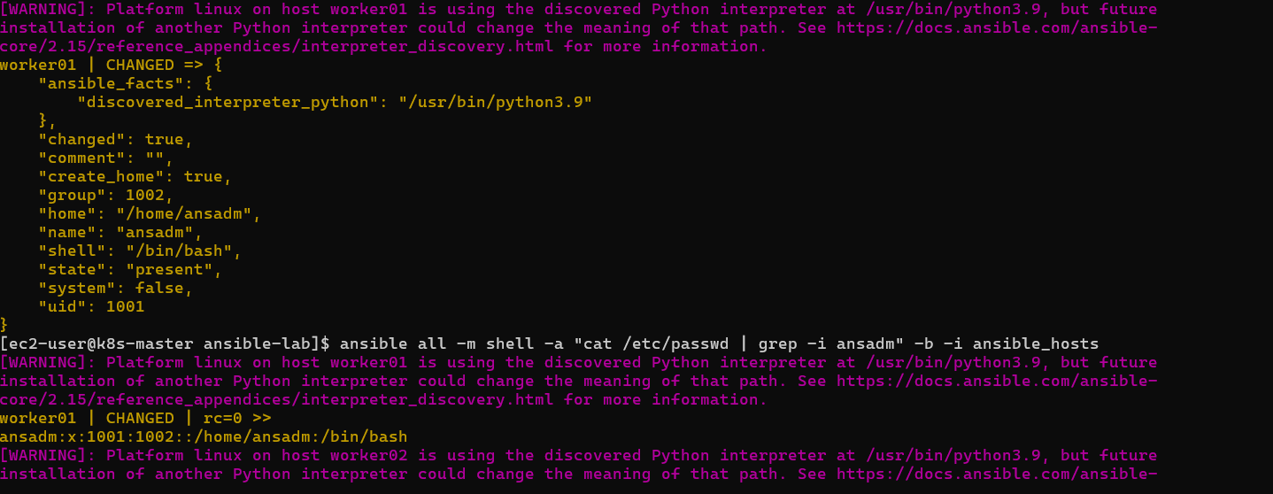
ansible all -m file -a "path=/home/ec2-user/testfile state=touch mode=0755" -i ansible_hosts
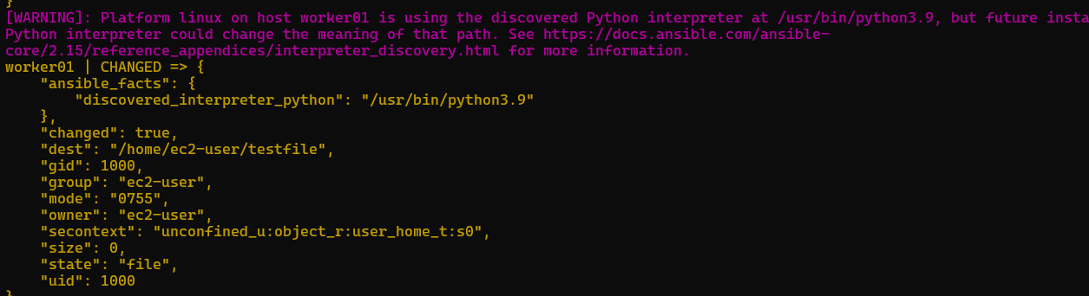
Install HTTPD
(For Amazon Linux 2023 use dnf)
ansible all -m dnf -a "name=httpd state=present" -b -i ansible_hosts
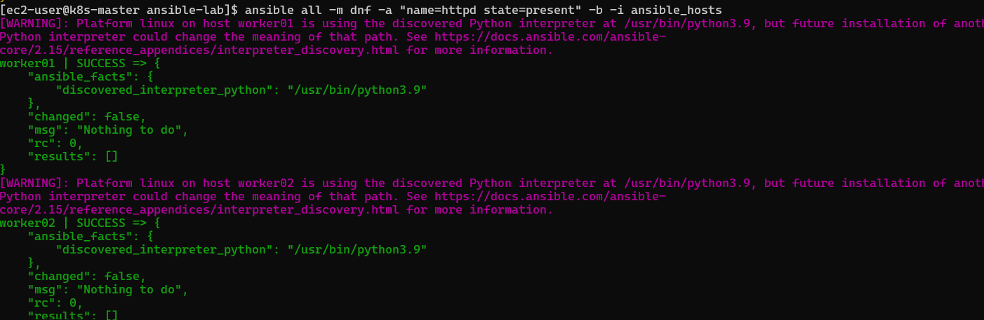
6. Start HTTPD service
ansible all -m service -a "name=httpd state=started enabled=yes" -b -i ansible_hosts
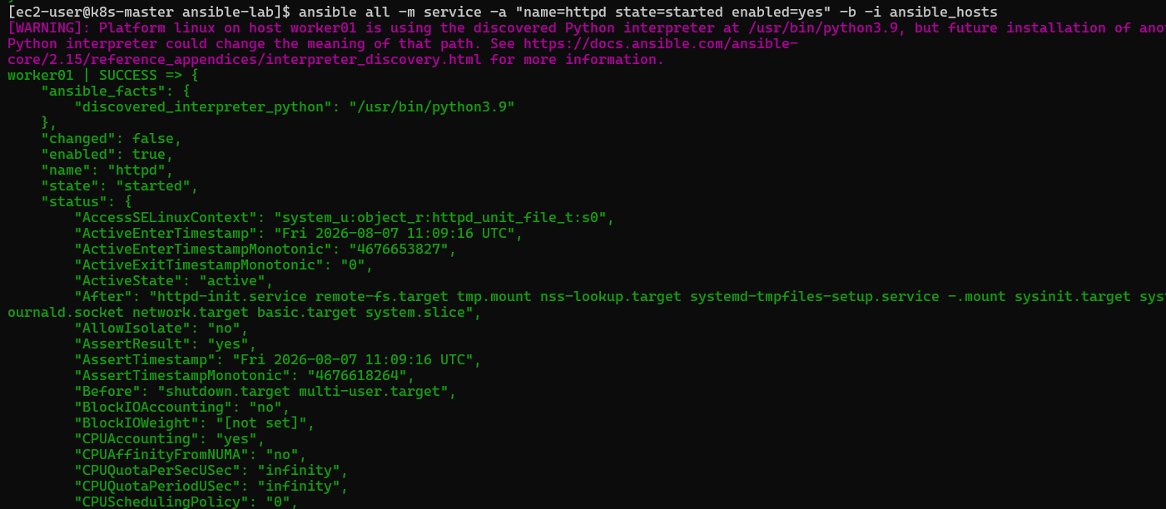

Great 👍 Your Ansible assignment is completed successfully. ✅🎉
Final completion status:
Task | Status
Create Ansible Master EC2 | ✅ Completed
Create 2 Worker EC2 nodes | ✅ Completed
Install Ansible on Master | ✅ Completed
Configure SSH key-based authentication | ✅ Completed
Connect Master → Worker01 | ✅ Completed
Connect Master → Worker02 | ✅ Completed
Create Ansible inventory (ansible_hosts) | ✅ Completed
Test connectivity using ansible ping | ✅ Completed
Execute hostname command | ✅ Completed
Execute uptime command | ✅ Completed
Gather worker facts (setup module) | ✅ Completed
Check memory usage (free -m) | ✅ Completed
Create user/group/file using Ansible modules | ✅ Completed
Install package using Ansible | ✅ Completed
Start/stop service using Ansible | ✅ Completed
What you learned:
- How Ansible works with a Control Node (Master) and Managed Nodes (Workers)
- SSH key-based authentication for automation
- Inventory file management
- Ansible ad-hoc commands
- Common Ansible modules:
  - ping
  - setup
  - shell
  - file
  - user
  - group
  - dnf/yum
  - service
- Using privilege escalation (-b) to execute commands as root
Final Architecture:
Ansible Master
k8s-master EC2
|
SSH Key Authentication
|
-------------------------
| |
Worker01 Worker02
172.31.0.40 172.31.12.116
k8s-Worker01 k8s-Worker02
You can now confidently mention this as a completed DevOps hands-on task:
"Configured Ansible Master-Worker architecture on AWS EC2 and executed Ansible ad-hoc automation commands for remote management." ✅

