  - KUBERNETES LAB DOCUMENTATION

K8S-01: Cluster Setup and Nginx Deployment
Minikube on Windows + One Control Plane and Two Workers on AWS

Task | Result
1. Set up Minikube locally | Completed
2. Set up one control plane and two workers | Completed
3. Run and test one Nginx pod | Completed
4. Learn control-plane and worker components | Covered

Implementation note The assignment originally mentioned Ubuntu. The completed AWS lab used Amazon Linux 2023, so this corrected guide uses dnf-based Amazon Linux commands throughout.

Prepared by: Mohd Abdul Wasif
Date: 20 July 2026

1. Objective
To build and validate two Kubernetes learning environments: a local single-node Minikube cluster on Windows, and a self-managed three-node Kubernetes cluster on AWS using one control-plane node and two worker nodes. The lab also deploys an Nginx pod and reviews the major Kubernetes components.

2. Prerequisites

Local machine
- Windows 10 or 11 with virtualization enabled
- At least 2 CPU cores, 4 GB available RAM, and 20 GB free disk space
- Docker Desktop installed and running
- Minikube and internet access

AWS environment
- AWS account and EC2 permissions
- Three Amazon Linux 2023 instances in the same VPC
- Recommended lab sizing: control plane with at least 2 vCPU/4 GB RAM; workers with at least 2 GB RAM
- One key pair, one shared security group, and outbound internet access
- SSH allowed only from the administrator’s public IP

Lab node plan
Node | Private IP | Role
k8s-master | 172.31.3.254 | Control plane
k8s-worker01 | 172.31.0.40 | Worker
k8s-worker02 | 172.31.12.116 | Worker

Security Never place access keys, private keys, bootstrap tokens, or unrestricted All Traffic rules in screenshots or final documentation.

3. Task 1 — Set Up Minikube Locally

3.1 Verify Docker Desktop
docker version
The output must include both Client and Server sections. A missing Server section means Docker Desktop’s Linux engine is not running.
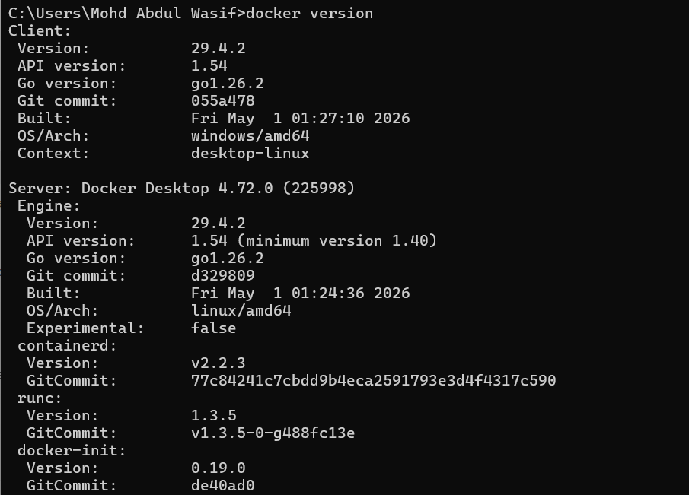
Figure 1. Docker client and Docker Desktop server are available.

3.2 Install Minikube
winget install Kubernetes.minikube
minikube version
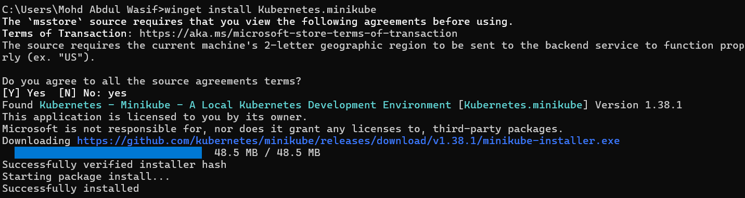
Figure 2. Minikube installed successfully with Windows Package Manager.

3.3 Start and verify Minikube
minikube delete --all
minikube config unset driver
minikube start --driver=docker --cpus=2 --memory=4096
minikube status
minikube kubectl -- get nodes
minikube kubectl -- get pods -A
Figure 3. Minikube node reports Ready.
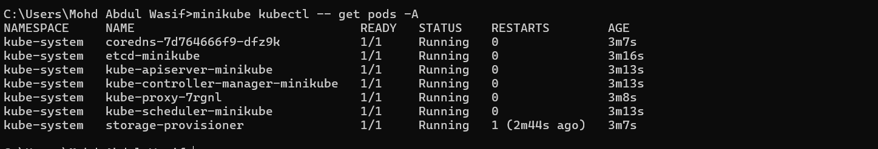
Figure 4. Minikube system pods are Running.

4. Task 3 — Run and Test an Nginx Pod in Minikube
minikube kubectl -- run nginx-pod --image=nginx:alpine
minikube kubectl -- get pods -o wide
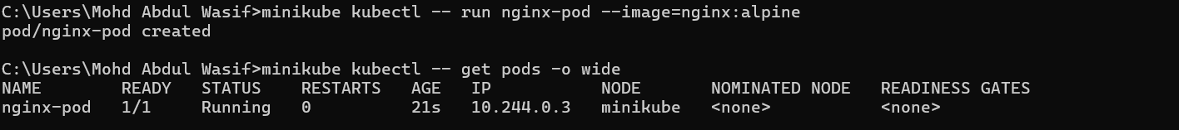
Figure 5. The Nginx pod is Running inside Minikube.

Access the application
minikube kubectl -- port-forward pod/nginx-pod 8080:80
Keep the terminal open and browse to http://localhost:8080. The blinking cursor means port forwarding is active.
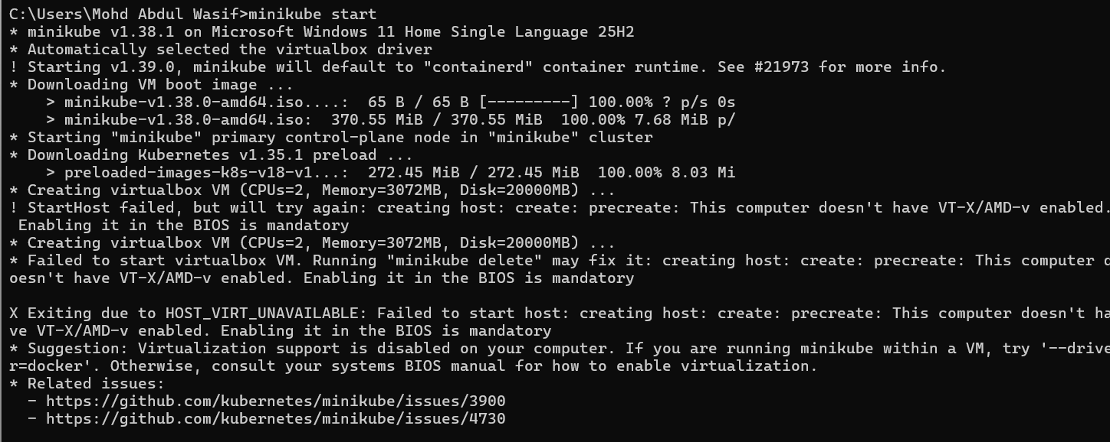
Figure 6. Nginx welcome page opened successfully on localhost:8080.
Result Minikube and the local Nginx pod were successfully tested.

5. Task 2 — Build the AWS Kubernetes Cluster

5.1 Create the three EC2 nodes
Node | Operating system | Recommended capacity
k8s-master | Amazon Linux 2023 | 2 vCPU / 4 GB RAM
k8s-worker01 | Amazon Linux 2023 | 2 vCPU / 2 GB RAM
k8s-worker02 | Amazon Linux 2023 | 2 vCPU / 2 GB RAM

- Place all nodes in the same VPC.
- Attach the same security group to every node.
- Use at least 15 GB gp3 storage per node.
- Stop or terminate instances after the lab to avoid unnecessary cost.
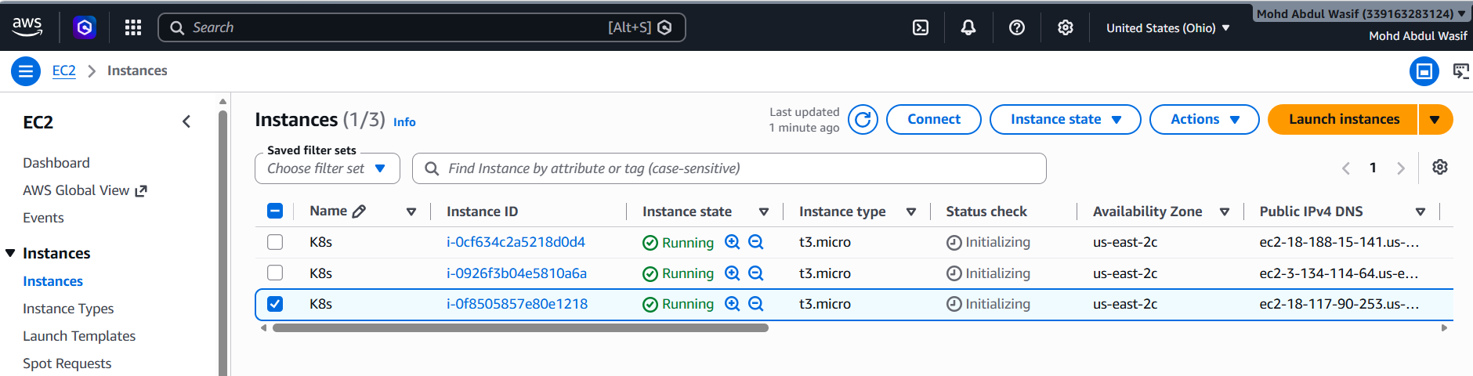
Figure 7. Three EC2 instances created for the Kubernetes cluster.

5.2 Configure the security group
Type | Port | Source
SSH | 22 | Administrator public IP /32
All traffic | All | The same Kubernetes security group

Important Do not use All traffic from 0.0.0.0/0. The self-referencing rule permits only the cluster nodes to communicate freely.

5.3 Connect and configure hostnames
ssh -i "Ohio.pem" ec2-user@MASTER_PUBLIC_IP
# Master
sudo hostnamectl set-hostname k8s-master
# Worker 1
sudo hostnamectl set-hostname k8s-worker01
# Worker 2
sudo hostnamectl set-hostname k8s-worker02
exec bash

Configure name resolution on every node
sudo tee -a /etc/hosts >/dev/null <<EOF
172.31.3.254 k8s-master
172.31.0.40 k8s-worker01 k8s-worker1
172.31.12.116 k8s-worker02 k8s-worker2
EOF
ping -c 2 k8s-master
ping -c 2 k8s-worker01
ping -c 2 k8s-worker02
Expected Each ping should show 0% packet loss. Hostnames are case-sensitive.

5.4 Prepare all three nodes
Run every command in this subsection on the master and both workers.

Update packages and disable swap
sudo dnf update -y
sudo swapoff -a
free -h

Load kernel modules
sudo modprobe overlay
sudo modprobe br_netfilter
sudo tee /etc/modules-load.d/k8s.conf >/dev/null <<EOF
overlay
br_netfilter
EOF

Enable forwarding and bridged traffic
sudo tee /etc/sysctl.d/k8s.conf >/dev/null <<EOF
net.bridge.bridge-nf-call-iptables = 1
net.bridge.bridge-nf-call-ip6tables = 1
net.ipv4.ip_forward = 1
EOF
sudo sysctl --system
sudo sysctl -w net.ipv4.ip_forward=1
sysctl net.ipv4.ip_forward
Required result net.ipv4.ip_forward must equal 1 on all three nodes.

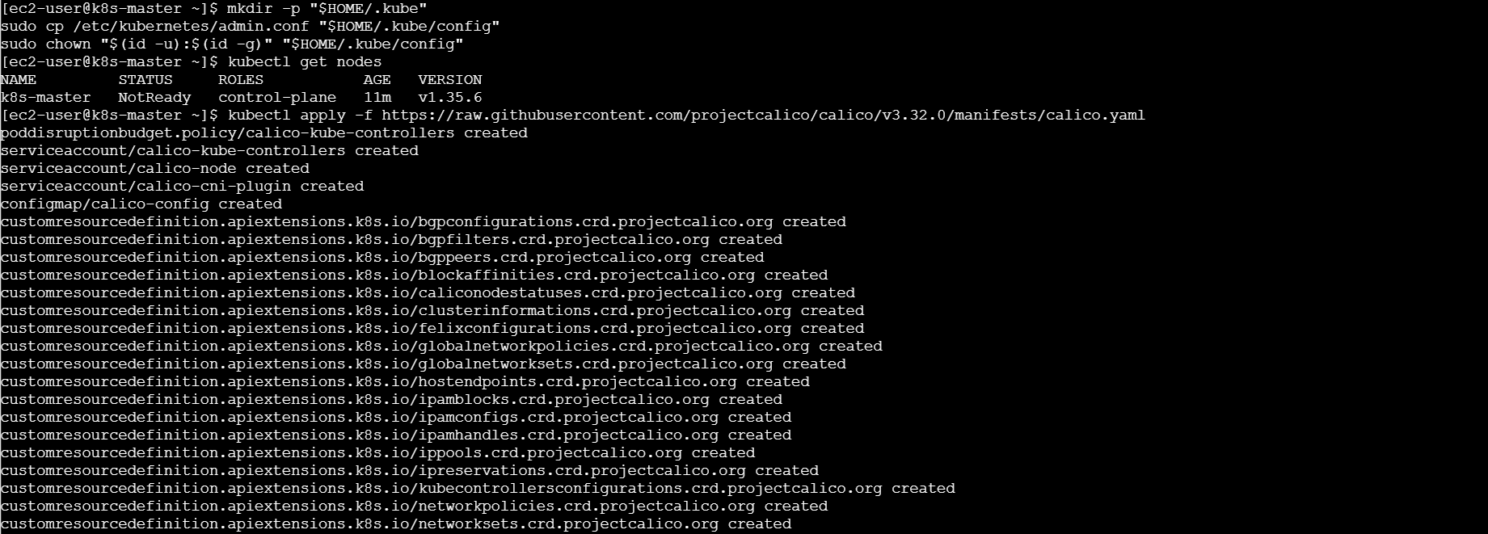
Figure 8. Worker networking modules and containerd verification.

5.5 Install and configure containerd
sudo dnf install -y containerd
sudo mkdir -p /etc/containerd
containerd config default | sudo tee /etc/containerd/config.toml >/dev/null
sudo sed -i 's/SystemdCgroup = false/SystemdCgroup = true/' /etc/containerd/config.toml
sudo systemctl enable --now containerd
sudo systemctl restart containerd
grep SystemdCgroup /etc/containerd/config.toml
sudo systemctl is-active containerd
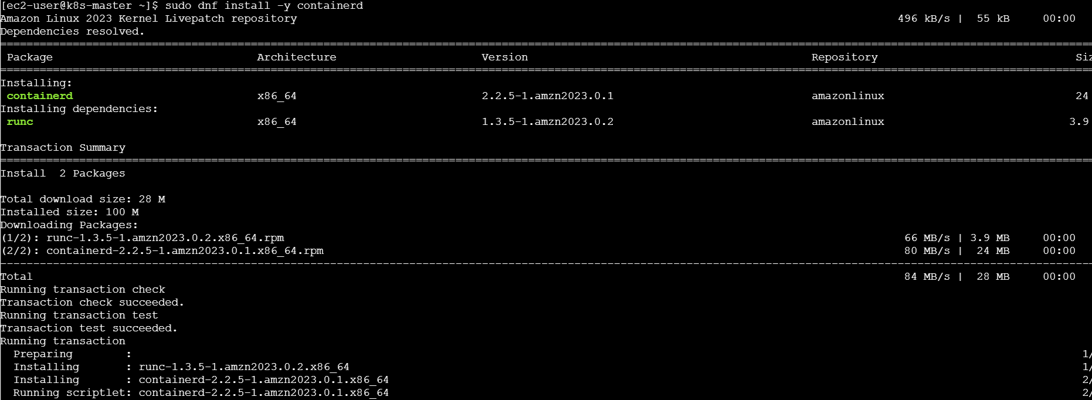
Figure 9. Containerd installation completed.
Expected SystemdCgroup = true and containerd status = active.

Optional CRI check
sudo dnf install -y cri-tools --disableexcludes=kubernetes
sudo tee /etc/crictl.yaml >/dev/null <<EOF
runtime-endpoint: unix:///run/containerd/containerd.sock
image-endpoint: unix:///run/containerd/containerd.sock
timeout: 10
debug: false
EOF
sudo crictl info

5.6 Install Kubernetes packages
sudo tee /etc/yum.repos.d/kubernetes.repo >/dev/null <<EOF
[kubernetes]
name=Kubernetes
baseurl=https://pkgs.k8s.io/core:/stable:/v1.35/rpm/
enabled=1
gpgcheck=1
gpgkey=https://pkgs.k8s.io/core:/stable:/v1.35/rpm/repodata/repomd.xml.key
exclude=kubelet kubeadm kubectl cri-tools kubernetes-cni
EOF
sudo dnf install -y kubelet kubeadm kubectl --disableexcludes=kubernetes
sudo systemctl enable --now kubelet
kubeadm version
kubelet --version
kubectl version --client
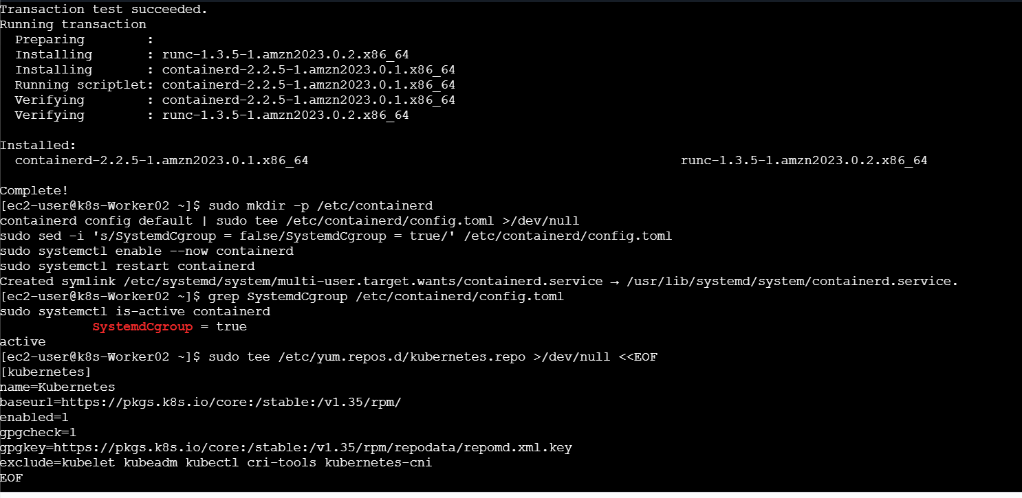
Figure 10. kubeadm, kubelet, and kubectl installed at v1.35.6.
Tool | Purpose
kubeadm | Initializes and joins cluster nodes
kubelet | Runs and monitors pods on each node
kubectl | Sends administrative requests to the API server

5.7 Initialize the control plane
Run only on k8s-master.
sudo systemctl is-active containerd
sysctl net.ipv4.ip_forward
free -h
sudo kubeadm init \
--apiserver-advertise-address=172.31.3.254 \
--pod-network-cidr=192.168.0.0/16 \
--cri-socket=unix:///run/containerd/containerd.sock
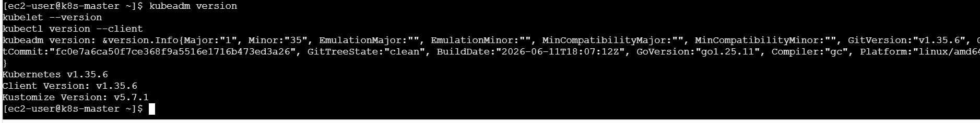
Figure 11. kubeadm initializes the Kubernetes control plane.
Important Run kubeadm init only once. If the first run succeeds, do not rerun it and do not reset the master.

Configure kubectl
mkdir -p "$HOME/.kube"
sudo cp /etc/kubernetes/admin.conf "$HOME/.kube/config"
sudo chown "$(id -u):$(id -g)" "$HOME/.kube/config"
kubectl get nodes

5.8 Install Calico networking
kubectl apply -f https://raw.githubusercontent.com/projectcalico/calico/v3.32.0/manifests/calico.yaml
kubectl get pods -n kube-system -w
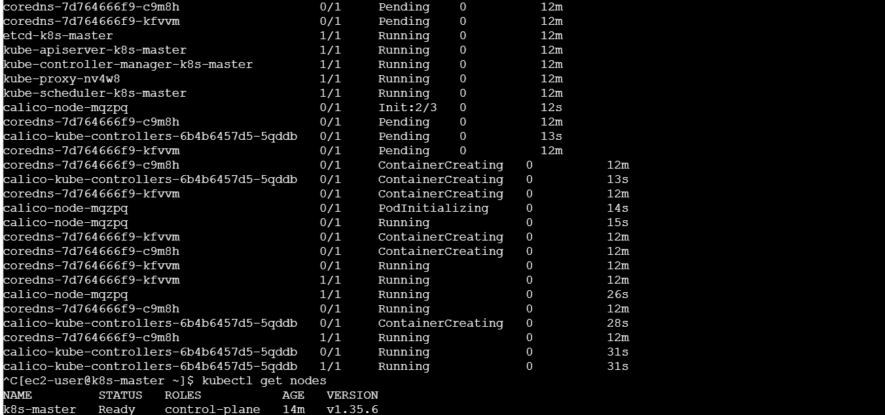
Figure 12. Calico networking resources created.
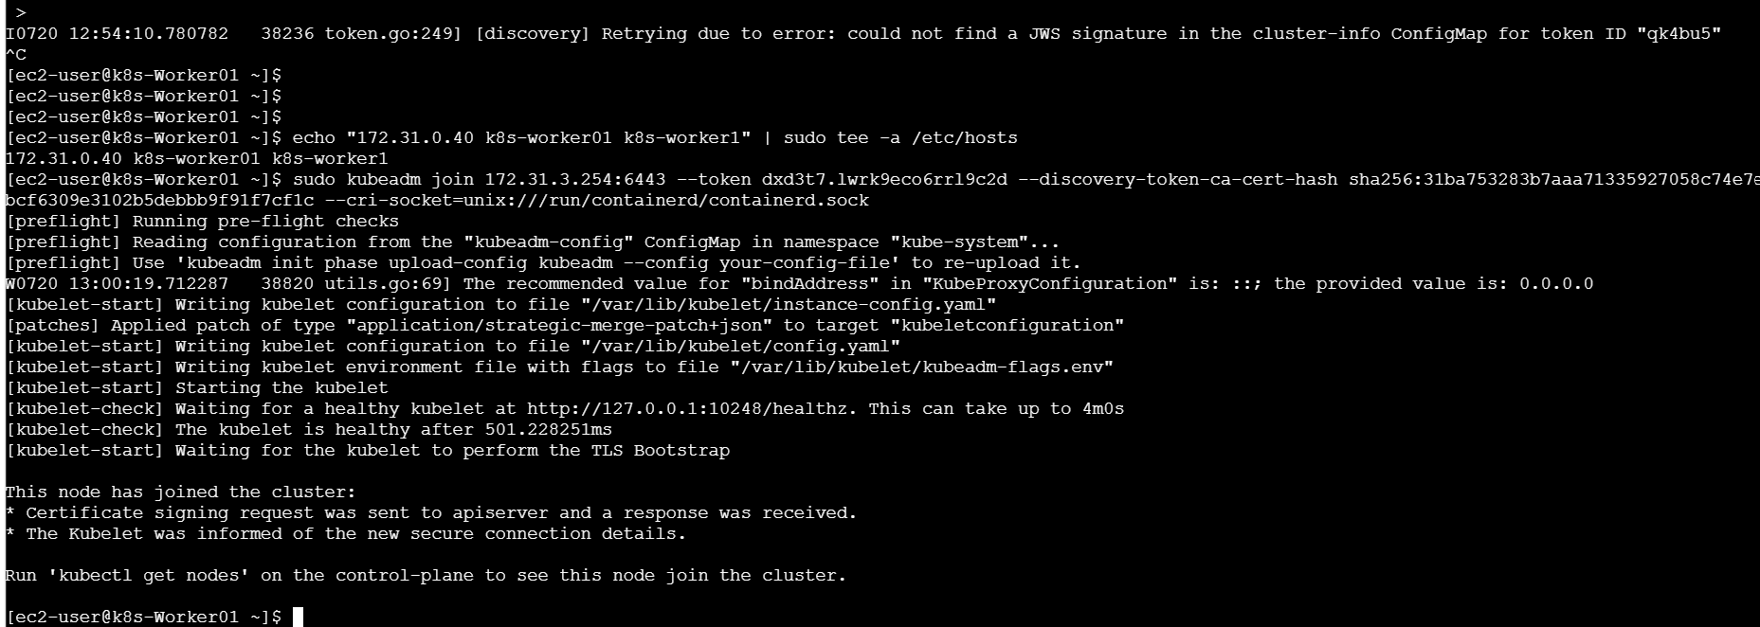
Figure 13. Calico and CoreDNS become Running; the master becomes Ready.
Press Ctrl+C after the networking pods become Running, then verify:
kubectl get nodes

5.9 Join both workers
Generate a fresh join command on the master. Do not store a real bootstrap token in documentation.
sudo kubeadm token create --ttl 2h --print-join-command
Run the generated command on each worker, adding sudo at the beginning and the containerd socket at the end:
sudo kubeadm join 172.31.3.254:6443 \
--token <generated-token> \
--discovery-token-ca-cert-hash sha256:<generated-hash> \
--cri-socket=unix:///run/containerd/containerd.sock

Verify the completed cluster
kubectl get nodes -o wide
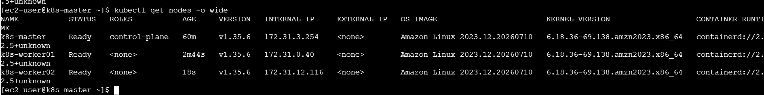
Figure 14. The control plane and both workers are Ready.
Result The three-node self-managed Kubernetes cluster is operational.

6. Run an Nginx Pod on the AWS Cluster
Run on the master:
kubectl run nginx-pod --image=nginx:alpine
kubectl get pods -o wide
kubectl describe pod nginx-pod
The scheduler should place the pod on one of the worker nodes. To test it from the master:
kubectl port-forward pod/nginx-pod 8080:80
Open a second master session and run:
curl http://localhost:8080
Expected The pod shows 1/1 Running and curl returns the Nginx welcome HTML.

Cleanup
kubectl delete pod nginx-pod
sudo kubeadm token list
# Delete any temporary token after workers have joined:
sudo kubeadm token delete <token>

7. Task 4 — Kubernetes Components

Control-plane components
Component | Simple meaning
API Server | Main entry point for kubectl and all Kubernetes API requests.
etcd | Key-value database that stores cluster configuration and state.
Scheduler | Chooses the best worker node for a newly created pod.
Controller Manager | Continuously compares desired and actual state and corrects differences.
Cloud Controller Manager | Integrates Kubernetes with cloud services when configured.

Memory trick A–E–S–C: API Server accepts, etcd stores, Scheduler selects, Controller controls.

Worker-node components
Component | Simple meaning
Kubelet | Node agent that ensures assigned pods are running.
Kube-proxy | Implements Service networking and traffic forwarding.
Containerd | Container runtime that pulls images and runs containers.
Pod | Smallest deployable Kubernetes unit; contains one or more containers.

Memory trick K–K–C–P: Kubelet, Kube-proxy, Containerd, Pod.

Simple working flow
- The user runs a kubectl command.
- The API Server validates and accepts the request.
- etcd stores the desired cluster state.
- The Scheduler selects a worker node.
- The worker’s Kubelet asks containerd to run the pod.
- Kube-proxy handles Service traffic.

8. Major Issues and Correct Fixes
Issue | Cause | Correct fix
Docker API unavailable | Docker Desktop Linux engine was stopped | Start Docker Desktop; confirm docker version shows Client and Server.
Minikube driver mismatch | Old profile used VirtualBox while Docker was requested | minikube delete --all; unset driver; start with --driver=docker.
Ping failed | Security group allowed only SSH | Use self-referencing All traffic rule for the shared cluster security group.
SSH publickey denied | Local PEM did not match authorized key | Verify assigned key pair; repair authorized_keys through EC2 Instance Connect.
kubeadm IP-forward error | net.ipv4.ip_forward was 0 | Set it to 1 persistently and apply sysctl on all nodes.
Ports already in use on master | kubeadm init was run again after success | Do not reinitialize a working control plane.
Invalid join token | Example placeholders or expired token were used | Generate a fresh command with kubeadm token create --print-join-command.
Missing JWS signature | Bootstrap-token signing data was not ready | Run kubeadm init phase bootstrap-token, create a fresh token, and verify cluster-info JWS.
Hostname lookup warning | Hostname differed from /etc/hosts alias | Add exact lowercase node hostname and alias to /etc/hosts.

9. Verification Checklist
Check | Command | Expected result
Minikube | minikube status | host, kubelet, API server running
Local node | minikube kubectl -- get nodes | minikube Ready
AWS nodes | kubectl get nodes -o wide | Three nodes Ready
System pods | kubectl get pods -n kube-system | Core components Running
Nginx | kubectl get pods -o wide | nginx-pod 1/1 Running
Application | curl http://localhost:8080 | Nginx HTML returned

10. What We Learned
- How Minikube provides a fast local Kubernetes learning environment.
- How to build a self-managed Kubernetes cluster using kubeadm.
- Why containerd, systemd cgroups, kernel modules, swap configuration, and IP forwarding are important.
- How the control plane and worker nodes communicate over private VPC networking.
- How Calico provides pod networking.
- How worker nodes join securely using short-lived bootstrap tokens.
- How to create, inspect, and test an Nginx pod.
- How to identify and correct common Kubernetes setup failures.

11. Conclusion
The K8S-01 lab was completed successfully. Minikube was configured on Windows and used to run an Nginx pod. A separate three-node Kubernetes cluster was built on AWS with Amazon Linux 2023, containerd, kubeadm, Calico, one control plane, and two worker nodes. All three AWS nodes reached Ready status, confirming that networking, runtime configuration, certificates, and node registration were working correctly. The lab also established a clear understanding of Kubernetes control-plane and worker-node components.

