Docker- Task
Task 1: Setup a Virtual Machine Using Ubuntu Image
Objective
To launch an Ubuntu virtual machine (EC2 instance) on AWS that will be used for Docker installation and container management.
Prerequisites
- AWS Account
- EC2 Key Pair (.pem file)
- Internet Connection
- Basic AWS EC2 knowledge
Steps
Step 1: Login to AWS Console
- Open AWS Management Console.
- Search for EC2.
- Click Launch Instance.
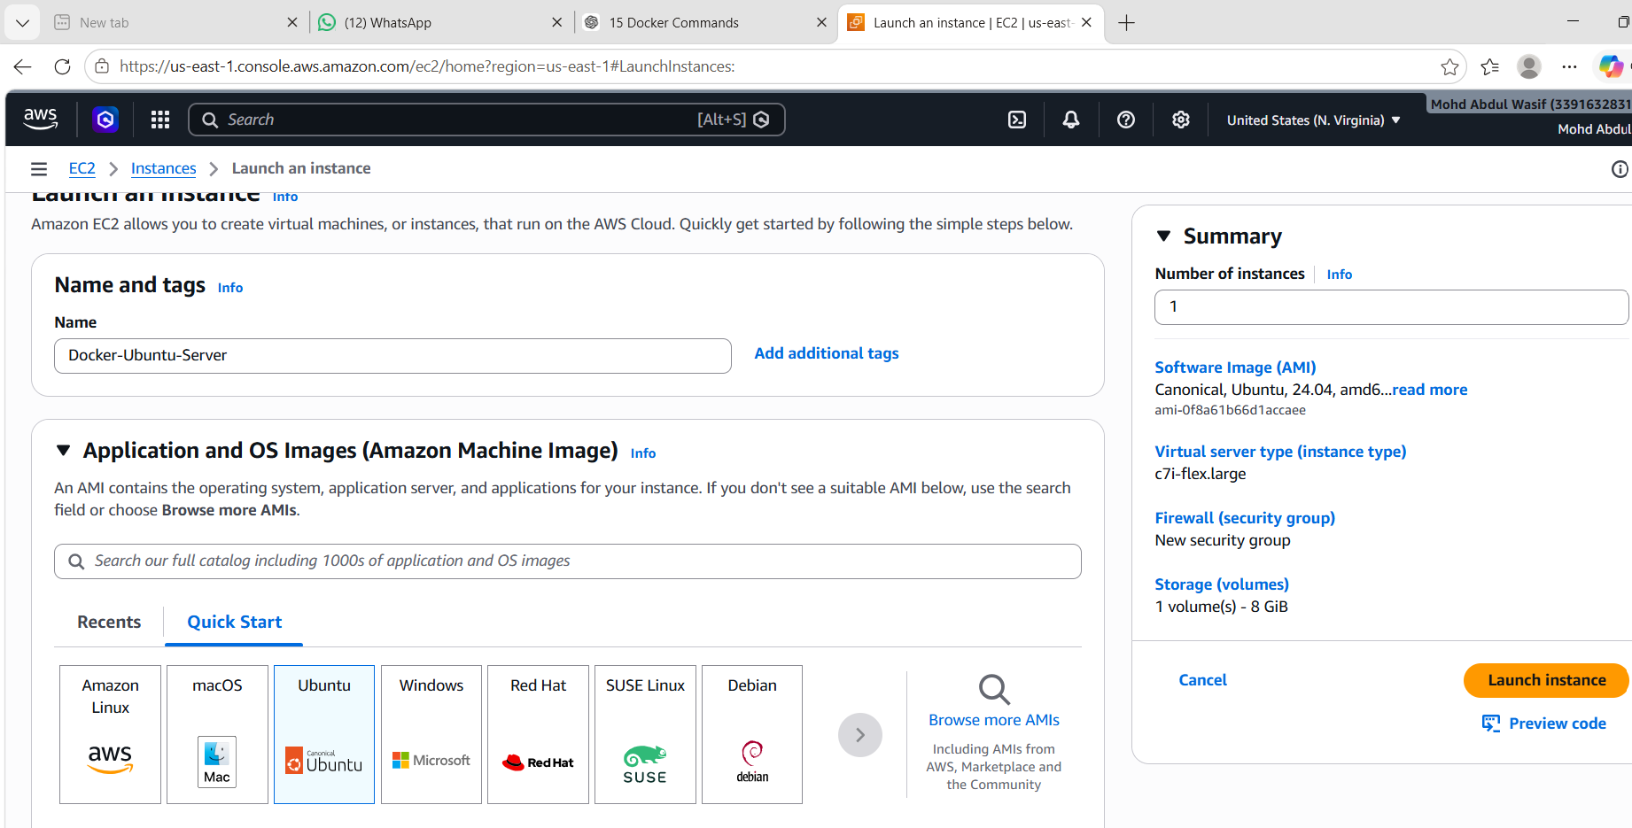
Step 2: Configure Instance
- Name: Docker-Ubuntu-Server
- AMI: Ubuntu Server (Latest LTS)
- Instance Type: t2.medium (or t3.medium)
- Select/Create Key Pair
- Create Security Group
Step 3: Open Required Ports
Port | Purpose
22 | SSH
81 | Nginx
8080 | Jenkins
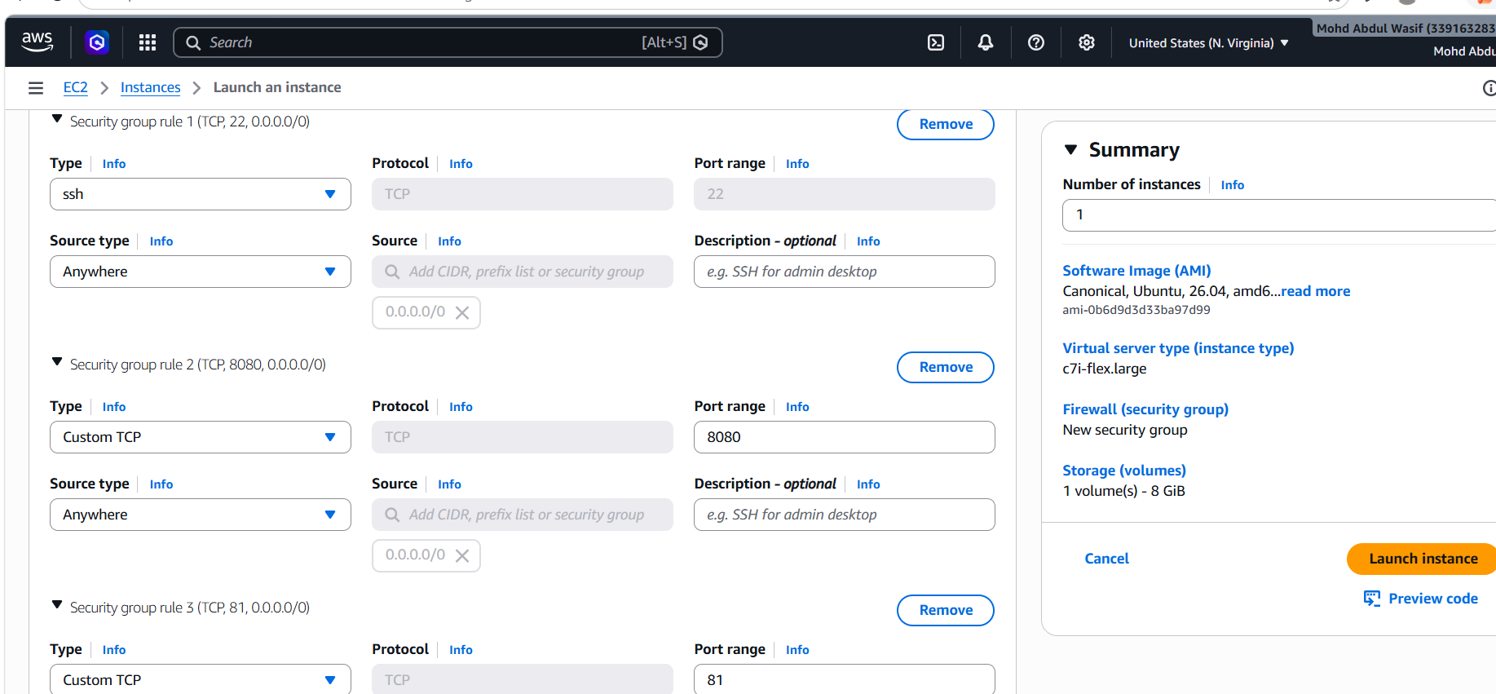
Step 4: Launch Instance
Click Launch Instance.
Step 5: Connect to EC2
ssh -i your-key.pem ubuntu@<Public-IP>
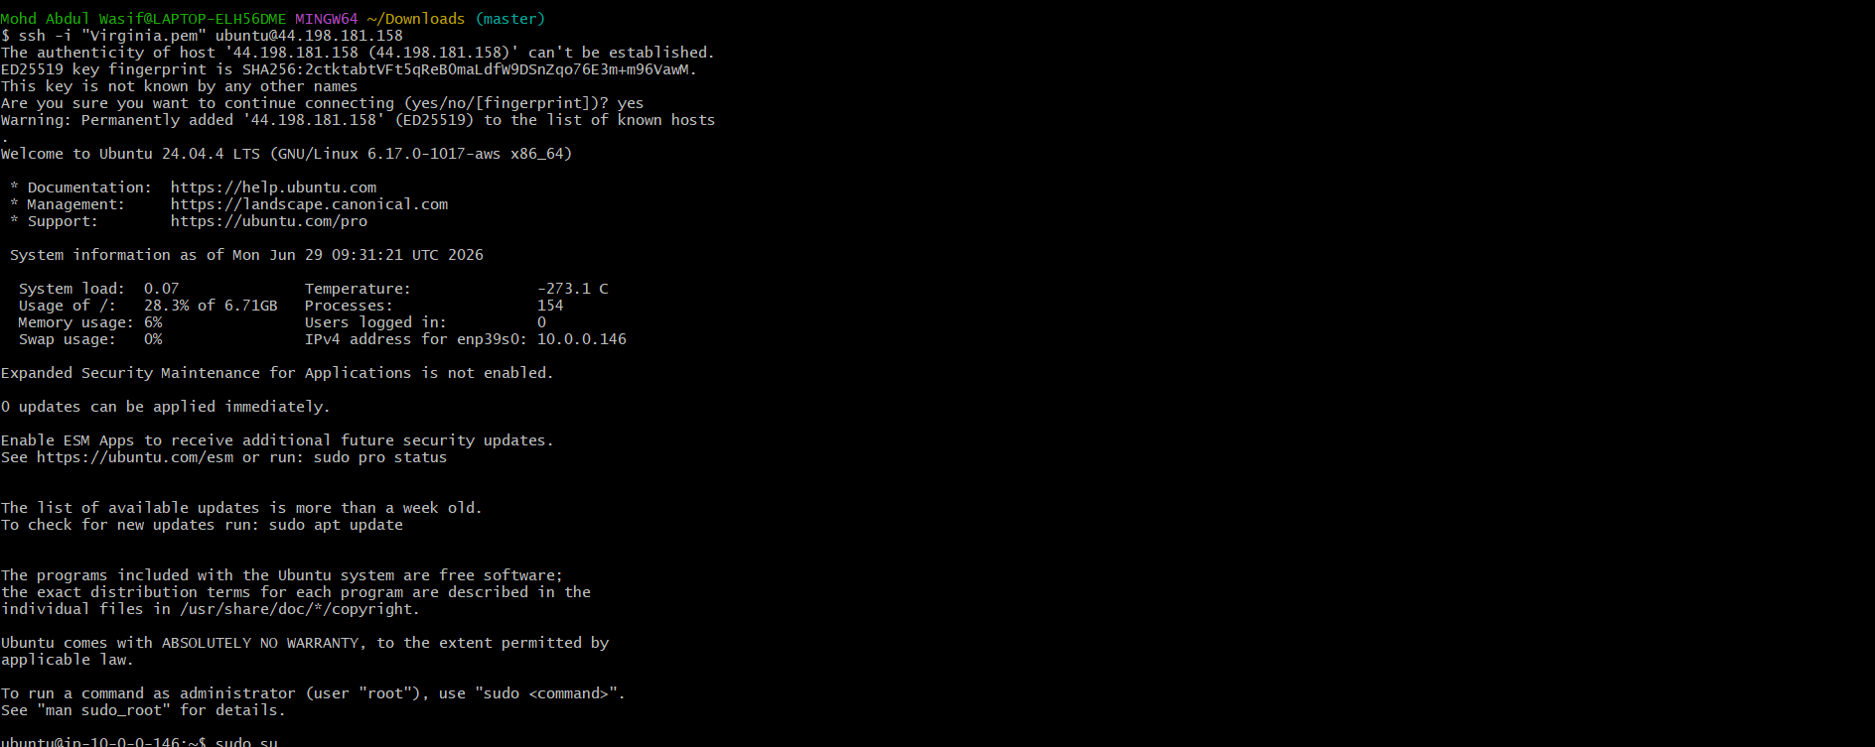
Step 6: Verify Ubuntu Version
lsb_release -a
or
cat /etc/os-release
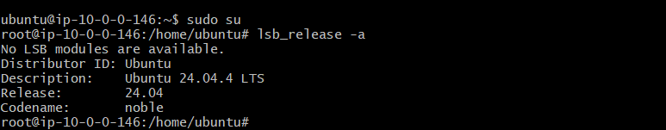

Expected Output
Ubuntu server should be accessible through SSH.

What We Learned
- How to launch an EC2 instance.
- How to select Ubuntu AMI.
- How to configure Security Groups.
- How to connect to EC2 using SSH.

Conclusion
Successfully launched an Ubuntu virtual machine on AWS and connected to it using SSH. This server is now ready for Docker installation.
Task 2: Install Docker on Ubuntu EC2
Objective
Install Docker Engine on the Ubuntu EC2 instance.
Prerequisites
- Ubuntu EC2 running
- SSH access
- Internet connectivity
Steps
Update Packages
sudo apt update -y
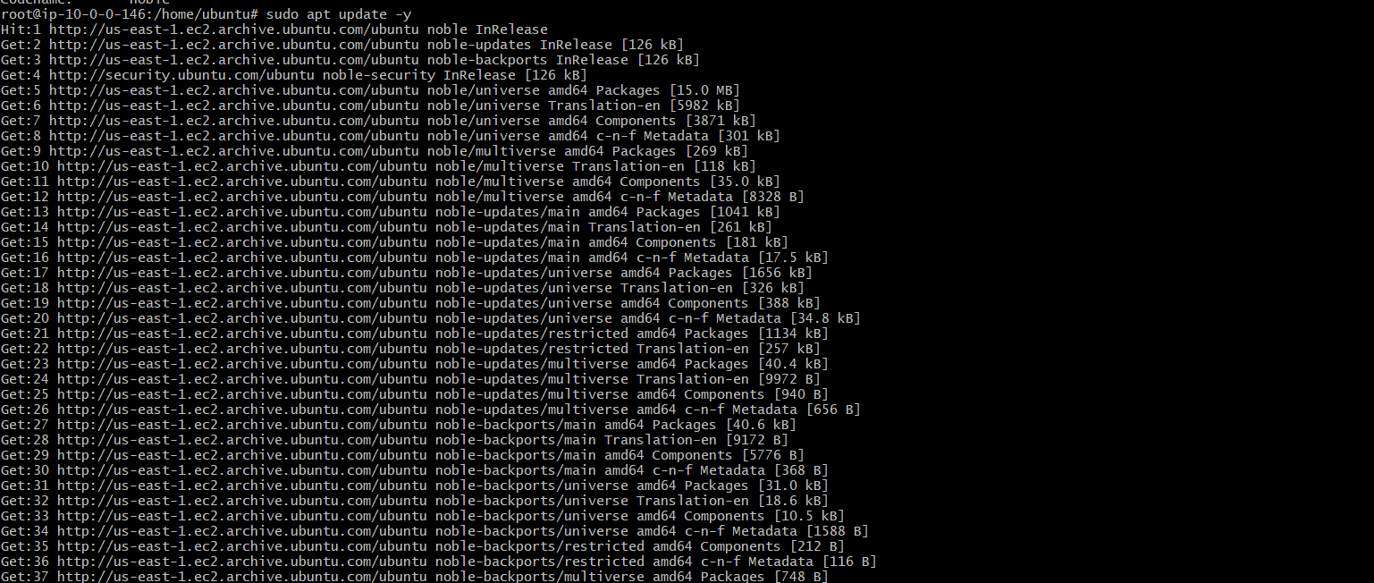
Install Required Packages
sudo apt install ca-certificates curl gnupg -y
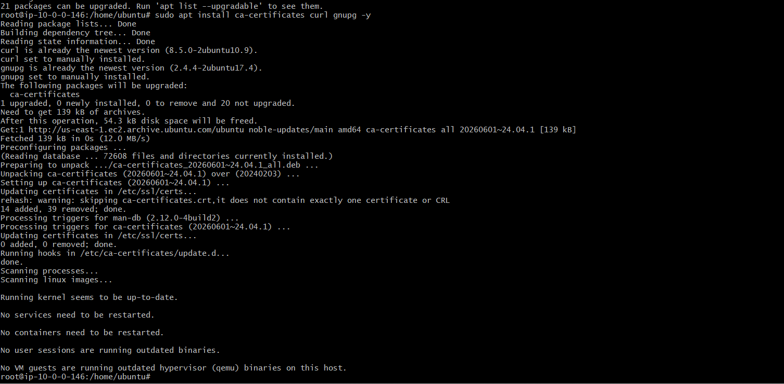
Add Docker Repository
sudo install -m 0755 -d /etc/apt/keyrings
curl -fsSL https://download.docker.com/linux/ubuntu/gpg | sudo gpg --dearmor -o /etc/apt/keyrings/docker.gpg
sudo chmod a+r /etc/apt/keyrings/docker.gpg
Add Docker Repository
echo \
"deb [arch=$(dpkg --print-architecture) signed-by=/etc/apt/keyrings/docker.gpg] https://download.docker.com/linux/ubuntu \
$(. /etc/os-release && echo "$VERSION_CODENAME") stable" | \
sudo tee /etc/apt/sources.list.d/docker.list
Install Docker
sudo apt update
sudo apt install docker-ce docker-ce-cli containerd.io docker-buildx-plugin docker-compose-plugin -y
Start Docker
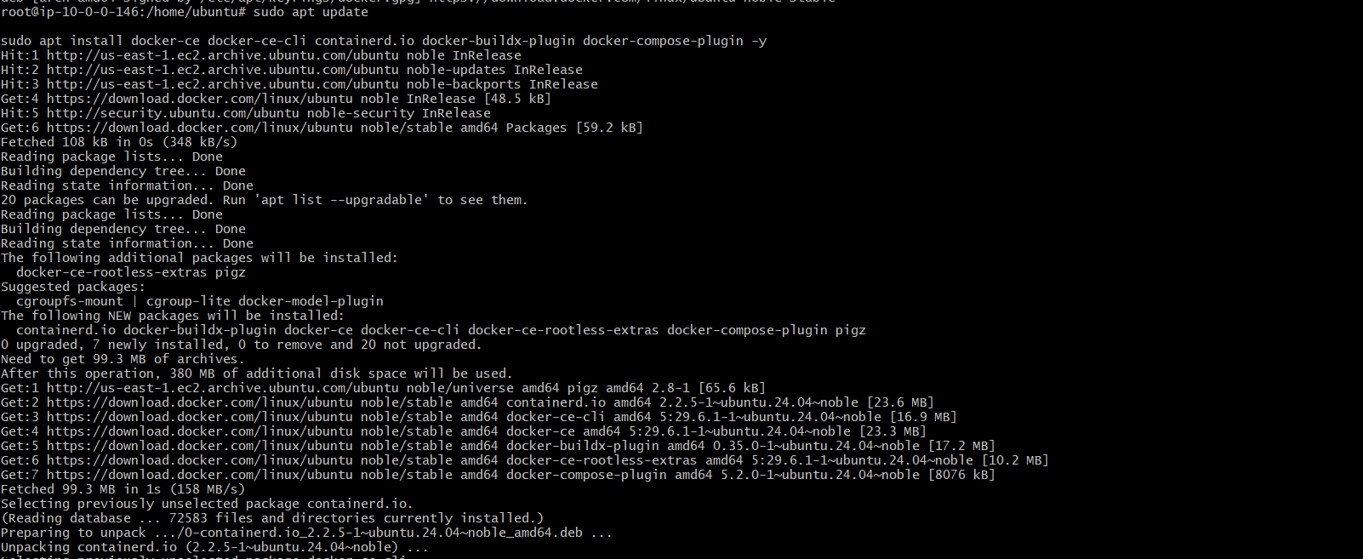
sudo systemctl start docker
sudo systemctl enable docker
Verify Docker
docker --version

What We Learned
- Docker installation on Ubuntu.
- Docker service management.
- Docker version verification.

Conclusion
Docker Engine was installed successfully and is ready to run containers.

Task 3: Pull 5 Docker Images
Objective
Download required Docker images from Docker Hub.
Prerequisites
- Docker Installed
- Internet Connection
Steps
Pull Nginx
docker pull nginx
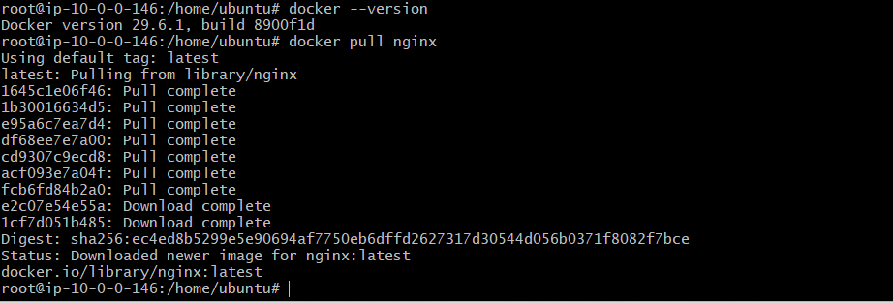
Pull Tomcat
docker pull tomcat
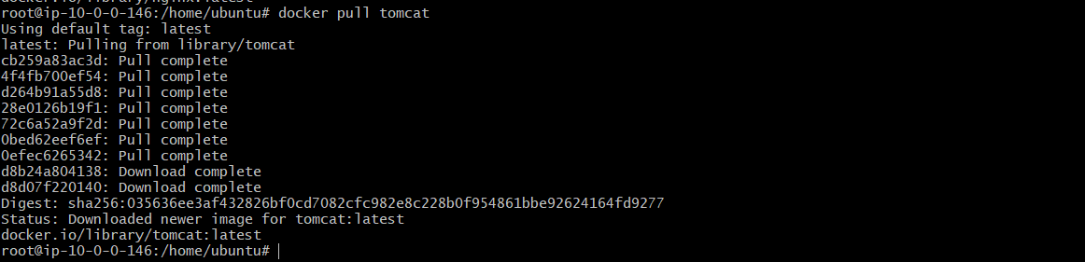
Pull Ubuntu
docker pull ubuntu
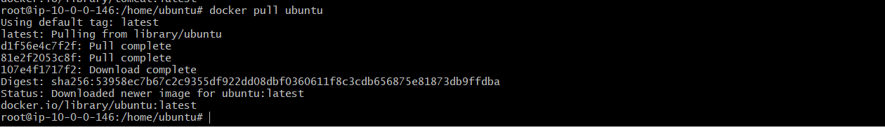

Pull Jenkins
docker pull jenkins/jenkins:lts
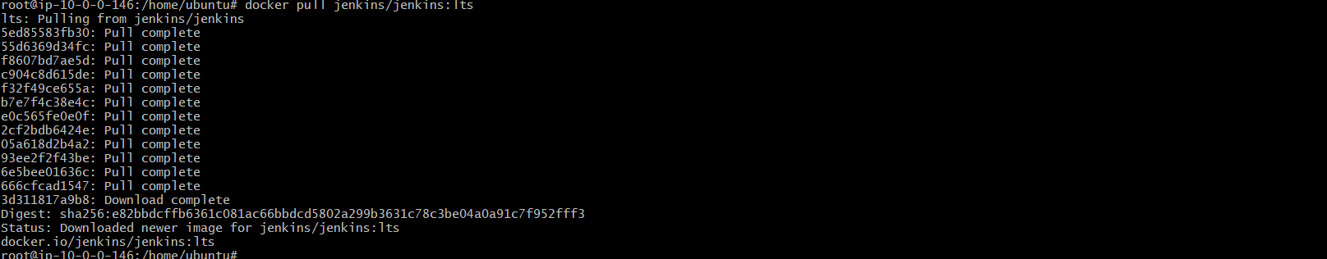
Pull SonarQube
docker pull sonarqube:lts-community
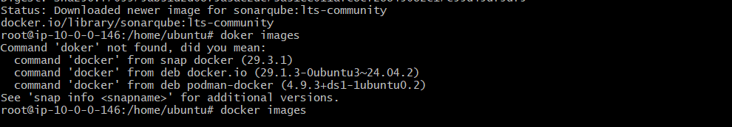
Verify Images
docker images
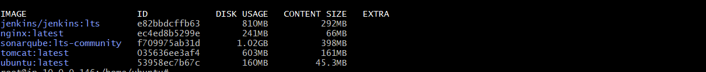

What We Learned
- Pull Docker images.
- Docker Hub usage.
- Verify downloaded images.

Conclusion
Successfully downloaded five Docker images from Docker Hub.

Task 4: Run Nginx Container on Port 81
Objective
Run an Nginx container and expose it using port 81.
Prerequisites
- Nginx image available
Steps
Run Container
docker run -d --name nginx-container -p 81:80 nginx
Verify
docker ps
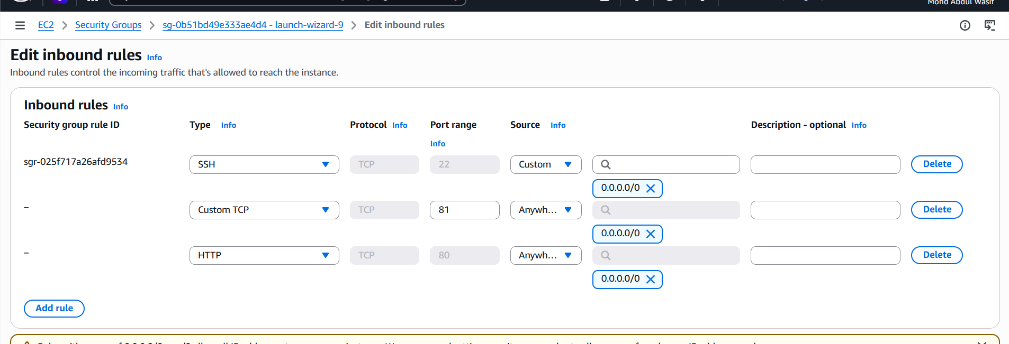
Open Browser
http://<Public-IP>:81
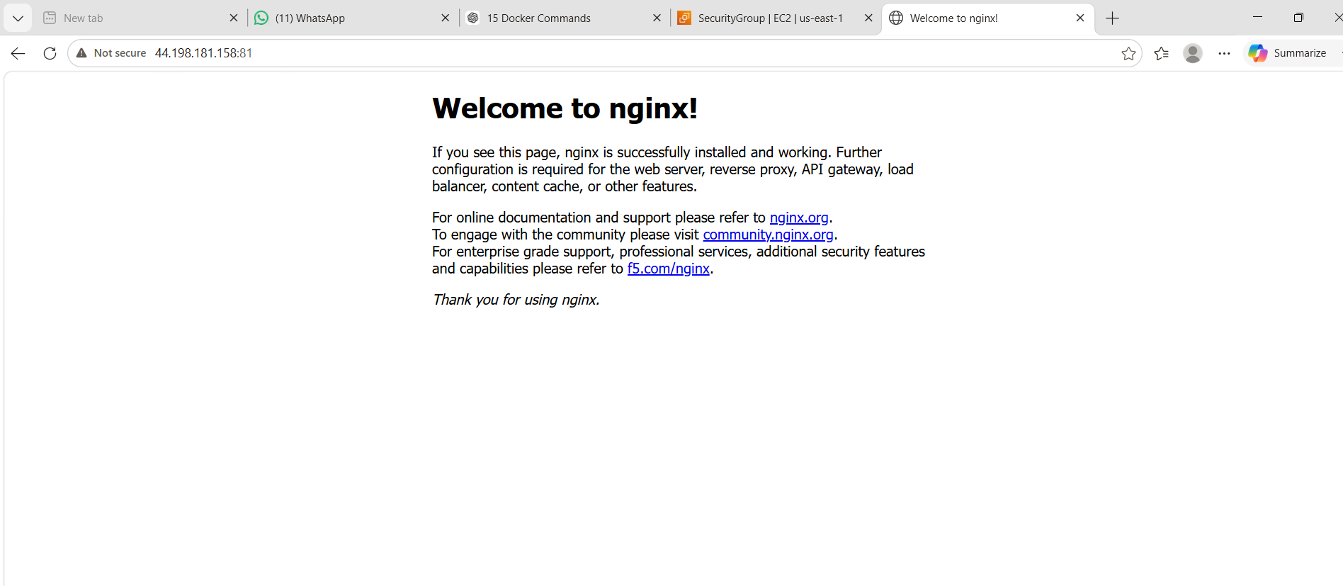

What We Learned
- Container creation.
- Port mapping.
- Container verification.

Conclusion
Successfully deployed an Nginx container on port 81.
Task 5: Delete Apache Tomcat Image
Objective
Remove the Apache Tomcat image from the local Docker repository.
Prerequisites
- Tomcat image downloaded
- No running Tomcat container
Steps
View Images
docker images
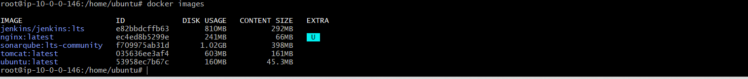
Delete Image
docker rmi tomcat
Verify
docker images
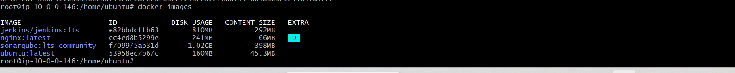

Expected Output
Tomcat image removed successfully.

What We Learned
- Image removal.
- Docker image management.

Conclusion
Successfully removed the Apache Tomcat image from the local Docker repository.
Task 6: Inspect Jenkins and SonarQube Images
Objective
View detailed metadata of Jenkins and SonarQube Docker images.
Prerequisites
- Images already downloaded
Steps
Inspect Jenkins
docker inspect jenkins/jenkins:lts
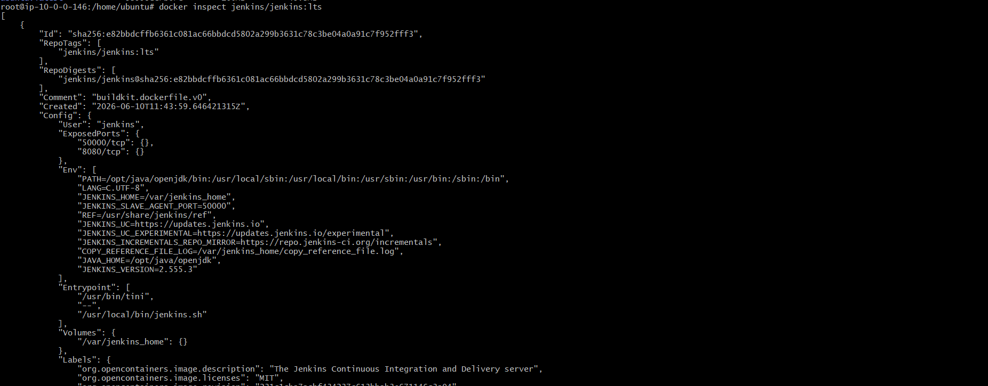
Inspect SonarQube
docker inspect sonarqube:lts-community
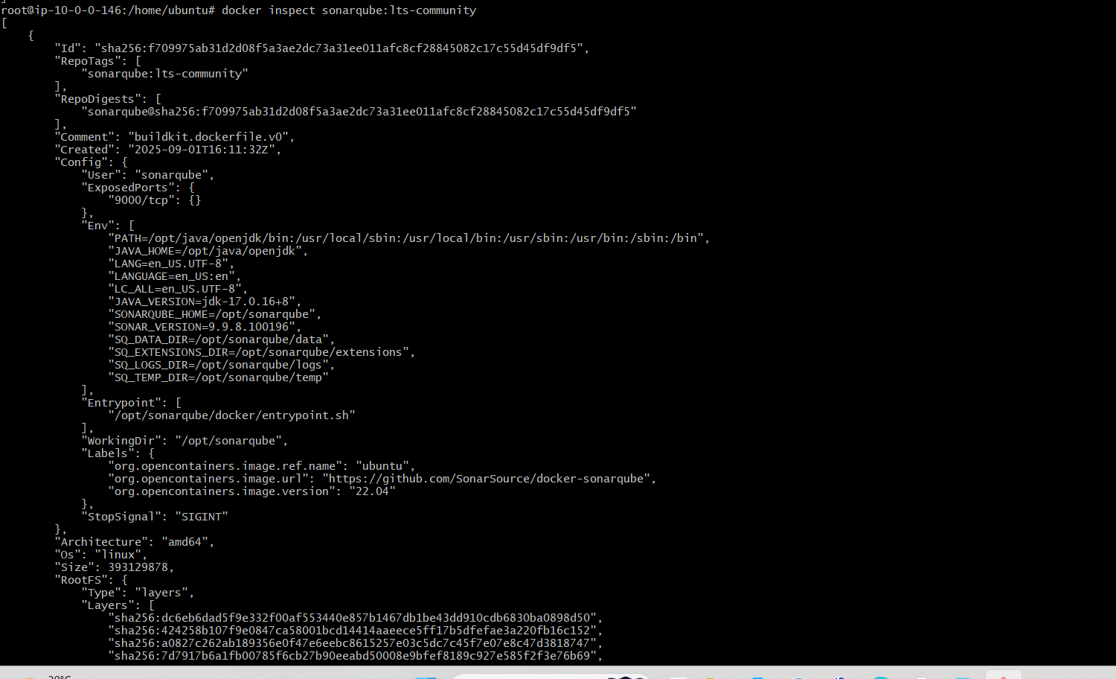

Expected Output
Detailed JSON information about the images.

What We Learned
- Image inspection.
- Docker metadata.
- Image configuration details.

Conclusion
Successfully inspected the Jenkins and SonarQube Docker images and viewed their configuration.

Task 7: Run Jenkins Container and Create One Sample Job
Objective
Run Jenkins in a Docker container and execute a sample Freestyle job.
Prerequisites
- Jenkins image downloaded
- Port 8080 open in Security Group
Steps
Run Jenkins
docker run -d \
--name jenkins-container \
-p 8080:8080 \
-p 50000:50000 \
-v jenkins_home:/var/jenkins_home \
jenkins/jenkins:lts
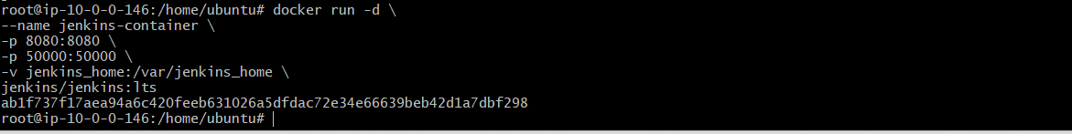

Check Running Container
docker ps
Get Initial Password
docker exec jenkins-container cat /var/jenkins_home/secrets/initialAdminPassword
Open Jenkins
http://<Public-IP>:8080
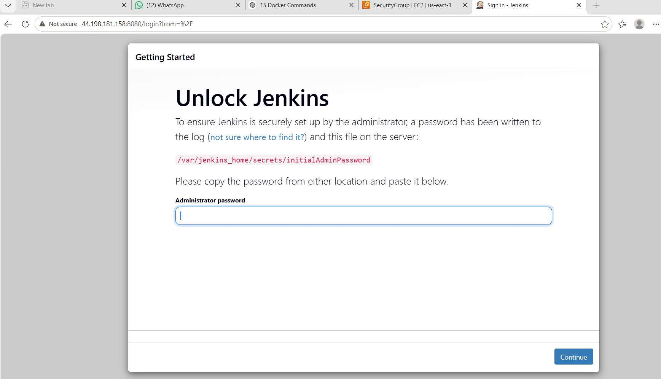
Install Suggested Plugins.
Create Admin User.
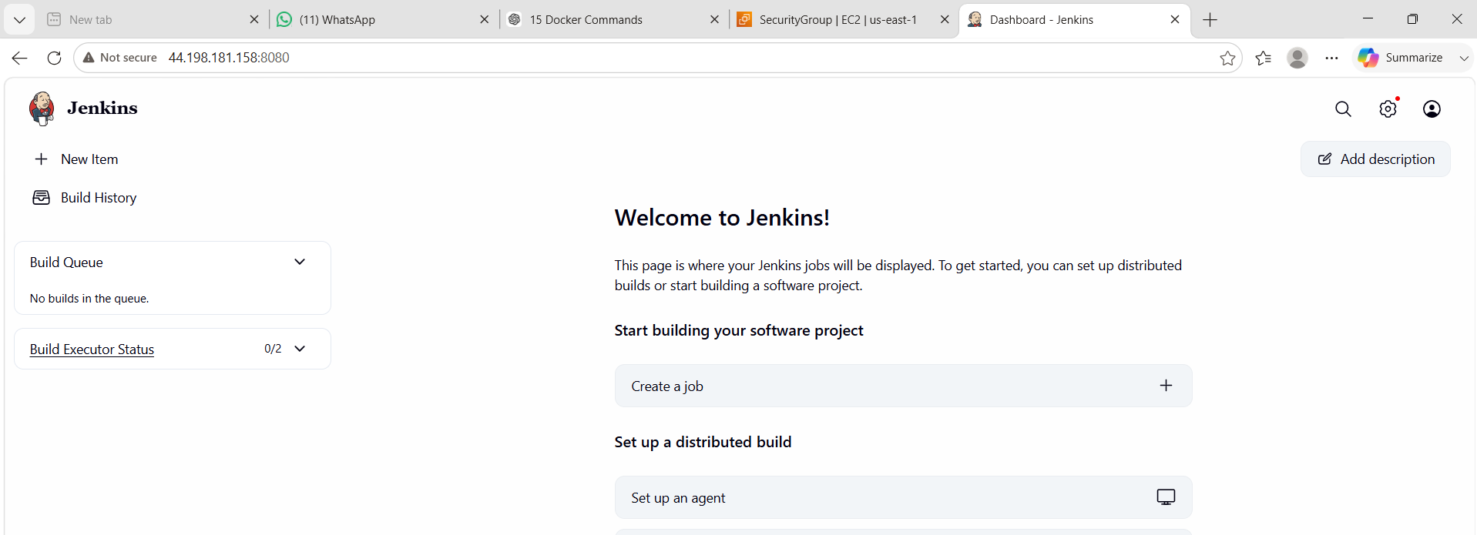
Create Freestyle Project.
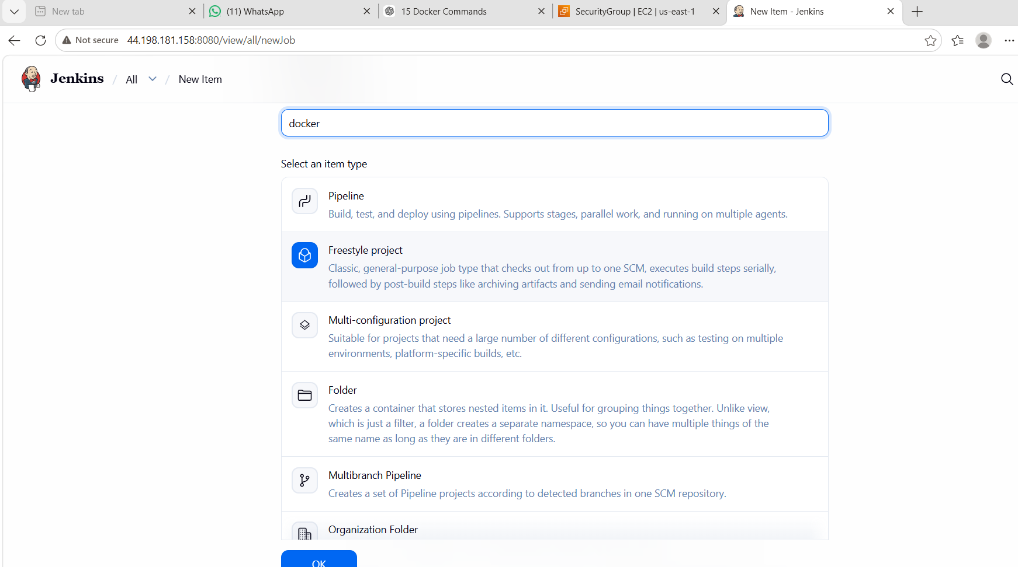
Add Build Step → Execute Shell
echo "Hello Docker Jenkins"
date
hostname
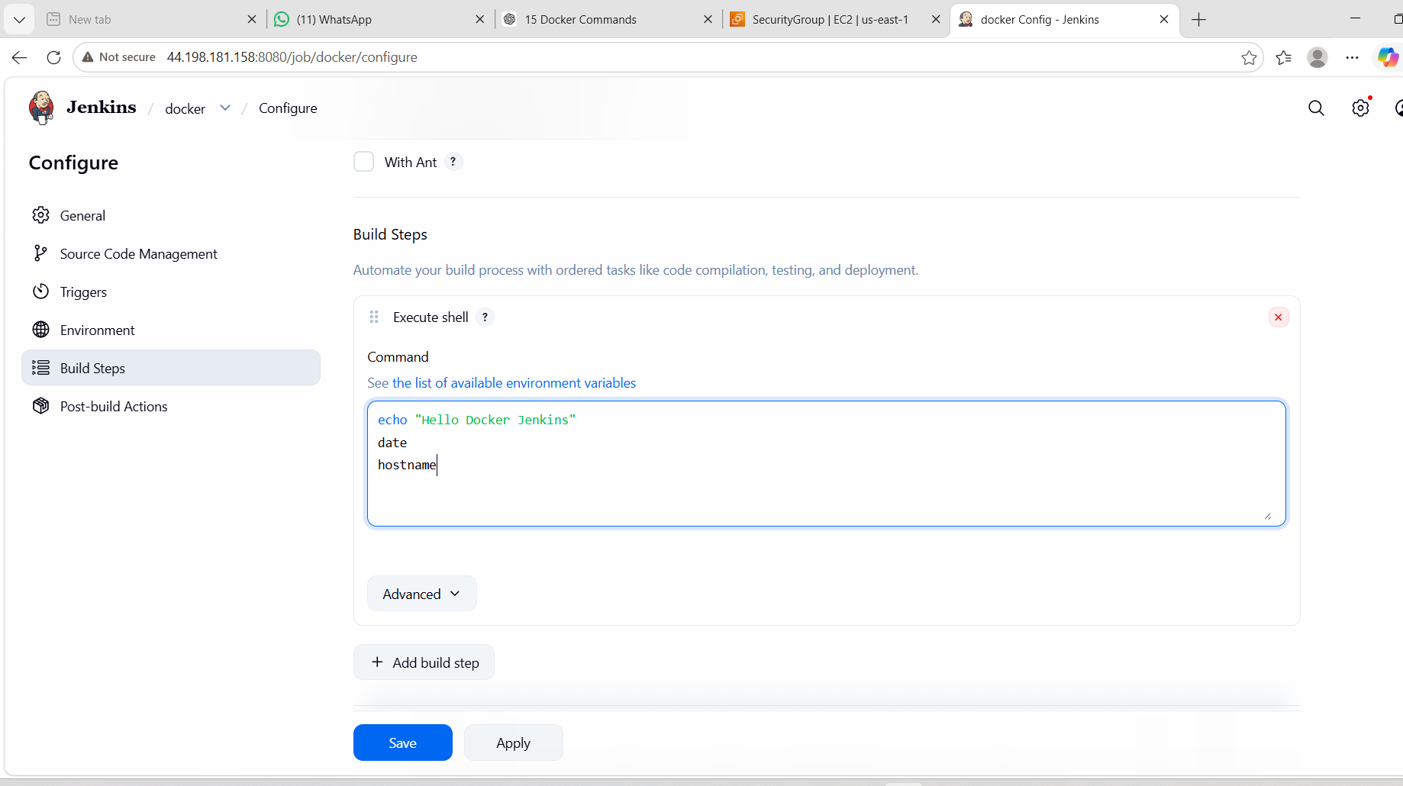
Click Build Now.
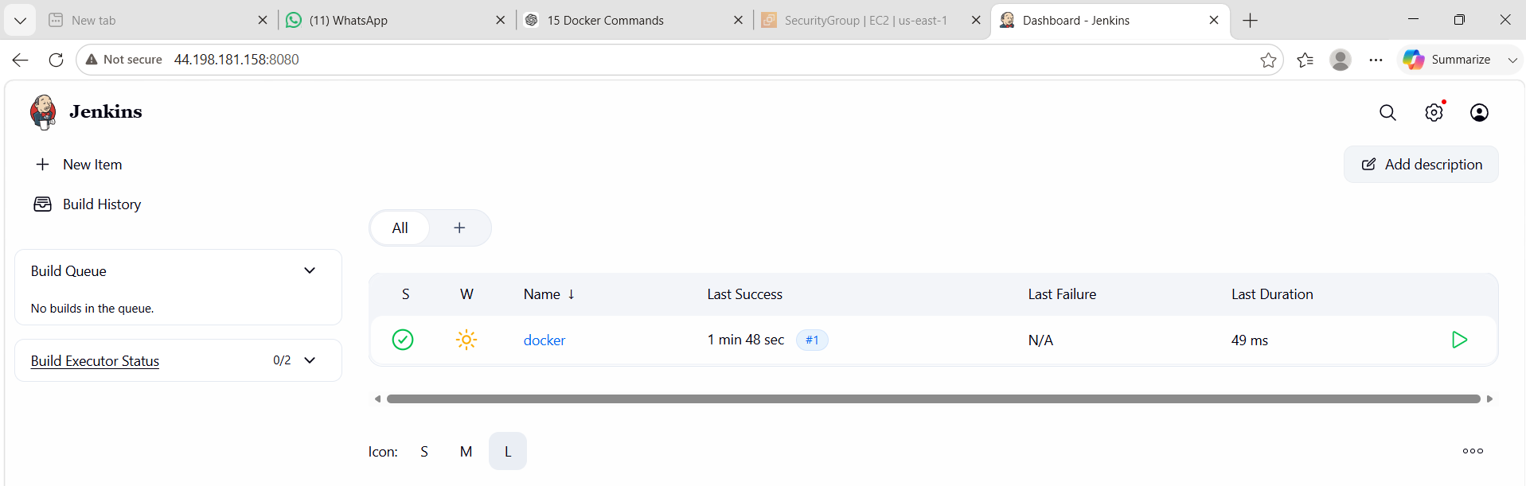
Open Console Output.
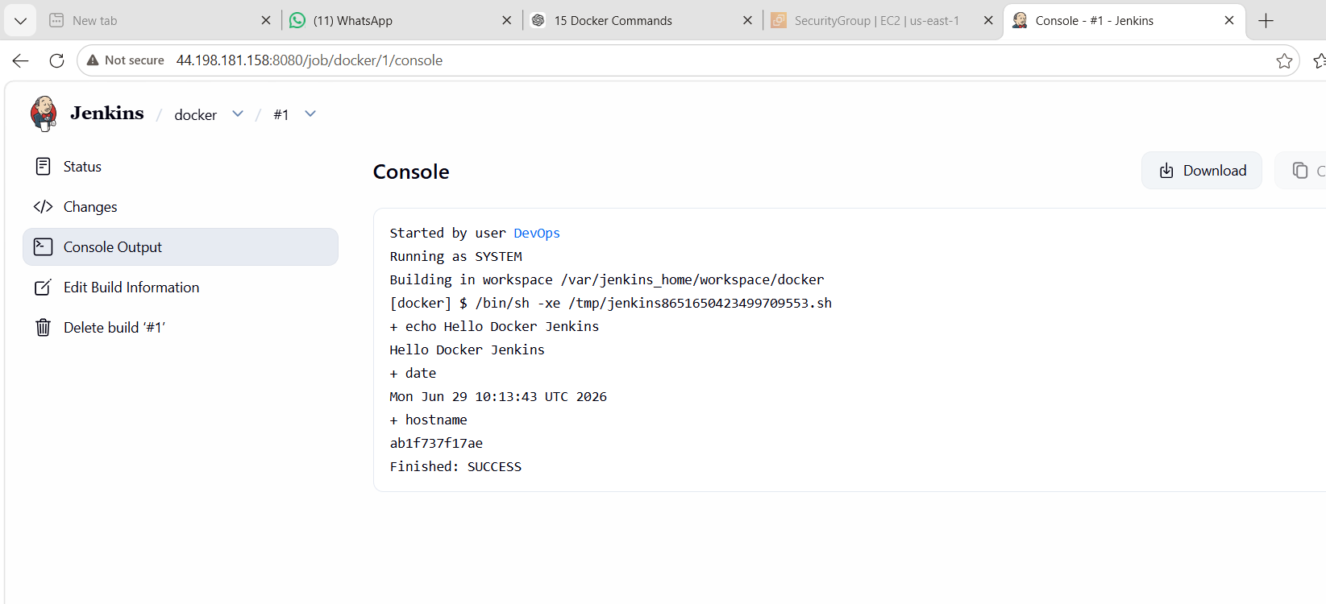

What We Learned
- Running Jenkins in Docker.
- Accessing Jenkins via browser.
- Creating a Freestyle job.
- Executing shell commands through Jenkins.

Conclusion
Successfully deployed Jenkins in a Docker container and executed a sample job, demonstrating the integration of Docker and Jenkins for basic CI automation.

