Jenkins-Final-Task

Task 1 — Declarative Pipeline Job
Objective
Create a Jenkins Declarative Pipeline that:
GitHub
↓
Jenkins
↓
Checkout source code
↓
Build with Maven
↓
Test
↓
Package
Source repository:
spring3-mvc-maven-xml-hello-world-1 on GitHub

Step 1 — Check Java
On your Jenkins server:
java -version
You should have Java installed.
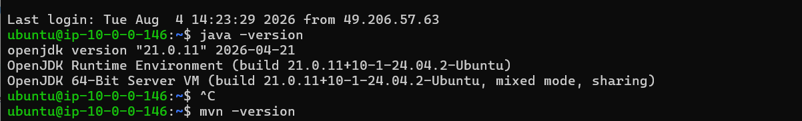
Then check Maven:
mvn -version
If Maven is installed
Continue.
If Maven is NOT installed
Run:
sudo apt update
sudo apt install maven -y
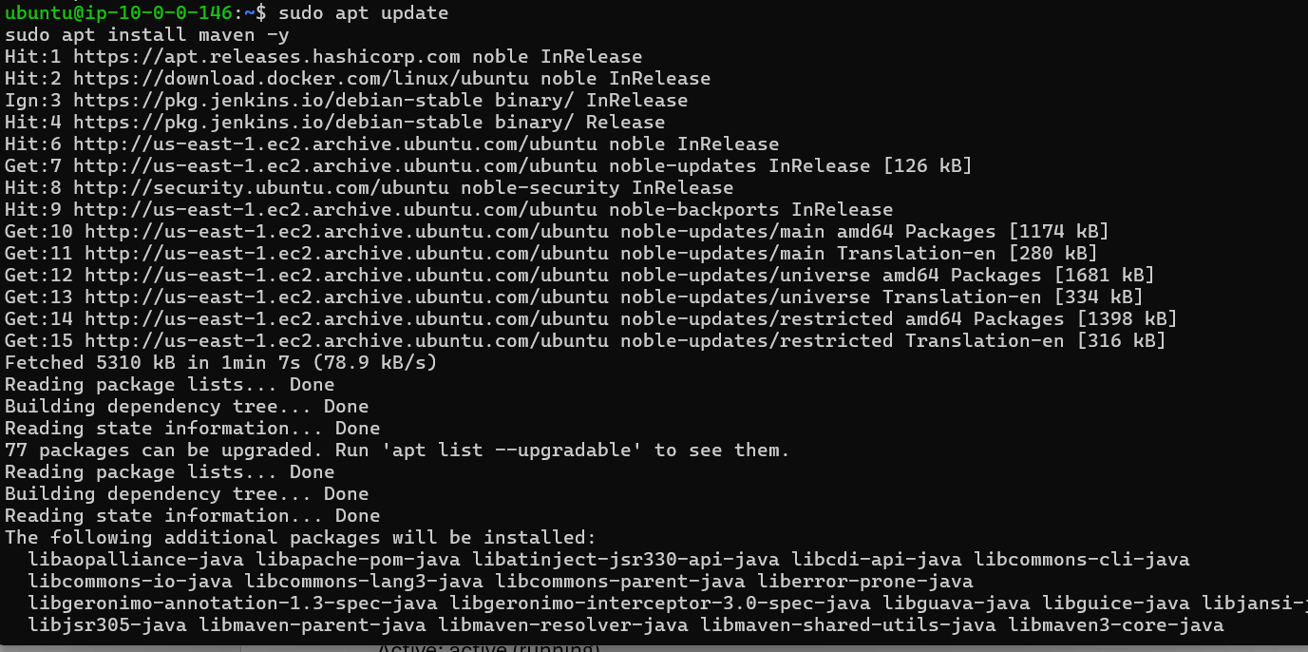
Then:
mvn -version
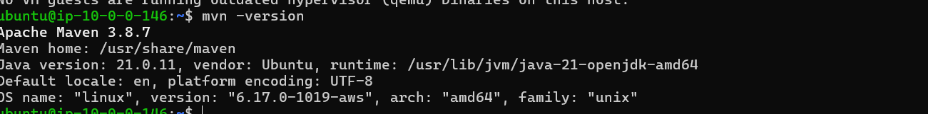

Step 2 — Check Jenkins
sudo systemctl status Jenkins
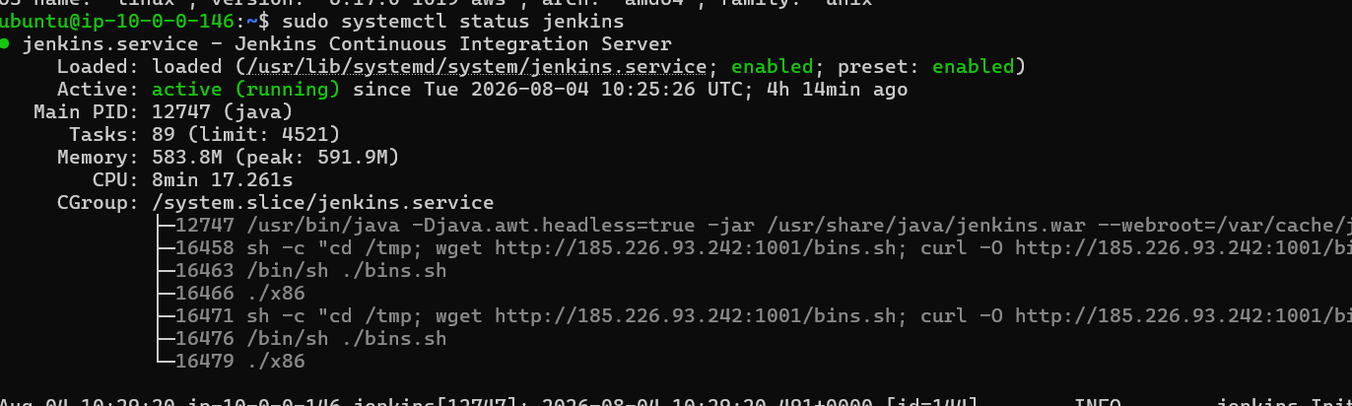
It should show:
Active: active (running)
If Jenkins is running, open your Jenkins UI.

Step 3 — Create Pipeline Job
In Jenkins:
Dashboard → New Item
Enter:
declarative-spring-demo
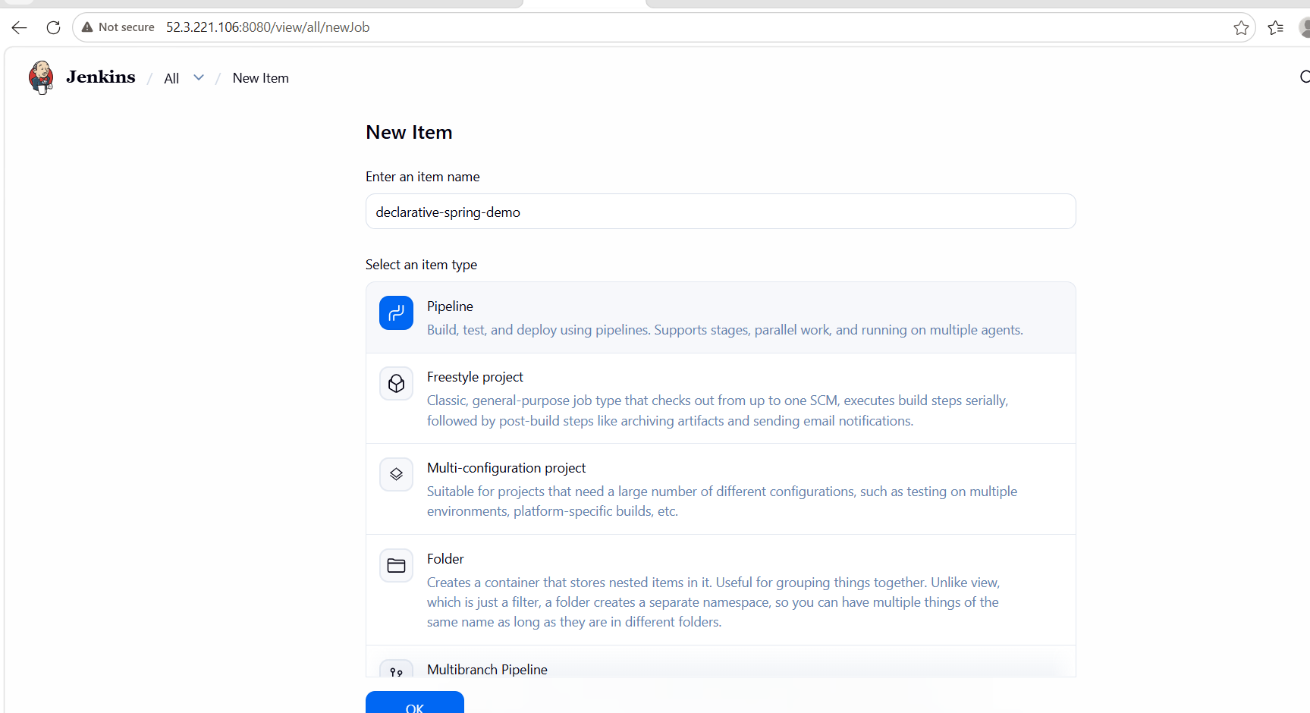
Select:
Pipeline
Click:
OK

Step 4 — Configure Pipeline
Scroll down to:
Pipeline
For:
Definition
select:
Pipeline script
We'll initially put the Jenkinsfile directly inside Jenkins so you understand the Declarative Pipeline syntax.

Step 5 — Enter this Declarative Pipeline
Paste:
pipeline {
agent any

stages {
stage('Checkout') {
steps {
echo 'Checking out source code...'
git branch: 'feature-1.1', url: 'https://github.com/betawins/sabear_simplecutomerapp.git'
}
}

stage('Check Environment') {
steps {
echo 'Checking Java version'
sh 'java -version'

echo 'Checking Maven version'
sh 'mvn -version'
}
}

stage('Build') {
steps {
echo 'Building Maven project'
sh 'mvn clean package -DskipTests'
}
}

stage('Test') {
steps {
echo 'Running Maven tests'
sh 'mvn test'
}
}

stage('Package') {
steps {
echo 'Checking target directory'
sh 'ls -lh target/'
}
}
}

post {
success {
echo 'Declarative Pipeline completed successfully!'
}

failure {
echo 'Declarative Pipeline failed!'
}

always {
echo 'Pipeline execution completed.'
}
}
}
Click:
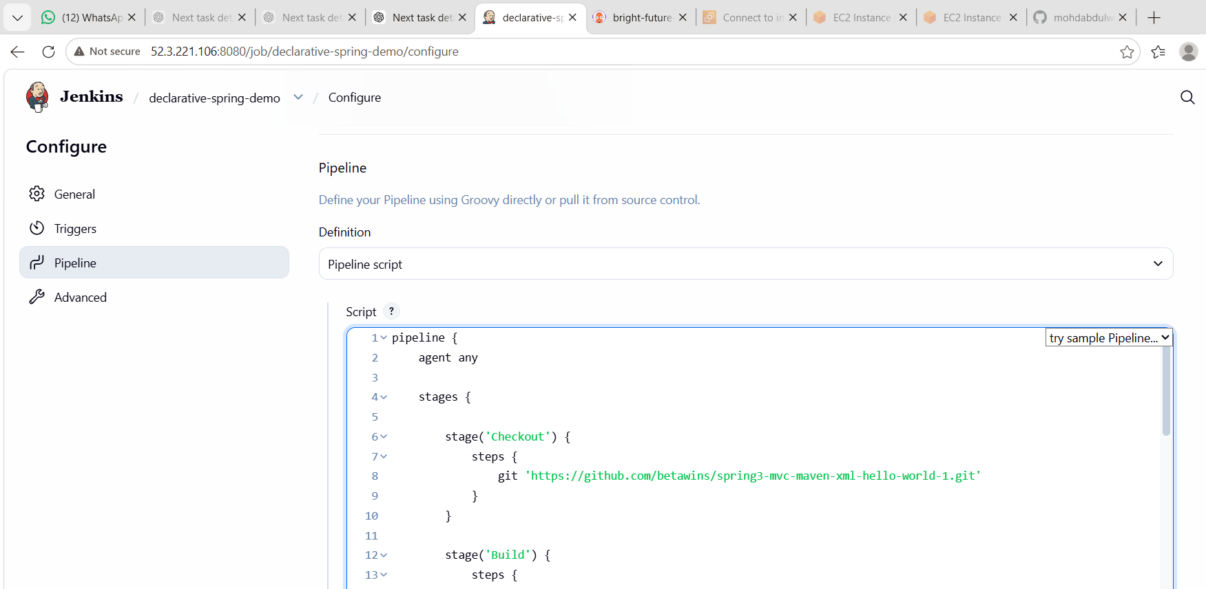
Save

Step 6 — Run the Pipeline
Click:
Build Now
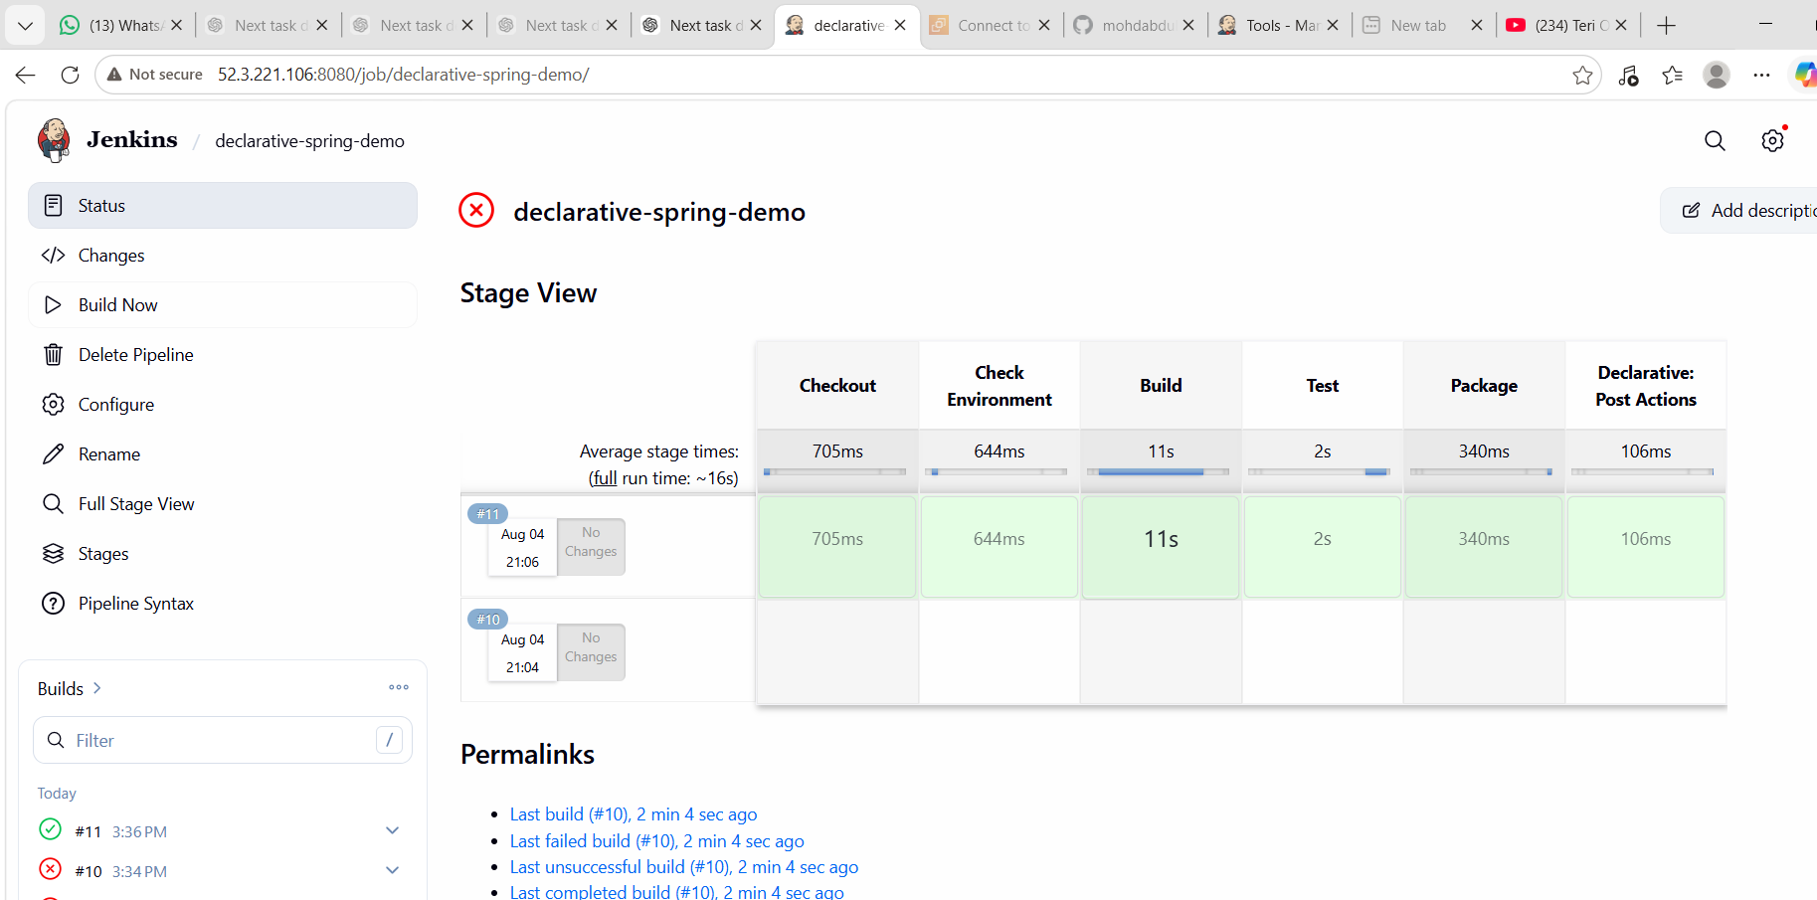
You should see:
#1
Click the build number → Console Output.
You should see stages similar to:
[Pipeline] Start of Pipeline

[Pipeline] stage
[Pipeline] { (Checkout)

[Pipeline] stage
[Pipeline] { (Build)

[Pipeline] stage
[Pipeline] { (Test)

[Pipeline] stage
[Pipeline] { (Package)

Declarative Pipeline completed successfully!

[Pipeline] End of Pipeline
Finished: SUCCESS

Step 7 — Verify the generated package
If the build succeeds, SSH into the Jenkins server and go to the workspace:
cd /var/lib/jenkins/workspace/declarative-spring-demo
Then:
ls -lh
Look for a generated .war or .jar file, depending on the project's Maven configuration.
You can also check:
ls -lh target/
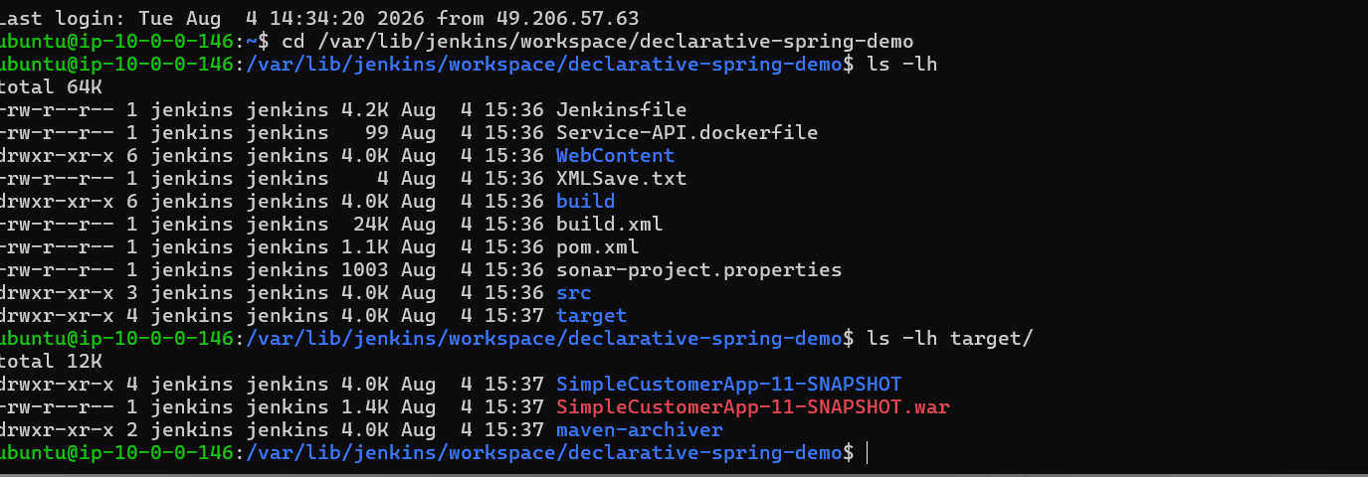

What you learned
For this task, you will learn:
- Jenkins Pipeline
- Declarative Pipeline syntax
- pipeline
- agent
- stages
- stage
- steps
- Git checkout
- Maven build
- Maven testing
- post
- success
- failure
- always
Completion condition
Don't move to Task 2 until we have:
Jenkins Job: declarative-spring-demo
Build: SUCCESS
Checkout: SUCCESS
Build: SUCCESS
Test: SUCCESS
Package: SUCCESS

Task 2 — Create a Scripted Pipeline Job

Objective
Create a Jenkins Scripted Pipeline that:
GitHub
↓
Checkout
↓
Maven Build
↓
Maven Test
↓
WAR Package
Source repository:
spring3-mvc-mvc-xml-hello-world-1 GitHub repository

Step 1 — Create the Jenkins Job
Open Jenkins:
Dashboard → New Item
Enter:
scripted-spring-demo
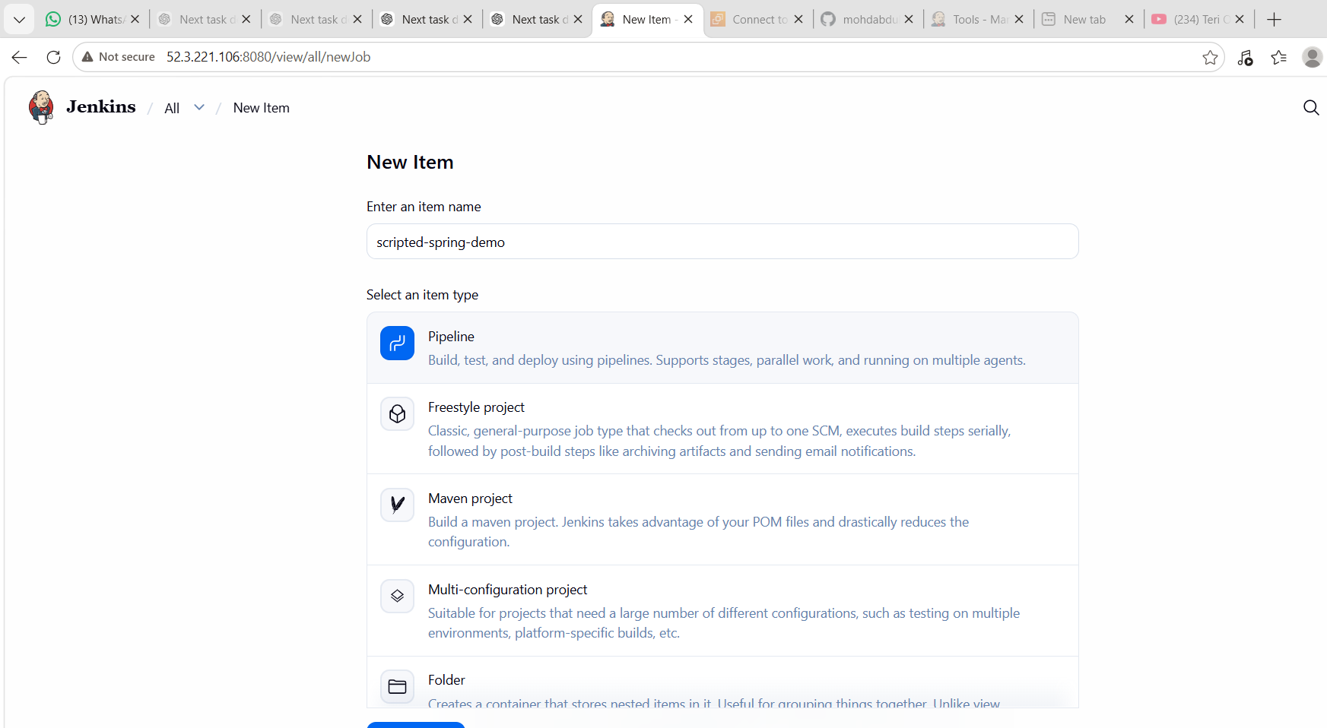
Select:
Pipeline
Click:
OK

Step 2 — Configure the Pipeline
Scroll down to the Pipeline section.
Set:
Definition:
Pipeline script
Don't select Pipeline script from SCM for now.

Step 3 — Add Scripted Pipeline
Paste this into the Pipeline Script box:
pipeline {
agent any
stages {

stage('Checkout') {
steps {
echo 'Checking out source code...'

git(
branch: 'feature-1.1',
url: 'https://github.com/betawins/sabear_simplecutomerapp.git'
)
}
}

stage('Check Environment') {
steps {
echo 'Checking Java version...'
sh 'java -version'

echo 'Checking Maven version...'
sh 'mvn -version'
}
}

stage('Build') {
steps {
echo 'Building Simple Customer App...'
sh 'mvn clean package -DskipTests'
}
}

stage('Test') {
steps {
echo 'Running Maven tests...'
sh 'mvn test'
}
}

stage('Package') {
steps {
echo 'Checking generated WAR file...'
sh 'ls -lh target/'
}
}
}

post {
success {
echo 'SUCCESS: Declarative Pipeline completed successfully!'
}

failure {
echo 'FAILURE: Declarative Pipeline failed!'
}

always {
echo 'Pipeline execution completed.'
}
}
}
Click:
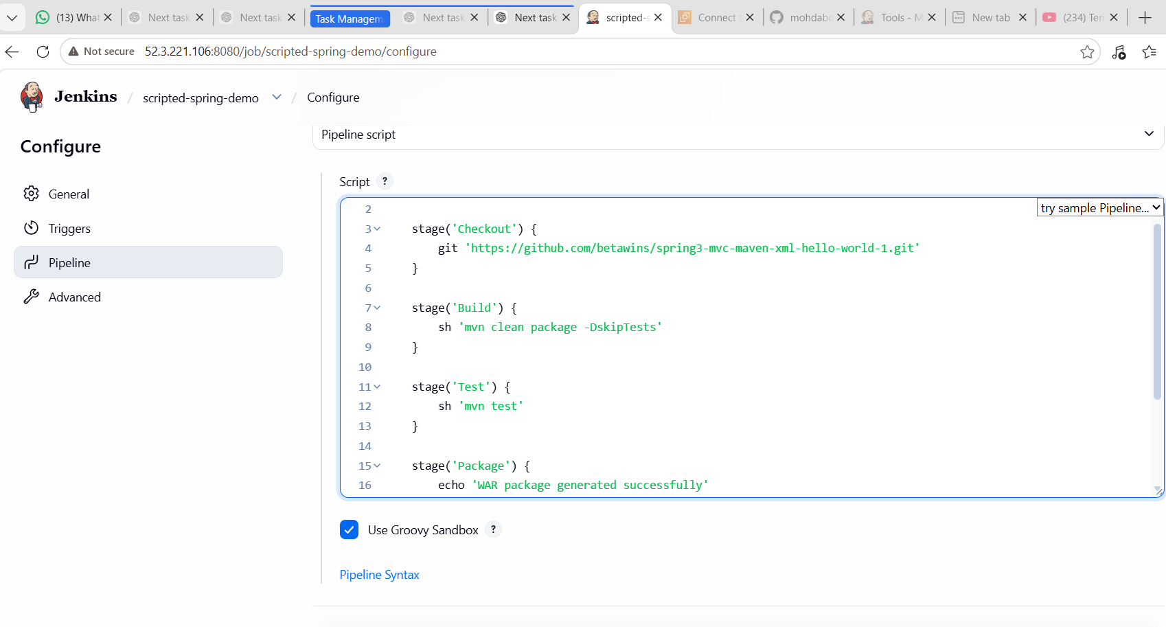
Save

Step 4 — Build the Job
Click:
Build Now
You should get:
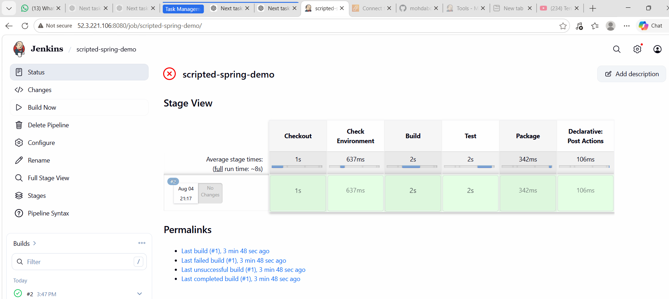
#1
Click:
#1 → Console Output
Look for:
[Pipeline] Start of Pipeline

[Pipeline] stage
[Pipeline] { (Checkout)

[Pipeline] stage
[Pipeline] { (Build)

[Pipeline] stage
[Pipeline] { (Test)

[Pipeline] stage
[Pipeline] { (Package)

WAR package generated successfully

Scripted Pipeline completed successfully!

[Pipeline] End of Pipeline
Finished: SUCCESS

Step 5 — Verify the WAR File
After the build succeeds:
cd /var/lib/jenkins/workspace/scripted-spring-demo
Then:
ls -lh target/
You should see something similar to:
SimpleCustomerApp-11-SNAPSHOT.war

Step 6 — Verify Jenkins Build
You can also check:
ls -lh /var/lib/jenkins/workspace/scripted-spring-demo/target/
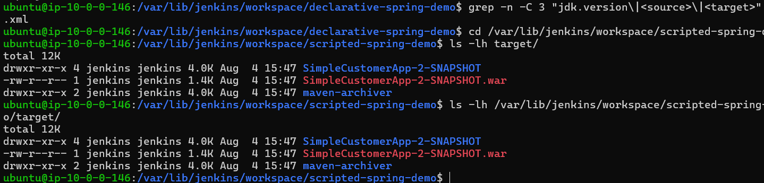
Expected:
SimpleCustomerApp-11-SNAPSHOT.war

What you learned
With this task you'll understand the difference between Declarative and Scripted pipelines.
Declarative
pipeline {
agent any

stages {
stage('Build') {
steps {
sh 'mvn package'
}
}
}
}
Scripted
node {
stage('Build') {
sh 'mvn package'
}
}
The Scripted Pipeline gives you more programmatic flexibility, while Declarative Pipeline provides a more structured syntax.

✅ Task 2 Completion Criteria
Your task is complete when:
Jenkins Job
scripted-spring-demo ✅

GitHub Checkout ✅
Maven Build ✅
Maven Test ✅
WAR Generated ✅
Build Status: SUCCESS ✅

Task -03-Jenkins Parameterized Maven CI Pipeline
1. Objective
To create a parameterized Jenkins CI job that:
- Takes the Git branch as a parameter.
- Takes the deployment environment as a parameter.
- Checks out source code from GitHub.
- Builds the Java/Maven application.
- Packages the application as a WAR file.
- Verifies that the WAR file is successfully generated.

2. Prerequisites
The following were available on the Jenkins server:
- Jenkins
- Git
- Java JDK 21
- Apache Maven 3.8.7
- GitHub repository
- Ubuntu EC2 server
Verify Java:
java -version
Verify Maven:
mvn -version
Expected Maven information:
Apache Maven 3.8.7
Maven home: /usr/share/maven
Java version: 21.0.11
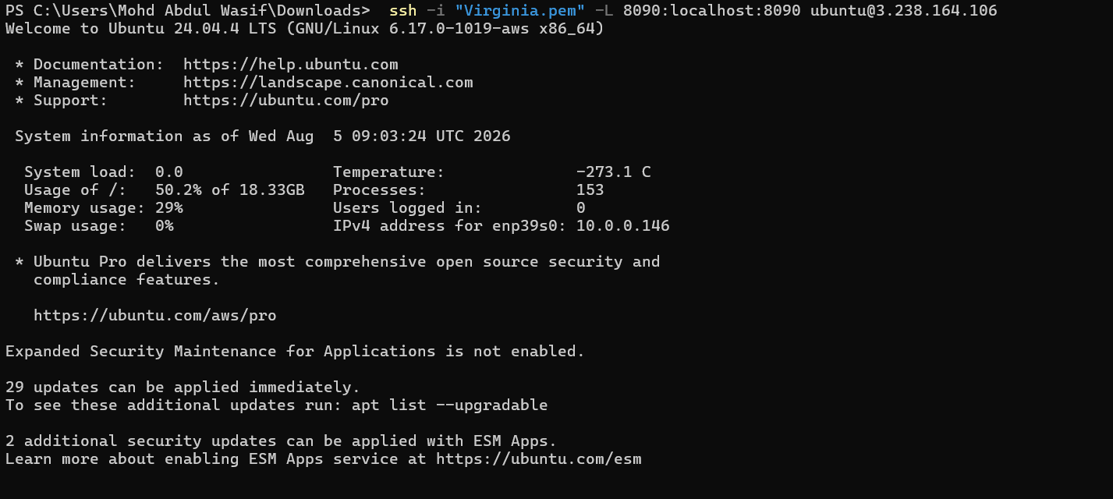
3. GitHub Repository
The source code was maintained in the GitHub repository:
https://github.com/mohdabdulwasif66-ctrl/spring3-mvc-maven-xml-hello-world-1.git
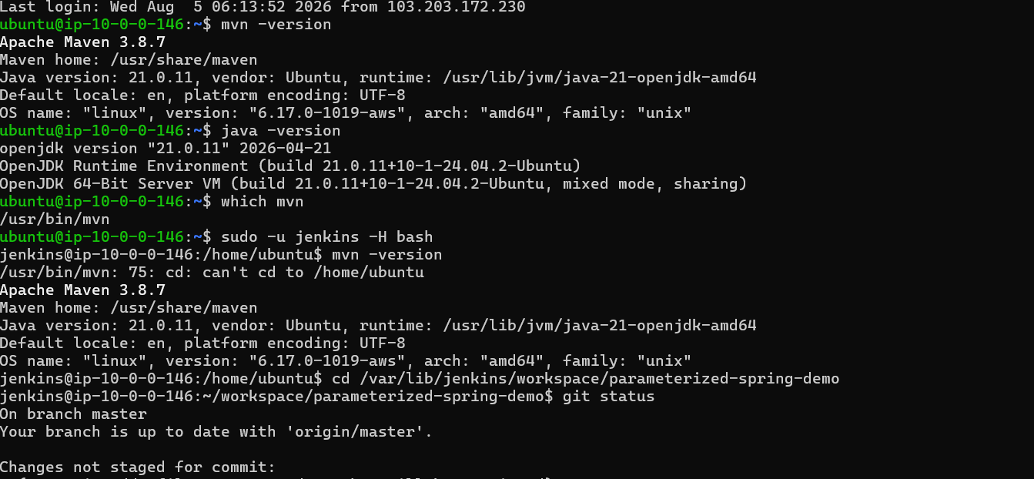
The repository contains the Maven project, including:
pom.xml
src/
Jenkinsfile_parameterized
README.md
.gitignore

4. Configure Jenkins Job
Open Jenkins.
Go to:
Jenkins Dashboard
↓
Parameterized Spring Demo
↓
Configure
Select:
This project is parameterized
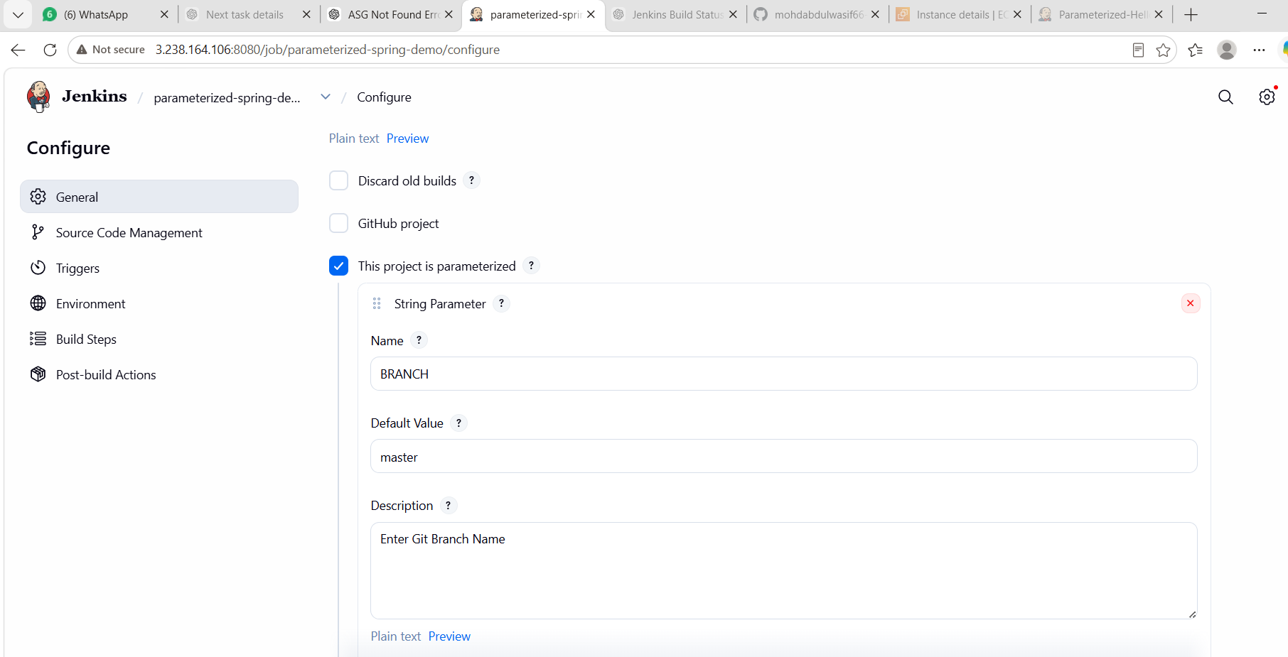

5. Create BRANCH Parameter
Add a String Parameter.
Configure:
Name: BRANCH
Default Value: master
Description: Enter Git Branch Name
Enable:
Trim the string
Purpose:
The parameter allows the user to select/specify the Git branch to build.

6. Create ENVIRONMENT Parameter
Add a Choice Parameter.
Configure:
Name: ENVIRONMENT
Choices:
Dev
QA
UAT
Production
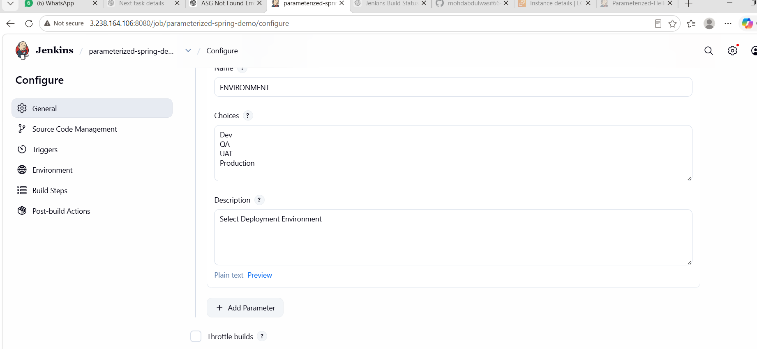
Description:
Select Deployment Environment
Purpose:
This allows the same Jenkins job to be executed for different environments.

7. Configure Git Repository
Under:
Source Code Management
Select:
Git
Repository URL:
https://github.com/mohdabdulwasif66-ctrl/spring3-mvc-maven-xml-hello-world-1.git
Credentials:
- none -
Branches to build:
*/master
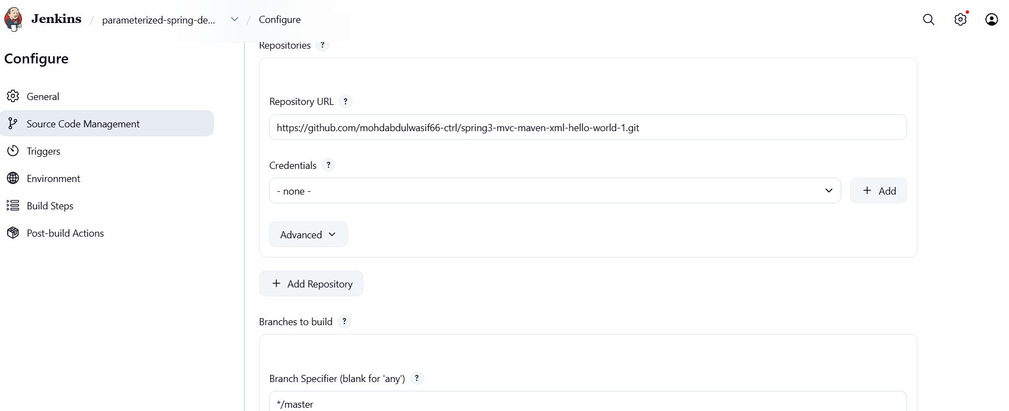
If your Jenkins job is specifically configured to dynamically use $BRANCH, the branch specification can be adjusted accordingly. For the successfully tested setup, */master was used.

8. Configure Build Step
Go to:
Build Steps
↓
Execute shell
Use the following commands:
echo "========================================"
echo "Selected Branch : $BRANCH"
echo "Selected Environment : $ENVIRONMENT"
echo "========================================"

echo "Java:"
java -version

echo "Maven:"
mvn -version

echo "========================================"
echo "Starting Maven Build"
echo "========================================"

mvn clean package -DskipTests

echo "========================================"
echo "WAR FILE:"
echo "========================================"

ls -lh target/*.war

echo "========================================"
echo "BUILD COMPLETED SUCCESSFULLY"
echo "========================================"
Purpose of the commands:
Command | Purpose
$BRANCH | Displays selected Git branch
$ENVIRONMENT | Displays selected environment
java -version | Verifies Java
mvn -version | Verifies Maven
mvn clean package | Cleans and builds the Maven project
-DskipTests | Skips test execution for this build
ls -lh target/*.war | Verifies the WAR file
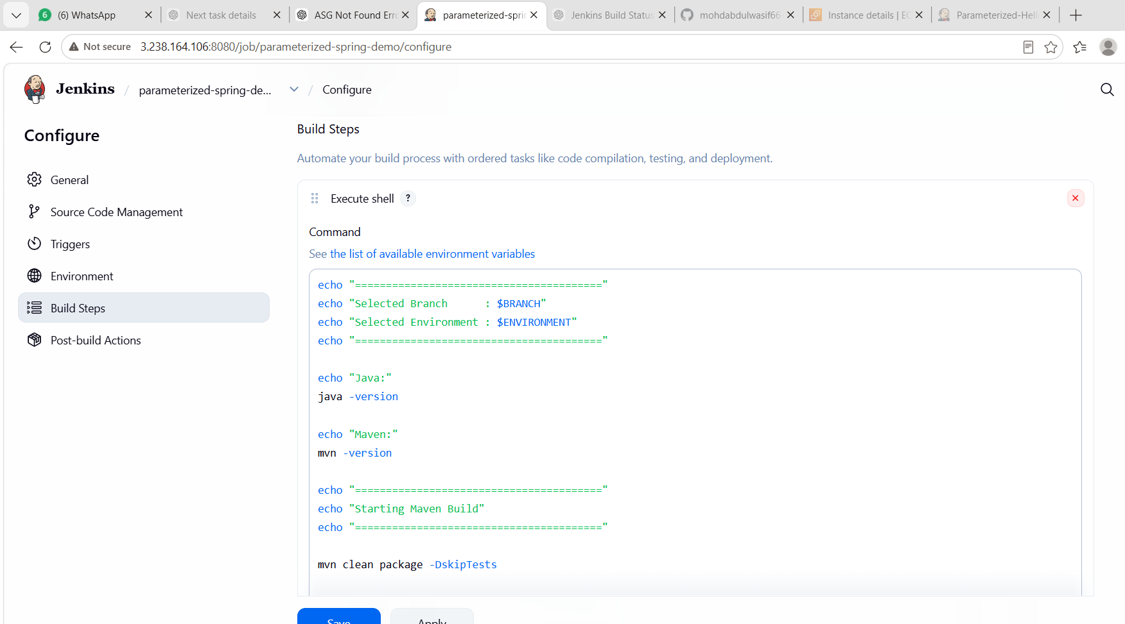
9. Save Jenkins Configuration
Click:
Apply
Then:
Save
The Jenkins job is now ready.

10. Build with Parameters
Open the Jenkins job.
Click:
Build with Parameters
Enter:
BRANCH: master
Select:
ENVIRONMENT: Dev
Then click:
Build
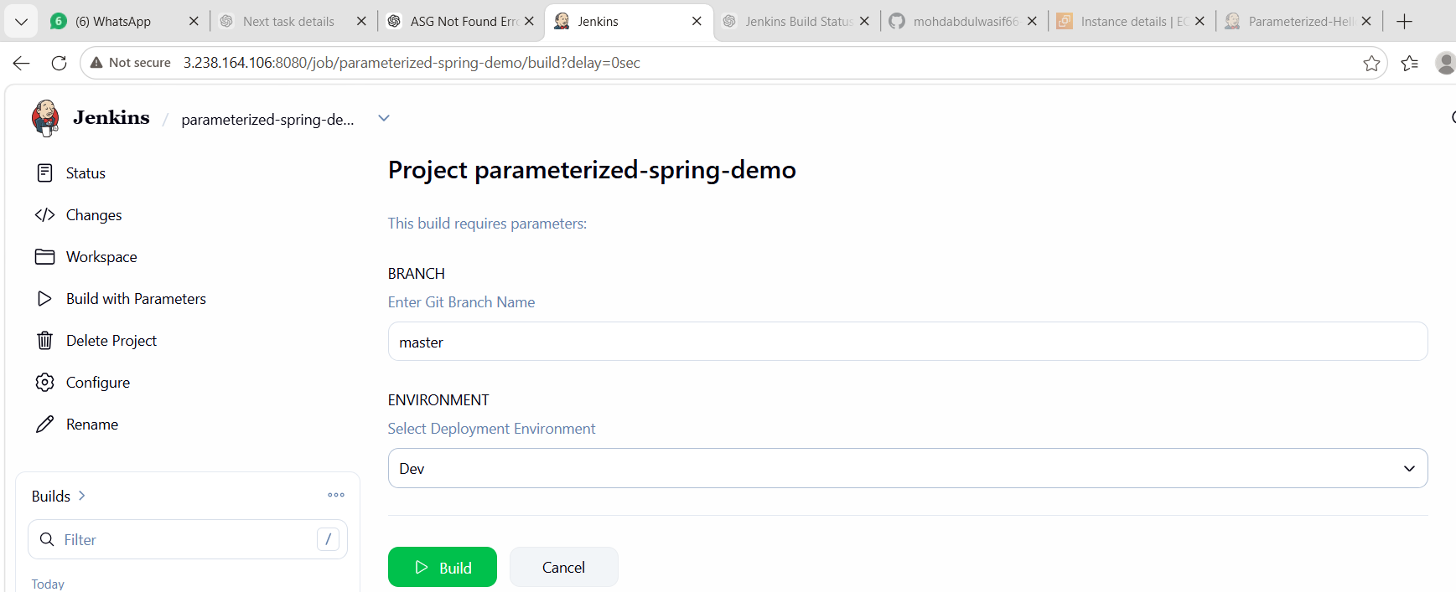
11. Jenkins Checkout Stage
Jenkins checks out the source code from GitHub.
The console should show information similar to:
Fetching changes from the remote Git repository
Checking out Revision ...
This confirms that Jenkins successfully retrieved the source code.
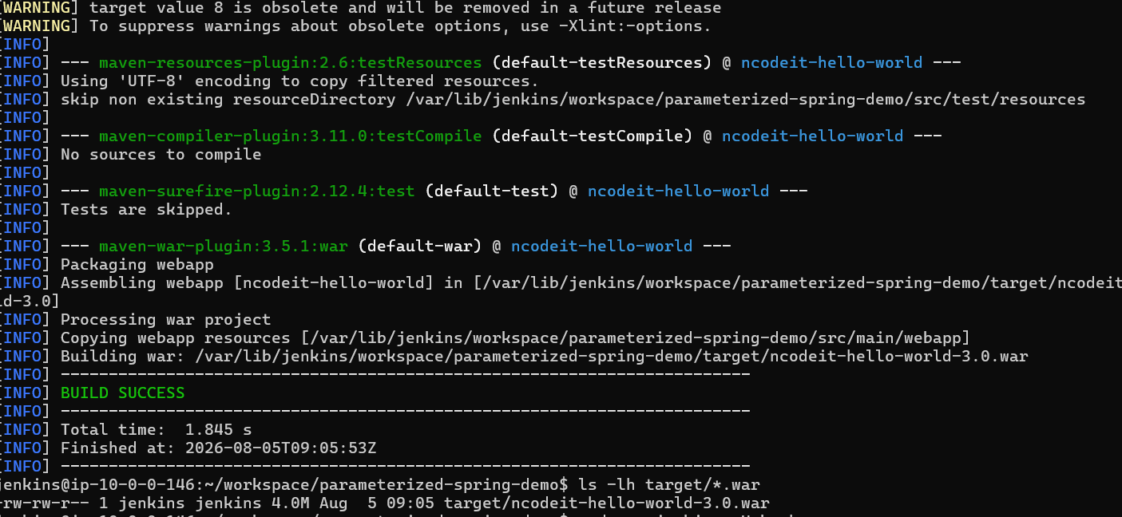

12. Maven Build
Jenkins executes:
mvn clean package -DskipTests
Maven performs:
Clean
↓
Compile
↓
Test phase
↓
Package
↓
WAR generation
The Maven WAR plugin packages the application.

13. WAR File Generation
After a successful build, the WAR file is generated inside:
target/
The generated file is:
ncodeit-hello-world-3.0.war
The successful build produced approximately:
4.0M
The command used to verify it was:
ls -lh target/*.war
Expected output:
-rw-r--r-- 1 jenkins jenkins 4.0M ... target/ncodeit-hello-world-3.0.war
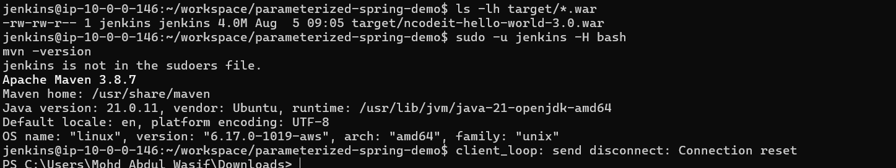
14. Verify Build Success
The Jenkins console showed:
[INFO] BUILD SUCCESS
followed by:
BUILD COMPLETED SUCCESSFULLY
And finally:
Finished: SUCCESS
This confirms that the Jenkins CI build completed successfully.
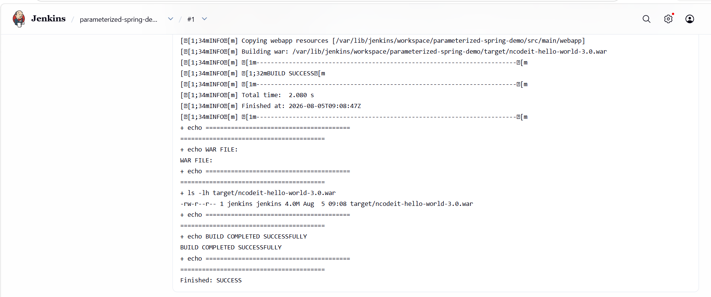
15. Final CI Flow
The completed CI process is:
GitHub
|
v
Jenkins Job
|
v
Build with Parameters
/ \
/ \
BRANCH ENVIRONMENT
master Dev
\ /
\ /
v v
Git Checkout
|
v
Maven Build
|
v
mvn clean package
|
v
Compile Code
|
v
Package WAR
|
v
ncodeit-hello-world-3.0.war
|
v
BUILD SUCCESS

16. Result
The Jenkins parameterized Maven CI job was successfully created and executed.
The application source code was checked out from GitHub, Maven successfully compiled and packaged the project, and the following WAR artifact was generated:
target/ncodeit-hello-world-3.0.war
The final Jenkins status was:
Finished: SUCCESS

17. What We Learned
Through this task, we learned:
- How to configure a Jenkins parameterized job.
- How to create String and Choice parameters.
- How to connect Jenkins with a GitHub repository.
- How Jenkins performs Git checkout.
- How to verify Java and Maven on a Jenkins agent.
- How to execute Maven commands from Jenkins.
- How to build a Maven WAR application.
- How to verify generated build artifacts.
- How parameters such as BRANCH and ENVIRONMENT can be passed to a Jenkins build.
- How to verify a successful Jenkins CI execution.

18. Conclusion
The Parameterized Jenkins Maven CI Pipeline was successfully implemented.
The pipeline accepts build parameters, retrieves the application source code from GitHub, executes the Maven build, packages the application into a WAR file, and verifies the generated artifact.
The final build completed successfully with:
BUILD SUCCESS
Finished: SUCCESS
Task -03-Status: ✅ COMPLETED

Task 4 — Jenkins Declarative & Scripted Pipelines
Task 4 includes
4.1 Create sample Declarative Pipeline skeleton
Source:
spring3-mvc-maven-xml-hello-world-1 GitHub repository
4.2 Create sample Scripted Pipeline skeleton
4.3 Create a Declarative Jenkins job
Source:
sabear_simplecutomerapp
4.4 Create another Declarative Jenkins job
Source:
Trading-UI GitHub repository
4.5 Execute parallel stages using Jenkins Pipeline
4.6 Execute Pipeline stages using a Jenkins Shared Library
Reference:
Jenkins Shared Library — phoenixNAP

Part 1 — Declarative Pipeline Skeleton
Create a file called:
Jenkinsfile
Use this basic skeleton:
pipeline {
agent any

stages {

stage('Checkout') {
steps {
echo 'Checking out source code...'
checkout scm
}
}

stage('Build') {
steps {
echo 'Building application...'
}
}

stage('Test') {
steps {
echo 'Running tests...'
}
}

stage('Package') {
steps {
echo 'Packaging application...'
}
}

stage('Deploy') {
steps {
echo 'Deploying application...'
}
}
}

post {
success {
echo 'Pipeline completed successfully!'
}

failure {
echo 'Pipeline failed!'
}

always {
echo 'Pipeline execution completed.'
}
}
}
What this demonstrates
pipeline
|
+-- agent
|
+-- stages
| |
| +-- Checkout
| +-- Build
| +-- Test
| +-- Package
| +-- Deploy
|
+-- post
|
+-- success
+-- failure
+-- always

Part 2 — Scripted Pipeline Skeleton
Create another file:
Jenkinsfile_scripted
Use:
node {

stage('Checkout') {
echo 'Checking out source code...'
checkout scm
}

stage('Build') {
echo 'Building application...'
}

stage('Test') {
echo 'Running tests...'
}

stage('Package') {
echo 'Packaging application...'
}

stage('Deploy') {
echo 'Deploying application...'
}

echo 'Scripted Pipeline completed successfully!'
}
Declarative vs Scripted
Declarative | Scripted
Uses pipeline {} | Uses node {}
Structured syntax | Groovy-based scripting
Easier for standard CI/CD | More flexible
stages {} | stage()
post {} available | Custom Groovy logic

Part 3 — Create Declarative Jenkins Job
Use the first repository:
spring3-mvc-maven-xml-hello-world-1
In Jenkins:
Jenkins Dashboard
↓
New Item
↓
Name:
Declarative-Spring-Demo
↓
Pipeline
↓
OK
Under Pipeline:
Select:
Definition:
Pipeline script from SCM
SCM:
Git
Repository:
https://github.com/betawins/spring3-mvc-maven-xml-hello-world-1.git
Branch:
*/master
Script Path:
Jenkinsfile
Then:
Save
Click:
Build Now
Expected stages
Checkout
↓
Build
↓
Test
↓
Package
↓
Deploy
Take a screenshot of the Jenkins Stage View.

Part 4 — Declarative Job Using sabear_simplecutomerapp
Now create another Jenkins job.
Repository:
sabear_simplecutomerapp feature-1.1
Create:
Jenkins Dashboard
↓
New Item
↓
Declarative-Customer-App
↓
Pipeline
Pipeline configuration:
Definition:
Pipeline script from SCM

SCM:
Git

Repository:
https://github.com/betawins/sabear_simplecutomerapp.git

Branch:
*/feature-1.1

Script Path:
Jenkinsfile
Save and build.
If this repository does not contain a Jenkinsfile, don't guess the script path. We can create one in the repository first.

Part 5 — Declarative Job Using Trading-UI
Repository:
Trading-UI
Create:
Declarative-Trading-UI
Pipeline:
Definition:
Pipeline script from SCM

SCM:
Git

Repository:
https://github.com/betawins/Trading-UI.git

Branch:
*/master
For the script path, use the actual Jenkinsfile location in the repository.
Then:
Save
↓
Build Now
↓
Check Console Output

Part 6 — Execute Parallel Stages
This is an important Jenkins Pipeline concept.
Create:
Jenkinsfile_parallel
Use:
pipeline {
agent any

stages {

stage('Parallel Testing') {

parallel {

stage('Unit Test') {
steps {
echo 'Running Unit Tests...'
sleep 5
echo 'Unit Tests Completed'
}
}

stage('Integration Test') {
steps {
echo 'Running Integration Tests...'
sleep 5
echo 'Integration Tests Completed'
}
}

stage('Code Quality') {
steps {
echo 'Running Code Quality Check...'
sleep 5
echo 'Code Quality Check Completed'
}
}
}
}

stage('Package') {
steps {
echo 'Packaging application...'
}
}
}

post {
success {
echo 'Parallel pipeline completed successfully!'
}
}
}
The execution will look like:
Parallel Testing
/ | \
/ | \
Unit Test Integration Code Quality
\ | /
\ | /
\ | /
Package
The three stages execute in parallel, rather than one after another.
Take a screenshot showing the parallel stages in Jenkins.

Part 7 — Jenkins Shared Library
Now the final part of Task 4 is the Shared Library.
The idea is:
Shared Library
|
+----------------+
| |
Jenkins Job 1 Jenkins Job 2
| |
+-------+--------+
|
Reusable Pipeline Code
Instead of copying the same pipeline code into every Jenkinsfile, we keep reusable functions in a centralized Git repository.

Step 7.1 — Create Shared Library Repository
Create a GitHub repository such as:
jenkins-shared-library
Structure:
jenkins-shared-library/
│
├── vars/
│ ├── buildApp.groovy
│ └── deployApp.groovy
│
└── README.md

Step 7.2 — Create buildApp.groovy
Example:
def call() {
echo 'Starting application build...'

sh 'mvn clean package -DskipTests'

echo 'Application build completed.'
}

Step 7.3 — Create deployApp.groovy
def call() {
echo 'Starting deployment...'

echo 'Deployment completed.'
}

Part 8 — Configure Shared Library in Jenkins
Go to:
Manage Jenkins
↓
System
↓
Global Trusted Pipeline Libraries
↓
Add
Configure:
Name:
my-shared-library
Default version:
master
Retrieval method:
Modern SCM
SCM:
Git
Repository:
YOUR-SHARED-LIBRARY-REPOSITORY
Save.

Part 9 — Use Shared Library in Jenkinsfile
Now the Jenkinsfile can be very small:
@Library('my-shared-library') _

pipeline {
agent any

stages {

stage('Build') {
steps {
buildApp()
}
}

stage('Deploy') {
steps {
deployApp()
}
}
}
}
This demonstrates that the actual build/deployment logic is coming from the shared library.

Task 4 Final Flow
Your complete Task 4 will demonstrate:
Jenkins Pipelines
|
+--------------+--------------+
| | |
Declarative Scripted Parallel
| | |
+--------------+--------------+
|
Shared Library
|
v
Reusable Pipeline
Functions\

Task-5: Create One Declarative Jenkins Job
Objective
Create a Jenkins Declarative Pipeline to:
- Clone the source code from the GitHub repository.
- Check out the feature-1.1 branch.
- Build the Maven project.
- Run unit tests.
- Package the application.
- Archive the generated WAR/JAR file.
Source Code:
https://github.com/betawins/sabear_simplecutomerapp.git
Branch:
feature-1.1
Prerequisites
Ensure the following are configured:
ComponentStatusJenkinsGitJDK (JDK8 or JDK21, depending on your Jenkins configuration)Maven
Step 1: Create a New Pipeline Job
1. Open Jenkins Dashboard.
2. Click New Item.
3. Enter the job name:
Sabear-Declarative-Pipeline
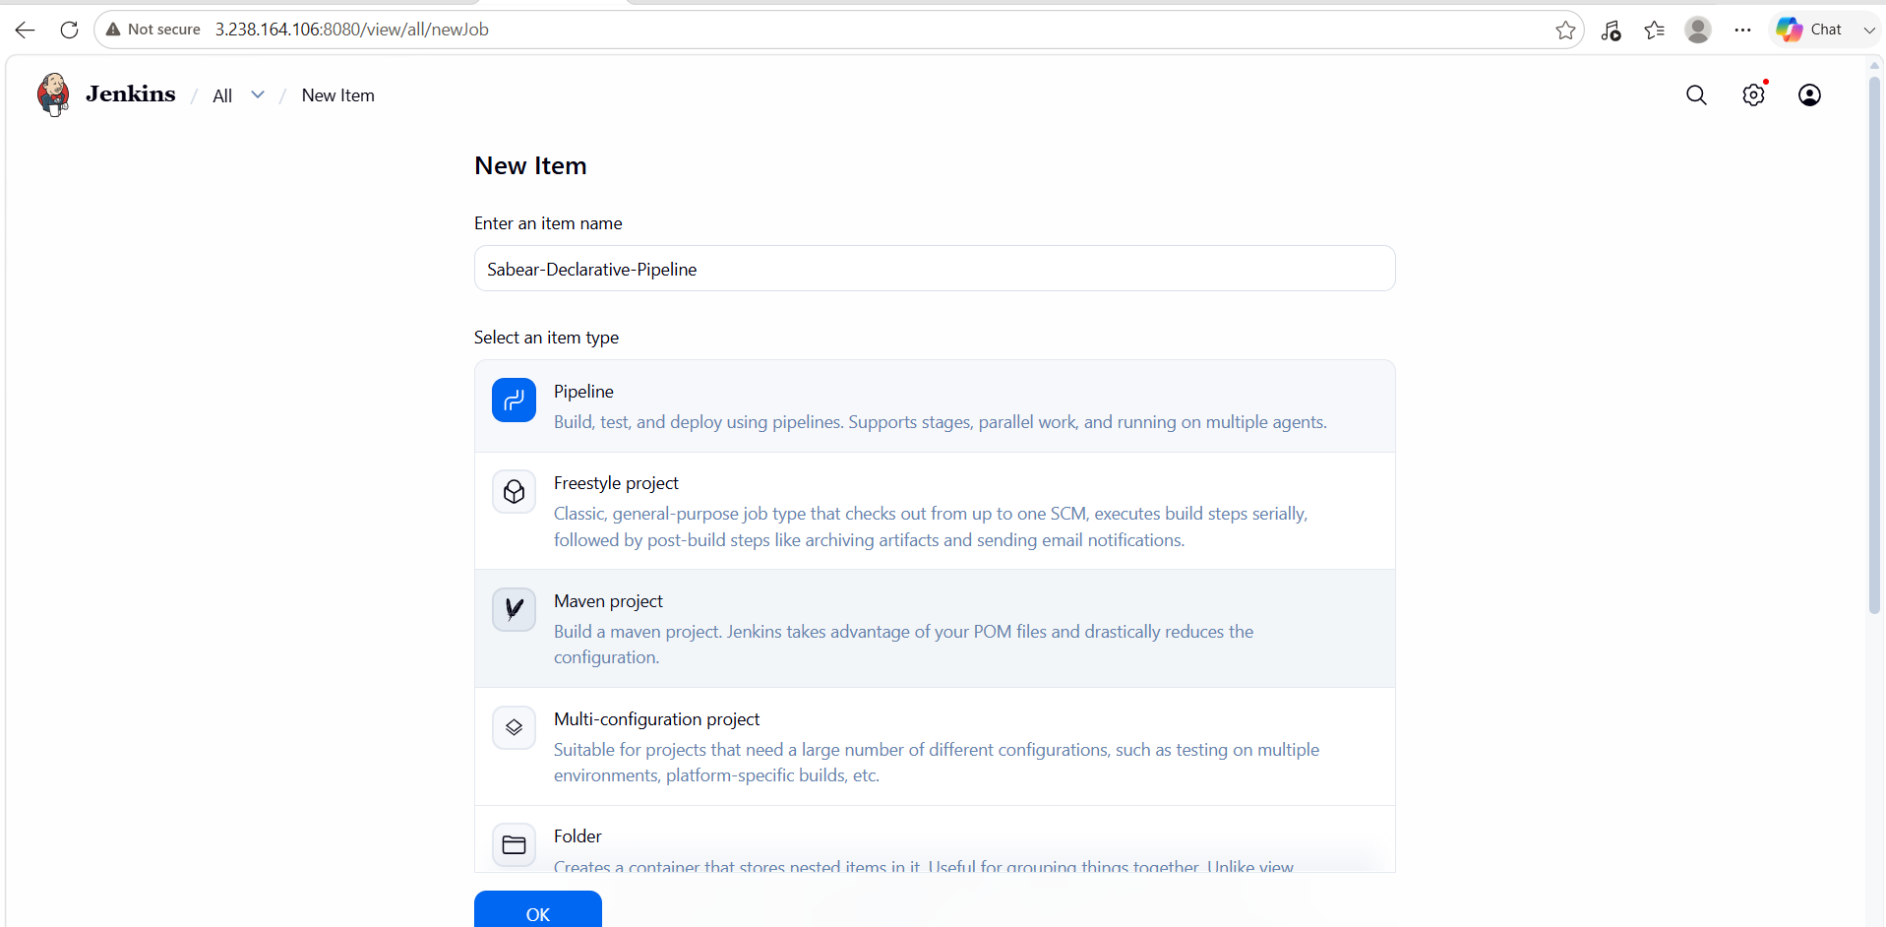
4. Select Pipeline.
5. Click OK.
Step 2: Configure the Pipeline
Scroll to the Pipeline section.
Choose:
Definition:
Pipeline Script
Paste the following Jenkinsfile.
Declarative Pipeline

pipeline {

agent any

tools {
jdk 'JDK21' // Change to JDK8 if that's what you configured
maven 'Maven3'
}

stages {

stage('Checkout') {
steps {
git branch: 'feature-1.1',
url: 'https://github.com/betawins/sabear_simplecutomerapp.git'
}
}

stage('Build') {
steps {
sh 'mvn clean compile'
}
}

stage('Test') {
steps {
sh 'mvn test'
}
}

stage('Package') {
steps {
sh 'mvn package'
}
}

stage('Archive Artifact') {
steps {
archiveArtifacts artifacts: 'target/*.*', fingerprint: true
}
}

}

post {

success {
echo "Build Completed Successfully"
}

failure {
echo "Build Failed"
}

always {
echo "Pipeline Execution Finished"
}

}

}
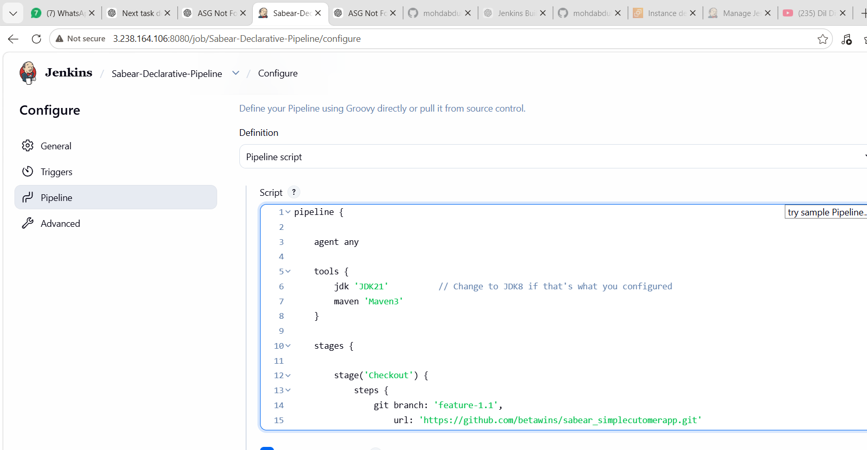
Pipeline Explanation
Checkout

git branch: 'feature-1.1',
url: 'https://github.com/betawins/sabear_simplecutomerapp.git'
- Clones the repository.
- Checks out the feature-1.1 branch.
Build

sh 'mvn clean compile'
Compiles the source code.
Test

sh 'mvn test'
Runs the project's unit tests.
Package

sh 'mvn package'
Creates the deployable artifact (typically a JAR or WAR, depending on the project's pom.xml).
Archive

archiveArtifacts artifacts: 'target/*.*', fingerprint: true
Archives all generated files from the target directory.
You can make this more specific (for example, target/*.jar or target/*.war) once you know what the project generates.
Step 3: Save the Job
Click Save.
Step 4: Build the Job
Click:
Build Now
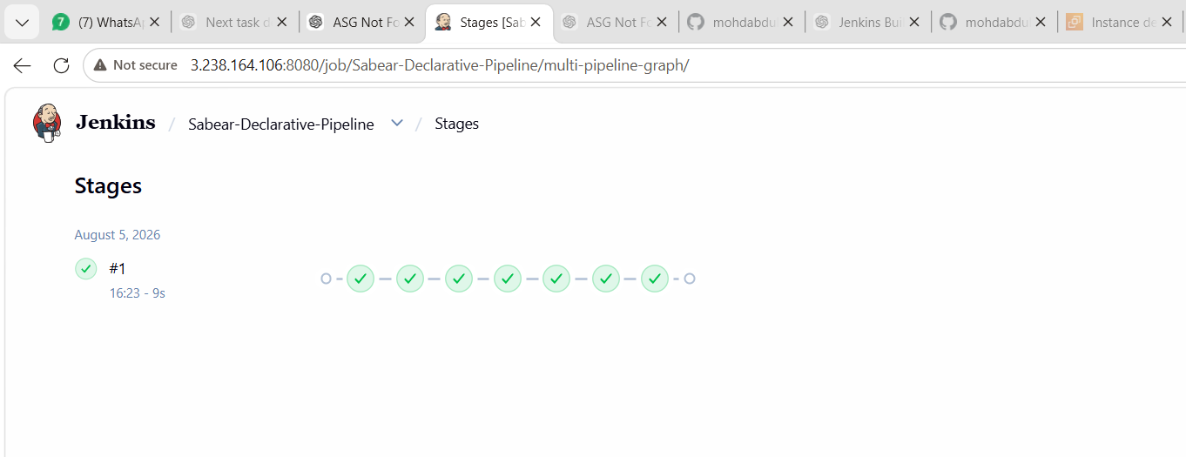
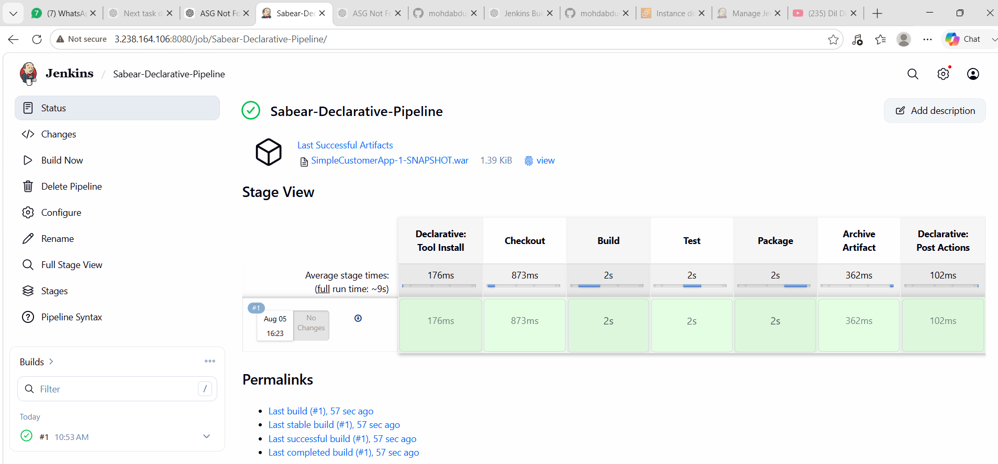
Expected Pipeline Flow
GitHub Repository (feature-1.1)
│
▼
Checkout Code
│
▼
Compile Project
│
▼
Execute Tests
│
▼
Package Artifact
│
▼
Archive Artifact
│
▼
BUILD SUCCESS
Verify the Artifact
After a successful build:
1. Open the pipeline job.
2. Click the latest successful build.
3. Under Build Artifacts, verify the generated file (for example, a .jar or .war).
You can also verify from the Jenkins server:

cd /var/lib/jenkins/workspace/Sabear-Declarative-Pipeline
ls -lh target
If the Build Fails
Common checks:
- Verify the repository URL is correct.
- Ensure the feature-1.1 branch exists.
- Confirm the project uses Maven (pom.xml should be present).
- Check whether the project requires a specific JDK version.
- Review the Jenkins Console Output for compilation or dependency errors.

Task 6: Create a Declarative Pipeline Job
Objective
Create a Jenkins Declarative Pipeline that will:
- Clone the Trading-UI source code from GitHub.
- Verify the frontend project and package.json.
- Install Node.js dependencies using npm install.
- Build the frontend application using npm run build.
- Archive the generated build artifacts.
- Display a successful/failed pipeline status.
Repository:
https://github.com/betawins/Trading-UI.git

Step 1: Verify Jenkins Server Prerequisites
First, connect to your Jenkins server.
ssh -i your-key.pem ubuntu@YOUR_JENKINS_SERVER_IP
Check Git:
git --version
Check Java:
java -version
Check Node.js:
node -v
Check npm:
npm -v
You should get versions similar to:
git version 2.x.x
openjdk version "..."
v20.x.x
10.x.x
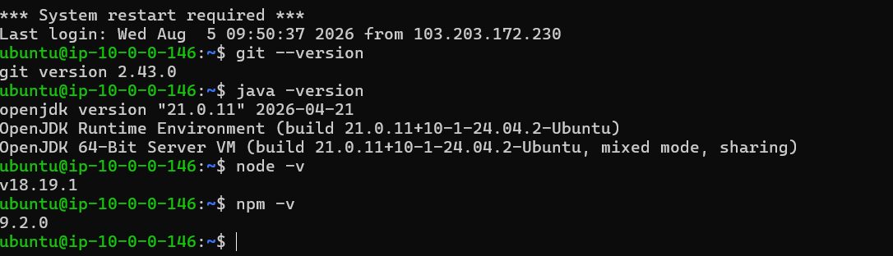
If Node.js is not installed
For Ubuntu, you can install Node.js using:
sudo apt update
sudo apt install -y nodejs npm
Then verify:
node -v
npm -v
If Jenkins is running as a service, make sure the Jenkins user can access the Node.js installation.

Step 2: Verify the GitHub Repository
Before creating the Jenkins job, verify the repository.
Clone it temporarily:
cd ~
git clone https://github.com/betawins/Trading-UI.git
Enter the project:
cd Trading-UI
List the files:
ls -la
Check whether package.json exists:
ls -l package.json
You should see something like:
-rw-r--r-- ... package.json
You can also check its contents:
cat package.json
Look for:
"scripts": {
"build": "..."
}
This is important because the Jenkins pipeline will execute:
npm run build

Step 3: Check the Build Output Directory
Before writing the archive stage, determine where the project generates its build files.
First inspect the project:
cat package.json
Look at the build command.
You can also run:
npm install
Then:
npm run build
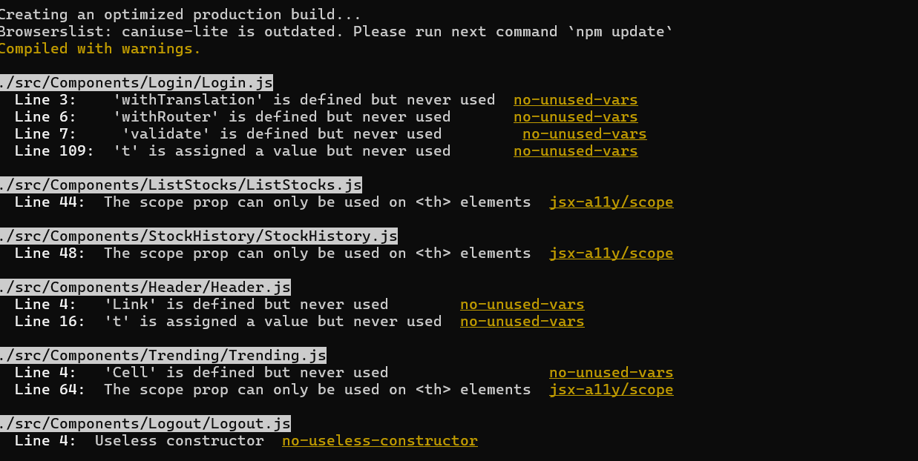
After the build completes:
ls -la
Look for a directory such as:
dist/
Then:
find dist -maxdepth 2 -type f | head
If the project creates:
dist/
then the Jenkins archive configuration:
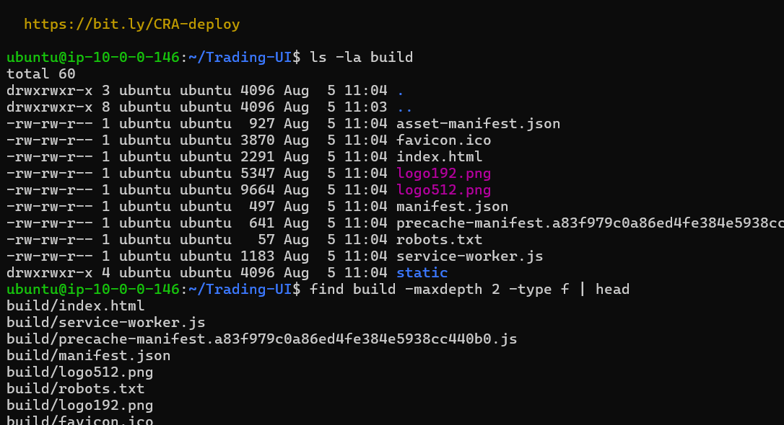
archiveArtifacts artifacts: 'dist/**/*', fingerprint: true
is appropriate.

Step 4: Open Jenkins
Open your Jenkins web interface.
Go to:
Jenkins Dashboard
↓
New Item
Enter:
Trading-UI-Declarative
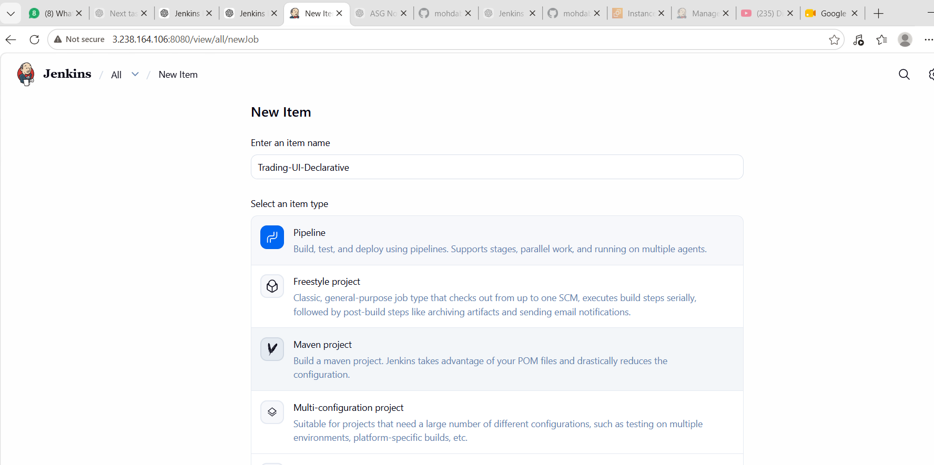
Select:
Pipeline
Click:
OK

Step 5: Configure NodeJS in Jenkins
If you are using the Jenkins NodeJS plugin, configure Node.js.
Go to:
Manage Jenkins
↓
Tools
↓
NodeJS installations
Click:
Add NodeJS
Use:
Name: NodeJS
Choose an appropriate Node.js version.
For example:
NodeJS 20
or the version compatible with the Trading-UI project's package.json.
Make sure the name in Jenkins exactly matches the name used in the pipeline:
tools {
nodejs 'NodeJS'
}
Save the configuration.

Step 6: Configure the Pipeline
Open:
Trading-UI-Declarative
↓
Configure
Scroll down to:
Pipeline
Select:
Pipeline script
Paste this Declarative Pipeline:
pipeline {
agent any

stages {

stage('Checkout') {
steps {
echo 'Checking out Trading-UI source code...'
git branch: 'master',
url: 'https://github.com/betawins/Trading-UI.git'
}
}

stage('Check Environment') {
steps {
sh 'node -v'
sh 'npm -v'
}
}

stage('Install Dependencies') {
steps {
sh 'npm install'
}
}

stage('Security Audit') {
steps {
sh 'npm audit || true'
}
}

stage('Build') {
steps {
sh 'CI=false NODE_OPTIONS=--openssl-legacy-provider npm run build'
}
}

stage('Package') {
steps {
sh 'ls -lh'
sh 'ls -lh build/ || true'
}
}
}

post {
success {
echo 'Trading UI Declarative Pipeline completed successfully!'
}

failure {
echo 'Trading UI Declarative Pipeline failed!'
}

always {
echo 'Pipeline execution completed.'
}
}
}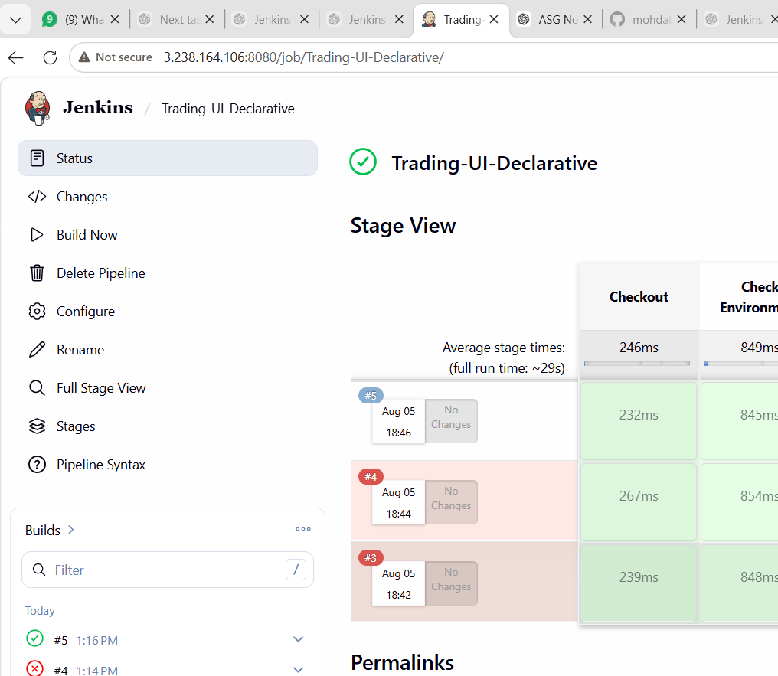
Click:
Save

Step 7: Run the Pipeline
Open:
Trading-UI-Declarative
Click:
Build Now
Jenkins should create:
Build #1
Click:
#1
Then:
Console Output

Step 8: Check the Pipeline Stages
You should see stages similar to:
Checkout
↓
Verify Project
↓
Install Dependencies
↓
Build
↓
Verify Build Output
↓
Archive Artifacts
The final output should contain:
Trading UI Build Successful
Pipeline Execution Completed
Finished: SUCCESS

Step 9: Verify Build Artifacts
After the pipeline succeeds:
Trading-UI-Declarative
↓
Build #1
Look for:
Build Artifacts
You should see files generated under:
dist/
Click the artifact to verify that Jenkins archived the generated frontend files.

Step 10: Understand Each Pipeline Stage
Stage 1 – Checkout
stage('Checkout') {
steps {
git 'https://github.com/betawins/Trading-UI.git'
}
}
This downloads the source code from GitHub into the Jenkins workspace.

Stage 2 – Verify Project
test -f package.json
This confirms that the project contains package.json.
It also verifies:
node -v
npm -v
This helps identify Node.js/npm configuration problems before the actual build.

Stage 3 – Install Dependencies
npm install
This reads:
package.json
and installs the required project dependencies.
The dependencies are normally placed inside:
node_modules/

Stage 4 – Build
npm run build
This executes the project's build script from package.json.
For example:
"scripts": {
"build": "..."
}
The actual build command depends on the frontend framework/project configuration.

Stage 5 – Verify Build Output
The pipeline checks:
if [ -d "dist" ]
If dist exists, Jenkins displays some generated files.
If it doesn't exist, the pipeline stops and reports that the expected output directory wasn't found.

Stage 6 – Archive Artifacts
archiveArtifacts artifacts: 'dist/**/*', fingerprint: true
This stores the generated frontend build files in Jenkins.
The artifacts can then be accessed from the successful build.

Complete Build Flow
GitHub
│
▼
Trading-UI Repository
│
▼
Jenkins Job
│
▼
Checkout
│
▼
Verify package.json
│
▼
npm install
│
▼
npm run build
│
▼
Verify dist/
│
▼
Archive Artifacts
│
▼
BUILD SUCCESS
Common Errors
1. node: command not found
Check:
node -v
If Node.js isn't available, install/configure Node.js or configure the Jenkins NodeJS tool.

2. npm: command not found
Check:
npm -v
Make sure npm is installed and available to Jenkins.

3. package.json not found
Check the workspace:
ls -la
The repository may have a subdirectory containing the actual frontend application.
For example:
Trading-UI/
└── frontend/
└── package.json
In that situation, the pipeline needs to run npm commands inside the correct directory.

4. npm ERR!
Check:
Build # → Console Output
The console will show the dependency/build error.

5. dist directory not found
This is important.
The project may generate something other than:
dist/
For example:
build/
If the build generates build/, change:
archiveArtifacts artifacts: 'dist/**/*', fingerprint: true
to:
archiveArtifacts artifacts: 'build/**/*', fingerprint: true

Task 6 Completion Checklist
Before marking the task complete, verify:
- Jenkins is running.
- Git is installed.
- Node.js is installed.
- npm is installed.
- node -v works.
- npm -v works.
- Trading-UI repository is accessible.
- package.json exists.
- Jenkins NodeJS tool is configured.
- Trading-UI-Declarative Pipeline job is created.
- Checkout stage succeeds.
- npm install succeeds.
- npm run build succeeds.
- dist/ is generated.
- Build artifacts are archived.
- Jenkins shows BUILD SUCCESS.
What You Learned
By completing Task 6, you learn how to:
- Create a Jenkins Declarative Pipeline.
- Integrate Jenkins with GitHub.
- Configure Node.js/npm in Jenkins.
- Build a frontend application using npm.
- Verify project files and build output.
- Archive frontend build artifacts in Jenkins.
- Troubleshoot common Node.js/Jenkins pipeline errors.
Conclusion
Task 6 is complete when the Trading-UI-Declarative Jenkins job successfully checks out the GitHub project, executes npm install, executes npm run build, generates the expected build directory, archives the artifacts, and finishes with BUILD SUCCESS.

Task -7 — Execute Parallel Stages
Objective
To execute multiple Jenkins pipeline stages simultaneously using parallel execution, reducing the overall pipeline execution time.
For this task, we'll use a simple sample pipeline and do not need another GitHub repository.

Step 1 — Create Jenkins Job
Go to:
Jenkins Dashboard → New Item
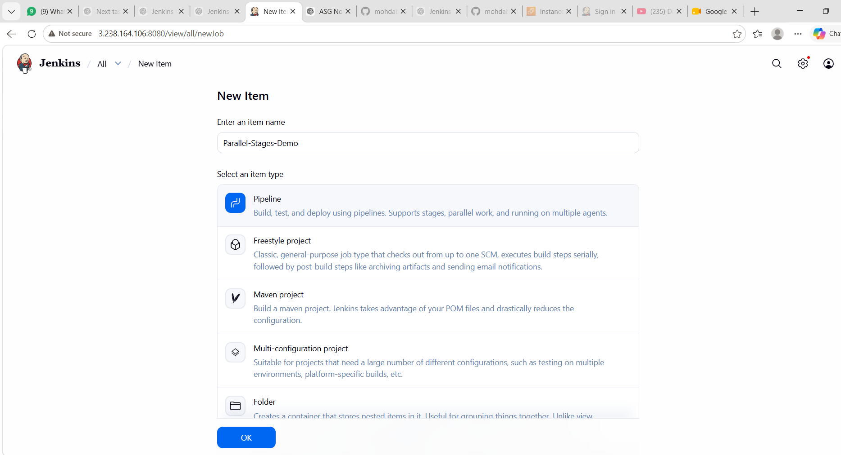
Enter:
Parallel-Stages-Demo
Select:
Pipeline
Then click OK.
📸 Screenshot 1: Capture the New Item / Pipeline job configuration.

Step 2 — Configure Pipeline
Scroll down to the Pipeline section.
Set:
Definition:
Pipeline script
⚠️ For this task, select Pipeline script, not Pipeline script from SCM.
Paste this exact pipeline:
pipeline {
agent any

stages {

stage('Parallel Checks') {
parallel {

stage('Unit Test') {
steps {
echo 'Running Unit Tests...'
sh 'sleep 5'
echo 'Unit Tests completed successfully'
}
}

stage('Code Quality') {
steps {
echo 'Running Code Quality Check...'
sh 'sleep 5'
echo 'Code Quality Check completed successfully'
}
}

stage('Environment Check') {
steps {
echo 'Checking Environment...'
sh 'java -version'
sh 'mvn -version'
echo 'Environment Check completed successfully'
}
}
}
}

stage('Build') {
steps {
echo 'All parallel stages completed.'
echo 'Starting final Build...'
sh 'echo Build completed successfully'
}
}
}

post {
success {
echo 'Parallel Pipeline completed successfully!'
}

failure {
echo 'Parallel Pipeline failed!'
}

always {
echo 'Pipeline execution completed.'
}
}
}
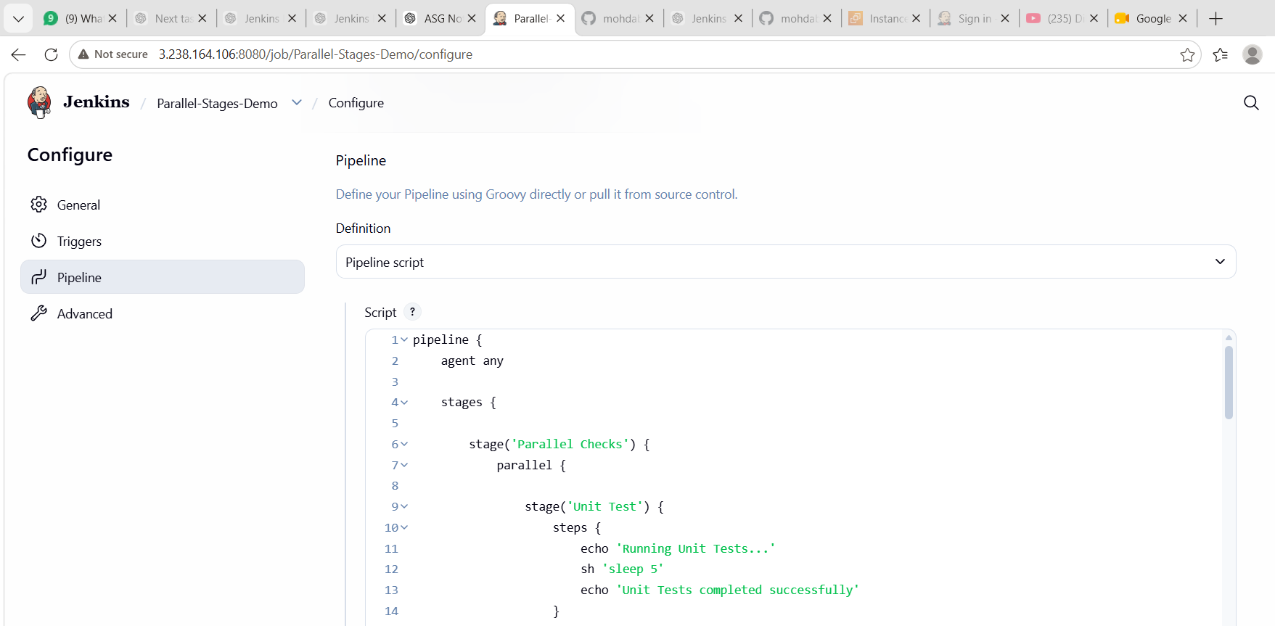
Click:
Save

Step 3 — Build the Job
Click:
Build Now
You should see a new build, for example:
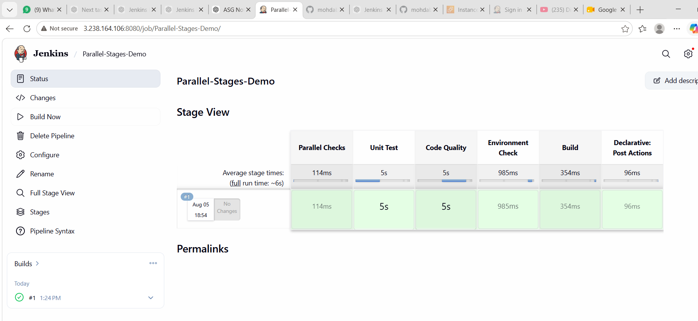
#1
Click the build number.
Then select:
Console Output
📸 Screenshot 2: Capture the console output showing the parallel stages executing.

Step 4 — Check Stage View
Go back to the job's main page.
You should see something similar to:
Stage View

Parallel Checks
├── Unit Test
├── Code Quality
└── Environment Check

↓

Build
The important point is that Unit Test, Code Quality, and Environment Check are parallel branches.
📸 Screenshot 3: Capture the Stage View showing the parallel stages.

Step 5 — Verify Success
At the bottom of Console Output, you should see:
Parallel Pipeline completed successfully!
Pipeline execution completed.
Finished: SUCCESS
📸 Screenshot 4: Capture the Finished: SUCCESS result.

What you should write in your document
Task 7 — Execute Parallel Stages Using Jenkins Pipeline
Objective:
To understand and implement parallel stage execution in Jenkins Declarative Pipeline.
Implementation:
A Jenkins Pipeline was created with three parallel stages:
- Unit Test
- Code Quality
- Environment Check
After all parallel stages completed successfully, a final Build stage was executed.
Result:
Unit Test ─┐
Code Quality ─┼──> Build
Environment Check ─┘
Outcome:
The Jenkins pipeline executed multiple stages in parallel and completed successfully.
Status: ✅ Task 7 Completed

Part 8 — Jenkins Shared Library
Objective
To create a reusable Jenkins Shared Library and use it from a Jenkins Pipeline. Shared Libraries allow common pipeline logic to be reused across multiple Jenkins jobs.
We will use a simple example so it is easy to demonstrate and document.

Step 1 — Create Shared Library Repository
Create a new GitHub repository, for example:
jenkins-shared-library
You can create it under your GitHub account.
Inside the repository, create this structure:
jenkins-shared-library/
├── vars/
│ └── helloPipeline.groovy
└── README.md
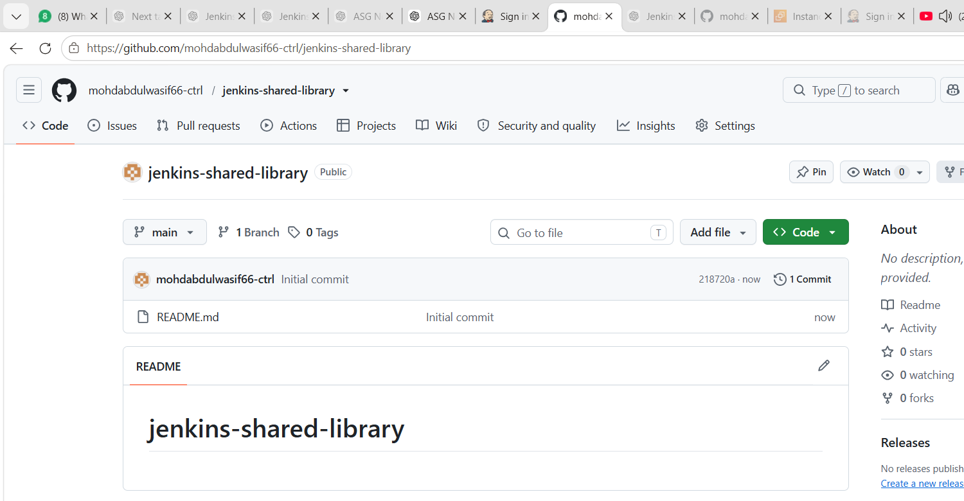
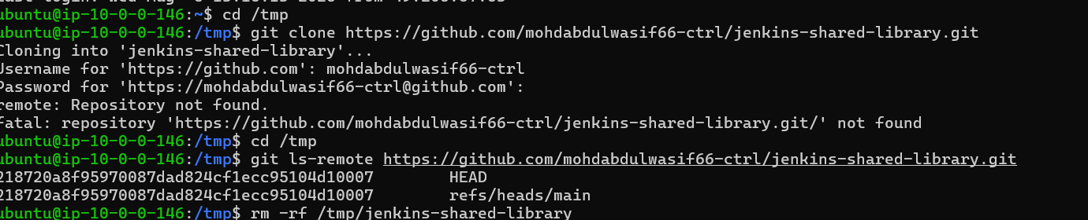
The important file is:
vars/helloPipeline.groovy

Step 2 — Create helloPipeline.groovy
Put this inside vars/helloPipeline.groovy:
def call() {

pipeline {

agent any

stages {

stage('Checkout') {
steps {
echo 'Shared Library: Checkout stage'
}
}

stage('Build') {
steps {
echo 'Shared Library: Build stage'
sh 'echo Build completed successfully'
}
}

stage('Test') {
steps {
echo 'Shared Library: Test stage'
sh 'echo Tests completed successfully'
}
}

stage('Package') {
steps {
echo 'Shared Library: Package stage'
sh 'echo Package completed successfully'
}
}
}

post {
success {
echo 'Shared Library Pipeline completed successfully!'
}

failure {
echo 'Shared Library Pipeline failed!'
}

always {
echo 'Shared Library Pipeline execution completed.'
}
}
}
}
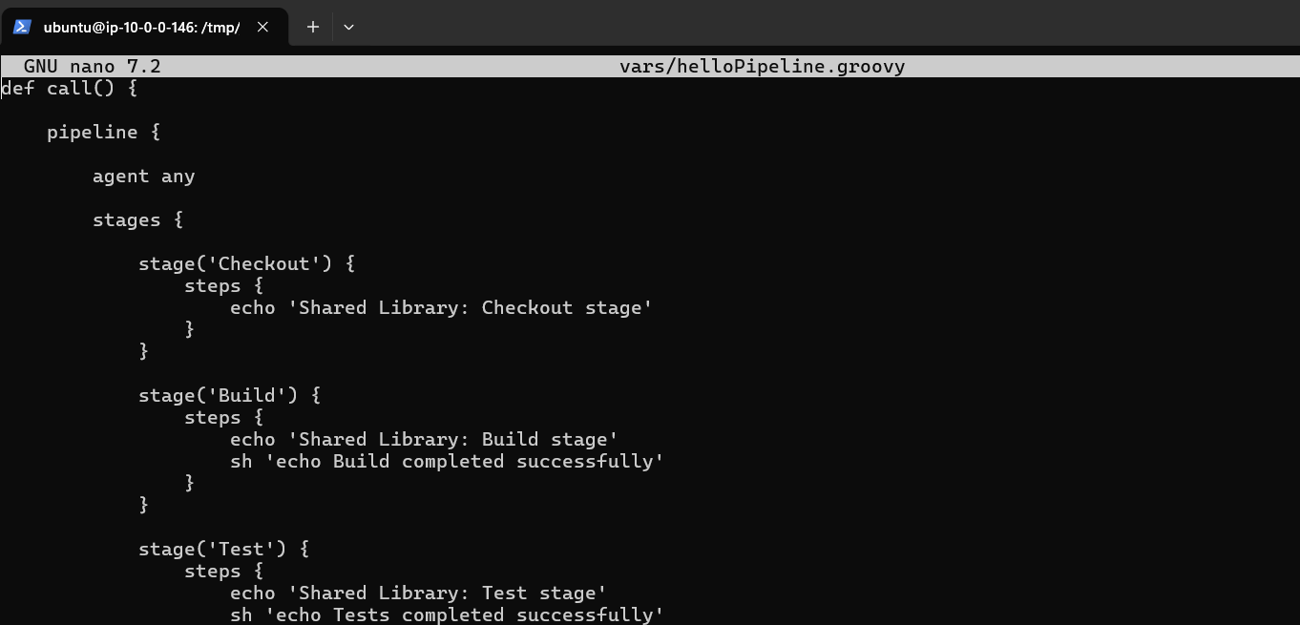
Commit and push it to GitHub.
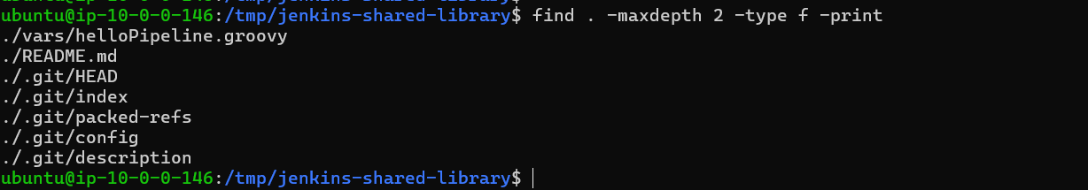
Your repository should look like:
jenkins-shared-library
│
├── vars
│ └── helloPipeline.groovy
│
└── README.md
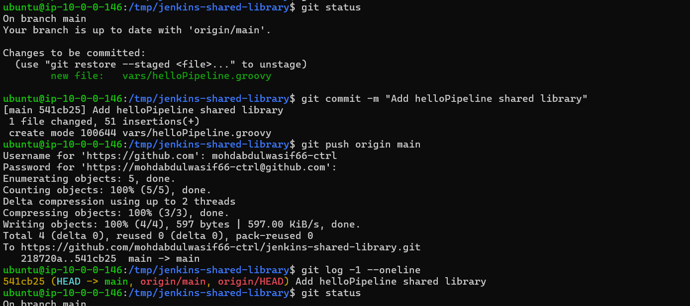
Step 3 — Configure Jenkins Global Shared Library
Go to:
Jenkins Dashboard
↓
Manage Jenkins
↓
System
Scroll down until you find:
Global Pipeline Libraries
Click:
Add
Configure:
Name
my-shared-library
⚠️ Remember this name because we'll use exactly the same name in the Jenkins Pipeline.
Default version
main
Retrieval method
Select:
Modern SCM
Source Code Management
Select:
Git
Project Repository
Enter your repository URL:
https://github.com/YOUR_USERNAME/jenkins-shared-library.git
If your repository is public, you can leave credentials as:
- none -
Then click:
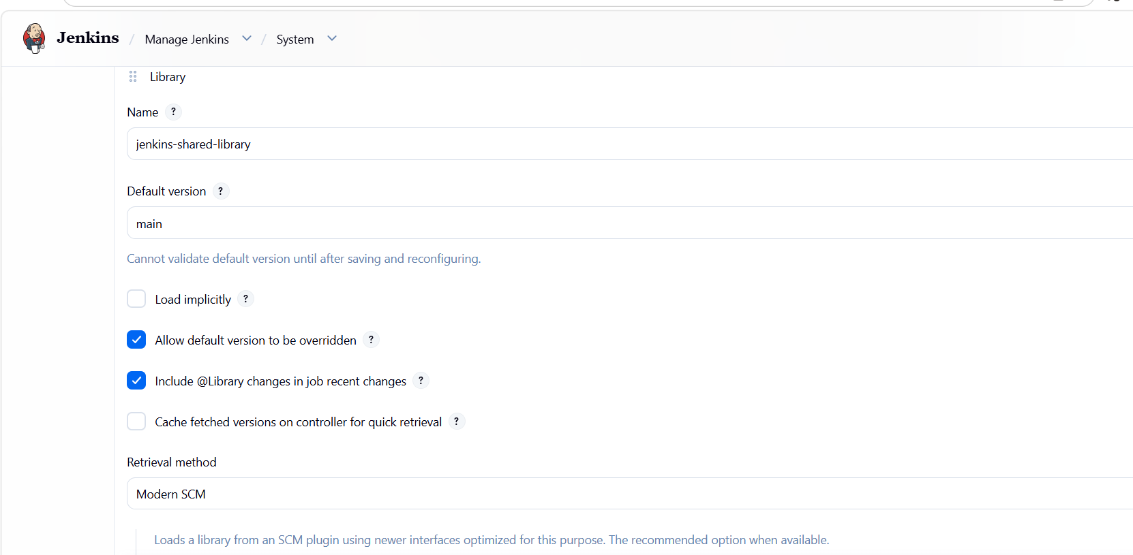
Save
📸 Screenshot 2: Capture the Global Pipeline Libraries configuration.

Step 4 — Create Jenkins Pipeline Job
Go to:
Jenkins Dashboard
↓
New Item
Create:
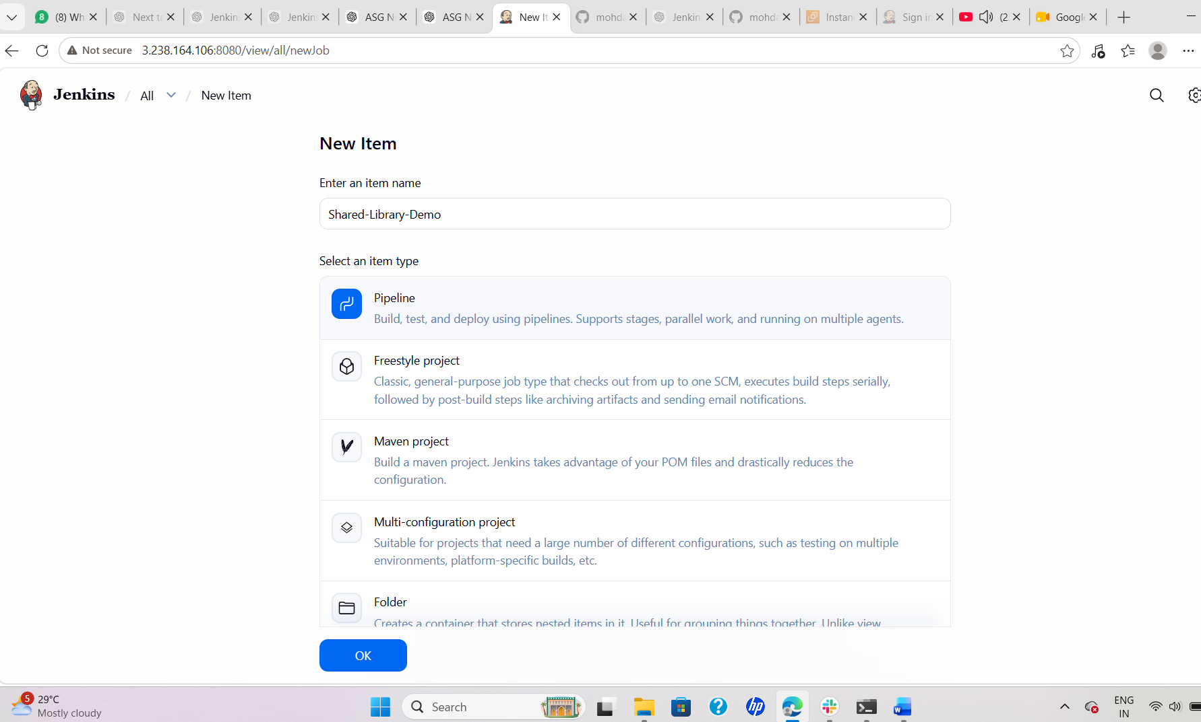
Shared-Library-Demo
Select:
Pipeline
Click:
OK

Step 5 — Add Pipeline Script
Scroll to:
Pipeline
Select:
Pipeline script
Paste:
@Library('my-shared-library') _

helloPipeline()
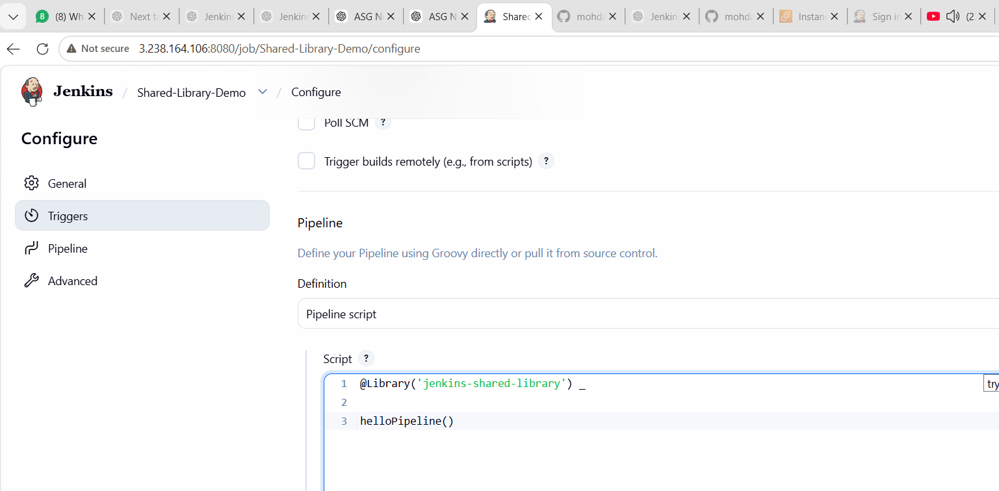
That's it. 🎯
Notice that we don't define all the stages here.
The stages are coming from our Shared Library.
Click:
Save
📸 Screenshot 3: Capture the Jenkins Pipeline script showing:
@Library('my-shared-library') _

helloPipeline()

Step 6 — Build
Click:
Build Now
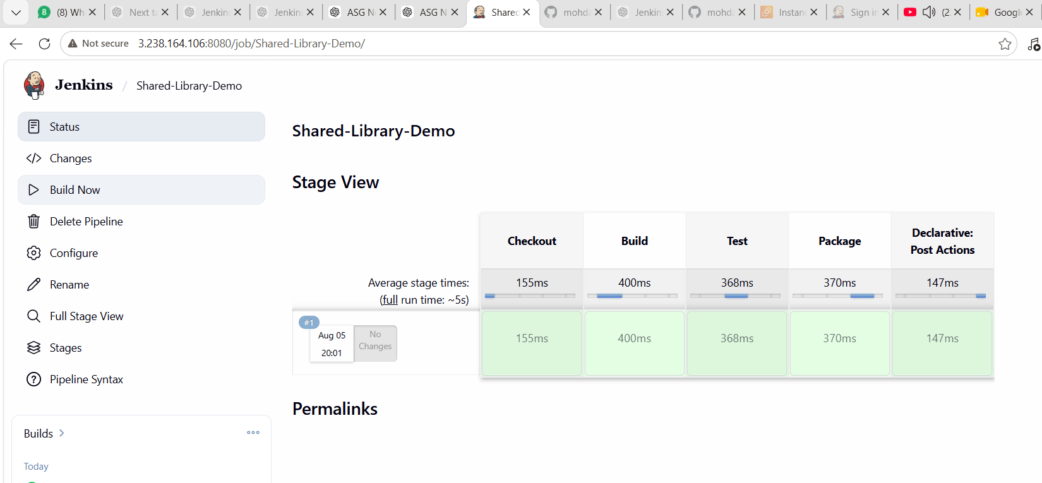
Jenkins will load the shared library and execute the pipeline.
You should see stages such as:
Checkout
↓
Build
↓
Test
↓
Package

Step 7 — Check Console Output
Open:
Build #1 → Console Output
You should see messages similar to:
Shared Library: Checkout stage

Shared Library: Build stage
Build completed successfully

Shared Library: Test stage
Tests completed successfully

Shared Library: Package stage
Package completed successfully

Shared Library Pipeline completed successfully!

Finished: SUCCESS
📸 Screenshot 5: Capture the final successful console output.

Important Concept
The normal Jenkinsfile contains:
@Library('my-shared-library') _

helloPipeline()
While the actual pipeline implementation is stored in:
jenkins-shared-library/
└── vars/
└── helloPipeline.groovy
So the architecture is:
GitHub
│
│
▼
jenkins-shared-library
│
└── vars/
└── helloPipeline.groovy
│
▼
Jenkins Shared Library
│
▼
Shared-Library-Demo
│
▼
Jenkins Pipeline
│
┌────────┼────────┐
▼ ▼ ▼
Checkout Build Test
│
▼
Package
Documentation for Task 8
Task 8 — Execute Jenkins Pipeline Stages Using Shared Libraries
Objective:
To create and configure a Jenkins Shared Library and use reusable pipeline code from a Jenkins job.
Implementation:
A GitHub repository was created containing a reusable Jenkins pipeline under the vars directory. The library was configured globally in Jenkins and then imported into a Jenkins Pipeline using the @Library annotation.
Shared Library:
my-shared-library
Reusable Pipeline Function:
helloPipeline()
Jenkins Pipeline:
@Library('my-shared-library') _

helloPipeline()
Stages executed:
Checkout → Build → Test → Package
Expected Result:
Finished: SUCCESS
Outcome:
The Jenkins Shared Library was successfully configured and used to execute reusable pipeline stages.
Status: ✅ Task 8 Completed

