Ansible-Task-02

Task 1: Install HTTPD using Ansible Playbook with Handlers and Notify
Objective
To create an Ansible playbook that:
- Installs Apache HTTP Server (httpd) on worker nodes
- Starts and enables the HTTPD service
- Uses handlers and notify
- Automatically restarts Apache when configuration changes

What are Handlers and Notify?
Normal task flow:
Task
|
|
Install Package
|
|
Start Service
With Handler:
Task
|
|
Configuration changed
|
|
Notify
|
|
Handler runs
|
|
Restart Service

What is Notify?
notify tells Ansible:
"If this task changes something, call this handler."
Example:
notify:
- restart httpd

What is Handler?
A handler is a special task that runs only when notified.
Example:
handlers:
- name: restart httpd
service:
name: httpd
state: restarted

Step 1: Login to Ansible Master
Connect:
ssh ec2-user@<MASTER-IP>
Go to your Ansible directory:
cd ~/ansible-lab
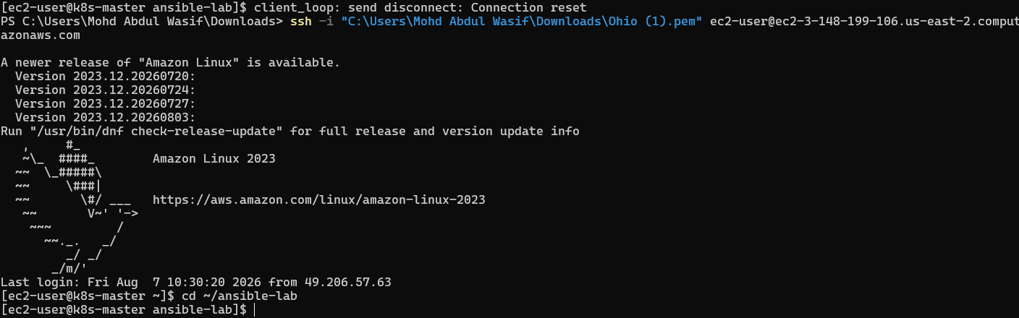
Check:
ls
You should have:
ansible_hosts

Step 2: Create Playbook Directory
Create:
mkdir playbooks
cd playbooks

Step 3: Create HTTPD Playbook
Create file:
vi install_httpd.yml
Press:
I
Paste:
---
- name: Install and configure Apache HTTP Server
hosts: workers
become: yes

tasks:

- name: Install httpd package
dnf:
name: httpd
state: present
notify:
- restart httpd

- name: Start httpd service
service:
name: httpd
state: started
enabled: yes

handlers:

- name: restart httpd
service:
name: httpd
state: restarted
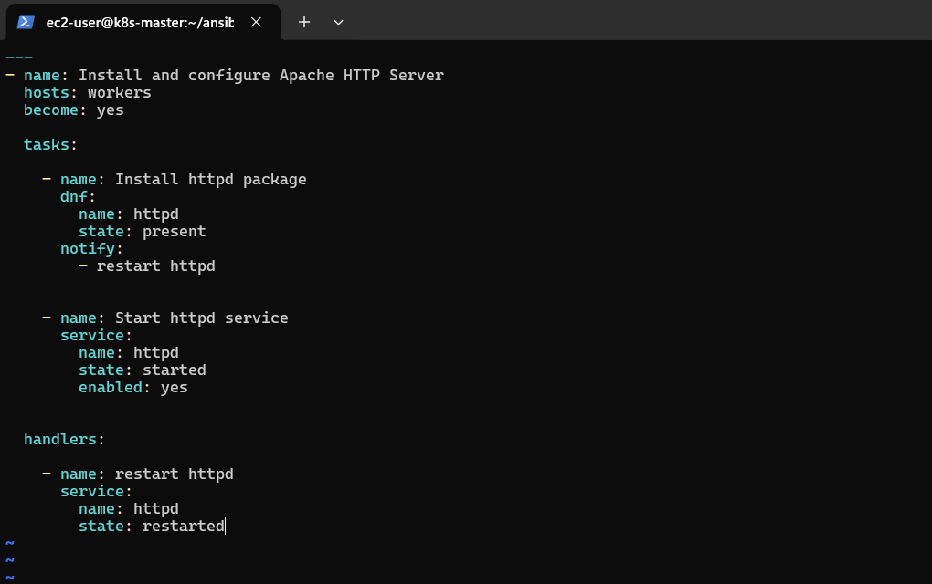
Save:
ESC
:wq
ENTER

Step 4: Understand the Playbook
Play definition
hosts: workers
Means:
Run on:
worker01
worker02
from inventory.

Become
become: yes
Means:
Execute with sudo/root privileges.

Task 1
dnf:
name: httpd
state: present
Installs Apache.
Equivalent Linux command:
sudo dnf install httpd -y
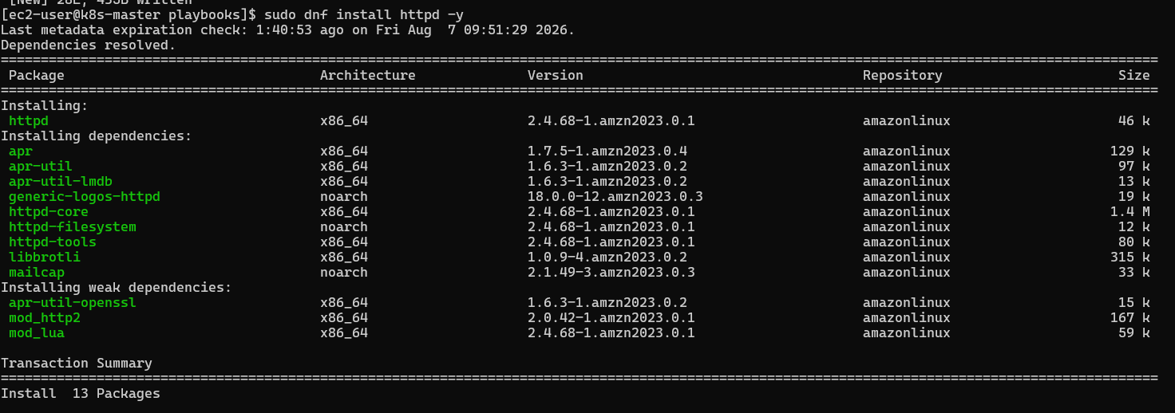

Notify
notify:
- restart httpd
Calls the handler if package changes.

Handler
handlers:

- name: restart httpd
Restarts Apache.

Step 5: Check YAML Syntax
Before running:
ansible-playbook install_httpd.yml --syntax-check -i ../ansible_hosts
Expected:
playbook: install_httpd.yml

Step 6: Run Playbook
Execute:
ansible-playbook install_httpd.yml -i ../ansible_hosts
Expected output:
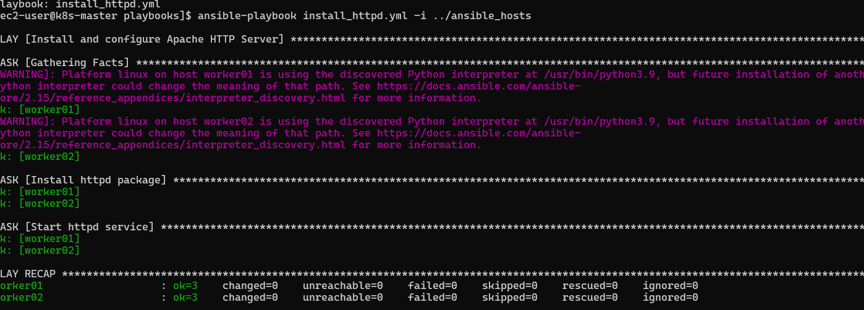
First run:
TASK [Install httpd package]
changed

TASK [Start httpd service]
changed

PLAY RECAP

worker01 ok=2 changed=2
worker02 ok=2 changed=2

Step 7: Verify HTTPD Installation
Check service:
ansible all -a "systemctl status httpd --no-pager" -b -i ../ansible_hosts
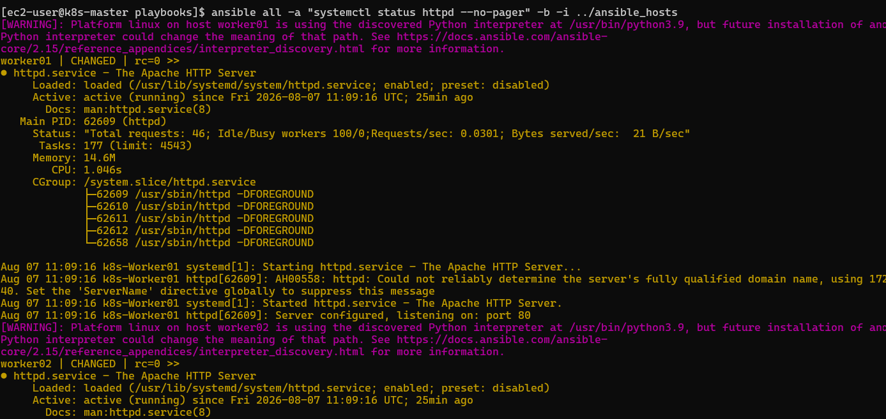
Expected:
Active: active (running)

Check Apache version:
ansible all -a "httpd -v" -i ../ansible_hosts
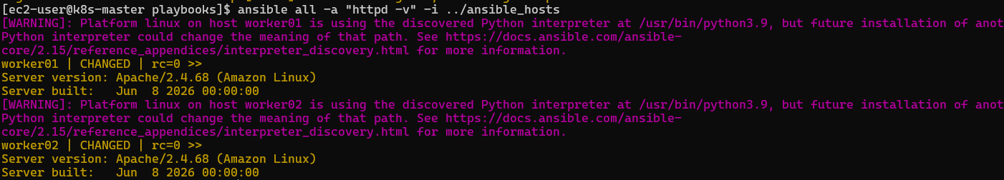
Example:
Server version: Apache/2.4.x

Step 8: Test Handler
Edit playbook and add a configuration change task:
- name: Update httpd config
lineinfile:
path: /etc/httpd/conf/httpd.conf
line: "ServerName localhost"
notify:
- restart httpd
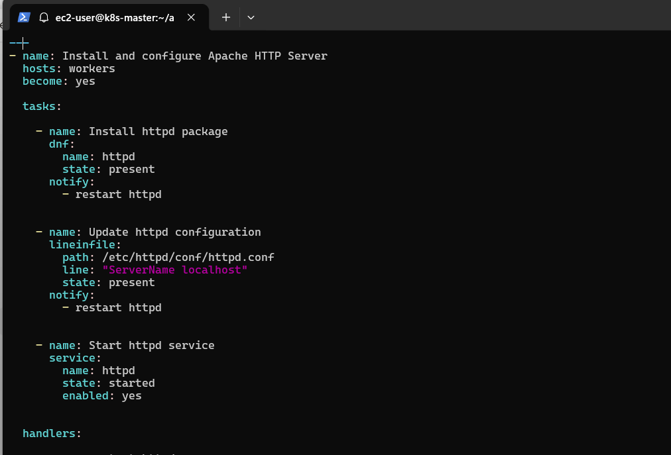
Run again:
ansible-playbook install_httpd.yml -i ../ansible_hosts
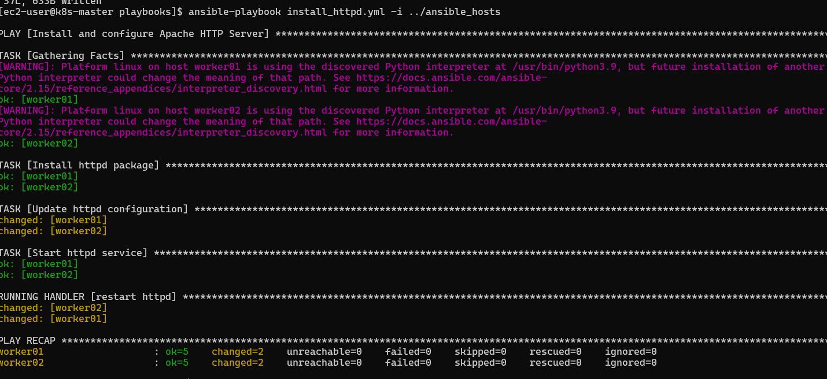
Output:
RUNNING HANDLER [restart httpd]
changed
This proves handler is working.

What We Learned
✅ How to write an Ansible YAML playbook
✅ Difference between ad-hoc commands and playbooks
✅ How to install packages using modules
✅ How become provides sudo access
✅ How handlers work
✅ How notify triggers handlers
✅ How to automate service management

Conclusion
In this task, we automated Apache HTTP Server installation on multiple worker nodes using an Ansible playbook. We used handlers and notify to restart the Apache service only when required, following Ansible automation best practices.

Task 2: Write an Ansible Playbook to Install Apache Tomcat
Objective
To create an Ansible playbook that will automatically install and configure Apache Tomcat on worker nodes.
The playbook will:
- Install Java (required for Tomcat)
- Create a Tomcat user
- Download Apache Tomcat
- Extract Tomcat files
- Configure permissions
- Create a systemd service
- Start and enable Tomcat service

What is Apache Tomcat?
Apache Tomcat is an open-source Java application server used to run:
- Java Web Applications
- JSP applications
- Servlet-based applications
- Spring Boot applications (WAR deployments)
Architecture:
Ansible Master
|
SSH Automation
|
---------------------
| |
Worker01 Worker02
| |
Tomcat Tomcat
:8080 :8080
Check if inventory file exists
Run:
ls -l /home/ec2-user/ansible_hosts
Expected:
-rw-r--r-- 1 ec2-user ec2-user 100 Aug 7 ansible_hosts
If you get:
No such file or directory
create it.

Step 2: Create Ansible Inventory File
Run:
vi ansible_hosts
Add your worker node private IPs.
Example:
[workers]
worker1 ansible_host=10.0.1.20
worker2 ansible_host=10.0.2.30

[workers:vars]
ansible_user=ec2-user
Replace:
10.0.1.20
10.0.2.30
with your actual worker private IP addresses.
Save:
ESC
:wq
ENTER

Step 3: Validate Inventory
Run:
ansible-inventory -i ansible_hosts --list
Expected:
{
"workers": {
"hosts": [
"worker1",
"worker2"
]
}
}

Step 4: Test SSH Connection Manually
From master:
ssh ec2-user@<worker-private-ip>
Example:
ssh ec2-user@10.0.1.20
If it asks for a password, SSH key is not configured.
Exit:
exit
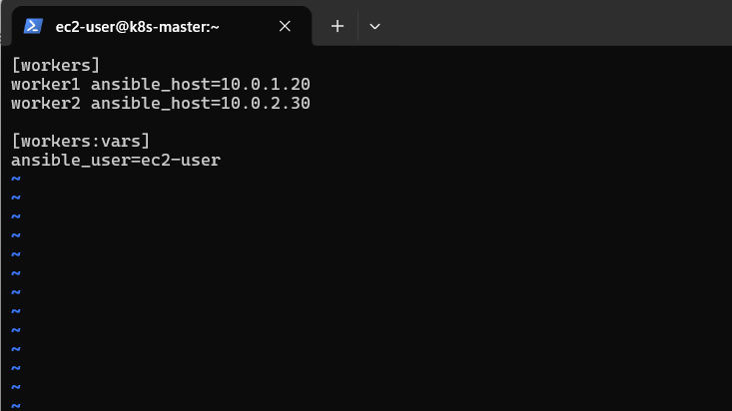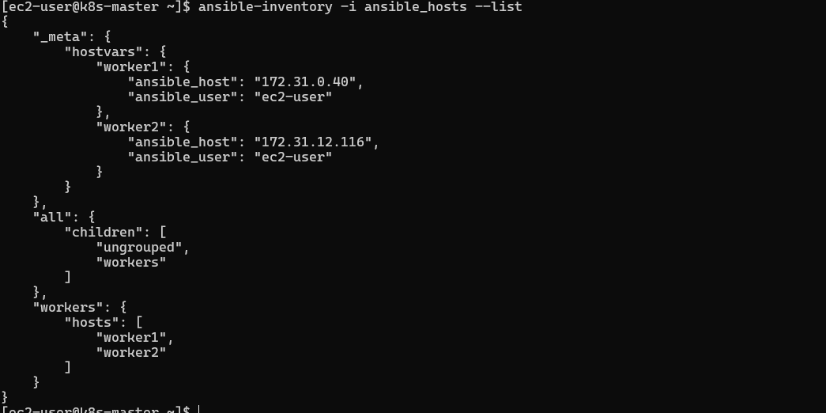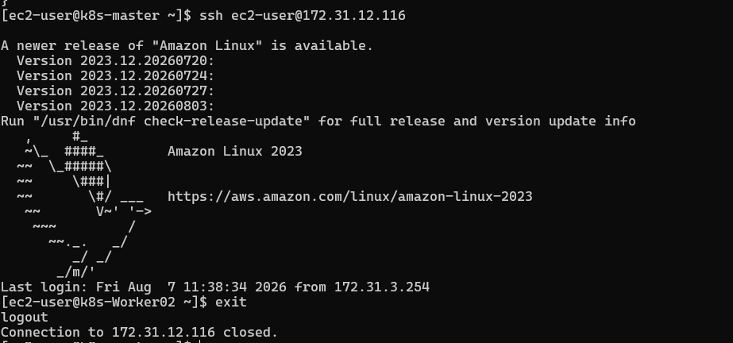
Prerequisites
Check workers are reachable:
ansible all -m ping -i ansible_hosts
Expected:
worker01 | SUCCESS => pong
worker02 | SUCCESS => pong
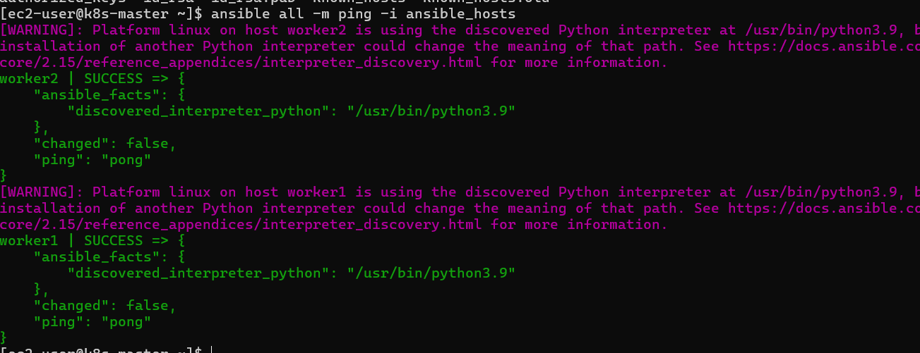

Step 1: Go to Playbook Directory
On Ansible master:
cd ~/ansible-lab/playbooks
Check:
ls
You should see:
install_httpd.yml

Step 2: Create Tomcat Playbook
Create file:
vi install_tomcat.yml
Press:
i
Paste:
---
- name: Install and Configure Apache Tomcat
hosts: workers
become: yes

vars:
tomcat_version: "10.1.24"
tomcat_user: "tomcat"
tomcat_dir: "/opt/tomcat"

tasks:

- name: Install Java
dnf:
name: java-17-amazon-corretto
state: present

- name: Create Tomcat User
user:
name: "{{ tomcat_user }}"
shell: /bin/false

- name: Download Tomcat
get_url:
url: "https://archive.apache.org/dist/tomcat/tomcat-10/v{{ tomcat_version }}/bin/apache-tomcat-{{ tomcat_version }}.tar.gz"
dest: "/tmp/tomcat.tar.gz"

- name: Create Tomcat Directory
file:
path: "{{ tomcat_dir }}"
state: directory

- name: Extract Tomcat
unarchive:
src: "/tmp/tomcat.tar.gz"
dest: "{{ tomcat_dir }}"
remote_src: yes
extra_opts:
- --strip-components=1

- name: Change Tomcat Ownership
file:
path: "{{ tomcat_dir }}"
owner: "{{ tomcat_user }}"
group: "{{ tomcat_user }}"
recurse: yes

- name: Create Tomcat Service
copy:
dest: /etc/systemd/system/tomcat.service
content: |
[Unit]
Description=Apache Tomcat Server
After=network.target

[Service]
Type=forking

User={{ tomcat_user }}

Environment=JAVA_HOME=/usr/lib/jvm/java-17-amazon-corretto

ExecStart={{ tomcat_dir }}/bin/startup.sh
ExecStop={{ tomcat_dir }}/bin/shutdown.sh

Restart=always

[Install]
WantedBy=multi-user.target

- name: Reload systemd
systemd:
daemon_reload: yes

- name: Start Tomcat Service
systemd:
name: tomcat
state: started
enabled: yes
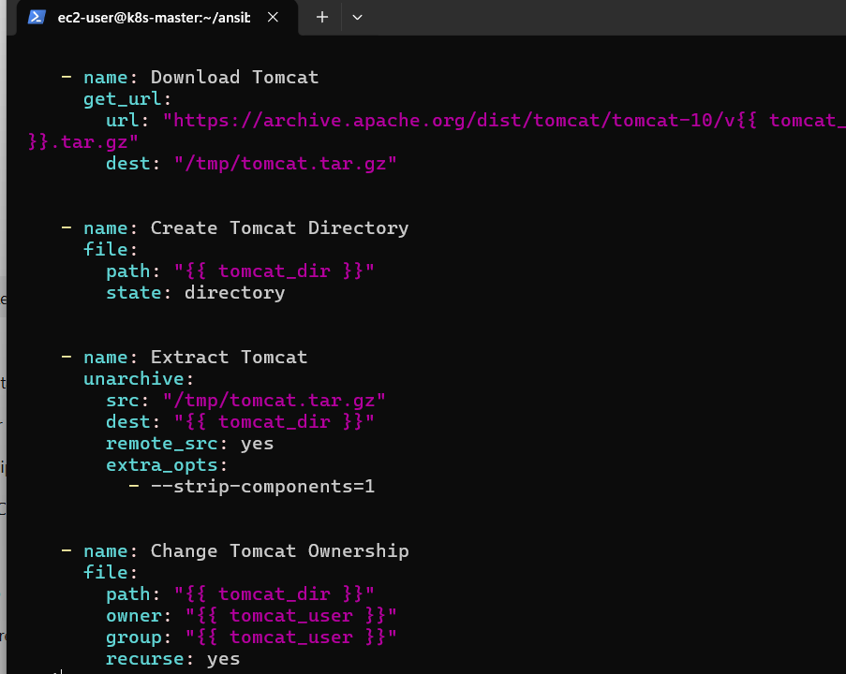
Save:
ESC
:wq
ENTER

Step 3: Check Syntax
Before execution:
ansible-playbook install_tomcat.yml --syntax-check -i ../ansible_hosts
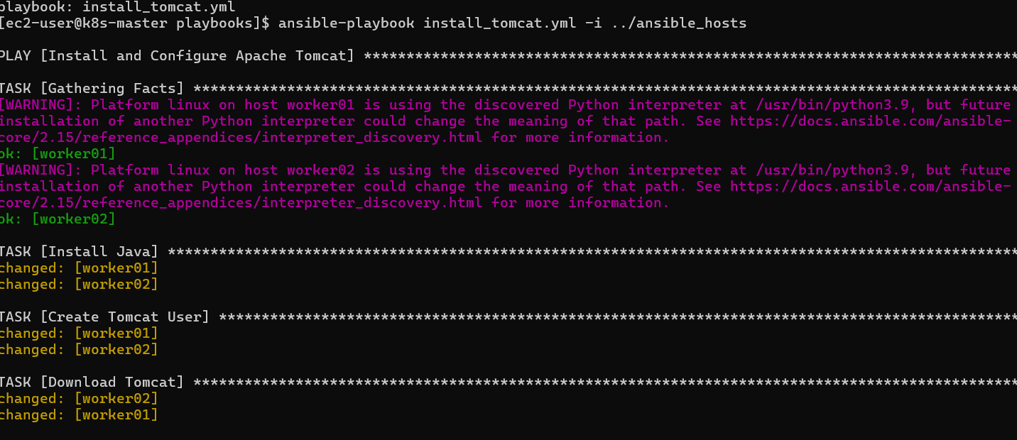
Expected:
playbook: install_tomcat.yml

Step 4: Run Tomcat Playbook
Execute:
ansible-playbook install_tomcat.yml -i ../ansible_hosts
Expected tasks:
TASK [Install Java]
changed

TASK [Create Tomcat User]
changed

TASK [Download Tomcat]
changed

TASK [Extract Tomcat]
changed

TASK [Create Tomcat Service]
changed

TASK [Start Tomcat Service]
changed

Step 5: Verify Tomcat Service
Run:
ansible all -a "systemctl status tomcat --no-pager" -b -i ../ansible_hosts
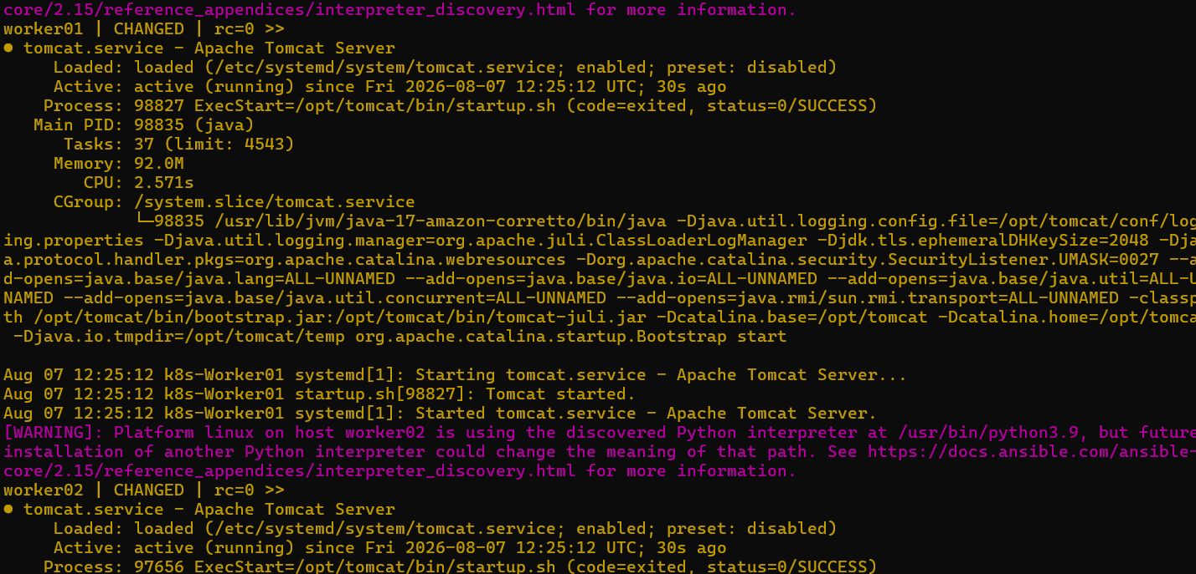
Expected:
Active: active (running)

Step 6: Check Tomcat Port
Tomcat runs on port:
8080
Check:
ansible all -m shell -a "ss -tulnp | grep 8080" -i ../ansible_hosts
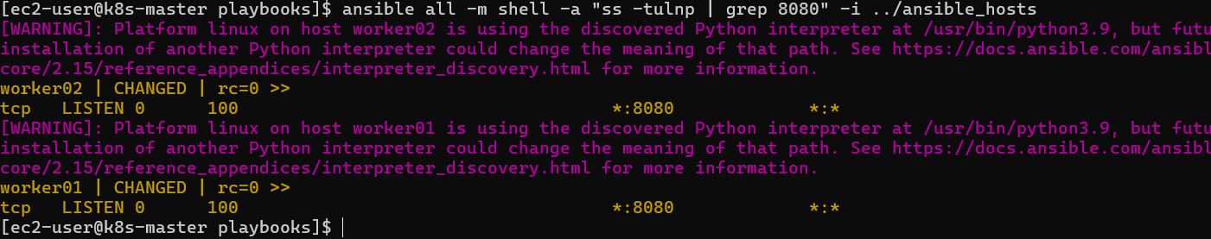
Expected:
LISTEN 0 100 *:8080
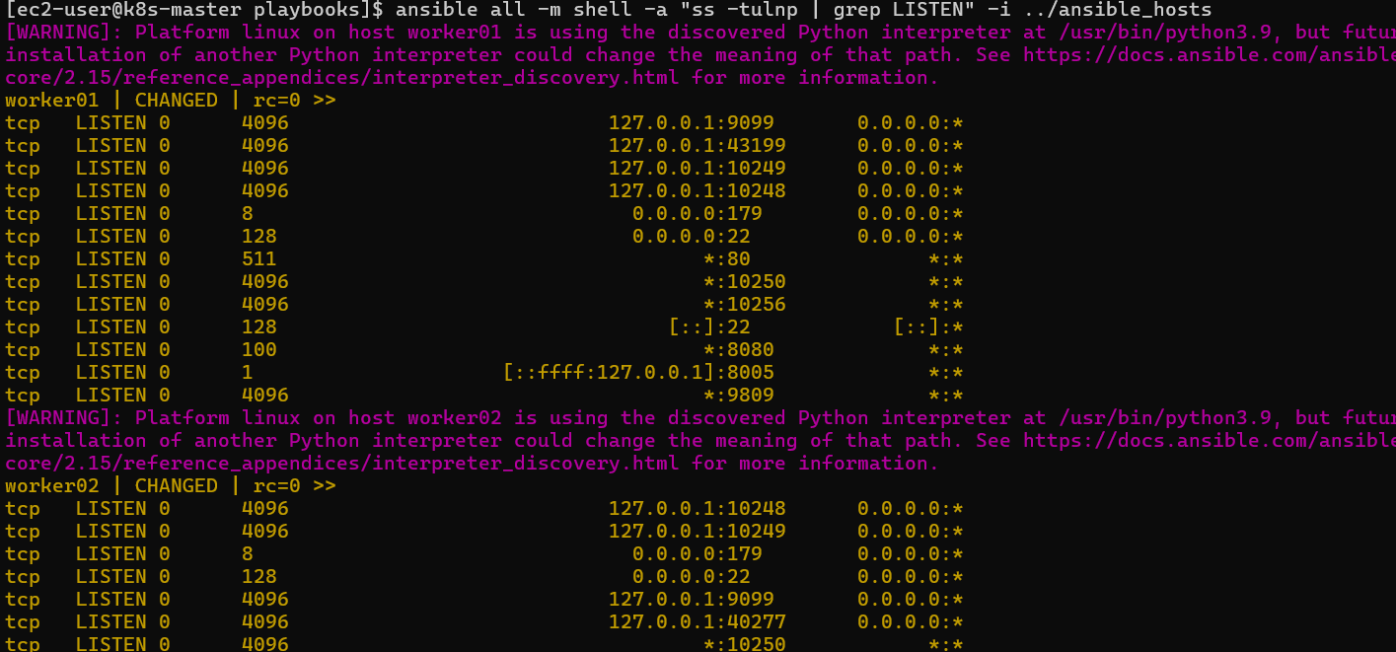

Step 7: Test From Browser (Optional)
Open:
http://<worker-public-ip>:8080
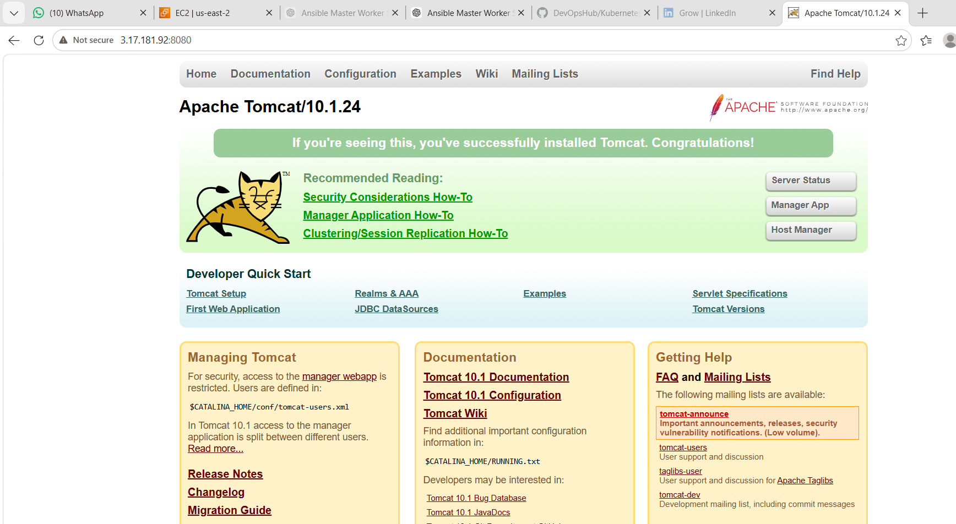
You should see:
Apache Tomcat Welcome Page

What We Learned
✅ How to automate application server installation
✅ Installing Java dependency using Ansible
✅ Using variables in playbooks
✅ Using modules:
- dnf
- user
- get_url
- unarchive
- file
- copy
- systemd
✅ Creating Linux services using Ansible
✅ Managing application lifecycle with Ansible

Conclusion
In this task, we created an Ansible playbook to install and configure Apache Tomcat automatically on worker nodes. The playbook installs Java, downloads Tomcat, configures it as a Linux service, and starts Tomcat without manual intervention.

Task 3: Write an Ansible Playbook to Provision One EC2 Instance on AWS

Objective
To create an Ansible playbook that will automatically provision an EC2 instance on AWS.
The playbook will:
- Connect to AWS using Ansible
- Create an EC2 instance
- Select AMI
- Select instance type
- Assign key pair
- Configure security group
- Launch the instance

Architecture
Before:
AWS Console
|
|
Manual EC2 Creation
After:
Ansible Master
|
|
AWS Ansible Module
|
|
AWS Cloud
|
EC2 Instance

Prerequisites
1. Install AWS Collection for Ansible
On Ansible Master:
ansible-galaxy collection install amazon.aws
Check:
ansible-galaxy collection list
You should see:
amazon.aws
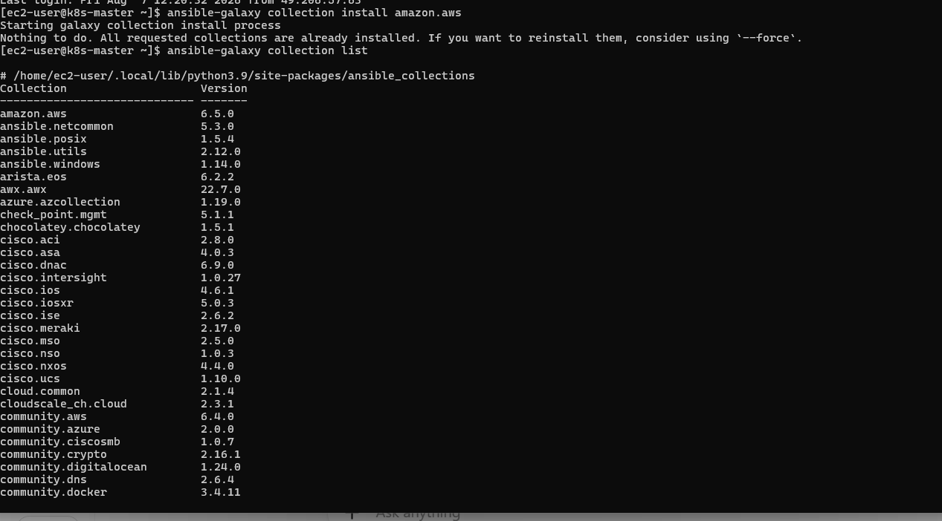

2. Install AWS Python SDK
Ansible AWS modules require boto3.
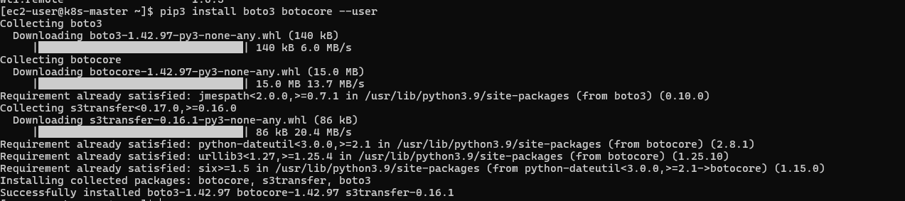
Run:
pip3 install boto3 botocore –user
Verify:
python3 -c "import boto3; print(boto3.__version__)"

Step 1: Configure AWS Credentials
On Ansible master:
aws configure
Enter:
AWS Access Key ID:
AWS Secret Access Key:
Default region:
us-east-2
Output format:
json
Test:
aws ec2 describe-instances
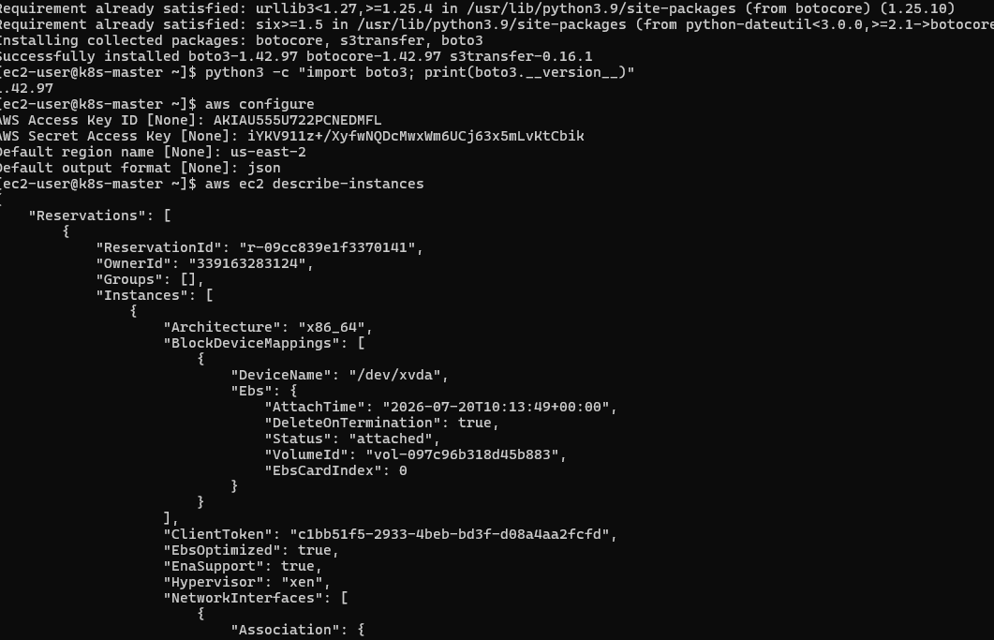
If it shows EC2 details → AWS connection is successful.

Step 2: Go to Playbook Directory
cd ~/ansible-lab/playbooks

Step 3: Create EC2 Provisioning Playbook
Create:
vi create_ec2.yml
Paste:
---
- name: Provision EC2 Instance
hosts: localhost
connection: local

tasks:

- name: Create EC2 Instance
amazon.aws.ec2_instance:
name: Ansible-Test-Server
key_name: Ohio
instance_type: t2.micro
image_id: ami-0ea3c35c5c3284d82
region: us-east-2

security_group: launch-wizard-2

network:
assign_public_ip: true

tags:
Environment: Dev
CreatedBy: Ansible

wait: yes

state: running
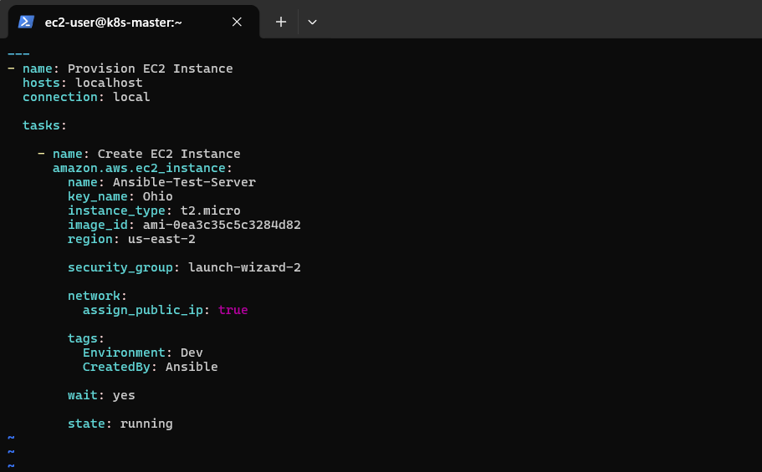
Save:
ESC
:wq
ENTER

Step 4: Understand Playbook
hosts
hosts: localhost
Means:
Run this task from Ansible Master.

connection
connection: local
No SSH required.

EC2 Module
amazon.aws.ec2_instance
This module creates AWS EC2 instances.

Instance Name
name: Ansible-Test-Server
EC2 Name tag.

Key Pair
key_name: Ohio
Uses your existing AWS key pair.

Instance Type
instance_type: t2.micro
Creates small instance.

AMI
image_id: ami-xxxx
Operating system image.

Step 5: Syntax Check
Run:
ansible-playbook create_ec2.yml --syntax-check
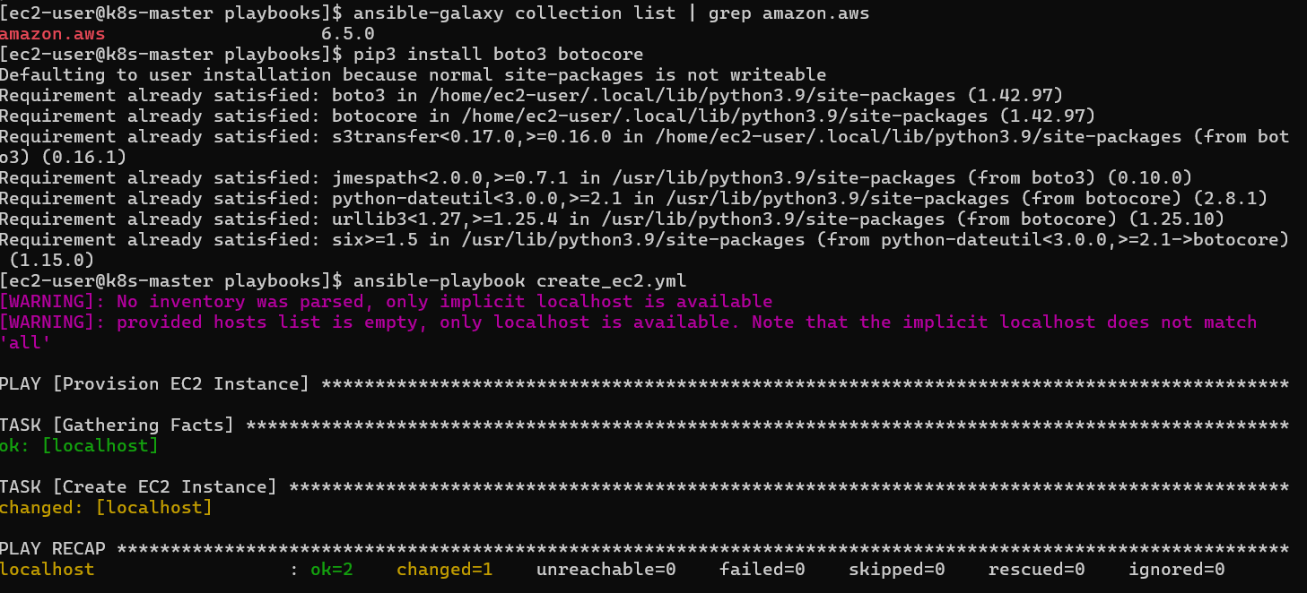
Expected:
playbook: create_ec2.yml

Step 6: Execute Playbook
Run:
ansible-playbook create_ec2.yml
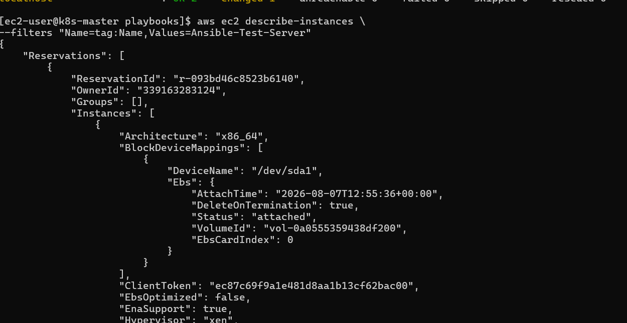
Expected:
TASK [Create EC2 Instance]

changed: [localhost]

PLAY RECAP

localhost : ok=1 changed=1 failed=0

Step 7: Verify EC2 Creation
AWS CLI:
aws ec2 describe-instances \
--filters "Name=tag:Name,Values=Ansible-Test-Server"

or check:
AWS Console
→ EC2
→ Instances
You should see:
Ansible-Test-Server
Running
Run:
aws ec2 describe-instances \
--filters "Name=tag:Name,Values=Ansible-Test-Server" \
--query "Reservations[*].Instances[*].[InstanceId,State.Name,InstanceType,PublicIpAddress,PrivateIpAddress]" \
--output table
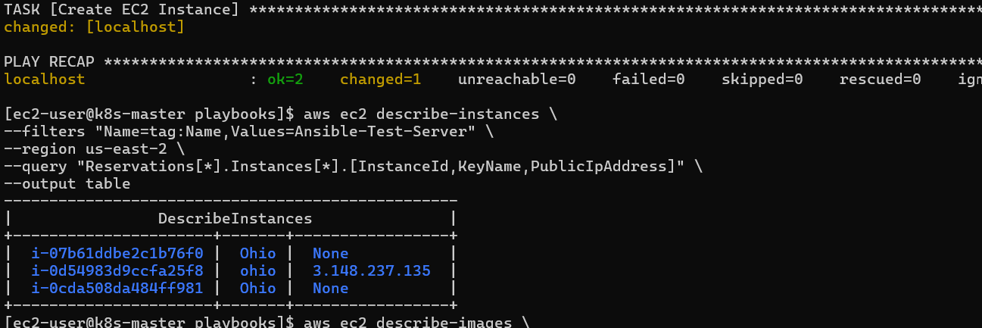
Expected output:
---------------------------------------------------------
| DescribeInstances |
+---------------+---------+----------+---------+--------+
| i-xxxxxxxxxxx | running | t3.small | x.x.x.x | 10.x.x |
---------------------------------------------------------
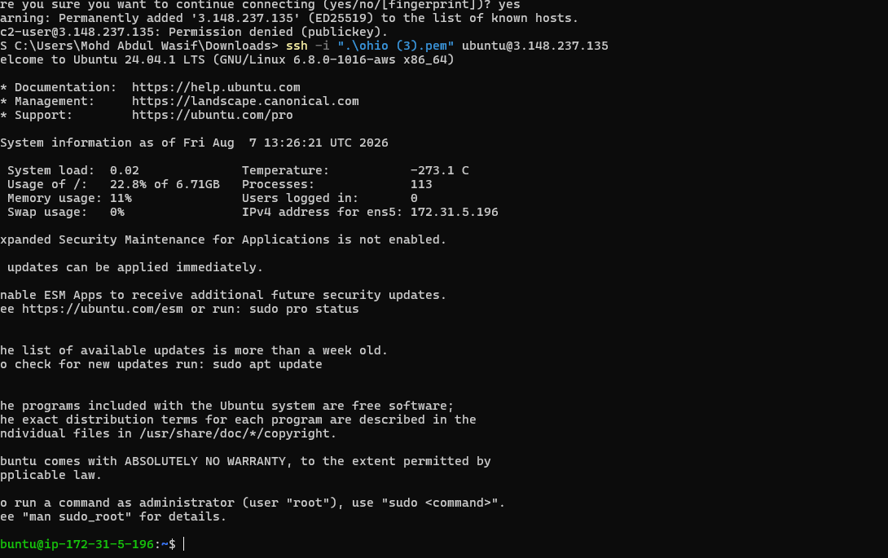

Important Note Before Running
Your current region is:
us-east-2 (Ohio)
Make sure the AMI ID matches us-east-2.
Find AMI:
AWS Console:
EC2
→ AMIs
→ Amazon Linux 2023
→ Copy AMI ID
Replace:
image_id:
with your AMI ID.

What We Learned
✅ Provisioning infrastructure using Ansible
✅ AWS automation using Ansible modules
✅ Using boto3 with Ansible
✅ Creating EC2 without AWS Console
✅ Infrastructure as Code concept

Conclusion
In this task, we automated EC2 instance creation using Ansible. Instead of manually creating servers from AWS Console, Ansible communicates with AWS APIs and provisions infrastructure automatically.
Task 4: Copy one file from Node-1 to Node-2 using Ansible Playbook
Objective
Transfer a file from one managed node (node-1) to another managed node (node-2) using Ansible.
Ansible normally copies files from control node → managed nodes, so we will use:
- fetch module → copy file from node-1 to Ansible master
- copy module → copy file from Ansible master to node-2

Architecture
Ansible Master
|
-----------------------
| |
node-1 node-2
| |
/tmp/source.txt /tmp/destination.txt

Step 1: Inventory File
Create inventory:
cd ~/ansible-lab
vi ansible_hosts
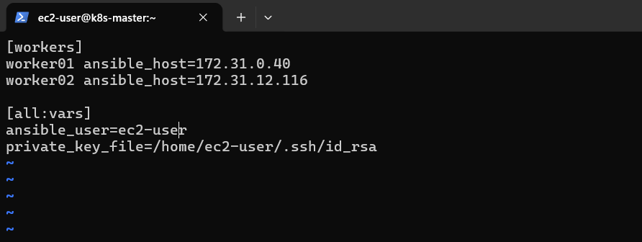
Add:
[node1]
node1 ansible_host=<NODE1_PRIVATE_IP> ansible_user=ubuntu ansible_private_key_file=~/ohio.pem

[node2]
node2 ansible_host=<NODE2_PRIVATE_IP> ansible_user=ubuntu ansible_private_key_file=~/ohio.pem
Example:
[node1]
node1 ansible_host=172.31.10.20 ansible_user=ubuntu ansible_private_key_file=~/ohio.pem

[node2]
node2 ansible_host=172.31.11.30 ansible_user=ubuntu ansible_private_key_file=~/ohio.pem

Step 2: Create Source File on Node-1
Create test file:
ansible worker01 -m copy \
-a "content='File copied from Node-1 to Node-2 using Ansible' dest=/tmp/source.txt" \
-b \
-i ansible_hosts
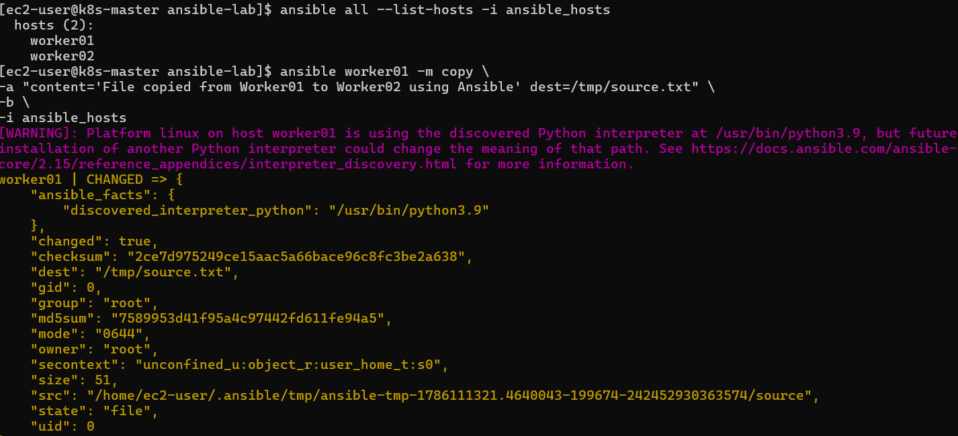
Verify:
ansible worker01 -a "cat /tmp/source.txt" -i ansible_hosts
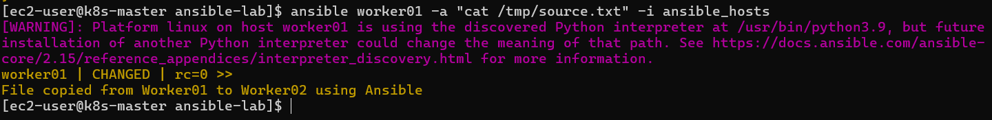
Output:
File copied from worker01 to worker02 using Ansible

Step 3: Create Playbook
Create file:
vi copy_worker01_to_worker02.yml
Use this:
---
- name: Copy file from Worker01 to Worker02
hosts: worker01
become: yes

tasks:

- name: Fetch file from Worker01 to Ansible Master
fetch:
src: /tmp/source.txt
dest: /tmp/
flat: yes

- name: Copy file from Ansible Master to Worker02
hosts: worker02
become: yes

tasks:

- name: Copy file to Worker02
copy:
src: /tmp/source.txt
dest: /tmp/destination.txt
owner: root
group: root
mode: '0644'
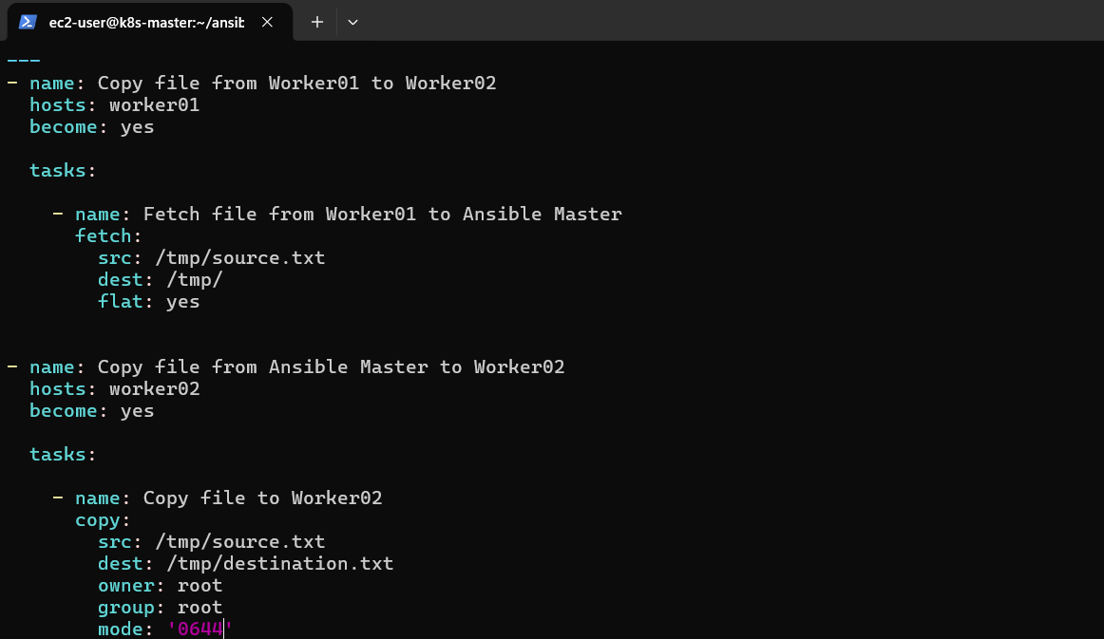

Step 4: Syntax Check
ansible-playbook copy_node1_to_node2.yml --syntax-check
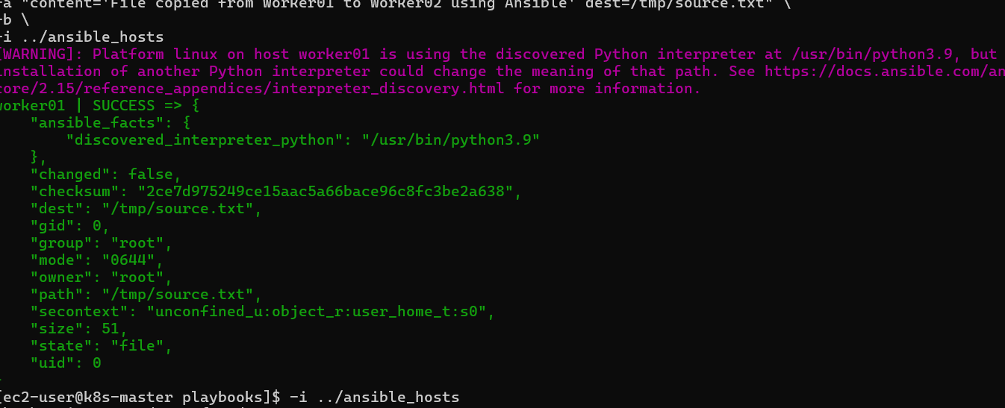
Run:
ansible-playbook copy_worker01_to_worker02.yml -i ../ansible_hosts
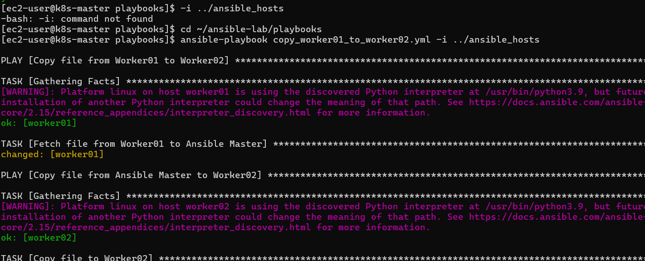
Expected output:
PLAY [Copy file from Worker01 to Worker02]

TASK [Fetch file from Worker01 to Ansible Master]
changed: [worker01]

PLAY [Copy file from Ansible Master to Worker02]

TASK [Copy file to Worker02]
changed: [worker02]

PLAY RECAP

worker01 : ok=2 changed=1 failed=0
worker02 : ok=2 changed=1 failed=0

After completion verify on Worker02:
ansible worker02 -a "cat /tmp/destination.txt" -i ../ansible_hosts
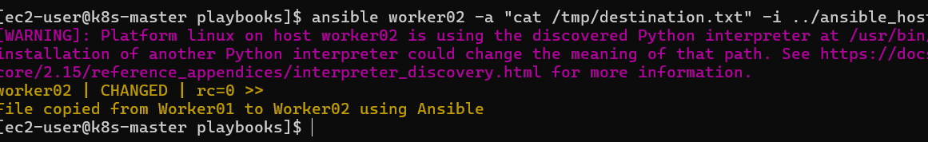
Expected:
File copied from Worker01 to Worker02 using Ansible
Then Task 4 is completed. 🎯
What We Learned
1. Ansible Inventory Management
We learned how Ansible identifies and manages multiple servers using an inventory file.
Example:
[workers]

worker01 ansible_host=172.31.0.40
worker02 ansible_host=172.31.12.116
Ansible uses these host names to execute tasks on specific machines.

2. Fetch Module
We learned how to use the fetch module.
Purpose:
- Copies files from managed node to Ansible Master.
Flow:
Worker01
|
| fetch module
↓
Ansible Master
Example:
fetch:
src: /tmp/source.txt
dest: /tmp/
flat: yes

3. Copy Module
We learned how to use the copy module.
Purpose:
- Copies files from Ansible Master to managed nodes.
Flow:
Ansible Master
|
| copy module
↓
Worker02
Example:
copy:
src: /tmp/source.txt
dest: /tmp/destination.txt

4. Multiple Plays in One Playbook
We learned that a single Ansible playbook can contain multiple plays.
Example:
First play:
hosts: worker01
Fetch file from Worker01.
Second play:
hosts: worker02
Copy file to Worker02.

5. Using Become (sudo)
We learned how to execute tasks with root privileges.
Example:
become: yes
This allows Ansible to create files with root ownership and permissions.

6. File Ownership and Permissions
We learned how to manage:
- Owner
- Group
- File permissions
Example:
owner: root
group: root
mode: '0644'

Task Execution Flow
Ansible Master
|
|
Fetch source.txt
|
↓
Worker01
|
|
Copy source.txt
|
↓
Worker02

/tmp/source.txt
|
↓
/tmp/destination.txt

Conclusion
In this task, we successfully automated file transfer between two Linux servers using Ansible.
We learned how Ansible can manage multiple nodes, retrieve files from one server using the fetch module, and distribute files to another server using the copy module.
This approach reduces manual effort, improves consistency, and is commonly used in DevOps environments for configuration management and deployment automation.

Task 5: Create Different Files with Different Names Using Single Ansible Playbook
Objective
To create multiple files with different names on managed nodes using one Ansible playbook.
We will learn how to use:
- Ansible file module
- Loop (with_items)
- Creating multiple resources using one task

Step 1: Create Playbook
Go to:
cd ~/ansible-lab/playbooks
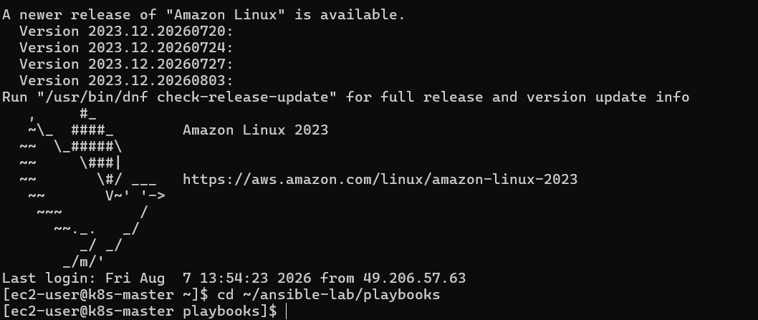
Create:
vi create_multiple_files.yml
Add:
---
- name: Create multiple files on workers
hosts: workers
become: yes

tasks:

- name: Create files using loop
file:
path: "/tmp/{{ item }}"
state: touch
mode: '0644'
loop:
- file1.txt
- file2.txt
- file3.txt
- application.log
- database.conf
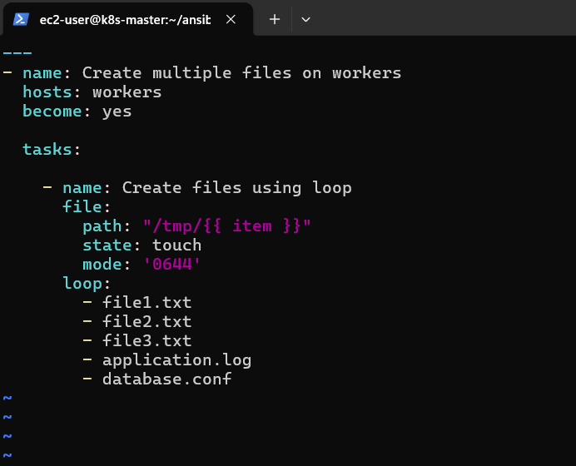
Save:
:wq

Step 2: Check Syntax
ansible-playbook create_multiple_files.yml --syntax-check -i ../ansible_hosts
Expected:
playbook: create_multiple_files.yml

Step 3: Execute Playbook
ansible-playbook create_multiple_files.yml -i ../ansible_hosts
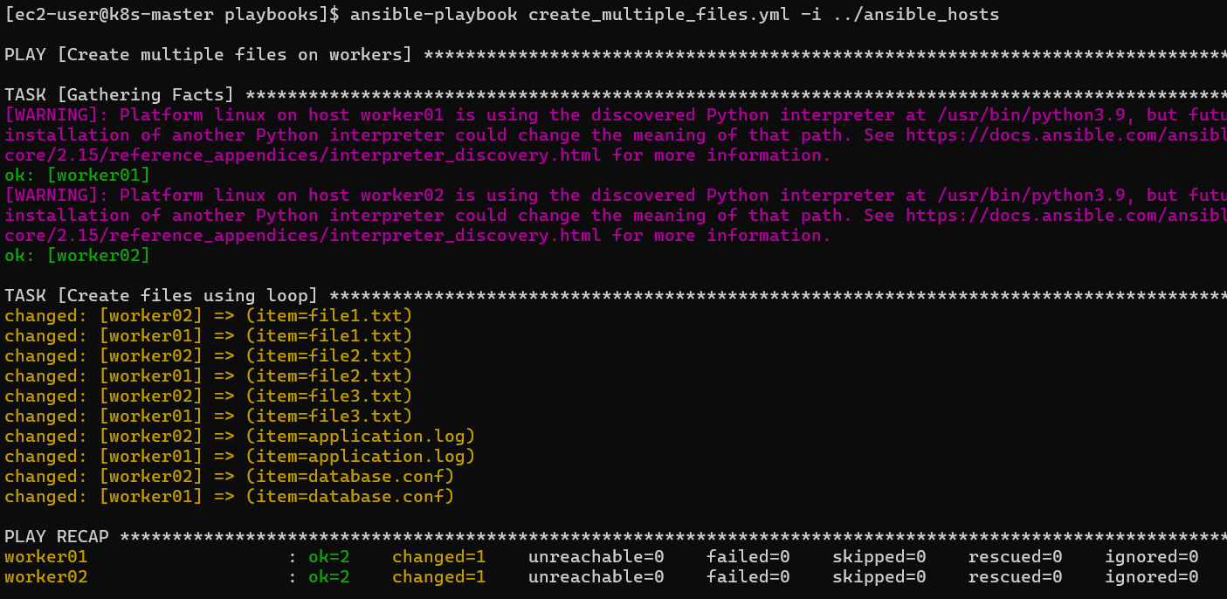
Expected:
TASK [Create files using loop]

changed: [worker01]
changed: [worker02]

PLAY RECAP

worker01 : ok=2 changed=1 failed=0
worker02 : ok=2 changed=1 failed=0

Step 4: Verify Files
Worker01:
ansible worker01 -a "ls -l /tmp" -i ../ansible_hosts
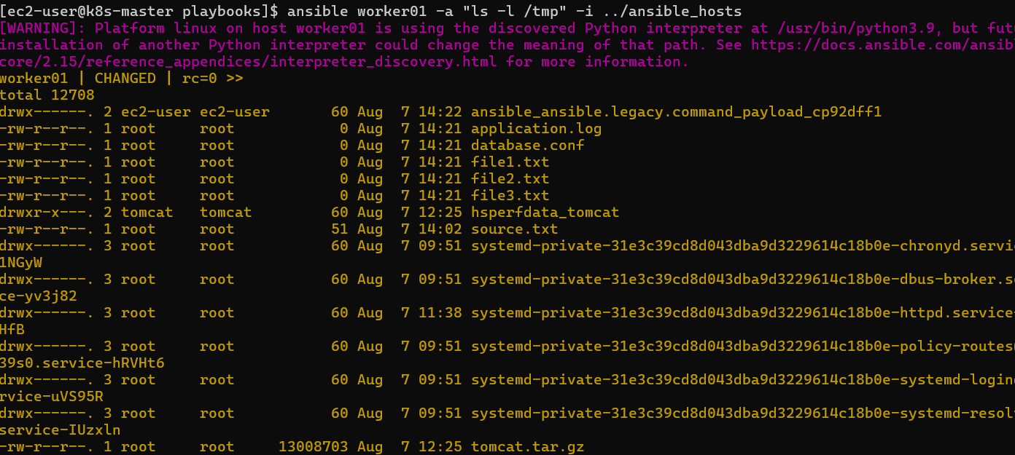
Worker02:
ansible worker02 -a "ls -l /tmp" -i ../ansible_hosts
You should see:
file1.txt
file2.txt
file3.txt
application.log
database.conf
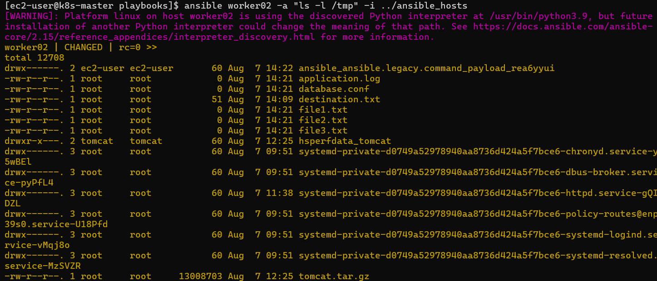

Task 5 Objective Achieved
Created multiple files on multiple servers using a single Ansible playbook.
What We Will Learn
✅ Creating multiple files automatically
✅ Using loops in Ansible
✅ Reducing repeated tasks
✅ Managing files using automation

Conclusion
We learned how Ansible loops help automate repetitive tasks. Instead of writing separate tasks for every file, we used one task with a loop to create multiple files efficiently.
This concept is widely used in DevOps automation for creating:
- Configuration files
- Directory structures
- User accounts
- Application deployment files

