Ansible-Task-03
Task-01
Write a single Ansible playbook which will install Apache and Nginx. The playbook should not be hardcoded and variables should be passed from a different file.
🎯 Objective
The objective is to learn how to:
- Install Apache and Nginx using one playbook.
- Avoid hardcoding package names in the playbook.
- Store variables in a separate variables file.
- Use Ansible variables inside a playbook.
- Install multiple packages using a loop.
Expected architecture
Ansible Master
|
| SSH
┌──────────┴──────────┐
↓ ↓
Worker 1 Worker 2
Apache Nginx
However, because the task says one playbook should install Apache and Nginx, we can initially install both on the worker nodes.

Step 1 — Check your EC2 instances
Since you just created the EC2 machines, first connect to your Ansible master.
On the master:
ssh -i your-key.pem ubuntu@<MASTER_PUBLIC_IP>
Check the OS:
cat /etc/os-release
Check Ansible:
ansible --version
You should see something similar to:
ansible [core 2.15.x]

Step 2 — Create the project directory
On your Ansible master:
mkdir -p ~/ansible-03/task1
cd ~/ansible-03/task1
Check:
pwd
Expected:
/home/ubuntu/ansible-03/task1

Step 3 — Create the inventory file
Create:
vim inventory
Put your worker private IP addresses:
[workers]
worker1 ansible_host=<WORKER1_PRIVATE_IP>
worker2 ansible_host=<WORKER2_PRIVATE_IP>

[workers:vars]
ansible_user=ubuntu
ansible_ssh_private_key_file=/home/ubuntu/your-key.pem
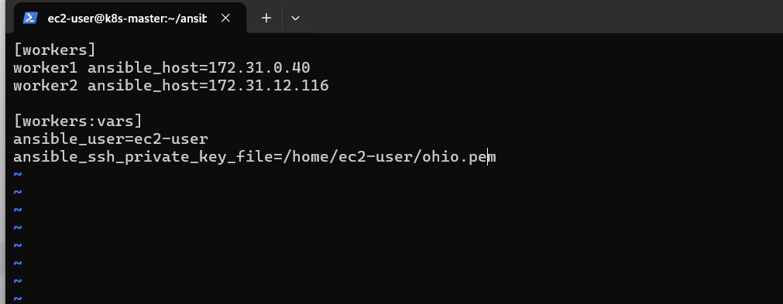
For example:
[workers]
worker1 ansible_host=10.0.1.20
worker2 ansible_host=10.0.1.21

[workers:vars]
ansible_user=ubuntu
ansible_ssh_private_key_file=/home/ubuntu/Virginia.pem
Don't copy my IPs. Use the private IPs of your newly created instances.

Step 4 — Test Ansible connectivity
Before creating the playbook, make sure Ansible can reach the workers.
Run:
ansible workers -i inventory -m ping
Expected:
worker1 | SUCCESS => {
"changed": false,
"ping": "pong"
}

worker2 | SUCCESS => {
"changed": false,
"ping": "pong"
}
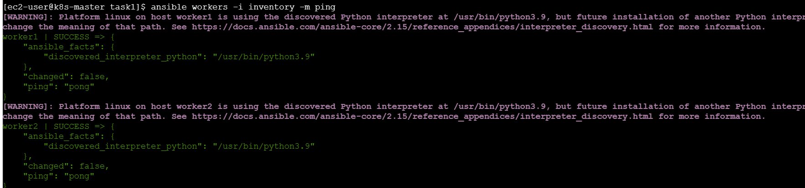
If you get UNREACHABLE
Don't continue yet. Send me the error.
Common causes:
- Wrong private IP
- Wrong SSH key path
- Wrong username
- Security Group doesn't allow SSH
- Key permissions

Step 5 — Create the variables file
This is the important part of Task 1.
We don't want this:
name: apache2
hardcoded directly inside our playbook.
Instead, create:
vim vars.yml
Add:
packages:
- apache2
- nginx
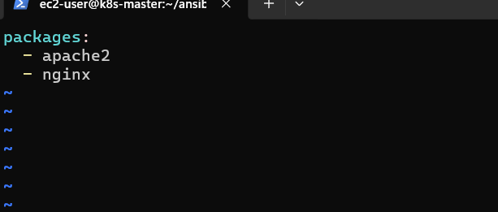
Now our package names are stored separately.
Why?
If tomorrow you want to install:
apache2
nginx
git
docker.io
you only need to modify vars.yml.
You don't need to modify the main playbook.

Step 6 — Create the playbook
Create:
vim install_webservers.yml
Add:
---
- name: Install Apache and Nginx
hosts: workers
become: yes

vars_files:
- vars.yml

tasks:
- name: Install Apache and Nginx
ansible.builtin.apt:
name: "{{ packages }}"
state: present
update_cache: yes
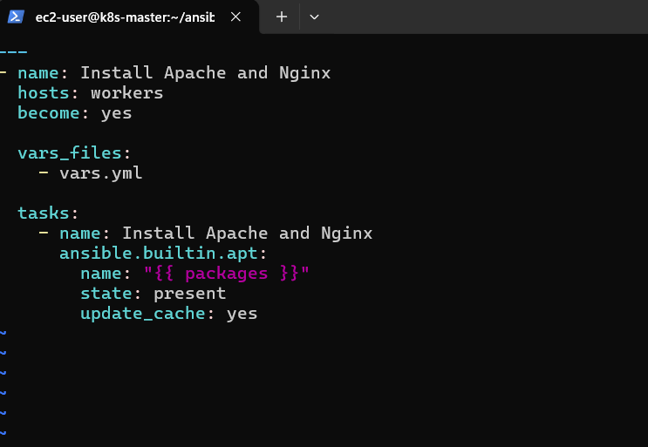

Step 7 — Understand the playbook
Let's break it down.
hosts
hosts: workers
Means:
Run this playbook against the servers inside the workers group in the inventory.

become
become: yes
Means:
Execute the task with elevated privileges.
Installing packages requires root privileges.

vars_files
vars_files:
- vars.yml
Means:
Load variables from the external vars.yml file.
Our variable is:
packages:
- apache2
- nginx

Variable usage
name: "{{ packages }}"
Ansible replaces:
{{ packages }}
with:
apache2
nginx
So Ansible effectively installs both packages.

Step 8 — Check your files
Run:
ls -l
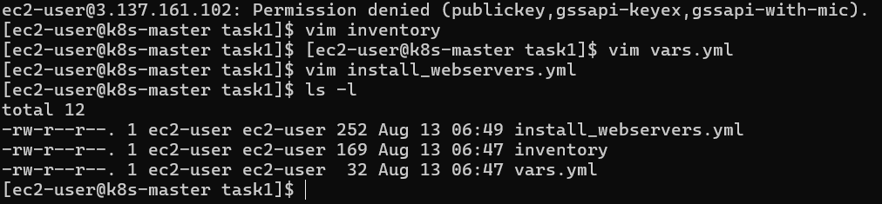
You should have:
inventory
vars.yml
install_webservers.yml
Your structure is:
ansible-03/
└── task1/
├── inventory
├── vars.yml
└── install_webservers.yml
This is a good structure because your playbook and variables are separated.

Step 9 — Check the playbook syntax
Before executing:
ansible-playbook -i inventory install_webservers.yml --syntax-check
Expected:
playbook: install_webservers.yml
That means there are no YAML/playbook syntax errors.

Step 10 — Run the playbook
Now execute:
ansible-playbook -i inventory install_webservers.yml
You should see something similar to:
PLAY [Install Apache and Nginx]

TASK [Gathering Facts]

TASK [Install Apache and Nginx]
changed: [worker1]
changed: [worker2]

PLAY RECAP
worker1 : ok=2 changed=1 failed=0
worker2 : ok=2 changed=1 failed=0
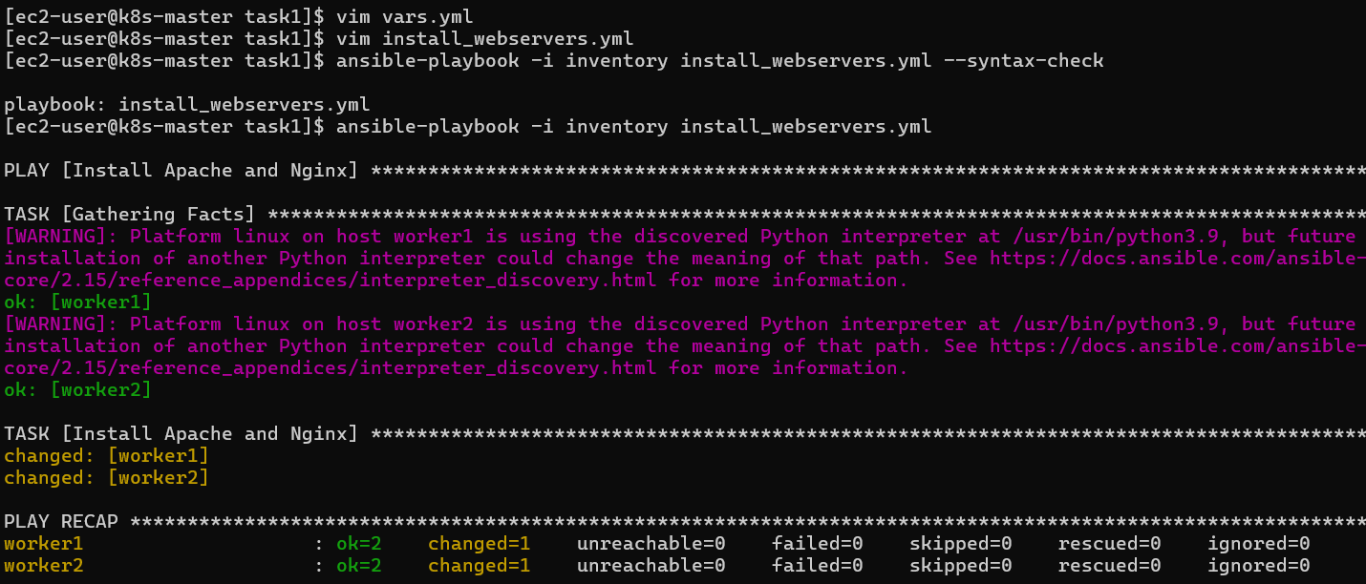

Step 11 — Verify Apache
SSH into worker 1:
ssh -i your-key.pem ubuntu@<WORKER1_PUBLIC_IP>
Check:
systemctl status apache2
You should see:
Active: active (running)
You can also check:
apache2 -v
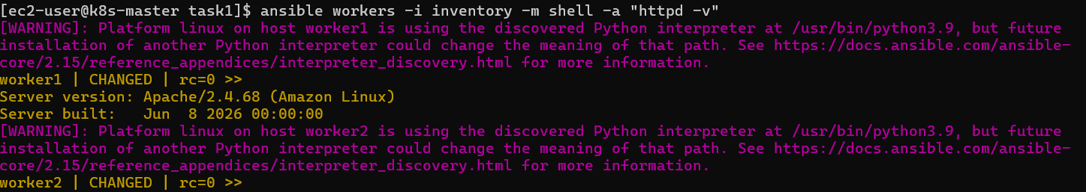

Step 12 — Verify Nginx
Check:
systemctl status nginx
You should see:
Active: active (running)
Check:
nginx -v
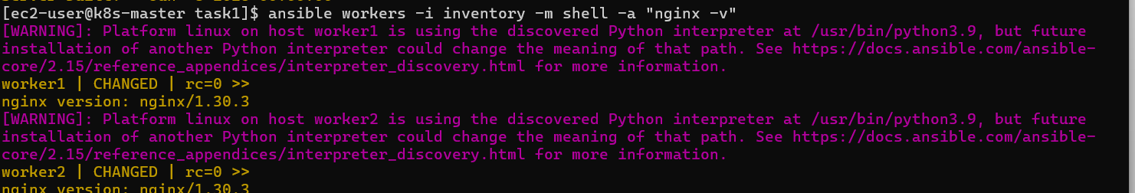
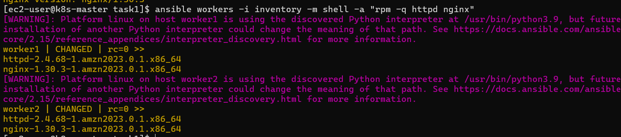

⚠️ Important: Apache and Nginx use different ports
By default, both Apache and Nginx try to use:
Port 80
Therefore, installing both is fine, but running both on the same server on the default port will cause a conflict.
For this task, the important requirement is installation, not necessarily having both services simultaneously listening on port 80.
You can verify installation with:
dpkg -l | grep apache2
and:
dpkg -l | grep nginx
If you want both services running simultaneously, later we can configure one of them to use another port such as 8080.

🧠 What did we learn?
1. Variables
We learned that values such as package names can be stored separately:
packages:
- apache2
- nginx

2. External variable file
We used:
vars_files:
- vars.yml
This keeps the main playbook clean and avoids hardcoding.

3. Loops/list variables
Ansible's package module can accept a list:
name: "{{ packages }}"
So we don't need:
- name: Install Apache
apt:
name: apache2

- name: Install Nginx
apt:
name: nginx
We can install both with a single task.

4. become
We learned:
become: yes
is used when the task requires elevated/root privileges.

5. Idempotency
If you run the same playbook again:
ansible-playbook -i inventory install_webservers.yml
Ansible should report something like:
ok=2
changed=0
because Apache and Nginx are already installed.
That's one of the important characteristics of Ansible: idempotency.

🎯 Task 1 Conclusion
In Task 1, we created a single Ansible playbook to install Apache and Nginx on the worker nodes. Instead of hardcoding package names inside the playbook, we stored them in a separate vars.yml file and loaded them using vars_files. We also learned how to use variables, privilege escalation, package modules, lists, syntax checking and Ansible idempotency.
Ansible-03 — Task 2
Task
Write an Ansible playbook to create 10 different directories with minimal code, and directory names should be passed as variables.

🎯 Objective
Create 10 directories on the worker nodes using:
- A single Ansible playbook
- A separate variables file
- A list of directory names
- A loop
The important concept is: don't write 10 separate tasks.
Instead of:
- name: Create dir1
- name: Create dir2
- name: Create dir3
...
we will use one task + one loop.

Step 1 — Create Task 2 directory
From your Ansible master:
cd ~/ansible-03
mkdir -p task2
cd task2
Check:
pwd
You should see something like:
/home/ec2-user/ansible-03/task2

Step 2 — Create inventory
You can reuse the same worker information.
Create:
vim inventory
Add:
[workers]
worker1 ansible_host=172.31.0.40
worker2 ansible_host=172.31.12.116

[workers:vars]
ansible_user=ec2-user
ansible_ssh_private_key_file=/home/ec2-user/ohio.pem
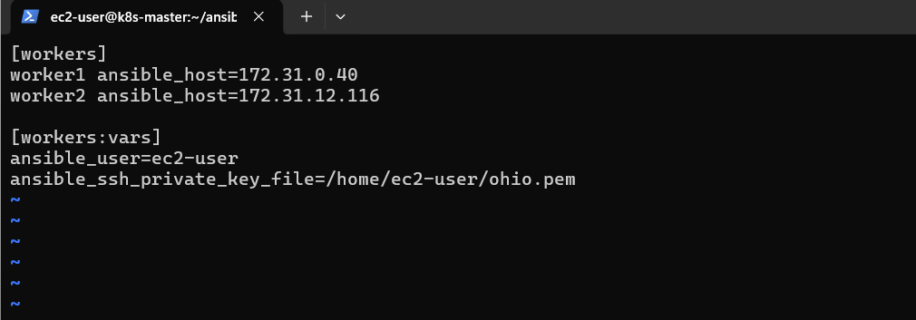
Test connectivity
ansible workers -i inventory -m ping
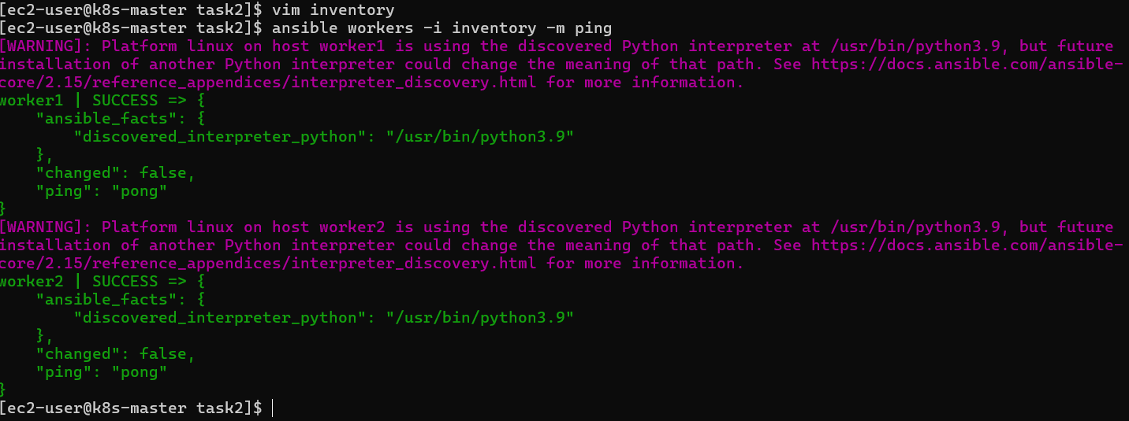
You should get:
worker1 | SUCCESS
worker2 | SUCCESS

Step 3 — Create variables file
This is the important requirement of the task.
Create:
vim vars.yml
Add:
directories:
- /opt/app
- /opt/config
- /opt/logs
- /opt/data
- /opt/backup
- /opt/scripts
- /opt/temp
- /opt/reports
- /opt/archive
- /opt/uploads
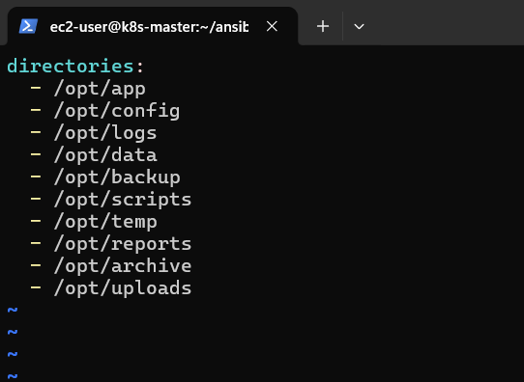
We have now passed all 10 directory names as variables.

Step 4 — Create the playbook
Create:
vim create_directories.yml
Add:
---
- name: Create 10 directories
hosts: workers
become: yes

vars_files:
- vars.yml

tasks:
- name: Create directories
ansible.builtin.file:
path: "{{ item }}"
state: directory
mode: '0755'
loop: "{{ directories }}"
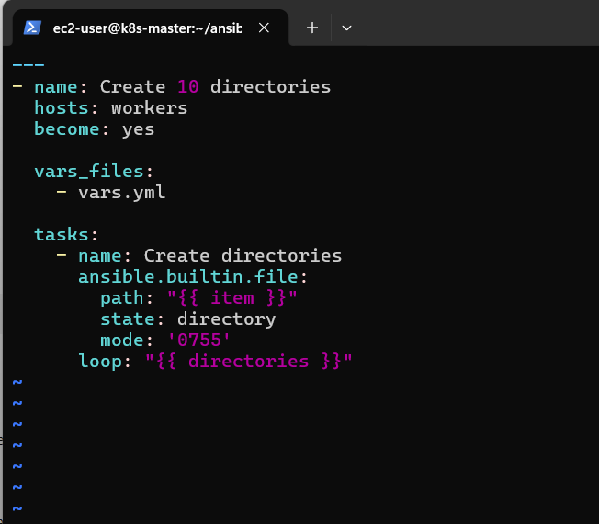

🧠 Understand the important part
The key line is:
loop: "{{ directories }}"
Our vars.yml contains:
directories:
- /opt/app
- /opt/config
- /opt/logs
Ansible takes each value one by one.
Conceptually:
directories
↓
/opt/app
↓
/opt/config
↓
/opt/logs
↓
...
And:
path: "{{ item }}"
means:
Use the current directory name from the loop.

Step 5 — Check your files
Run:
ls -l
You should have:
inventory
vars.yml
create_directories.yml
Check variables:
cat vars.yml
And:
cat create_directories.yml
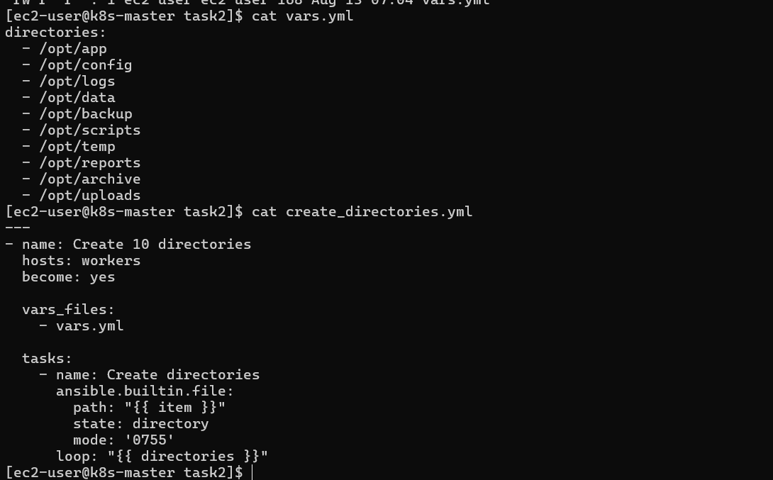

Step 6 — Syntax check
Before running:
ansible-playbook -i inventory create_directories.yml --syntax-check
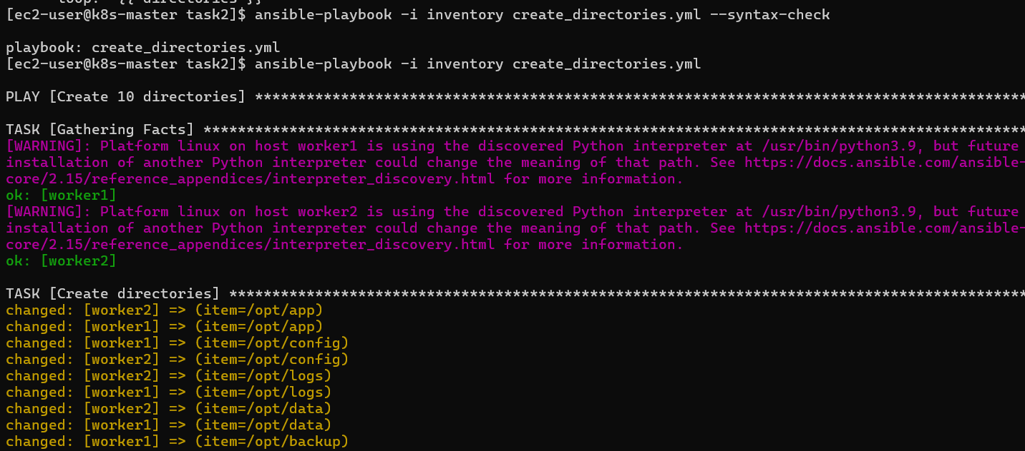
Expected:
playbook: create_directories.yml

Step 7 — Run the playbook
Now execute:
ansible-playbook -i inventory create_directories.yml

You should see the task running against both workers.
Something similar to:
TASK [Create directories]
changed: [worker1] => (item=/opt/app)
changed: [worker1] => (item=/opt/config)
...
changed: [worker2] => (item=/opt/app)
changed: [worker2] => (item=/opt/config)
...

Step 8 — Verify the directories
You can verify remotely from the master without manually SSHing into every worker.
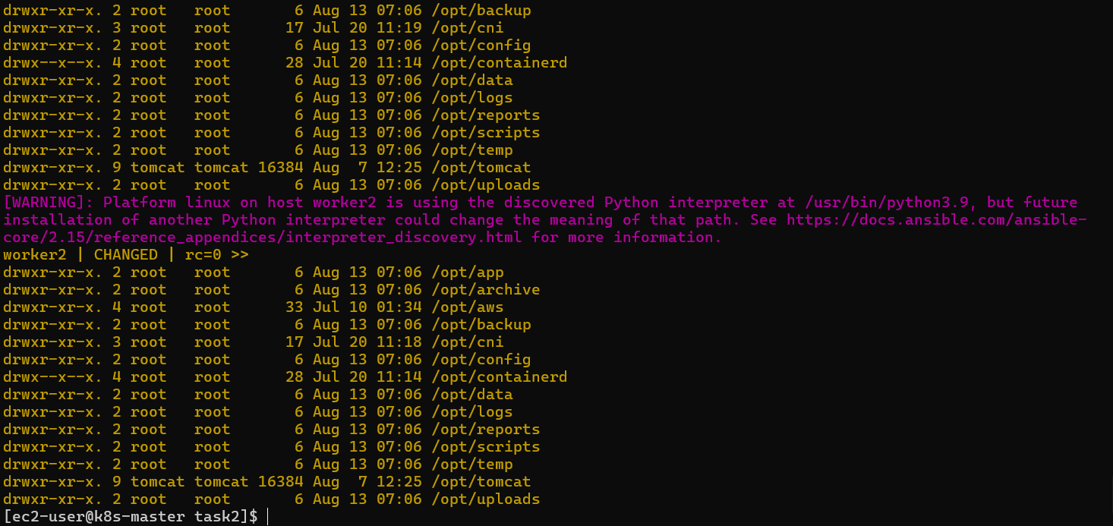
Run:
ansible workers -i inventory -m shell -a "ls -ld /opt/*"
You should see your directories:
/opt/app
/opt/config
/opt/logs
/opt/data
/opt/backup
/opt/scripts
/opt/temp
/opt/reports
/opt/archive
/opt/uploads
You can also check specifically:
ansible workers -i inventory -m shell -a "ls -ld /opt/app /opt/config /opt/logs"
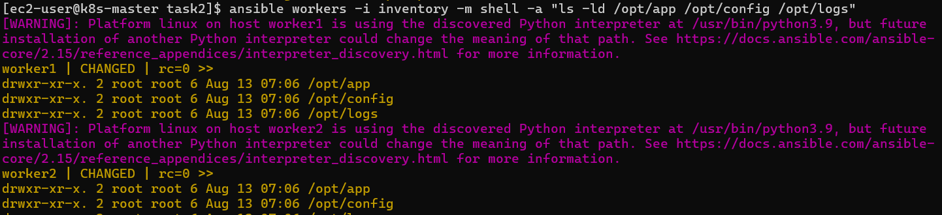

⭐ Step 9 — Test Ansible idempotency
This is a good practical demonstration.
Run the playbook again:
ansible-playbook -i inventory create_directories.yml
This time, you should see:
ok: [worker1]
ok: [worker2]
rather than changed for the directories that already exist.
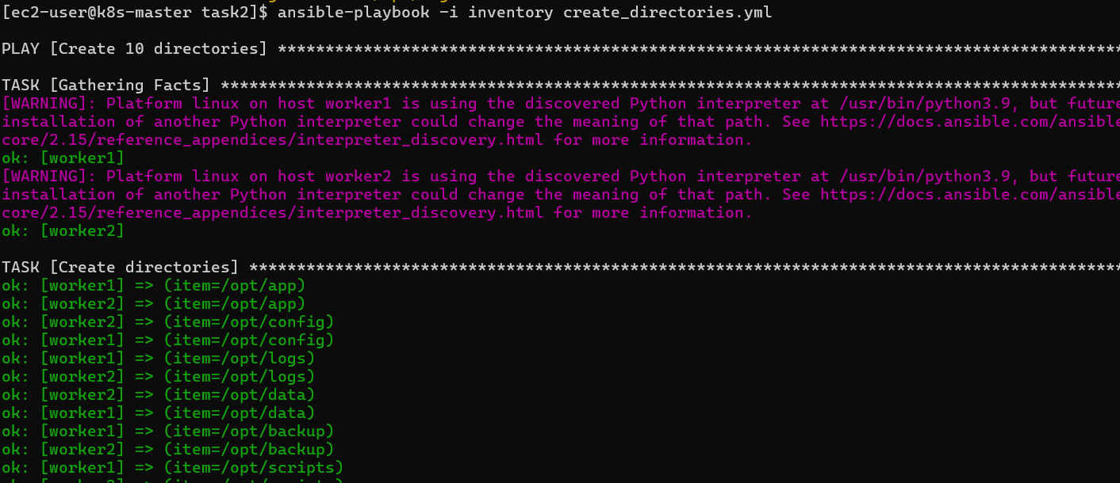
Why?
Because Ansible is idempotent.
It checks:
Does the directory already exist in the desired state?
If yes → no change required.

🧠 What did we learn?
1. Variables
We stored directory names separately:
directories:
- /opt/app
- /opt/config
- /opt/logs
So the playbook isn't hardcoded.
2. Loop
Instead of creating 10 tasks, we used:
loop: "{{ directories }}"
One task handles all 10 directories.
3. item
path: "{{ item }}"
item represents the current value from the loop.
4. File module
We used:
ansible.builtin.file
with:
state: directory
to create directories.
5. Idempotency
Running the same playbook repeatedly doesn't unnecessarily recreate existing directories.

🎯 Interview question from this task
Interviewer:
How would you create 10 directories using minimal Ansible code?
Answer:
I would define the directory names as a list in a separate variables file and use the Ansible file module with a loop. This avoids creating separate tasks for every directory and makes the playbook reusable.
Example:
directories:
- /opt/app
- /opt/config
- /opt/logs
and:
- name: Create directories
ansible.builtin.file:
path: "{{ item }}"
state: directory
mode: '0755'
loop: "{{ directories }}"

✅ Task 2 Conclusion
In Task 2, we created 10 directories using a single Ansible task and a loop. The directory names were stored in a separate variables file, making the playbook dynamic and reusable. We also learned how item, loops, the file module, variables, and idempotency work together in Ansible.
Ansible-03 — Task 3
📌 Task requirement
Write an Ansible playbook to copy SSH key from master to worker nodes.
Requirements:
- Provision 3 EC2 machines — 1 master + 2 workers.
- Create common user ansadm on all 3 EC2 instances.
- Give ansadm sudo privileges.
- Generate SSH key on the master.
- Copy the master's public key to both workers.
- Configure passwordless SSH authentication.

🎯 Objective
By the end of this task, you'll have:
k8s-master
ansadm user
|
SSH Key Pair
|
┌───────────┴───────────┐
↓ ↓
k8s-Worker01 k8s-Worker02
ansadm ansadm
↑ ↑
└──── Passwordless SSH ─┘
You'll learn:
- Ansible user management
- user module
- Sudo configuration
- SSH key generation
- Public/private keys
- authorized_keys
- Passwordless SSH
- delegate_to
- run_once
- Ansible variables

🟢 STEP 1 — Confirm your 3 EC2 machines
You already have:
Machine | Private IP | User
Master | Your master IP | ec2-user
Worker 1 | 172.31.0.40 | ec2-user
Worker 2 | 172.31.12.116 | ec2-user
Your existing Ansible connectivity to the workers is working.
First, from the master run:
ansible all -i inventory -m ping
But your current Task 2 inventory only contains workers.
So for Task 3, we need an inventory containing master + workers.

🟢 STEP 2 — Create Task 3 directory
On the master:
cd ~/ansible-03
mkdir -p task3
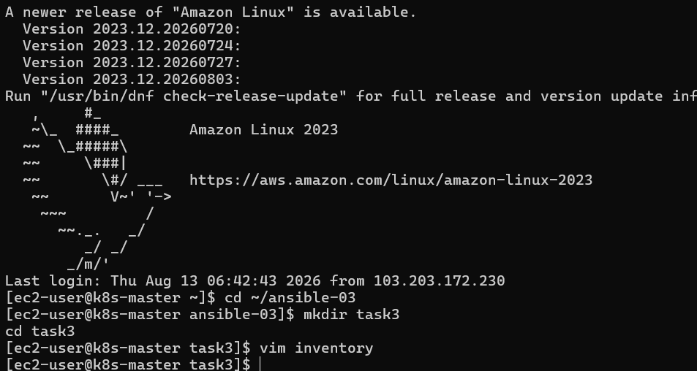
cd task3
Check:
pwd
You should get:
/home/ec2-user/ansible-03/task3

🟢 STEP 3 — Create the Task 3 inventory
Create:
vim inventory
Put:
[master]
k8s-master ansible_host=<MASTER_PRIVATE_IP>

[workers]
worker1 ansible_host=172.31.0.40
worker2 ansible_host=172.31.12.116

[all:vars]
ansible_user=ec2-user
ansible_ssh_private_key_file=/home/ec2-user/ohio.pem
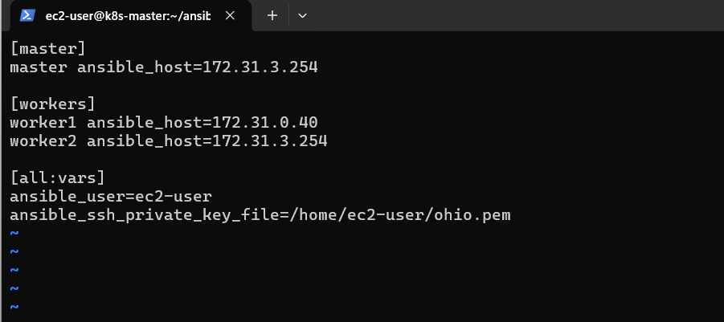
Example
If your master private IP were 172.31.3.254, it would be:
[master]
k8s-master ansible_host=172.31.3.254

[workers]
worker1 ansible_host=172.31.0.40
worker2 ansible_host=172.31.12.116

[all:vars]
ansible_user=ec2-user
ansible_ssh_private_key_file=/home/ec2-user/ohio.pem
⚠️ Use your actual master private IP. Don't blindly use my example.

🟢 STEP 4 — Test all 3 machines
Run:
ansible all -i inventory -m ping
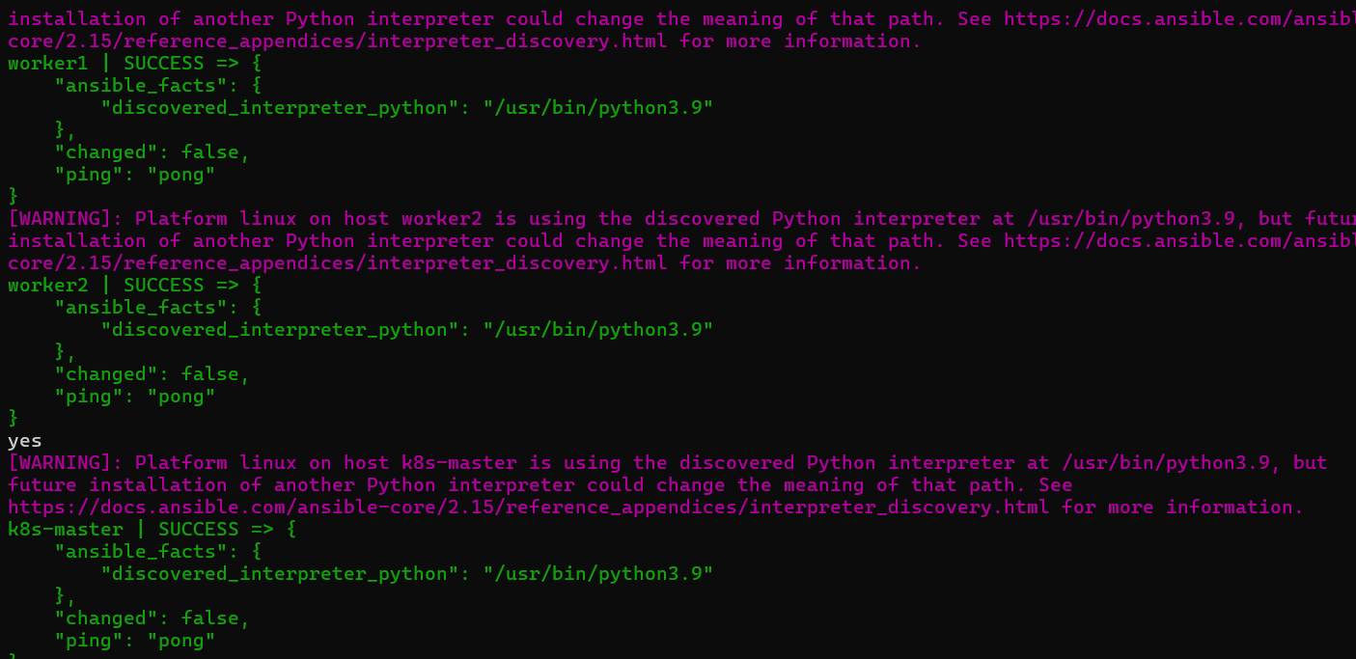
Expected:
k8s-master | SUCCESS
worker1 | SUCCESS
worker2 | SUCCESS
If all three show:
"ping": "pong"
we are ready.

🟢 STEP 5 — Create the ansadm user
Now we'll create the common user on all 3 machines.
Create:
vim create_ansadm.yml
Use:
---
- name: Create ansadm user on all servers
hosts: all
become: yes

tasks:

- name: Create ansadm user
ansible.builtin.user:
name: ansadm
shell: /bin/bash
create_home: yes
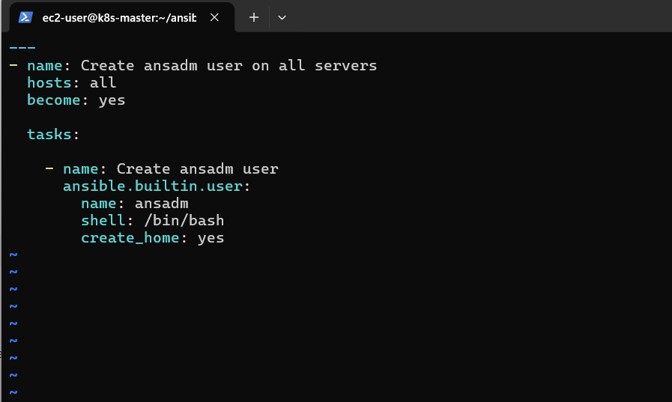
What this does
name: ansadm
Creates:
ansadm
And:
shell: /bin/bash
gives the user Bash shell.
And:
create_home: yes
creates:
/home/ansadm

🟢 STEP 6 — Give ansadm sudo privileges
Now modify the playbook:
vim create_ansadm.yml
Use:
---
- name: Create ansadm user on all servers
hosts: all
become: yes

tasks:

- name: Create ansadm user
ansible.builtin.user:
name: ansadm
shell: /bin/bash
create_home: yes

- name: Give ansadm sudo privileges
ansible.builtin.copy:
content: "ansadm ALL=(ALL) NOPASSWD: ALL\n"
dest: /etc/sudoers.d/ansadm
owner: root
group: root
mode: '0440'
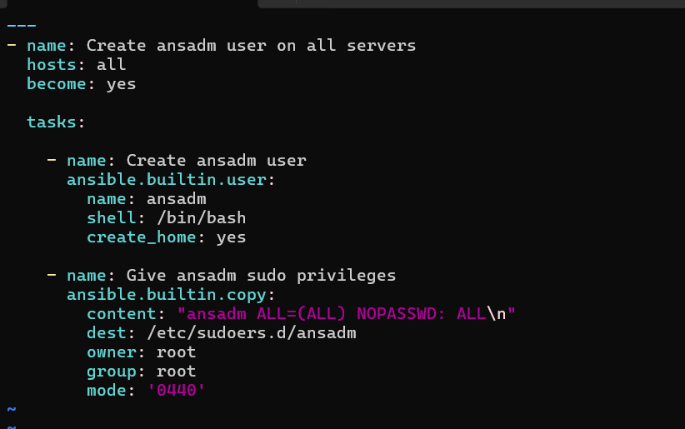
What does this mean?
This:
ansadm ALL=(ALL) NOPASSWD: ALL
means:
ansadm can execute commands using sudo without entering a password.
For example:
sudo dnf install nginx
will work without asking for an ansadm password.

🟢 STEP 7 — Syntax check
Before running:
ansible-playbook -i inventory create_ansadm.yml --syntax-check
Expected:
playbook: create_ansadm.yml

🟢 STEP 8 — Run the playbook
Now:
ansible-playbook -i inventory create_ansadm.yml
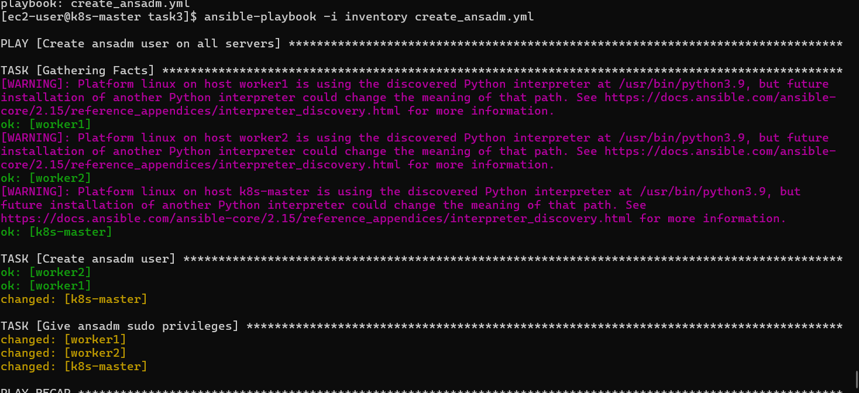
You should see:
TASK [Create ansadm user]
changed: [k8s-master]
changed: [worker1]
changed: [worker2]

TASK [Give ansadm sudo privileges]
changed: [k8s-master]
changed: [worker1]
changed: [worker2]

🟢 STEP 9 — Verify ansadm
Check on all three machines remotely:
ansible all -i inventory -m shell -a "id ansadm"
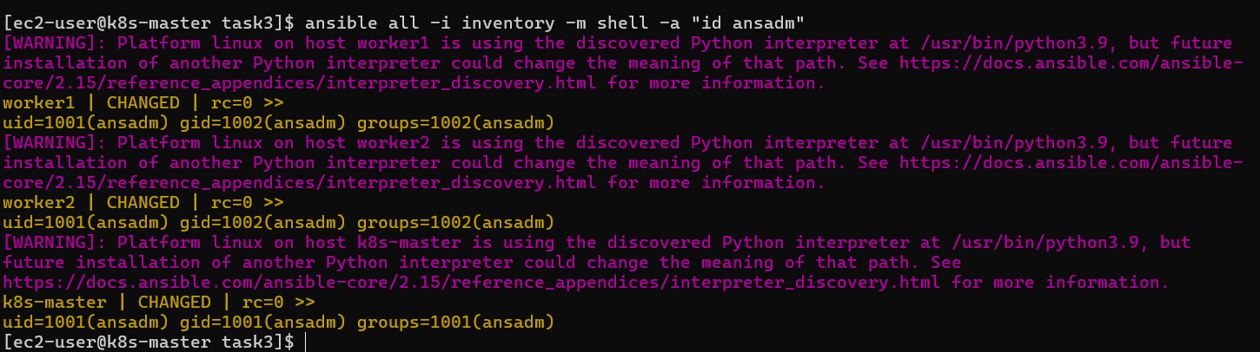
Expected:
k8s-master | CHANGED | rc=0 >>
uid=... (ansadm) gid=... (ansadm) groups=... (ansadm)

worker1 | CHANGED | rc=0 >>
uid=... (ansadm) gid=... (ansadm) groups=... (ansadm)

worker2 | CHANGED | rc=0 >>
uid=... (ansadm) gid=... (ansadm) groups=... (ansadm)

🟢 STEP 10 — Verify sudo
Run:
ansible all -i inventory -m shell -a "sudo whoami"
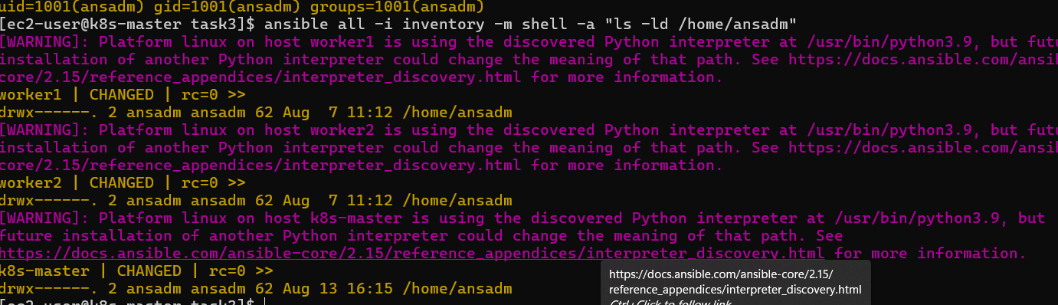
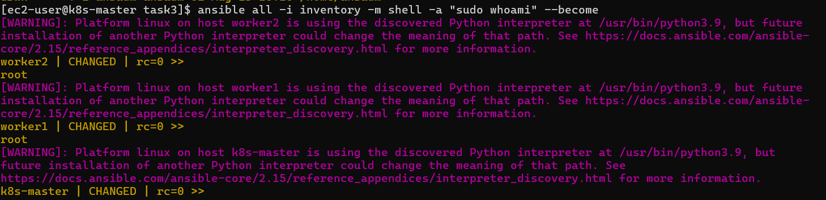
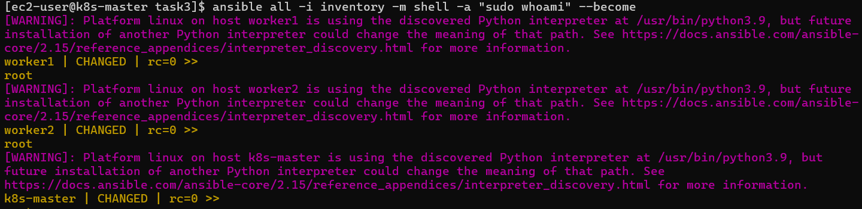
Expected:
k8s-master | CHANGED | rc=0 >>
root

worker1 | CHANGED | rc=0 >>
root

worker2 | CHANGED | rc=0 >>
root
This confirms that ansadm has sudo privileges.

🛑 STOP HERE
Don't generate SSH keys yet.
At this point, we have completed Stage 1 of Task 3:
3 EC2 Instances
↓
Create ansadm
↓
Master Worker1 Worker2
✓ ✓ ✓
↓
Sudo privileges
✓ ✓ ✓
What we learned so far
Ansible user module
Used to create users.
Ansible copy module
Used to create the sudoers configuration.
become: yes
Allows Ansible to perform privileged operations.
NOPASSWD
Allows ansadm to use sudo without entering a password.

Part B — Generate SSH key on MASTER
Now comes the important part.
The requirement says:
Create ssh-keygen in master and copy the key to worker nodes.
We do not want to generate the key on workers.
The key should exist here:
MASTER
/home/ansadm/.ssh/id_rsa
and the public key should eventually be added here:
WORKER 1
/home/ansadm/.ssh/authorized_keys

WORKER 2
/home/ansadm/.ssh/authorized_keys

Step 9 — Create SSH key using Ansible
Create:
vim ssh_key.yml
Use:
---
- name: Generate SSH key on master
hosts: master
become: yes

tasks:

- name: Create .ssh directory
ansible.builtin.file:
path: /home/ansadm/.ssh
state: directory
owner: ansadm
group: ansadm
mode: '0700'

- name: Generate SSH key pair
become_user: ansadm
community.crypto.openssh_keypair:
path: /home/ansadm/.ssh/id_rsa
type: rsa
size: 2048
owner: ansadm
group: ansadm
mode: '0600'
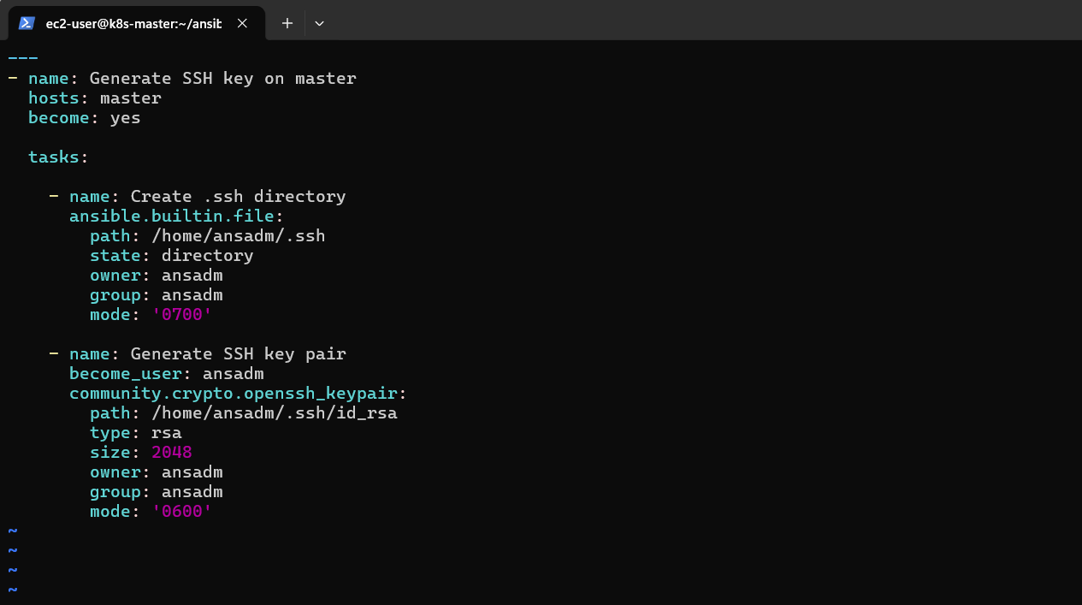
Important
This uses:
community.crypto.openssh_keypair
You may need the collection installed.
Check:
ansible-galaxy collection list | grep community.crypto
If nothing appears, install it:
ansible-galaxy collection install community.crypto

Step 10 — Run the SSH-key playbook
First syntax check:
ansible-playbook -i inventory ssh_key.yml --syntax-check
Then:
ansible-playbook -i inventory ssh_key.yml
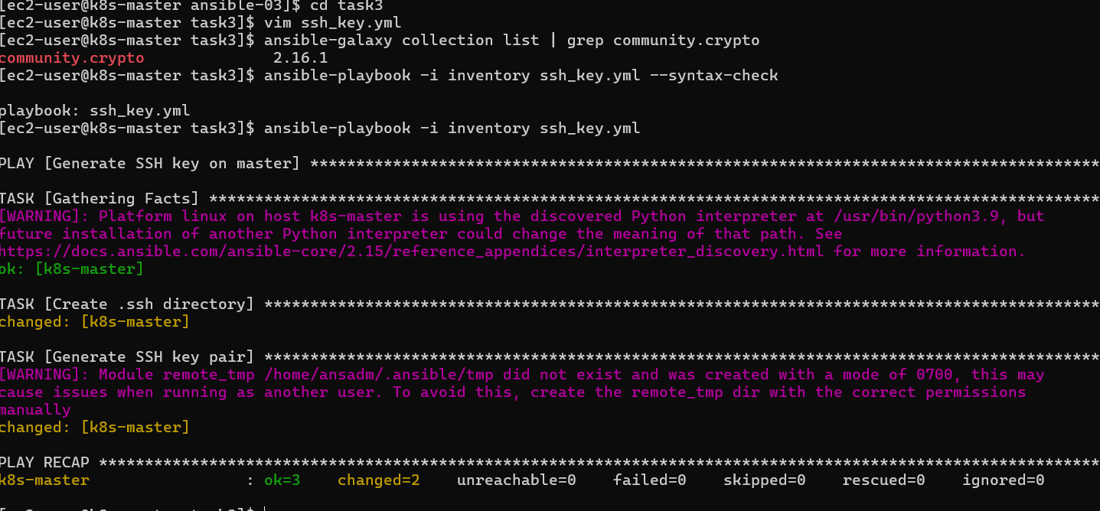

Step 11 — Verify the key on MASTER
Run:
ansible master -i inventory -m shell -a "ls -la /home/ansadm/.ssh" –become
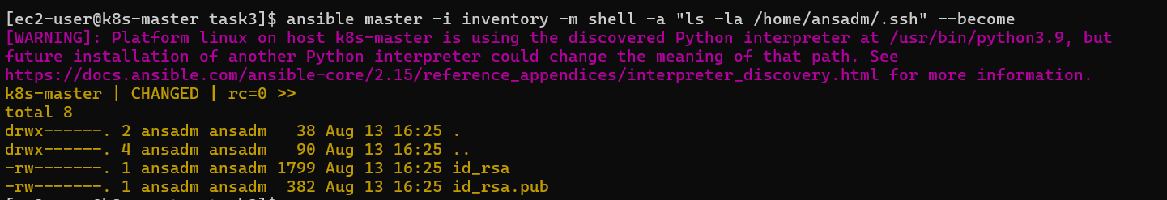
You should see:
id_rsa
id_rsa.pub
The important files are:
id_rsa → private key
id_rsa.pub → public key
Important security rule
Never copy:
id_rsa
to the workers.
Only copy:
id_rsa.pub

Part C — Copy public key to workers
Now we'll use Ansible's:
authorized_key
module.
Create:
vim copy_key.yml
Use:
---
- name: Configure passwordless SSH from master to workers
hosts: workers
become: yes

tasks:

- name: Add master's public key to ansadm
ansible.posix.authorized_key:
user: ansadm
state: present
key: "{{ hostvars['master']['ansadm_public_key'] }}"
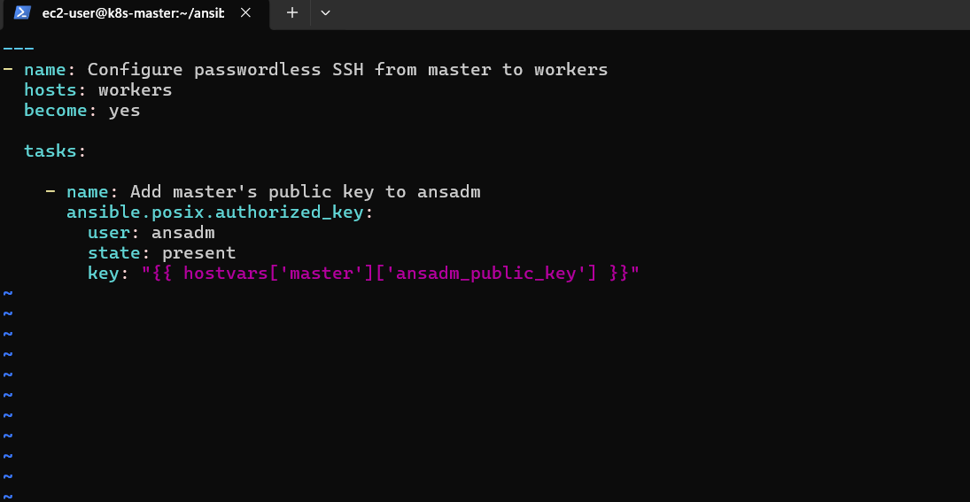
But we need to first retrieve the master's public key.
So let's make this a two-play playbook.
Use this complete version instead:
---
---
- name: Read public key from master
hosts: master
become: yes

tasks:
- name: Read ansadm public key
ansible.builtin.slurp:
src: /home/ansadm/.ssh/id_rsa.pub
register: ansadm_public_key

- name: Store public key as fact
ansible.builtin.set_fact:
master_public_key: "{{ ansadm_public_key.content | b64decode }}"

- name: Copy public key to workers
hosts: workers
become: yes

tasks:
- name: Add master's public key to ansadm
ansible.posix.authorized_key:
user: ansadm
state: present
key: "{{ hostvars['k8s-master']['master_public_key'] }}"
This is more advanced and is good interview knowledge.
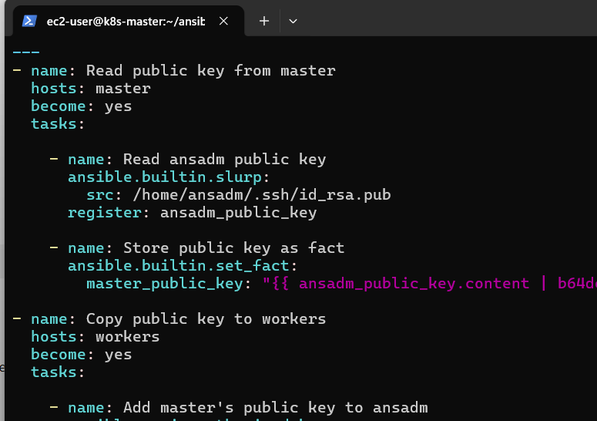

Step 12 — Install the required collection
Run:
ansible-galaxy collection install ansible.posix

Step 13 — Run the key-copy playbook
Syntax check:
ansible-playbook -i inventory copy_key.yml --syntax-check
Then:
ansible-playbook -i inventory copy_key.yml
Expected:
PLAY [Read public key from master]

TASK [Read ansadm public key]
ok: [master]

TASK [Store public key as fact]
ok: [master]

PLAY [Copy public key to workers]

TASK [Add master's public key to ansadm]
changed: [worker1]
changed: [worker2]
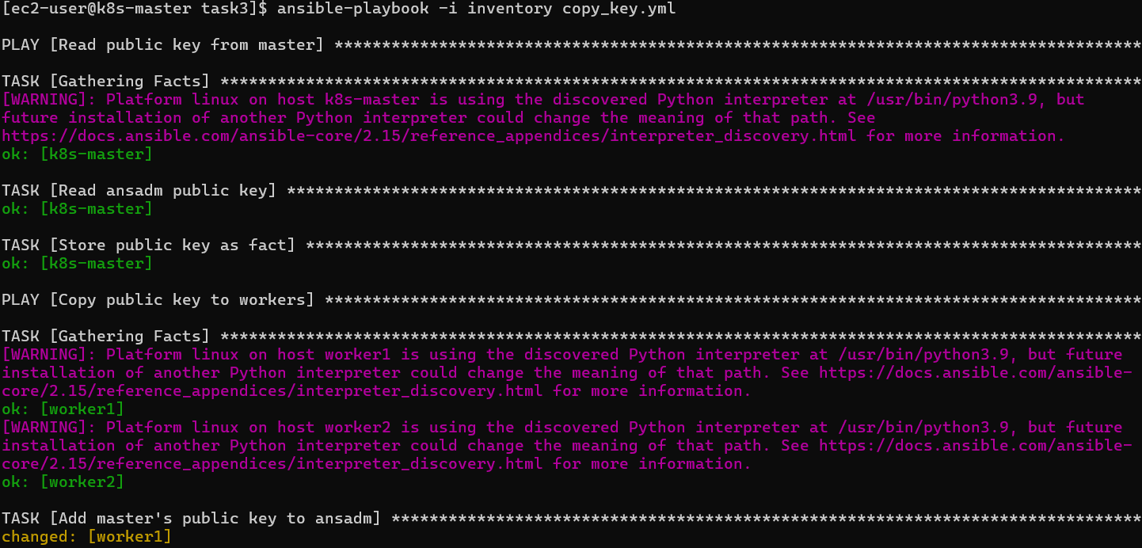

Part D — Test Passwordless Authentication
Now we need to verify the actual requirement.
From the master, switch to ansadm:
sudo su - ansadm
Check:
whoami
Expected:
ansadm
Now connect to worker 1 using its private IP:
ssh ansadm@172.31.0.40
It should not ask for a password.
You should get:
[ansadm@worker1 ~]$
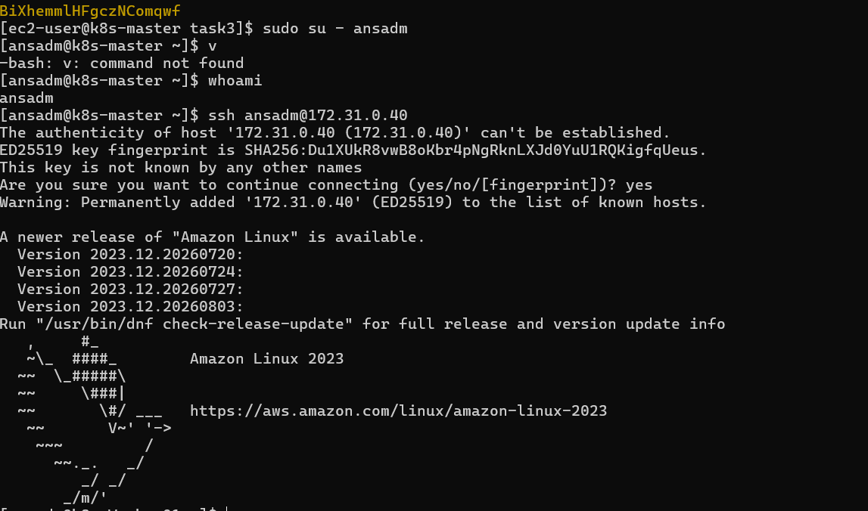
Exit:
exit
Test worker 2:
ssh ansadm@172.31.12.116
Again, it should connect without asking for a password.
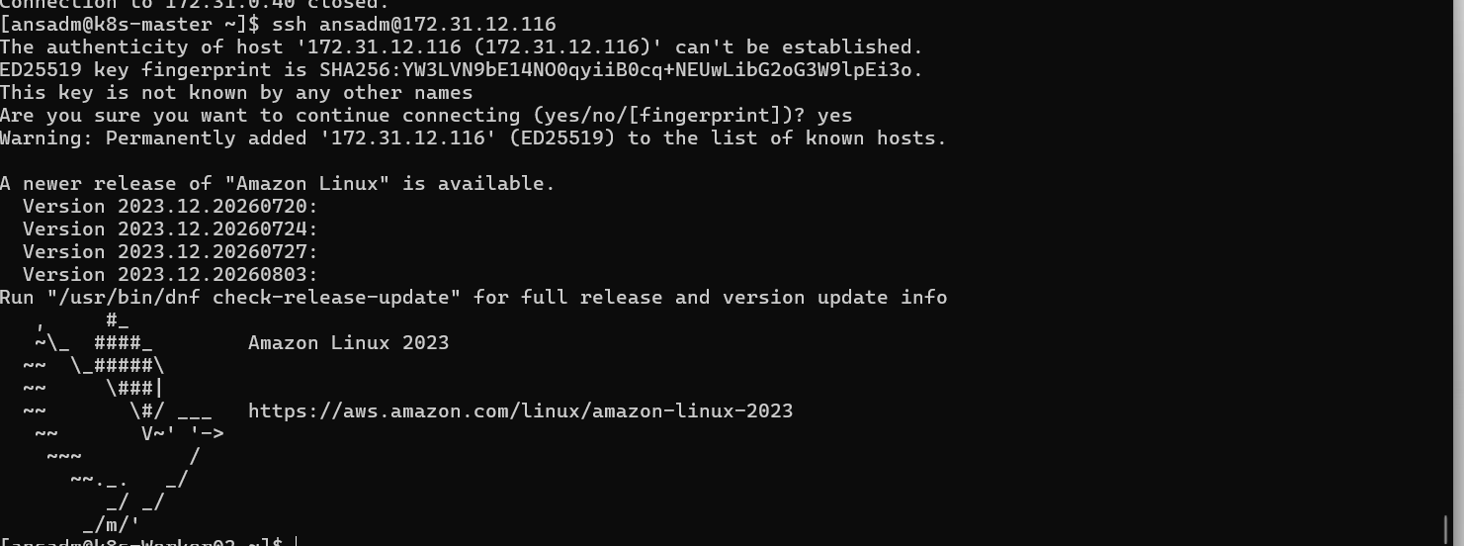

Final architecture
After completing Task 3:
MASTER
k8s-master
|
ansadm user
|
/home/ansadm/.ssh/
├── id_rsa
└── id_rsa.pub
|
┌──────┴──────┐
↓ ↓
WORKER 1 WORKER 2
ansadm ansadm
↑ ↑
└──────┬──────┘
|
authorized_keys
The authentication flow becomes:
MASTER
ansadm
|
| SSH using private key
↓
WORKER 1
ansadm
and:
MASTER
ansadm
|
| SSH using private key
↓
WORKER 2
ansadm

🎯 What we learned in Task 3
Concept | What we learned
user module | Create ansadm
copy module | Configure sudo privileges
become | Execute privileged tasks
SSH key pair | Private + public key
authorized_key | Add public key to remote user
slurp | Read a remote file
set_fact | Store a value during playbook execution
hostvars | Access variables/facts from another host
Passwordless SSH | SSH using keys instead of passwords
Task 4: Ansible Vault
Write an Ansible playbook to inject Ansible Vault variables.
🎯 Objective
The objective is to learn how to:
- Store sensitive information securely using Ansible Vault.
- Create an encrypted variables file.
- Use Vault variables inside a playbook.
- Run a playbook using an encrypted Vault file.
- Avoid putting passwords/secrets directly in a playbook.

Step 1 — Create Task 4 directory
On your Ansible master:
cd ~/ansible-03
mkdir -p task4
cd task4
Check:
pwd
You should see:
/home/ec2-user/ansible-03/task4

Step 2 — Create the Vault file
We'll create an encrypted file called:
vault.yml
Run:
ansible-vault create vault.yml
It will ask:
New Vault password:
Confirm New Vault password:
Enter a password that you can remember.
For your lab, you can use something simple such as:
Ansible@123
Don't use this password for real production secrets.

Step 3 — Add Vault variables
After entering the password, an editor will open.
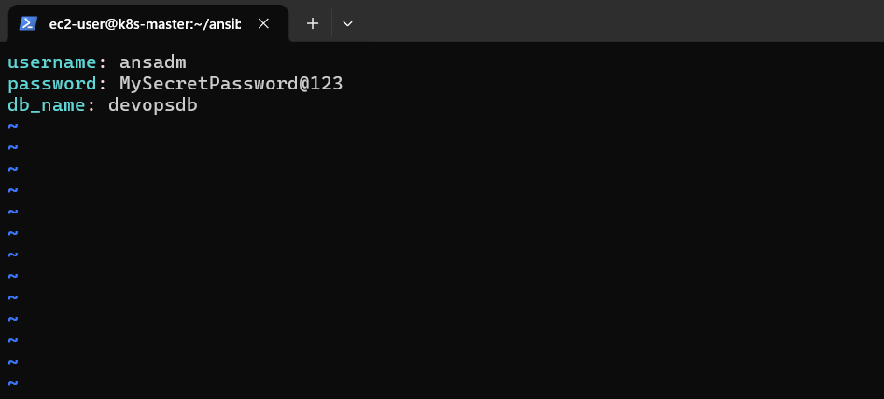
Add:
username: ansadm
password: MySecretPassword@123
db_name: devopsdb
Save and exit:
Esc
:wq
Enter
Now your file contains encrypted content.

Step 4 — Check the Vault file
Run:
cat vault.yml
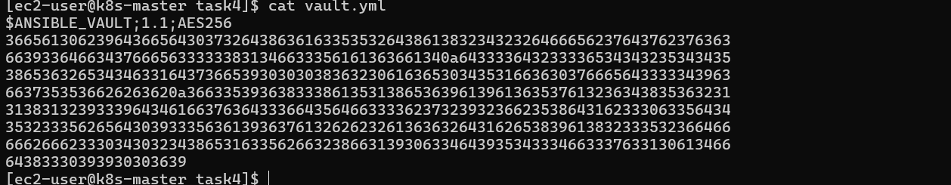
You should not see:
username: ansadm
password: MySecretPassword@123
Instead, you'll see something similar to:
$ANSIBLE_VAULT;1.1;AES256
663263613636333936...
...
That's the main purpose of Ansible Vault.

Step 5 — View the encrypted variables
If you want to see the actual contents:
ansible-vault view vault.yml
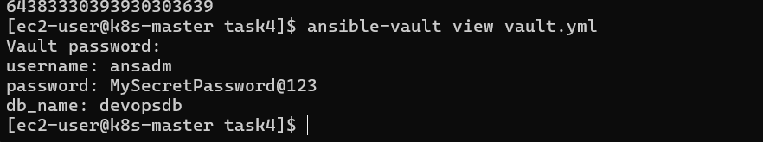
It will ask for the Vault password.
Enter your password.
You'll see:
username: ansadm
password: MySecretPassword@123
db_name: devopsdb
Press:
:q
if it opens in the pager.

Step 6 — Create the playbook
Create:
vim inject_vault.yml
Use:
---
- name: Inject Ansible Vault variables
hosts: workers
become: yes

vars_files:
- vault.yml

tasks:

- name: Create application configuration file
ansible.builtin.copy:
content: |
Username={{ username }}
Password={{ password }}
Database={{ db_name }}
dest: /tmp/application.conf
owner: root
group: root
mode: '0600'
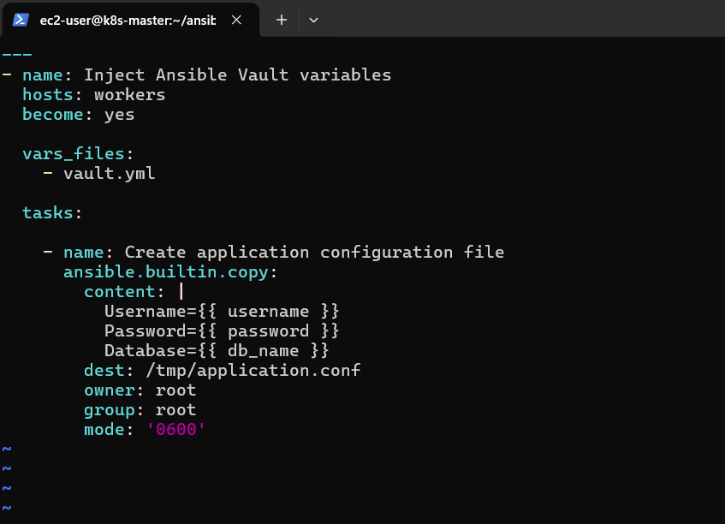
Save:
Esc
:wq
Enter

Step 7 — Understand the important part
This:
vars_files:
- vault.yml
loads our encrypted variables.
Then:
Username={{ username }}
Password={{ password }}
Database={{ db_name }}
uses those variables.
So Ansible automatically decrypts the Vault file when executing the playbook.

Step 8 — Syntax check
Run:
ansible-playbook -i ../task1/inventory inject_vault.yml --syntax-check
You may get:
Vault password:
Enter your Vault password.
Expected:
playbook: inject_vault.yml

Step 9 — Run the playbook
Now:
ansible-playbook -i ../task1/inventory inject_vault.yml --ask-vault-pass
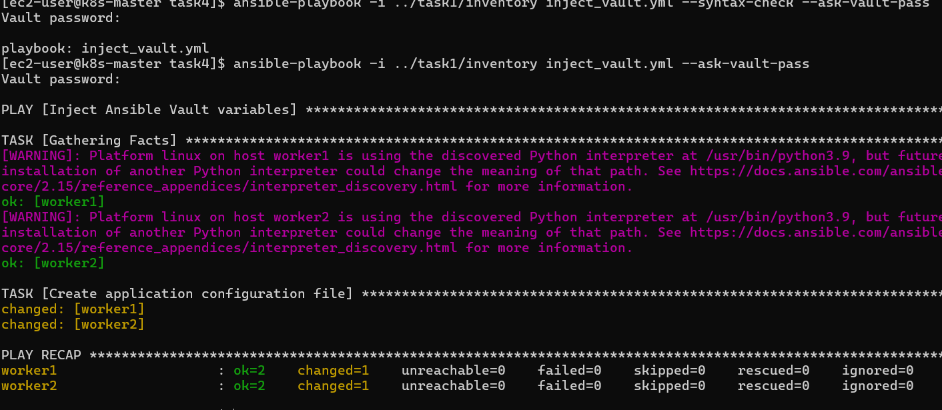
It will ask:
Vault password:
Enter your password.
Expected output:
PLAY [Inject Ansible Vault variables]

TASK [Gathering Facts]
ok: [worker1]
ok: [worker2]

TASK [Create application configuration file]
changed: [worker1]
changed: [worker2]

PLAY RECAP
worker1 : ok=2 changed=1 failed=0
worker2 : ok=2 changed=1 failed=0

Step 10 — Verify the injected variables
Run:
ansible workers -i ../task1/inventory -m shell -a "ls -l /tmp/application.conf" –become
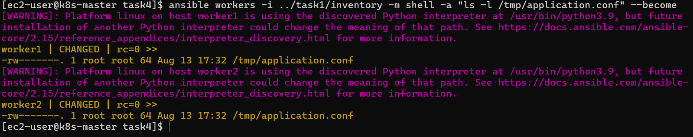
You should see something similar to:
-rw------- 1 root root ... /tmp/application.conf

Step 2 — Read it using sudo
Run:
ansible workers -i ../task1/inventory -m shell -a "cat /tmp/application.conf" –become
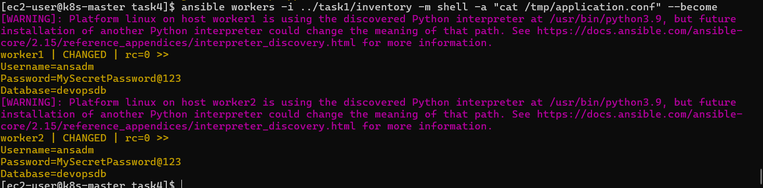
Now you should see:
Username=ansadm
Password=MySecretPassword@123
Database=devopsdb
That confirms the Vault variables were successfully injected into the configuration file. ✅
We're doing it only to verify that the lab works.

What exactly does "inject Vault variables" mean?
In simple terms:
vault.yml
↓
Encrypted variables
↓
vars_files
↓
Playbook
↓
{{ username }}
{{ password }}
{{ db_name }}
↓
Configuration file on worker
The secret is encrypted while stored, and Ansible decrypts it when the playbook needs the values.

🔐 Important Ansible Vault commands
Create
ansible-vault create vault.yml
View
ansible-vault view vault.yml
Edit
ansible-vault edit vault.yml
Encrypt an existing file
ansible-vault encrypt secrets.yml
Decrypt
ansible-vault decrypt vault.yml
Change Vault password
ansible-vault rekey vault.yml
Run playbook
ansible-playbook -i inventory playbook.yml --ask-vault-pass

⭐ Better approach for real projects
Instead of typing:
--ask-vault-pass
every time, you can use a Vault password file.
For example:
echo 'Ansible@123' > .vault_pass
chmod 600 .vault_pass
Then:
ansible-playbook -i ../task1/inventory inject_vault.yml --vault-password-file .vault_pass
However, do not commit .vault_pass to Git.
Add it to .gitignore:
.vault_pass

What we learned
1. Ansible Vault
Ansible Vault protects sensitive data such as:
- Passwords
- API keys
- Database credentials
- SSH-related secrets
- Tokens

2. Encrypted variables
Instead of:
password: MySecretPassword@123
inside a normal file, Vault encrypts the entire file.

3. vars_files
vars_files:
- vault.yml
loads the encrypted variables into the playbook.

4. Variable injection
We can then use:
{{ username }}
{{ password }}
{{ db_name }}
normally inside tasks.
Conclusion – Ansible Task 4
In this task, I implemented Ansible Vault to securely manage sensitive variables such as usernames, passwords, and database details. I created an encrypted Vault file and used vars_files to load the variables into the Ansible playbook. The variables were successfully injected into a configuration file on multiple worker nodes. I also applied proper file ownership and 0600 permissions to protect the sensitive information. This task helped me understand secure secret management and how Ansible Vault can be used in real-world DevOps automation.

