Ansible-Task-04
TASK 1 — Create Ansible Vault
🎯 Objective
The objective of this task is to create and manage an Ansible Vault file that securely stores sensitive information such as:
- Username
- Password
- Database credentials
- API keys
- Application secrets
Instead of keeping secrets in plain-text YAML files, Ansible Vault encrypts them.

Step 1 — Create Task 1 directory
Since you already have your Ansible lab:
cd ~/ansible-03
Create a new directory:
mkdir -p task1-new
cd task1-new
Check:
pwd
You should get something similar to:
/home/ec2-user/ansible-03/task1-new

Step 2 — Create the Vault
Run:
ansible-vault create vault.yml
You'll see:
New Vault password:
Confirm New Vault password:
Enter a password you can remember.
For your lab you can use:
Ansible@123
For a real project, use a strong unique password and don't share it.

Step 3 — Add secret variables
After entering the password, Vim will open.
Enter:
---
username: ansadm
password: MySecretPassword@123
db_name: devopsdb
Save and exit:
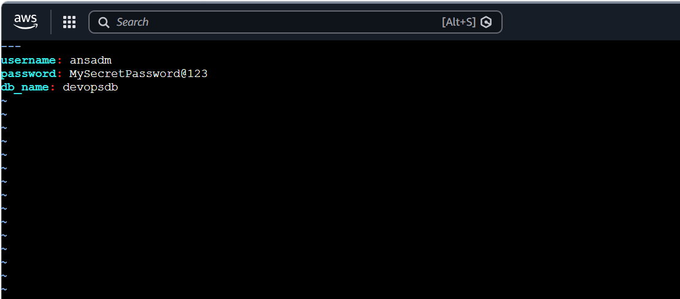
Esc
:wq
Enter

Step 4 — Verify that the file is encrypted
Run:
cat vault.yml
You should not see your actual variables.
Instead, you'll see something similar to:
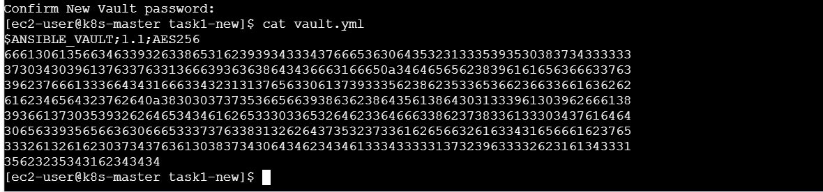
$ANSIBLE_VAULT;1.1;AES256
623234656231...
...
This confirms that the file is encrypted. 🔐

Step 5 — View the encrypted variables
To safely view the contents:
ansible-vault view vault.yml
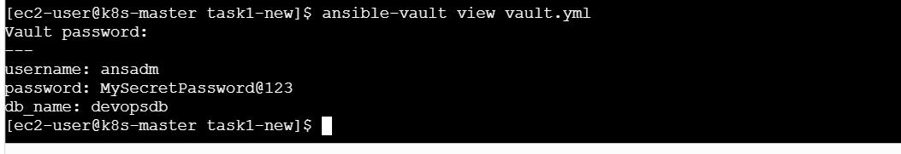
Enter your Vault password.
You should see:
---
username: ansadm
password: MySecretPassword@123
db_name: devopsdb
When finished, exit Vim:
:q

Step 6 — Edit the Vault
You don't need to decrypt the file to modify it.
Run:
ansible-vault edit vault.yml
Enter your Vault password.
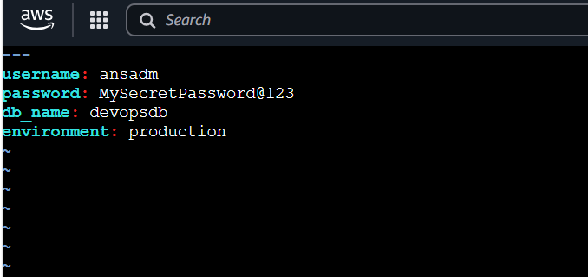
For example, add:
environment: production
So it becomes:
---
username: ansadm
password: MySecretPassword@123
db_name: devopsdb
environment: production
Save:
Esc
:wq
Enter
The file remains encrypted.

Step 7 — Create a normal variables file for comparison
Create:
vim normal_vars.yml
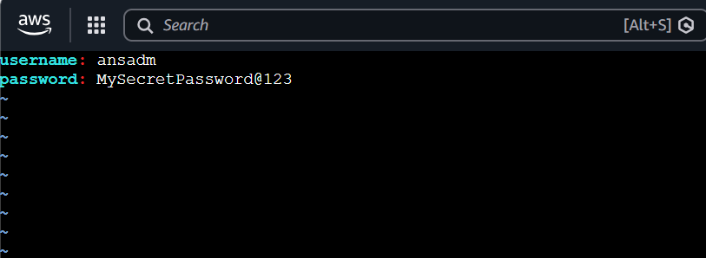
Add:
username: ansadm
password: MySecretPassword@123
Now compare:
cat normal_vars.yml
You can directly see the password.
But:
cat vault.yml
shows encrypted data.
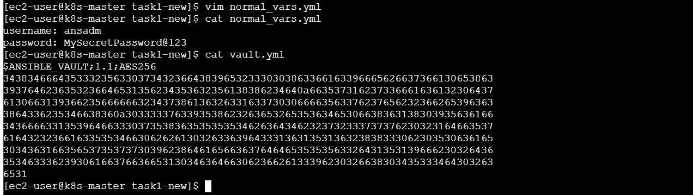
This is the main purpose of Vault:
Plain YAML
↓
Password visible ❌

Ansible Vault
↓
Password encrypted ✅

Step 8 — Important Vault commands
You should know these commands for interviews and practical work.
Create
ansible-vault create vault.yml
View
ansible-vault view vault.yml
Edit
ansible-vault edit vault.yml
Encrypt existing file
ansible-vault encrypt normal_vars.yml
Decrypt
ansible-vault decrypt vault.yml
Change Vault password
ansible-vault rekey vault.yml

Step 9 — Verify the Vault file
Run:
ansible-vault view vault.yml
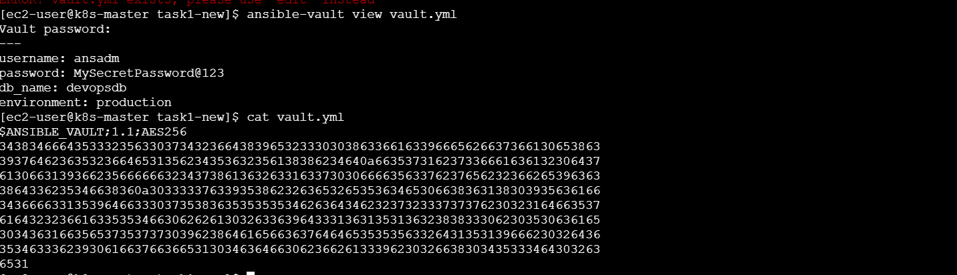
Confirm you can see:
username: ansadm
password: MySecretPassword@123
db_name: devopsdb
environment: production
Then:
cat vault.yml
should show encrypted content.

🧠 What We Learned
1. Ansible Vault
Ansible Vault is used to encrypt sensitive data.
Example:
password: MySecretPassword@123
Instead of storing this in plain text, we encrypt the entire YAML file.

2. Vault is not a separate server
Ansible Vault is a feature provided by Ansible itself.
You don't need to install another application/server for it.

3. Vault encryption
The encrypted file begins with:
$ANSIBLE_VAULT;1.1;AES256
This tells Ansible that the file is an encrypted Vault file.

4. Vault commands
The most important commands are:
ansible-vault create
ansible-vault view
ansible-vault edit
ansible-vault encrypt
ansible-vault decrypt
ansible-vault rekey

🎤 Interview Question
What is Ansible Vault?
You can answer:
"Ansible Vault is an Ansible feature used to securely encrypt sensitive information such as passwords, credentials, API keys and other secrets. It allows us to store sensitive variables in encrypted YAML files and decrypt them only when required during Ansible execution."
Why do we use it?
"We use Ansible Vault to prevent sensitive information from being exposed in plain-text configuration files or Git repositories."

📝 Conclusion
In this task, I created and managed an Ansible Vault to securely store sensitive variables. I learned how to create, view, edit, encrypt, decrypt, and rekey Vault files. Ansible Vault provides a secure way to manage credentials and other confidential information while using Ansible automation.

Task 2 — Install Apache on Linux and Ubuntu using when
🎯 Objective
Create one Ansible playbook that can install Apache on different Linux distributions using a when condition.
For our lab, we'll handle:
- Amazon Linux / Red Hat family → package httpd, package manager dnf
- Ubuntu / Debian family → package apache2, package manager apt
The important concept is that one playbook automatically chooses the correct package and package manager based on the target OS.

Step 1 — Create Task 2 directory
On your Ansible master:
cd ~/ansible-03
mkdir -p task2
cd task2
Check:
pwd

Step 2 — Create inventory
Create:
vim inventory
For your current Amazon Linux workers, use:
[amazon]
worker1
worker2

[ubuntu]
ubuntu1

[all:vars]
ansible_user=ec2-user
ansible_ssh_private_key_file=/home/ec2-user/ohio.pem
⚠️ Important
You cannot put a fake ubuntu1 server in the inventory and run the playbook.
You need an actual Ubuntu EC2 instance for the Ubuntu part.
For now, if you only have your two Amazon Linux workers, use:
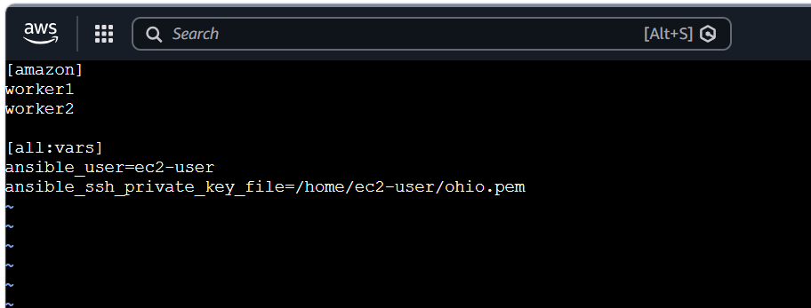
[amazon]
worker1
worker2

[all:vars]
ansible_user=ec2-user
ansible_ssh_private_key_file=/home/ec2-user/ohio.pem
We can later add an Ubuntu machine.

Step 3 — Test connectivity
Run:
ansible all -i inventory -m ping
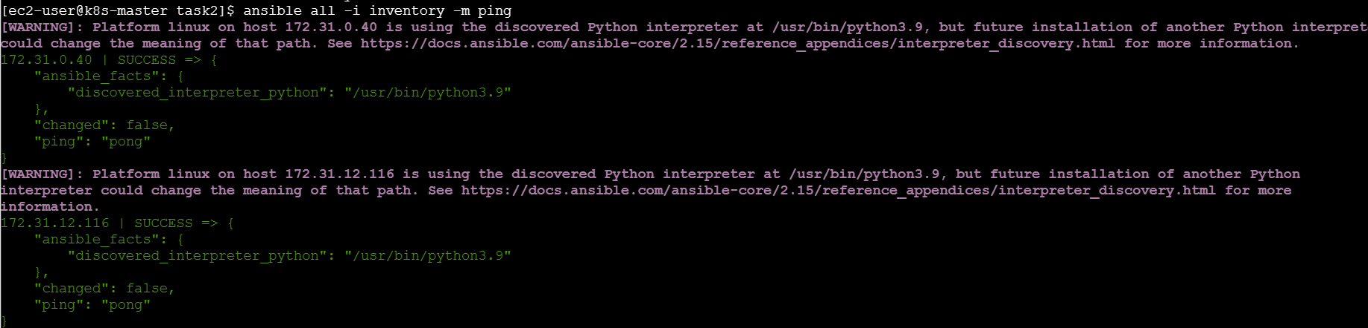
Expected:
worker1 | SUCCESS
worker2 | SUCCESS
Don't proceed if connectivity fails.

Step 4 — Understand ansible_os_family
Before writing the playbook, let's check what Ansible detects.
Run:
ansible all -i inventory -m setup -a "filter=ansible_os_family"
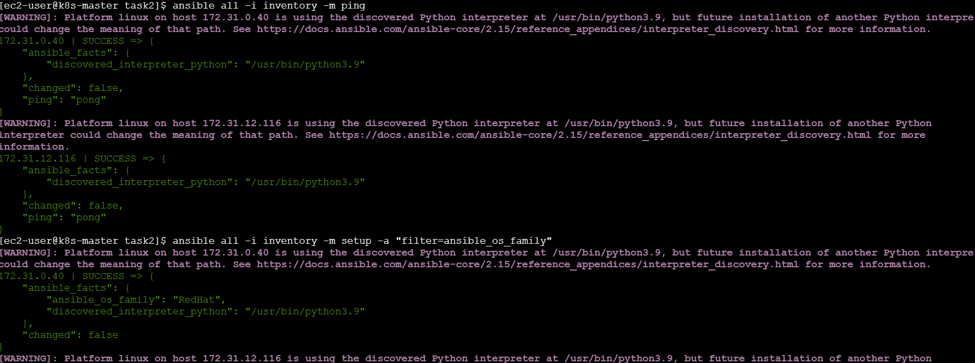
For your Amazon Linux workers, you should get:
"ansible_os_family": "RedHat"
For Ubuntu, it would be:
"ansible_os_family": "Debian"
This fact is what we'll use in our when condition.

Step 5 — Create the playbook
Create:
vim install_apache.yml
Use:
---
- name: Install Apache on Linux systems
hosts: all
become: yes

tasks:

- name: Install Apache on RedHat family
ansible.builtin.dnf:
name: httpd
state: present
when: ansible_os_family == "RedHat"

- name: Install Apache on Debian family
ansible.builtin.apt:
name: apache2
state: present
update_cache: yes
when: ansible_os_family == "Debian"
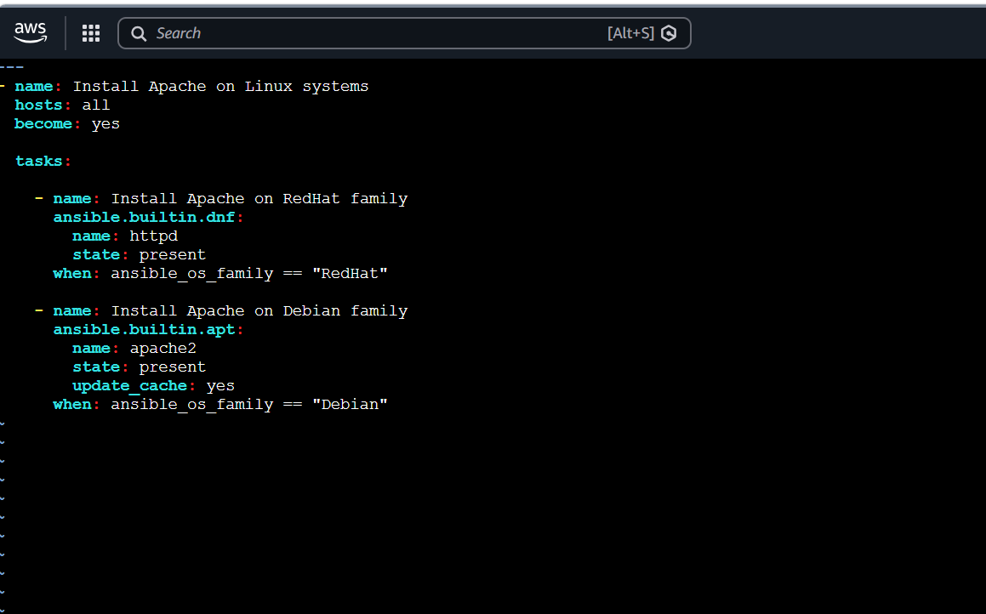
Save:
Esc
:wq
Enter

🧠 Understand the playbook
First task
ansible.builtin.dnf:
name: httpd
This is executed only when:
when: ansible_os_family == "RedHat"
Amazon Linux:
ansible_os_family = RedHat
Therefore:
dnf → httpd → installed

Second task
ansible.builtin.apt:
name: apache2
is executed only when:
when: ansible_os_family == "Debian"
Ubuntu:
ansible_os_family = Debian
Therefore:
apt → apache2 → installed

Step 6 — Syntax check
Run:
ansible-playbook -i inventory install_apache.yml --syntax-check
Expected:
playbook: install_apache.yml

Step 7 — Run on your Amazon Linux workers
Run:
ansible-playbook -i inventory install_apache.yml
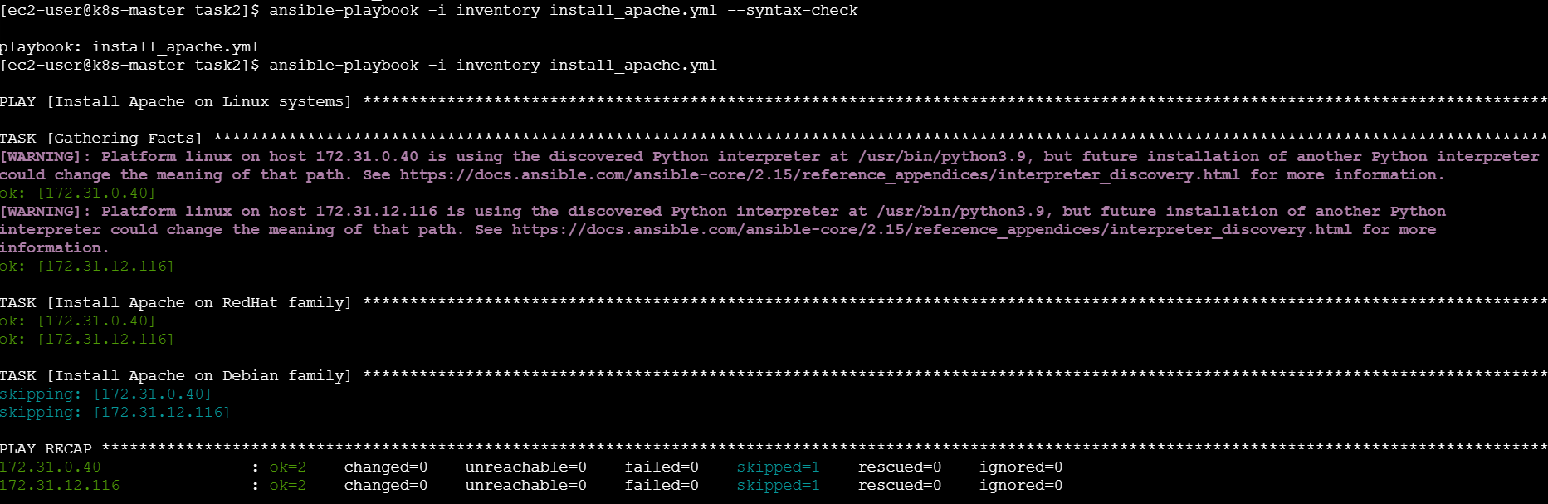
You should see something like:
TASK [Install Apache on RedHat family]
changed: [worker1]
changed: [worker2]

TASK [Install Apache on Debian family]
skipping: [worker1]
skipping: [worker2]
Why is the Debian task skipped?
Because:
worker1 → RedHat
worker2 → RedHat
So:
when: ansible_os_family == "Debian"
is false.
That's exactly what we want.

Step 8 — Verify Apache
Run:
ansible all -i inventory -m shell -a "httpd -v"
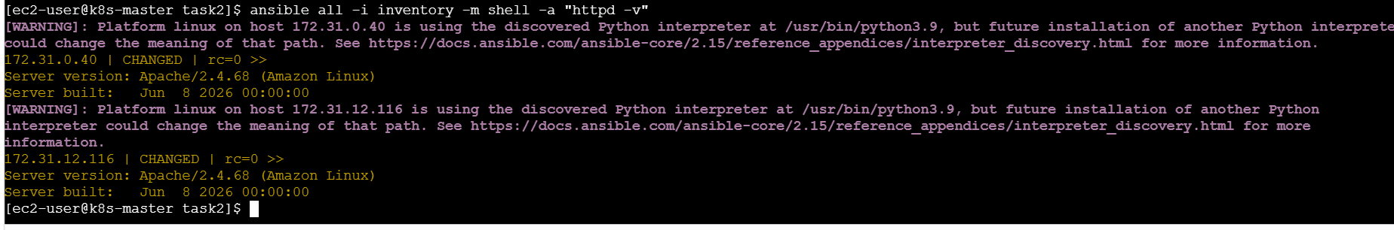
Expected:
Server version: Apache/2.4.68
You can also verify the RPM:
ansible all -i inventory -m shell -a "rpm -q httpd"
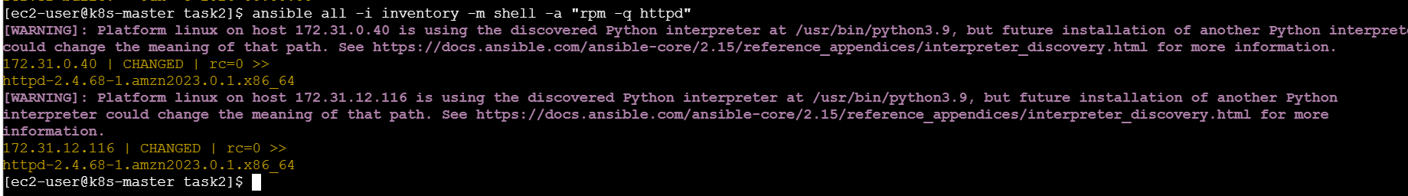

Step 9 — Test with an Ubuntu machine
When you have an Ubuntu EC2 instance, add it to inventory.
For example:
[amazon]
worker1
worker2

[ubuntu]
ubuntu1 ansible_host=10.0.1.50 ansible_user=ubuntu

[all:vars]
ansible_ssh_private_key_file=/home/ec2-user/ohio.pem
Then:
ansible all -i inventory -m ping
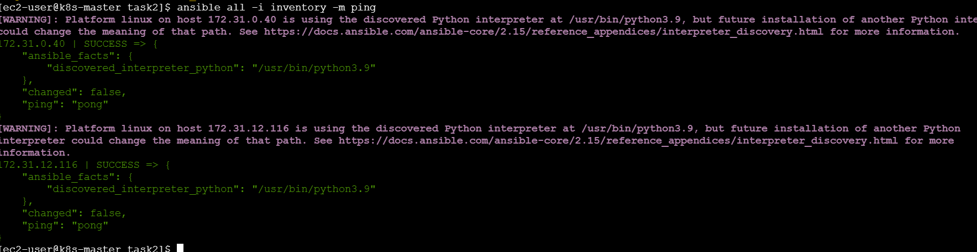
You want:
worker1 | SUCCESS
worker2 | SUCCESS
ubuntu1 | SUCCESS
Then run the same playbook:
ansible-playbook -i inventory install_apache.yml
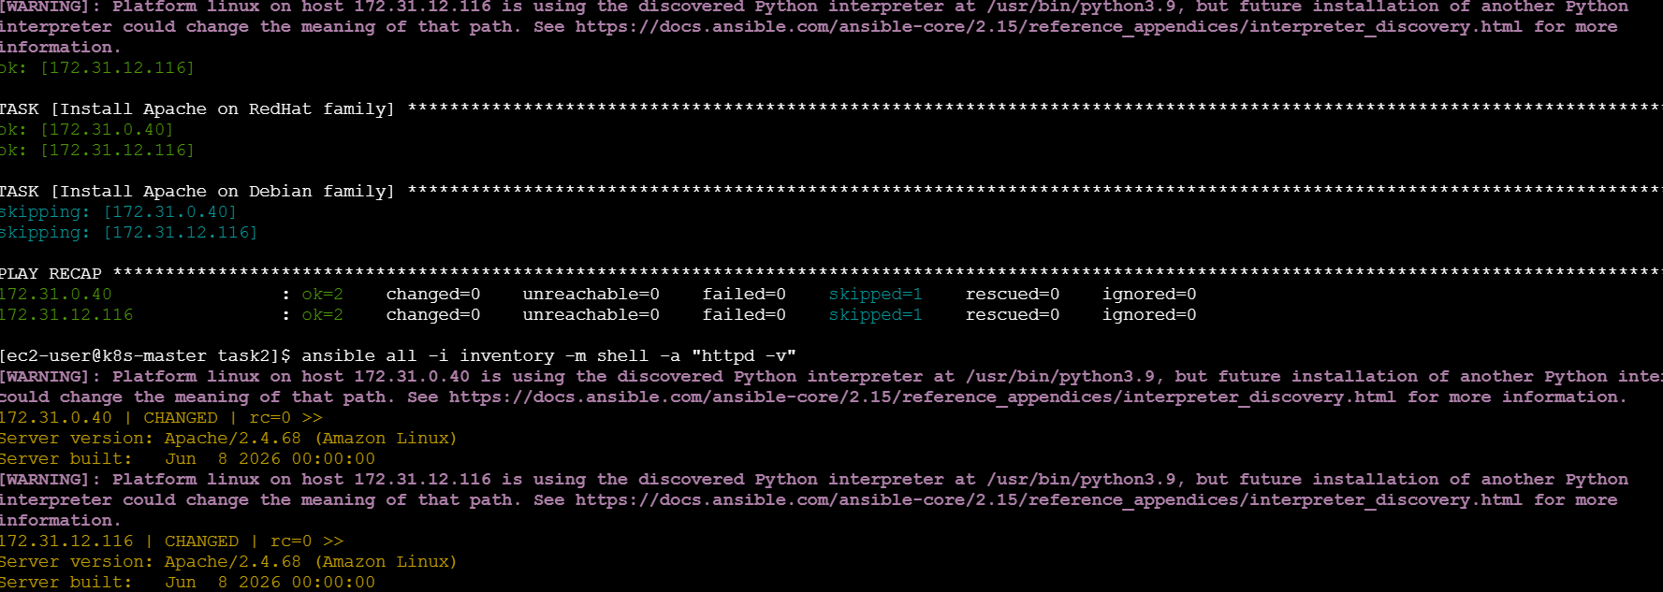
This time you'll see:
Install Apache on RedHat family
changed: [worker1]
changed: [worker2]
skipping: [ubuntu1]

Install Apache on Debian family
skipping: [worker1]
skipping: [worker2]
changed: [ubuntu1]
So the same playbook handles both operating systems.

Step 10 — Verify Ubuntu
On Ubuntu, Apache is called:
apache2
Run:
ansible ubuntu -i inventory -m shell -a "apache2 -v"

Expected:
Server version: Apache/2.4.x

⭐ Why when is important
Without when, you might need separate playbooks:
install-apache-amazon.yml
install-apache-ubuntu.yml
With when, we can have:
One Playbook
|
Detect OS Family
/ \
/ \
RedHat Debian
| |
dnf apt
| |
httpd apache2
This makes your automation more reusable.

🧠 What We Learned
1. Ansible Facts
Ansible automatically collects information about the target machine.
For example:
ansible_os_family
can return:
RedHat
Debian

2. when condition
when controls whether a task should execute.
Example:
when: ansible_os_family == "RedHat"

3. Different package managers
Amazon Linux:
dnf
httpd
Ubuntu:
apt
apache2

4. One playbook for multiple operating systems
This is a very common real-world Ansible use case.

🎤 Interview Question
Q: How do you install Apache on both Amazon Linux and Ubuntu using Ansible?
Answer:
"I use Ansible facts to identify the operating system family and use when conditions to execute the appropriate task. For RedHat-based systems such as Amazon Linux, I use the DNF module with the httpd package. For Debian-based systems such as Ubuntu, I use the APT module with the apache2 package."
Example:
- name: Install Apache on RedHat
dnf:
name: httpd
state: present
when: ansible_os_family == "RedHat"

- name: Install Apache on Debian
apt:
name: apache2
state: present
when: ansible_os_family == "Debian"

📝 Conclusion
In this task, I created a single Ansible playbook to install Apache across different Linux distributions. I used Ansible facts and when conditions to identify the operating system family and select the appropriate package manager and Apache package. This approach makes the playbook reusable and allows the same automation code to support both RedHat-based and Debian-based systems.
TASK 3 — Configure LAMP Stack Using Ansible Roles
🎯 Objective
Create an Ansible Role to automate the installation and configuration of a LAMP stack.
LAMP =
L → Linux
A → Apache
M → MariaDB/MySQL
P → PHP
In your current Amazon Linux 2023 environment, we'll use:
Apache → httpd
MariaDB → mariadb105-server
PHP → php
The final architecture will be:
Ansible Master
|
| Ansible Role
↓
Worker 1
|
├── Apache
├── MariaDB
└── PHP

Worker 2
|
├── Apache
├── MariaDB
└── PHP

Step 1 — Create Task 3 directory
On your Ansible master:
cd ~/ansible-03
mkdir -p task3
cd task3
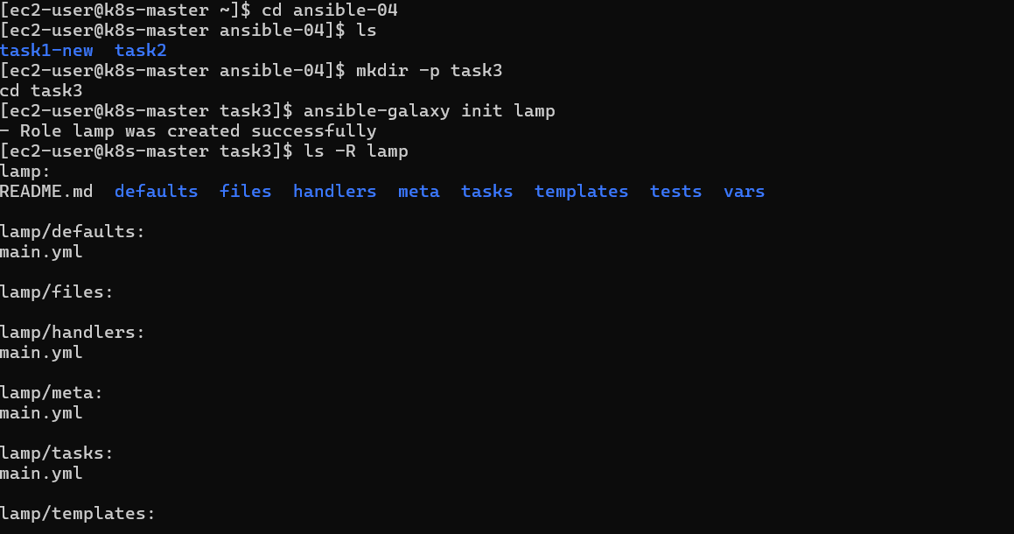
Verify:
pwd
You should see:
/home/ec2-user/ansible-03/task3

Step 2 — Create the Ansible Role
Ansible provides a command to automatically create the role structure.
Run:
ansible-galaxy init lamp

Now check:
ls -R lamp
You should get a structure similar to:
lamp/
├── README.md
├── defaults/
│ └── main.yml
├── handlers/
│ └── main.yml
├── meta/
│ └── main.yml
├── tasks/
│ └── main.yml
├── templates/
├── tests/
│ ├── inventory
│ └── test.yml
└── vars/
└── main.yml
This is one of the most important things to understand about Ansible Roles.

🧠 What is an Ansible Role?
A role is a standardized way of organizing Ansible automation.
Instead of putting everything into one huge playbook:
install Apache
install MariaDB
install PHP
configure Apache
start services
create web page
we organize the automation into separate directories:
lamp/
├── tasks/
├── handlers/
├── templates/
├── defaults/
├── vars/
└── meta/
This makes automation:
- reusable
- organized
- maintainable
- easier to troubleshoot

Step 3 — Understand the important role directories
You don't need to memorize every directory right now.
Focus on these:
tasks/
Contains the main tasks.
lamp/tasks/main.yml
For example:
Install Apache
Install MariaDB
Install PHP
Start services

handlers/
Contains handlers that run when notified.
For example:
Restart Apache

templates/
Used for Jinja2 templates.
Example:
index.php.j2

defaults/
Contains default variables.
Example:
apache_package: httpd
These variables can easily be overridden.

vars/
Contains role-specific variables.

Step 4 — Create the inventory
Inside task3:
vim inventory
Add your two existing workers:
[webservers]
172.31.0.40
172.31.12.116

[webservers:vars]
ansible_user=ec2-user
ansible_ssh_private_key_file=/home/ec2-user/ohio.pem
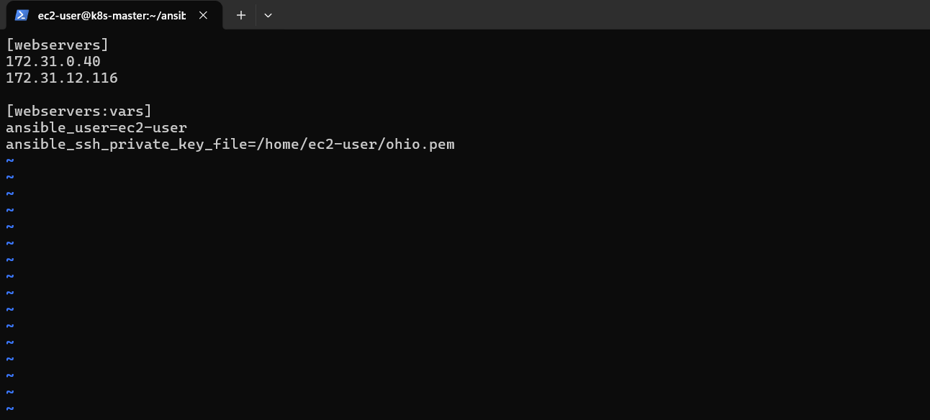
Save:
Esc
:wq
Enter

Step 5 — Test connectivity
Run:
ansible webservers -i inventory -m ping
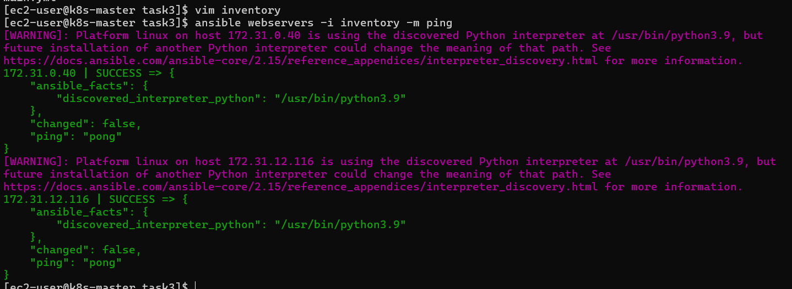
Expected:
172.31.0.40 | SUCCESS
172.31.12.116 | SUCCESS
If you get SUCCESS, continue.

Step 6 — Create LAMP tasks
Now edit:
vim lamp/tasks/main.yml
Replace everything with:
---
- name: Install Apache
ansible.builtin.dnf:
name: httpd
state: present

- name: Install MariaDB
ansible.builtin.dnf:
name:
- mariadb105-server
- mariadb105
state: present

- name: Install PHP
ansible.builtin.dnf:
name:
- php
- php-mysqlnd
state: present

- name: Start and enable Apache
ansible.builtin.service:
name: httpd
state: started
enabled: true

- name: Start and enable MariaDB
ansible.builtin.service:
name: mariadb
state: started
enabled: true
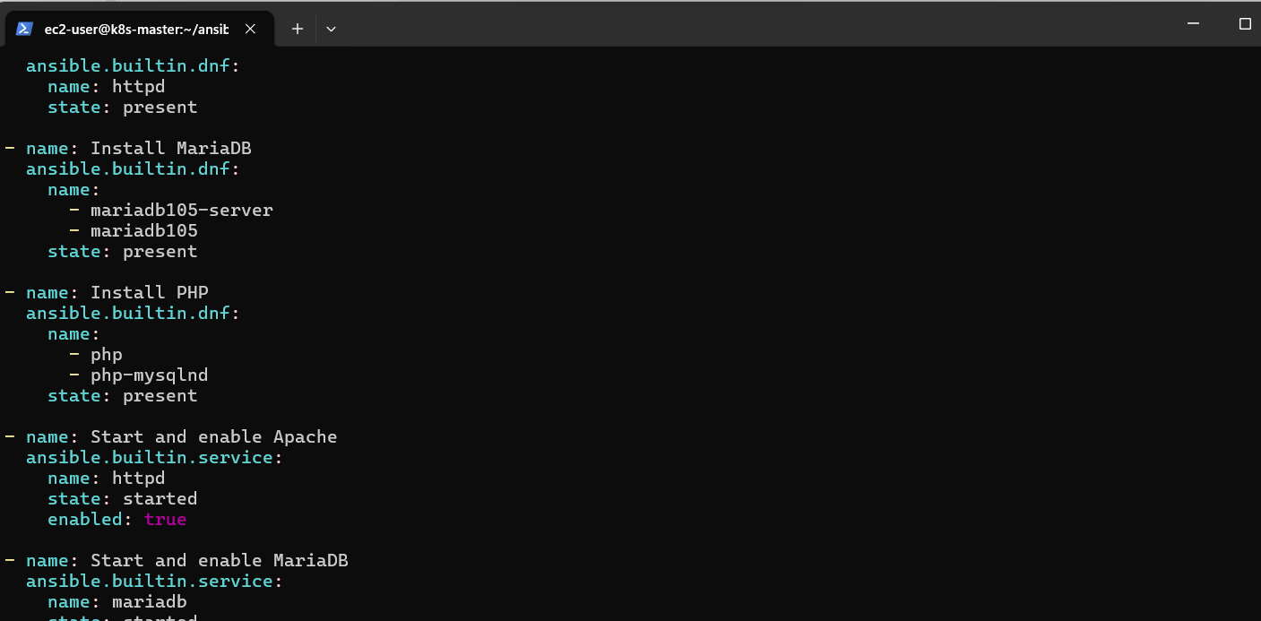
What this does
The role will install:
httpd
↓
Apache

mariadb105-server
↓
MariaDB database server

php
php-mysqlnd
↓
PHP + MySQL/MariaDB support
Then it starts:
httpd
mariadb
and enables them so they automatically start after reboot.

Step 7 — Create the main playbook
Go back to task3:
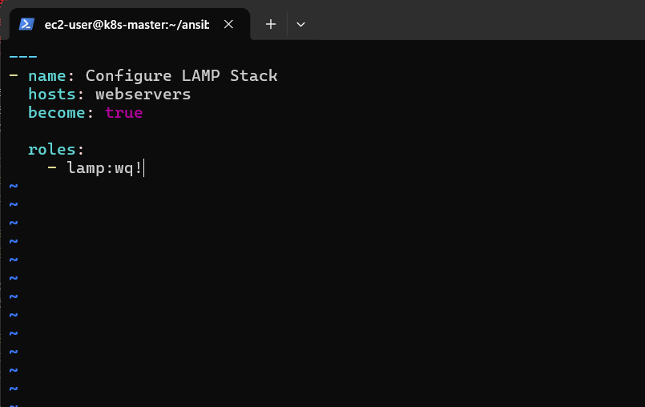
cd ~/ansible-03/task3
Create:
vim lamp.yml
Add:
---
- name: Configure LAMP Stack
hosts: webservers
become: true

roles:
- lamp
That's it.
This is one of the biggest benefits of Roles.
Your main playbook is very small:
roles:
- lamp
The actual implementation is inside:
lamp/

Step 8 — Check your complete structure
Run:
tree
If tree isn't installed:
find . -maxdepth 3 -type f
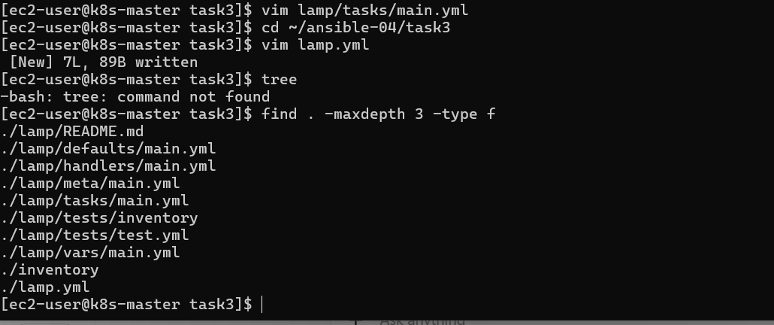
You should have approximately:
task3/
├── inventory
├── lamp.yml
└── lamp/
├── defaults/
│ └── main.yml
├── handlers/
│ └── main.yml
├── meta/
│ └── main.yml
├── tasks/
│ └── main.yml
├── templates/
├── tests/
└── vars/
└── main.yml

Step 9 — Syntax check
Before executing anything:
ansible-playbook -i inventory lamp.yml --syntax-check
Expected:
playbook: lamp.yml
If you get that, your YAML and role structure are valid.

Step 10 — Run the LAMP Role
Now execute:
ansible-playbook -i inventory lamp.yml
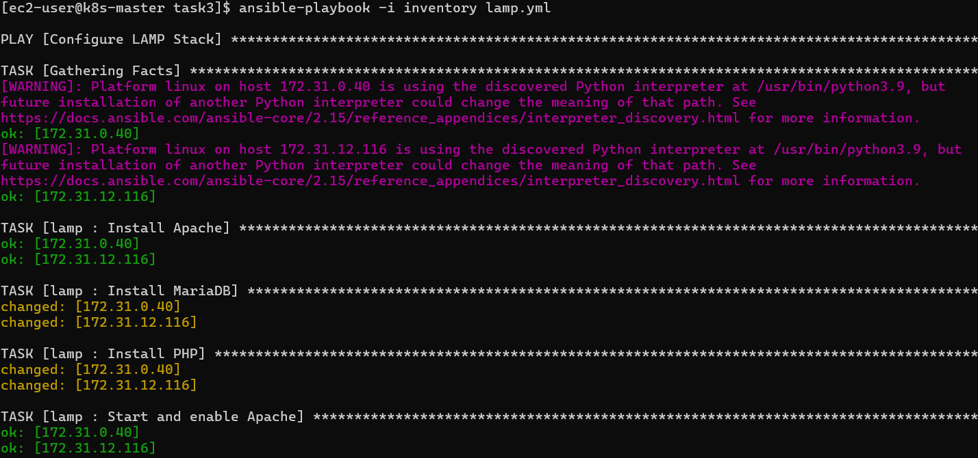
The first run should install the packages.
You should see tasks similar to:
TASK [lamp : Install Apache]
changed: [172.31.0.40]
changed: [172.31.12.116]

TASK [lamp : Install MariaDB]
changed: [172.31.0.40]
changed: [172.31.12.116]

TASK [lamp : Install PHP]
changed: [172.31.0.40]
changed: [172.31.12.116]

TASK [lamp : Start and enable Apache]
changed: [172.31.0.40]
changed: [172.31.12.116]

TASK [lamp : Start and enable MariaDB]
changed: [172.31.0.40]
changed: [172.31.12.116]

Step 11 — Verify Apache
Run:
ansible webservers -i inventory -m shell -a "httpd -v"
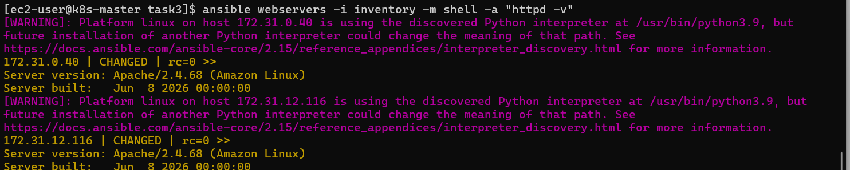
Expected:
Server version: Apache/2.4.68

Step 12 — Verify PHP
Run:
ansible webservers -i inventory -m shell -a "php -v"
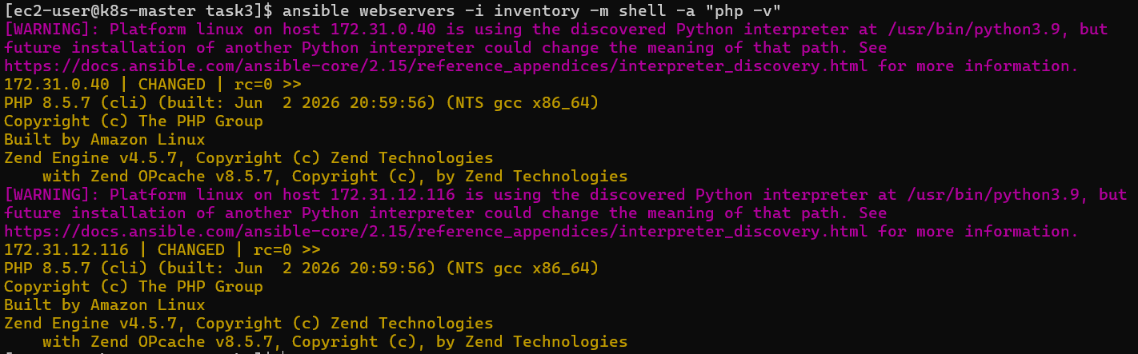
You should get something like:
PHP 8.x.x

Step 13 — Verify MariaDB
Run:
ansible webservers -i inventory -m shell -a "mariadb --version"
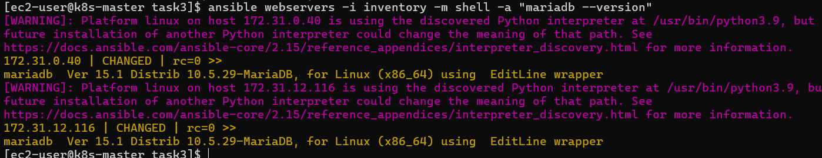
Expected:
mariadb Ver ...
You can also check the service:
ansible webservers -i inventory -m shell -a "systemctl is-active mariadb" –become
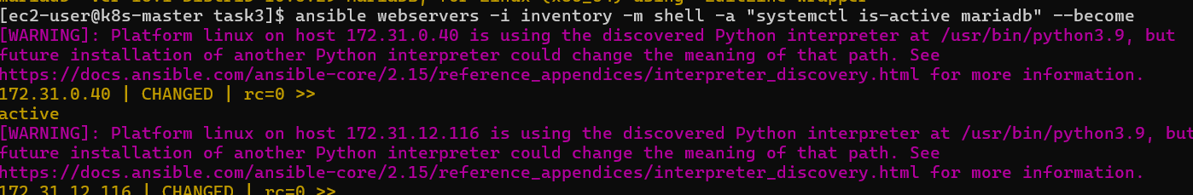
Expected:
active
And Apache:
ansible webservers -i inventory -m shell -a "systemctl is-active httpd" –become
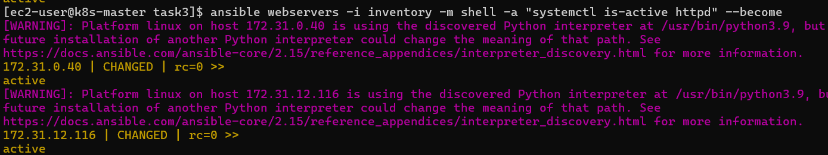
Expected:
active

Step 14 — Important: Test Idempotency
This is an important Ansible concept and interview point.
Run the same playbook again:
ansible-playbook -i inventory lamp.yml
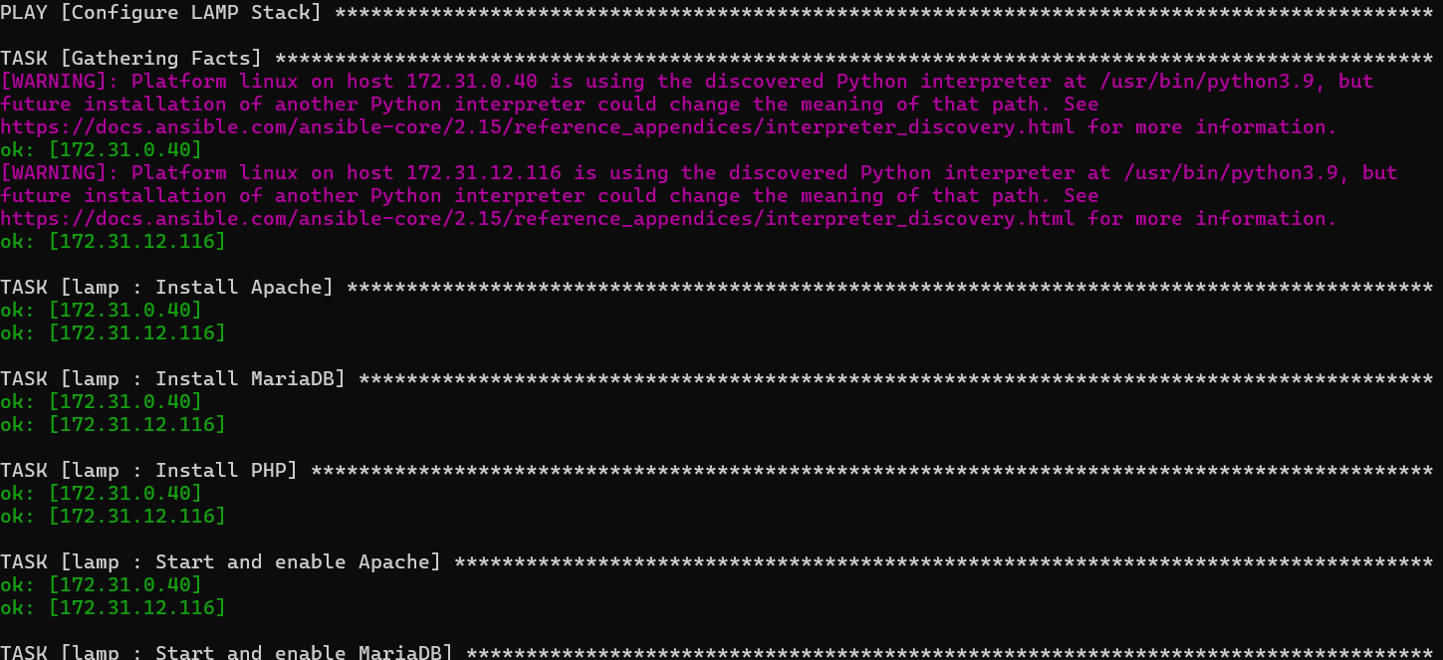
This time, most tasks should show:
ok
instead of:
changed
Why?
Because everything is already installed/configured.
Ansible doesn't unnecessarily make changes.
This is called idempotency.
Example:
First run
changed: [worker1]
changed: [worker2]
Second run
ok: [worker1]
ok: [worker2]

🧠 What We Learned
1. Ansible Role
A Role provides a standard structure for organizing automation.
Instead of one large playbook, we separate:
tasks
handlers
templates
variables
defaults

2. ansible-galaxy init
We used:
ansible-galaxy init lamp
to automatically create the role structure.

3. tasks/main.yml
This is where we put the main automation tasks:
Install Apache
Install MariaDB
Install PHP
Start services
Enable services

4. roles
Our main playbook simply calls:
roles:
- lamp
This keeps the playbook clean.

5. become
We used:
become: true
because installing packages and managing services requires root privileges.

6. Idempotency
Running the same playbook multiple times should not continuously make unnecessary changes.
This is one of the key advantages of Ansible.

🎤 Interview Questions
Q1. What is an Ansible Role?
Ansible Role is a standardized directory structure used to organize and reuse Ansible automation. It separates tasks, handlers, templates, variables and defaults, making playbooks easier to maintain and reuse.
Q2. Why do you use Roles?
I use Roles to modularize automation. Instead of maintaining a large playbook, I separate functionality into reusable roles such as Apache, MySQL, PHP, Docker or Kubernetes configuration.
Q3. How do you create a Role?
ansible-galaxy init lamp
Q4. Where do you define the main tasks?
lamp/tasks/main.yml
Q5. What is the purpose of handlers?
Handlers are tasks that execute only when they are notified, commonly used for restarting or reloading services after a configuration change.

📝 Conclusion
In this task, I created an Ansible Role to automate the configuration of a LAMP stack. I used the role structure to install and configure Apache, MariaDB and PHP, and managed the required services using Ansible. This helped me understand how Roles provide modular, reusable and maintainable automation compared with putting all tasks into a single playbook. I also verified idempotency by executing the playbook multiple times and confirming that no unnecessary changes were made.

TASK 4 — Setup Ansible AWX
🎯 Objective
The objective is to install AWX, access its web UI, and understand how AWX is used to centrally manage Ansible automation.
What is AWX?
AWX provides a web-based interface and API for Ansible automation.
Instead of running:
ansible-playbook -i inventory lamp.yml
from the command line every time, AWX allows you to manage and execute automation through a web interface.
Basic flow:
Developer / DevOps Engineer
|
↓
AWX
|
┌─────┼─────────┐
↓ ↓ ↓
Projects Credentials Inventories
|
↓
Job Template
|
↓
Ansible Playbook
|
↓
Worker Servers

⚠️ Important before installation
AWX is not simply installed with:
yum install awx
Modern AWX is deployed as a Kubernetes application, typically using the AWX Operator.
Since you already have Kubernetes experience, we'll use Kubernetes for this lab.
Our setup will be:
EC2 / Kubernetes Master
|
↓
Kubernetes
|
↓
AWX Operator
|
↓
AWX
|
↓
AWX Web UI

Step 1 — Check your Kubernetes cluster
You're currently on:
ec2-user@k8s-master
First run:
kubectl get nodes
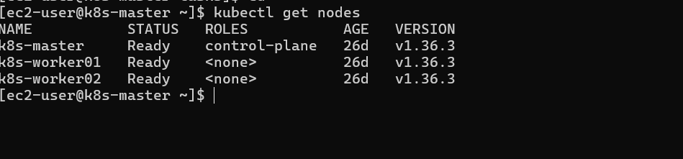
You should see something similar to:
NAME STATUS ROLES AGE VERSION
k8s-master Ready control-plane ... ...
worker1 Ready <none> ... ...
worker2 Ready <none> ... ...
Why?
AWX needs a working Kubernetes cluster.

Step 2 — Check kubectl
Run:
kubectl version --short
If your version of kubectl doesn't support --short, use:
kubectl version
We just want to confirm Kubernetes communication is working.
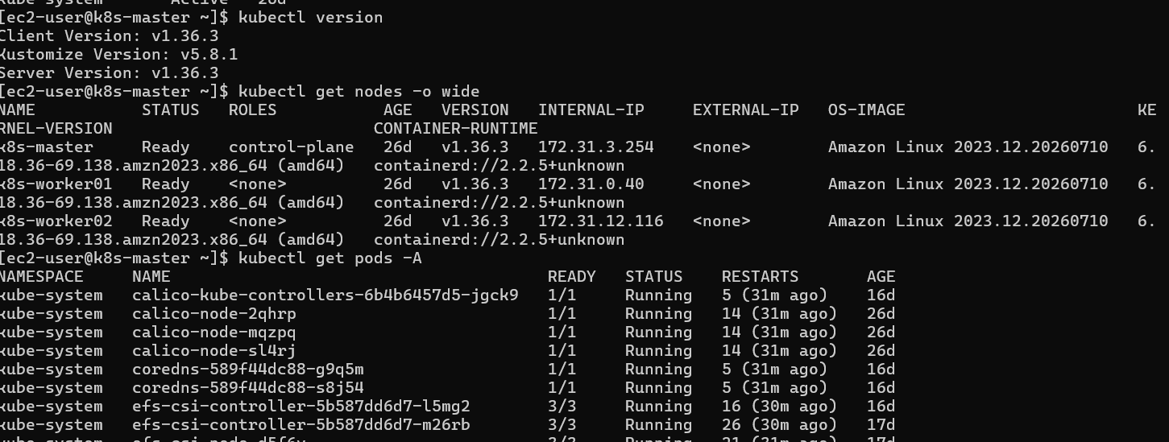

Step 3 — Check available resources
Run:
kubectl get pods -A
Then:
kubectl get nodes -o wide
AWX can be resource-intensive compared with simple Kubernetes applications, so we should check your cluster before deploying it.
Also run:
kubectl top nodes
If you get:
error: Metrics API not available
that's okay. It simply means Metrics Server isn't installed.


Step 4 — Create an AWX namespace
Create a namespace:
kubectl create namespace awx
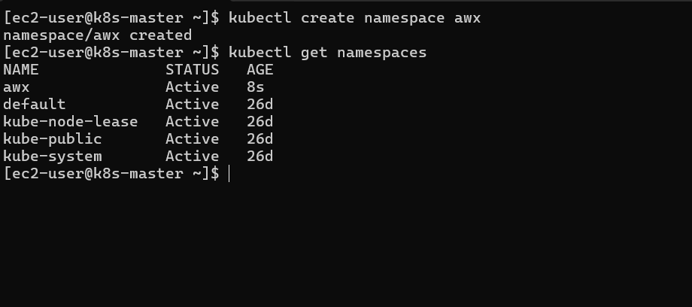
Verify:
kubectl get namespaces
You should see:
awx

Step 5 — Install the AWX Operator
For this step, don't run a random AWX installation command from an old tutorial.
AWX Operator versions and the Kubernetes versions they support change over time. We'll first identify your Kubernetes version and then use a compatible operator release.
Run these commands and send me the output:
kubectl version
and:
kubectl get nodes -o wide
and:
kubectl get pods -A


Step 6: Install AWX Operator
We're going to use a specific released version rather than devel, which is safer for a lab.
1. Go to your home directory
cd ~
Create a directory:
mkdir -p awx
cd awx

2. Create kustomization.yaml
Run:
vim kustomization.yaml
Put this inside:
apiVersion: kustomize.config.k8s.io/v1beta1
kind: Kustomization

resources:
- github.com/ansible/awx-operator/config/default?ref=2.19.1

namespace: awx

images:
- name: quay.io/ansible/awx-operator
newTag: 2.19.1
The AWX Operator documentation uses Kustomize and recommends selecting a specific release tag rather than blindly using the development branch.
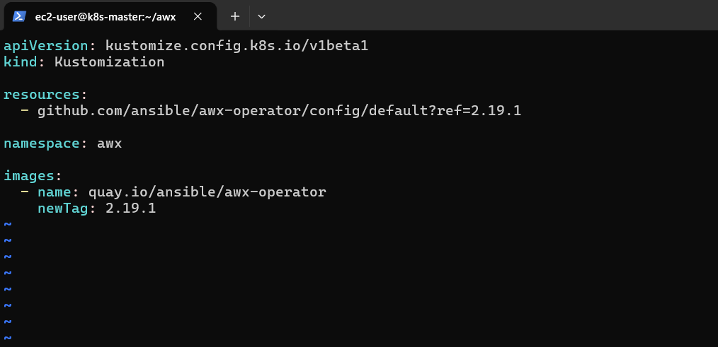
Save:
Esc
:wq
Enter

3. Verify the file
Run:
cat kustomization.yaml
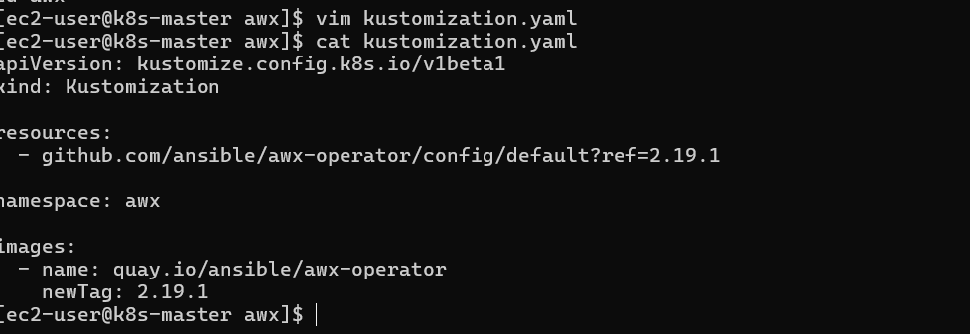
You should see:
apiVersion: kustomize.config.k8s.io/v1beta1
kind: Kustomization

resources:
- github.com/ansible/awx-operator/config/default?ref=2.19.1

namespace: awx

images:
- name: quay.io/ansible/awx-operator
newTag: 2.19.1

4. Install the AWX Operator
Now run:
kubectl apply -k .
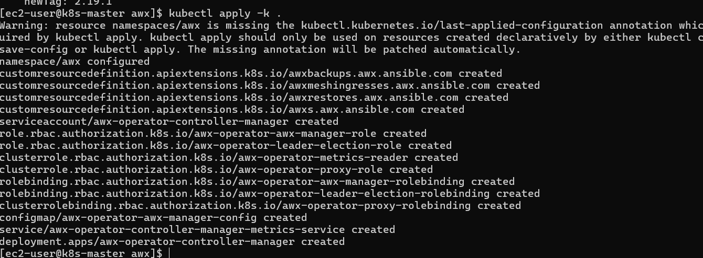
This is the important installation command.
The operator creates the AWX Custom Resource Definitions and controller resources.
You should see resources being created, such as:
namespace/awx created
customresourcedefinition.apiextensions.k8s.io/awxs.awx.ansible.com created
...

5. Check the AWX namespace
Run:
kubectl get pods -n awx
Initially, you may see something like:
awx-operator-controller-manager-xxxxx 0/2 ContainerCreating
That's okay.
Wait around 30–60 seconds and run again:
kubectl get pods -n awx
Eventually we want the operator pod to become:
Running

6. Check the operator deployment
Run:
kubectl get deployments -n awx
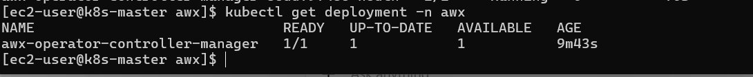
You should see something similar to:
NAME READY
awx-operator-controller-manager 1/1
Step 8 — Create the AWX Instance
Now that the Operator is running, we'll create the actual AWX application.
Create:
vim awx-instance.yml
Put:
---
apiVersion: awx.ansible.com/v1beta1
kind: AWX
metadata:
name: awx
spec:
service_type: nodeport
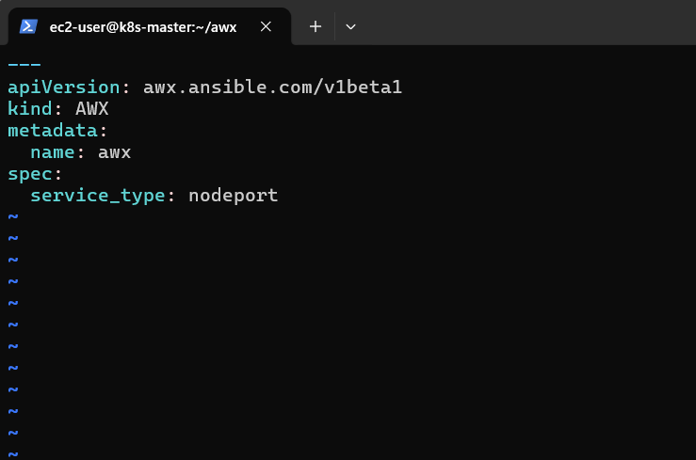
Save:
Esc
:wq
Enter
What does this mean?
kind: AWX
tells the AWX Operator:
"Create an AWX application."
And:
service_type: nodeport
allows us to access AWX externally through a Kubernetes NodePort, which is convenient for your EC2 lab.

Step 9 — Apply the AWX instance
Run:
kubectl apply -f awx-instance.yml
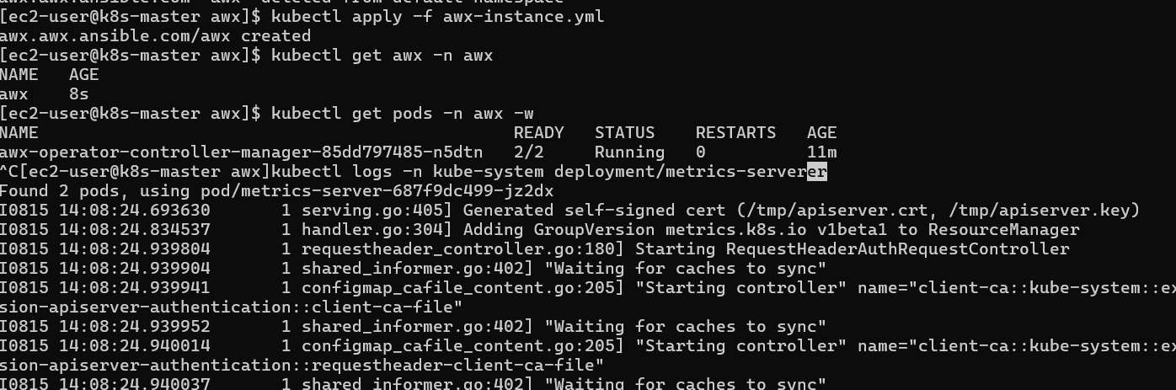
Expected:
awx.awx.ansible.com/awx created

Step 10 — Watch AWX pods
Run:
kubectl get pods -n awx -w
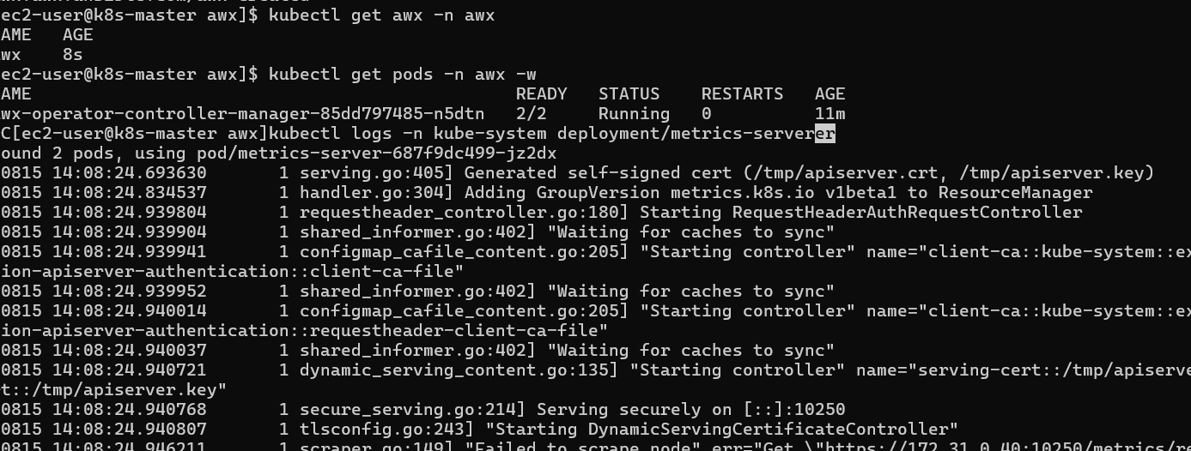
Initially you may see:
awx-postgres-...
awx-task-...
awx-web-...
Some pods may take several minutes to become ready.
Don't worry if they're initially Pending, ContainerCreating, or Init.
AWX has multiple components and PostgreSQL needs to initialize.
Eventually we want something approximately like:
awx-postgres-... 1/1 Running
awx-task-... 4/4 Running
awx-web-... 3/3 Running
awx-operator-... 2/2 Running
The exact pod names and container counts can differ by AWX version.

Run this one command:
kubectl patch deployment metrics-server -n kube-system --type='json' -p='[{"op":"add","path":"/spec/template/spec/containers/0/args/-","value":"--kubelet-
insecure-tls"}]'
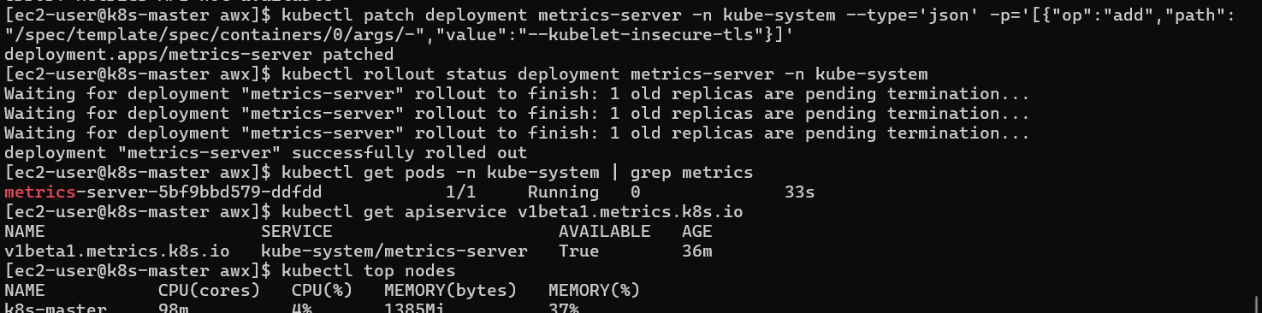
You should get:
deployment.apps/metrics-server patched
Then watch the rollout:
kubectl rollout status deployment metrics-server -n kube-system
You should eventually get:
deployment "metrics-server" successfully rolled out
Then check the pod
kubectl get pods -n kube-system | grep metrics
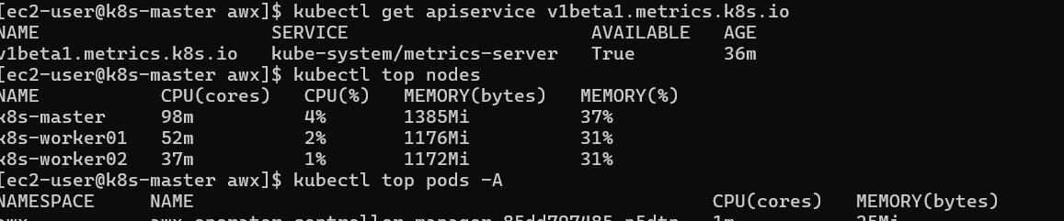
You want:
metrics-server-xxxxxxxxxx-xxxxx 1/1 Running 0 ...
Important: Don't worry if you temporarily see two pods. The old one will be terminated after the new one becomes Ready.
Check Metrics API
Run:
kubectl get apiservice v1beta1.metrics.k8s.io
You want:
v1beta1.metrics.k8s.io kube-system/metrics-server True ...
Instead of:
False (MissingEndpoints)
Finally
kubectl top nodes
You should now get CPU and memory information for:
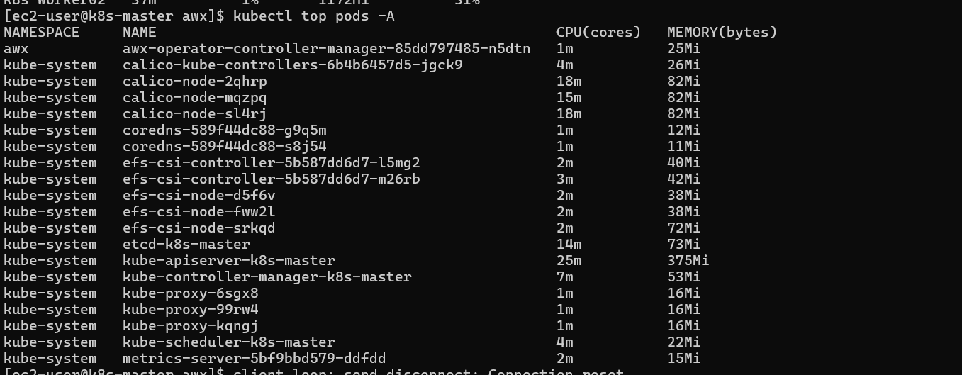
k8s-master
k8s-worker01
k8s-worker02
And also test:
kubectl top pods -A
Conclusion — Task 4: Kubernetes Metrics Server
In Task 4, we installed and configured Kubernetes Metrics Server to collect CPU and memory usage from the cluster nodes and pods. We resolved the kubelet TLS certificate issue by adding the --kubelet-insecure-tls argument.
We verified that the Metrics API is available and successfully retrieved resource usage using kubectl top nodes and kubectl top pods -A

