Challenge 07
- AWS Cloud Architecture Overview
- AWS Infrastructure Design: WAF, ALB & EC2 with Secrets Management
- Cloud Architecture Reference Guide
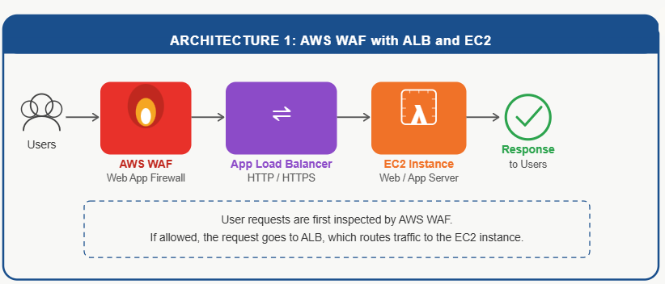

Architecture
Users
│
▼
AWS WAF
│
▼
Application Load Balancer
│
▼
EC2 Instance
Deliverable Summary
Service Used: AWS WAF, ALB, EC2
Objective: Secure web application from common web attacks.
Result: WAF filters malicious requests before they reach the EC2 application through the Load Balancer.

1. Verify EC2 Web Server
SSH into EC2 and run:
sudo systemctl status httpd
If stopped:
sudo systemctl start httpd
sudo systemctl enable httpd
Test locally:
curl localhost
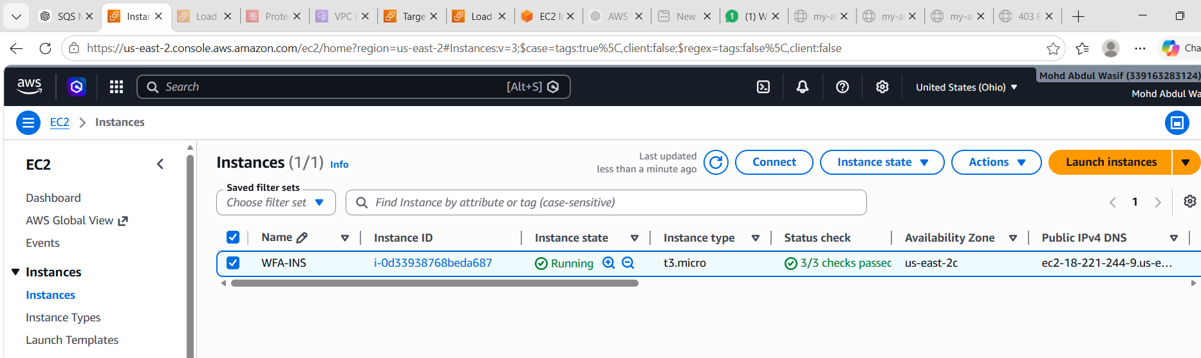
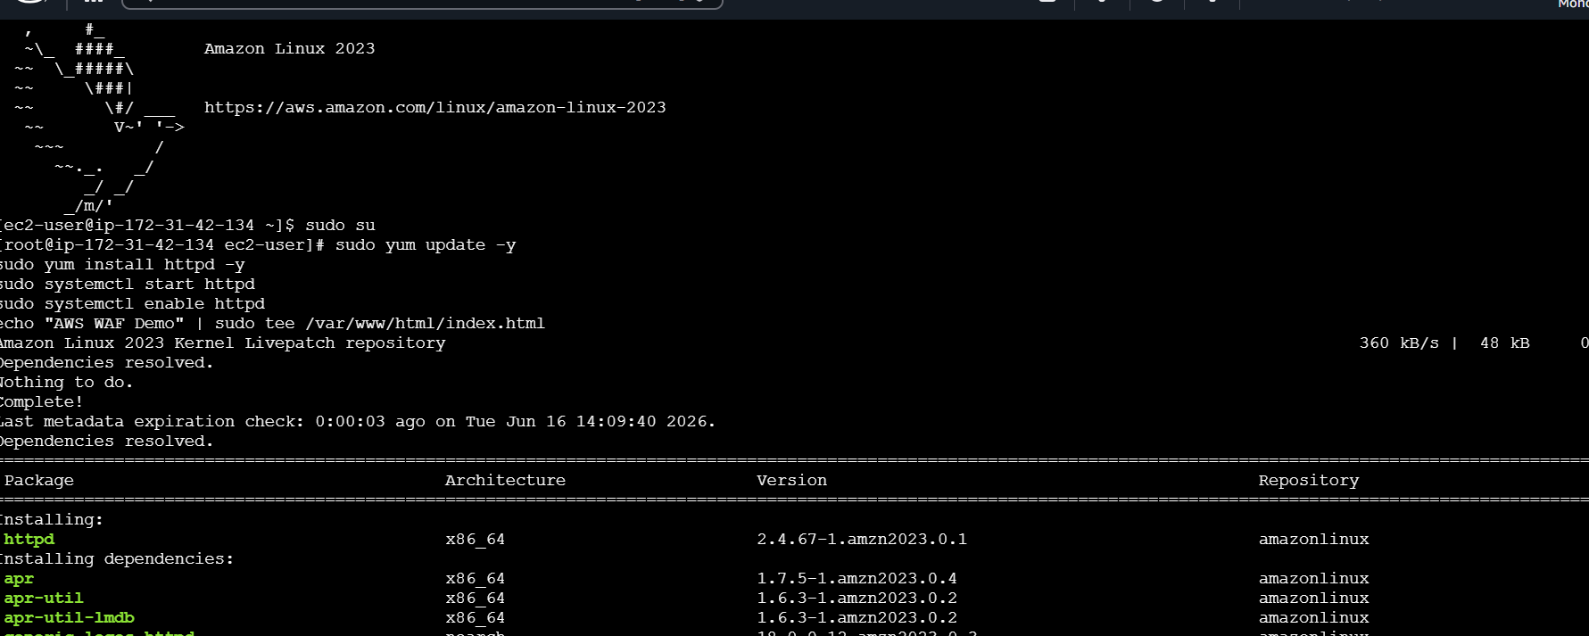

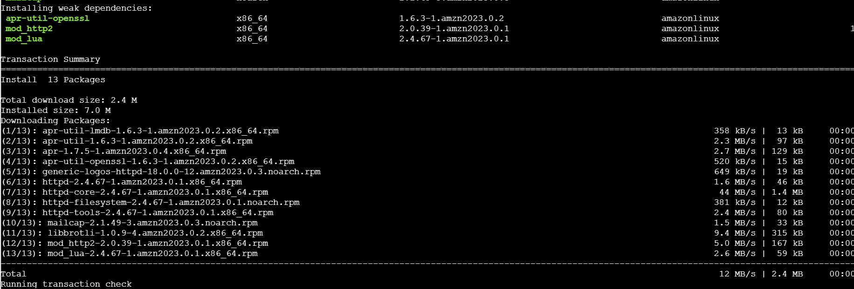
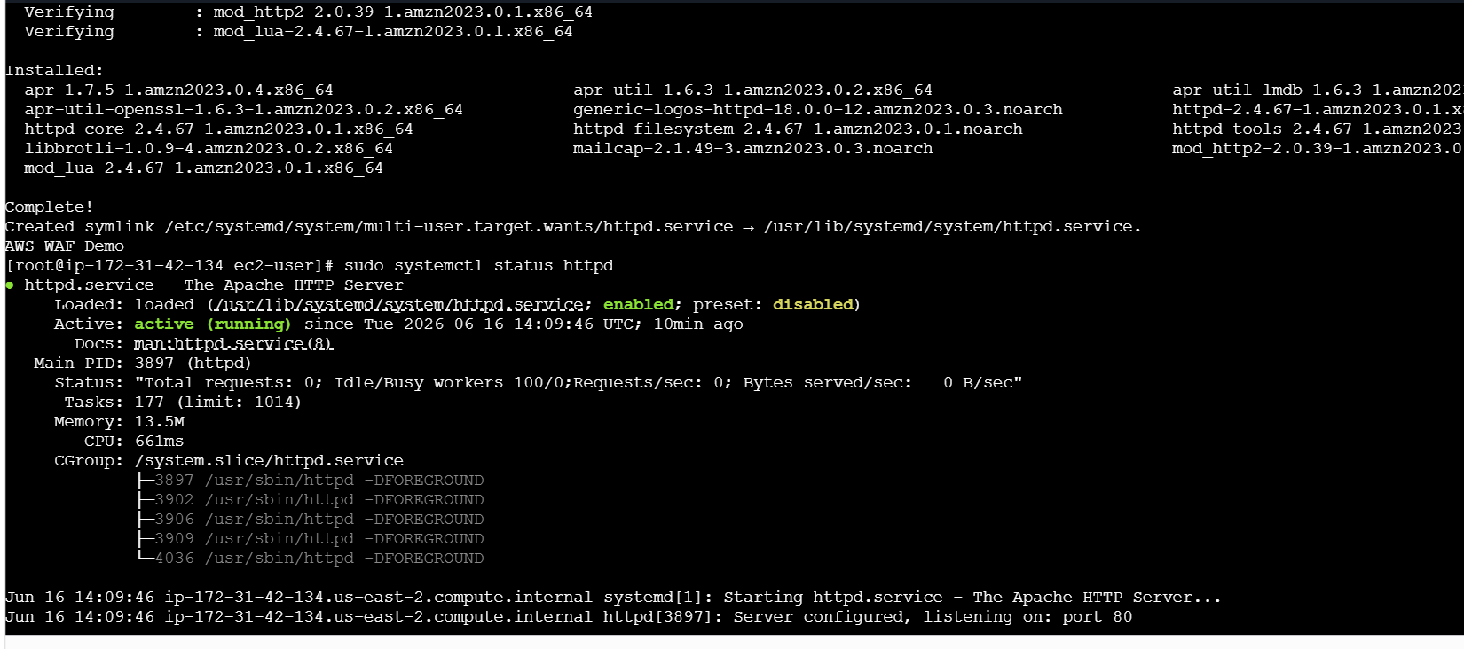

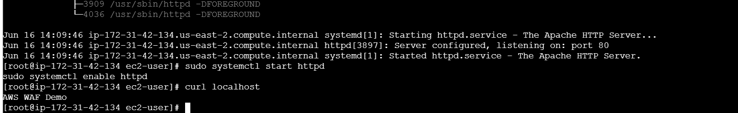

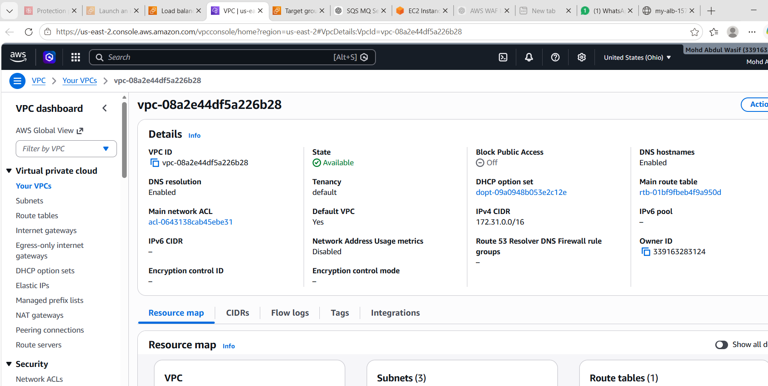
Check Target Group Health
Go to:
EC2 → Target Groups → Targets
Look at the target status.
- Healthy ✅ → Target is fine.
- Unhealthy ❌ → Check the reason shown.
Common reasons:
- Health check path incorrect.
- Port mismatch.
- Security Group blocking traffic.

3. Verify Security Group
EC2 Security Group should allow:
Type | Port | Source
HTTP | 80 | ALB Security Group or 0.0.0.0/0

4. Check Health Check Settings
Target Group → Health Checks
Typical settings:
- Protocol: HTTP
- Port: Traffic Port
- Path: /
If your application is Tomcat:
- Path: /
or
- Path: /appname

5. Test Directly on EC2
Open:
http://EC2-Public-IP
If this doesn't work, the problem is on EC2, not ALB.

6. If Using Tomcat
Check:
sudo systemctl status tomcat
or
ps -ef | grep tomcat
Verify Tomcat is listening:
sudo netstat -tulpn | grep 8080
If ALB Target Group uses port 8080, ensure Tomcat is running on 8080.

Most Common Cause
After creating ALB:
- Target Group port = 80
- Apache/Tomcat not running
- Target marked Unhealthy
- ALB returns 503 Service Temporarily Unavailable
Tell me:
- Are you using Apache, Nginx, or Tomcat?
- What is the Target Group port (80 or 8080)?
- What status do you see under Target Group → Targets?

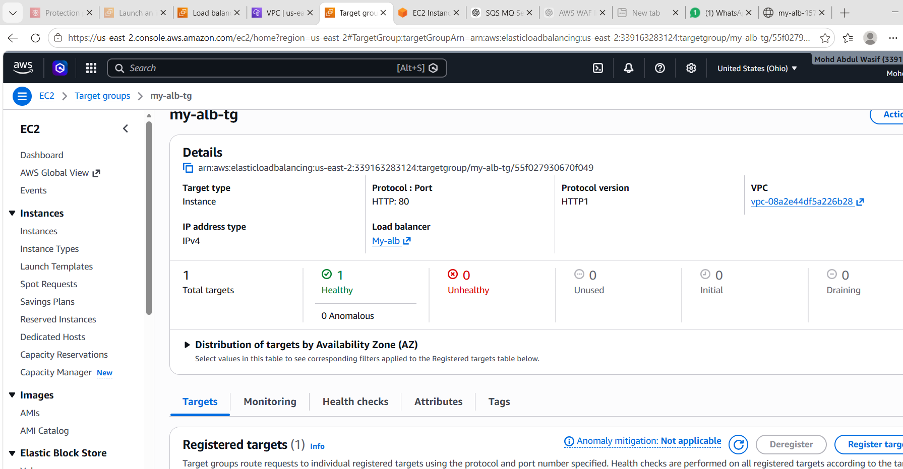

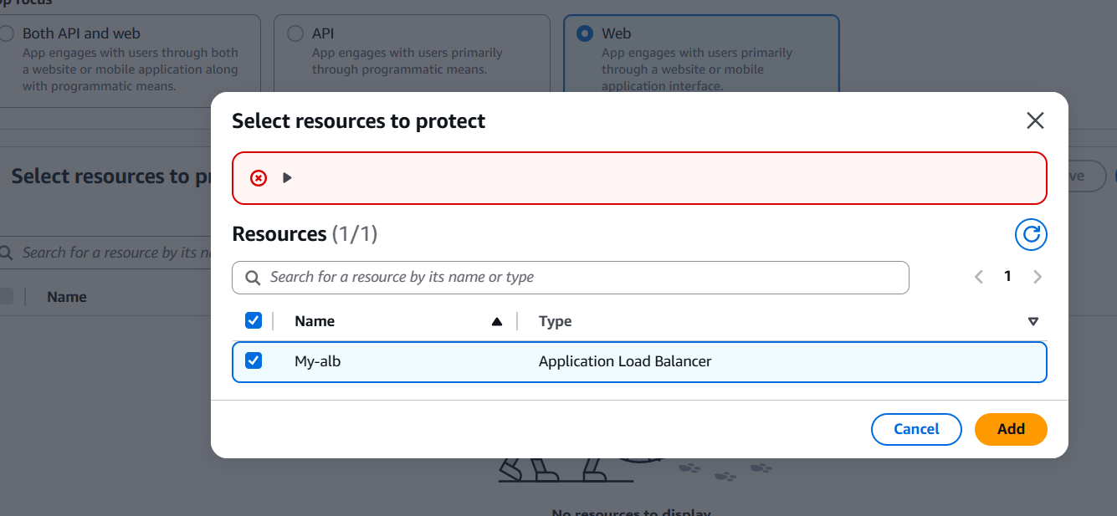
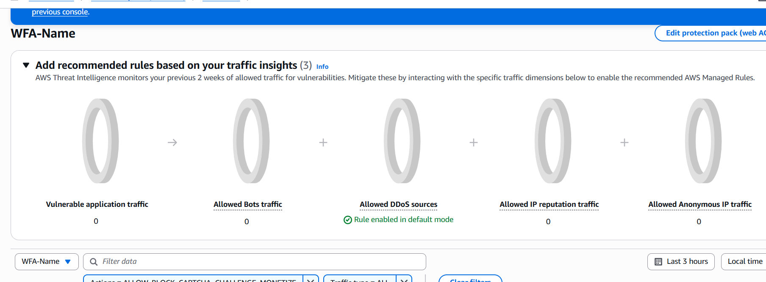
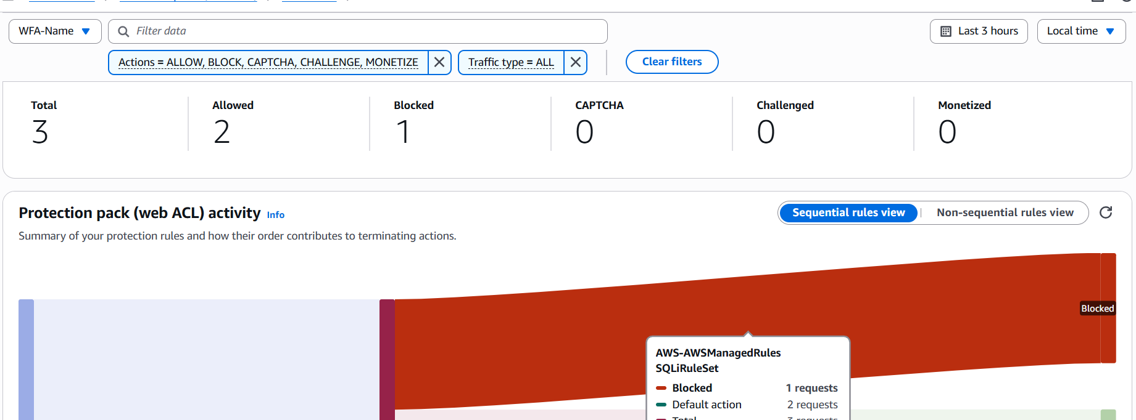

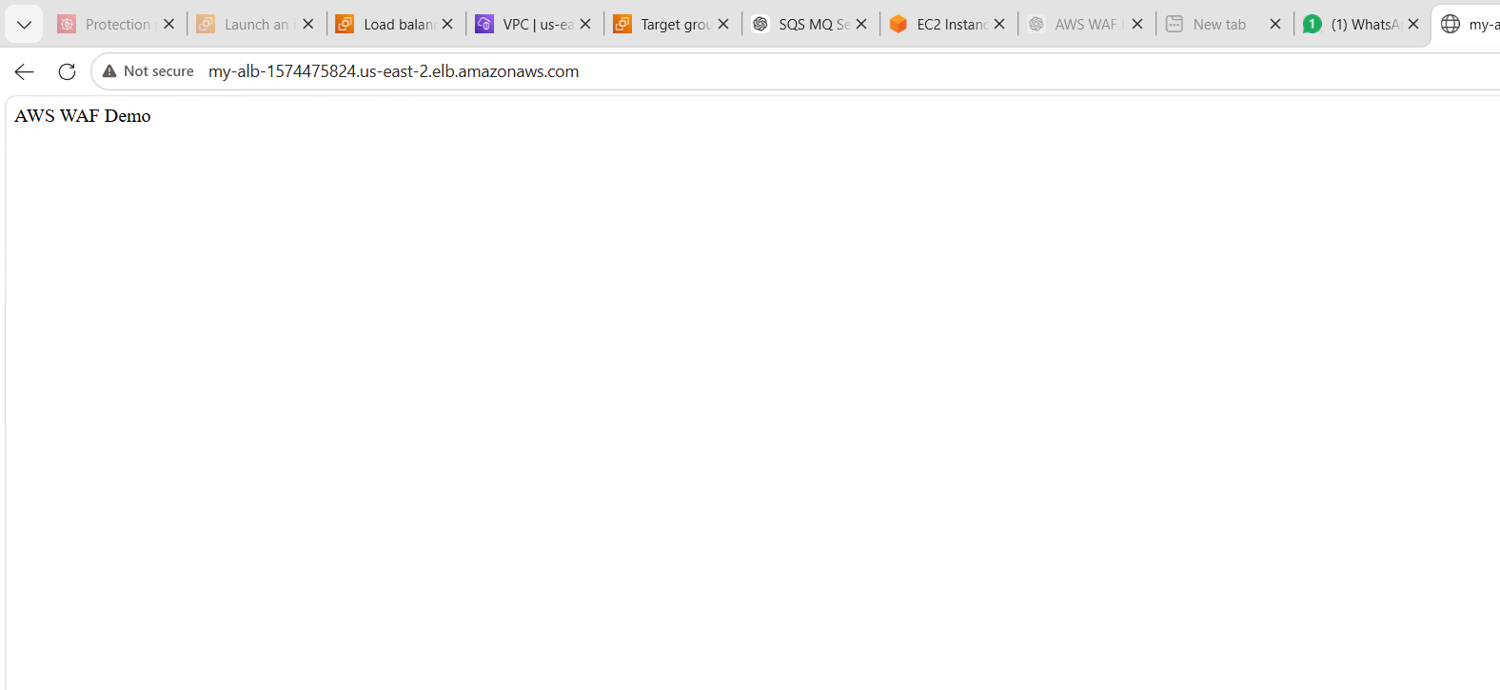

Step 4: Open correct ALB URL
Go to:
👉 EC2 → Load Balancers → WFA-INS
Copy DNS like:
http://wfa-ins-123456.us-east-2.elb.amazonaws.com
❌ Do NOT use:
- AWS WAF Demo ❌ (this is just page content)
- alb-dns ❌

🔥 Step 5: WAF check (after ALB works)
Go to:
👉 WAF → Web ACL → WFA-Name
Check:
- ALB is attached ✅
- Rules enabled ✅
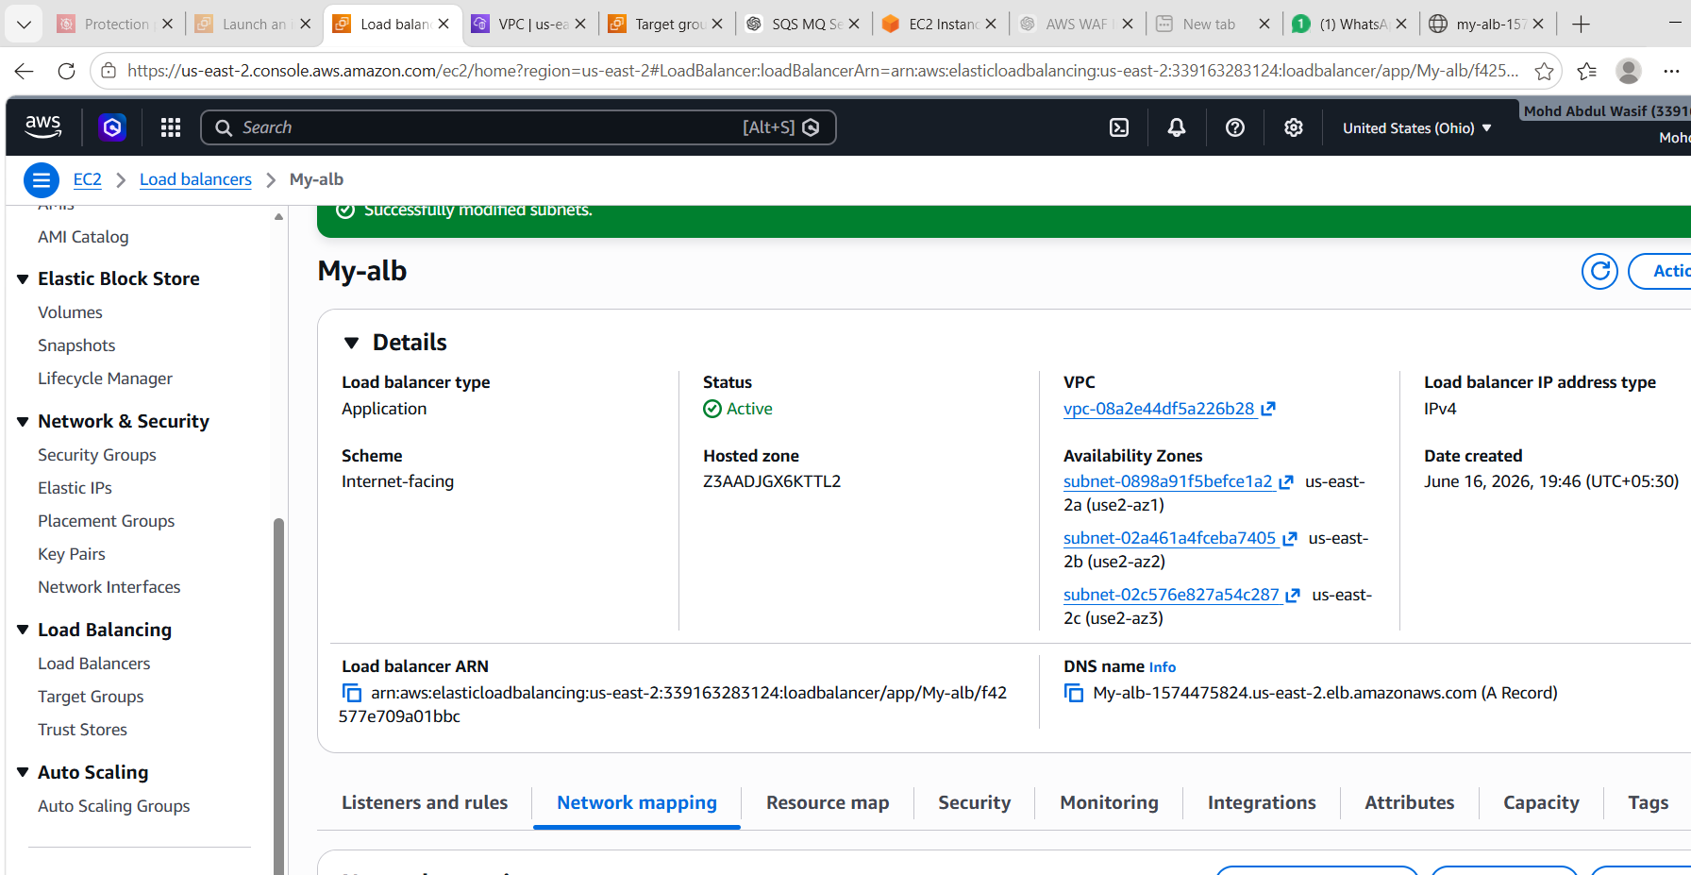
Optional final test (for demo marks)
Try this in browser:
Normal request:
http://my-alb-1574475824.us-east-2.elb.amazonaws.com
Attack simulation:
http://my-alb-1574475824.us-east-2.elb.amazonaws.com/?id=' OR 1=1 --
If WAF is active:
- Normal → allowed ✅
- Malicious → blocked ❌

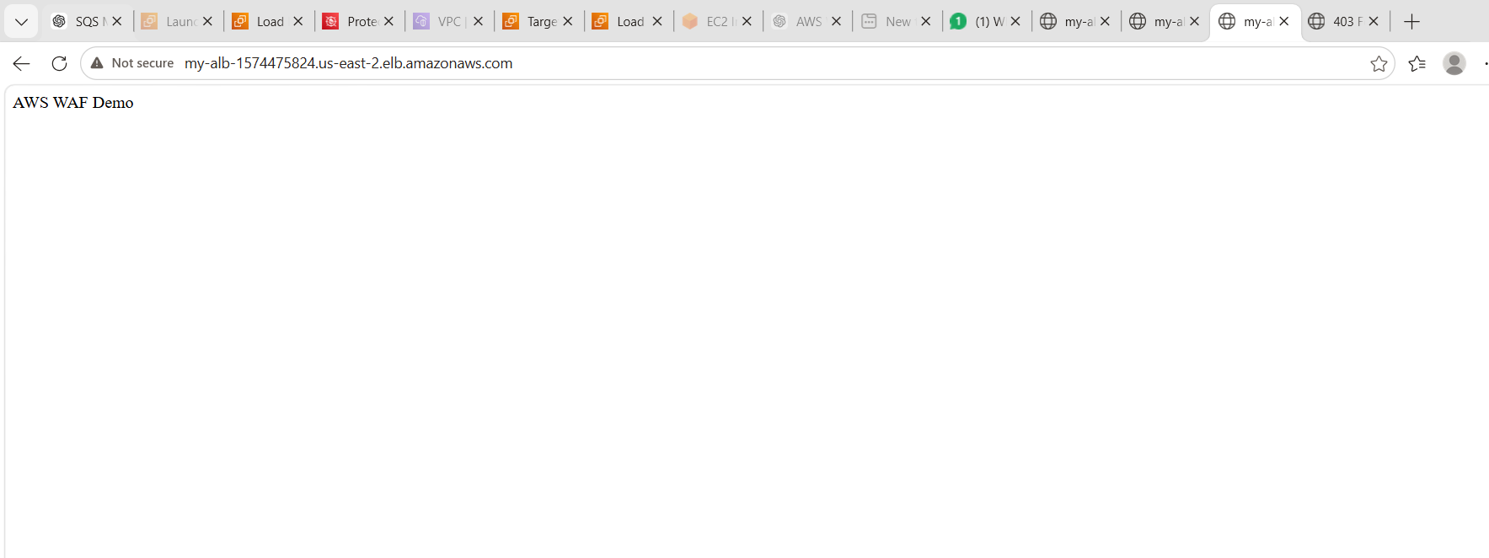

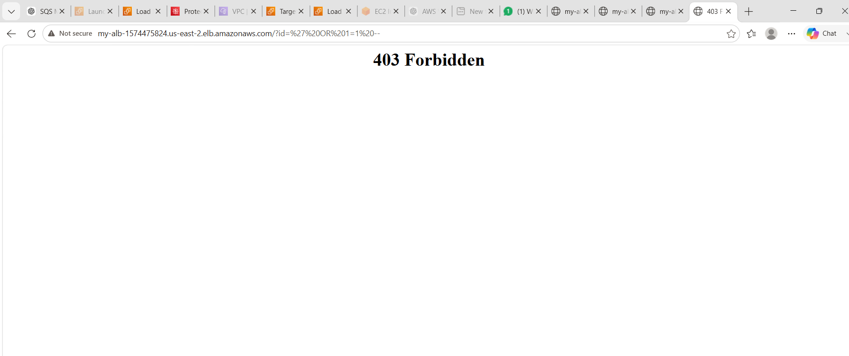

- Final Status of your setup
✔ EC2 instance running
✔ Apache (httpd) working
✔ ALB DNS working
✔ Target group healthy
✔ WAF created and attached
✔ Page loading successfully

🎯 Conclusion (for your document)
Your AWS environment successfully demonstrates a secure web architecture using EC2, Application Load Balancer, and AWS WAF. The ALB routes traffic to a healthy EC2 instance, while WAF provides protection against malicious web requests.

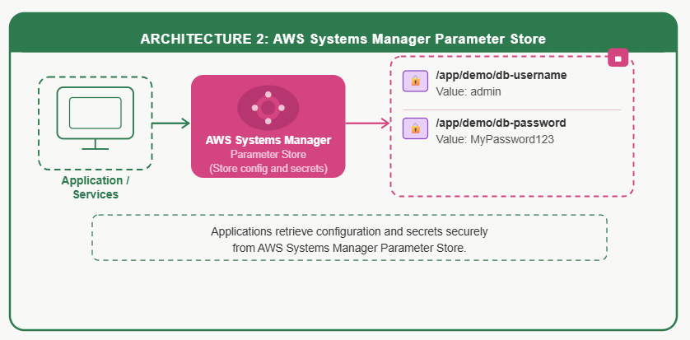

TASK 2: AWS SYSTEMS MANAGER PARAMETER STORE
🎯 Goal
Store and retrieve secure configuration values

🟢 STEP 1: Open Parameter Store
Go to AWS Systems Manager

🟢 STEP 2: Create Parameters
Parameter 1:
- Name: /app/demo/db-password
- Type: String
- Value: MyPassword123

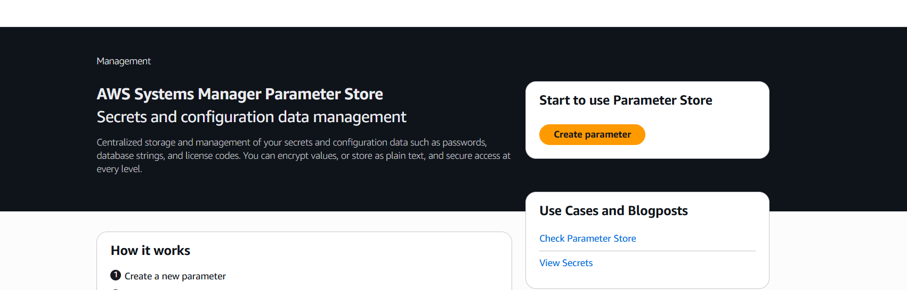
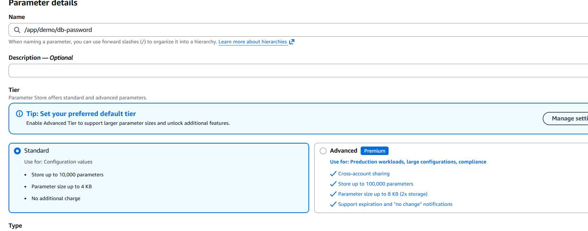

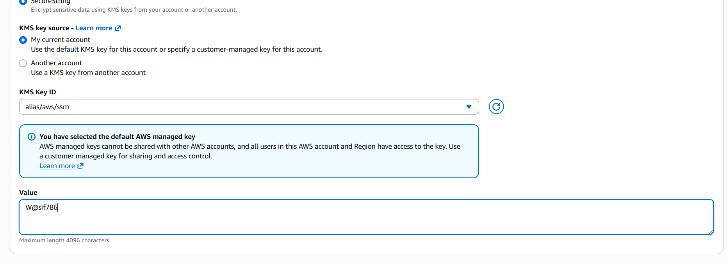

Parameter 2:
- Name: /app/demo/db-username
- Type: String
- Value: admin

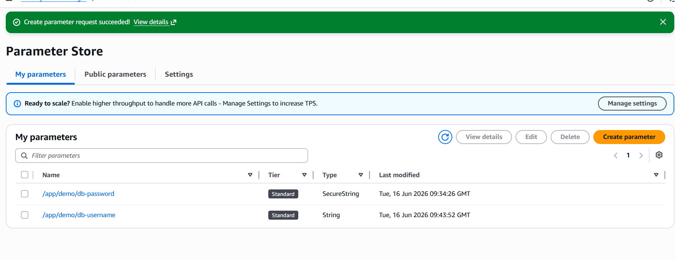
STEP 3: Verify in Console
You should see both parameters listed

🟢 STEP 4: AWS CLI Setup Check
aws sts get-caller-identity

🟢 STEP 5: List Parameters
aws ssm describe-parameters --region us-east-1

🟢 STEP 6: Get Parameter (IMPORTANT)
Method 1:
aws ssm get-parameter \
--name "/app/demo/db-password" \
--region us-east-1
Method 2 (SAFE - YOU USED THIS):
aws ssm get-parameter \
--name "arn:aws:ssm:us-east-1:ACCOUNT_ID:parameter/app/demo/db-password" \
--region us-east-1

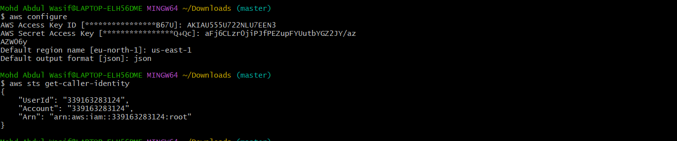

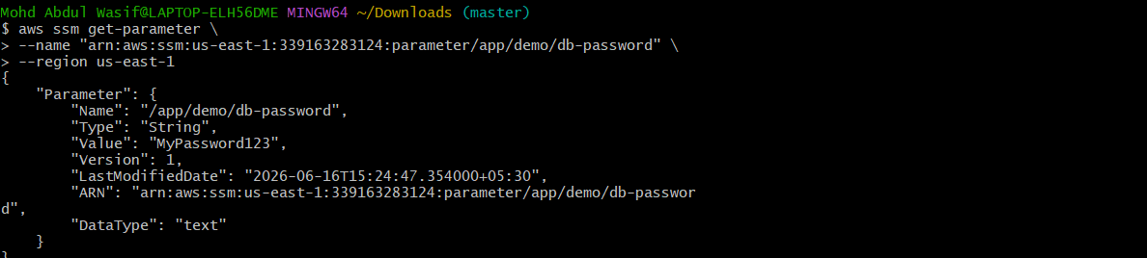
AWS Systems Manager Parameter Store
- Created secure configuration parameters
- Stored database credentials
- Retrieved parameters using AWS CLI
- Used both name and ARN for retrieval
Application
↓
AWS Systems Manager Parameter Store

