Jenkins_03_Task
Task-01
1. Create one Jenkins job using the below code and create three stages.
- stage1: Git clone to download the source code.
- stage2: Sonarqube Integration to check the quality of code.
- stage3: Slack Integration to send the alerts to slack.
Source Code: https://github.com/betawins/VProfile-1.git

Jenkins CI/CD Job – VProfile Project
🎯 Objective
To create a Jenkins job that automates the CI/CD process using:
- GitHub (Source Code Management)
- SonarQube (Code Quality Analysis)
- Slack (Build Notifications)

🧰 Tools Used
- Jenkins
- GitHub Repository: https://github.com/betawins/VProfile-1.git
- SonarQube Server
- Slack Workspace
- Jenkins Plugins:
  - Git Plugin
  - SonarQube Scanner Plugin
  - Slack Notification Plugin

⚙️ STEP 1: Install Required Plugins
Go to:
👉 Manage Jenkins → Manage Plugins
Install:
- Git Plugin
- Pipeline Plugin (if pipeline job)
- SonarQube Scanner Plugin
- Slack Notification Plugin

⚙️ STEP 2: Configure Git
Go to:
👉 Manage Jenkins → Global Tool Configuration
- Git will be auto-installed in most cases

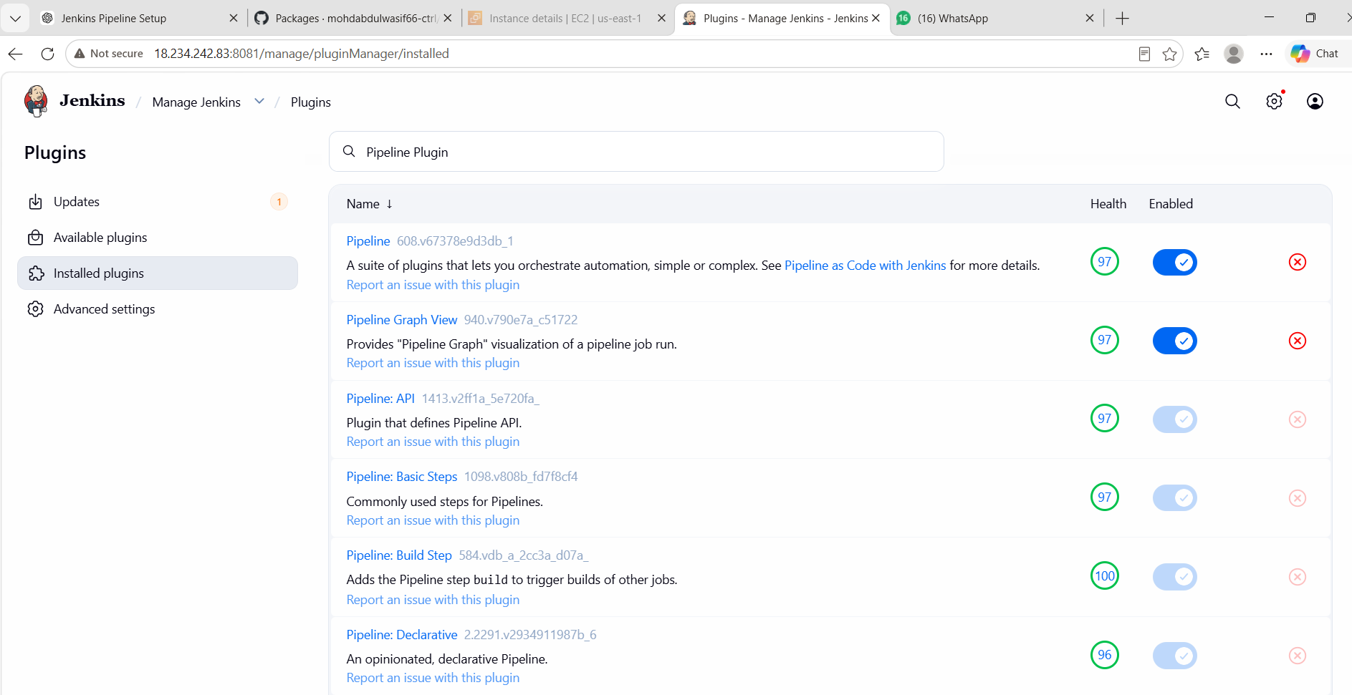

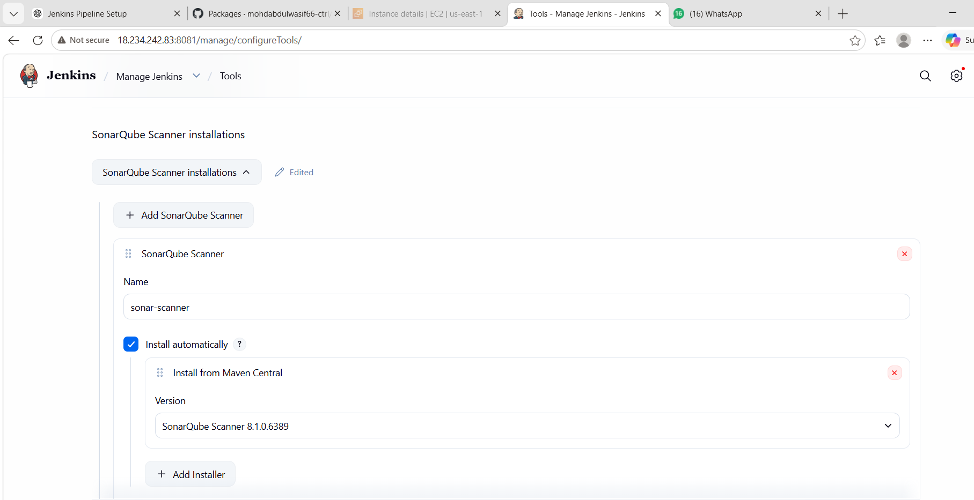
STEP 3: Configure SonarQube in Jenkins
Go to:
👉 Manage Jenkins → Configure System
Add SonarQube Server:
Field | Value
Name | sonar
Server URL | http://44.203.237.63:9000
Token | sonar-token
✔ Save configuration

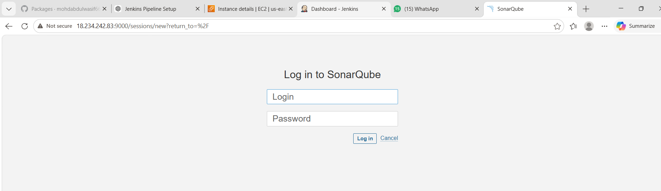

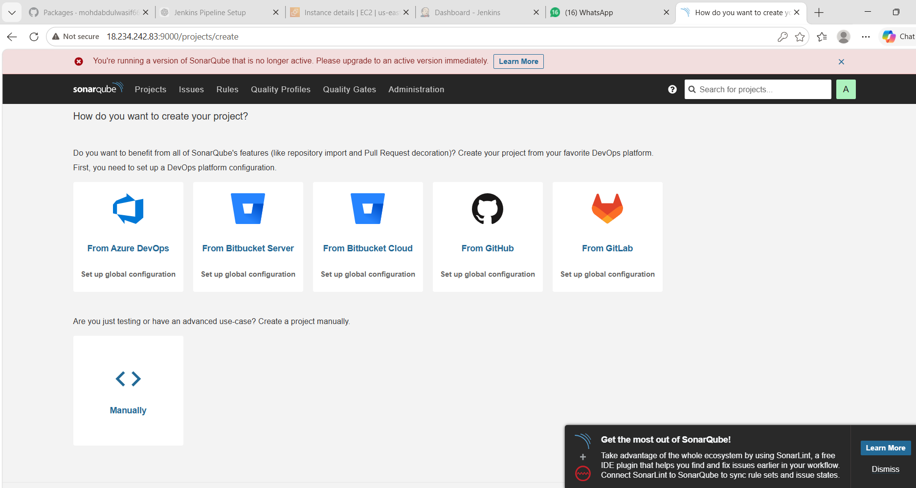
STEP 4: Configure SonarQube Scanner
Go to:
👉 Global Tool Configuration
- Add SonarScanner
- Name: sonar-scanner
STEP 5: Configure Slack Integration
Go to:
👉 Manage Jenkins → Configure System → Slack
Fill details:
Field | Value
Workspace | your Slack workspace
Credential | slack-webhook (Bot token xoxb-xxxx)
Default Channel | #jenkins-alerts

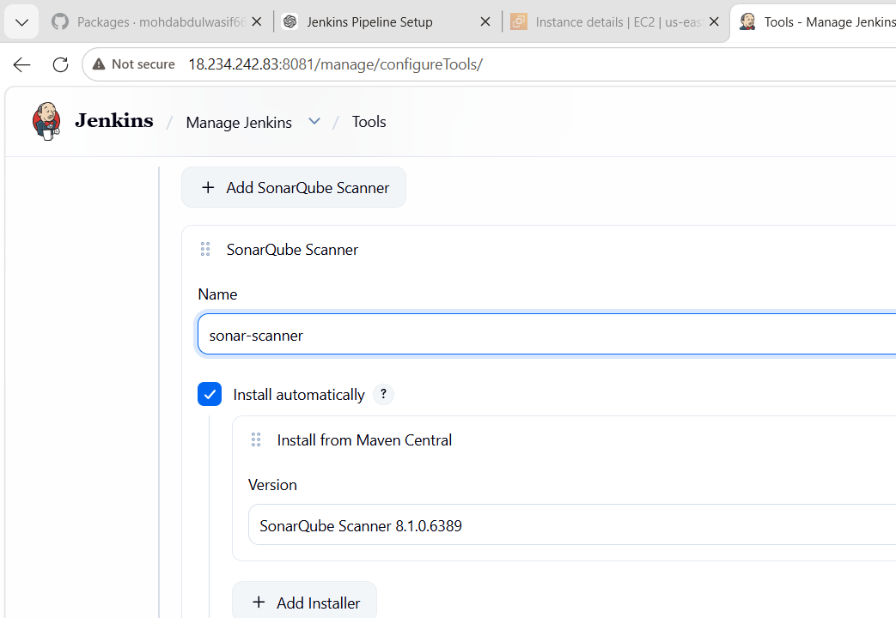

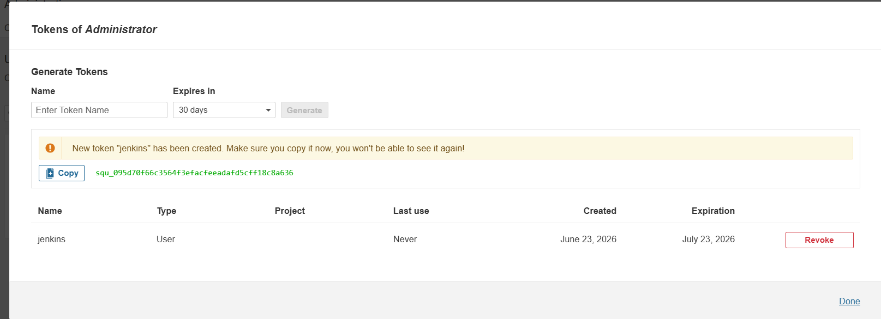

STEP 6: Create Jenkins Job
Go to:
👉 Jenkins Dashboard → New Item
- Name: VProfile-Pipeline
- Select: Pipeline
- Click OK

⚙️ STEP 7: Add Pipeline Script (3 Stages)

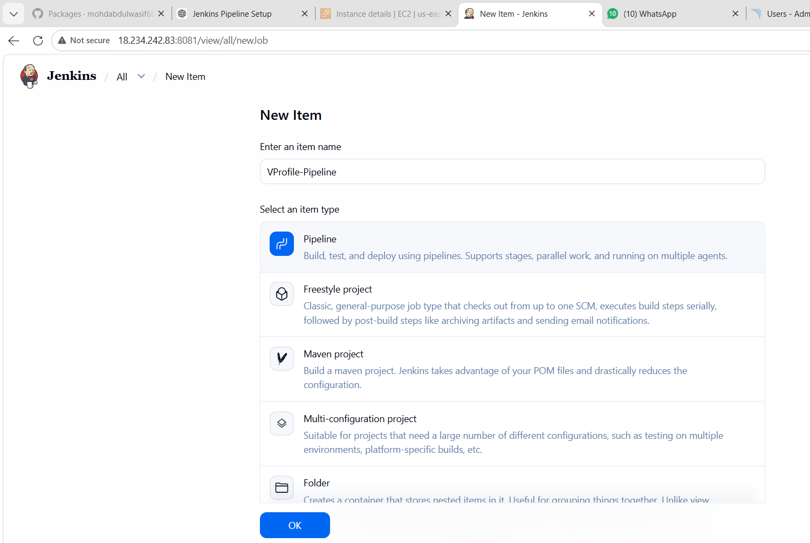

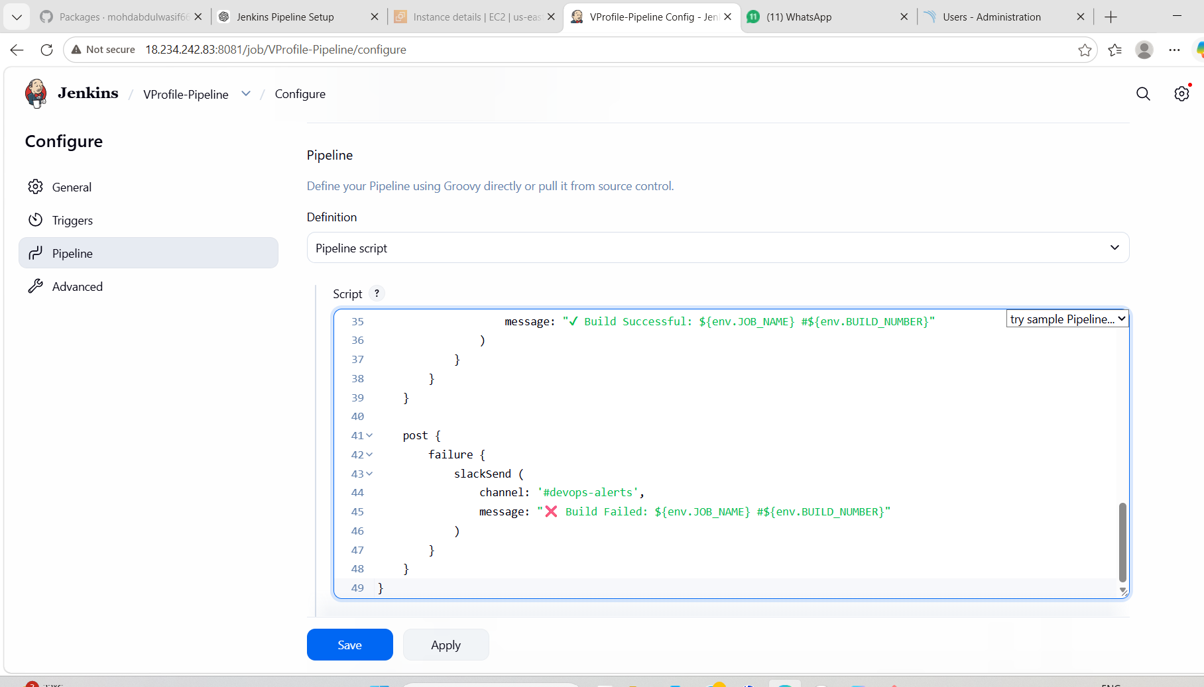
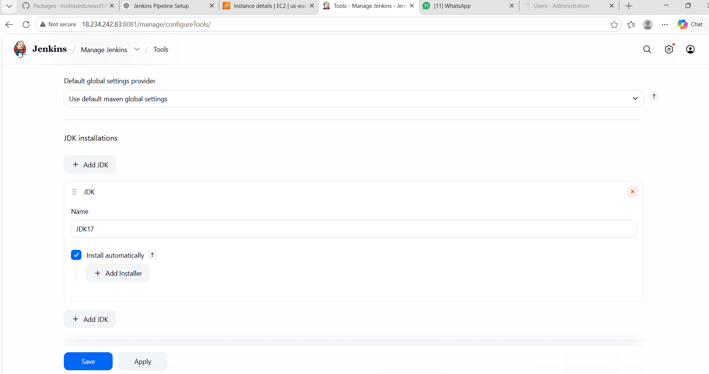

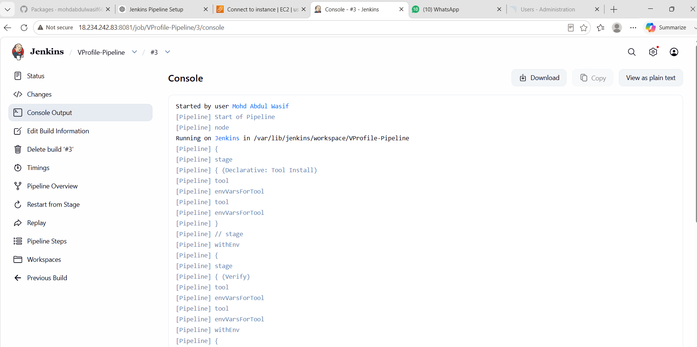
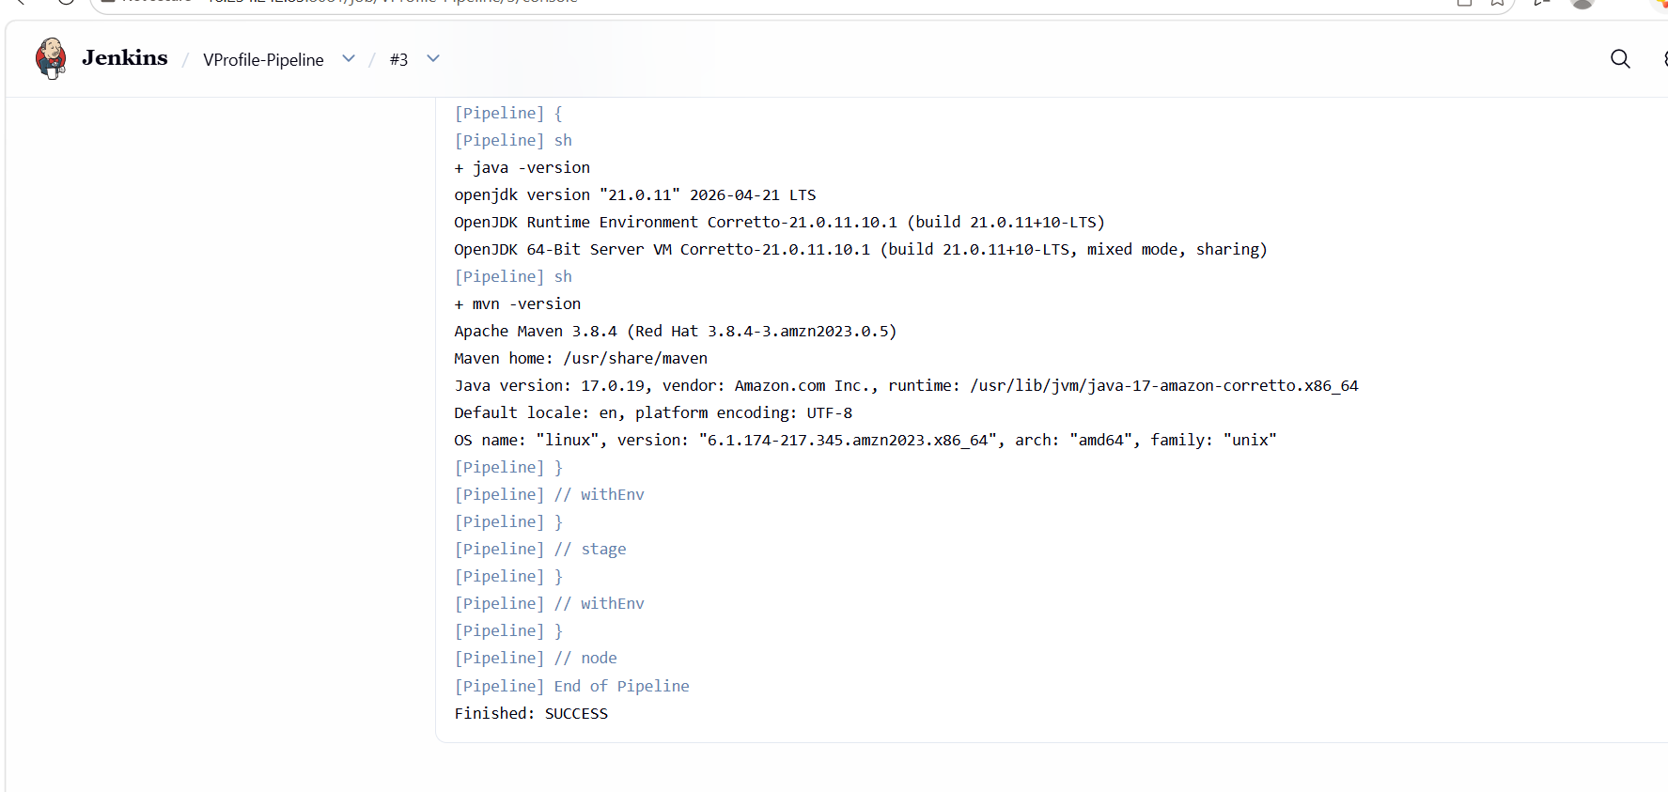
STEP 8: Run the Job
Click:
👉 Build Now

📊 EXPECTED OUTPUT
✔ Stage 1: Git Clone SUCCESS
✔ Stage 2: SonarQube Analysis SUCCESS
✔ Stage 3: Slack Notification SENT

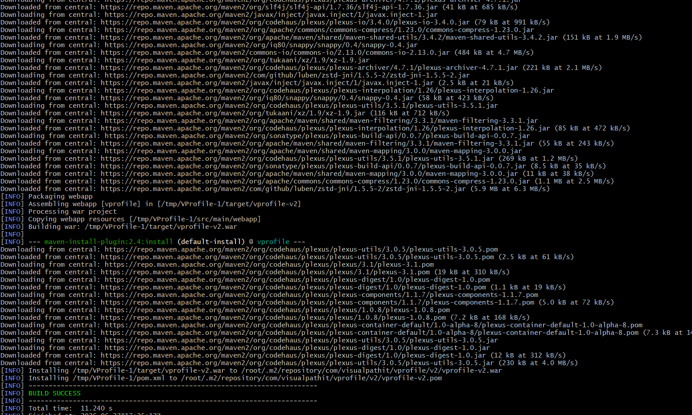

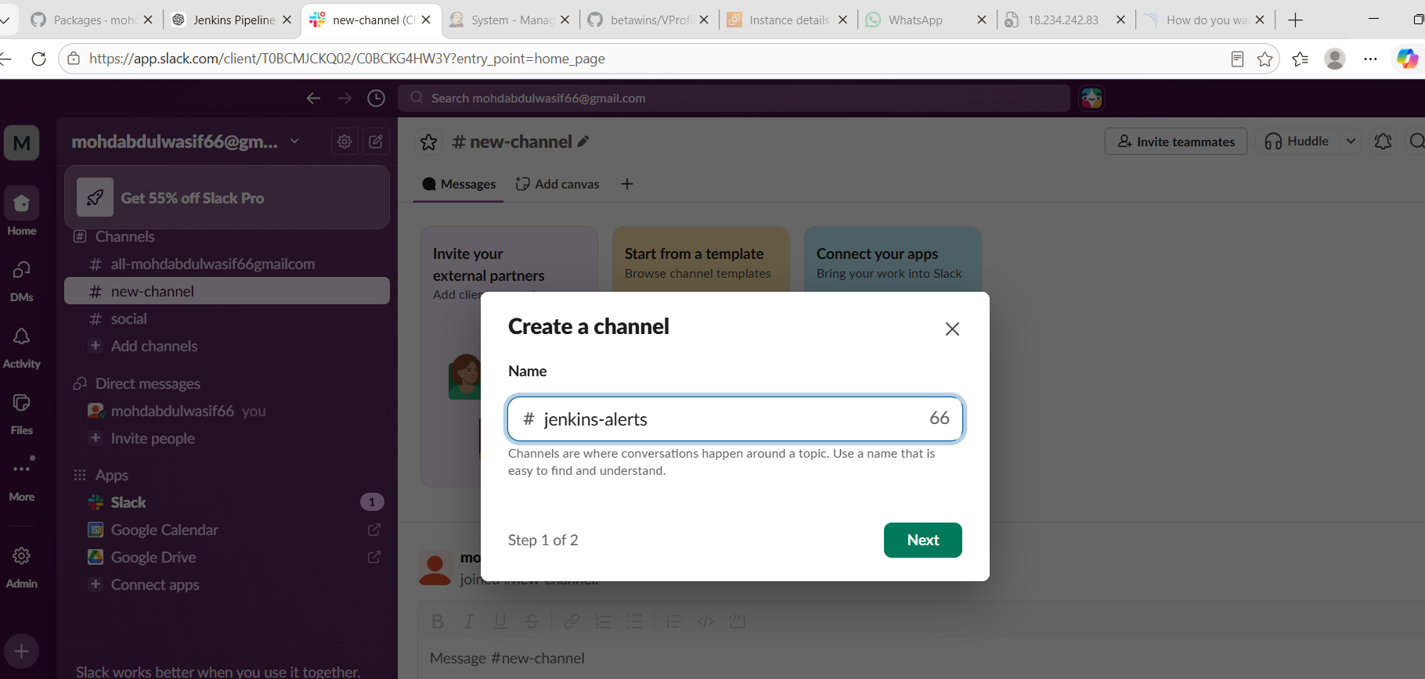
STEP 1: Create Slack App (API Setup)
- Open Slack API:
👉 https://api.slack.com/apps
- Click:
👉 Create New App
- Choose:
👉 From scratch
- Enter:
- App Name: Jenkins-Bot
- Workspace: select your workspace
- Click:
👉 Create App

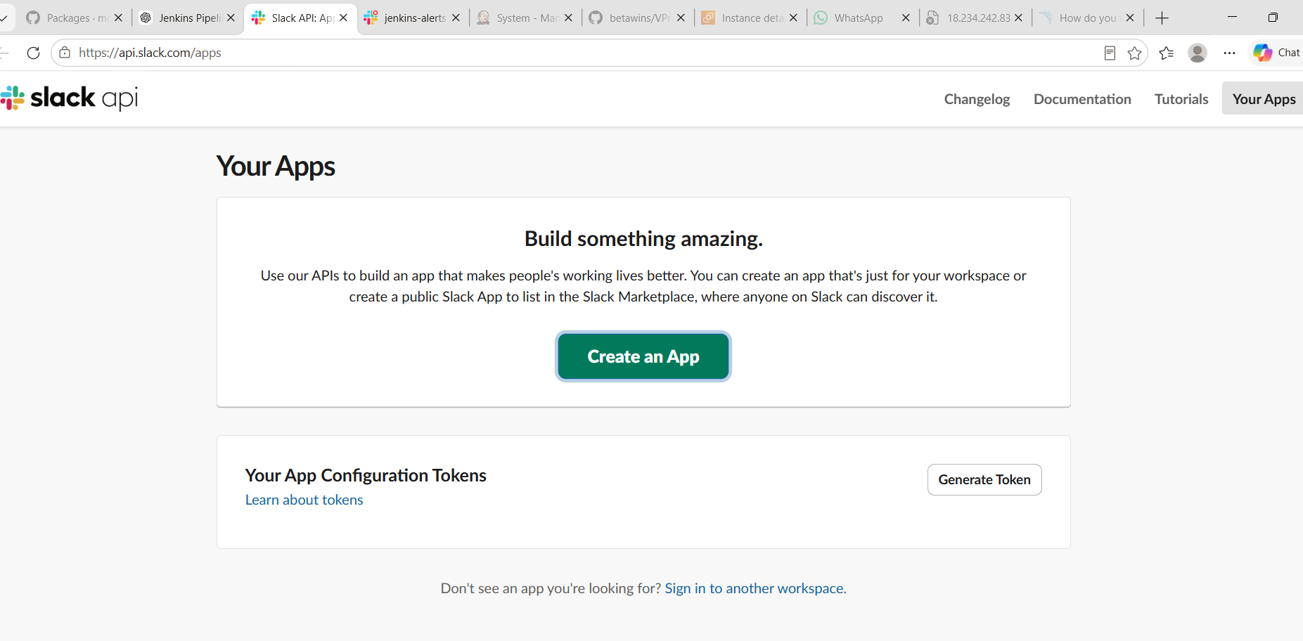
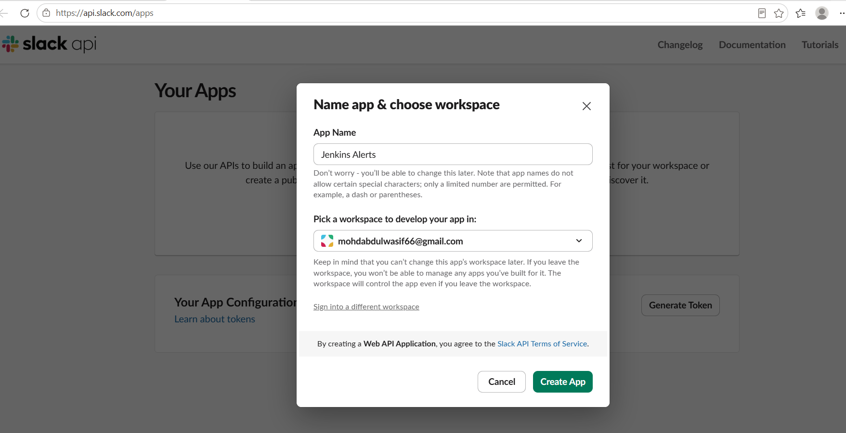
STEP 2: Enable Incoming Webhooks
- Inside your app page, go to:
👉 Incoming Webhooks
- Turn ON:
Activate Incoming Webhooks = ON
- Click:
👉 Add New Webhook to Workspace

⚙️ STEP 3: Select Channel
When prompted:
👉 Choose channel:
#jenkins-alerts
Click:
👉 Allow

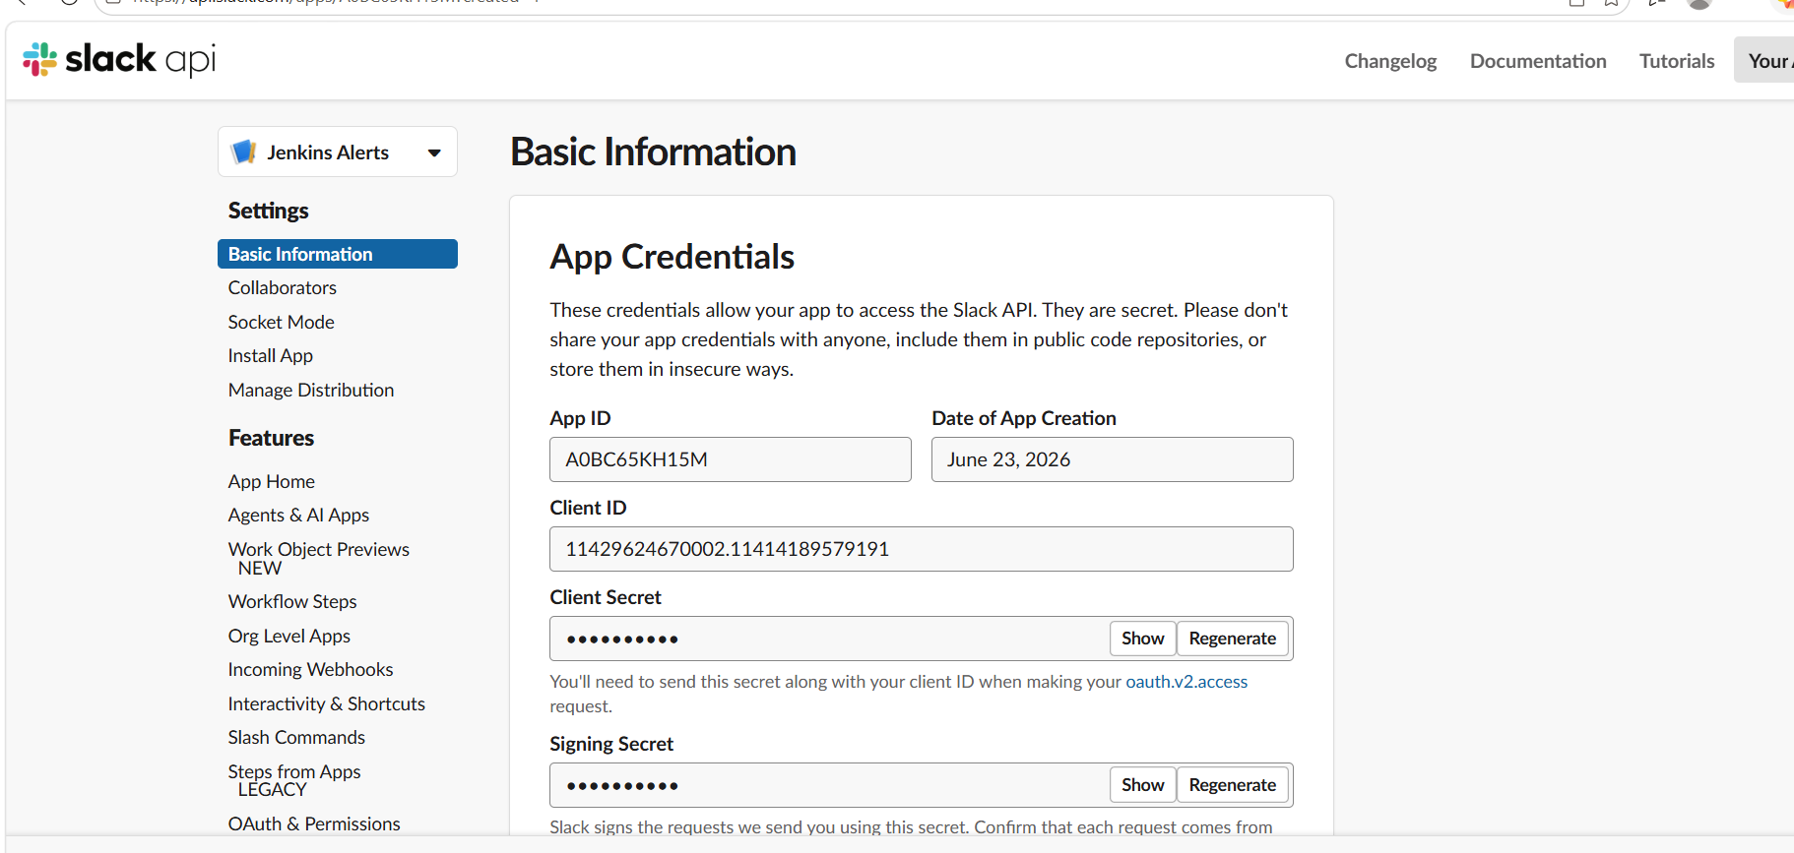
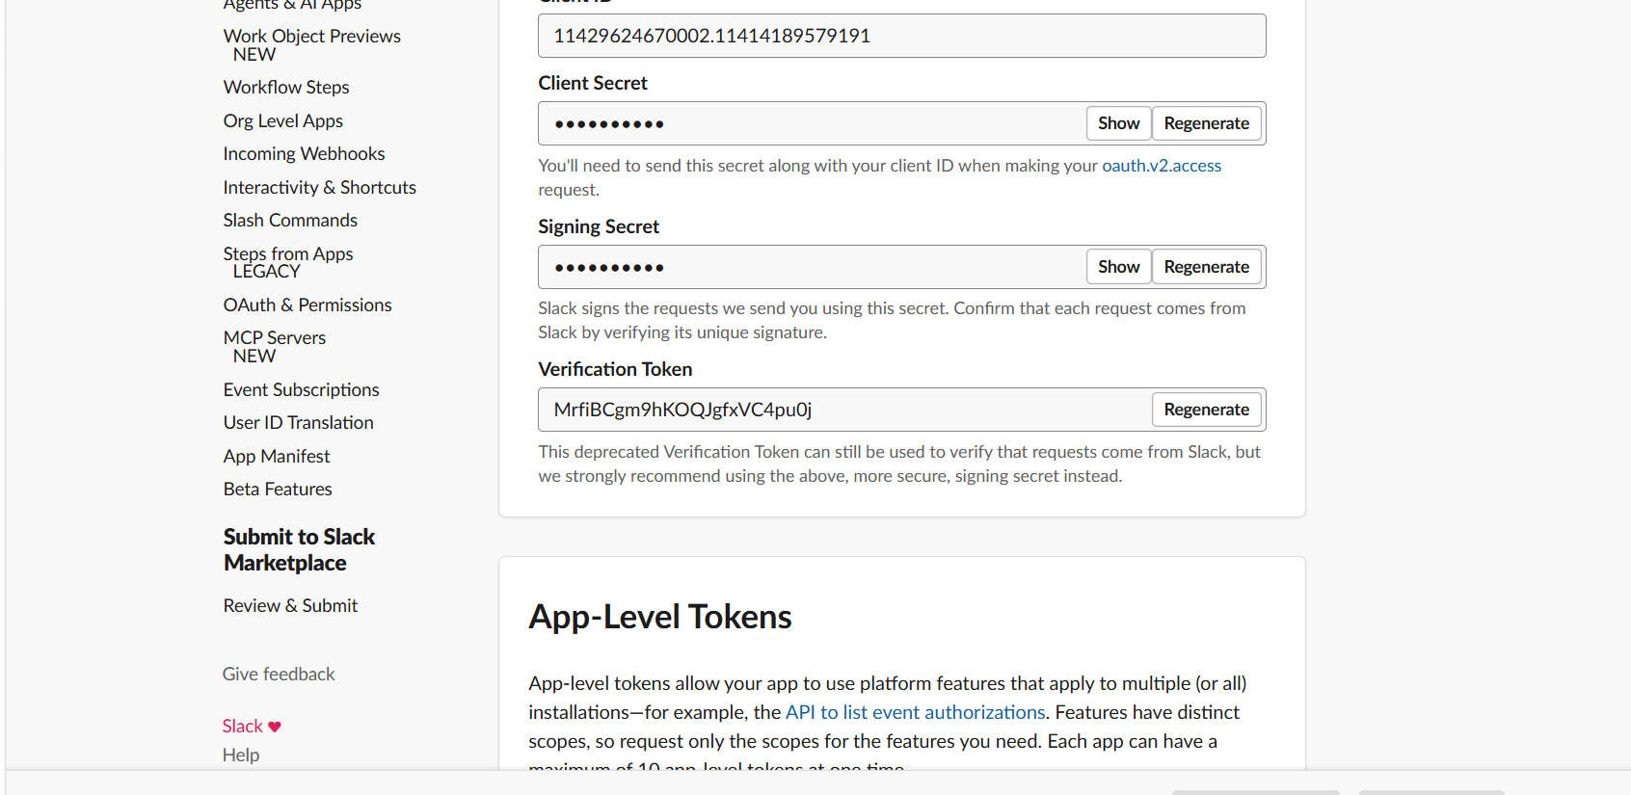
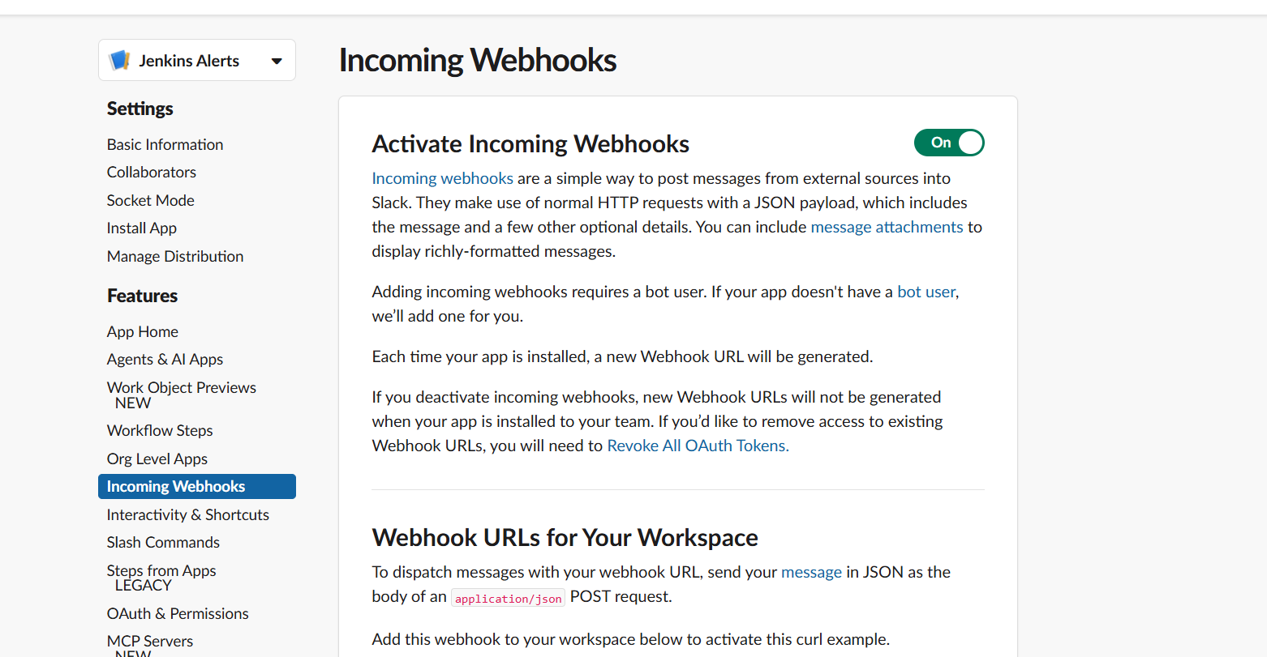

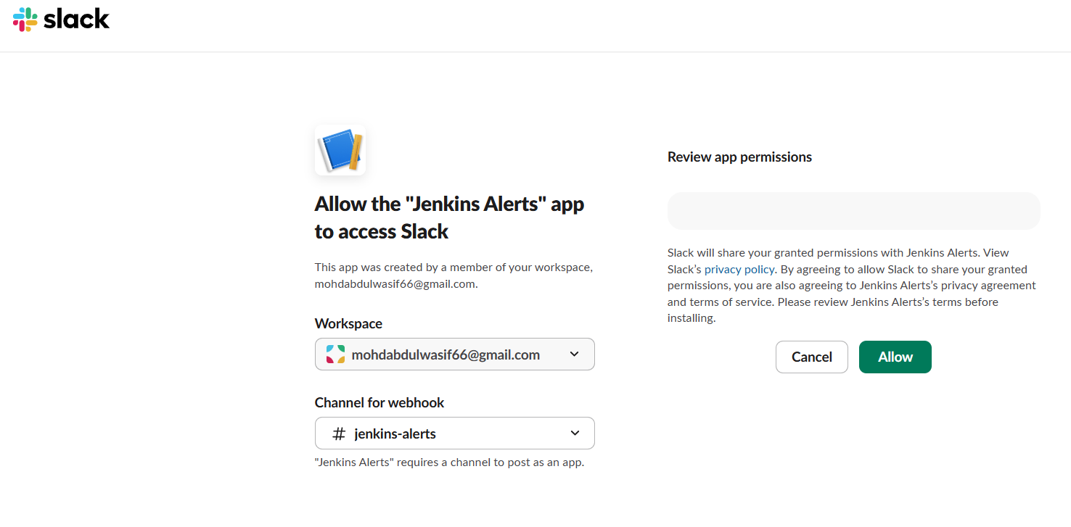

STEP 4: Copy Webhook URL
You will get a URL like:
https://hooks.slack.com/services/T00000000/B00000000/XXXXXXXXXXXXXXXX
✔ Copy this URL (VERY IMPORTANT)

⚙️ STEP 5: Invite Bot to Channel (IMPORTANT)
Go to Slack channel:
👉 #jenkins-alerts
Then run:
/invite @Jenkins-Bot

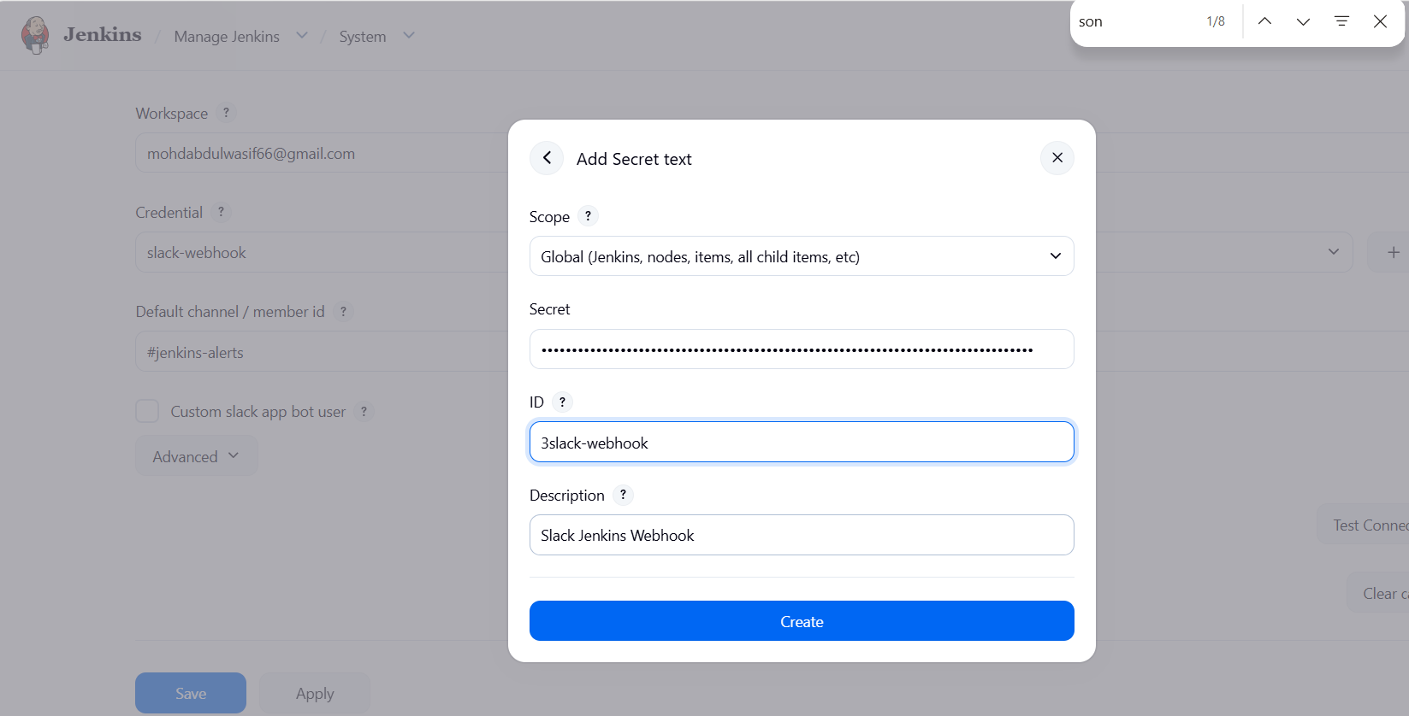
STEP 6: Add Webhook in Jenkins
Go to Jenkins:
👉 Manage Jenkins → Configure System
Find:
👉 Slack / Webhook / Credentials section
Add:
Field | Value
Credential ID | slack-webhook
Secret | Paste webhook URL
Channel | #jenkins-alerts

⚙️ STEP 7: Test Webhook
You can test using Jenkins or curl:
curl -X POST -H 'Content-type: application/json' \
--data '{"text":"Hello from Jenkins ✔ Slack is working"}' \
https://hooks.slack.com/services/XXX/XXX/XXX

⚙️ STEP 8: Use in Jenkins Pipeline
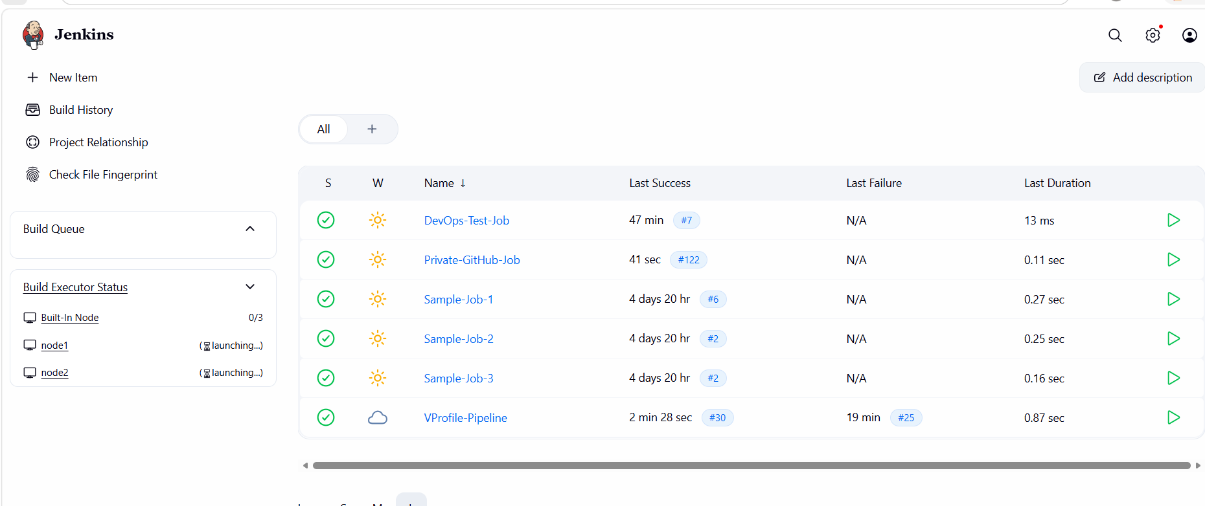
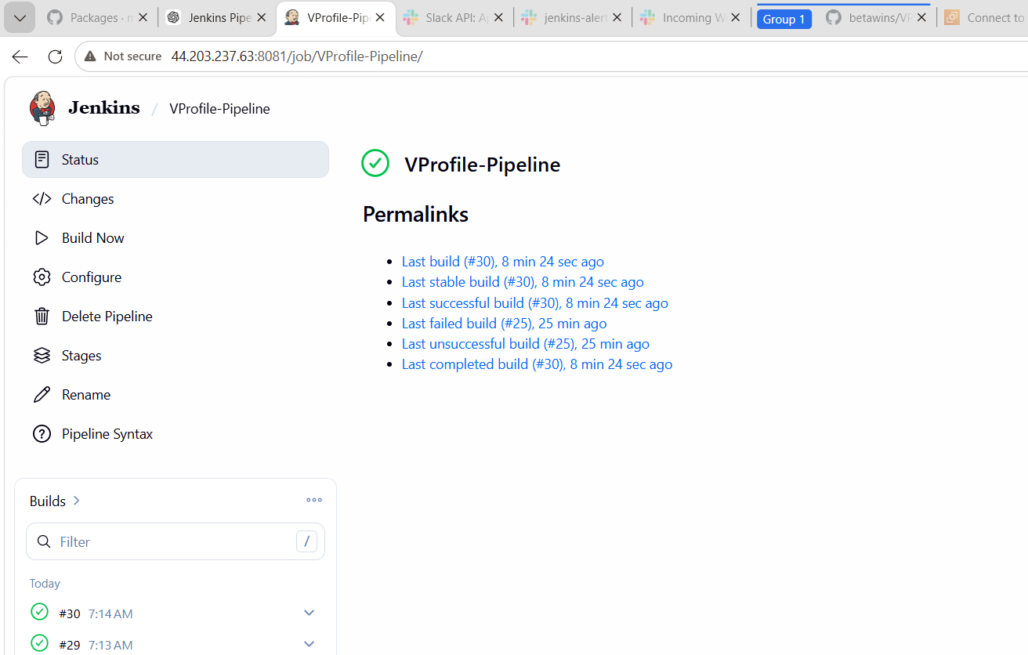
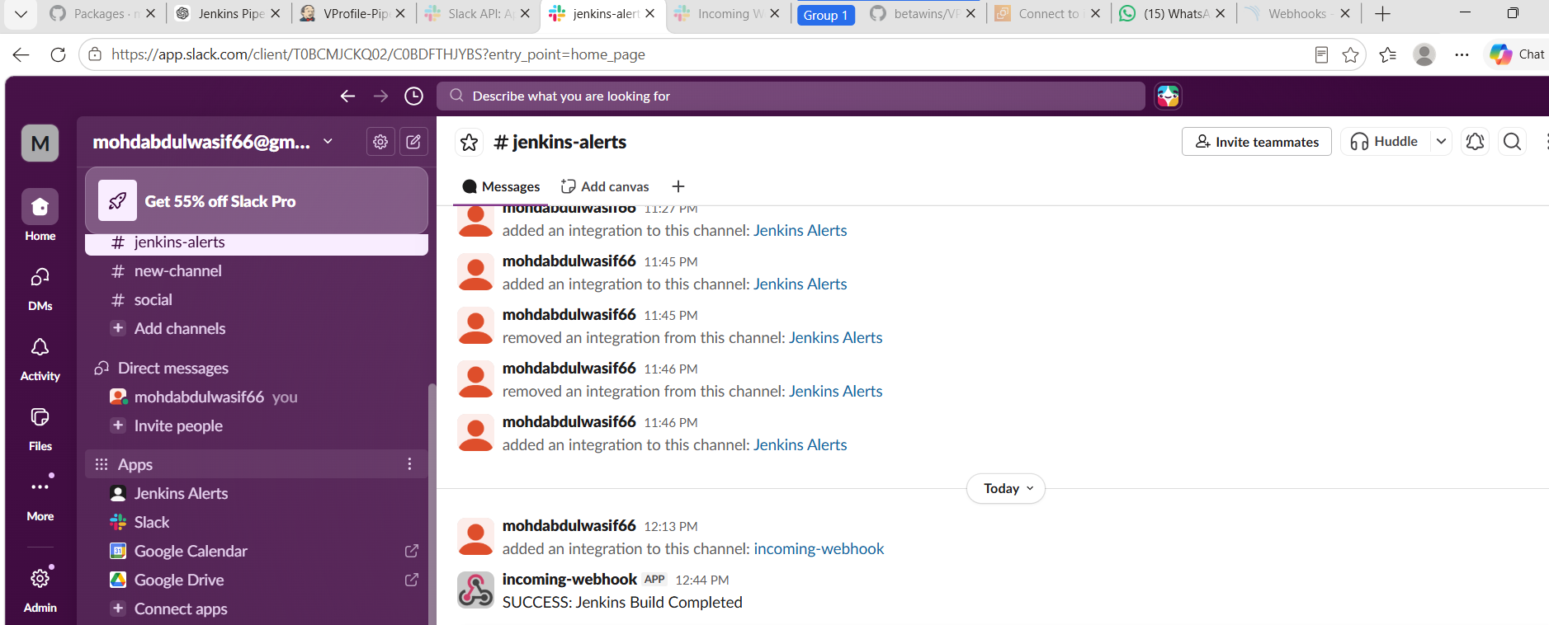
WHAT WE LEARNED
- How to create Jenkins Pipeline job
- GitHub integration with Jenkins
- Automating code checkout process
- Performing static code analysis using SonarQube
- Sending notifications using Slack integration
- Understanding CI/CD workflow in DevOps
- Debugging Jenkins build failures and fixing configuration issues

📘 CONCLUSION
This task demonstrates a complete CI/CD pipeline implementation using Jenkins. The pipeline successfully integrates GitHub for source control, SonarQube for code quality analysis, and Slack for real-time build notifications.
By completing this task, we gained practical experience in DevOps automation, continuous integration, and continuous delivery workflows. It also helped in understanding real-world Jenkins configuration, tool integration, and troubleshooting common build issues.

2 task
Create one Jenkins job using the below code and create three stages.
- stage1: Git clone to download the source code.
- stage2: Sonarqube Integration to check the quality of code.
- stage3: Slack Integration to send the alerts to slack.
Source Code: https://github.com/betawins/hiring-app.git
Objective
To create a Jenkins Freestyle job that:
- Clones source code from GitHub
- Performs SonarQube code quality analysis
- Sends notifications to Slack

🧰 Tools Used
- Jenkins Freestyle Job
- GitHub Repository: https://github.com/betawins/hiring-app.git
- SonarQube Server (http://44.203.237.63:9000)
- Slack Workspace
- Jenkins Plugins:
  - Git Plugin
  - SonarQube Scanner Plugin
  - Slack Notification Plugin

⚙️ STEP 1: Install Required Plugins
Go to:
👉 Manage Jenkins → Manage Plugins
Install:
- Git Plugin
- SonarQube Scanner Plugin
- Slack Notification Plugin

⚙️ STEP 2: Configure Git
Go to:
👉 Manage Jenkins → Global Tool Configuration
- Git: Auto-installed (default)
STEP 3: Configure SonarQube Server
Go to:
👉 Manage Jenkins → Configure System
Add SonarQube:
Field | Value
Name | sonar
Server URL | http://44.203.237.63:9000
Token | sonar-token
✔ Save

⚙️ STEP 4: Configure SonarQube Scanner
Go to:
👉 Global Tool Configuration
- Add SonarScanner
- Name: sonar-scanner
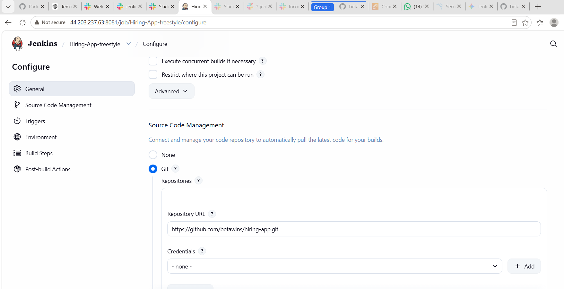
STEP 7: Source Code Management
Select:
👉 Git
Add:
https://github.com/betawins/hiring-app.git
Branch:
main

⚙️ STEP 8: Build Steps
Click:
👉 Build → Add build step → Execute Shell
Add this command:
echo "Starting Build..."
ls -la
echo "Code cloned successfully"

(Optional SonarQube Step)
Add:
👉 Build Step → Execute Shell
sonar-scanner \
-Dsonar.projectKey=hiring-app \
-Dsonar.sources=. \
-Dsonar.host.url=http://44.203.237.63:9000 \
-Dsonar.login=sonar-token

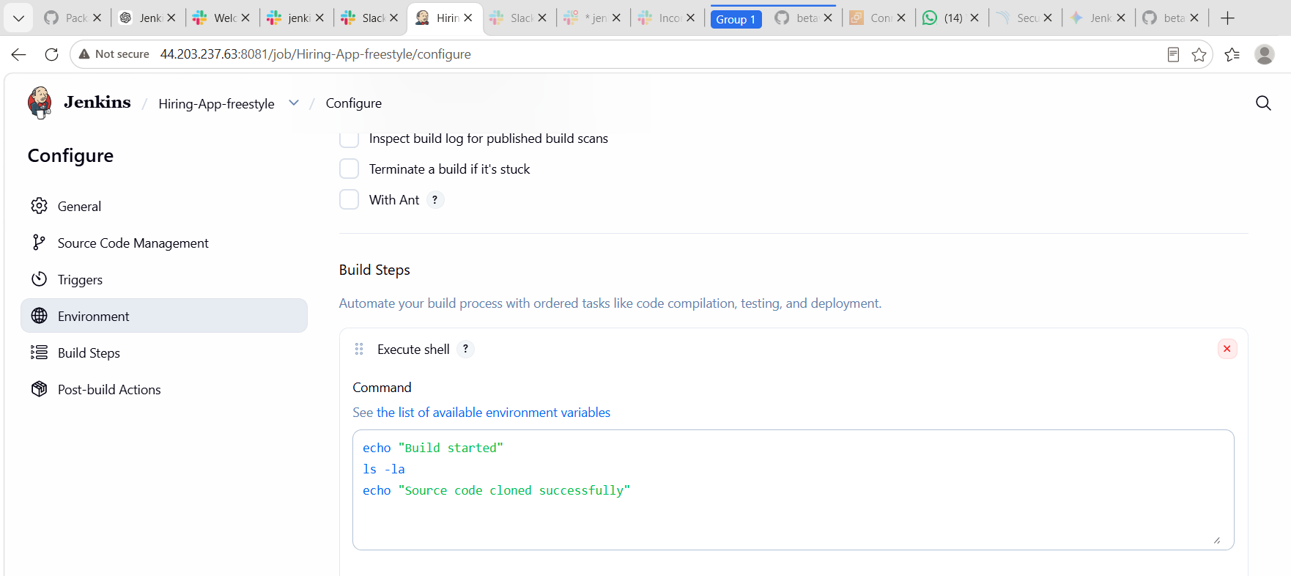

STEP 5: Configure Slack Integration
Go to:
👉 Manage Jenkins → Configure System → Slack
Fill:
Field | Value
Workspace | your Slack workspace
Credential | new-token (Bot token xoxb-xxxx)
Default Channel | #jenkins-alerts
STEP 6: Create Freestyle Job
Go to:
👉 Jenkins Dashboard → New Item
- Enter name: Hiring-App-Freestyle
- Select: Freestyle Project
- Click OK

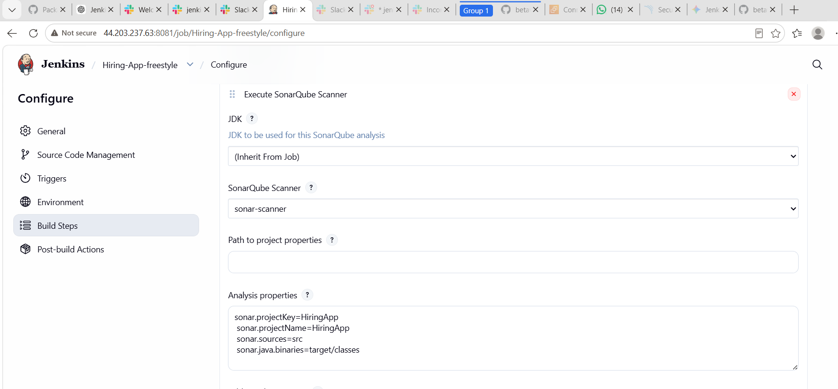
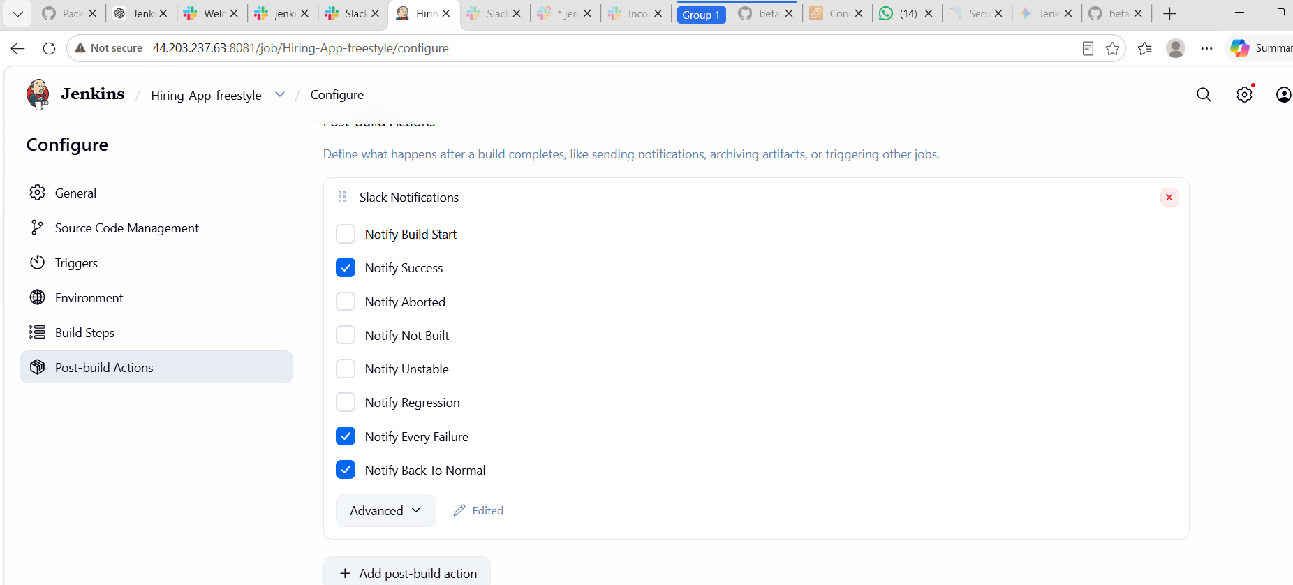

STEP 9: Post-Build Actions
1. Slack Notification
Select:
👉 Post-build Actions → Slack Notifications
Configure:
- Channel: #jenkins-alerts
- Message: Build Status

▶️ STEP 10: Run Freestyle Job
Click:
👉 Build Now

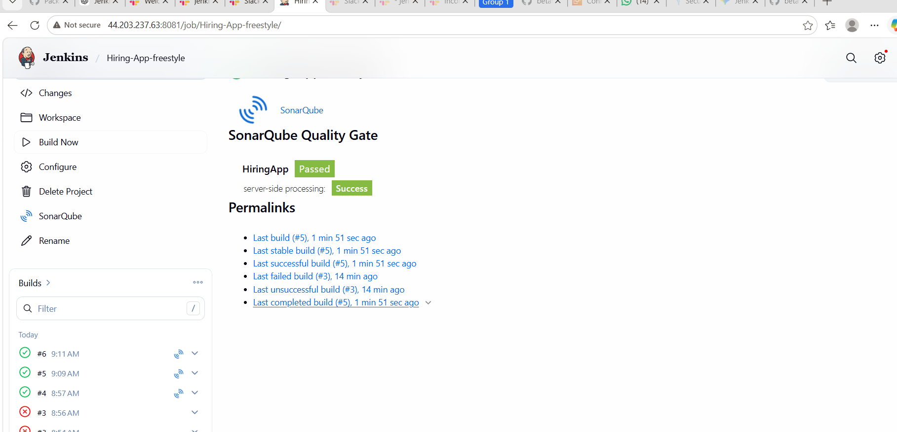
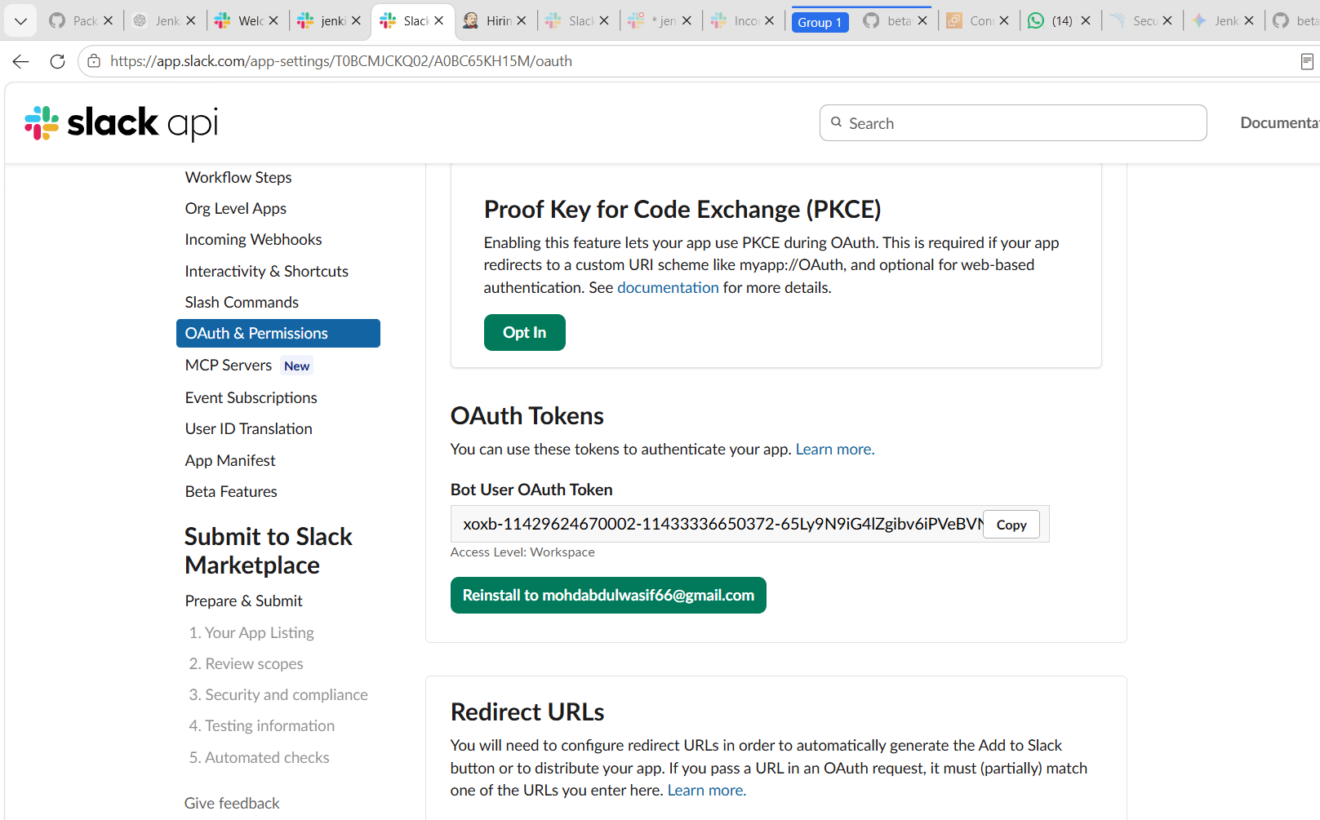
Slack Fix
If error occurs:
/invite @jenkins-bot

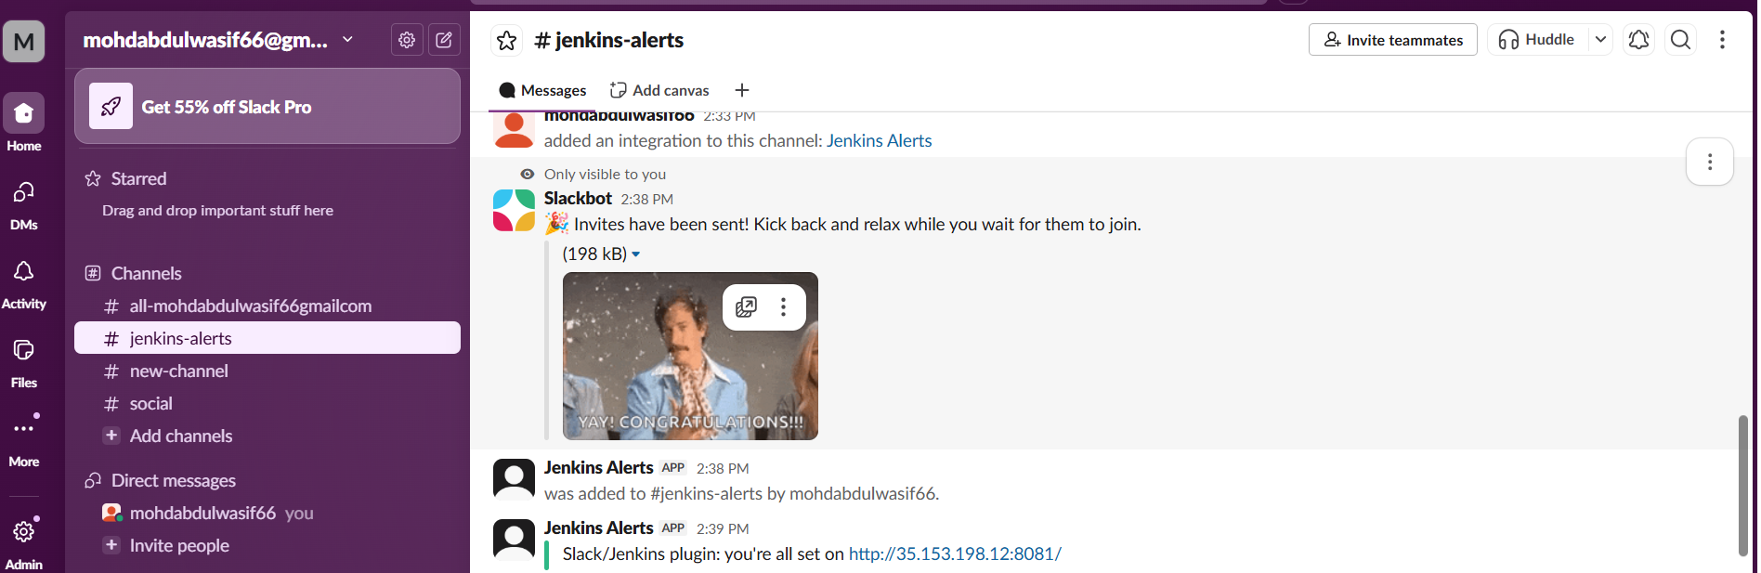
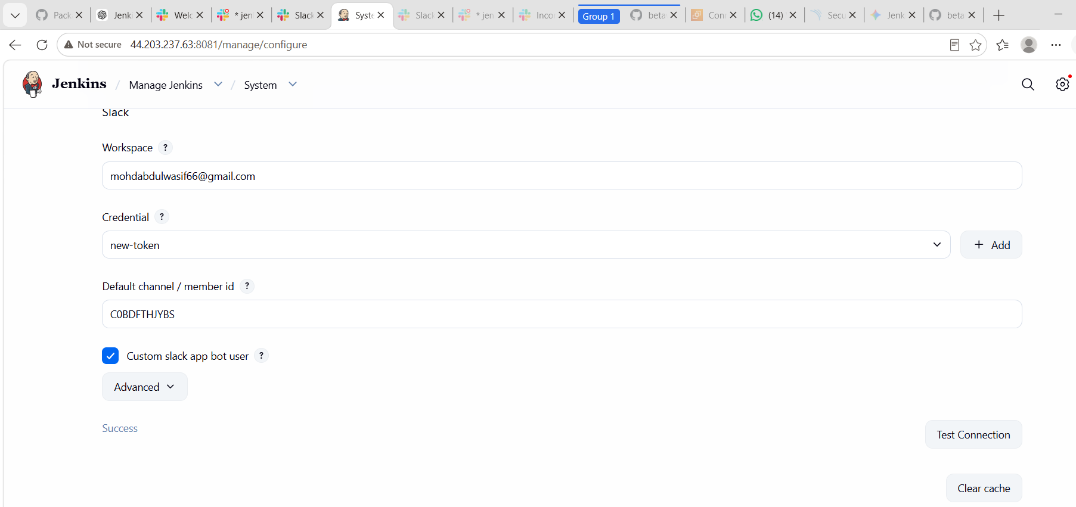
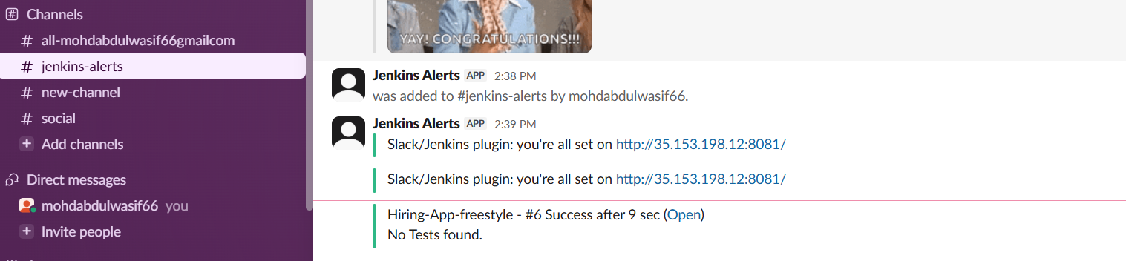

What We Learned
During this Jenkins Freestyle CI/CD task, we learned the practical implementation of a complete DevOps workflow using Jenkins.
🔹 Key Learnings:
- How to create a Freestyle Jenkins job
- How to integrate GitHub repository with Jenkins
- How Jenkins automatically pulls source code using Git SCM
- How to configure and run SonarQube for code quality analysis
- How to integrate Slack with Jenkins for notifications
- Understanding of build steps and post-build actions in Freestyle jobs
- Basics of CI/CD pipeline flow (Git → Jenkins → SonarQube → Slack)
- How to debug and fix common Jenkins build failures

📘 Conclusion
This task helped in understanding the end-to-end CI/CD process using Jenkins Freestyle project. We successfully configured Jenkins to automate source code cloning, perform static code analysis using SonarQube, and send build notifications to Slack.
The project demonstrated how DevOps tools work together to improve software quality, automation, and collaboration. This implementation improved practical knowledge of Jenkins job configuration, integration of external tools, and troubleshooting real-time build issues.

