ECS-Task
Task: Highly Available ECS Cluster with ALB and Dynamic Port Mapping
Objective
To deploy a highly available containerized application on Amazon ECS using an Application Load Balancer. The ECS service must always maintain minimum 6 running tasks across multiple Availability Zones.
Image used:
sabair0509/hiring-app:works

Prerequisites
AWS account, VPC with at least 2 public subnets, ECS access, IAM permissions, Docker image available on Docker Hub, security groups, Application Load Balancer knowledge.

Why We Are Implementing This
We are implementing this to make the application:
Highly available, because tasks run in multiple Availability Zones.
Fault tolerant, because if one task fails ECS starts another task automatically.
Scalable, because ECS can run multiple tasks behind a load balancer.
Reliable, because ALB sends traffic only to healthy tasks.

Step-by-Step Implementation
Step 1: Create ECS Cluster
Go to:
ECS → Clusters → Create Cluster
Select:
AWS Fargate
Cluster name:
hiring-app-cluster
Create cluster.
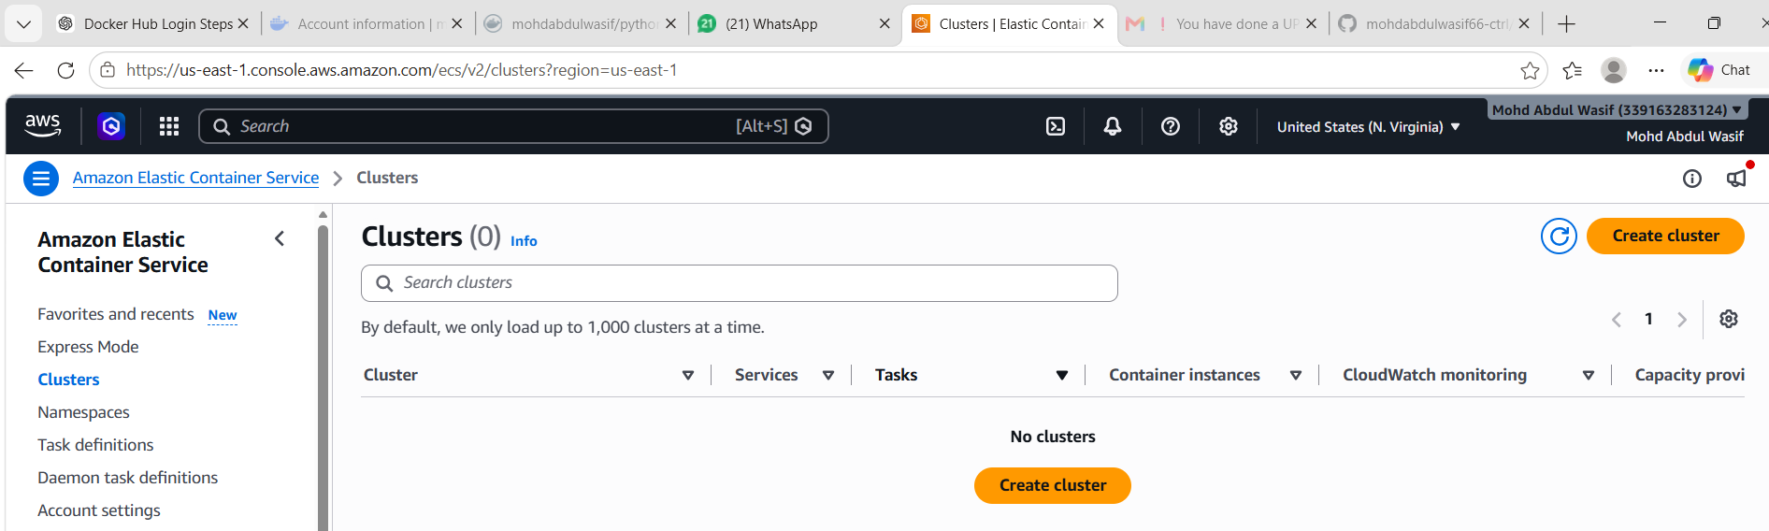
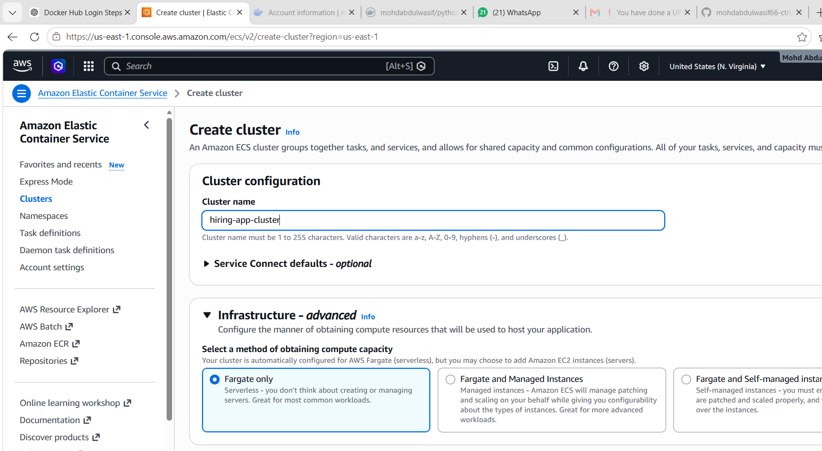
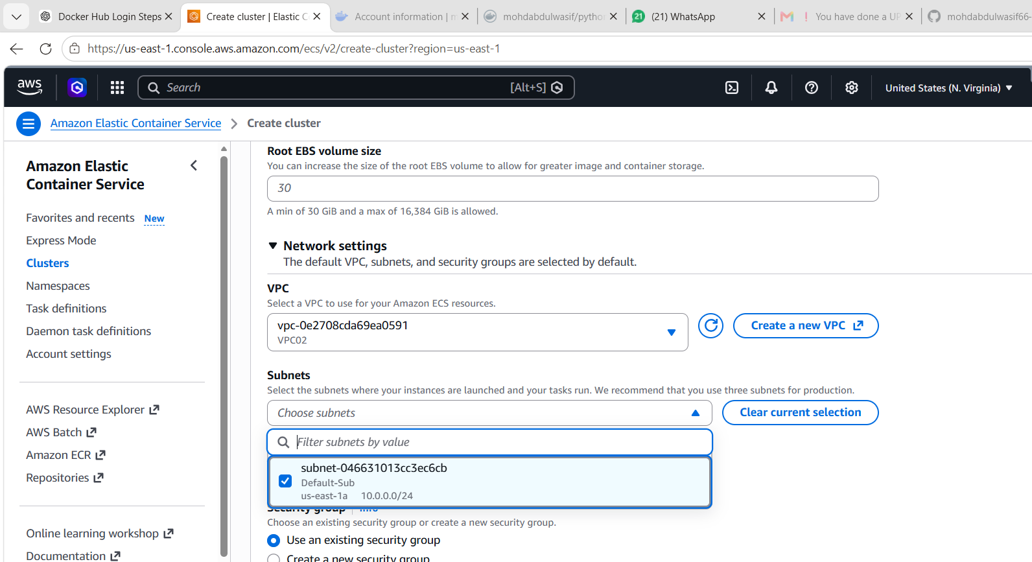
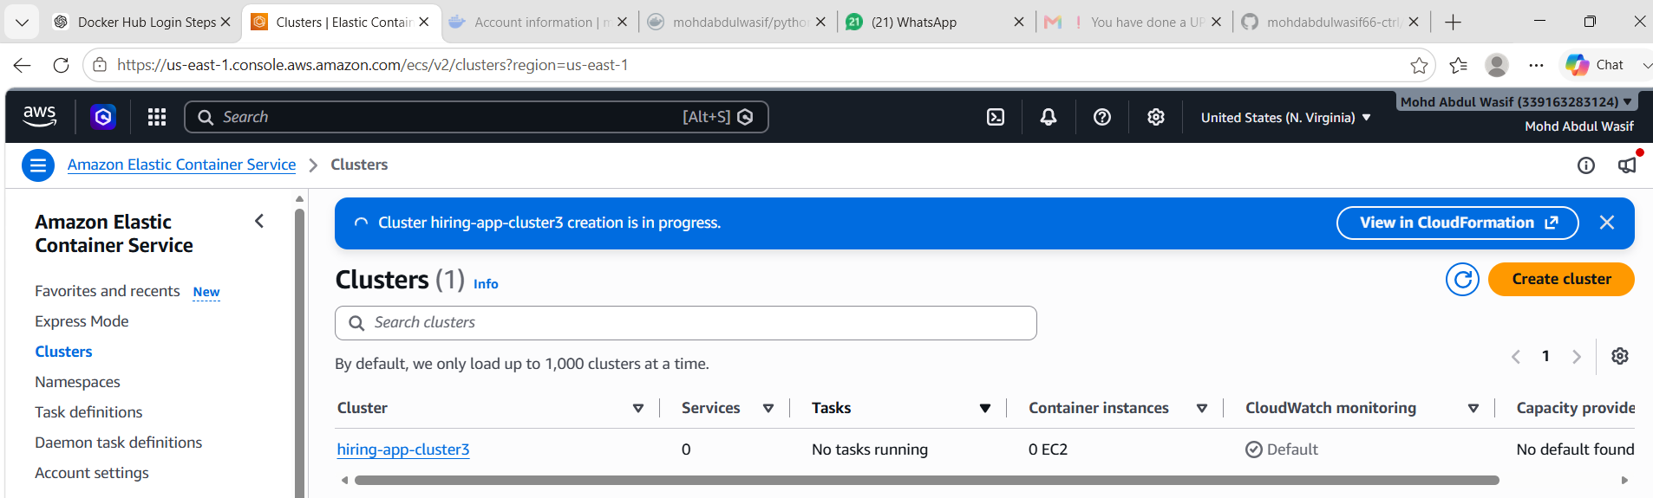

Step 2: Create Task Definition
Go to:
ECS → Task Definitions → Create new task definition
Use:
Launch type: AWS Fargate
Task Definition Name: hiring-app-task
CPU: 0.5 vCPU
Memory: 1 GB
Network mode: awsvpc
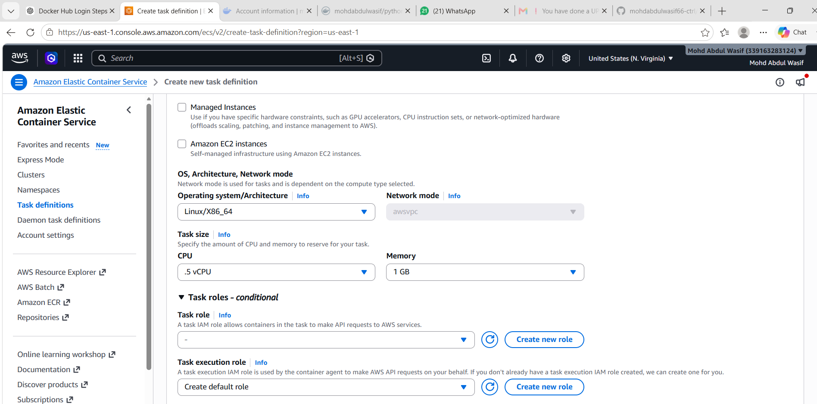
Container details:
Container name: hiring-app
Image: sabair0509/hiring-app:works
Container port: 8080
Protocol: TCP
Create task definition.
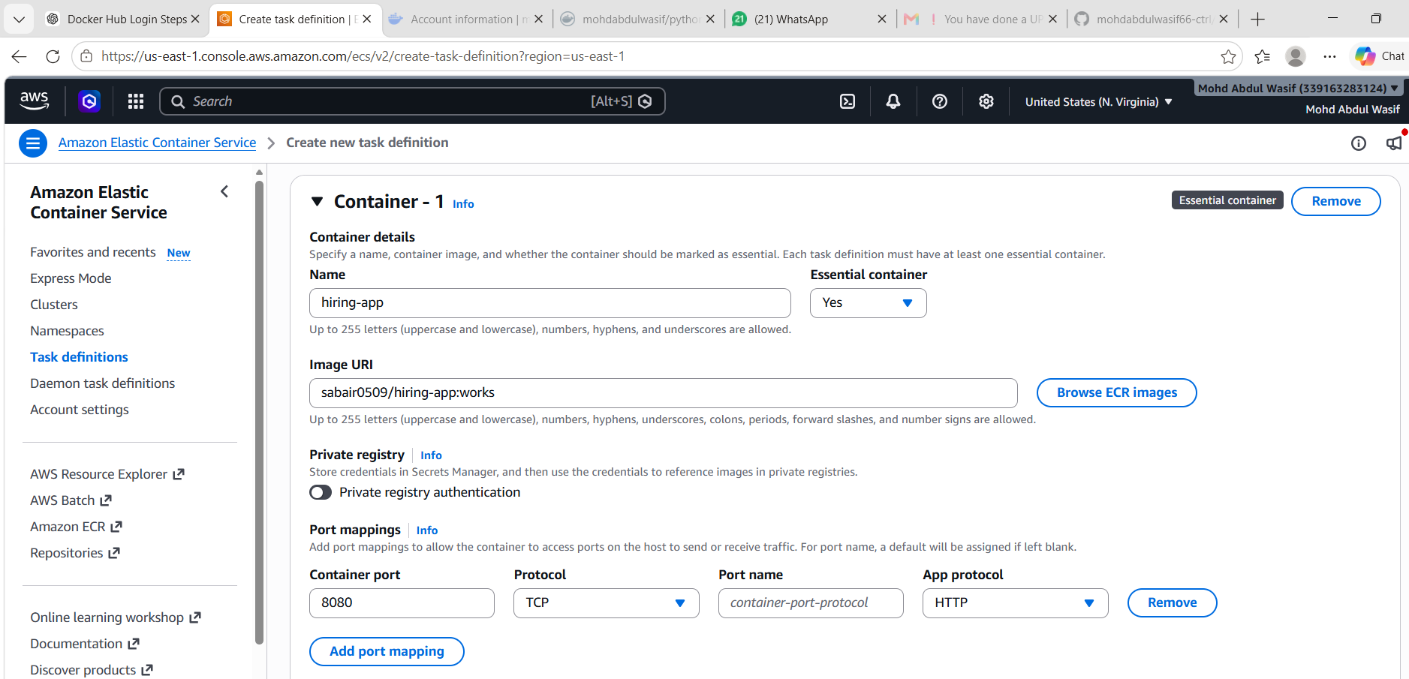

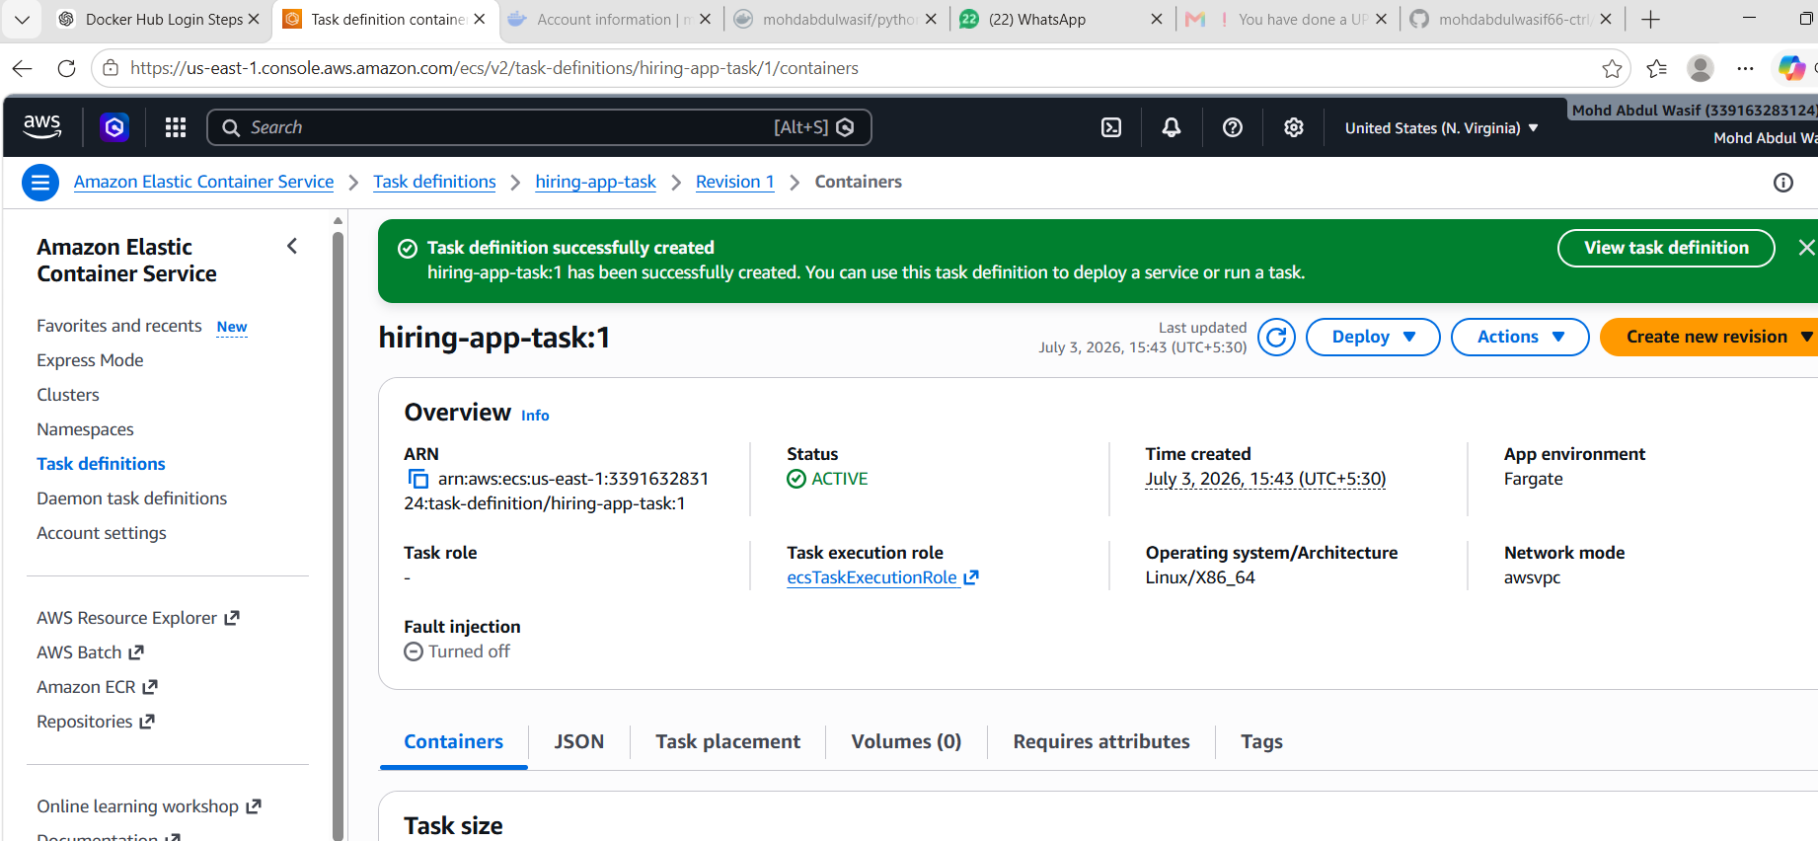
Step 3: Create Application Load Balancer
Go to:
EC2 → Load Balancers → Create Load Balancer
Select:
Application Load Balancer
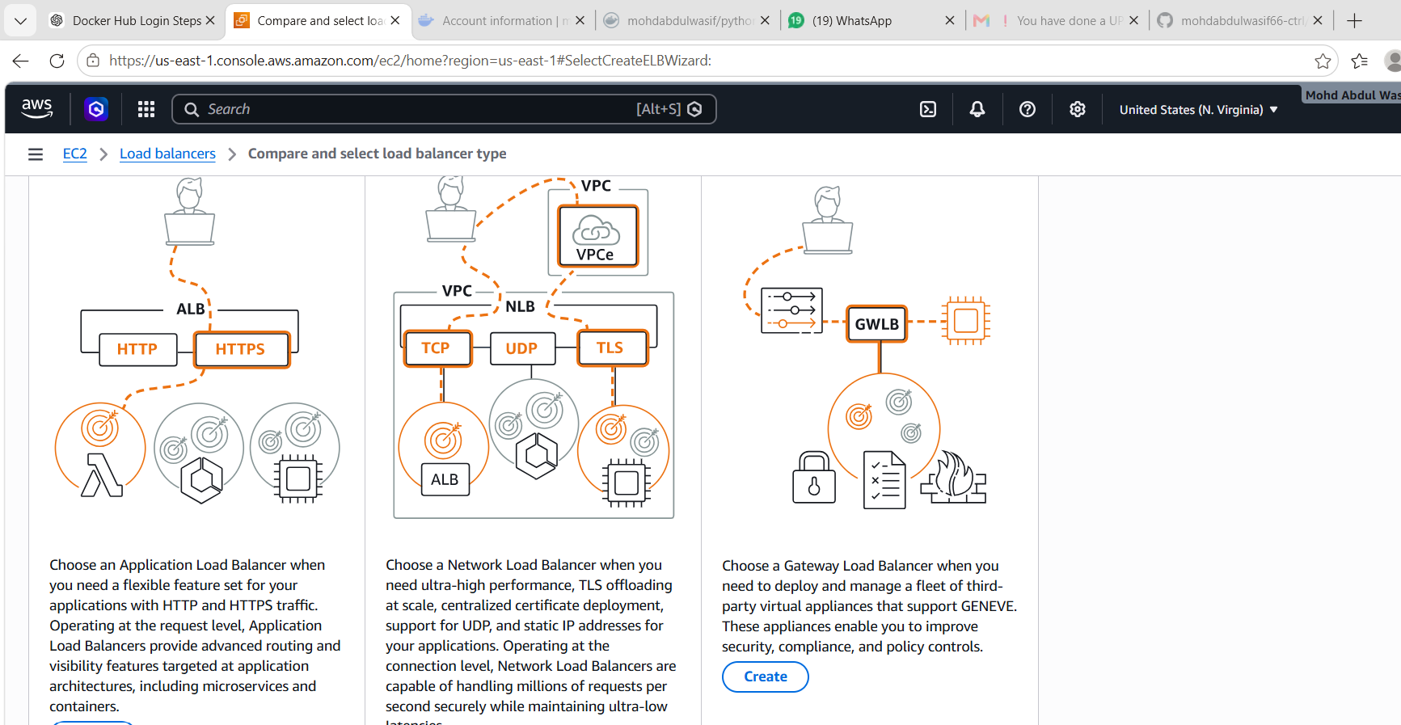
Use:
Name: hiring-app-alb
Scheme: Internet-facing
Listener: HTTP 80
Subnets: Select at least 2 public subnets from different AZs
Create security group for ALB:
Inbound: HTTP 80 from 0.0.0.0/0
Outbound: All traffic
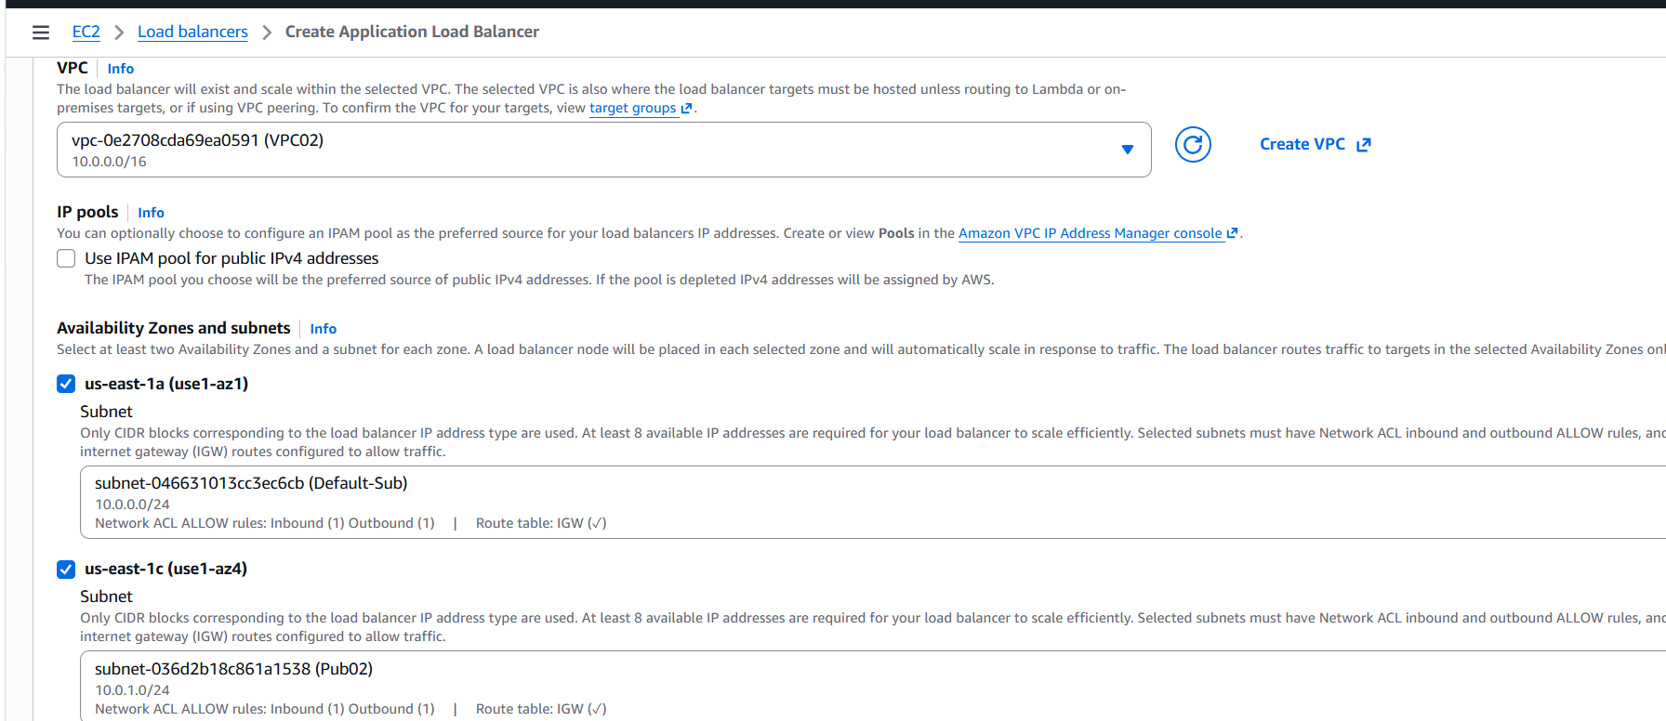
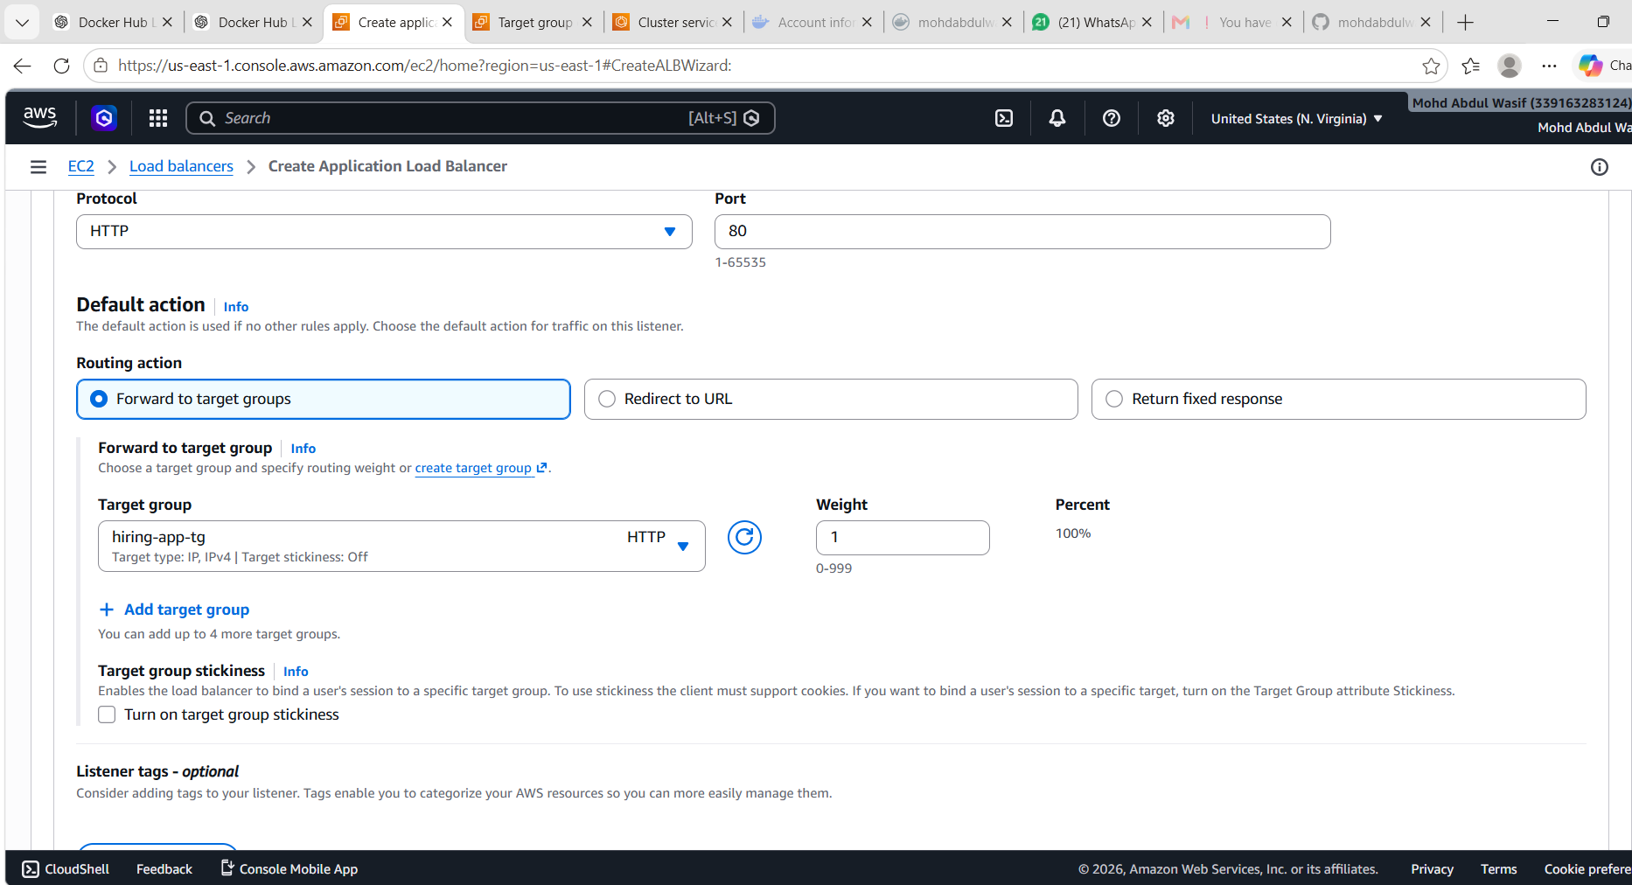
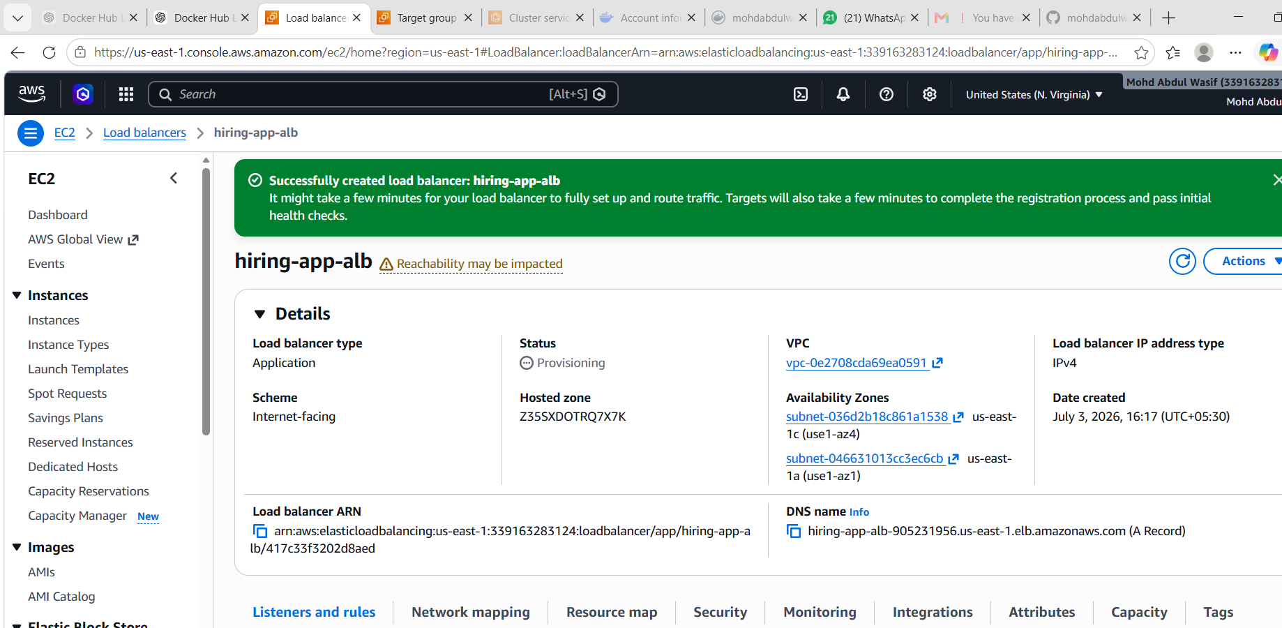

Step 4: Create Target Group
Go to:
EC2 → Target Groups → Create Target Group
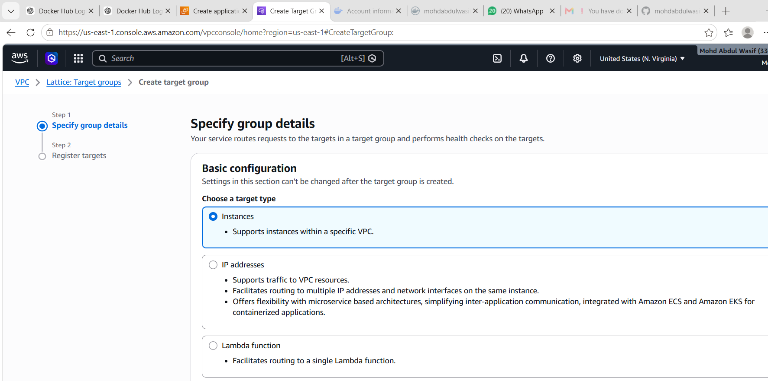
Use:
Target type: IP
Protocol: HTTP
Port: 8080
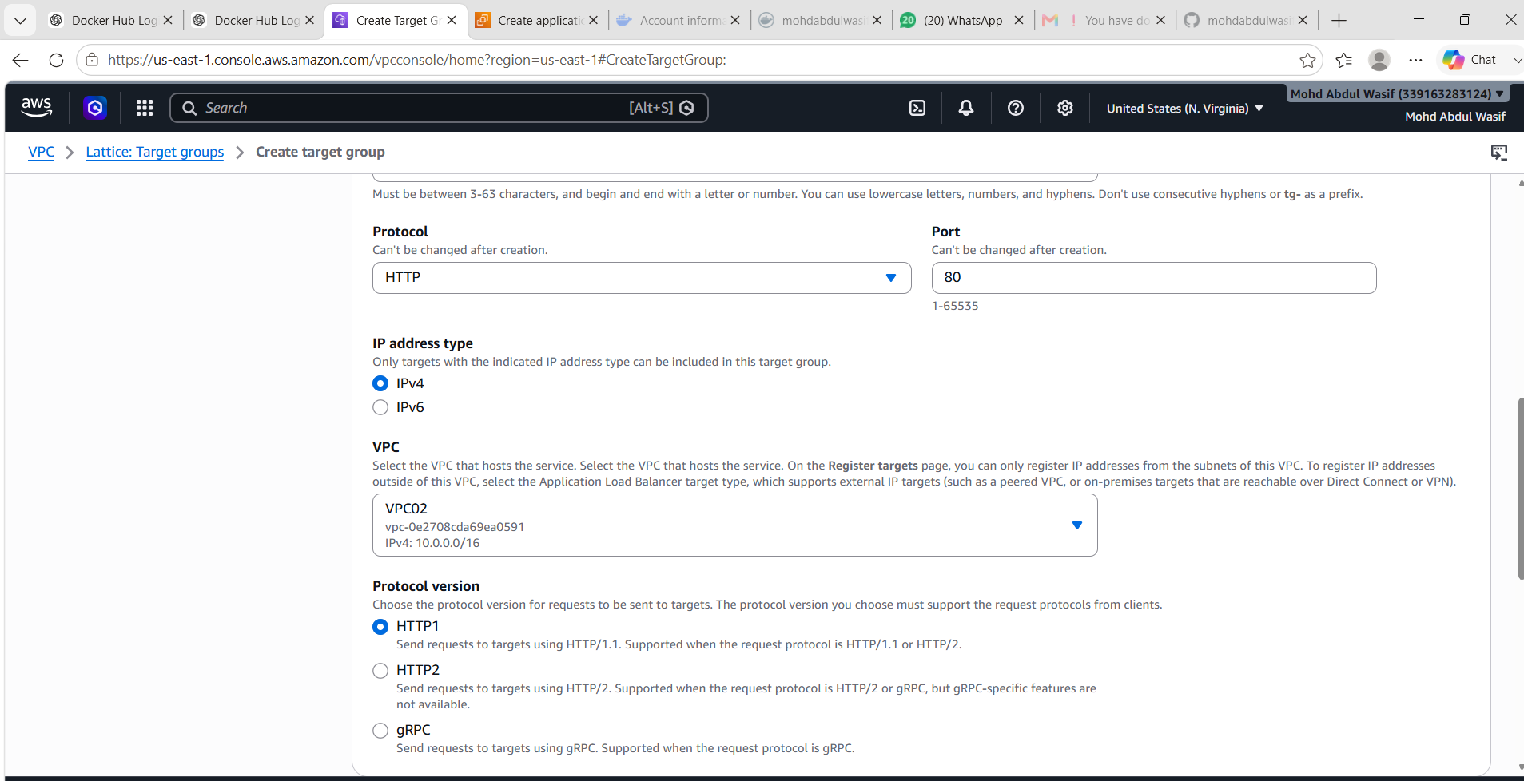
VPC: Your VPC
Health check path: /
Target group name:
hiring-app-tg
Create target group.

Step 5: Create ECS Service
Go to:
ECS → Cluster → hiring-app-cluster → Create Service
Use:
Launch type: Fargate
Task Definition: hiring-app-task
Service name: hiring-app-service
Desired tasks: 6
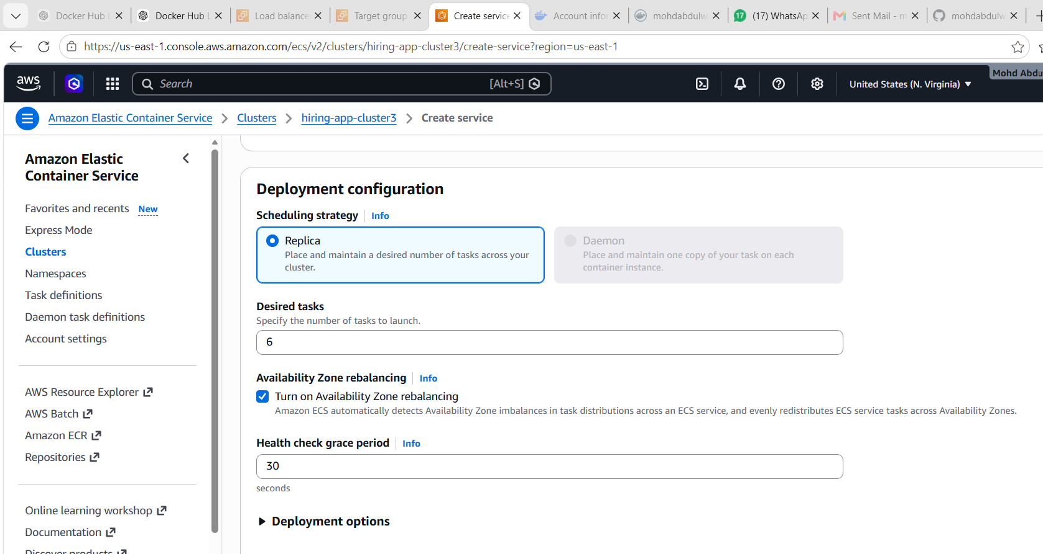
Networking:
VPC: Your VPC
Subnets: Select at least 2 subnets from different AZs
Security group: ECS task security group
Public IP: Enabled if using public subnets
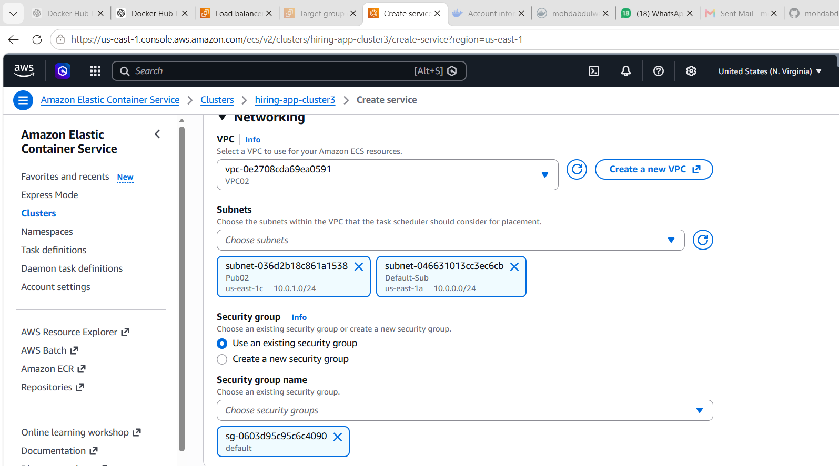
Load balancer:
Load balancer type: Application Load Balancer
ALB: hiring-app-alb
Target group: hiring-app-tg
Container: hiring-app
Container port: 8080
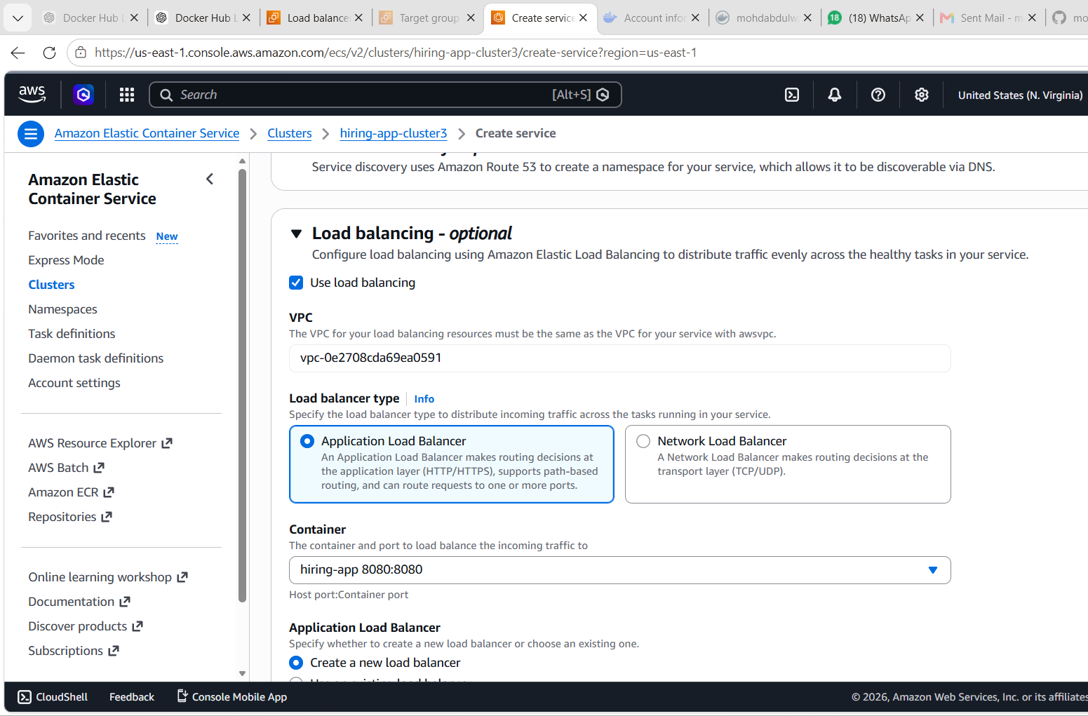
Create service.

Step 6: ECS Task Security Group
For ECS task security group, allow traffic from ALB security group:
Inbound:
Type: Custom TCP
Port: 8080
Source: ALB Security Group
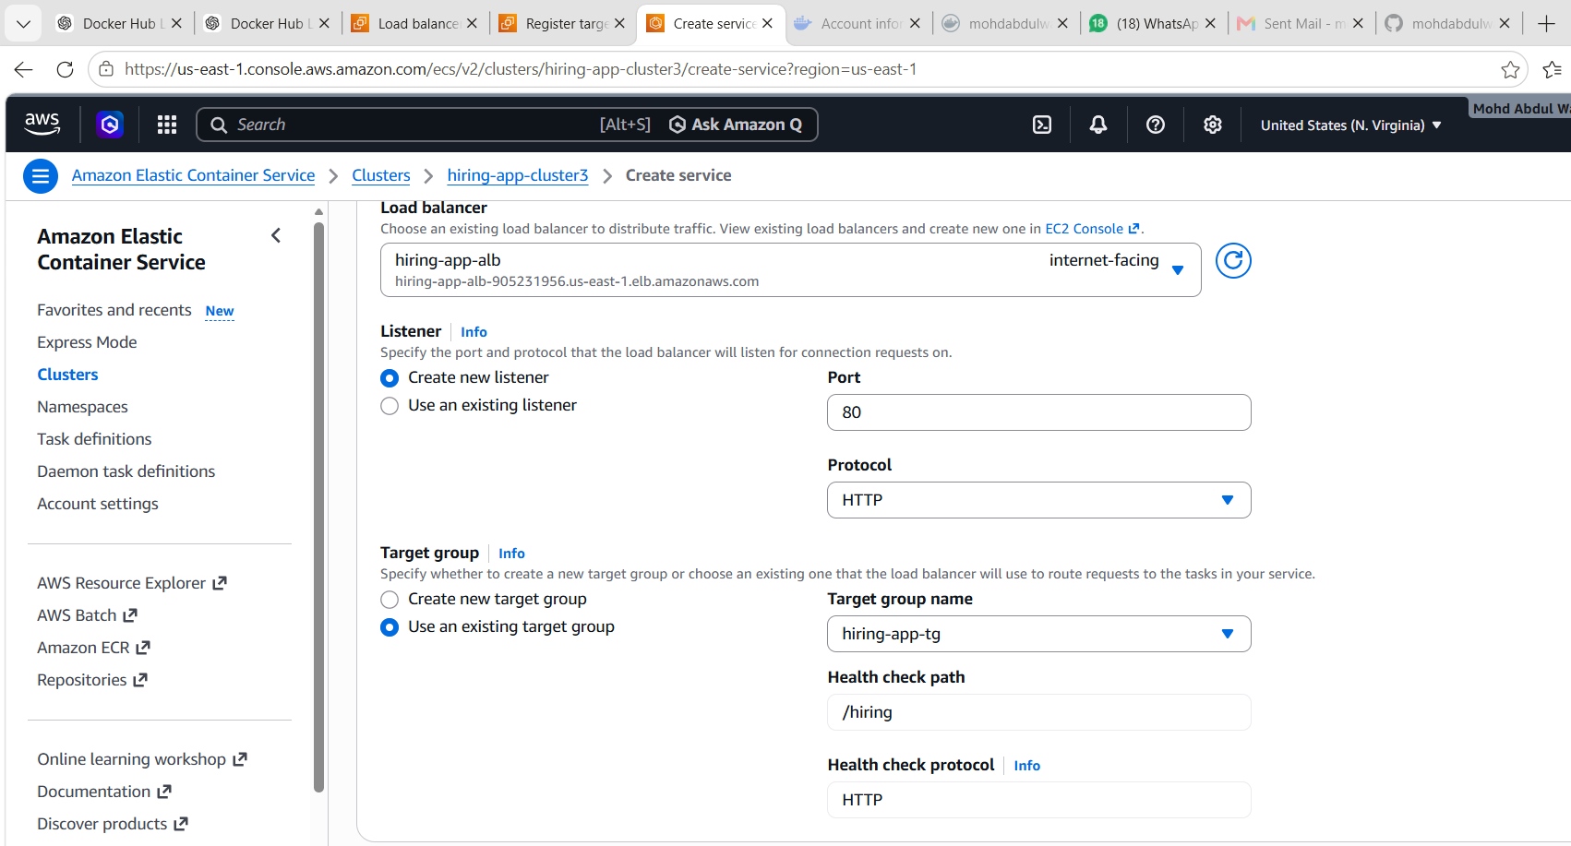
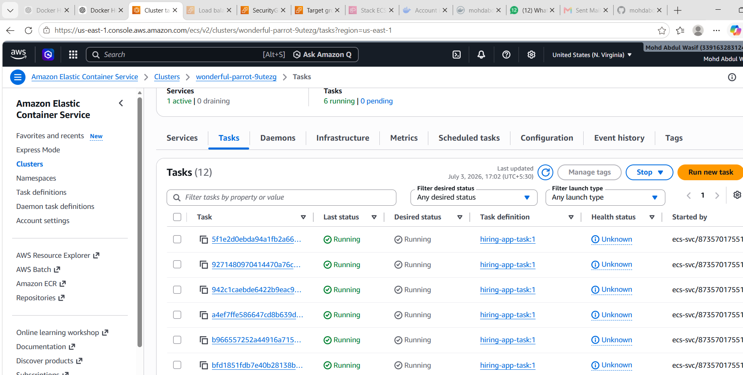
Outbound:
All traffic
This means only ALB can access ECS tasks.

Step 7: Verify 6 Tasks
Go to:
ECS → Cluster → Services → Tasks
Check:
Running tasks = 6
Tasks should be distributed across multiple Availability Zones.
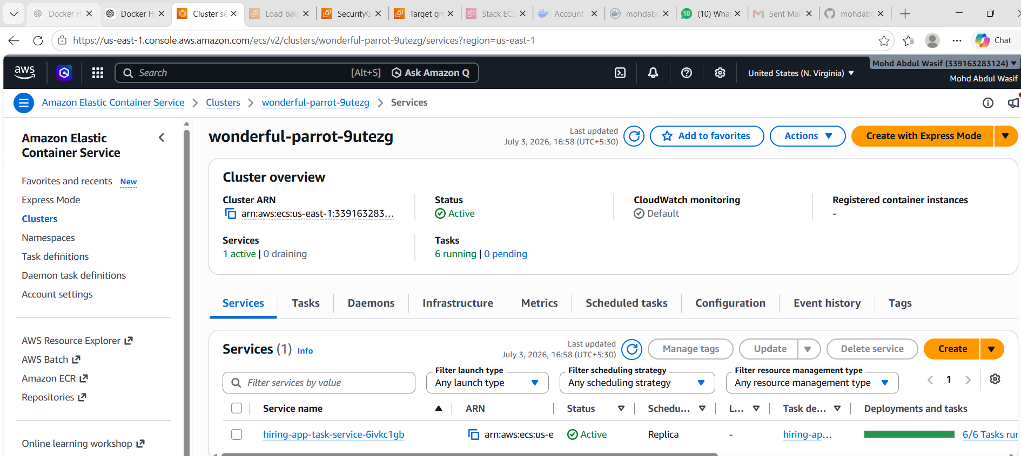

Step 8: Test Application
Go to:
EC2 → Load Balancers → Copy DNS name
Open in browser:
http://<ALB-DNS-NAME>
Application should open.
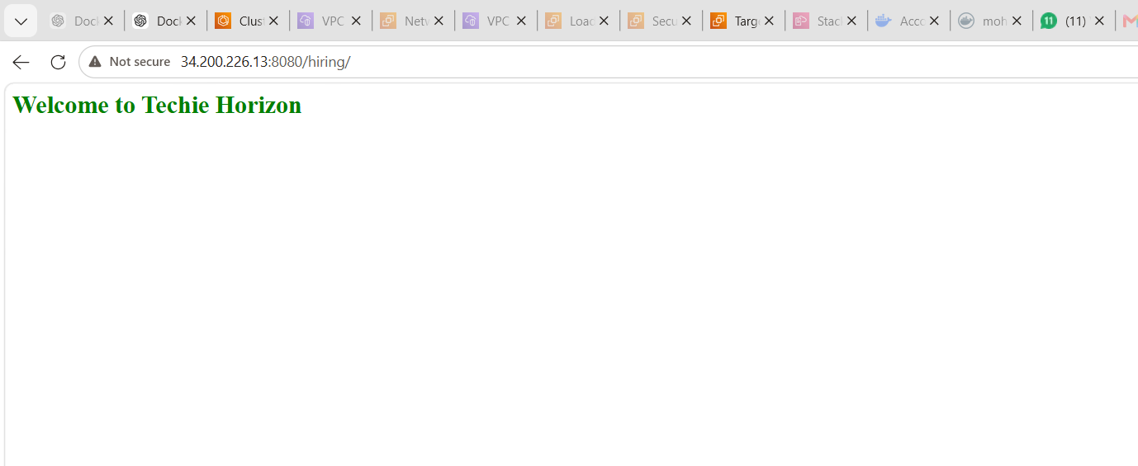

Dynamic Port Mapping Explanation
Dynamic port mapping means ECS/ALB routes traffic to the correct running task automatically.
In Fargate, each task gets its own network interface and IP address. ALB forwards traffic to healthy task IPs through the target group.

What We Learned
We learned how to create an ECS cluster, task definition, ECS service, Application Load Balancer, target group, and security groups. We also learned how ECS maintains desired task count and provides high availability across multiple Availability Zones.

Conclusion
Successfully deployed a highly available ECS Fargate application using ALB and 6 running tasks. The application is fault tolerant, load balanced, and available across multiple Availability Zones.

