**POC TITLE: Feedback Form**

**TEAM-3**: Rasagnya Munjam, Mohammed Abraruddin, Uday Bhanu Masani, Abhijeet Radaboyana, Sandeep Panuganti, Govindarao Vadavalasa

**ABSTRACT:** In this POC Feedback-Form our main aim is to create a portal where we can create a dynamic feedback form according to their requirement and get the feedback genuinely from the user and store them in the database. In this POC as we are using the dynamic form to the user, for that we have generate a token to user email id and for form we have generated another token for which form we want to send to the user. If user already submitted or attempted the feedback once, he can’t send again it will show a message you have already submitted to this feedback form you can’t respond again.

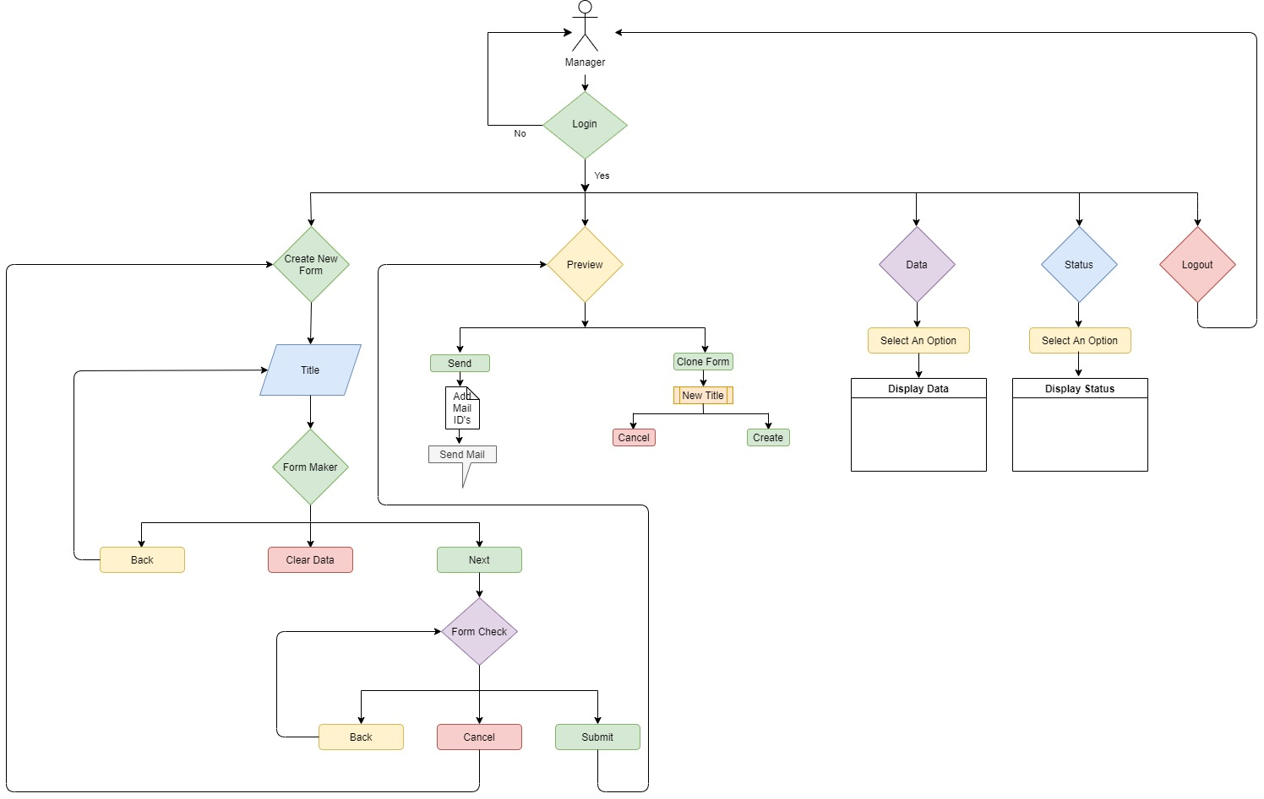Flow-Chart:

If the manager credentials are correct then it will open 1.Create New Form else if credentials are not correct then it goes back to

After Create New Form it will open Title you have give title and after giving form maker will open.

in form maker we have 3 options 1.Back 2.Clear data 3.Next and you will be having delete option for every row you add so that if you want to

delete single line what you added then you can use delete option or else if you want to delete entire thing use clear data and if you are done

with your form making then you can go for 3rd option i.e; next

now you will be directing to form check page where you will be having again 3 options 1.Back 2.Cancel 3.Submit

you can verify everything once you are done and then you can choose the option accordingly.

if you choose back it will show just above page i.e; Form check or if you choose cancel you will be directing to

create new form which starts again from beginning or if you select submit it gets submitted and you will be getting preview page

2.PREVIEW:

In preview we will have 2 options 1.send 2.Clone Form

if you are done with the form you can go with first option and you can send to respective emailid's

or else if you want same questions with different form name you can go with 2nd option clone form

then you will get inside that 2 options create and cancel choose accordingly

3.DATA:

in data you can see the data what is entered

4.STATUS:

in this option you can see the status of the form like how many submitted and how many are yet to submit

and the percentage will be displayed.

5.LOGOUT:

once you are done you can log out and then it will redirect to the manager portal.