***Schematics:-***

* ***Two Stage fully Differential amplifier***

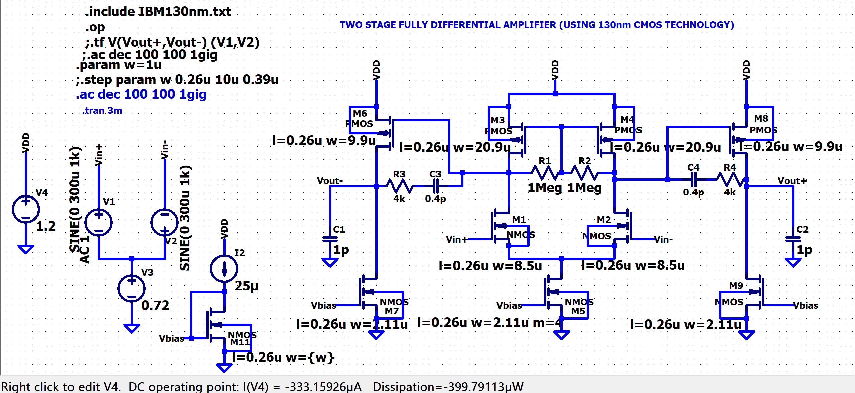

* ***Frequency Analysis:-***

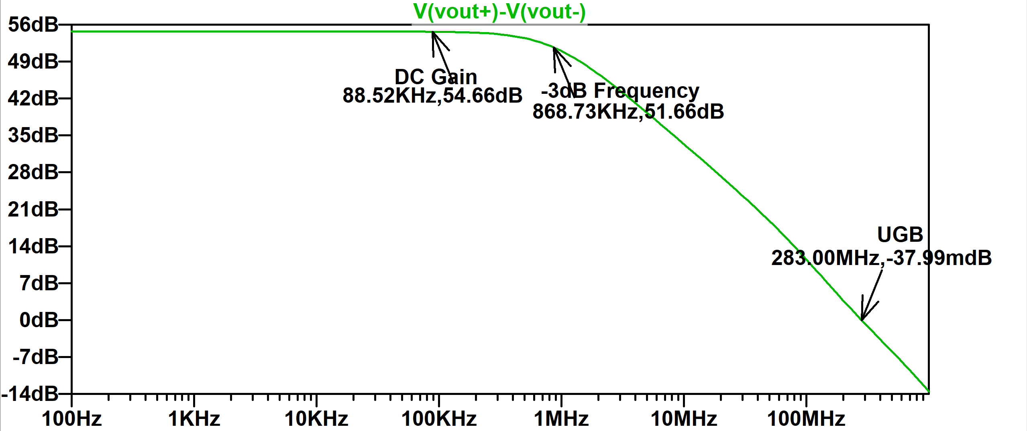

***DC GAIN(db))🡪***

***Frequency🡪***

* ***Transient Analysis:-***

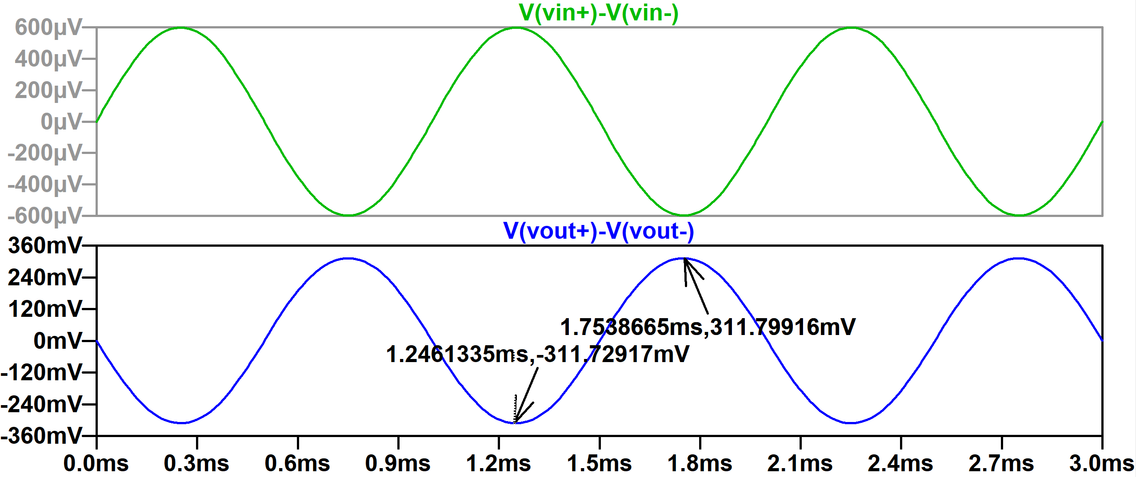

***Voltage🡪***

***Time🡪***

* ***Transfer Function***

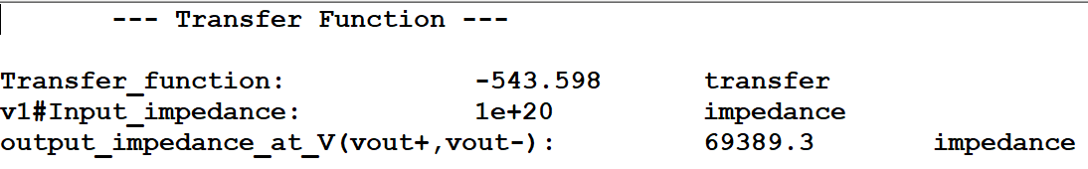

***Summary Table***

|  |  |  |
| --- | --- | --- |
| ***Parameters*** | ***Target values*** | ***Simulation Results*** |
| *Gain (dB)* | *>50* | *54.66* |
| *Phase Margin(degrees)* | ***>*** *50* | *59.47* |
| *-3dB frequency (KHz)* | ***-*** | *868.73* |
| *Unity Gain frequency (MHz)* | *250* | *283.00* |
| *Power Dissipation (uW)* | ***<***  *1080* | *399.79* |