SQLServer Lab
Note: Use ITI DB
- Create a view that displays student full name, course name if the student has a grade more than 50.

- Create an Encrypted view that displays manager names and the topics they teach.

- Create a view that will display Instructor Name, Department Name for the ‘SD’ or ‘Java’ Department

- Create a view “V1” that displays student data for student who lives in Alex or Cairo.
Note: Prevent the users to run the following query
Update V1 set st_address=’tanta’
Where st_address=’alex’;

- Create a view that will display the project name and the number of employees work on it. “Use SD database”

- Create index on column (Hiredate) that allow u to cluster the data in table Department. What will happen?

- Create index that allow u to enter unique ages in student table. What will happen?

- Using Merge statement between the following two tables [User ID, Transaction Amount]

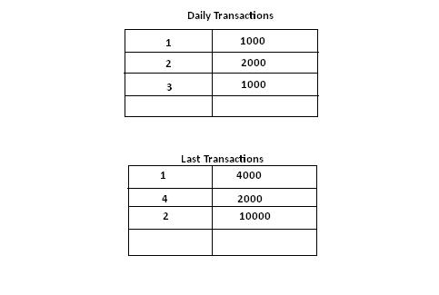

Part2: use SD_DB
- Create view named “v_clerk” that will display employee#,project#, the date of hiring of all the jobs of the type 'Clerk'.

- Create view named “v_without_budget” that will display all the projects data
without budget

- Create view named “v_count “ that will display the project name and the # of jobs in it

- Create view named ” v_project_p2” that will display the emp# for the project# ‘p2’
use the previously created view “v_clerk”

- modifey the view named “v_without_budget” to display all DATA in project p1 and p2

- Delete the views “v_ clerk” and “v_count”

- Create view that will display the emp# and emp lastname who works on dept# is ‘d2’
- Display the employee lastname that contains letter “J”
Use the previous view created in Q#7

- Create view named “v_dept” that will display the department# and department name.
- using the previous view try enter new department data where dept# is ’d4’ and dept name is ‘Development’

- Create view name “v_2006_check” that will display employee#, the project #where he works and the date of joining the project which must be from the first of January and the last of December 2006.

