A

PROJECT PROJECT

ON

HOTEL MANAGEMENT SYSTEM

Submitted in Partial Fulfillment of the Requirements
for the award of the degree of

BACHELOR OF COMPUTER APPLICATIONS
(BCA)



Submitted By : Project Guide:
Mohd Sabir (1709541784) Mr. Vikas Arora
Mohd Anas (1709541779) (Lecturer)
Aashif (1709541743)

DAV PG College MUZAFFARNAGAR

(Affiliated to Ch.Charan Singh University MEERUT)
ACKNOWLEDGEMENT

This project report on "HOTEL MANAGEMENT SYSTEM” is the result of idea and suggestions to me by Mr. Vikas Arora.
We have received unfailing encouragement and inspiration of Mr. Vikas Arora whose exceptional knowledge and unparalleled behavior is full of ardent inspiration in it. However, we can never adequate thank all those who have their assistance, guidance, cooperation criticism contributed to the improvement of this report. We are ebullient in expressing my intense in debtless heartiest gratitude to all of them.
Since performance feedback is essential for effective communication, mistakes and creative feedback of the report may be unhesitatingly communicated to me, which will be as far as possible duly acknowledged and most welcome.
In this report, whatever is beneficial comes from almighty, and whatever is faulty is mine.

Mohd Sabir
Mohd Anas

Aassshif

DECLARATION

This is to certify that the dissertation / project report entitled “Hotel management System” is an authentic work carried out for the partial fulfillment of the Bachelors Degree of Computer Application under the guidance of Mr. Vikas Arora. The matter embodied in this project work has not been submitted earlier for award of any degree or diploma to the best of my knowledge and belief.

Mohd Sabir
Mohd Anas

Aassshif

INTRODUCTION

Hotel Management System is a tool that it provides efficient services to its customer. The various types of operations and dealings take places in the Hotel. But we had undertaken the work of Computerization of Generation of Hotel and Management which covers the activities related to Patient, Staff etc. & All Types of activities corresponds to the Doctors, these operations were manually operated by the clerks and Operator and the operations were really time consuming task to perform. The present system will help them a lot.
ADVANTAGE OF PROJECT

The purpose of this project is to convey the requirements of the project (as specified by the client) to the programmers to ensure that the programmers understand and fulfill the requirements to the expectation of the client.

Secondly, this project is used to ensure that the development team understands the requirements specified by the client. This document will act as the contract for all future development; all development spawns from and adheres to the details in the requirements. The SRS also outlines the performance requirements that may be set and required by the client/user.

This is the Software requirement specification for the “Hotel Management System” Project. This document provides a description of the purpose, functionality and interface of the software designed by the developer with input of the project. In this Software Requirement Specification, constraints and other design issues are addressed.
MINIMUM HARDWARE REQUIREMENT

This software run in any environment .This software needs at least Pentium prosessor 32MB RAM memory,2.1GB of Hard disk ,SVGA display of 1 MB video memory and color monitor but with this lot of processor power consumed and speed of the system will be very slow. Therefore a realistic hardware configuration for this software is:-

Processor : i3 or higher processor
Operating System : Microsoft windows 7
Ram Memory : 4GB
Hard Disk : 160 GB of free space required during installation
Display : VGA card
Keyboard : 104 keys
Mouse : True Mouse
JAVA NeatBeans : 7.1
Microsoft Access : 2007
FRONT END

JAVA NEATBEANS has been developed by MicroSystem. Can use a large number of reference liabraries and components. JAVA NEATBEANS –the environment-provides integration with a variety of other tools, including source code management, component reuse tools and data manipulation. NeatBeans truly is much more of a “programming environment” than just a language. using this environment ,a single developer can quickly create a simple application; a team of developers can create a so sophisticated, distributed application.

Features in JAVA NEATBEANS 7.1

- Data access
- Internet features
- Controls
- Component creation
- Language
- Wizards

JAVA NeatBean has evolved to be much more than a language-it is an application producing “machine”.no other development environment on the planet provides as wide a variety of capabilities in the box as NeatBeans. Even though JAVA NeatBeans is much more productive than other tools,it also requires more discipline to produce clean design. A key to improving your programming technique is to embrace the capabilities to create classes and ActiveX in Java.

As system becomes more complex and distributed, no single tool can address all of the needs of the system. JAVA NeatBeans provides the development environments with the raw tools needed to build small systems well as components of large system.

If we look at all of the new features and functions added to the 6.5 release of the JAVA NeatBeans, a couple of themes become evident: the internet and the database

BACK END

A database is a collection of information that’s related to a particular subject or purpose, such as tracking customer orders or maintaining a music collection .If your database isn’t stored on a computer, or only parts of it are , you may be tracking information from a variety of sources that you have having to coordinate and organize yourself.

For example, suppose the phone numbers of your suppliers are stored in various locations: in a card file containing supplier phone numbers, in product information file cabinet, and in a spreadsheet containing order information .if a supplier’s phone number changes, you might have to update that information in all three places in database, however, you only have to update that information in one place- the supplier’s phone number is automatically updated wherever you use it in database.

Using Microsoft Access, you can manage all your information from a single database file. Within the file, you can use:

- Tables to store your data.
- Queries to find and retrieve just the data you want
- Forms to view add and update data in tables.
- Reports to analyze or print data in a specific layout.
- Data access pages to view, update, or analyze the database’s data from the internet or an intranet.
RECOGNITION OF NEED:
The Hotel Management is undertaken as a project based on relevant technologies. The main objective of the project is to develop software for a Furniture Shop. This project is developed to carry out the process quickly and easily which is process is not possible with the manual system. This project is developed using java language and MS Access.
The current Hotel Management is manual time consuming and more manpower are required to handle this system with this project we replace manual system to computerized system which is faster, less time consuming and manpower.

Feasibility study
It is feasible to automate the system. The three major areas to determine the feasibility of project:

Technical Feasibility:
The current level of technology can support the proposed system. The proposed software is enabling to meet all the objective of the system and output received is more efficient. So the project is technical feasible.

Economic Feasibility:
The proposed system needs to get hardware and software installed. The short-term costs are over shadowed by the long-term gains. The profits of the business is raised as this visual drafting system help in establishing the better relationship between client and also satisfy their query’s and so the cost of the development of the software and hardware is over shadowed. Thus, project is economically feasible.

Operational Feasibility:
The current system faces a lot of problems that are removed in the proposed system. The Clients of the system will be free from the burden and a lot of confusion. The clients are themselves interested in getting the manual system replace by the automated one. The proposal system is user friendly, so even a layman can use it. Thus it is operationally feasible.

DFD FOR USER LOGIN

USER
1
User_id
User Enter Their Password & User_Id for
Opening the application
Accessing User
Information
Pasword Validity Process
Process
Invalid

User Matched Accessing User Information

Valid User for Type
Matching

User Type Validity Process
Invalid User Type

Matched

DFD FOR ROOM

t
ROOM
Room details

Data Validity
Process
1
Patient1
Room not available

2
Patient2

DFD FOR CUSTOMER

1
Room1
CUSTOMER

Accessing Patient Info

Searching Room

Not found

Display Process
Available room

ENTITY – RELATIONSHIP DIAGRAM

The entity – relationship (E – R) data model is based on a perception of a real world that consists of a collection of basic objects, called entities, and of relationships among these objects. An entity is a thing or objects in the real world that is distinguishable from other objects. Entities are described in database by a set of attributes.
A relationship is an association among several entities. The set of all entities of the same type and the set of all relationships of the same type are termed as entity set and relationship set, respectively.
The overall logical structure (schema) of a database can be expressed graphically by an E-R Diagram, which is built up from the following components:

- Rectangles, which represents entity sets.
- Ellipses, which represents attributes.
- Diamonds, which represents relationships among entity sets.
- Lines, which link attributes to entity sets and entity sets to relationships.
3.5 System Development
- Cost Of Each Option
  - The time Available to write software
  - The availability of programmers
Starting coding of any subsystem we were required to carefully study information and requirements regarding that application, stored in MS-ACCESS Dictionary. Once the problem is well thought off and ideas were shared /discussed among other team members, design phase is through i.e. how exactly the user interface will be and what is the best way to deduce the logic of the application, we were required to write down the flow of logic and other parameters being used or getting effected on a document of Home Decorating Accessories Shop called Requirement Specification Document.
The RSD has to get approved us and used to get further suggestions, also this RDS is used to prepare the documentation of the system at later and helps to keep trace of the changes in the logic.

Testing Implementation & Maintenance
Testing
During system testing, the system is used experimentally to ensure that the software does not fail, specific test data are input for processing and results examined. It is desirable to discover any surprises before the organization implements the system & depends on it.
Testing Objectives: -
- Testing is a process of executing a program with the intent of finding an error.
- A good test case is one that has a high probability of finding an undiscovered error.
- A successful test is one that uncovers an undiscovered error.
- Testing Principles:-
- All tests should be traceable to customer’s requirements.
- Test should be planned long before the testing begins.
- Testing should begin “in the small” & progress towards “in the large”.
- Exhaustive Testing is not possible.
- To be most effective, an independent third party should conduct testing.
White Box Testing: -
It is also known as glass box testing and internal testing. It is a test case design method that uses a control structure of the procedural design to derive test cases. Using white box testing methods, software engineer can derive test cases that: -
- Guarantee that all independent paths within the module have been exercised at least once.
- Exercised all logical decisions on their true & false sides.
- Execute all loops at their boundaries & within their operational bounds.
- Exercise internal data structures to ensure their validity.
Black Box Testing: -
It is also called behavioral testing & external testing. It focuses in the functional requirements of the software i.e. it enables the software engineer to derive sets of input conditions that will fully exercise all functional requirements for a program. It is not an alternative to white box techniques. Rather it is a complementary approach that is likely to uncover a different class of errors than white box methods.
Black Box testing attempts to find errors in the following categories: -
- Incorrect or missing functions.
- Interface errors.
- Errors in data structures.
- Behavior or performance errors.
- Initialization & termination errors.
Activity network for system testing:-
1. prepare test plan
2. specify conditions for user acceptance testing
3. prepare test data for program testing
4. Plan user training
5. Compile/assemble programs
6. Prepare job performance helps.
7. Prepare operational documents.

Implementation

Implementation, literally, means to put into effects or to carry out. The system implementation phase of software engineering deals with all activities that take place to convert from the old system to the new. Proper implementation is essential to provide system to meet organization’s requirements.

During the implementation phase debugging, documentation of the system was created out, module in the project for
- Accuracy of Results,
- Minimization of response Time,
- Clarity and Simplicity of the code,
- Minimization of hard – Coding i.e. (a generic approach was followed)
- Minimization of amount of memory used.

Various types of errors were discovered while debugging the modules. These ranged from errors to failure to account for various processing cases. Proper documentation of each module was done by embedding comments in the executable portion of the code. To enhance the readability, comments, indentation, parenthesis, block spaces, blank lines and borders were around the blocks of comments. Care was taken to use descriptive names for table, field modules, forms etc. The proper use of indentation, parenthesis and blank lines was also ensured during coding.

Testing of the report Generation module was carried out to find out the response time of the system for the generating reports. To make the response time negligible.
Prepare test data for transaction path testing.
5. Plan user training
6. Compile/assemble programs
7. Prepare job performance helps.
8. Prepare operational documents.
Testing of the report Generation module was carried out to find out the response time of the system for the generating reports. To make the response time negligible.

System maintenance

Like any system, there is an aging process that requires periodic maintenance of hardware & software. If new information is inconsistent with design specifications, then changes have to be made. Hardware also requires periodic maintenance to keep in tune with design specifications. The importance of maintenance is to continue to bring the new system to standards.
Types of Maintenance
- Corrective maintenance:-
Repairing processing or performance failures or making changes due to uncorrected errors.
- Adaptive Maintenance: -
Adaptive maintenance means changing the program function to make it adaptable according to its future environment.
- Perfective Maintenance: -
Perfective Maintenance means enhancing the performance or modifying the programs to responds to the changing needs.
Fundamental objective of system maintenance:-
1 To complete the system tasks as quickly as possible without compromising the system reliability and quality.
2 To preserve those aspects of programs that were correct and to avoid the possibility that fixes applications and causes other aspects of those applications to behave differently.
3 To react proactively to affect changes to existing applications, to correct errors that were made during system design or implementation.
4 To avoid as much as possible degradation of system performance.

HOTEL DATA BASE
ROOM
Customer
STAFF
Gender
Roomtype
rent

Orderno.
contains
Name
Address
Age
Phone
has
Has staff members
Roomno
Roomno
Pid
address
staffid
name
post
Admit
Modules

The Hotel Management is further the integration of various sub-systems. Broadly speaking these sub-system are based on following broadly classified activities.
- Login Window
- Login Id
- Password
- Room Management
- Add new Room Entry
- Delete Room Entry
- Modify Room Entry
- Search Room Entry
- Booking Management
- Add new Booking Entry
- Delete Booking Entry
- Modify Booking Entry
- Search Booking Form
- Staff management
- Add new staff Entry
- Delete staff Entry
- Modify staff Entry
- Search staff Entry
- Salary Staff

DATABASE DESIGN
All the tables, sequences, triggers are stored in database for storing the information about entrance test made by the users.
Following are the tables:
Login Table
Loginname | Text
Password | Text

Table:- bookingtable

Field Name | Field type
Booking no | Number
Date | Date&Time
Custname | Text
Age | Number
Contact no | Text
Address | Text
Room No | Text
Room type | Text
Rent per day | Number
Total amount | Number

Table:- Roomtable

Field Name | Field type
RoomID | Number
Roomtype | Text
Rent per day | Number

Staff Table
Staff id | AutoNumber
Name | Text
Age | Number
Dateofjoining | Date
Qualificateion | Text
Address | Text
Phone | Text
Dept | Text
Salary | Number

Login WIndow
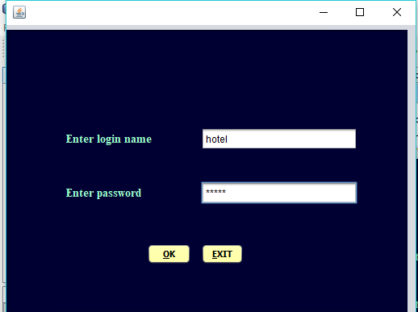

SPLASH FORM
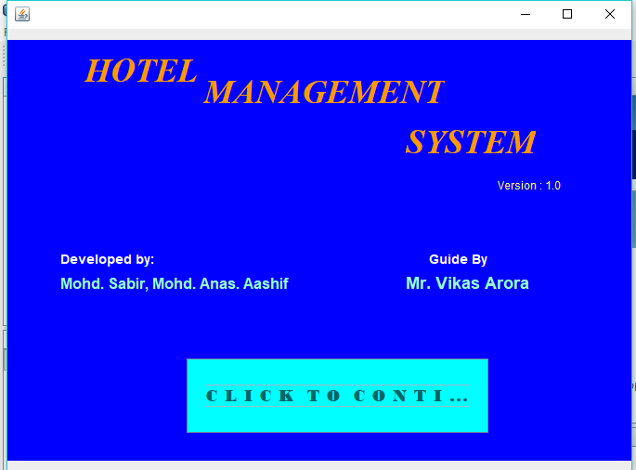

MAIN WINDOW
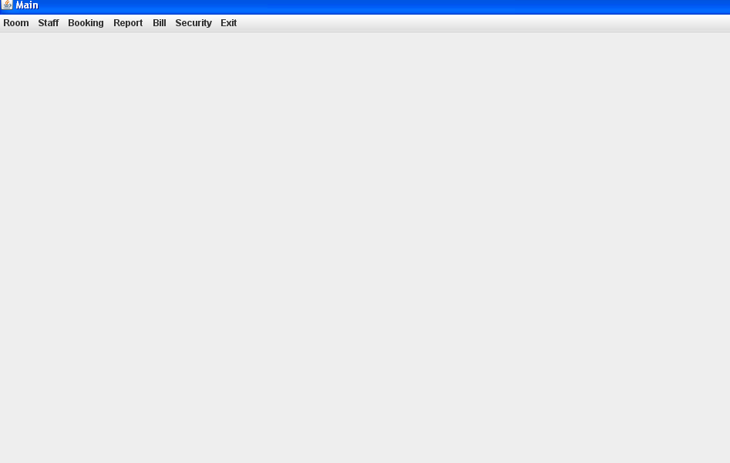

ADD ROOM FORM
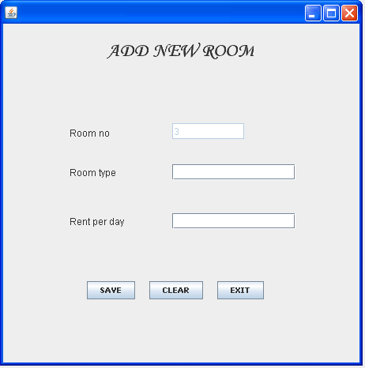

MODIFY ROOM
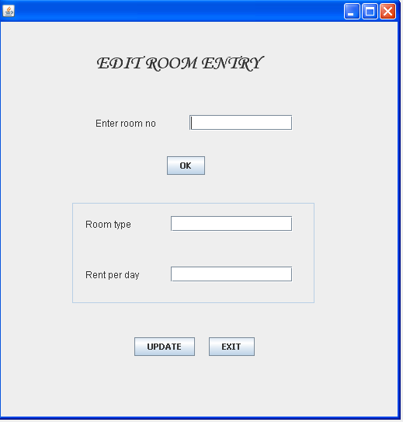

Search Room

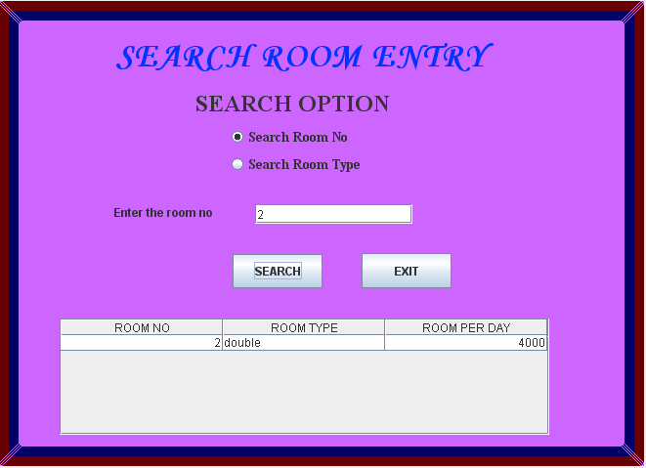

ADD NEW BOOKING
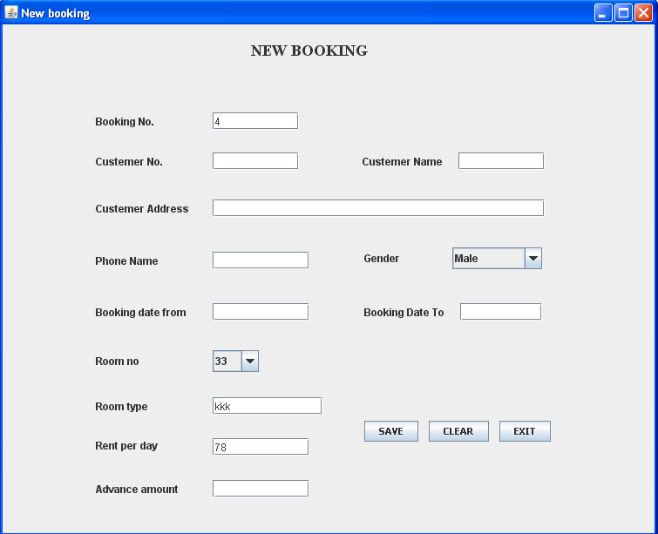
DELETE BOOKING
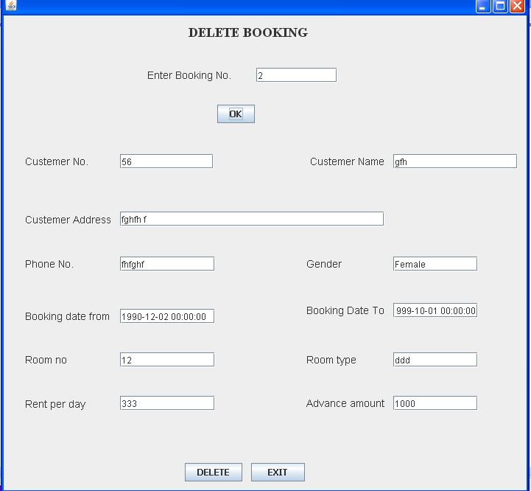

DELETE BOOKING

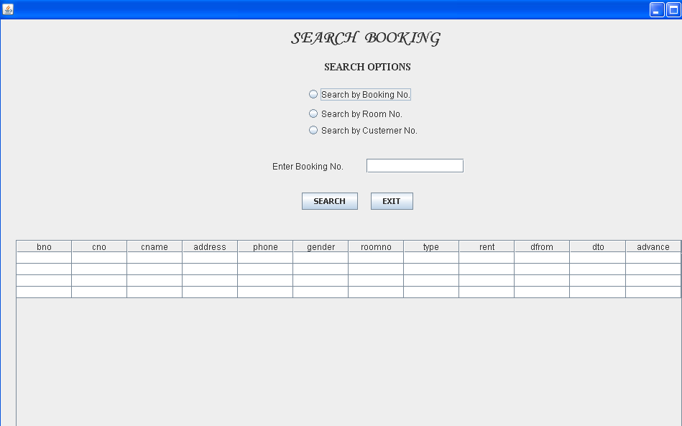

LIST OF ROOM

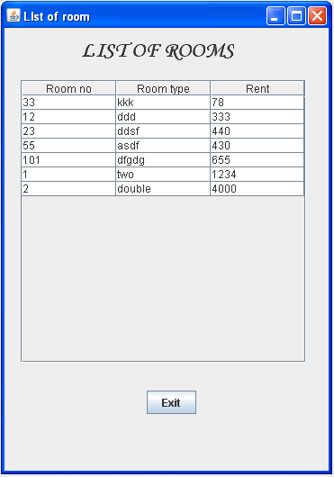

LIST OF BOOKING

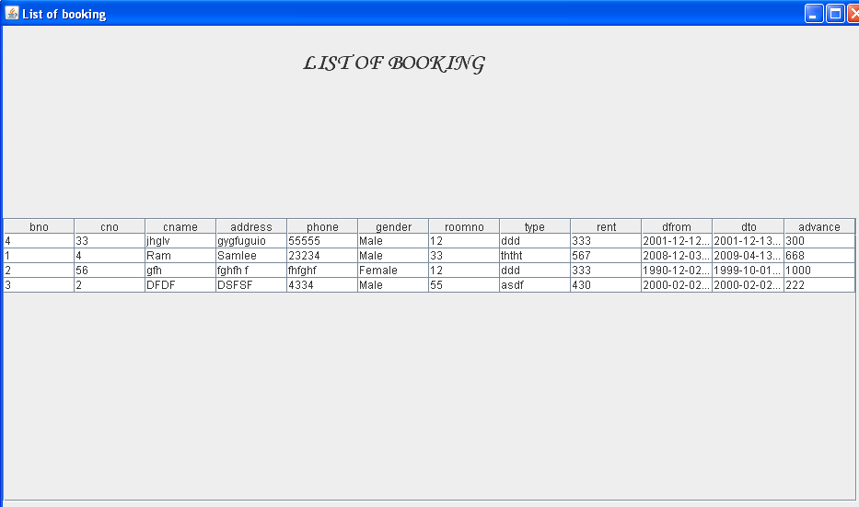

BILL FORM
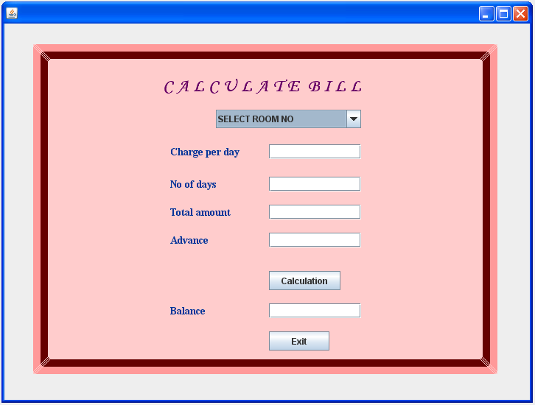

CHANGE PASSWORD
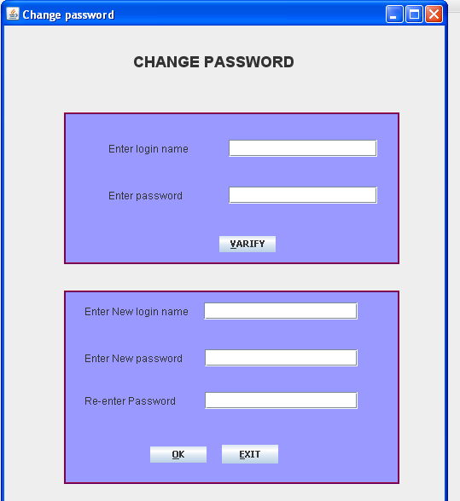

Login form

package hotelmanagement;
import javax.swing.*;
import java.sql.*;
private void OKActionPerformed(java.awt.event.ActionEvent evt) {
// TODO add your handling code here:
try {
Class.forName("sun.jdbc.odbc.JdbcOdbcDriver");
Connection c=DriverManager.getConnection("jdbc:odbc:hotel");
Statement state=c.createStatement();
String query="select * from logintable";
ResultSet res=state.executeQuery(query);
res.next();
String lname,pass,lname2,pass2;
lname=txtlogin.getText();
pass=txtpassword.getText();
lname2=res.getString("login");
pass2=res.getString("password");
if(lname.equals(lname2)&&pass.equals(pass2)) {
dispose();
Splashfrm frm=new Splashfrm();
frm.setVisible(true);

} else {
JOptionPane.showMessageDialog(null,"Incorrect");
}
}catch(Exception e) {
}
private void EXITActionPerformed(java.awt.event.ActionEvent evt) {
// TODO add your handling code here:
System.exit(0);
}

public static void main(String args[]) {
java.awt.EventQueue.invokeLater(new Runnable() {
public void run() {
new Loginfrm().setVisible(true);
}
});
}

Splash from

package hotelmanagement;
import java.awt.*;
private void CONTI2MouseMoved(java.awt.event.MouseEvent evt) {
CONTI2.setBackground(Color.red );
}

private void CONTI2ActionPerformed(java.awt.event.ActionEvent evt) {
dispose();
Mainform obj =new Mainform();
obj.setVisible(true);
}

private void jPanel3MouseMoved(java.awt.event.MouseEvent evt) {
CONTI2.setBackground(Color.cyan);
}
public static void main(String args[]) {
java.awt.EventQueue.invokeLater(new Runnable() {
public void run() {
new Splashfrm().setVisible(true);
}
});
}

Main Form

private void jMenuItem9ActionPerformed(java.awt.event.ActionEvent evt) {
newbookingfrm obj=new newbookingfrm();
obj.setVisible(true);

}

private void jMenuItem11ActionPerformed(java.awt.event.ActionEvent evt) {
Searchbooking obj=new Searchbooking();
obj.setVisible(true);

}

private void jMenuItem1ActionPerformed(java.awt.event.ActionEvent evt) {
// TODO add your handling code here:
Roomaddfrm ob=new Roomaddfrm();
ob.setVisible(true);
}

private void jMenuItem2ActionPerformed(java.awt.event.ActionEvent evt) {
// TODO add your handling code here:
Deleteroomfrm ob=new Deleteroomfrm();
ob.setVisible(true);
}

private void jMenuItem3ActionPerformed(java.awt.event.ActionEvent evt) {
// TODO add your handling code here:
Editroomfrm ob=new Editroomfrm();
ob.setVisible(true);
}

private void jMenuItem4ActionPerformed(java.awt.event.ActionEvent evt) {
// TODO add your handling code here:
SearchRoom ob =new SearchRoom();
ob.setVisible(true);

}

private void jMenuItem5ActionPerformed(java.awt.event.ActionEvent evt) {
// TODO add your handling code here:
AddNewStaff ob=new AddNewStaff();
ob.setVisible(true);
}

private void jMenuItem6ActionPerformed(java.awt.event.ActionEvent evt) {
DeleteStaff ob=new DeleteStaff();
ob.setVisible(true);
}

private void jMenuItem7ActionPerformed(java.awt.event.ActionEvent evt) {
// TODO add your handling code here:
ModifyStaff ob = new ModifyStaff();
ob.setVisible(true);
}

private void jMenuItem8ActionPerformed(java.awt.event.ActionEvent evt) {
// TODO add your handling code here:
SerachStaff ob =new SerachStaff();
ob.setVisible(true);
}

private void jMenuItem10ActionPerformed(java.awt.event.ActionEvent evt) {
// TODO add your handling code here:
Deletebooking ob =new Deletebooking();
ob.setVisible(true);
}

private void jMenu4ActionPerformed(java.awt.event.ActionEvent evt) {
// TODO add your handling code here:

}

private void jMenuItem14ActionPerformed(java.awt.event.ActionEvent evt) {
// TODO add your handling code here:
Listofbookingfrm ob=new Listofbookingfrm();
ob.setVisible(true);
}

private void jMenuItem13ActionPerformed(java.awt.event.ActionEvent evt) {
// TODO add your handling code here:
Listofstafffrm ob=new Listofstafffrm();
ob.setVisible(true);
}

private void jMenuItem12ActionPerformed(java.awt.event.ActionEvent evt) {
// TODO add your handling code here:
Listofroomfrm ob=new Listofroomfrm();
ob.setVisible(true);
}

private void jMenuItem15ActionPerformed(java.awt.event.ActionEvent evt) {
// TODO add your handling code here:
Chagepass ob=new Chagepass();
ob.setVisible(true);
}

private void jMenuItem16ActionPerformed(java.awt.event.ActionEvent evt) {
System.exit(0);
}

private void jMenuItem18ActionPerformed(java.awt.event.ActionEvent evt) {
// TODO add your handling code here:
Bill ob=new Bill();
ob.setVisible(true);
}
public static void main(String args[]) {
java.awt.EventQueue.invokeLater(new Runnable() {
public void run() {
new Mainform().setVisible(true);
}
});
}
Add room

package hotelmanagement;
import java.sql.*;
import javax.swing.*;
/**
*
* @author nbc
*/
public class newbookingfrm extends javax.swing.JFrame {

/** Creates new form newbookingfrm */
public newbookingfrm() {
initComponents();
}

private void formWindowActivated(java.awt.event.WindowEvent evt) {
int tbno=0;
try
{
Class.forName("sun.jdbc.odbc.JdbcOdbcDriver");
Connection c=DriverManager.getConnection("jdbc:odbc:hotel");
Statement state=c.createStatement();
ResultSet res=state.executeQuery("select * from roomtable");
while(res.next())
{
cmbroomno.addItem((Object)res.getString("roomno"));

}
res=state.executeQuery("select * from bookingtable");
while(res.next())
{
tbno=res.getInt("bno");

}

}catch(Exception e)
{
JOptionPane.showMessageDialog(null,e.getMessage());
}
txtbno.setText(String.valueOf(tbno+1));
txtcno.requestFocus();

}

private void cmbroomnoActionPerformed(java.awt.event.ActionEvent evt) {
int r;
r=Integer.parseInt(String.valueOf(cmbroomno.getSelectedItem()));
String qtype,qrent;

try
{
Class.forName("sun.jdbc.odbc.JdbcOdbcDriver");
Connection c=DriverManager.getConnection("jdbc:odbc:hotel");
Statement state=c.createStatement();
ResultSet res=state.executeQuery("select * from roomtable where roomno="+r);
res.next();
qtype=res.getString("roomtype");
qrent=res.getString("rent");

txttype.setText(qtype);
txtrent.setText(qrent);

}catch(Exception e)
{
JOptionPane.showMessageDialog(null,"Invalid data");
}

}

private void saveActionPerformed(java.awt.event.ActionEvent evt) {
int tbno,tcno,troomno,trent,tadv;
String tcname,tphone,tadd,tgender,tfrom,tto,ttype;
try
{
Class.forName("sun.jdbc.odbc.JdbcOdbcDriver");
Connection c=DriverManager.getConnection("jdbc:odbc:hotel");
Statement state=c.createStatement();
tbno=Integer.parseInt(txtbno.getText());
tcno=Integer.parseInt(txtcno.getText());
troomno=Integer.parseInt((String)cmbroomno.getSelectedItem());
trent=Integer.parseInt(txtrent.getText());
tadv=Integer.parseInt(txtamount.getText());
tcname=txtcname.getText();
tphone=txtphone.getText();
tadd=txtaddress.getText();
tgender=String.valueOf(cmbgender.getSelectedItem());
tfrom=txtdfrom.getText();
tto=txtdto.getText();
ttype=txttype.getText();
String query;
query = "insert into bookingtable values("+tbno+","+tcno+",'"+tcname+"','"+tadd+"','"+tphone+"','"+tgender+"',"+troomno+",'"+ttype+"',"+trent+",'"+tfrom+"','"+tto+"',"+tadv+")";
state.executeUpdate(query);
JOptionPane.showMessageDialog(null,"Successfully saved");
}catch(Exception e)
{
JOptionPane.showMessageDialog(null,e.getMessage());
}

}

private void exitActionPerformed(java.awt.event.ActionEvent evt) {
dispose();
}

private void clearActionPerformed(java.awt.event.ActionEvent evt) {
txtbno.setText("");
txtcno.setText("");
txtrent.setText("");
txtamount.setText("");
txtcname.setText("");
txtphone.setText("");
txtaddress.setText("");
txtdfrom.setText("");
txtdto.setText("");
txttype.setText("");
int tbno=0;

try
{
Class.forName("sun.jdbc.odbc.JdbcOdbcDriver");
Connection c=DriverManager.getConnection("jdbc:odbc:hotel");
Statement state=c.createStatement();
ResultSet res;
res=state.executeQuery("select * from bookingtable");
while(res.next())
{
tbno=res.getInt("bno");

}

}catch(Exception e)
{
JOptionPane.showMessageDialog(null,e.getMessage());
}
txtbno.setText(String.valueOf(tbno+1));
txtcno.requestFocus();
}
public static void main(String args[]) {
java.awt.EventQueue.invokeLater(new Runnable() {
public void run() {
new newbookingfrm().setVisible(true);
}
});
}

Edit room
package hotelmanagement;
import java.sql.*;
import javax.swing.*;
private void okActionPerformed(java.awt.event.ActionEvent evt) {
try {
Class.forName("sun.jdbc.odbc.JdbcOdbcDriver");
Connection c=DriverManager.getConnection("jdbc:odbc:hotel");
state=c.createStatement();

s=Integer.parseInt(txtrno.getText());
ResultSet res;
res=state.executeQuery("select * from roomtable where roomno="+s);
if(res.next()) {
txttype.setText(res.getString("roomtype"));
txtrent.setText(res.getString("rent"));

} else
JOptionPane.showMessageDialog(null,"Not found");
}catch(Exception e) {
}
}

private void updateActionPerformed(java.awt.event.ActionEvent evt) {
try
{
int trno,trent;
String ttype,query;
trno=Integer.parseInt(txtrno.getText());
ttype=txttype.getText();
trent=Integer.parseInt(txtrent.getText());
query="update roomtable set roomtype='"+ttype+"',rent="+trent+" where roomno="+s+"";
state.executeUpdate(query);
JOptionPane.showMessageDialog(null,"Successfully updated");

}catch(Exception e)
{
JOptionPane.showMessageDialog(null,"Invalid data");
}
}

private void exitActionPerformed(java.awt.event.ActionEvent evt) {
// TODO add your handling code here:
dispose();
}

/**
* @param args the command line arguments
*/
public static void main(String args[]) {
java.awt.EventQueue.invokeLater(new Runnable() {
public void run() {
new Editroomfrm().setVisible(true);
}
});
}

try

{

Class.forName("sun.jdbc.odbc.JdbcOdbcDriver");

Connection c=DriverManager.getConnection("jdbc:odbc:hotel");

Statement state=c.createStatement();

tbno=Integer.parseInt(txtbno.getText());

tcno=Integer.parseInt(txtcno.getText());

troomno=Integer.parseInt((String)cmbroomno.getSelectedItem());

trent=Integer.parseInt(txtrent.getText());

tadv=Integer.parseInt(txtamount.getText());

tcname=txtcname.getText();

tphone=txtphone.getText();

tadd=txtaddress.getText();

tgender=String.valueOf(cmbgender.getSelectedItem());

tfrom=txtdfrom.getText();

tto=txtdto.getText();

ttype=txttype.getText();

String query;

query = "insert into bookingtable values("+tbno+","+tcno+",'"+tcname+"','"+tadd+"','"+tphone+"','"+tgender+"',"+troomno+",'"+ttype+"',"+trent+",'"+tfrom+"','"+tto+"',"+tadv+")";

state.executeUpdate(query);

JOptionPane.showMessageDialog(null,"Successfully saved");

}catch(Exception e)

{

JOptionPane.showMessageDialog(null,e.getMessage());

}

}

private void exitActionPerformed(java.awt.event.ActionEvent evt) {

dispose();

}

private void clearActionPerformed(java.awt.event.ActionEvent evt) {

txtbno.setText("");

txtcno.setText("");

txtrent.setText("");

txtamount.setText("");

txtcname.setText("");

txtphone.setText("");

txtaddress.setText("");

txtdfrom.setText("");

txtdto.setText("");

txttype.setText("");

int tbno=0;

try

{

Class.forName("sun.jdbc.odbc.JdbcOdbcDriver");

Connection c=DriverManager.getConnection("jdbc:odbc:hotel");

Statement state=c.createStatement();

ResultSet res;

res=state.executeQuery("select * from bookingtable");

while(res.next())

{

tbno=res.getInt("bno");

}

}catch(Exception e)

{

JOptionPane.showMessageDialog(null,e.getMessage());

}

txtbno.setText(String.valueOf(tbno+1));

txtcno.requestFocus();

}

/**

* @param args the command line arguments

*/

public static void main(String args[]) {

java.awt.EventQueue.invokeLater(new Runnable() {

public void run() {

new newbookingfrm().setVisible(true);

}

});

}

Delete room form

private void okActionPerformed(java.awt.event.ActionEvent evt) {

try {

Class.forName("sun.jdbc.odbc.JdbcOdbcDriver");

Connection c=DriverManager.getConnection("jdbc:odbc:hotel");

state=c.createStatement();

s=Integer.parseInt(txtrno.getText());

ResultSet res;

res=state.executeQuery("select * from roomtable where roomno="+s);

if(res.next()) {

txttype.setText(res.getString("roomtype"));

txtrent.setText(res.getString("rent"));

} else

JOptionPane.showMessageDialog(null,"Not found");

}catch(Exception e) {

}

}

private void updateActionPerformed(java.awt.event.ActionEvent evt) {

try

{

int trno,trent;

String ttype,query;

trno=Integer.parseInt(txtrno.getText());

ttype=txttype.getText();

trent=Integer.parseInt(txtrent.getText());

query="update roomtable set roomtype='"+ttype+"',rent="+trent+" where roomno="+s+"";

state.executeUpdate(query);

JOptionPane.showMessageDialog(null,"Successfully updated");

}catch(Exception e)

{

JOptionPane.showMessageDialog(null,"Invalid data");

}

}

private void exitActionPerformed(java.awt.event.ActionEvent evt) {

// TODO add your handling code here:

dispose();

}

Search room

package hotelmanagement;

import java.sql.*;

import javax.swing.*;

import javax.swing.table.*;

private void op1ActionPerformed(java.awt.event.ActionEvent evt) {

lbl.setText("Enter booking no");

txt.requestFocus();

}

private void op2ActionPerformed(java.awt.event.ActionEvent evt) {

lbl.setText("Enter room no");

txt.requestFocus();

}

private void SEARCHActionPerformed(java.awt.event.ActionEvent evt) {

DefaultTableModel m=(DefaultTableModel) tb.getModel();

try {

Class.forName("sun.jdbc.odbc.JdbcOdbcDriver");

Connection c=DriverManager.getConnection("jdbc:odbc:hotel");

Statement state=c.createStatement();

String query;

ResultSet res;

//Removing all rows;

int rows=m.getRowCount();

for(int i=0;i<rows;i++) {

m.removeRow(0);

}

if (op1.isSelected())

{

int s=Integer.parseInt(txt.getText());

query="select * from bookingtable where bno="+s;

res=state.executeQuery(query);

while(res.next())

{

m.addRow(new Object[] { res.getString("bno"),res.getString("cno"),res.getString("cname"),res.getString("address"),res.getString("phone"),res.getString("gender"),res.getString("roomno"),res.getString("type"),res.getString("rent"),res.getString("dfrom"),res.getString("dto"),res.getString("advance")});

}

}

else if (op2.isSelected())

{

int s2=Integer.parseInt(txt.getText());

query="select * from bookingtable where roomno="+s2;

res=state.executeQuery(query);

while(res.next())

{

m.addRow(new Object[] { res.getString("bno"),res.getString("cno"),res.getString("cname"),res.getString("address"),res.getString("phone"),res.getString("gender"),res.getString("roomno"),res.getString("type"),res.getString("rent"),res.getString("dfrom"),res.getString("dto"),res.getString("advance")});

}

}

else if (op3.isSelected())

{

int s3=Integer.parseInt(txt.getText());

query="select * from bookingtable where cno="+s3;

res=state.executeQuery(query);

while(res.next())

{

m.addRow(new Object[] { res.getString("bno"),res.getString("cno"),res.getString("cname"),res.getString("address"),res.getString("phone"),res.getString("gender"),res.getString("roomno"),res.getString("type"),res.getString("rent"),res.getString("dfrom"),res.getString("dto"),res.getString("advance")});

}

}

}catch(Exception e)

{

JOptionPane.showMessageDialog(null,"Invalid data");

}

}

private void EXITActionPerformed(java.awt.event.ActionEvent evt) {

dispose();

}

private void op3ActionPerformed(java.awt.event.ActionEvent evt) {

lbl.setText("Enter customer no");

txt.requestFocus();

}

public static void main(String args[]) {

java.awt.EventQueue.invokeLater(new Runnable() {

public void run() {

new Searchbooking().setVisible(true);

}

});

}

Add booking from

package hotelmanagement;
import java.sql.*;
import javax.swing.*;
private void formWindowActivated(java.awt.event.WindowEvent evt) {
int tbno=0;
try
{
Class.forName("sun.jdbc.odbc.JdbcOdbcDriver");
Connection c=DriverManager.getConnection("jdbc:odbc:hotel");
Statement state=c.createStatement();
ResultSet res=state.executeQuery("select * from roomtable");
while(res.next())
{
cmbroomno.addItem((Object)res.getString("roomno"));

}
res=state.executeQuery("select * from bookingtable");
while(res.next())
{
tbno=res.getInt("bno");

}

}catch(Exception e)
{
JOptionPane.showMessageDialog(null,e.getMessage());
}
txtbno.setText(String.valueOf(tbno+1));
txtcno.requestFocus();

}

private void cmbroomnoActionPerformed(java.awt.event.ActionEvent evt) {
int r;
r=Integer.parseInt(String.valueOf(cmbroomno.getSelectedItem()));
String qtype,qrent;

try
{
Class.forName("sun.jdbc.odbc.JdbcOdbcDriver");
Connection c=DriverManager.getConnection("jdbc:odbc:hotel");
Statement state=c.createStatement();
ResultSet res=state.executeQuery("select * from roomtable where roomno="+r);
res.next();
qtype=res.getString("roomtype");
qrent=res.getString("rent");

txttype.setText(qtype);
txtrent.setText(qrent);

}catch(Exception e)
{
JOptionPane.showMessageDialog(null,"Invalid data");
}

}

private void saveActionPerformed(java.awt.event.ActionEvent evt) {
int tbno,tcno,troomno,trent,tadv;
String tcname,tphone,tadd,tgender,tfrom,tto,ttype;
try
{
Class.forName("sun.jdbc.odbc.JdbcOdbcDriver");
Connection c=DriverManager.getConnection("jdbc:odbc:hotel");
Statement state=c.createStatement();
tbno=Integer.parseInt(txtbno.getText());
tcno=Integer.parseInt(txtcno.getText());
troomno=Integer.parseInt((String)cmbroomno.getSelectedItem());
trent=Integer.parseInt(txtrent.getText());
tadv=Integer.parseInt(txtamount.getText());
tcname=txtcname.getText();
tphone=txtphone.getText();
tadd=txtaddress.getText();
tgender=String.valueOf(cmbgender.getSelectedItem());
tfrom=txtdfrom.getText();
tto=txtdto.getText();
ttype=txttype.getText();
String query;
query = "insert into bookingtable values("+tbno+","+tcno+",'"+tcname+"','"+tadd+"','"+tphone+"','"+tgender+"',"+troomno+",'"+ttype+"',"+trent+",'"+tfrom+"','"+tto+"',"+tadv+")";
state.executeUpdate(query);
JOptionPane.showMessageDialog(null,"Successfully saved");
}catch(Exception e)
{
JOptionPane.showMessageDialog(null,e.getMessage());
}

}

private void exitActionPerformed(java.awt.event.ActionEvent evt) {
dispose();
}

private void clearActionPerformed(java.awt.event.ActionEvent evt) {
txtbno.setText("");
txtcno.setText("");
txtrent.setText("");
txtamount.setText("");
txtcname.setText("");
txtphone.setText("");
txtaddress.setText("");
txtdfrom.setText("");
txtdto.setText("");
txttype.setText("");
int tbno=0;

try
{
Class.forName("sun.jdbc.odbc.JdbcOdbcDriver");
Connection c=DriverManager.getConnection("jdbc:odbc:hotel");
Statement state=c.createStatement();
ResultSet res;
res=state.executeQuery("select * from bookingtable");
while(res.next())
{
tbno=res.getInt("bno");

}

}catch(Exception e)
{
JOptionPane.showMessageDialog(null,e.getMessage());
}
txtbno.setText(String.valueOf(tbno+1));
txtcno.requestFocus();
}
public static void main(String args[]) {
java.awt.EventQueue.invokeLater(new Runnable() {
public void run() {
new newbookingfrm().setVisible(true);
}
});
}

Delete booking from

package hotelmanagement;
import java.sql.*;
import javax.swing.*;
private void deleteActionPerformed(java.awt.event.ActionEvent evt) {
int choice,s;
s=Integer.parseInt(txtbno.getText());

choice=JOptionPane.showConfirmDialog(null,"Delete it");
if (choice==JOptionPane.YES_OPTION) {
try {
state.executeUpdate("delete from bookingtable where bno="+s);
txtcno.setText("");
txtcname.setText("");
txtphone.setText("");
txtaddress.setText("");
txtdfrom.setText("");
txtgender.setText("");
txtdto.setText("");
txtrno.setText("");
txtrno.setText("");
txttype.setText("");
txtrent.setText("");
txtamount.setText("");
JOptionPane.showMessageDialog(null,"Successfully deleted");
} catch(Exception e) {
JOptionPane.showMessageDialog(null,"Invalid data");

}
}
}

private void exitActionPerformed(java.awt.event.ActionEvent evt) {
dispose();
}

private void OKActionPerformed(java.awt.event.ActionEvent evt) {

try {
Class.forName("sun.jdbc.odbc.JdbcOdbcDriver");
Connection c=DriverManager.getConnection("jdbc:odbc:hotel");
state=c.createStatement();
int s;
s=Integer.parseInt(txtbno.getText());
ResultSet res;
res=state.executeQuery("select * from bookingtable where bno="+s);
if(res.next()) {
txtcno.setText(res.getString("cno"));
txtcname.setText(res.getString("cname"));
txtphone.setText(res.getString("phone"));
txtaddress.setText(res.getString("address"));
txtdfrom.setText(res.getString("dfrom"));
txtgender.setText(res.getString("gender"));
txtdto.setText(res.getString("dto"));
txtrno.setText(res.getString("roomno"));
txttype.setText(res.getString("type"));
txtrent.setText(res.getString("rent"));
txtamount.setText(res.getString("advance"));

} else
JOptionPane.showMessageDialog(null,"Not found");
} catch(Exception e) {
}
}
public static void main(String args[]) {
java.awt.EventQueue.invokeLater(new Runnable() {
public void run() {
new Deletebooking().setVisible(true);
}
});}
Search booking
package hotelmanagement;
import java.sql.*;
import javax.swing.*;
import javax.swing.table.*;
private void op1ActionPerformed(java.awt.event.ActionEvent evt) {
lbl.setText("Enter booking no");
txt.requestFocus();
}

private void op2ActionPerformed(java.awt.event.ActionEvent evt) {
lbl.setText("Enter room no");
txt.requestFocus();
}

private void SEARCHActionPerformed(java.awt.event.ActionEvent evt) {
DefaultTableModel m=(DefaultTableModel) tb.getModel();
try {
Class.forName("sun.jdbc.odbc.JdbcOdbcDriver");
Connection c=DriverManager.getConnection("jdbc:odbc:hotel");
Statement state=c.createStatement();
String query;
ResultSet res;
//Removing all rows;
int rows=m.getRowCount();
for(int i=0;i<rows;i++) {
m.removeRow(0);

}
if (op1.isSelected())
{
int s=Integer.parseInt(txt.getText());

query="select * from bookingtable where bno="+s;
res=state.executeQuery(query);
while(res.next())
{
m.addRow(new Object[] { res.getString("bno"),res.getString("cno"),res.getString("cname"),res.getString("address"),res.getString("phone"),res.getString("gender"),res.getString("roomno"),res.getString("type"),res.getString("rent"),res.getString("dfrom"),res.getString("dto"),res.getString("advance")});
}
}
else if (op2.isSelected())
{
int s2=Integer.parseInt(txt.getText());
query="select * from bookingtable where roomno="+s2;
res=state.executeQuery(query);
while(res.next())
{
m.addRow(new Object[] { res.getString("bno"),res.getString("cno"),res.getString("cname"),res.getString("address"),res.getString("phone"),res.getString("gender"),res.getString("roomno"),res.getString("type"),res.getString("rent"),res.getString("dfrom"),res.getString("dto"),res.getString("advance")});
}
}
else if (op3.isSelected())
{
int s3=Integer.parseInt(txt.getText());
query="select * from bookingtable where cno="+s3;
res=state.executeQuery(query);
while(res.next())
{
m.addRow(new Object[] { res.getString("bno"),res.getString("cno"),res.getString("cname"),res.getString("address"),res.getString("phone"),res.getString("gender"),res.getString("roomno"),res.getString("type"),res.getString("rent"),res.getString("dfrom"),res.getString("dto"),res.getString("advance")});
}
}
}catch(Exception e)
{
JOptionPane.showMessageDialog(null,"Invalid data");

}
}

private void EXITActionPerformed(java.awt.event.ActionEvent evt) {
dispose();
}

private void op3ActionPerformed(java.awt.event.ActionEvent evt) {
lbl.setText("Enter customer no");
txt.requestFocus();
}

public static void main(String args[]) {
java.awt.EventQueue.invokeLater(new Runnable() {
public void run() {
new Searchbooking().setVisible(true);
}
});
}

List of room

package hotelmanagement;
import java.sql.*;
import javax.swing.table.*;

private void formWindowActivated(java.awt.event.WindowEvent evt) {
DefaultTableModel m=(DefaultTableModel) tb.getModel();
try
{
Class.forName("sun.jdbc.odbc.JdbcOdbcDriver");
Connection c=DriverManager.getConnection("jdbc:odbc:hotel");
Statement state=c.createStatement();
String query;
ResultSet res;
//Removing all rows;
int rows=m.getRowCount();
for(int i=0;i<rows;i++)
{
m.removeRow(0);

}
query="select * from roomtable";
res=state.executeQuery(query);
while(res.next())
{
m.addRow(new Object[] { res.getString("roomno"),res.getString("roomtype"),res.getString("rent")});
}
}catch(Exception e)
{
}
}

private void ExitActionPerformed(java.awt.event.ActionEvent evt) {
dispose();
}
public static void main(String args[]) {
java.awt.EventQueue.invokeLater(new Runnable() {
public void run() {
new Listofroomfrm().setVisible(true);
}
});
}

List of list of staf

package hotelmanagement;
import java.sql.*;
import javax.swing.table.*;
private void formWindowActivated(java.awt.event.WindowEvent evt) {
DefaultTableModel m=(DefaultTableModel) tb.getModel();
try
{
Class.forName("sun.jdbc.odbc.JdbcOdbcDriver");
Connection c=DriverManager.getConnection("jdbc:odbc:hotel");
Statement sate=c.createStatement();
ResultSet res;
String query;
int row=m.getRowCount();
for(int i=0;i<row;i++)
{
m.removeRow(0);
}

query="select * from sftable";
res=sate.executeQuery(query);
while(res.next())
{
m.addRow(new Object[]{res.getString("staffid"),res.getString("stname"),res.getString("age"),res.getString("gender"),res.getString("contactno"),res.getString("address")});

}
}
catch(Exception e)
{}
}

private void jButton1ActionPerformed(java.awt.event.ActionEvent evt) {
// TODO add your handling code here:
dispose();
}

public static void main(String args[]) {
java.awt.EventQueue.invokeLater(new Runnable() {
public void run() {
new Listofstafffrm().setVisible(true);
}
});
}

List of booking
package hotelmanagement;
import java.sql.*;
import javax.swing.table.*;

private void EXITActionPerformed(java.awt.event.ActionEvent evt) {
dispose();
}

private void formWindowActivated(java.awt.event.WindowEvent evt) {
DefaultTableModel m=(DefaultTableModel) tb.getModel();
try {
Class.forName("sun.jdbc.odbc.JdbcOdbcDriver");
Connection c=DriverManager.getConnection("jdbc:odbc:hotel");
Statement state=c.createStatement();
String query;
ResultSet res;
//Removing all rows;
int rows=m.getRowCount();
for(int i=0;i<rows;i++)
{
m.removeRow(0);

}

query="select * from bookingtable";
res=state.executeQuery(query);
while(res.next())
{
m.addRow(new Object[] { res.getString("bno"),res.getString("cno"),res.getString("cname"),res.getString("address"),res.getString("phone"),res.getString("gender"),res.getString("roomno"),res.getString("type"),res.getString("rent"),res.getString("dfrom"),res.getString("dto"),res.getString("advance")});
}

}catch(Exception e)
{
}
}
public static void main(String args[]) {
java.awt.EventQueue.invokeLater(new Runnable() {
public void run() {
new Listofbookingfrm().setVisible(true);
}
});
}

Bill form

package hotelmanagement;
import java.sql.*;
import javax.swing.*;
import java.awt.event.*;
private void txtdaysKeyTyped(java.awt.event.KeyEvent evt) {
// TODO add your handling code here:
char ch;
ch=evt.getKeyChar();
if(ch==KeyEvent.VK_ENTER) {
long charge,days,total;
charge=Long.parseLong(txtcharge.getText());
days=Long.parseLong(txtdays.getText());
total=charge*days;
txtamount.setText(String.valueOf(total));
txtadvance.requestFocus();
evt.consume();
}
}

private void calculationActionPerformed(java.awt.event.ActionEvent evt) {
// TODO add your handling code here:
long bal,adv;
adv=Long.parseLong(txtadvance.getText());
bal=Long.parseLong(txtamount.getText())-adv;
txtbalance.setText(String.valueOf(bal));
}

private void exitActionPerformed(java.awt.event.ActionEvent evt) {
// TODO add your handling code here:
this.hide();
}

private void txtchargeActionPerformed(java.awt.event.ActionEvent evt) {
// TODO add your handling code here:
}

private void formWindowActivated(java.awt.event.WindowEvent evt) {
// TODO add your handling code here:
try
{
Class.forName("sun.jdbc.odbc.JdbcOdbcDriver");
Connection c=DriverManager.getConnection("jdbc:odbc:hotel");
Statement state=c.createStatement();
String query;
ResultSet res=state.executeQuery("select * from roomtable");
while(res.next())
{
combo.addItem(res.getString("roomno"));
}
}
catch(Exception e)
{}
}

private void comboActionPerformed(java.awt.event.ActionEvent evt) {
// TODO add your handling code here:
int rno;
String s=String.valueOf(combo.getSelectedItem());
rno=Integer.parseInt(s);
try {
Class.forName("sun.jdbc.odbc.JdbcOdbcDriver");
Connection c=DriverManager.getConnection("jdbc:odbc:hotel");
Statement state=c.createStatement();
ResultSet res=state.executeQuery("select * from roomtable where roomno="+rno+"");
if(res.next())
{
txtcharge.setText(res.getString("rent"));
}
}
catch(Exception e)
{}
}

public static void main(String args[]) {
java.awt.EventQueue.invokeLater(new Runnable() {
public void run() {
new Bill().setVisible(true);
}
});
}
Change password

package hotelmanagement;
import java.sql.*;
import javax.swing.*;
private void OKActionPerformed(java.awt.event.ActionEvent evt) {
String lname,pass,repass,query;
lname=txtnewlogin.getText();
pass=txtnewpass.getText();
repass=txtrpass.getText();
try {
Class.forName("sun.jdbc.odbc.JdbcOdbcDriver");
Connection c=DriverManager.getConnection("jdbc:odbc:hotel");
Statement state=c.createStatement();
if(pass.equals(repass)) {
query="update logintable set Login= '"+lname+"',Password='"+pass+"'";
state.executeUpdate(query);
JOptionPane.showMessageDialog(null, "Successfully Saved");

}
if(lname.equals("")) {
JOptionPane.showMessageDialog(null, "Invalis Username");
}

} catch(Exception t) {
}

}

private void EXIT1ActionPerformed(java.awt.event.ActionEvent evt) {
dispose();
}

private void varifyActionPerformed(java.awt.event.ActionEvent evt) {
String lname,pass;
try {
Class.forName("sun.jdbc.odbc.JdbcOdbcDriver");
Connection c=DriverManager.getConnection("jdbc:odbc:hotel");
Statement state=c.createStatement();
ResultSet res=state.executeQuery("select * from Logintable");
res.next();
lname=res.getString(1);
pass=res.getString(2);
if (lname.equals(txtlogin.getText()) && pass.equals(txtpass.getText()))
{
JOptionPane.showMessageDialog(null, "Enter New Loginnaeme and Password");
txtnewlogin.requestFocus();

} else {
int val;
val=JOptionPane.showConfirmDialog(null, "Incorrect, Try again");
if(val==JOptionPane.NO_OPTION ) {
System.exit(0);

}

}
} catch(Exception t) {
}
}

/**
* @param args the command line arguments
*/
public static void main(String args[]) {
java.awt.EventQueue.invokeLater(new Runnable() {
public void run() {
new Chagepass().setVisible(true);
}
});
}
CONCLUSION

After having completed this project, We felt that it was an excellent learning experience as I deal with a real life project that give a oppurtunity to working for the students to make their test more easy, while working on this project I got a good exposure to the sharp programming skills and the various programming techniques while coding for this system I was exposed to the vast knowledge about the strength and weakness of JAVA language .

A part from this I have been able to appreciate the hardwork of programmers spent in developing such a system the most important realization was the amount of cooperation, dedication, hardwork and team spirit that goes into making of a successful project.
BIBLIOGRAPHY

The following are the books references that have been studied in the duration of making of this project.

- Mastering in NeatBeans6.0
- Microsoft office
- C get crystal reports 6.0
- Black book of Java NeatBeans6
- Complete Ref. Microsoft Acess

WEB REFRENCES
www.microsoft.com

