**Abstract**

Description:

The application is designed for the patients to retrieve the doctors who are associated with the hospital. Here, we have three hospitals listed for their information retrieval. Patient asks for one of the hospital’s information among the listed hospitals. Then, the Patient chooses the hospital name. Depending on the choice, Patient gets the hospital doctors Info.

Workflow:(overview)

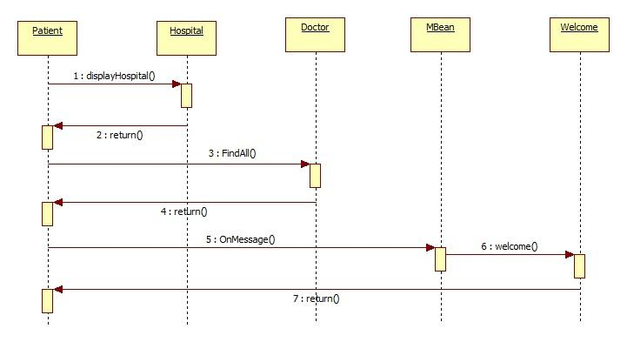

Implementation details:

Server:

|  |  |
| --- | --- |
| **EJB Type** | **EJB Name** |
| Session Bean | * Hospital(Stateless) * Welcome(Stateful) * Timeout (Singleton) |
| Entity Bean | * DocRush * DocUI * Doctor |
| Message Driven Bean | * MBean |

Client: (Patient)

|  |  |
| --- | --- |
| **Class** | **Description** |
| Main | Staring point of the execution in the application, calls all types of beans and timeout. |