[TITLE — to be supplied]
Mohammad Dastgheib
Table of contents

DRAFT — numbers from run r10_20261017_081458 for pupil results; behavioral results final.

Abstract
[PROSE TO BE SUPPLIED: Abstract] Resolves Lani comments: C0, C1, C2, C3, C5, C6. Inline value keys available for this section: n_enrolled, n_excluded, n_final, n_trials_primary, crit, qual, bs, bias, drift_diff_trials, drift_same_trials, P3_bs, delta_elpd_P3_vs_P0. Tables/figures in this section: none.

1 Introduction
[PROSE TO BE SUPPLIED: 1 Introduction] Resolves Lani comments: C4, C7, C8, C9, C10, C13, C14, C15, C16, C17, C18, C19, C20, C21, C22. Inline value keys available for this section: n_enrolled, n_final, n_trials_primary. Tables/figures in this section: none.

2 Methods
[PROSE TO BE SUPPLIED: 2 Methods] Resolves Lani comments: none. Inline value keys available for this section: none. Tables/figures in this section: none.

2.1 Participants
[PROSE TO BE SUPPLIED: 2.1 Participants] Resolves Lani comments: C23, C24, C25, C56. Inline value keys available for this section: n_enrolled, n_excluded, n_final, n_adt, n_vdt, n_subchance_excluded, n_subchance_remaining. Tables/figures in this section: Table 1.
Table 1: [CAPTION TO BE SUPPLIED]
Characteristic | Full sample
N | 67
Age (SD) | 69.5 (6.4)
Gender, female (%) | 34 (50.7%)
Education, years (SD) | 15.7 (2.6)
MoCA-telephone, score /22 (SD) | 19.8 (1.5)
Race, count (%)
White/Caucasian | 51 (76.1%)
Black/African American | 4 (6.0%)
Asian | 5 (7.5%)
Other | 5 (7.5%)
Not reported | 2 (3.0%)
Ethnicity, count (%)
Hispanic/Latino | 10 (14.9%)

2.2 Task and stimuli
[PROSE TO BE SUPPLIED: 2.2 Task and stimuli] Resolves Lani comments: C26, C27. Inline value keys available for this section: none. Tables/figures in this section: Figure 1.
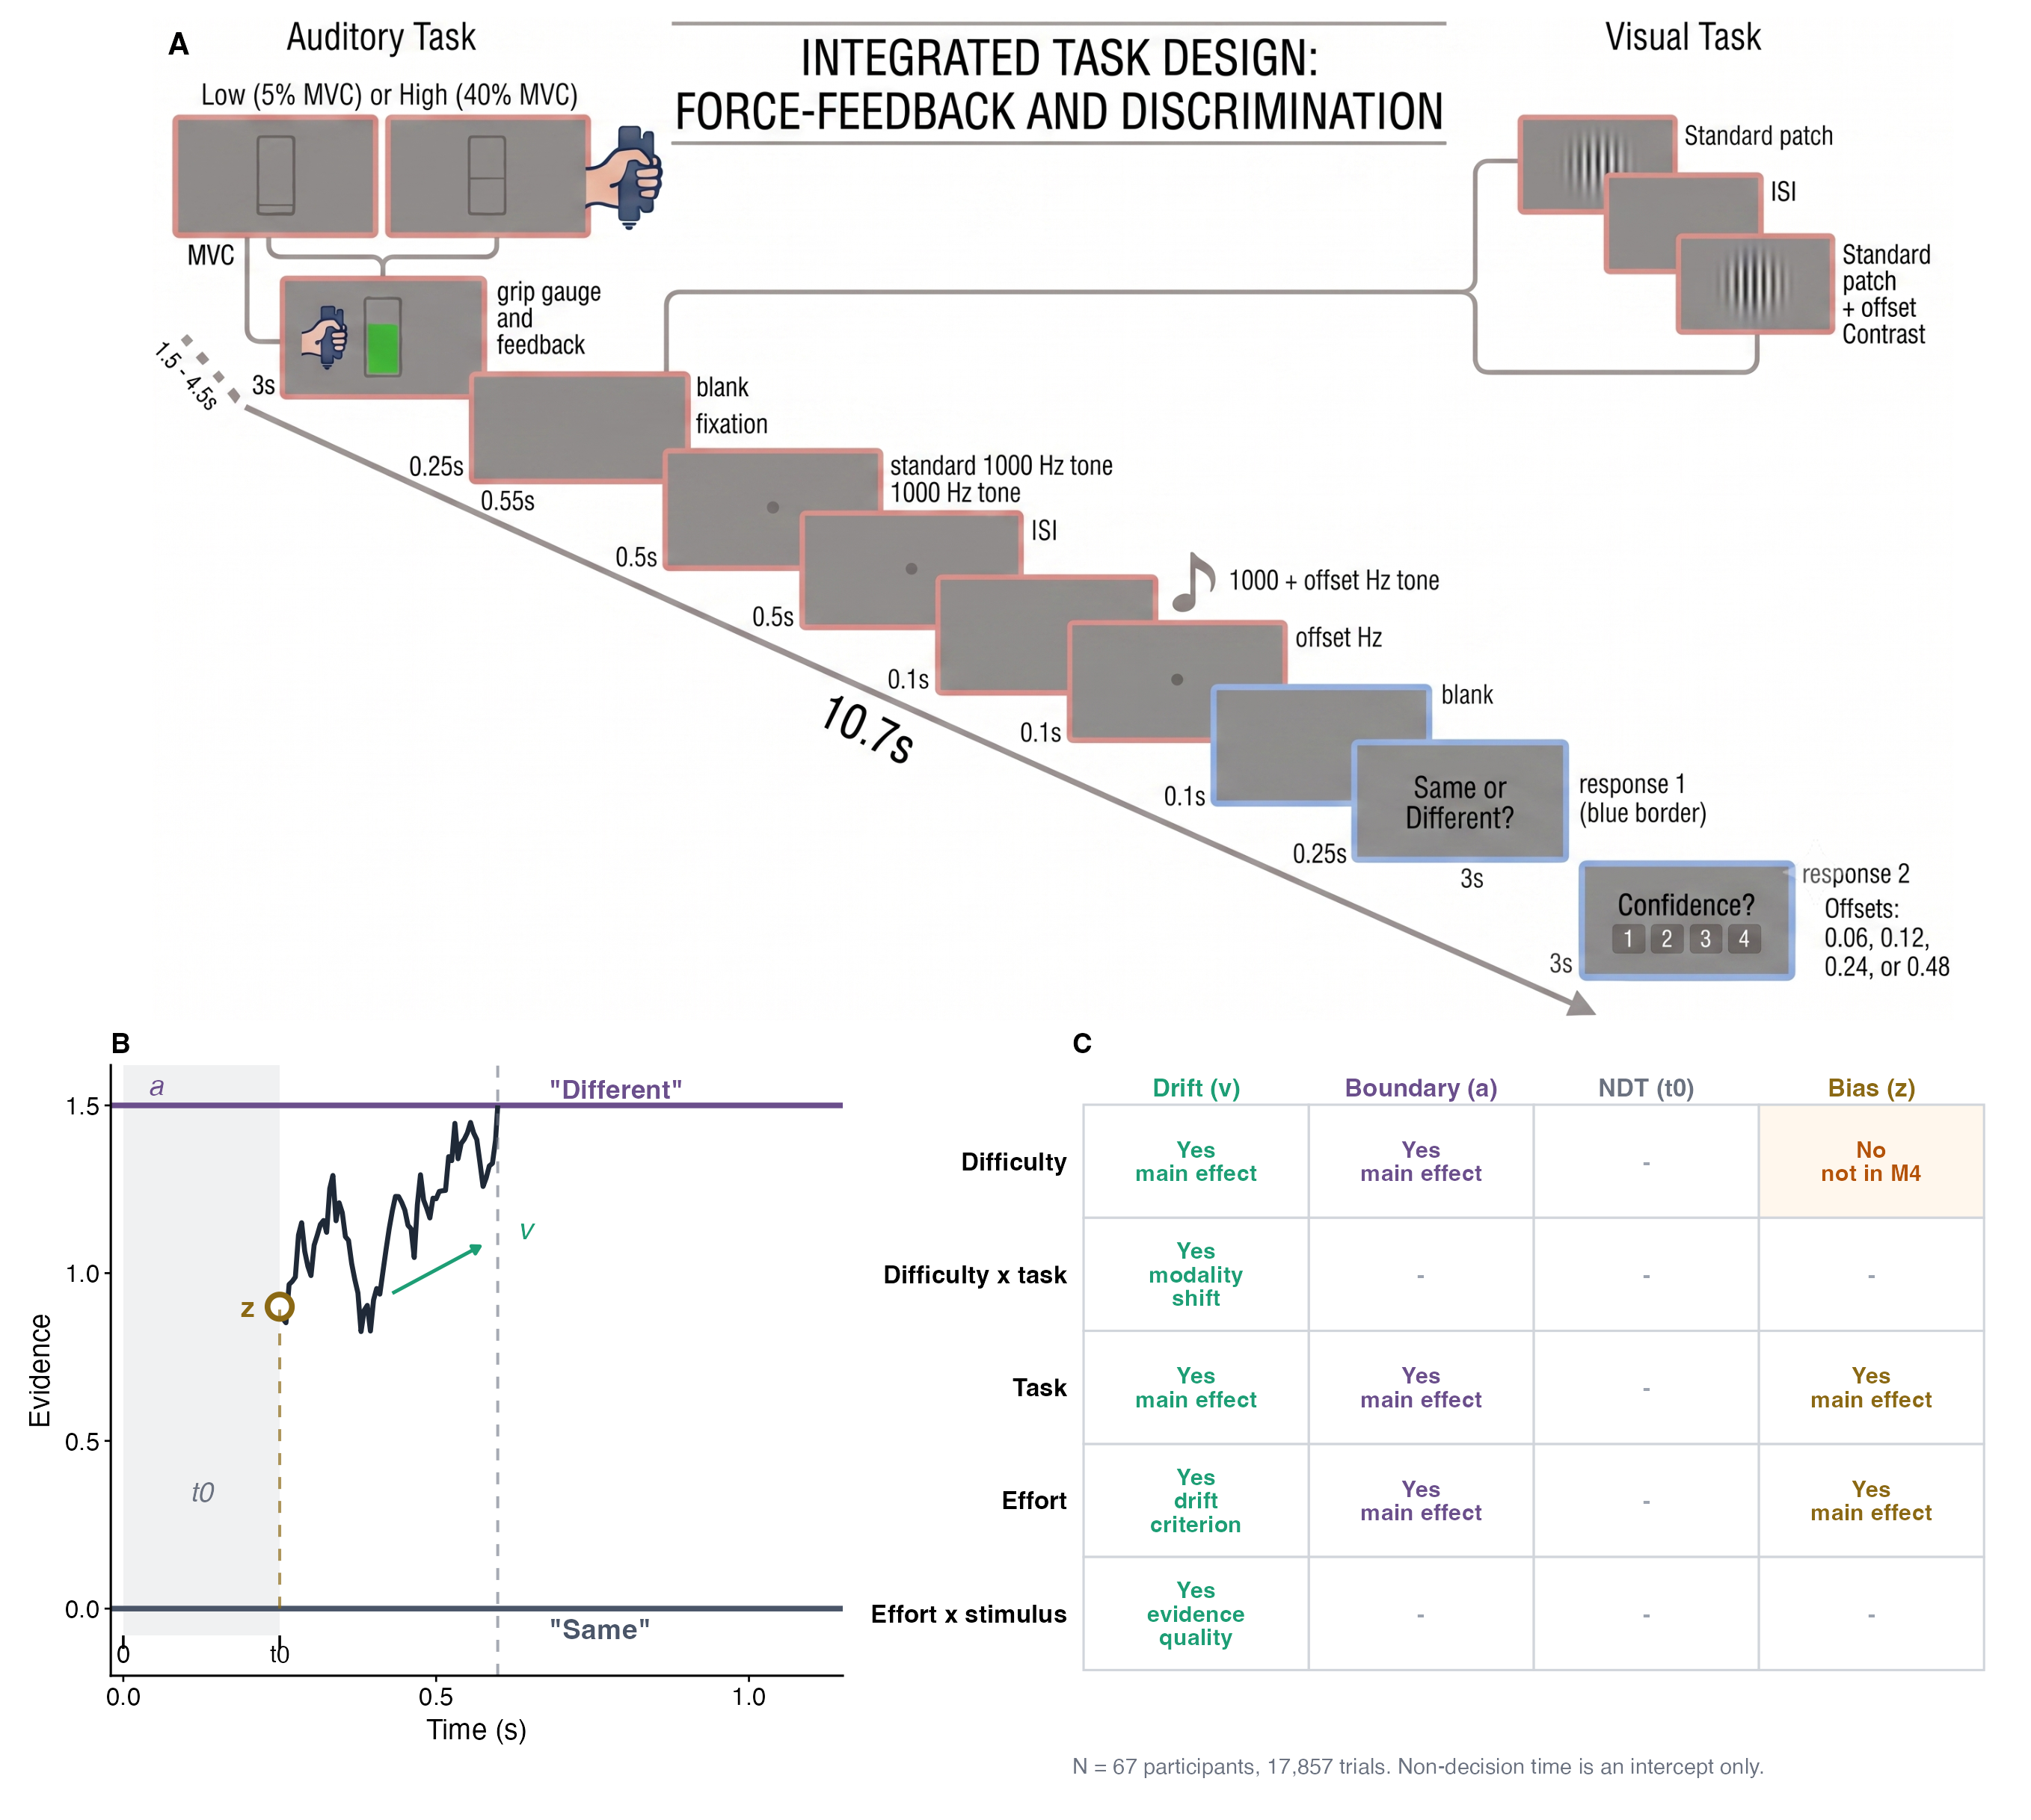
Figure 1: [CAPTION TO BE SUPPLIED]

2.3 Maximum voluntary contraction calibration
[PROSE TO BE SUPPLIED: 2.3 Maximum voluntary contraction calibration] Resolves Lani comments: C28. Inline value keys available for this section: none. Tables/figures in this section: none.

2.4 Apparatus
[PROSE TO BE SUPPLIED: 2.4 Apparatus] Resolves Lani comments: none. Inline value keys available for this section: none. Tables/figures in this section: none.

2.5 Behavioral data processing
[PROSE TO BE SUPPLIED: 2.5 Behavioral data processing] Resolves Lani comments: none. Inline value keys available for this section: n_trials_primary, n_trials_cutoff_excluded, n_trials_thr015, n_trials_thr025, n_subchance_excluded, n_subchance_remaining. Tables/figures in this section: none.

2.6 Pupillometry
[PROSE TO BE SUPPLIED: 2.6 Pupillometry] Resolves Lani comments: C11, C12, C37, C38, C39, C40, C41, C42, C43, C44. Inline value keys available for this section: tepr_window_start, tepr_window_end, tepr_baseline_start, tepr_baseline_end, tepr_window_post_probe, tepr_baseline_pre_probe, n_pupil_matched_trials, n_pupil_matched_subjects, n_pupil_tepr_present_trials, n_pupil_tepr_present_subjects, n_pupil_b1_quality_trials, n_pupil_b1_quality_subjects, n_pupil_window_quality_trials, n_pupil_window_quality_subjects, n_pupil_final_trials, n_pupil_final_subjects. Tables/figures in this section: none.

2.7 Drift-diffusion model
[PROSE TO BE SUPPLIED: 2.7 Drift-diffusion model] Resolves Lani comments: C45, C46, C47, C48, C49, C50. Inline value keys available for this section: n_chains, n_iter, n_warmup, adapt_delta, max_treedepth, seed, rope_v, rope_a, rope_z. Tables/figures in this section: none.

2.7.1 Response coding and parameterization
[PROSE TO BE SUPPLIED: 2.7.1 Response coding and parameterization] Resolves Lani comments: none. Inline value keys available for this section: none. Tables/figures in this section: none.

2.7.2 Model specification
[PROSE TO BE SUPPLIED: 2.7.2 Model specification] Resolves Lani comments: C51. Inline value keys available for this section: none. Tables/figures in this section: none.

2.7.3 Priors and estimation
[PROSE TO BE SUPPLIED: 2.7.3 Priors and estimation] Resolves Lani comments: none. Inline value keys available for this section: t0_M4, max_rhat_M4, min_bulk_ess_M4, min_tail_ess_M4. Tables/figures in this section: none.

2.8 Pupil-linked extensions
[PROSE TO BE SUPPLIED: 2.8 Pupil-linked extensions] Resolves Lani comments: C52. Inline value keys available for this section: n_pupil_final_trials, n_pupil_final_subjects, n_pupil_base_trials, n_pupil_rt80_trials, n_pupil_lag_trials, n_pupil_pre_trials, n_pupil_grip_trials, max_k_pupil_models, n_pupil_models_k_gt_0.7. Tables/figures in this section: none.

2.9 Statistical inference and model comparison
[PROSE TO BE SUPPLIED: 2.9 Statistical inference and model comparison] Resolves Lani comments: C29, C30, C31, C32, C33, C34, C35, C36, C53. Inline value keys available for this section: delta_elpd_M3_vs_M4, se_delta_elpd_M3_vs_M4, delta_elpd_M4b_vs_M4, se_delta_elpd_M4b_vs_M4, delta_elpd_M0_vs_M1, se_delta_elpd_M0_vs_M1, rope_v, rope_a, rope_z, ppc_choice_inside_M4, ppc_rt_inside_pct_M4. Tables/figures in this section: none.

3 Results

3.1 Primary diffusion model
Allowing drift rate to differ between tasks improved out-of-sample prediction (M4 vs. M3: ΔELPD = 158.3 ± 20.0). Allowing the effort effects to differ between tasks did not (M4b vs. M4: ΔELPD = −1.6 ± 1.5; Table S2). M4 is therefore reported below.
Stimulus and task effects. The upper boundary corresponds to a “different” response. Drift was therefore negative on Standard trials, where “same” is correct, and positive on Easy trials (Figure 2). Drift was also negative on Hard trials (low effort; ADT: v = −0.575, 95% CrI [−0.675, −0.476]; VDT: v = −0.525, 95% CrI [−0.627, −0.425]). These stimuli differed from the standard, but evidence still accumulated toward “same”, so most Hard trials ended in an incorrect response. Relative to Standard trials, drift was higher on Hard (β = 0.468, 95% CrI [0.396, 0.543], P(β > 0) > .999) and Easy trials (β = 1.828, 95% CrI [1.750, 1.906], P(β > 0) > .999). Both differences were larger in the VDT than in the ADT (Hard × VDT: β = 0.341, 95% CrI [0.257, 0.426], P(β > 0) > .999; Easy × VDT: β = 0.771, 95% CrI [0.676, 0.866], P(β > 0) > .999). Boundary separation was narrower on Hard (β = −0.098, 95% CrI [−0.118, −0.078], P(β < 0) > .999; −9.3% [−11.1, −7.5]) and Easy trials (β = −0.128, 95% CrI [−0.150, −0.106], P(β < 0) > .999; −12.0% [−14.0, −10.1]) than on Standard trials. Standard, Hard and Easy trials were randomly intermixed, so these boundary differences cannot reflect a setting chosen before the trial (Ratcliff & McKoon, 2008). We treat them as descriptive (see Limitations). Boundary separation did not differ between tasks (β = −0.003, 95% CrI [−0.018, 0.011], P(β < 0) = .680, 100% in ROPE). In both tasks the starting point lay closer to the “different” boundary (ADT: z = 0.552 [0.536, 0.568]; VDT: z = 0.538 [0.522, 0.555]), slightly less so in the VDT (β = −0.054, 95% CrI [−0.099, −0.010], P(β < 0) = .992).
Effort effects. Effort effects were estimated in the same model and are reported in the same way (Figure 3; Table 2). High effort shifted drift toward “same” on all trials (drift criterion: β = −0.053, 95% CrI [−0.103, −0.003], P(β < 0) = .981). There was no evidence that it changed how strongly drift separated identical from different stimuli (evidence quality: β = −0.013, 95% CrI [−0.052, 0.028], P(β < 0) = .730), although the interval does not rule out a small decline. Drift decreased on trials with a different comparison stimulus (β = −0.065, 95% CrI [−0.111, −0.021], P(β < 0) = .998); on Standard trials the change was smaller and its interval included zero (β = −0.041, 95% CrI [−0.119, 0.038], P(β < 0) = .845). High effort widened the boundary by +2.0% [0.6, 3.4]. This change lay entirely within the region of practical equivalence (100% in ROPE). The starting point was unchanged (β = −0.005, 95% CrI [−0.048, 0.037], P(β < 0) = .590, 98% in ROPE).
In observed accuracy, high effort was associated with lower accuracy on Hard trials (High − Low: −4.5 percentage points, 95% CI [−6.6, −2.4], OR = 0.80, p < .001). On Standard trials accuracy was slightly higher, a difference that was not significant (+1.7 percentage points, 95% CI [−0.1, 3.5], OR = 1.23, p = .068). Accuracy on Easy trials did not change (−0.9 percentage points, 95% CI [−2.4, 0.6], OR = 0.92, p = .226; Table S10).
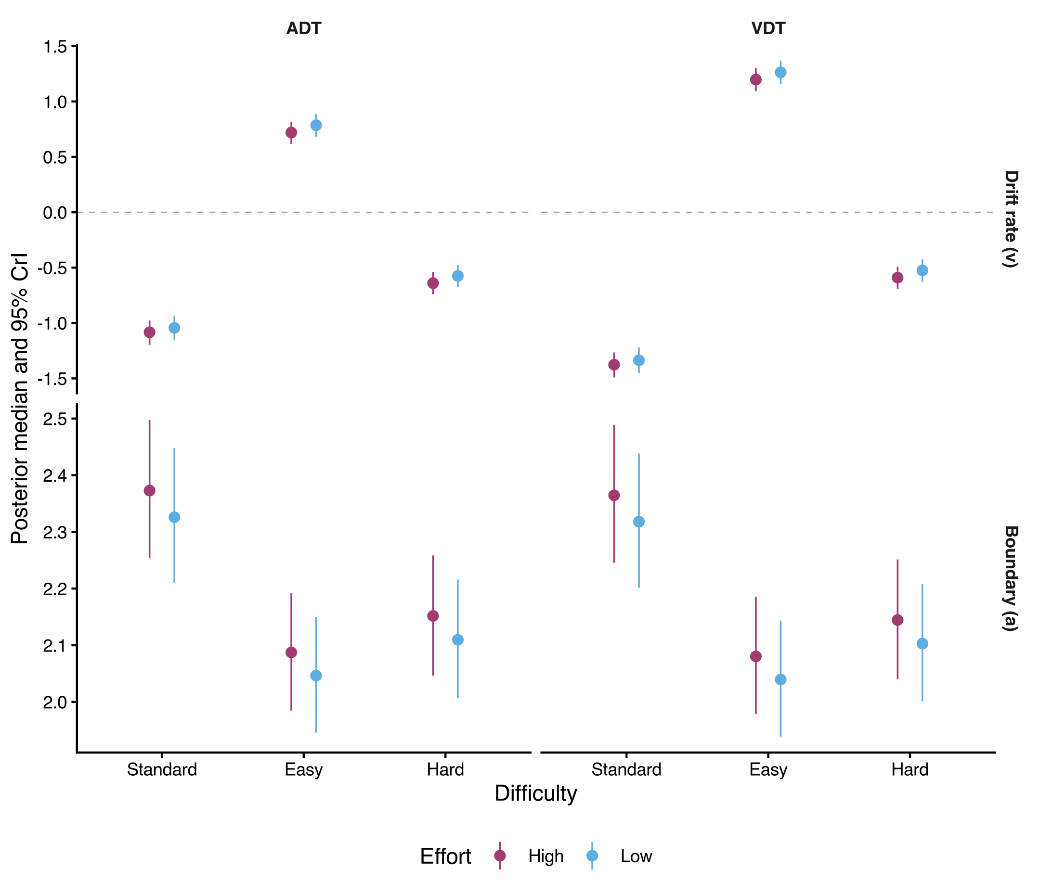
Figure 2: Posterior drift rate (top) and boundary separation (bottom) by task, stimulus type and effort in the primary model (M4). Points are posterior medians and bars 95% credible intervals. Drift is signed toward the “different” boundary, so negative drift on Standard trials accumulates toward the correct “same” response. Starting point and non-decision time did not vary by stimulus type and are not shown.
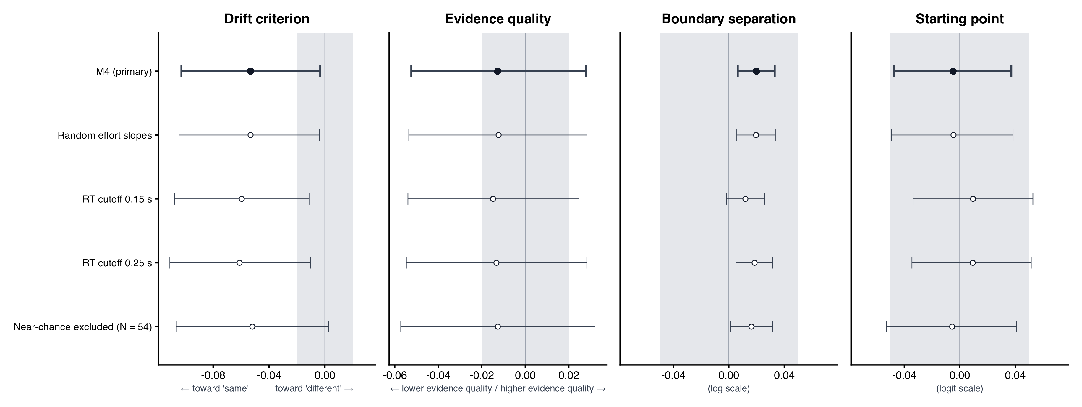
Figure 3: Effects of high versus low effort in the primary model (M4, filled) and four robustness variants (open). Points are posterior medians and bars 95% credible intervals. Shaded bands mark the region of practical equivalence (drift ±0.02; log boundary and logit starting point ±0.05). Drift criterion is the effort effect common to all trials (negative values favor “same”); evidence quality is the effort effect on the separation between identical and different stimuli.
Table 2: Effects of high versus low effort on decision parameters in the primary model (M4)
Parameter | Estimate | 95% CrI | Direction | In ROPE | Change in a
Drift criterion | −0.053 | [−0.103, −0.003] | P(β < 0) = .981 | 9%
Evidence quality | −0.013 | [−0.052, 0.028] | P(β < 0) = .730 | 59%
Boundary separation | 0.020 | [0.006, 0.033] | P(β > 0) = .997 | 100% | +2.0% [0.6, 3.4]
Starting point | −0.005 | [−0.048, 0.037] | P(β < 0) = .590 | 98%
Drift on different trials | −0.065 | [−0.111, −0.021] | P(β < 0) = .998 | 2%
Drift on same trials | −0.041 | [−0.119, 0.038] | P(β < 0) = .845 | 24%
Note. Estimates are posterior medians with 95% credible intervals (CrI) on the link scale: drift, identity; boundary separation, log; starting point, logit. Direction is the posterior probability that the effect has the sign of its median. Change in a is the percentage change in boundary separation. ROPE = region of practical equivalence (drift ±0.02; boundary and starting point ±0.05).

3.2 Robustness of the effort effects
The drift criterion shift was unchanged when the effort effects were allowed to vary across participants (M4r: β = −0.053, 95% CrI [−0.104, −0.004], P(β < 0) = .982). The between-participant SD of that effect was small (0.019, 95% CrI [0.001, 0.062]). The shift was also stable at RT cutoffs of 0.15 s (β = −0.060, 95% CrI [−0.107, −0.011], P(β < 0) = .993) and 0.25 s (β = −0.061, 95% CrI [−0.111, −0.010], P(β < 0) = .992). Excluding the 13 participants with near-chance accuracy left the point estimate unchanged. With N = 54, however, the interval included zero (β = −0.052, 95% CrI [−0.106, 0.003], P(β < 0) = .969). When effort effects were allowed to differ by task (M4b), the criterion shift was larger in the ADT (β = −0.077, 95% CrI [−0.139, −0.017], P(β < 0) = .994) than in the VDT (β = −0.024, 95% CrI [−0.087, 0.040], P(β < 0) = .767), but the task difference was uncertain (β = 0.054, 95% CrI [−0.024, 0.131], P(β > 0) = .912). Evidence quality was null in every variant. The boundary effect was positive at the 0.25-s cutoff (β = 0.019, 95% CrI [0.005, 0.032], P(β > 0) = .997; +1.9% [0.5, 3.2]) and after the near-chance exclusion (β = 0.016, 95% CrI [0.001, 0.031], P(β > 0) = .985; +1.6% [0.1, 3.2]), but at the 0.15-s cutoff its interval included zero (β = 0.012, 95% CrI [−0.002, 0.026], P(β > 0) = .955; +1.2% [−0.2, 2.6]; Table S7).

3.3 Pupil-linked decision dynamics
Effort and pupil size. High effort dilated the pupil during the grip period in both tasks (ADT: M_{diff} = 0.59, t(27) = 3.37, p = .002; VDT: M_{diff} = 0.21, t(28) = 2.08, p = .047). In the post-probe window, the direction of the effort effect depended on the baseline. Relative to the pre-probe baseline used for the TEPR, the response was smaller under high effort (ADT: M_{diff} = −0.72, t(30) = −2.35, p = .026; VDT: M_{diff} = −0.43, t(29) = −2.40, p = .023). Relative to the pre-squeeze baseline, it was larger in the ADT (M_{diff} = 1.00, t(30) = 2.45, p = .020) and unchanged in the VDT (M_{diff} = 0.03, t(29) = 0.10, p = .919; Table S12; Figure S3). In the pupil subsample, high effort widened the boundary (β = 0.030, 95% CrI [0.003, 0.056], P(β > 0) = .984; +3.0% [0.3, 5.8]). The drift criterion shift had the same sign as in the full sample, with a wider interval (β = −0.048, 95% CrI [−0.142, 0.045], P(β < 0) = .840).
Which parameter tracked the TEPR. Trial-wise TEPR predicted boundary separation. Each within-person SD increase in TEPR widened the boundary by +7.9% [6.5, 9.2] and improved out-of-sample prediction (P3: ΔELPD = 67.9 ± 9.1; Figure 4; Table 3). TEPR did not predict the starting point (P1: β = 0.008, 95% CrI [−0.023, 0.041], P(β > 0) = .695, ΔELPD = −0.2 ± 0.5). In the drift model, higher TEPR was associated with weaker separation between identical and different stimuli (TEPR × stimulus: β = −0.089, 95% CrI [−0.128, −0.050], P(β < 0) > .999), with a smaller and less certain predictive gain (ΔELPD = 8.8 ± 5.1; Table S11).
Timing of the TEPR–boundary association. The TEPR window overlapped the response on most trials, and TEPR correlated with RT within participants (r = .30 [.23, .36]). The association with boundary separation remained after the slowest 20% of trials in each participant and task were removed (P3_rt: +5.0% [3.3, 6.7], ΔELPD = 17.6 ± 4.7). Pupil size in the 0.5 s before the response did not predict boundary separation (P7: +1.2% [−0.2, 2.7], ΔELPD = 0.2 ± 1.7). Measures taken before the decision showed small associations in the same direction: previous-trial TEPR (P6: +2.8% [1.3, 4.4], ΔELPD = 6.8 ± 2.7) and pre-squeeze baseline pupil (P5: +1.5% [0.2, 2.9], ΔELPD = 1.7 ± 1.8). Grip-period pupil showed a small association in the opposite direction (P8: −1.7% [−3.1, −0.4], ΔELPD = 2.3 ± 2.0). Of the measures preceding the decision, only the previous-trial TEPR improved prediction by more than two standard errors.
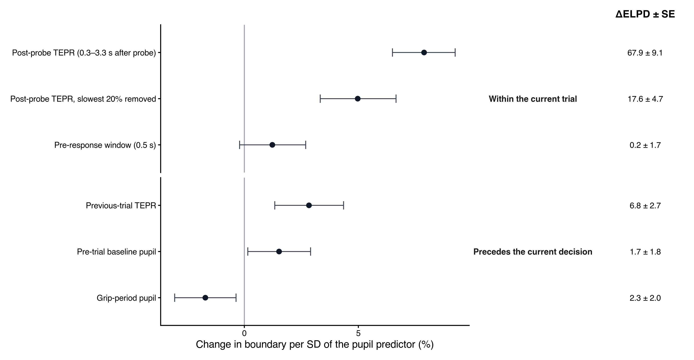
Figure 4: Pupil measures and boundary separation. Each row is a separate model. Points are posterior median percentage changes in boundary separation per within-person SD of the pupil predictor, and bars are 95% credible intervals. ΔELPD ± SE compares each model with a baseline model fit to the same trials. Upper rows: measures from the current trial; lower rows: measures preceding the current decision.
Table 3: Pupil predictors of boundary separation
Model | Predictor | Estimate [95% CrI] | Change in a | ΔELPD ± SE | Trials | Subjects
P3 | Post-probe TEPR (0.3–3.3 s after probe) | 0.076 [0.063, 0.088] | +7.9% [6.5, 9.2] | 67.9 ± 9.1 | 4,935 | 43
P3_rt | Post-probe TEPR, slowest 20% removed | 0.049 [0.033, 0.064] | +5.0% [3.3, 6.7] | 17.6 ± 4.7 | 3,973 | 43
P7 | Pre-response window (0.5 s) | 0.012 [−0.002, 0.027] | +1.2% [−0.2, 2.7] | 0.2 ± 1.7 | 3,799 | 43
P6 | Previous-trial TEPR | 0.028 [0.013, 0.043] | +2.8% [1.3, 4.4] | 6.8 ± 2.7 | 3,842 | 43
P5 | Pre-trial baseline pupil | 0.015 [0.002, 0.029] | +1.5% [0.2, 2.9] | 1.7 ± 1.8 | 4,488 | 43
P8 | Grip-period pupil | −0.017 [−0.031, −0.004] | −1.7% [−3.1, −0.4] | 2.3 ± 2.0 | 4,209 | 42
Note. Each row is a separate model. Estimates are slopes on log boundary separation per within-person SD of the predictor, with the percentage change in a. ΔELPD ± SE is relative to a baseline model without the pupil predictor, fit to the same trials. Trial counts differ because each predictor requires its own valid window.

3.4 Model adequacy
M4 reproduced the observed choice proportions in 10 of 12 condition cells (Table S6). It fit the RT distributions less well. 27.5% of observed RT quantiles fell inside the 95% predictive intervals, and observed median RTs were on average 175 ms slower than predicted (Figure S2). The misfit was concentrated in minority responses (“different” on Standard trials, “same” on Easy trials and “different” on Hard trials), which were slower than predicted. Non-decision time tracked the RT cutoff: 0.483 s, 0.527 s and 0.572 s at cutoffs of 0.15 s, 0.20 s and 0.25 s.

4 Discussion
[PROSE TO BE SUPPLIED: 4 Discussion] Resolves Lani comments: none. Inline value keys available for this section: crit, qual, bs, P3_bs, delta_elpd_P3_vs_P0, tepr_rt_r, grip_high_low_ADT, grip_high_low_VDT. Tables/figures in this section: none.

4.1 Limitations and future directions
[PROSE TO BE SUPPLIED: 4.1 Limitations and future directions] Resolves Lani comments: none. Inline value keys available for this section: ppc_rt_inside_pct_M4, ppc_rt_median_bias_ms_M4, n_pupil_final_subjects, n_final, n_pupil_final_trials. Tables/figures in this section: none.

References
Ratcliff, R., & McKoon, G. (2008). The diffusion decision model: Theory and data for two-choice decision tasks. Neural Computation, 20(4), 873–922. https://doi.org/10.1162/neco.2008.12-06-420

Supplementary Materials

S1 Participant and trial flow
[PROSE TO BE SUPPLIED: S1 Participant and trial flow] Resolves Lani comments: none. Inline value keys available for this section: n_enrolled, n_excluded, n_final, n_trials_primary, n_pupil_matched_trials, n_pupil_final_trials, n_pupil_final_subjects. Tables/figures in this section: Figure S1, Table S1.
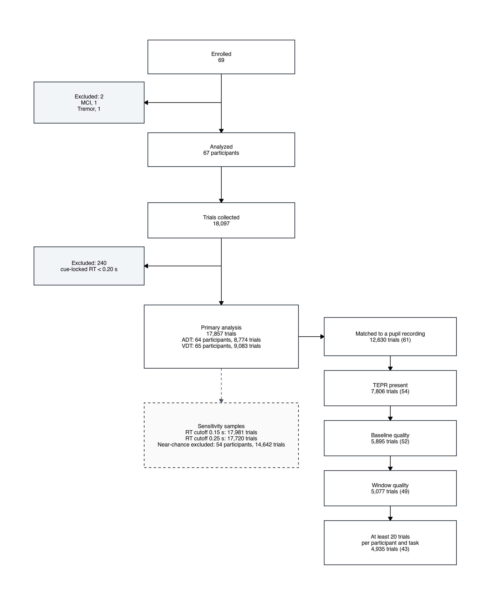
Figure S1: [CAPTION TO BE SUPPLIED]

Table S1: [CAPTION TO BE SUPPLIED]
Task | Difficulty | Effort | Trials | Subjects | Trials per subject
ADT | Easy | High | 1,772 | 64 | 27.7
ADT | Easy | Low | 1,740 | 64 | 27.2
ADT | Hard | High | 1,777 | 64 | 27.8
ADT | Hard | Low | 1,738 | 64 | 27.2
ADT | Standard | High | 887 | 64 | 13.9
ADT | Standard | Low | 860 | 64 | 13.4
VDT | Easy | High | 1,838 | 65 | 28.3
VDT | Easy | Low | 1,749 | 65 | 26.9
VDT | Hard | High | 1,863 | 65 | 28.7
VDT | Hard | Low | 1,788 | 65 | 27.5
VDT | Standard | High | 939 | 65 | 14.4
VDT | Standard | Low | 906 | 65 | 13.9

S2 Model comparison and convergence
[PROSE TO BE SUPPLIED: S2 Model comparison and convergence] Resolves Lani comments: none. Inline value keys available for this section: delta_elpd_M0_vs_M1, se_delta_elpd_M0_vs_M1, delta_elpd_M3_vs_M4, se_delta_elpd_M3_vs_M4, delta_elpd_M4b_vs_M4, se_delta_elpd_M4b_vs_M4, max_rhat_M4, min_bulk_ess_M4, min_tail_ess_M4, n_chains, n_iter, n_warmup. Tables/figures in this section: Table S2, Table S3, Table S4, Table S5.
Table S2: [CAPTION TO BE SUPPLIED]
Model | ELPD | SE | Delta ELPD vs M4 | SE of delta | k > 0.7 | Max R-hat | Min bulk ESS | Pass
M0 | −17820.6 | 155.3 | −162.1 | 20.4 | 0 | 1.009 | 817 | Yes
M1 | −17816.6 | 155.4 | −158.1 | 20.0 | 0 | 1.005 | 1,496 | Yes
M2 | −17815.9 | 155.5 | −157.4 | 20.1 | 0 | 1.004 | 1,622 | Yes
M3 | −17816.8 | 155.3 | −158.3 | 20.0 | 0 | 1.006 | 870 | Yes
M4 | −17658.5 | 155.5 | 0.0 | 0.0 | 0 | 1.009 | 863 | Yes
M4b | −17660.1 | 155.6 | −1.6 | 1.5 | 0 | 1.008 | 738 | Yes
Note. M0 NA M1 NA M2 NA M3 NA M4 NA M4b NA

Table S3: [CAPTION TO BE SUPPLIED]
Model | Role | Max R-hat | Min bulk ESS | Min tail ESS | Divergences | Pass
M4 | primary | 1.009 | 863 | 1,958 | 0 | Yes
M0 | comparison | 1.009 | 817 | 1,874 | 0 | Yes
M1 | comparison | 1.005 | 1,496 | 3,049 | 0 | Yes
M2 | comparison | 1.004 | 1,622 | 3,086 | 0 | Yes
M3 | comparison | 1.006 | 870 | 2,022 | 0 | Yes
M4b | comparison | 1.008 | 738 | 1,364 | 0 | Yes
M4r | robustness (random effort slopes) | 1.006 | 1,074 | 2,236 | 0 | Yes
M4_thr0.15 | robustness (RT cutoff) | 1.009 | 1,576 | 3,017 | 0 | Yes
M4_thr0.25 | robustness (RT cutoff) | 1.008 | 893 | 1,787 | 0 | Yes
M4_subchance | robustness (sub-chance excluded) | 1.008 | 941 | 1,844 | 0 | Yes
P0 | pupil (baseline) | 1.006 | 1,394 | 2,610 | 0 | Yes
P0_base | pupil-ordering baseline | 1.009 | 1,550 | 2,831 | 0 | Yes
P0_rt | pupil-ordering baseline | 1.005 | 1,776 | 3,652 | 0 | Yes
P0_lag | pupil-ordering baseline | 1.005 | 1,216 | 2,231 | 0 | Yes
P0_pre | pupil-ordering baseline | 1.006 | 1,537 | 3,115 | 0 | Yes
P0_grip | pupil-ordering baseline | 1.005 | 1,683 | 3,105 | 0 | Yes
P1 | pupil | 1.005 | 1,414 | 2,405 | 0 | Yes
P2 | pupil | 1.007 | 1,248 | 2,264 | 0 | Yes
P3 | pupil (main pupil result) | 1.006 | 1,177 | 2,476 | 0 | Yes
P3_rt | pupil-ordering | 1.006 | 1,799 | 3,223 | 0 | Yes
P4 | pupil | 1.005 | 1,602 | 2,943 | 0 | Yes
P5 | pupil-ordering | 1.007 | 1,561 | 3,064 | 0 | Yes
P6 | pupil-ordering | 1.004 | 1,341 | 2,780 | 0 | Yes
P7 | pupil-ordering | 1.006 | 1,355 | 2,750 | 0 | Yes
P8 | pupil-ordering | 1.004 | 1,639 | 3,276 | 0 | Yes
Note. A model passes when max R-hat < 1.01, bulk ESS and tail ESS are at least 400, and there are 0 divergences. Every displayed model passes.

Table S4: [CAPTION TO BE SUPPLIED]
Parameter | Estimate | 95% CrI | Direction | In ROPE | R-hat
Drift intercept (identity) | −1.043 | [−1.156, −0.933] |  |  | 1.003
Boundary separation intercept (log) | 0.844 | [0.793, 0.895] |  |  | 1.008
Non-decision time intercept (log) | −0.641 | [−0.645, −0.637] |  |  | 1.001
Starting point intercept (logit) | 0.208 | [0.143, 0.273] |  |  | 1.002
Hard (drift, identity) | 0.468 | [0.396, 0.543] |  |  | 1.000
Easy (drift, identity) | 1.828 | [1.750, 1.906] |  |  | 1.000
Visual task (drift, identity) | −0.292 | [−0.370, −0.214] |  |  | 1.001
Drift criterion (identity) | −0.053 | [−0.103, −0.003] | P(β < 0) = .981 | 9% | 1.000
Evidence quality (identity) | −0.013 | [−0.052, 0.028] | P(β < 0) = .730 | 59% | 1.001
Hard × visual (drift, identity) | 0.341 | [0.257, 0.426] |  |  | 1.001
Easy × visual (drift, identity) | 0.771 | [0.676, 0.866] |  |  | 1.000
Hard (boundary separation, log) | −0.098 | [−0.118, −0.078] |  |  | 1.000
Easy (boundary separation, log) | −0.128 | [−0.150, −0.106] |  |  | 1.000
Visual task (boundary separation, log) | −0.003 | [−0.018, 0.011] |  |  | 1.000
High effort (boundary separation, log) | 0.020 | [0.006, 0.033] | P(β > 0) = .997 | 100% | 1.000
Visual task (starting point, logit) | −0.054 | [−0.099, −0.010] |  |  | 1.001
High effort (starting point, logit) | −0.005 | [−0.048, 0.037] | P(β < 0) = .590 | 98% | 1.000

Table S5: [CAPTION TO BE SUPPLIED]
Task | Difficulty | Drift, low | Drift, high | Boundary, low | Boundary, high
ADT | Standard | −1.043 [−1.156, −0.933] | −1.084 [−1.197, −0.976] | 2.326 [2.210, 2.448] | 2.373 [2.254, 2.497]
ADT | Easy | 0.786 [0.682, 0.886] | 0.720 [0.616, 0.817] | 2.046 [1.946, 2.150] | 2.087 [1.985, 2.192]
ADT | Hard | −0.575 [−0.675, −0.476] | −0.640 [−0.741, −0.542] | 2.110 [2.007, 2.216] | 2.152 [2.047, 2.258]
VDT | Standard | −1.336 [−1.452, −1.221] | −1.376 [−1.491, −1.265] | 2.318 [2.202, 2.438] | 2.365 [2.246, 2.489]
VDT | Easy | 1.263 [1.160, 1.368] | 1.197 [1.094, 1.301] | 2.040 [1.939, 2.143] | 2.080 [1.978, 2.185]
VDT | Hard | −0.525 [−0.627, −0.425] | −0.590 [−0.693, −0.492] | 2.103 [2.001, 2.208] | 2.144 [2.040, 2.251]
Note. Starting point varies by task and effort only: ADT low 0.552 [0.536, 0.568]; ADT high 0.551 [0.535, 0.566]; VDT low 0.538 [0.522, 0.555]; VDT high 0.537 [0.521, 0.553]. Non-decision time is 0.527 [0.525, 0.529] in every cell. These note values are the condition-cell summaries, not the link-scale coefficients.

S3 Posterior predictive checks
[PROSE TO BE SUPPLIED: S3 Posterior predictive checks] Resolves Lani comments: none. Inline value keys available for this section: ppc_choice_inside_M4, ppc_rt_inside_pct_M4, ppc_rt_median_bias_ms_M4. Tables/figures in this section: Figure S2, Table S6.
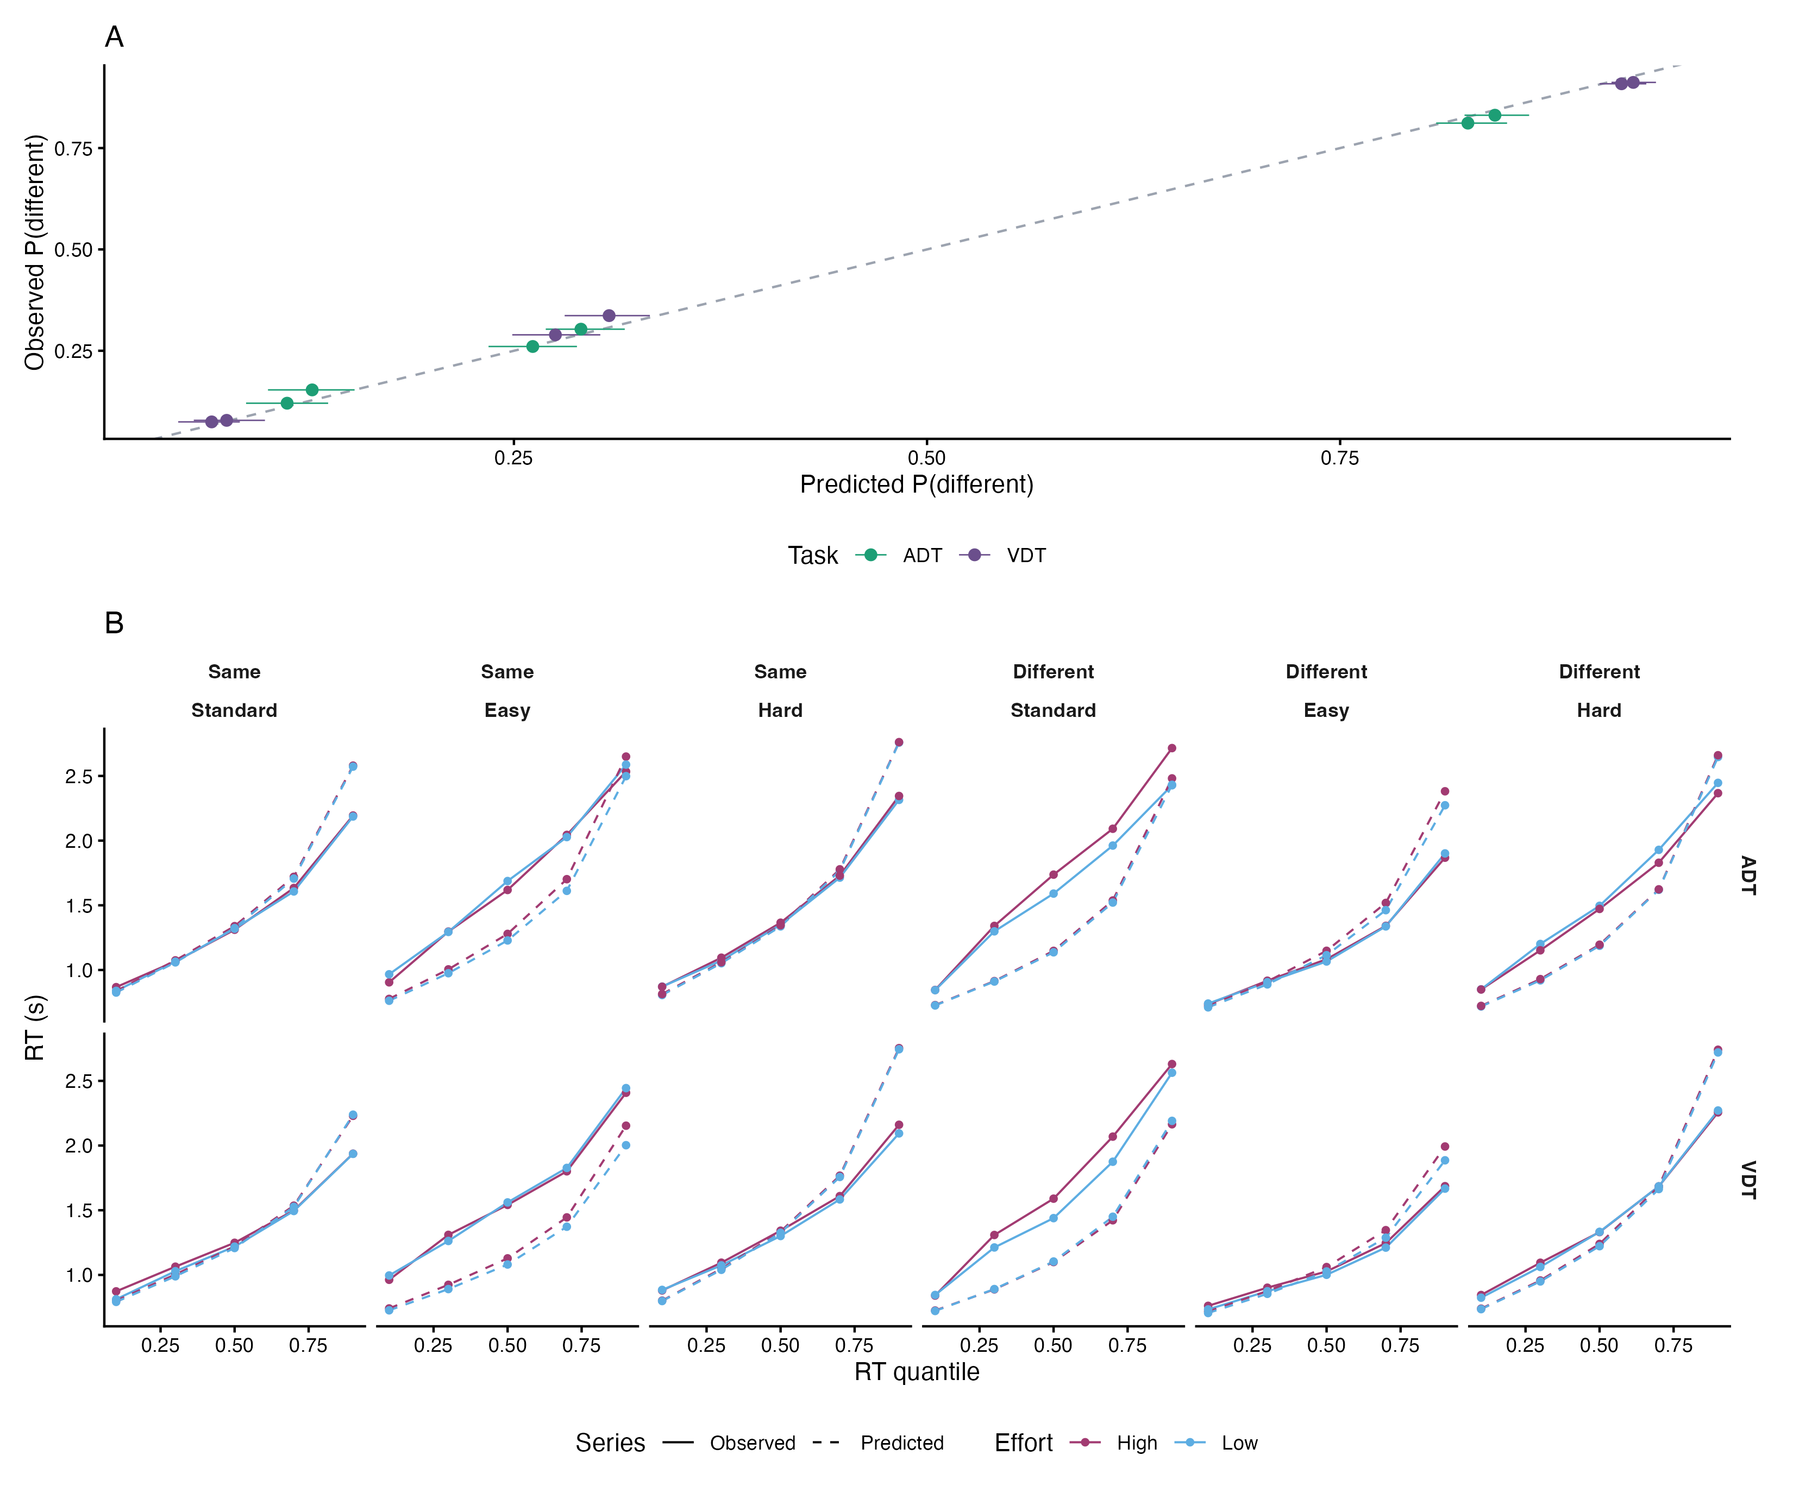
Figure S2: [CAPTION TO BE SUPPLIED]

Table S6: [CAPTION TO BE SUPPLIED]
Task | Difficulty | Effort | Observed | Predicted | 95% PI | Inside
ADT | Hard | Low | 0.303 | 0.291 | [0.269, 0.317] | Yes
ADT | Easy | High | 0.812 | 0.827 | [0.808, 0.851] | Yes
ADT | Standard | High | 0.121 | 0.113 | [0.088, 0.138] | Yes
ADT | Easy | Low | 0.831 | 0.844 | [0.825, 0.864] | Yes
ADT | Hard | High | 0.261 | 0.261 | [0.235, 0.288] | Yes
ADT | Standard | Low | 0.153 | 0.128 | [0.101, 0.154] | Yes
VDT | Hard | High | 0.289 | 0.275 | [0.249, 0.302] | Yes
VDT | Hard | Low | 0.337 | 0.308 | [0.281, 0.332] | No
VDT | Easy | High | 0.909 | 0.920 | [0.907, 0.935] | Yes
VDT | Standard | High | 0.075 | 0.067 | [0.047, 0.084] | Yes
VDT | Easy | Low | 0.912 | 0.927 | [0.914, 0.941] | No
VDT | Standard | Low | 0.078 | 0.076 | [0.056, 0.099] | Yes

S4 Robustness analyses and observed accuracy
[PROSE TO BE SUPPLIED: S4 Robustness analyses and observed accuracy] Resolves Lani comments: none. Inline value keys available for this section: crit_M4r, qual_M4r, bs_M4r, crit_thr015, qual_thr015, bs_thr015, crit_thr025, qual_thr025, bs_thr025, crit_subchance, qual_subchance, bs_subchance, sd_effort_M4r, sd_bs_effort_M4r, m4b_effort_x_task, m4b_quality_x_task, crit_ADT_M4b, crit_VDT_M4b, n_trials_thr015, n_trials_thr025, n_subchance_excluded, n_subchance_remaining, n_trials_cutoff_excluded, n_trials_collected, pass_M4_thr015, acc_high_low_Standard, acc_high_low_Hard, acc_high_low_Easy. Tables/figures in this section: Table S7, Table S8, Table S9, Table S10.
Table S7: [CAPTION TO BE SUPPLIED]
Model | Parameter | Estimate | 95% CrI | In ROPE | Trials | Subjects | Pass
M4 | Drift criterion | −0.053 | [−0.103, −0.003] | 9% | 17,857 | 67 | Yes
M4 | Evidence quality | −0.013 | [−0.052, 0.028] | 59% | 17,857 | 67 | Yes
M4 | Boundary separation | 0.020 | [0.006, 0.033] | 100% | 17,857 | 67 | Yes
M4 | Starting point | −0.005 | [−0.048, 0.037] | 98% | 17,857 | 67 | Yes
M4 | Drift on different trials | −0.065 | [−0.111, −0.021] | 2% | 17,857 | 67 | Yes
M4 | Drift on same trials | −0.041 | [−0.119, 0.038] | 24% | 17,857 | 67 | Yes
M4r | Drift criterion | −0.053 | [−0.104, −0.004] | 9% | 17,857 | 67 | Yes
M4r | Evidence quality | −0.012 | [−0.054, 0.028] | 59% | 17,857 | 67 | Yes
M4r | Boundary separation | 0.020 | [0.006, 0.034] | 100% | 17,857 | 67 | Yes
M4r | Starting point | −0.005 | [−0.049, 0.038] | 97% | 17,857 | 67 | Yes
M4r | Drift on different trials | −0.066 | [−0.112, −0.019] | 3% | 17,857 | 67 | Yes
M4r | Drift on same trials | −0.041 | [−0.121, 0.039] | 24% | 17,857 | 67 | Yes
M4_thr0.15 | Drift criterion | −0.060 | [−0.107, −0.011] | 5% | 17,981 | 67 | Yes
M4_thr0.15 | Evidence quality | −0.015 | [−0.054, 0.025] | 56% | 17,981 | 67 | Yes
M4_thr0.15 | Boundary separation | 0.012 | [−0.002, 0.026] | 100% | 17,981 | 67 | Yes
M4_thr0.15 | Starting point | 0.010 | [−0.034, 0.053] | 96% | 17,981 | 67 | Yes
M4_thr0.15 | Drift on different trials | −0.074 | [−0.119, −0.030] | 1% | 17,981 | 67 | Yes
M4_thr0.15 | Drift on same trials | −0.044 | [−0.121, 0.032] | 22% | 17,981 | 67 | Yes
M4_thr0.25 | Drift criterion | −0.061 | [−0.111, −0.010] | 5% | 17,720 | 67 | Yes
M4_thr0.25 | Evidence quality | −0.013 | [−0.055, 0.028] | 58% | 17,720 | 67 | Yes
M4_thr0.25 | Boundary separation | 0.019 | [0.005, 0.032] | 100% | 17,720 | 67 | Yes
M4_thr0.25 | Starting point | 0.009 | [−0.034, 0.051] | 97% | 17,720 | 67 | Yes
M4_thr0.25 | Drift on different trials | −0.074 | [−0.120, −0.029] | 1% | 17,720 | 67 | Yes
M4_thr0.25 | Drift on same trials | −0.048 | [−0.128, 0.032] | 20% | 17,720 | 67 | Yes
M4_subchance | Drift criterion | −0.052 | [−0.106, 0.003] | 13% | 14,642 | 54 | Yes
M4_subchance | Evidence quality | −0.013 | [−0.057, 0.032] | 55% | 14,642 | 54 | Yes
M4_subchance | Boundary separation | 0.016 | [0.001, 0.031] | 100% | 14,642 | 54 | Yes
M4_subchance | Starting point | −0.005 | [−0.053, 0.041] | 96% | 14,642 | 54 | Yes
M4_subchance | Drift on different trials | −0.064 | [−0.115, −0.015] | 4% | 14,642 | 54 | Yes
M4_subchance | Drift on same trials | −0.039 | [−0.124, 0.048] | 24% | 14,642 | 54 | Yes

Table S8: [CAPTION TO BE SUPPLIED]
Parameter | Estimate | 95% CrI
SD, drift criterion | 0.019 | [0.001, 0.062]
SD, boundary separation | 0.007 | [0.000, 0.023]
Correlation, drift intercept and drift criterion | r = −.19 | [−.84, .69]
Correlation, boundary intercept and boundary slope | r = .03 | [−.78, .80]

Table S9: [CAPTION TO BE SUPPLIED]
Parameter | Estimate | 95% CrI | Direction | In ROPE
Drift criterion | −0.077 | [−0.139, −0.017] | P(β < 0) = .994 | 3%
Drift criterion × task | 0.054 | [−0.024, 0.131] | P(β > 0) = .912 | 17%
Evidence quality × task | −0.041 | [−0.118, 0.036] | P(β < 0) = .850 | 24%
Drift criterion, auditory | −0.077 | [−0.139, −0.017] | P(β < 0) = .994 | 3%
Drift criterion, visual | −0.024 | [−0.087, 0.040] | P(β < 0) = .767 | 37%
Evidence quality | 0.007 | [−0.047, 0.062] | P(β > 0) = .597 | 52%

Table S10: Observed accuracy, high minus low effort, at each stimulus type. Estimates are from a binomial GLMM with a random intercept for participant (see S7 in the dissertation version); percentage points are averaged over task.
Difficulty | High − low (pp) | 95% CI (pp) | Odds ratio | 95% CI (OR) | z | p
Standard | 1.69 | [−0.14, 3.52] | 1.23 | [0.99, 1.53] | 1.83 | p = .068
Hard | −4.51 | [−6.64, −2.38] | 0.80 | [0.72, 0.89] | −4.19 | p < .001
Easy | −0.90 | [−2.36, 0.56] | 0.92 | [0.80, 1.06] | −1.21 | p = .226
Note. High minus low, averaged over task with equal weights. Percentage points are 100 times the probability difference. The odds ratio, z, and p are the logit-scale contrast. df is asymptotic.

S5 Pupil-linked models
[PROSE TO BE SUPPLIED: S5 Pupil-linked models] Resolves Lani comments: none. Inline value keys available for this section: P3_bs, P3_rt_bs, P5_bs, P6_bs, P7_bs, P8_bs, P1_bias, P2_drift_tepr, P2_drift_tepr_x_stim, P4_bias_base, P0_crit, P0_qual, P0_bs, P0_bias, delta_elpd_P3_vs_P0, delta_elpd_P3rt_vs_P0rt, delta_elpd_P5_vs_P0base, delta_elpd_P6_vs_P0lag, delta_elpd_P7_vs_P0pre, delta_elpd_P8_vs_P0grip, delta_elpd_P1_vs_P0, delta_elpd_P2_vs_P0, delta_elpd_P4_vs_P0base, tepr_rt_r, grip_high_low_ADT, grip_high_low_VDT, tepr_high_low_ADT_B1, tepr_high_low_VDT_B1, tepr_high_low_ADT_B0, tepr_high_low_VDT_B0, n_pupil_matched_trials, n_pupil_matched_subjects, n_pupil_tepr_present_trials, n_pupil_tepr_present_subjects, n_pupil_b1_quality_trials, n_pupil_b1_quality_subjects, n_pupil_window_quality_trials, n_pupil_window_quality_subjects, n_pupil_final_trials, n_pupil_final_subjects, n_pupil_base_trials, n_pupil_rt80_trials, n_pupil_lag_trials, n_pupil_pre_trials, n_pupil_grip_trials, n_pupil_models_k_gt_0.7, max_k_pupil_models. Tables/figures in this section: Table S11, Table S12, Figure S3.
Table S11: [CAPTION TO BE SUPPLIED]
Block | Model | Parameter | Estimate | 95% CrI | Change in a | Delta ELPD | Trials
Pupil slope | P0 | Baseline (no pupil slope) |  |  |  | 0.0 ± 0.0 | 4,935
Pupil slope | P1 | Current-trial TEPR on starting point | 0.008 | [−0.023, 0.041] |  | −0.2 ± 0.5 | 4,935
Pupil slope | P2 | Current-trial TEPR on drift | 0.049 | [0.010, 0.088] |  | 8.8 ± 5.1 | 4,935
Pupil slope | P2 | Current-trial TEPR × stimulus | −0.089 | [−0.128, −0.050] |  |  | 4,935
Pupil slope | P3 | Current-trial TEPR on boundary separation | 0.076 | [0.063, 0.088] | +7.9% [6.5, 9.2] | 67.9 ± 9.1 | 4,935
Pupil slope | P4 | Pre-squeeze baseline on starting point | −0.010 | [−0.043, 0.023] |  | −0.6 ± 0.5 | 4,488
Effort effects in the pupil subsample (P0) | P0 | Drift criterion | −0.048 | [−0.142, 0.045] |  |  | 4,935
Effort effects in the pupil subsample (P0) | P0 | Evidence quality | 0.025 | [−0.050, 0.101] |  |  | 4,935
Effort effects in the pupil subsample (P0) | P0 | Boundary separation | 0.030 | [0.003, 0.056] | +3.0% [0.3, 5.8] |  | 4,935
Effort effects in the pupil subsample (P0) | P0 | Starting point | −0.019 | [−0.101, 0.064] |  |  | 4,935
Note. P1, P2, and P3 are compared with P0. P4 and P5 are compared with P0_base. P3_rt is compared with P0_rt. P6 is compared with P0_lag, P7 with P0_pre, and P8 with P0_grip. P5, P3_rt, P6, P7, and P8 are in the ordering table rather than this slope table.

Table S12: [CAPTION TO BE SUPPLIED: Effort effects on pupil measures]
Measure | Task | n | High M (SD) | Low M (SD) | High − Low | t (df) | p
TEPR (B1 baseline) | ADT | 31 | −0.207 (1.724) | 0.516 (1.804) | −0.723 | t(30) = −2.35 | p = .026
TEPR (B1 baseline) | VDT | 30 | 0.810 (2.123) | 1.241 (2.185) | −0.432 | t(29) = −2.40 | p = .023
TEPR (B0 baseline) | ADT | 31 | 1.520 (4.064) | 0.517 (4.495) | 1.003 | t(30) = 2.45 | p = .020
TEPR (B0 baseline) | VDT | 30 | 1.075 (2.111) | 1.047 (2.466) | 0.028 | t(29) = 0.10 | p = .919
Grip-period pupil | ADT | 28 | 0.268 (1.128) | −0.352 (0.724) | 0.593 | t(27) = 3.37 | p = .002
Grip-period pupil | VDT | 29 | −0.090 (0.757) | −0.273 (0.780) | 0.212 | t(28) = 2.08 | p = .047
Note. n is the number of participants with both effort levels for that task. The paired test drops anyone missing one level. The final pupil sample is 43 participants.

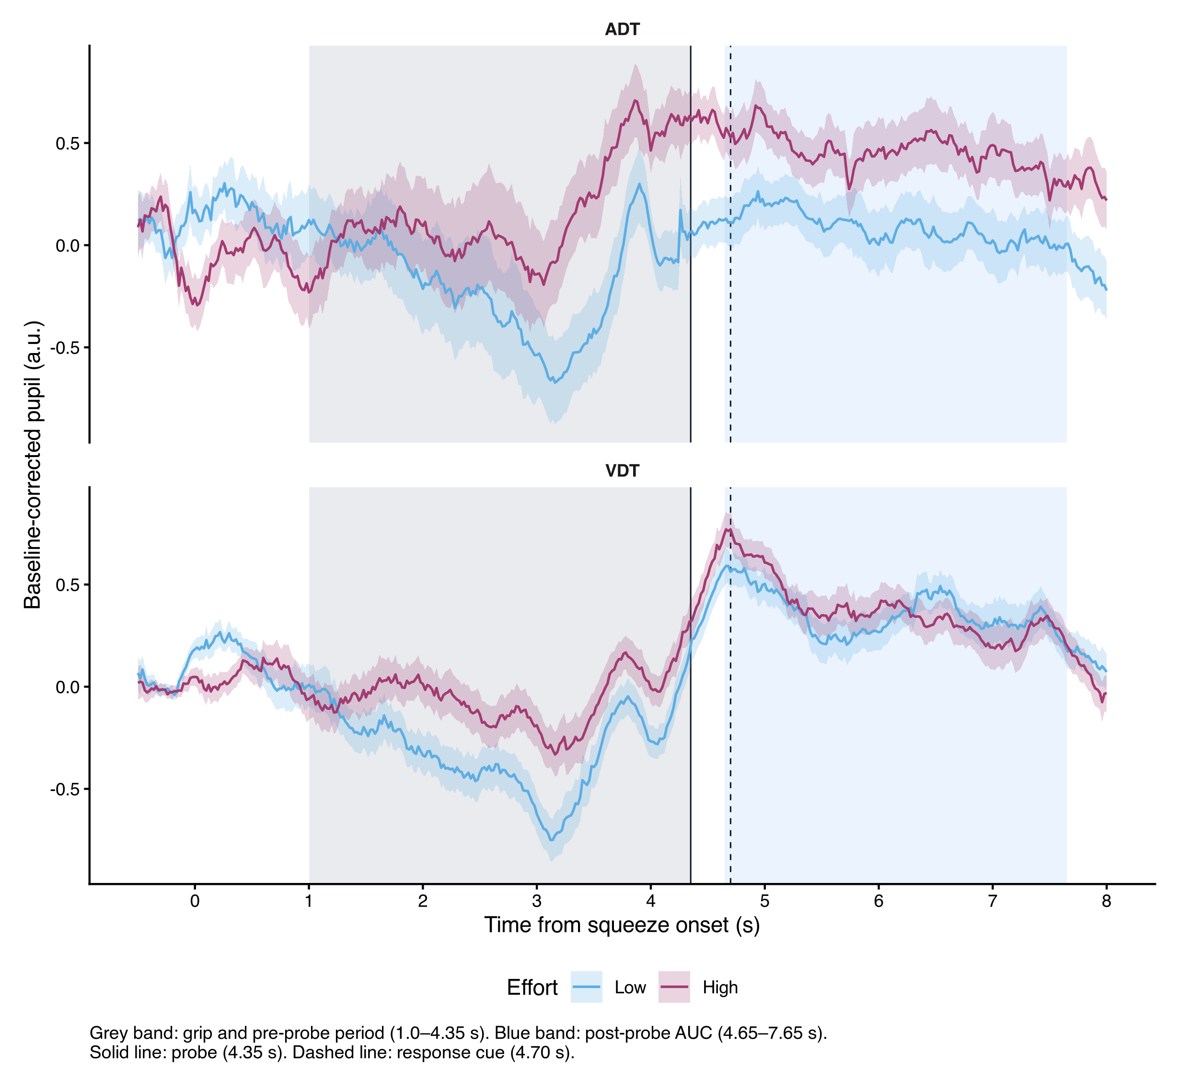
Figure S3: [CAPTION TO BE SUPPLIED]

S6 Model specification details
[PROSE TO BE SUPPLIED: S6 Model specification details] Resolves Lani comments: none. Inline value keys available for this section: t0_M4, t0_thr015, t0_thr025, rope_v, rope_a, rope_z, n_chains, n_iter, n_warmup, adapt_delta, max_treedepth, seed. Tables/figures in this section: Figure S4.
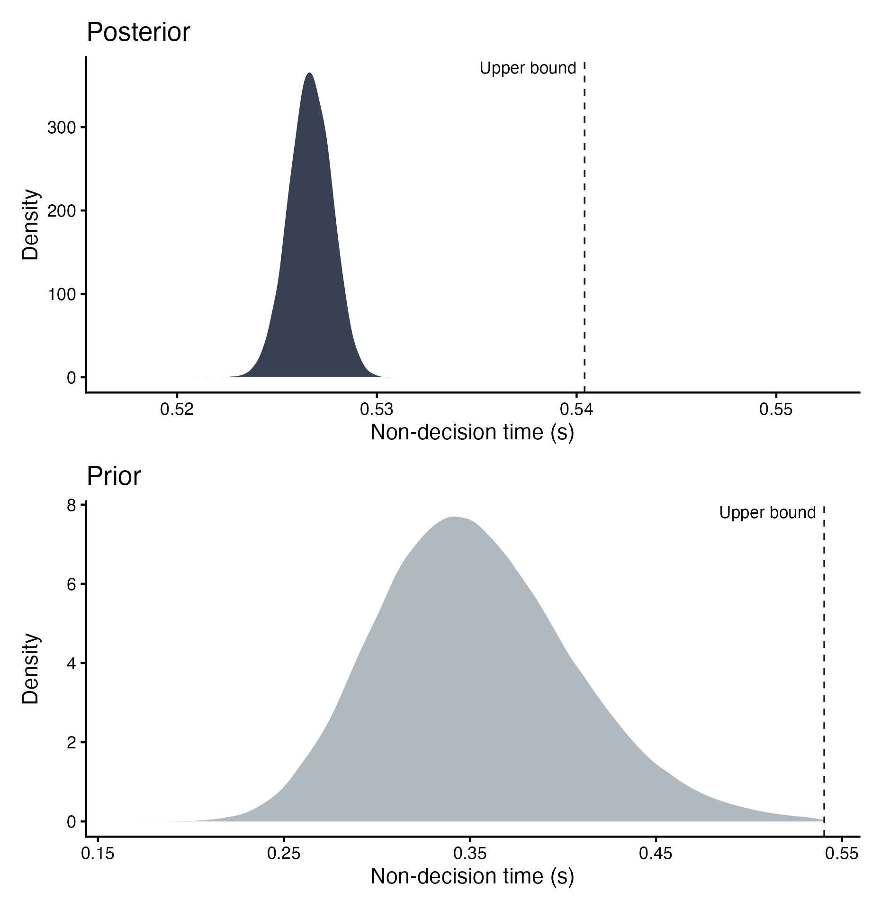
Figure S4: [CAPTION TO BE SUPPLIED]

