[TITLE — to be supplied]
Mohammad Dastgheib
Table of contents

DRAFT — numbers from run r8_20261017_015218 for pupil results; behavioral results final.

Abstract
[PROSE TO BE SUPPLIED: Abstract] Resolves Lani comments: C0, C1, C2, C3, C5, C6. Inline value keys available for this section: n_enrolled, n_excluded, n_final, n_trials_primary, crit, qual, bs, bias, drift_diff_trials, drift_same_trials, bs_pct_change, P3_bs, delta_elpd_P3_vs_P0. Tables/figures in this section: none.

1 Introduction
[PROSE TO BE SUPPLIED: 1 Introduction] Resolves Lani comments: C4, C7, C8, C9, C10, C13, C14, C15, C16, C17, C18, C19, C20, C21, C22. Inline value keys available for this section: n_enrolled, n_final, n_trials_primary. Tables/figures in this section: none.

2 Methods
[PROSE TO BE SUPPLIED: 2 Methods] Resolves Lani comments: none. Inline value keys available for this section: none. Tables/figures in this section: none.

2.1 Participants
[PROSE TO BE SUPPLIED: 2.1 Participants] Resolves Lani comments: C23, C24, C25, C56. Inline value keys available for this section: n_enrolled, n_excluded, n_final, n_adt, n_vdt, n_subchance_excluded, n_subchance_remaining. Tables/figures in this section: Table 1.
Table 1: ​[CAPTION TO BE SUPPLIED]
Characteristic | Full sample
N | 67
Age (SD) | 69.5 (6.4)
Gender, female (%) | 34 (50.7%)
Education, years (SD) | 15.7 (2.6)
MoCA, score (SD) | 19.8 (1.5)
Race, count (%)
White/Caucasian | 51 (76.1%)
Black/African American | 4 (6.0%)
Asian | 5 (7.5%)
Other | 5 (7.5%)
Hispanic/Latino | 10 (14.9%)

2.2 Task and stimuli
[PROSE TO BE SUPPLIED: 2.2 Task and stimuli] Resolves Lani comments: C26, C27. Inline value keys available for this section: none. Tables/figures in this section: Figure 1.
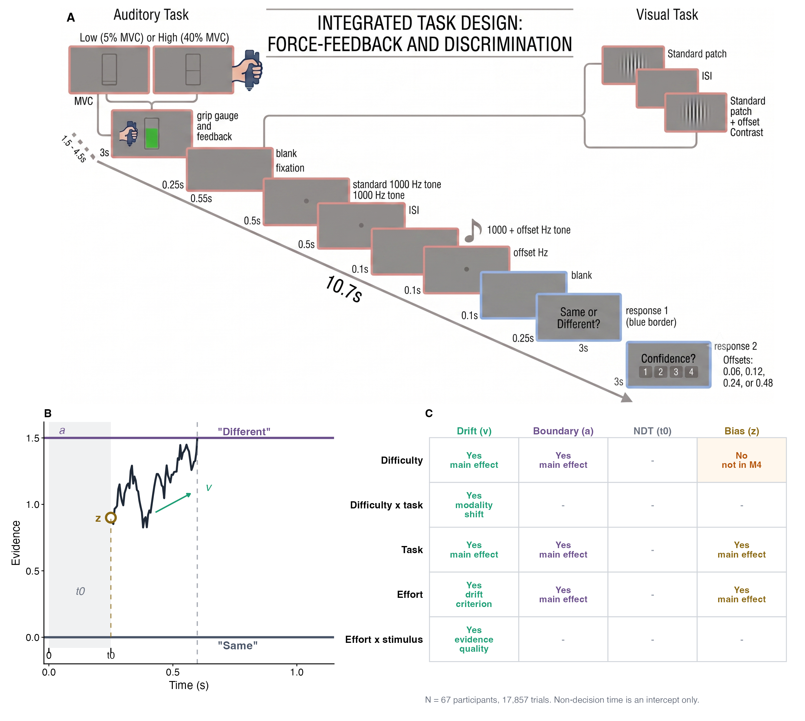
Figure 1: [CAPTION TO BE SUPPLIED]

2.3 Maximum voluntary contraction calibration
[PROSE TO BE SUPPLIED: 2.3 Maximum voluntary contraction calibration] Resolves Lani comments: C28. Inline value keys available for this section: none. Tables/figures in this section: none.

2.4 Apparatus
[PROSE TO BE SUPPLIED: 2.4 Apparatus] Resolves Lani comments: none. Inline value keys available for this section: none. Tables/figures in this section: none.

2.5 Behavioral data processing
[PROSE TO BE SUPPLIED: 2.5 Behavioral data processing] Resolves Lani comments: none. Inline value keys available for this section: n_trials_primary, n_trials_cutoff_excluded, n_trials_thr015, n_trials_thr025, n_subchance_excluded, n_subchance_remaining. Tables/figures in this section: none.

2.6 Pupillometry
[PROSE TO BE SUPPLIED: 2.6 Pupillometry] Resolves Lani comments: C11, C12, C37, C38, C39, C40, C41, C42, C43, C44. Inline value keys available for this section: tepr_window_start, tepr_window_end, tepr_baseline_start, tepr_baseline_end, tepr_window_post_probe, tepr_baseline_pre_probe, n_pupil_matched_trials, n_pupil_matched_subjects, n_pupil_tepr_present_trials, n_pupil_tepr_present_subjects, n_pupil_b1_quality_trials, n_pupil_b1_quality_subjects, n_pupil_window_quality_trials, n_pupil_window_quality_subjects, n_pupil_final_trials, n_pupil_final_subjects, n_pupil_entered_vs_r5, n_pupil_left_vs_r5. Tables/figures in this section: none.

2.7 Drift-diffusion model
[PROSE TO BE SUPPLIED: 2.7 Drift-diffusion model] Resolves Lani comments: C45, C46, C47, C48, C49, C50. Inline value keys available for this section: n_chains, n_iter, n_warmup, adapt_delta, max_treedepth, seed, rope_v, rope_a, rope_z. Tables/figures in this section: none.

2.7.1 Response coding and parameterization
[PROSE TO BE SUPPLIED: 2.7.1 Response coding and parameterization] Resolves Lani comments: none. Inline value keys available for this section: none. Tables/figures in this section: none.

2.7.2 Model specification
[PROSE TO BE SUPPLIED: 2.7.2 Model specification] Resolves Lani comments: none. Inline value keys available for this section: none. Tables/figures in this section: none.

2.7.3 Priors and estimation
[PROSE TO BE SUPPLIED: 2.7.3 Priors and estimation] Resolves Lani comments: none. Inline value keys available for this section: t0_M4, max_rhat_M4, min_bulk_ess_M4, min_tail_ess_M4. Tables/figures in this section: none.

2.8 Pupil-linked extensions
[PROSE TO BE SUPPLIED: 2.8 Pupil-linked extensions] Resolves Lani comments: C52. Inline value keys available for this section: n_pupil_final_trials, n_pupil_final_subjects, n_pupil_base_trials, n_pupil_rt80_trials, n_pupil_lag_trials, n_pupil_pre_trials, n_pupil_grip_trials, max_k_pupil_models, n_pupil_models_k_gt_0.7. Tables/figures in this section: none.

2.9 Statistical inference and model comparison
[PROSE TO BE SUPPLIED: 2.9 Statistical inference and model comparison] Resolves Lani comments: C29, C30, C31, C32, C33, C34, C35, C36, C53. Inline value keys available for this section: delta_elpd_M3_vs_M4, se_delta_elpd_M3_vs_M4, delta_elpd_M4b_vs_M4, se_delta_elpd_M4b_vs_M4, delta_elpd_M0_vs_M1, se_delta_elpd_M0_vs_M1, rope_v, rope_a, rope_z, ppc_choice_inside_M4, ppc_rt_inside_pct_M4. Tables/figures in this section: none.

3 Results
[PROSE TO BE SUPPLIED: 3 Results] Resolves Lani comments: C54, C55, C59, C60, C61, C64, C65, C67, C68, C75. Inline value keys available for this section: n_final, n_trials_primary, max_rhat_M4, min_bulk_ess_M4, min_tail_ess_M4, delta_elpd_M3_vs_M4, se_delta_elpd_M3_vs_M4. Tables/figures in this section: none.

3.1 Behavioral performance
[PROSE TO BE SUPPLIED: 3.1 Behavioral performance] Resolves Lani comments: C58, C71. Inline value keys available for this section: acc_high_low_Standard, acc_high_low_Hard, acc_high_low_Easy, n_final, n_adt, n_vdt, n_trials_primary. Tables/figures in this section: Figure 2.
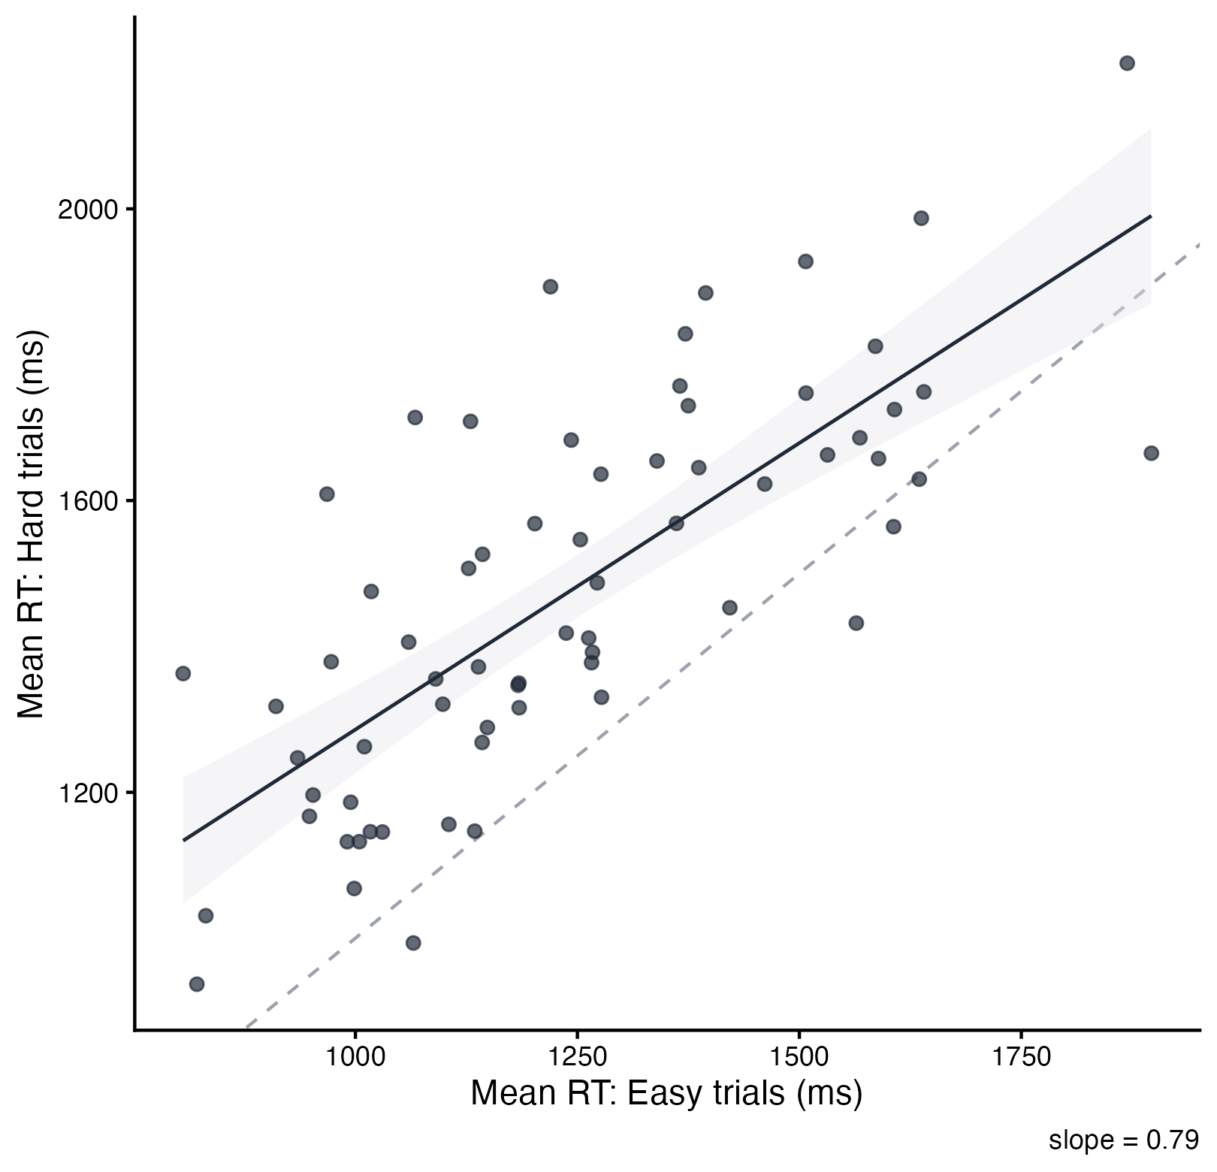
Figure 2: [CAPTION TO BE SUPPLIED]

3.2 Effort effects on decision parameters
[PROSE TO BE SUPPLIED: 3.2 Effort effects on decision parameters] Resolves Lani comments: C62, C63, C66, C69, C70, C72, C73. Inline value keys available for this section: crit, qual, bs, bias, drift_diff_trials, drift_same_trials, bs_pct_change, rope_v, rope_a, rope_z. Tables/figures in this section: Figure 3, Table 2.
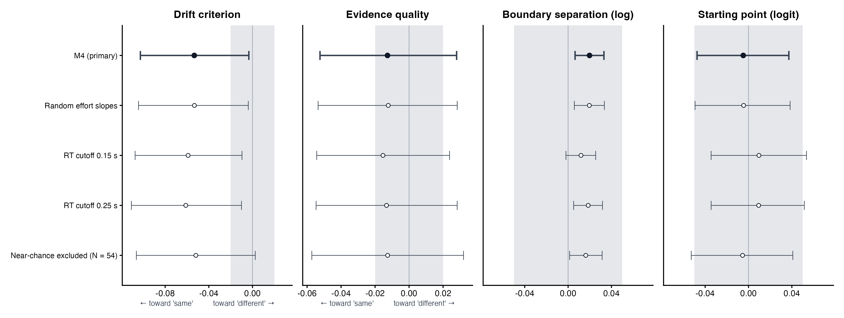
Figure 3: [CAPTION TO BE SUPPLIED]
Table 2: ​[CAPTION TO BE SUPPLIED]
Parameter | Estimate | 95% CrI | Direction | In ROPE | Change in a
Drift criterion | −0.053 | [−0.103, −0.003] | P(β < 0) = .981 | 9%
Evidence quality | −0.013 | [−0.052, 0.028] | P(β < 0) = .730 | 59%
Boundary separation | 0.020 | [0.006, 0.033] | P(β > 0) = .997 | 100% | +2.0% [0.6, 3.4]
Starting point | −0.005 | [−0.048, 0.037] | P(β < 0) = .590 | 98%
Drift on different trials | −0.065 | [−0.111, −0.021] | P(β < 0) = .998 | 2%
Drift on same trials | −0.041 | [−0.119, 0.038] | P(β < 0) = .845 | 24%

3.3 Task and difficulty effects
[PROSE TO BE SUPPLIED: 3.3 Task and difficulty effects] Resolves Lani comments: C74. Inline value keys available for this section: task_v, task_hard_x_vdt, task_easy_x_vdt, task_bs, task_bias. Tables/figures in this section: Figure 4.
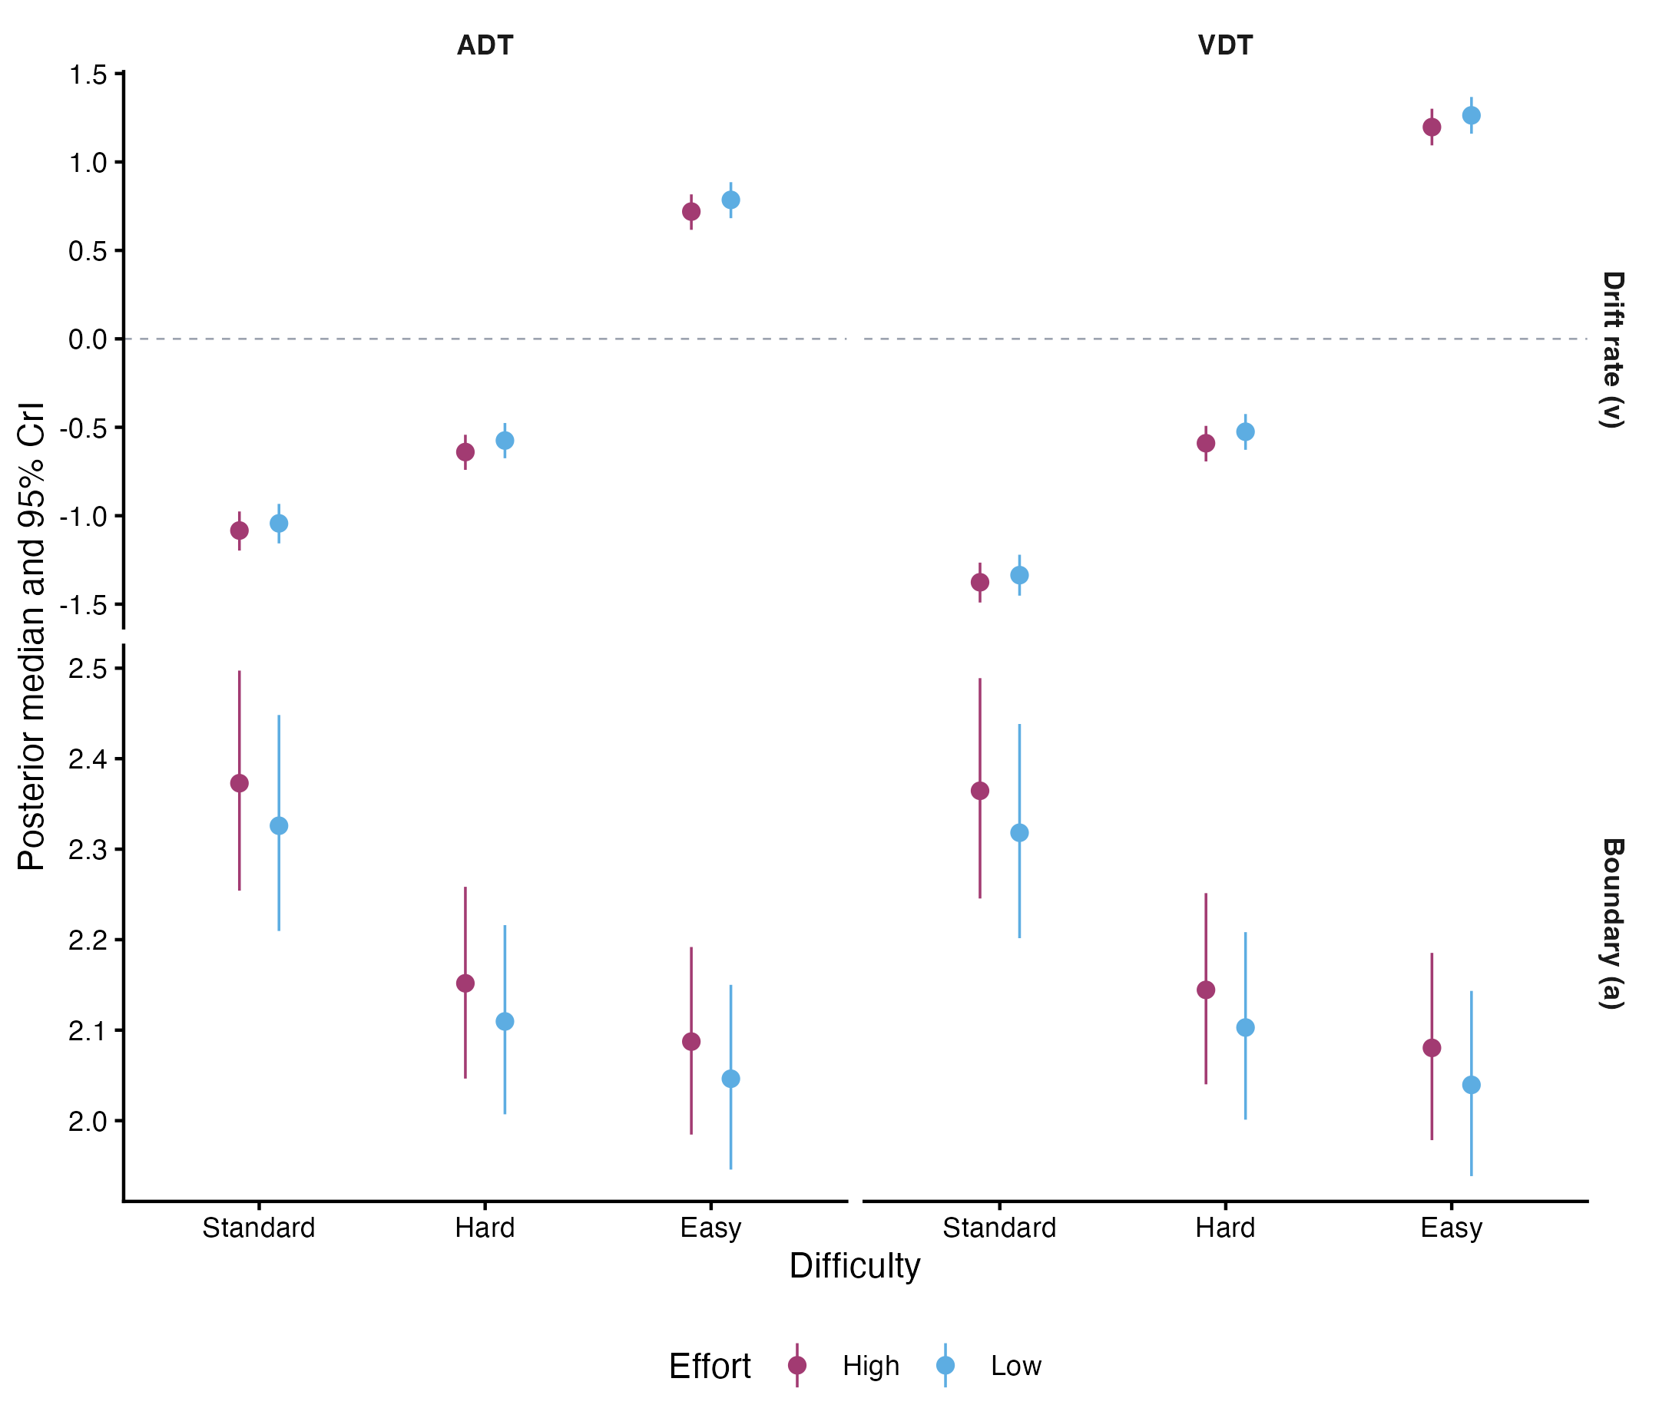
Figure 4: [CAPTION TO BE SUPPLIED]

3.4 Robustness
[PROSE TO BE SUPPLIED: 3.4 Robustness] Resolves Lani comments: C57. Inline value keys available for this section: crit_M4r, qual_M4r, crit_thr015, qual_thr015, crit_thr025, qual_thr025, crit_subchance, qual_subchance, sd_effort_M4r, sd_bs_effort_M4r, m4b_effort_x_task, m4b_quality_x_task, crit_ADT_M4b, crit_VDT_M4b, n_trials_thr015, n_trials_thr025, n_subchance_excluded, n_subchance_remaining, n_trials_cutoff_excluded. Tables/figures in this section: none.

3.5 Pupil-linked decision dynamics
[PROSE TO BE SUPPLIED: 3.5 Pupil-linked decision dynamics] Resolves Lani comments: C76, C77, C78. Inline value keys available for this section: P3_bs, P3_rt_bs, P5_bs, P6_bs, P7_bs, P8_bs, P1_bias, P2_drift_tepr, P2_drift_tepr_x_stim, P4_bias_base, P0_crit, P0_qual, P0_bs, P0_bias, delta_elpd_P3_vs_P0, delta_elpd_P3rt_vs_P0rt, delta_elpd_P5_vs_P0base, delta_elpd_P6_vs_P0lag, delta_elpd_P7_vs_P0pre, delta_elpd_P8_vs_P0grip, delta_elpd_P1_vs_P0, delta_elpd_P2_vs_P0, delta_elpd_P4_vs_P0base, tepr_rt_r, grip_high_low_ADT, grip_high_low_VDT, tepr_high_low_ADT_B1, tepr_high_low_VDT_B1, tepr_high_low_ADT_B0, tepr_high_low_VDT_B0, n_pupil_matched_trials, n_pupil_matched_subjects, n_pupil_tepr_present_trials, n_pupil_tepr_present_subjects, n_pupil_b1_quality_trials, n_pupil_b1_quality_subjects, n_pupil_window_quality_trials, n_pupil_window_quality_subjects, n_pupil_final_trials, n_pupil_final_subjects, n_pupil_base_trials, n_pupil_rt80_trials, n_pupil_lag_trials, n_pupil_pre_trials, n_pupil_grip_trials, n_pupil_entered_vs_r5, n_pupil_left_vs_r5, n_pupil_models_k_gt_0.7, pct_gain_lost_rt_trim, max_k_pupil_models. Tables/figures in this section: Figure 5, Table 3.
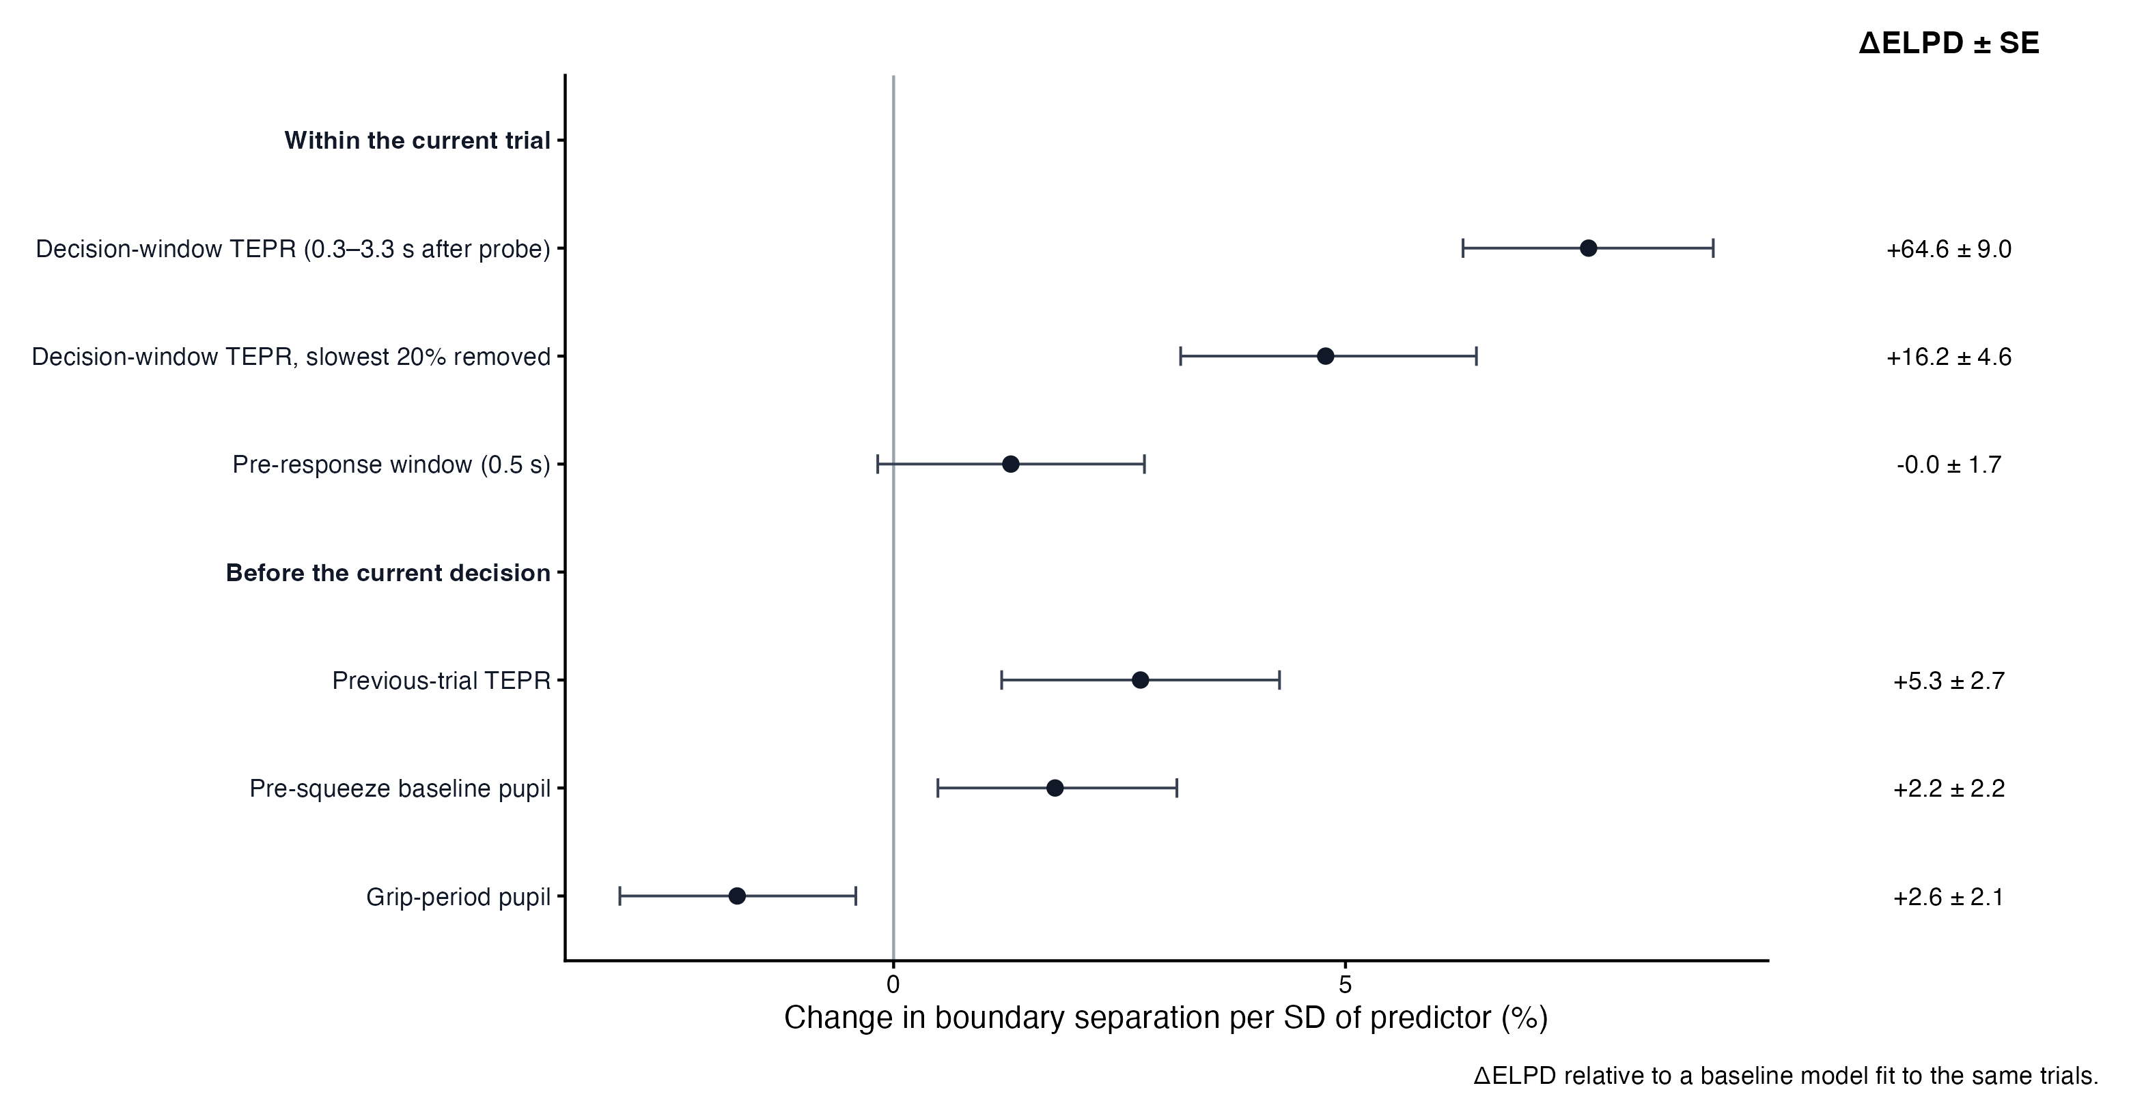
Figure 5: [CAPTION TO BE SUPPLIED]
Table 3: ​[CAPTION TO BE SUPPLIED]
Model | Predictor | Estimate | 95% CrI | Change in a | Delta ELPD | Trials | Subjects
P3 | current-trial TEPR | 0.074 | [0.061, 0.087] | +7.7% [6.3, 9.1] | 64.6 ± 9.0 | 4,952 | 42
P5 | pre-squeeze baseline | 0.018 | [0.005, 0.031] | +1.8% [0.5, 3.1] | 2.2 ± 2.2 | 4,612 | 42
P3_rt | current-trial TEPR, fastest 80% of RTs | 0.047 | [0.031, 0.062] | +4.8% [3.2, 6.4] | 16.2 ± 4.6 | 3,986 | 42
P6 | previous-trial TEPR | 0.027 | [0.012, 0.042] | +2.7% [1.2, 4.3] | 5.3 ± 2.7 | 3,823 | 42
P7 | 0.5 s before the response | 0.013 | [−0.002, 0.027] | +1.3% [−0.2, 2.8] | 0.0 ± 1.7 | 3,678 | 42
P8 | grip period before the probe | −0.017 | [−0.031, −0.004] | −1.7% [−3.0, −0.4] | 2.6 ± 2.1 | 4,444 | 42

3.6 Model adequacy
[PROSE TO BE SUPPLIED: 3.6 Model adequacy] Resolves Lani comments: none. Inline value keys available for this section: ppc_choice_inside_M4, ppc_rt_inside_pct_M4, ppc_rt_median_bias_ms_M4, t0_M4, t0_thr015, t0_thr025, max_rhat_M4, min_bulk_ess_M4, min_tail_ess_M4. Tables/figures in this section: none.

4 Discussion
[PROSE TO BE SUPPLIED: 4 Discussion] Resolves Lani comments: none. Inline value keys available for this section: crit, qual, bs, bs_pct_change, P3_bs, delta_elpd_P3_vs_P0, tepr_rt_r, grip_high_low_ADT, grip_high_low_VDT. Tables/figures in this section: none.

4.1 Limitations and future directions
[PROSE TO BE SUPPLIED: 4.1 Limitations and future directions] Resolves Lani comments: none. Inline value keys available for this section: ppc_rt_inside_pct_M4, ppc_rt_median_bias_ms_M4, n_pupil_final_subjects, n_final, n_pupil_final_trials. Tables/figures in this section: none.

References

Supplementary Materials

S1 Participant and trial flow
[PROSE TO BE SUPPLIED: S1 Participant and trial flow] Resolves Lani comments: none. Inline value keys available for this section: n_enrolled, n_excluded, n_final, n_trials_primary, n_pupil_matched_trials, n_pupil_final_trials, n_pupil_final_subjects. Tables/figures in this section: Figure S1, Table S1.
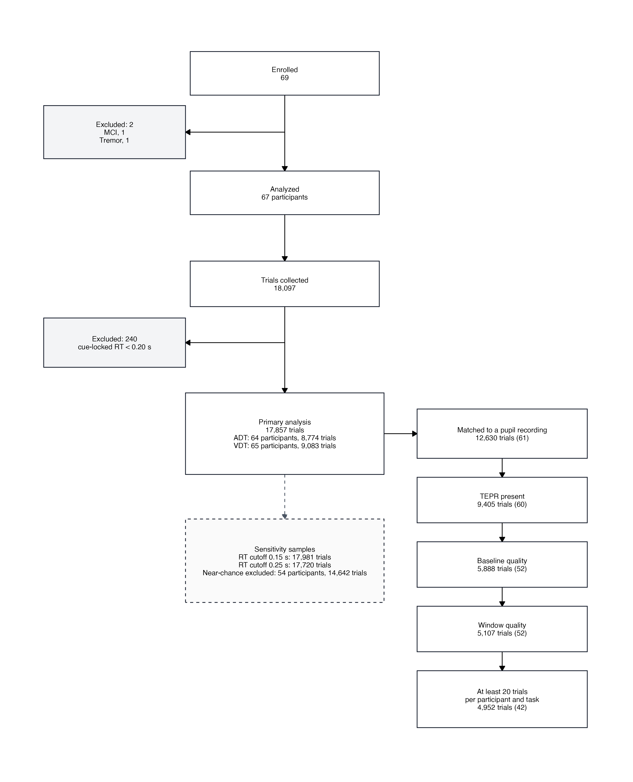
Figure S1: [CAPTION TO BE SUPPLIED]

Table S1: [CAPTION TO BE SUPPLIED]
Task | Difficulty | Effort | Trials | Subjects | Trials per subject
ADT | Easy | High | 1,772 | 64 | 27.7
ADT | Easy | Low | 1,740 | 64 | 27.2
ADT | Hard | High | 1,777 | 64 | 27.8
ADT | Hard | Low | 1,738 | 64 | 27.2
ADT | Standard | High | 887 | 64 | 13.9
ADT | Standard | Low | 860 | 64 | 13.4
VDT | Easy | High | 1,838 | 65 | 28.3
VDT | Easy | Low | 1,749 | 65 | 26.9
VDT | Hard | High | 1,863 | 65 | 28.7
VDT | Hard | Low | 1,788 | 65 | 27.5
VDT | Standard | High | 939 | 65 | 14.4
VDT | Standard | Low | 906 | 65 | 13.9

S2 Model comparison and convergence
[PROSE TO BE SUPPLIED: S2 Model comparison and convergence] Resolves Lani comments: none. Inline value keys available for this section: delta_elpd_M0_vs_M1, se_delta_elpd_M0_vs_M1, delta_elpd_M3_vs_M4, se_delta_elpd_M3_vs_M4, delta_elpd_M4b_vs_M4, se_delta_elpd_M4b_vs_M4, max_rhat_M4, min_bulk_ess_M4, min_tail_ess_M4, n_chains, n_iter, n_warmup. Tables/figures in this section: Table S2, Table S3, Table S4, Table S5.
Table S2: [CAPTION TO BE SUPPLIED]
|Model | ELPD| SE| Delta ELPD vs M4| SE of delta| k > 0.7| Max R-hat| Min bulk ESS| Pass|
Note. M1 Fails the convergence rule (max R-hat >= 1.01). M2 Fails the convergence rule (max R-hat >= 1.01). |:—–|——–:|—–:|—————-:|———–:|——-:|———:|————:|—-:|
Note. M1 Fails the convergence rule (max R-hat >= 1.01). M2 Fails the convergence rule (max R-hat >= 1.01). |M0 | −17820.6| 155.3| −162.1| 20.4| 0| 1.009| 817| Yes|
Note. M1 Fails the convergence rule (max R-hat >= 1.01). M2 Fails the convergence rule (max R-hat >= 1.01). |M1 | −17816.9| 155.5| −158.4| 19.9| 0| 1.013| 664| No|
Note. M1 Fails the convergence rule (max R-hat >= 1.01). M2 Fails the convergence rule (max R-hat >= 1.01). |M2 | −17816.0| 155.5| −157.4| 20.1| 0| 1.014| 652| No|
Note. M1 Fails the convergence rule (max R-hat >= 1.01). M2 Fails the convergence rule (max R-hat >= 1.01). |M3 | −17816.8| 155.3| −158.3| 20.0| 0| 1.006| 870| Yes|
Note. M1 Fails the convergence rule (max R-hat >= 1.01). M2 Fails the convergence rule (max R-hat >= 1.01). |M4 | −17658.5| 155.5| 0.0| 0.0| 0| 1.009| 863| Yes|
Note. M1 Fails the convergence rule (max R-hat >= 1.01). M2 Fails the convergence rule (max R-hat >= 1.01). |M4b | −17660.1| 155.6| −1.6| 1.5| 0| 1.008| 738| Yes|
Note. M1 Fails the convergence rule (max R-hat >= 1.01). M2 Fails the convergence rule (max R-hat >= 1.01).

Table S3: [CAPTION TO BE SUPPLIED]
Model | Role | Max R-hat | Min bulk ESS | Min tail ESS | Divergences | Pass
M4 | primary | 1.009 | 863 | 1,958 | 0 | Yes
M4b | comparison | 1.008 | 738 | 1,364 | 0 | Yes
M0 | comparison | 1.009 | 817 | 1,874 | 0 | Yes
M1 | comparison | 1.013 | 664 | 1,216 | 0 | No
M2 | comparison | 1.014 | 652 | 1,217 | 0 | No
M3 | comparison | 1.006 | 870 | 2,022 | 0 | Yes
M4r | robustness (random effort slopes) | 1.006 | 1,074 | 2,236 | 0 | Yes
M4_thr0.15 | robustness (RT cutoff) | 1.013 | 926 | 1,843 | 0 | No
M4_thr0.25 | robustness (RT cutoff) | 1.008 | 893 | 1,787 | 0 | Yes
P0 | pupil (baseline) | 1.003 | 1,677 | 3,128 | 0 | Yes
P1 | pupil | 1.004 | 1,573 | 2,831 | 0 | Yes
P2 | pupil | 1.006 | 1,613 | 2,786 | 0 | Yes
P3 | pupil (main pupil result) | 1.004 | 1,610 | 3,025 | 0 | Yes
P4 | pupil | 1.003 | 2,009 | 3,707 | 0 | Yes
P5 | pupil-ordering | 1.005 | 1,548 | 2,788 | 0 | Yes
P6 | pupil-ordering | 1.003 | 1,866 | 3,587 | 0 | Yes
P7 | pupil-ordering | 1.008 | 1,379 | 2,795 | 0 | Yes
P8 | pupil-ordering | 1.006 | 1,615 | 2,698 | 0 | Yes
P3_rt | pupil-ordering | 1.002 | 2,269 | 3,886 | 0 | Yes
P0_lag | pupil-ordering baseline | 1.003 | 2,102 | 3,485 | 0 | Yes
P0_pre | pupil-ordering baseline | 1.006 | 1,354 | 2,734 | 0 | Yes
P0_grip | pupil-ordering baseline | 1.005 | 1,539 | 2,917 | 0 | Yes
P0_rt | pupil-ordering baseline | 1.004 | 2,030 | 4,079 | 0 | Yes
M3_thr0.15 | superseded |  |  |  |  | Yes
M3_thr0.25 | superseded |  |  |  |  | No
M4_subchance | robustness (sub-chance excluded) | 1.008 | 941 | 1,844 | 0 | Yes

Table S4: [CAPTION TO BE SUPPLIED]
Parameter | Estimate | 95% CrI | Direction | In ROPE | R-hat
Drift intercept | −1.043 | [−1.156, −0.933] | P(β < 0) > .999 | 0% | 1.003
Boundary separation intercept | 0.844 | [0.793, 0.895] | P(β > 0) > .999 | 0% | 1.008
Non-decision time intercept | −0.641 | [−0.645, −0.637] | P(β < 0) > .999 | 0% | 1.001
Starting point intercept | 0.208 | [0.143, 0.273] | P(β > 0) > .999 | 0% | 1.002
Hard (drift) | 0.468 | [0.396, 0.543] | P(β > 0) > .999 | 0% | 1.000
Easy (drift) | 1.828 | [1.750, 1.906] | P(β > 0) > .999 | 0% | 1.000
Visual task (drift) | −0.292 | [−0.370, −0.214] | P(β < 0) > .999 | 0% | 1.001
Drift criterion | −0.053 | [−0.103, −0.003] | P(β < 0) = .981 | 9% | 1.000
Evidence quality | −0.013 | [−0.052, 0.028] | P(β < 0) = .730 | 59% | 1.001
Hard × visual (drift) | 0.341 | [0.257, 0.426] | P(β > 0) > .999 | 0% | 1.001
Easy × visual (drift) | 0.771 | [0.676, 0.866] | P(β > 0) > .999 | 0% | 1.000
Hard (boundary separation) | −0.098 | [−0.118, −0.078] | P(β < 0) > .999 | 0% | 1.000
Easy (boundary separation) | −0.128 | [−0.150, −0.106] | P(β < 0) > .999 | 0% | 1.000
Visual task (boundary separation) | −0.003 | [−0.018, 0.011] | P(β < 0) = .680 | 100% | 1.000
Boundary separation | 0.020 | [0.006, 0.033] | P(β > 0) = .997 | 100% | 1.000
Visual task (starting point) | −0.054 | [−0.099, −0.010] | P(β < 0) = .992 | 43% | 1.001
Starting point | −0.005 | [−0.048, 0.037] | P(β < 0) = .590 | 98% | 1.000

Table S5: [CAPTION TO BE SUPPLIED]
Task | Difficulty | Effort | Parameter | Estimate | 95% CrI
ADT | Standard | Low | Drift | −1.043 | [−1.156, −0.933]
VDT | Standard | Low | Drift | −1.336 | [−1.452, −1.221]
ADT | Hard | Low | Drift | −0.575 | [−0.675, −0.476]
VDT | Hard | Low | Drift | −0.525 | [−0.627, −0.425]
ADT | Easy | Low | Drift | 0.786 | [0.682, 0.886]
VDT | Easy | Low | Drift | 1.263 | [1.160, 1.368]
ADT | Standard | High | Drift | −1.084 | [−1.197, −0.976]
VDT | Standard | High | Drift | −1.376 | [−1.491, −1.265]
ADT | Hard | High | Drift | −0.640 | [−0.741, −0.542]
VDT | Hard | High | Drift | −0.590 | [−0.693, −0.492]
ADT | Easy | High | Drift | 0.720 | [0.616, 0.817]
VDT | Easy | High | Drift | 1.197 | [1.094, 1.301]
ADT | Standard | Low | Boundary separation | 2.326 | [2.210, 2.448]
VDT | Standard | Low | Boundary separation | 2.318 | [2.202, 2.438]
ADT | Hard | Low | Boundary separation | 2.110 | [2.007, 2.216]
VDT | Hard | Low | Boundary separation | 2.103 | [2.001, 2.208]
ADT | Easy | Low | Boundary separation | 2.046 | [1.946, 2.150]
VDT | Easy | Low | Boundary separation | 2.040 | [1.939, 2.143]
ADT | Standard | High | Boundary separation | 2.373 | [2.254, 2.497]
VDT | Standard | High | Boundary separation | 2.365 | [2.246, 2.489]
ADT | Hard | High | Boundary separation | 2.152 | [2.047, 2.258]
VDT | Hard | High | Boundary separation | 2.144 | [2.040, 2.251]
ADT | Easy | High | Boundary separation | 2.087 | [1.985, 2.192]
VDT | Easy | High | Boundary separation | 2.080 | [1.978, 2.185]
ADT | Standard | Low | Starting point | 0.552 | [0.536, 0.568]
VDT | Standard | Low | Starting point | 0.538 | [0.522, 0.555]
ADT | Hard | Low | Starting point | 0.552 | [0.536, 0.568]
VDT | Hard | Low | Starting point | 0.538 | [0.522, 0.555]
ADT | Easy | Low | Starting point | 0.552 | [0.536, 0.568]
VDT | Easy | Low | Starting point | 0.538 | [0.522, 0.555]
ADT | Standard | High | Starting point | 0.551 | [0.535, 0.566]
VDT | Standard | High | Starting point | 0.537 | [0.521, 0.553]
ADT | Hard | High | Starting point | 0.551 | [0.535, 0.566]
VDT | Hard | High | Starting point | 0.537 | [0.521, 0.553]
ADT | Easy | High | Starting point | 0.551 | [0.535, 0.566]
VDT | Easy | High | Starting point | 0.537 | [0.521, 0.553]
ADT | Standard | Low | Non-decision time | 0.527 | [0.525, 0.529]
VDT | Standard | Low | Non-decision time | 0.527 | [0.525, 0.529]
ADT | Hard | Low | Non-decision time | 0.527 | [0.525, 0.529]
VDT | Hard | Low | Non-decision time | 0.527 | [0.525, 0.529]
ADT | Easy | Low | Non-decision time | 0.527 | [0.525, 0.529]
VDT | Easy | Low | Non-decision time | 0.527 | [0.525, 0.529]
ADT | Standard | High | Non-decision time | 0.527 | [0.525, 0.529]
VDT | Standard | High | Non-decision time | 0.527 | [0.525, 0.529]
ADT | Hard | High | Non-decision time | 0.527 | [0.525, 0.529]
VDT | Hard | High | Non-decision time | 0.527 | [0.525, 0.529]
ADT | Easy | High | Non-decision time | 0.527 | [0.525, 0.529]
VDT | Easy | High | Non-decision time | 0.527 | [0.525, 0.529]

S3 Posterior predictive checks
[PROSE TO BE SUPPLIED: S3 Posterior predictive checks] Resolves Lani comments: none. Inline value keys available for this section: ppc_choice_inside_M4, ppc_rt_inside_pct_M4, ppc_rt_median_bias_ms_M4. Tables/figures in this section: Figure S2, Table S6.
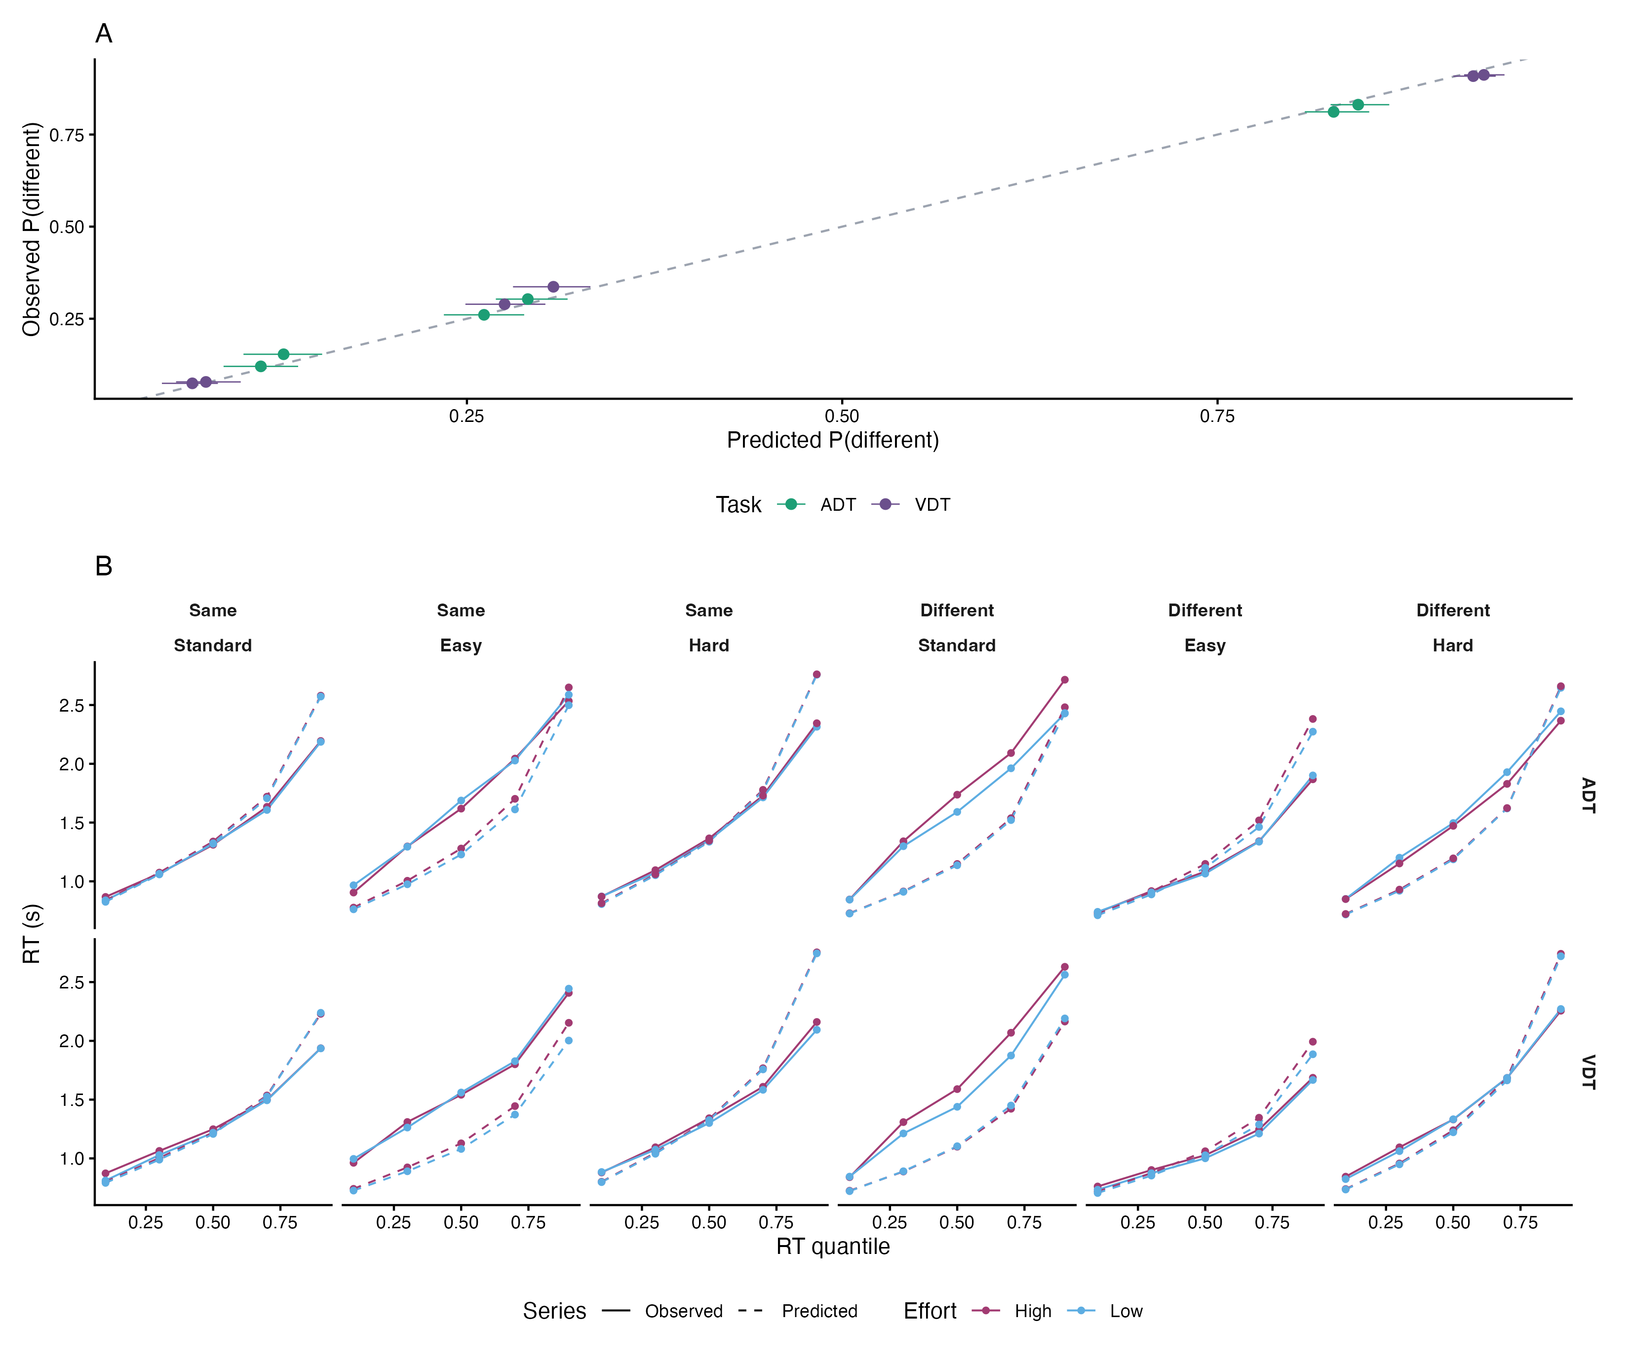
Figure S2: [CAPTION TO BE SUPPLIED]

Table S6: [CAPTION TO BE SUPPLIED]
Task | Difficulty | Effort | Observed | Predicted | 95% PI | Inside
ADT | Hard | Low | 0.303 | 0.291 | [0.269, 0.317] | Yes
ADT | Easy | High | 0.812 | 0.827 | [0.808, 0.851] | Yes
ADT | Standard | High | 0.121 | 0.113 | [0.088, 0.138] | Yes
ADT | Easy | Low | 0.831 | 0.844 | [0.825, 0.864] | Yes
ADT | Hard | High | 0.261 | 0.261 | [0.235, 0.288] | Yes
ADT | Standard | Low | 0.153 | 0.128 | [0.101, 0.154] | Yes
VDT | Hard | High | 0.289 | 0.275 | [0.249, 0.302] | Yes
VDT | Hard | Low | 0.337 | 0.308 | [0.281, 0.332] | No
VDT | Easy | High | 0.909 | 0.920 | [0.907, 0.935] | Yes
VDT | Standard | High | 0.075 | 0.067 | [0.047, 0.084] | Yes
VDT | Easy | Low | 0.912 | 0.927 | [0.914, 0.941] | No
VDT | Standard | Low | 0.078 | 0.076 | [0.056, 0.099] | Yes

S4 Robustness analyses
[PROSE TO BE SUPPLIED: S4 Robustness analyses] Resolves Lani comments: none. Inline value keys available for this section: crit_M4r, qual_M4r, crit_thr015, qual_thr015, crit_thr025, qual_thr025, crit_subchance, qual_subchance, sd_effort_M4r, sd_bs_effort_M4r, m4b_effort_x_task, m4b_quality_x_task, crit_ADT_M4b, crit_VDT_M4b, n_trials_thr015, n_trials_thr025, n_subchance_excluded, n_subchance_remaining, n_trials_cutoff_excluded. Tables/figures in this section: Table S7, Table S8, Table S9.
Table S7: [CAPTION TO BE SUPPLIED]
Model | Parameter | Estimate | 95% CrI | In ROPE | Trials | Subjects | Pass
M4 | Drift criterion | −0.053 | [−0.103, −0.003] | 9% | 17,857 | 67 | Yes
M4 | Evidence quality | −0.013 | [−0.052, 0.028] | 59% | 17,857 | 67 | Yes
M4 | Boundary separation | 0.020 | [0.006, 0.033] | 100% | 17,857 | 67 | Yes
M4 | Starting point | −0.005 | [−0.048, 0.037] | 98% | 17,857 | 67 | Yes
M4 | Drift on different trials | −0.065 | [−0.111, −0.021] | 2% | 17,857 | 67 | Yes
M4 | Drift on same trials | −0.041 | [−0.119, 0.038] | 24% | 17,857 | 67 | Yes
M4r | Drift criterion | −0.053 | [−0.104, −0.004] | 9% | 17,857 | 67 | Yes
M4r | Evidence quality | −0.012 | [−0.054, 0.028] | 59% | 17,857 | 67 | Yes
M4r | Boundary separation | 0.020 | [0.006, 0.034] | 100% | 17,857 | 67 | Yes
M4r | Starting point | −0.005 | [−0.049, 0.038] | 97% | 17,857 | 67 | Yes
M4r | Drift on different trials | −0.066 | [−0.112, −0.019] | 3% | 17,857 | 67 | Yes
M4r | Drift on same trials | −0.041 | [−0.121, 0.039] | 24% | 17,857 | 67 | Yes
M4_thr0.15 | Drift criterion | −0.059 | [−0.108, −0.010] | 6% | 17,981 | 67 | No
M4_thr0.15 | Evidence quality | −0.015 | [−0.054, 0.024] | 56% | 17,981 | 67 | No
M4_thr0.15 | Boundary separation | 0.012 | [−0.002, 0.025] | 100% | 17,981 | 67 | No
M4_thr0.15 | Starting point | 0.010 | [−0.035, 0.053] | 96% | 17,981 | 67 | No
M4_thr0.15 | Drift on different trials | −0.074 | [−0.120, −0.030] | 1% | 17,981 | 67 | No
M4_thr0.15 | Drift on same trials | −0.044 | [−0.120, 0.033] | 22% | 17,981 | 67 | No
M4_thr0.25 | Drift criterion | −0.061 | [−0.111, −0.010] | 5% | 17,720 | 67 | Yes
M4_thr0.25 | Evidence quality | −0.013 | [−0.055, 0.028] | 58% | 17,720 | 67 | Yes
M4_thr0.25 | Boundary separation | 0.019 | [0.005, 0.032] | 100% | 17,720 | 67 | Yes
M4_thr0.25 | Starting point | 0.009 | [−0.034, 0.051] | 97% | 17,720 | 67 | Yes
M4_thr0.25 | Drift on different trials | −0.074 | [−0.120, −0.029] | 1% | 17,720 | 67 | Yes
M4_thr0.25 | Drift on same trials | −0.048 | [−0.128, 0.032] | 20% | 17,720 | 67 | Yes
M4_subchance | Drift criterion | −0.052 | [−0.106, 0.003] | 13% | 14,642 | 54 | Yes
M4_subchance | Evidence quality | −0.013 | [−0.057, 0.032] | 55% | 14,642 | 54 | Yes
M4_subchance | Boundary separation | 0.016 | [0.001, 0.031] | 100% | 14,642 | 54 | Yes
M4_subchance | Starting point | −0.005 | [−0.053, 0.041] | 96% | 14,642 | 54 | Yes
M4_subchance | Drift on different trials | −0.064 | [−0.115, −0.015] | 4% | 14,642 | 54 | Yes
M4_subchance | Drift on same trials | −0.039 | [−0.124, 0.048] | 24% | 14,642 | 54 | Yes

Table S8: [CAPTION TO BE SUPPLIED]
Parameter | Estimate | 95% CrI
SD, drift criterion | 0.019 | [0.001, 0.062]
SD, boundary separation | 0.007 | [0.000, 0.023]
Correlation, drift intercept and drift criterion | r = −.19 | [−.84, .69]
Correlation, boundary intercept and boundary slope | r = .03 | [−.78, .80]

Table S9: [CAPTION TO BE SUPPLIED]
Parameter | Estimate | 95% CrI | Direction | In ROPE
Drift criterion | −0.077 | [−0.139, −0.017] | P(β < 0) = .994 | 3%
Drift criterion × task | 0.054 | [−0.024, 0.131] | P(β > 0) = .912 | 17%
Evidence quality × task | −0.041 | [−0.118, 0.036] | P(β < 0) = .850 | 24%
Drift criterion, auditory | −0.077 | [−0.139, −0.017] | P(β < 0) = .994 | 3%
Drift criterion, visual | −0.024 | [−0.087, 0.040] | P(β < 0) = .767 | 37%
Evidence quality | 0.007 | [−0.047, 0.062] | P(β > 0) = .597 | 52%

S5 Pupil-linked models
[PROSE TO BE SUPPLIED: S5 Pupil-linked models] Resolves Lani comments: none. Inline value keys available for this section: P3_bs, P3_rt_bs, P5_bs, P6_bs, P7_bs, P8_bs, P1_bias, P2_drift_tepr, P2_drift_tepr_x_stim, P4_bias_base, P0_crit, P0_qual, P0_bs, P0_bias, delta_elpd_P3_vs_P0, delta_elpd_P3rt_vs_P0rt, delta_elpd_P5_vs_P0base, delta_elpd_P6_vs_P0lag, delta_elpd_P7_vs_P0pre, delta_elpd_P8_vs_P0grip, delta_elpd_P1_vs_P0, delta_elpd_P2_vs_P0, delta_elpd_P4_vs_P0base, tepr_rt_r, grip_high_low_ADT, grip_high_low_VDT, tepr_high_low_ADT_B1, tepr_high_low_VDT_B1, tepr_high_low_ADT_B0, tepr_high_low_VDT_B0, n_pupil_matched_trials, n_pupil_matched_subjects, n_pupil_tepr_present_trials, n_pupil_tepr_present_subjects, n_pupil_b1_quality_trials, n_pupil_b1_quality_subjects, n_pupil_window_quality_trials, n_pupil_window_quality_subjects, n_pupil_final_trials, n_pupil_final_subjects, n_pupil_base_trials, n_pupil_rt80_trials, n_pupil_lag_trials, n_pupil_pre_trials, n_pupil_grip_trials, n_pupil_entered_vs_r5, n_pupil_left_vs_r5, n_pupil_models_k_gt_0.7, pct_gain_lost_rt_trim, max_k_pupil_models. Tables/figures in this section: Table S10, Table S11, Figure S3.
Table S10: [CAPTION TO BE SUPPLIED]
Block | Model | Parameter | Estimate | 95% CrI | Change in a | Delta ELPD | Trials
Pupil slope | P0 | Baseline (no pupil slope) |  |  |  | 0.0 ± 0.0 | 4,952
Pupil slope | P1 | Current-trial TEPR on starting point | 0.002 | [−0.030, 0.035] |  | −0.9 ± 0.2 | 4,952
Pupil slope | P2 | Current-trial TEPR on drift | 0.050 | [0.011, 0.088] |  | 8.7 ± 5.3 | 4,952
Pupil slope | P2 | Current-trial TEPR × stimulus | −0.091 | [−0.130, −0.053] |  | 8.7 ± 5.3 | 4,952
Pupil slope | P3 | Current-trial TEPR on boundary separation | 0.074 | [0.061, 0.087] | +7.7% [6.3, 9.1] | 64.6 ± 9.0 | 4,952
Pupil slope | P4 | Pre-squeeze baseline on starting point | −0.013 | [−0.045, 0.019] |  | −0.4 ± 0.6 | 4,612
P0 effort term | P0 | Drift criterion | −0.071 | [−0.166, 0.025] |  |  | 4,952
P0 effort term | P0 | Evidence quality | 0.051 | [−0.029, 0.129] |  |  | 4,952
P0 effort term | P0 | Boundary separation | 0.039 | [0.011, 0.066] | +4.0% [1.1, 6.8] |  | 4,952
P0 effort term | P0 | Starting point | −0.020 | [−0.104, 0.063] |  |  | 4,952

Table S11: [CAPTION TO BE SUPPLIED]
Gate | Block | Task | Effort | Outcome | Trials | Subjects | Mean | SD | High minus low | t | df | p | r | r CrI | Grip mean
matched | qc_gate |  |  |  | 12,630 | 61
tepr_nonmissing | qc_gate |  |  |  | 9,405 | 60
B1_quality_ge_0.50 | qc_gate |  |  |  | 5,888 | 52
cog_quality_ge_0.50 | qc_gate |  |  |  | 5,107 | 52
subject_task_ge_20 | qc_gate |  |  |  | 4,952 | 42
 | tepr_rt_correlation |  |  |  | 4,952 | 42 |  |  |  |  |  |  | r = .29 | [.23, .35]
 | raw_means | ADT | high | tepr_raw |  | 30 | −0.458 | 1.761
 | raw_means | ADT | low | tepr_raw |  | 30 | 0.332 | 1.876
 | raw_means | VDT | high | tepr_raw |  | 30 | 0.784 | 2.106
 | raw_means | VDT | low | tepr_raw |  | 30 | 1.238 | 2.123
 | raw_means | ADT | high | auc_b0 |  | 30 | 1.367 | 3.975
 | raw_means | ADT | low | auc_b0 |  | 30 | 0.708 | 3.858
 | raw_means | VDT | high | auc_b0 |  | 30 | 1.033 | 2.414
 | raw_means | VDT | low | auc_b0 |  | 30 | 1.094 | 2.241
 | paired_high_minus_low | ADT |  | tepr_raw |  | 30 |  |  | −0.791 | −2.12 | 29 | p = .042
 | paired_high_minus_low | VDT |  | tepr_raw |  | 30 |  |  | −0.454 | −2.74 | 29 | p = .011
 | paired_high_minus_low | ADT |  | auc_b0 |  | 30 |  |  | 0.659 | 1.50 | 29 | p = .145
 | paired_high_minus_low | VDT |  | auc_b0 |  | 30 |  |  | −0.061 | −0.16 | 29 | p = .874
 | grip_means | ADT | high |  |  | 30 |  |  |  |  |  |  |  |  | 0.150
 | grip_means | ADT | low |  |  | 29 |  |  |  |  |  |  |  |  | −0.392
 | grip_means | VDT | high |  |  | 30 |  |  |  |  |  |  |  |  | −0.135
 | grip_means | VDT | low |  |  | 29 |  |  |  |  |  |  |  |  | −0.273
 | grip_paired | ADT |  |  |  | 29 |  |  | 0.513 | 2.72 | 28 | p = .011
 | grip_paired | VDT |  |  |  | 29 |  |  | 0.206 | 2.04 | 28 | p = .051

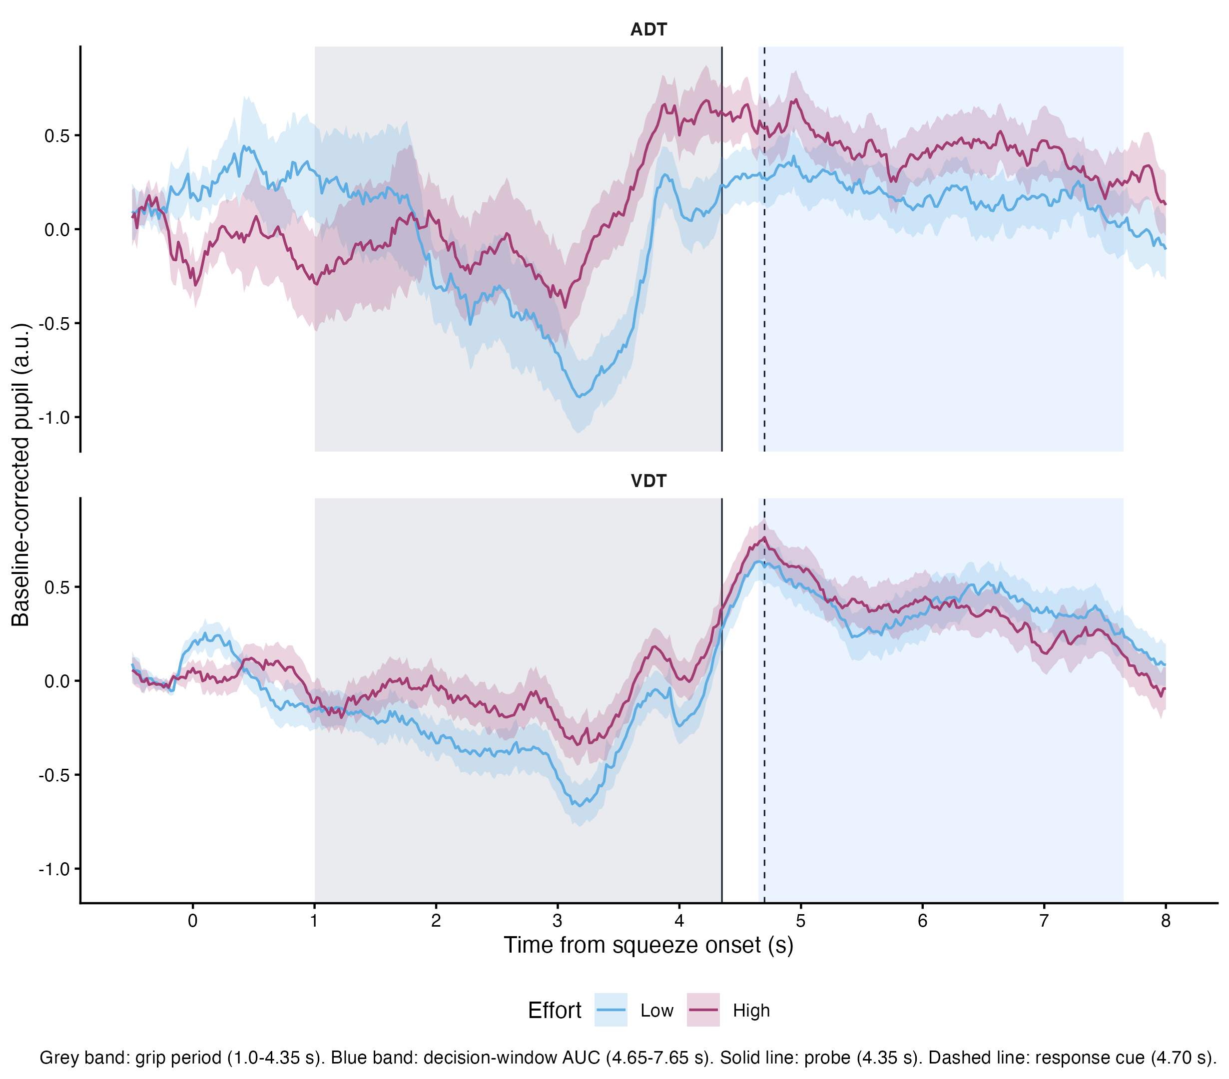
Figure S3: [CAPTION TO BE SUPPLIED]

S6 Model specification details
[PROSE TO BE SUPPLIED: S6 Model specification details] Resolves Lani comments: none. Inline value keys available for this section: t0_M4, t0_thr015, t0_thr025, rope_v, rope_a, rope_z, n_chains, n_iter, n_warmup, adapt_delta, max_treedepth, seed. Tables/figures in this section: Figure S4.
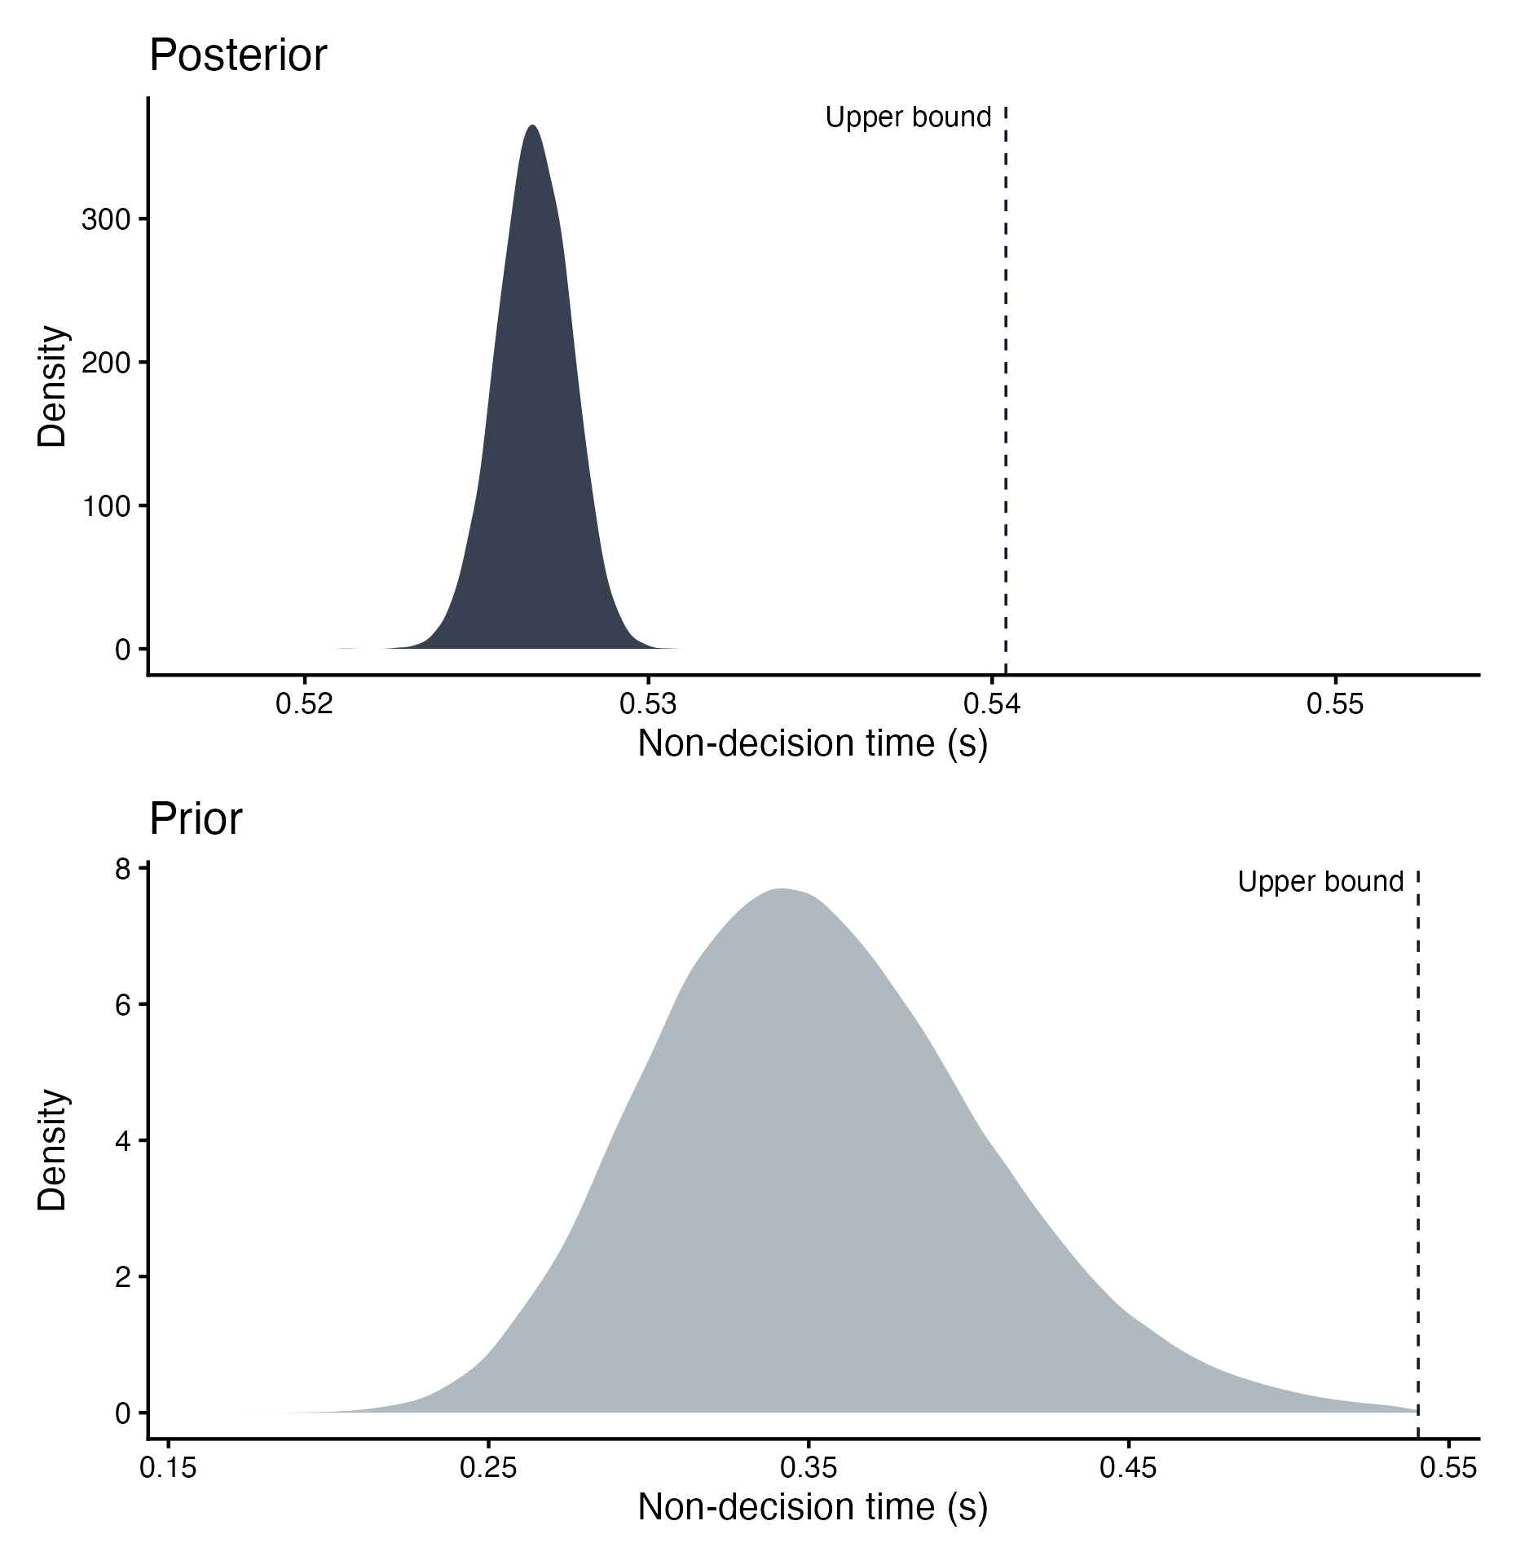
Figure S4: [CAPTION TO BE SUPPLIED]

S7 Behavioral mixed-effects models (dissertation only)
[PROSE TO BE SUPPLIED: S7 Behavioral mixed-effects models (dissertation only)] Resolves Lani comments: none. Inline value keys available for this section: acc_high_low_Standard, acc_high_low_Hard, acc_high_low_Easy. Tables/figures in this section: Table S12, Table S13, Figure S5.
Table S12: [CAPTION TO BE SUPPLIED]
Effect | Estimate | SE | Statistic | p | 95% CI
Intercept | 1.991 | 0.117 | 17.04 | p < .001 | [1.762, 2.220]
Hard | −3.064 | 0.087 | −35.26 | p < .001 | [−3.234, −2.894]
Easy | −0.134 | 0.093 | −1.44 | p = .150 | [−0.316, 0.048]
High effort | 0.204 | 0.112 | 1.83 | p = .068 | [−0.015, 0.423]
Visual task | 0.417 | 0.041 | 10.08 | p < .001 | [0.336, 0.499]
Hard × high effort | −0.431 | 0.124 | −3.47 | p < .001 | [−0.674, −0.188]
Easy × high effort | −0.291 | 0.133 | −2.19 | p = .028 | [−0.552, −0.031]

Table S13: [CAPTION TO BE SUPPLIED]
Effect | Estimate | SE | Statistic | 95% CI
Intercept | 1.379 | 0.038 | 36.73 | [1.305, 1.452]
Hard | 0.054 | 0.027 | 1.99 | [0.001, 0.107]
Easy | −0.186 | 0.027 | −6.90 | [−0.239, −0.133]
High effort | 0.036 | 0.027 | 1.35 | [−0.017, 0.089]
Visual task | −0.100 | 0.016 | −6.33 | [−0.131, −0.069]
Hard × high effort | −0.029 | 0.038 | −0.77 | [−0.104, 0.045]
Easy × high effort | −0.025 | 0.038 | −0.66 | [−0.100, 0.050]

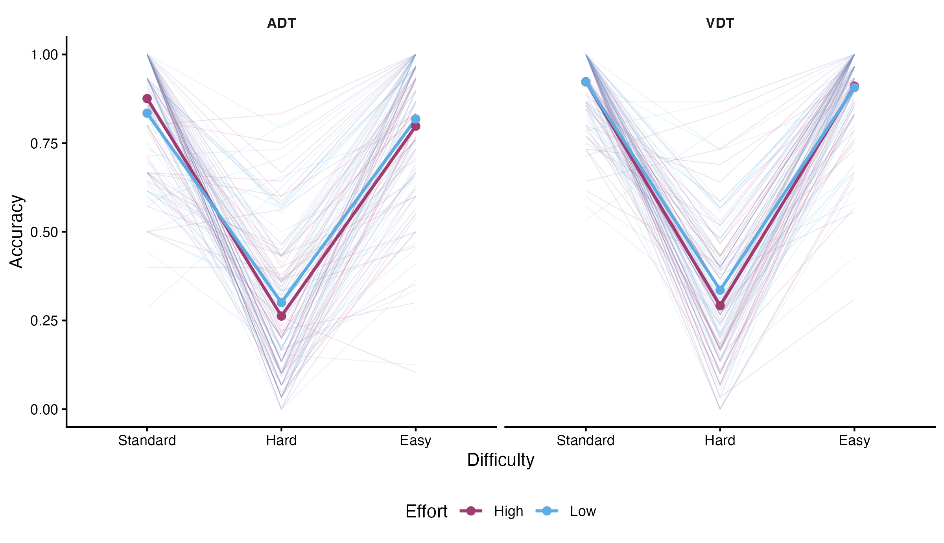
Figure S5: [CAPTION TO BE SUPPLIED]

S8 Exploratory LC structural correlates (dissertation only)
[PROSE TO BE SUPPLIED: S8 Exploratory LC structural correlates (dissertation only)] Resolves Lani comments: none. Inline value keys available for this section: none. Tables/figures in this section: Table S14, Figure S6, Figure S7.
Table S14: [CAPTION TO BE SUPPLIED]
Predictor | Outcome | Analysis | r | p | n
LC_CNR_max | dprime_mean | lc | r = .13 | p = .322 | 58
LC_CNR_max | dprime_variability | lc | r = .20 | p = .133 | 58
LC_CNR_max | grip_sd | lc | r = −.05 | p = .713 | 58
LC_CNR_max | pf_slope | lc | r = .12 | p = .381 | 58
LC_CNR_max | rt_diff_abs | lc | r = −.08 | p = .552 | 58
LC_CNR_max | rt_mean | lc | r = .06 | p = .638 | 58
LC_CNR_max | tepr_mean | lc | r = .18 | p = .188 | 58
LC_Composite_v2 | dprime_mean | lc | r = .23 | p = .087 | 58
LC_Composite_v2 | dprime_variability | lc | r = −.13 | p = .321 | 58
LC_Composite_v2 | grip_sd | lc | r = .33 | p = .012 | 58
LC_Composite_v2 | pf_slope | lc | r = −.22 | p = .097 | 58
LC_Composite_v2 | rt_diff_abs | lc | r = .29 | p = .025 | 58
LC_Composite_v2 | rt_mean | lc | r = .25 | p = .062 | 58
LC_Composite_v2 | tepr_mean | lc | r = .00 | p = .980 | 58
LC_fICVF | dprime_mean | lc | r = .05 | p = .701 | 57
LC_fICVF | dprime_variability | lc | r = .15 | p = .276 | 57
LC_fICVF | grip_sd | lc | r = .04 | p = .785 | 57
LC_fICVF | pf_slope | lc | r = −.08 | p = .570 | 57
LC_fICVF | rt_diff_abs | lc | r = .11 | p = .408 | 57
LC_fICVF | rt_mean | lc | r = .03 | p = .846 | 57
LC_fICVF | tepr_mean | lc | r = .21 | p = .115 | 57
LC_fISO | dprime_mean | lc | r = −.18 | p = .177 | 57
LC_fISO | dprime_variability | lc | r = .40 | p = .002 | 57
LC_fISO | grip_sd | lc | r = −.36 | p = .005 | 57
LC_fISO | pf_slope | lc | r = .34 | p = .010 | 57
LC_fISO | rt_diff_abs | lc | r = −.31 | p = .019 | 57
LC_fISO | rt_mean | lc | r = −.41 | p = .002 | 57
LC_fISO | tepr_mean | lc | r = .22 | p = .101 | 57
PC1_v2 | dprime_mean | lc | r = .21 | p = .110 | 58
PC1_v2 | dprime_variability | lc | r = −.28 | p = .033 | 58
PC1_v2 | grip_sd | lc | r = .35 | p = .007 | 58
PC1_v2 | pf_slope | lc | r = −.24 | p = .071 | 58
PC1_v2 | rt_diff_abs | lc | r = .28 | p = .034 | 58
PC1_v2 | rt_mean | lc | r = .30 | p = .020 | 58
PC1_v2 | tepr_mean | lc | r = −.15 | p = .252 | 58
LC_CNR_max | a_mean | lc | r = .13 | p = .345 | 58
LC_CNR_max | v_mean | lc | r = .02 | p = .875 | 58
LC_CNR_max | z_mean | lc | r = −.04 | p = .786 | 58
LC_Composite_v2 | a_mean | lc | r = .25 | p = .059 | 58
LC_Composite_v2 | v_mean | lc | r = −.10 | p = .478 | 58
LC_Composite_v2 | z_mean | lc | r = .01 | p = .927 | 58
LC_fICVF | a_mean | lc | r = .04 | p = .754 | 57
LC_fICVF | v_mean | lc | r = −.17 | p = .216 | 57
LC_fICVF | z_mean | lc | r = −.09 | p = .494 | 57
LC_fISO | a_mean | lc | r = −.39 | p = .003 | 57
LC_fISO | v_mean | lc | r = −.09 | p = .488 | 57
LC_fISO | z_mean | lc | r = −.08 | p = .578 | 57
PC1_v2 | a_mean | lc | r = .29 | p = .026 | 58
PC1_v2 | v_mean | lc | r = .02 | p = .874 | 58
PC1_v2 | z_mean | lc | r = .07 | p = .603 | 58

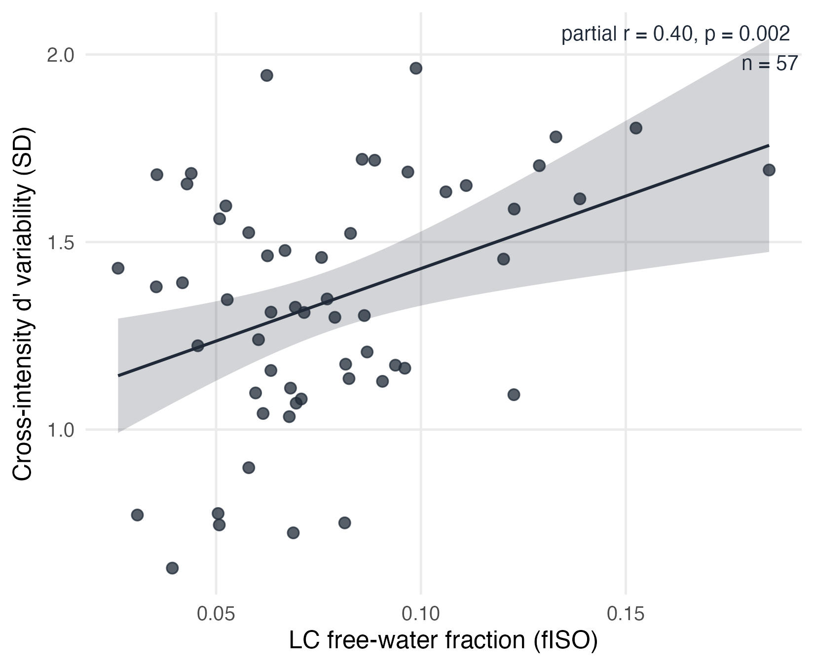
Figure S6: [CAPTION TO BE SUPPLIED]

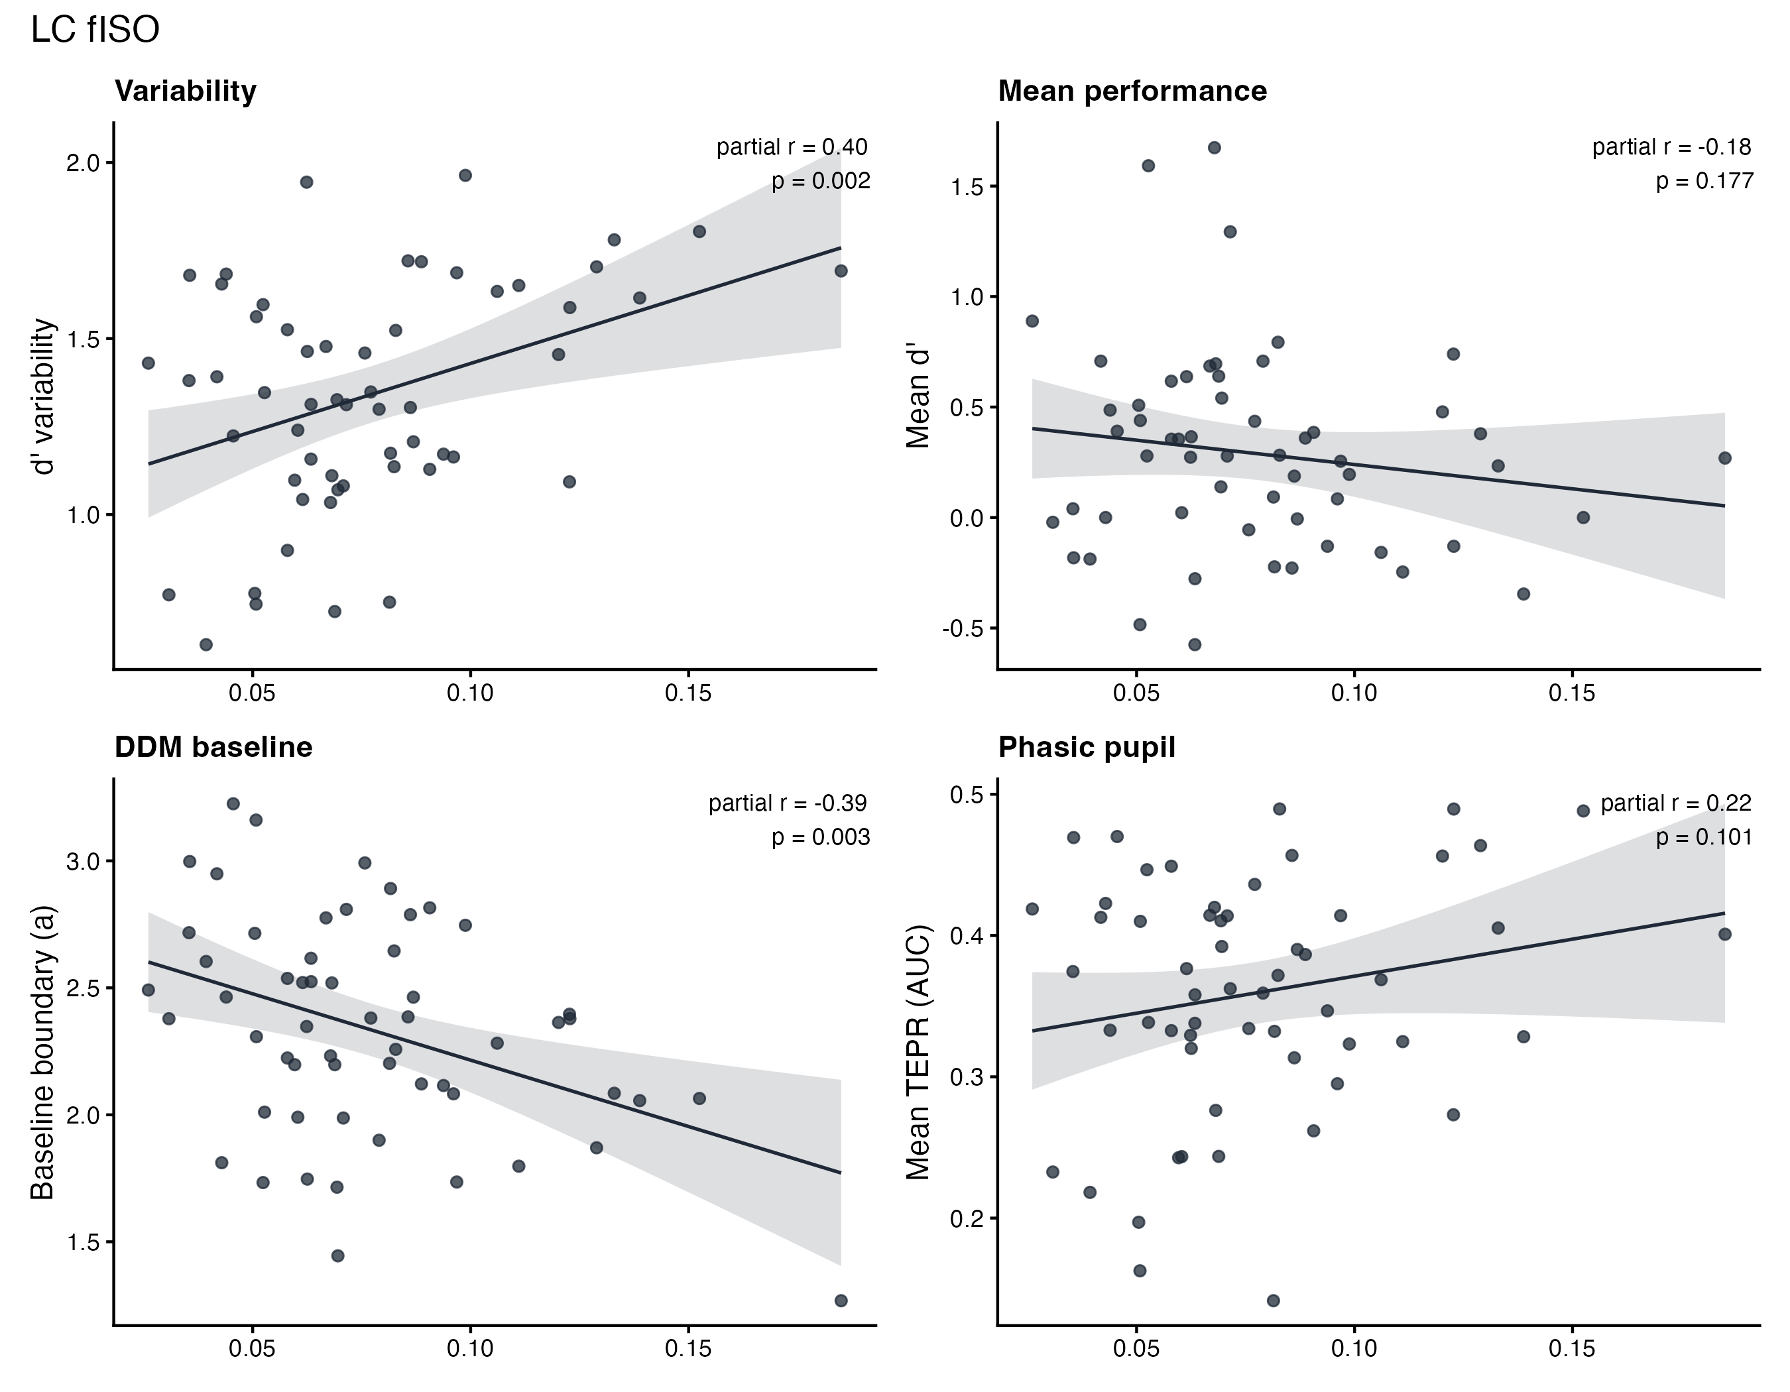
Figure S7: [CAPTION TO BE SUPPLIED]

S9 Extended baseline and neuropsychological profile (dissertation only)
[PROSE TO BE SUPPLIED: S9 Extended baseline and neuropsychological profile (dissertation only)] Resolves Lani comments: none. Inline value keys available for this section: none. Tables/figures in this section: Table S15.
Table S15: [CAPTION TO BE SUPPLIED]
Predictor | Outcome | Analysis | r | p | n
boston_naming | accuracy | neuropsych | r = .32 | p = .012 | 62
boston_naming | accuracy_diff_abs | neuropsych | r = −.14 | p = .270 | 62
boston_naming | dprime_var | neuropsych | r = .33 | p = .009 | 62
boston_naming | rt_diff_abs | neuropsych | r = −.20 | p = .121 | 62
boston_naming | rt_mean | neuropsych | r = −.17 | p = .182 | 62
edu | accuracy | neuropsych | r = .30 | p = .015 | 64
edu | accuracy_diff_abs | neuropsych | r = .24 | p = .054 | 64
edu | dprime_var | neuropsych | r = .07 | p = .596 | 64
edu | rt_diff_abs | neuropsych | r = −.05 | p = .689 | 64
edu | rt_mean | neuropsych | r = −.07 | p = .601 | 64
emq | accuracy | neuropsych | r = .02 | p = .859 | 62
emq | accuracy_diff_abs | neuropsych | r = .19 | p = .140 | 62
emq | dprime_var | neuropsych | r = −.12 | p = .358 | 62
emq | rt_diff_abs | neuropsych | r = .04 | p = .732 | 62
emq | rt_mean | neuropsych | r = .33 | p = .008 | 62
gad | accuracy | neuropsych | r = −.03 | p = .834 | 61
gad | accuracy_diff_abs | neuropsych | r = .20 | p = .113 | 61
gad | dprime_var | neuropsych | r = .01 | p = .931 | 61
gad | rt_diff_abs | neuropsych | r = −.02 | p = .864 | 61
gad | rt_mean | neuropsych | r = −.02 | p = .883 | 61
gds | accuracy | neuropsych | r = −.03 | p = .844 | 61
gds | accuracy_diff_abs | neuropsych | r = .07 | p = .569 | 61
gds | dprime_var | neuropsych | r = −.27 | p = .034 | 61
gds | rt_diff_abs | neuropsych | r = .19 | p = .134 | 61
gds | rt_mean | neuropsych | r = .19 | p = .144 | 61
moca | accuracy | neuropsych | r = .01 | p = .964 | 62
moca | accuracy_diff_abs | neuropsych | r = .18 | p = .164 | 62
moca | dprime_var | neuropsych | r = .10 | p = .449 | 62
moca | rt_diff_abs | neuropsych | r = .06 | p = .658 | 62
moca | rt_mean | neuropsych | r = −.16 | p = .226 | 62
sils | accuracy | neuropsych | r = .37 | p = .003 | 63
sils | accuracy_diff_abs | neuropsych | r = −.03 | p = .816 | 63
sils | dprime_var | neuropsych | r = .26 | p = .038 | 63
sils | rt_diff_abs | neuropsych | r = −.26 | p = .041 | 63
sils | rt_mean | neuropsych | r = −.36 | p = .004 | 63
tmt_a | accuracy | neuropsych | r = −.23 | p = .074 | 63
tmt_a | accuracy_diff_abs | neuropsych | r = −.05 | p = .726 | 63
tmt_a | dprime_var | neuropsych | r = .20 | p = .117 | 63
tmt_a | rt_diff_abs | neuropsych | r = −.11 | p = .371 | 63
tmt_a | rt_mean | neuropsych | r = .05 | p = .725 | 63
tmt_b_minus_a | accuracy | neuropsych | r = −.14 | p = .268 | 63
tmt_b_minus_a | accuracy_diff_abs | neuropsych | r = .10 | p = .423 | 63
tmt_b_minus_a | dprime_var | neuropsych | r = .16 | p = .197 | 63
tmt_b_minus_a | rt_diff_abs | neuropsych | r = −.06 | p = .668 | 63
tmt_b_minus_a | rt_mean | neuropsych | r = .02 | p = .850 | 63
boston_naming | a_mean | neuropsych | r = −.04 | p = .771 | 62
boston_naming | v_mean | neuropsych | r = .08 | p = .525 | 62
boston_naming | z_mean | neuropsych | r = .08 | p = .522 | 62
edu | a_mean | neuropsych | r = .02 | p = .887 | 64
edu | v_mean | neuropsych | r = .17 | p = .181 | 64
edu | z_mean | neuropsych | r = .10 | p = .451 | 64
emq | a_mean | neuropsych | r = .35 | p = .006 | 62
emq | v_mean | neuropsych | r = .17 | p = .187 | 62
emq | z_mean | neuropsych | r = −.22 | p = .086 | 62
gad | a_mean | neuropsych | r = .01 | p = .968 | 61
gad | v_mean | neuropsych | r = .04 | p = .776 | 61
gad | z_mean | neuropsych | r = −.18 | p = .164 | 61
gds | a_mean | neuropsych | r = .18 | p = .156 | 61
gds | v_mean | neuropsych | r = .14 | p = .283 | 61
gds | z_mean | neuropsych | r = −.26 | p = .045 | 61
moca | a_mean | neuropsych | r = −.10 | p = .454 | 62
moca | v_mean | neuropsych | r = .01 | p = .950 | 62
moca | z_mean | neuropsych | r = −.05 | p = .714 | 62
sils | a_mean | neuropsych | r = −.20 | p = .107 | 63
sils | v_mean | neuropsych | r = .14 | p = .266 | 63
sils | z_mean | neuropsych | r = .08 | p = .528 | 63
tmt_a | a_mean | neuropsych | r = .01 | p = .939 | 63
tmt_a | v_mean | neuropsych | r = −.10 | p = .420 | 63
tmt_a | z_mean | neuropsych | r = −.30 | p = .019 | 63
tmt_b_minus_a | a_mean | neuropsych | r = .08 | p = .518 | 63
tmt_b_minus_a | v_mean | neuropsych | r = −.15 | p = .235 | 63
tmt_b_minus_a | z_mean | neuropsych | r = .01 | p = .949 | 63
Age (years) | descriptive | neuropsych_baseline_continuous |  |  | 67
Education (years) | descriptive | neuropsych_baseline_continuous |  |  | 64
MoCA (telephone screen /22) | descriptive | neuropsych_baseline_continuous |  |  | 62
Trail Making A (seconds) | descriptive | neuropsych_baseline_continuous |  |  | 63
Trail Making B (seconds) | descriptive | neuropsych_baseline_continuous |  |  | 63
TMT B − A (seconds) | descriptive | neuropsych_baseline_continuous |  |  | 63
Boston Naming (/23) | descriptive | neuropsych_baseline_continuous |  |  | 62
SILS (/40) | descriptive | neuropsych_baseline_continuous |  |  | 63
GDS (/15) | descriptive | neuropsych_baseline_continuous |  |  | 61
GAD-7 (/8) | descriptive | neuropsych_baseline_continuous |  |  | 61
EMQ-13 | descriptive | neuropsych_baseline_continuous |  |  | 62
Female, n (%) | descriptive | neuropsych_baseline_categorical
Right-handed, n (%) | descriptive | neuropsych_baseline_categorical
White race, n (%) | descriptive | neuropsych_baseline_categorical
Hispanic/Latino ethnicity, n (%) | descriptive | neuropsych_baseline_categorical

S10 Exploratory temporal dynamics (dissertation only; pre-revision model structure)
[PROSE TO BE SUPPLIED: S10 Exploratory temporal dynamics (dissertation only; pre-revision model structure)] Resolves Lani comments: none. Inline value keys available for this section: none. Tables/figures in this section: Table S16.
Table S16: [CAPTION TO BE SUPPLIED]
|Model | Parameter| Estimate| SD| p…0|
Note. Fit on the pre-revision model structure. |:——|————————————————–:|——–:|—–:|——:|
Note. Fit on the pre-revision model structure. |M_hist | Starting-point intercept| 0.197| 0.033| > .999|
Note. Fit on the pre-revision model structure. |M_hist | Starting point, low effort| −0.016| 0.022| .225|
Note. Fit on the pre-revision model structure. |M_hist | Starting point, previous choice| 0.065| 0.031| .982|
Note. Fit on the pre-revision model structure. |M_hist | Starting point, previous choice × low effort| −0.001| 0.033| .488|
Note. Fit on the pre-revision model structure. |M_hist | Drift, previous choice| 0.054| 0.023| .991|
Note. Fit on the pre-revision model structure. |M_wsls | Starting-point intercept| 0.214| 0.042| > .999|
Note. Fit on the pre-revision model structure. |M_wsls | Starting point, low effort| −0.017| 0.022| .225|
Note. Fit on the pre-revision model structure. |M_wsls | Starting point, previous choice| 0.137| 0.061| .987|
Note. Fit on the pre-revision model structure. |M_wsls | Starting point, previous choice × low effort| −0.001| 0.033| .489|
Note. Fit on the pre-revision model structure. |M_wsls | Starting point, previous choice × previous correct| −0.107| 0.060| .036|
Note. Fit on the pre-revision model structure. |M_wsls | Starting point, previous correct| 0.000| 0.031| .499|
Note. Fit on the pre-revision model structure. |M_wsls | Drift, previous choice| 0.053| 0.023| .991|
Note. Fit on the pre-revision model structure. | | Boundary separation, age| 0.003| 0.025| .552|
Note. Fit on the pre-revision model structure. | | Boundary separation, second half| −0.022| 0.009| .007|
Note. Fit on the pre-revision model structure. | | Boundary separation, high effort| 0.009| 0.010| .819|
Note. Fit on the pre-revision model structure. | | Boundary separation, high effort × second half| 0.011| 0.013| .808|
Note. Fit on the pre-revision model structure. | | Drift, age| −0.027| 0.051| .301|
Note. Fit on the pre-revision model structure. | | Drift, second half| 0.014| 0.027| .705|
Note. Fit on the pre-revision model structure. | | Drift, second half × age| 0.048| 0.027| .958|
Note. Fit on the pre-revision model structure. | | Drift, high effort| −0.038| 0.024| .052|
Note. Fit on the pre-revision model structure. | | Drift, high effort × age| −0.029| 0.024| .113|
Note. Fit on the pre-revision model structure. | | Drift, high effort × second half| −0.035| 0.034| .147|
Note. Fit on the pre-revision model structure. | | Drift, high effort × second half × age| −0.023| 0.035| .260|
Note. Fit on the pre-revision model structure.

S11 Additional diagnostics (dissertation only): CAF, RT distributions, DAG
[PROSE TO BE SUPPLIED: S11 Additional diagnostics (dissertation only): CAF, RT distributions, DAG] Resolves Lani comments: none. Inline value keys available for this section: none. Tables/figures in this section: Figure S8, Figure S9, Figure S10.
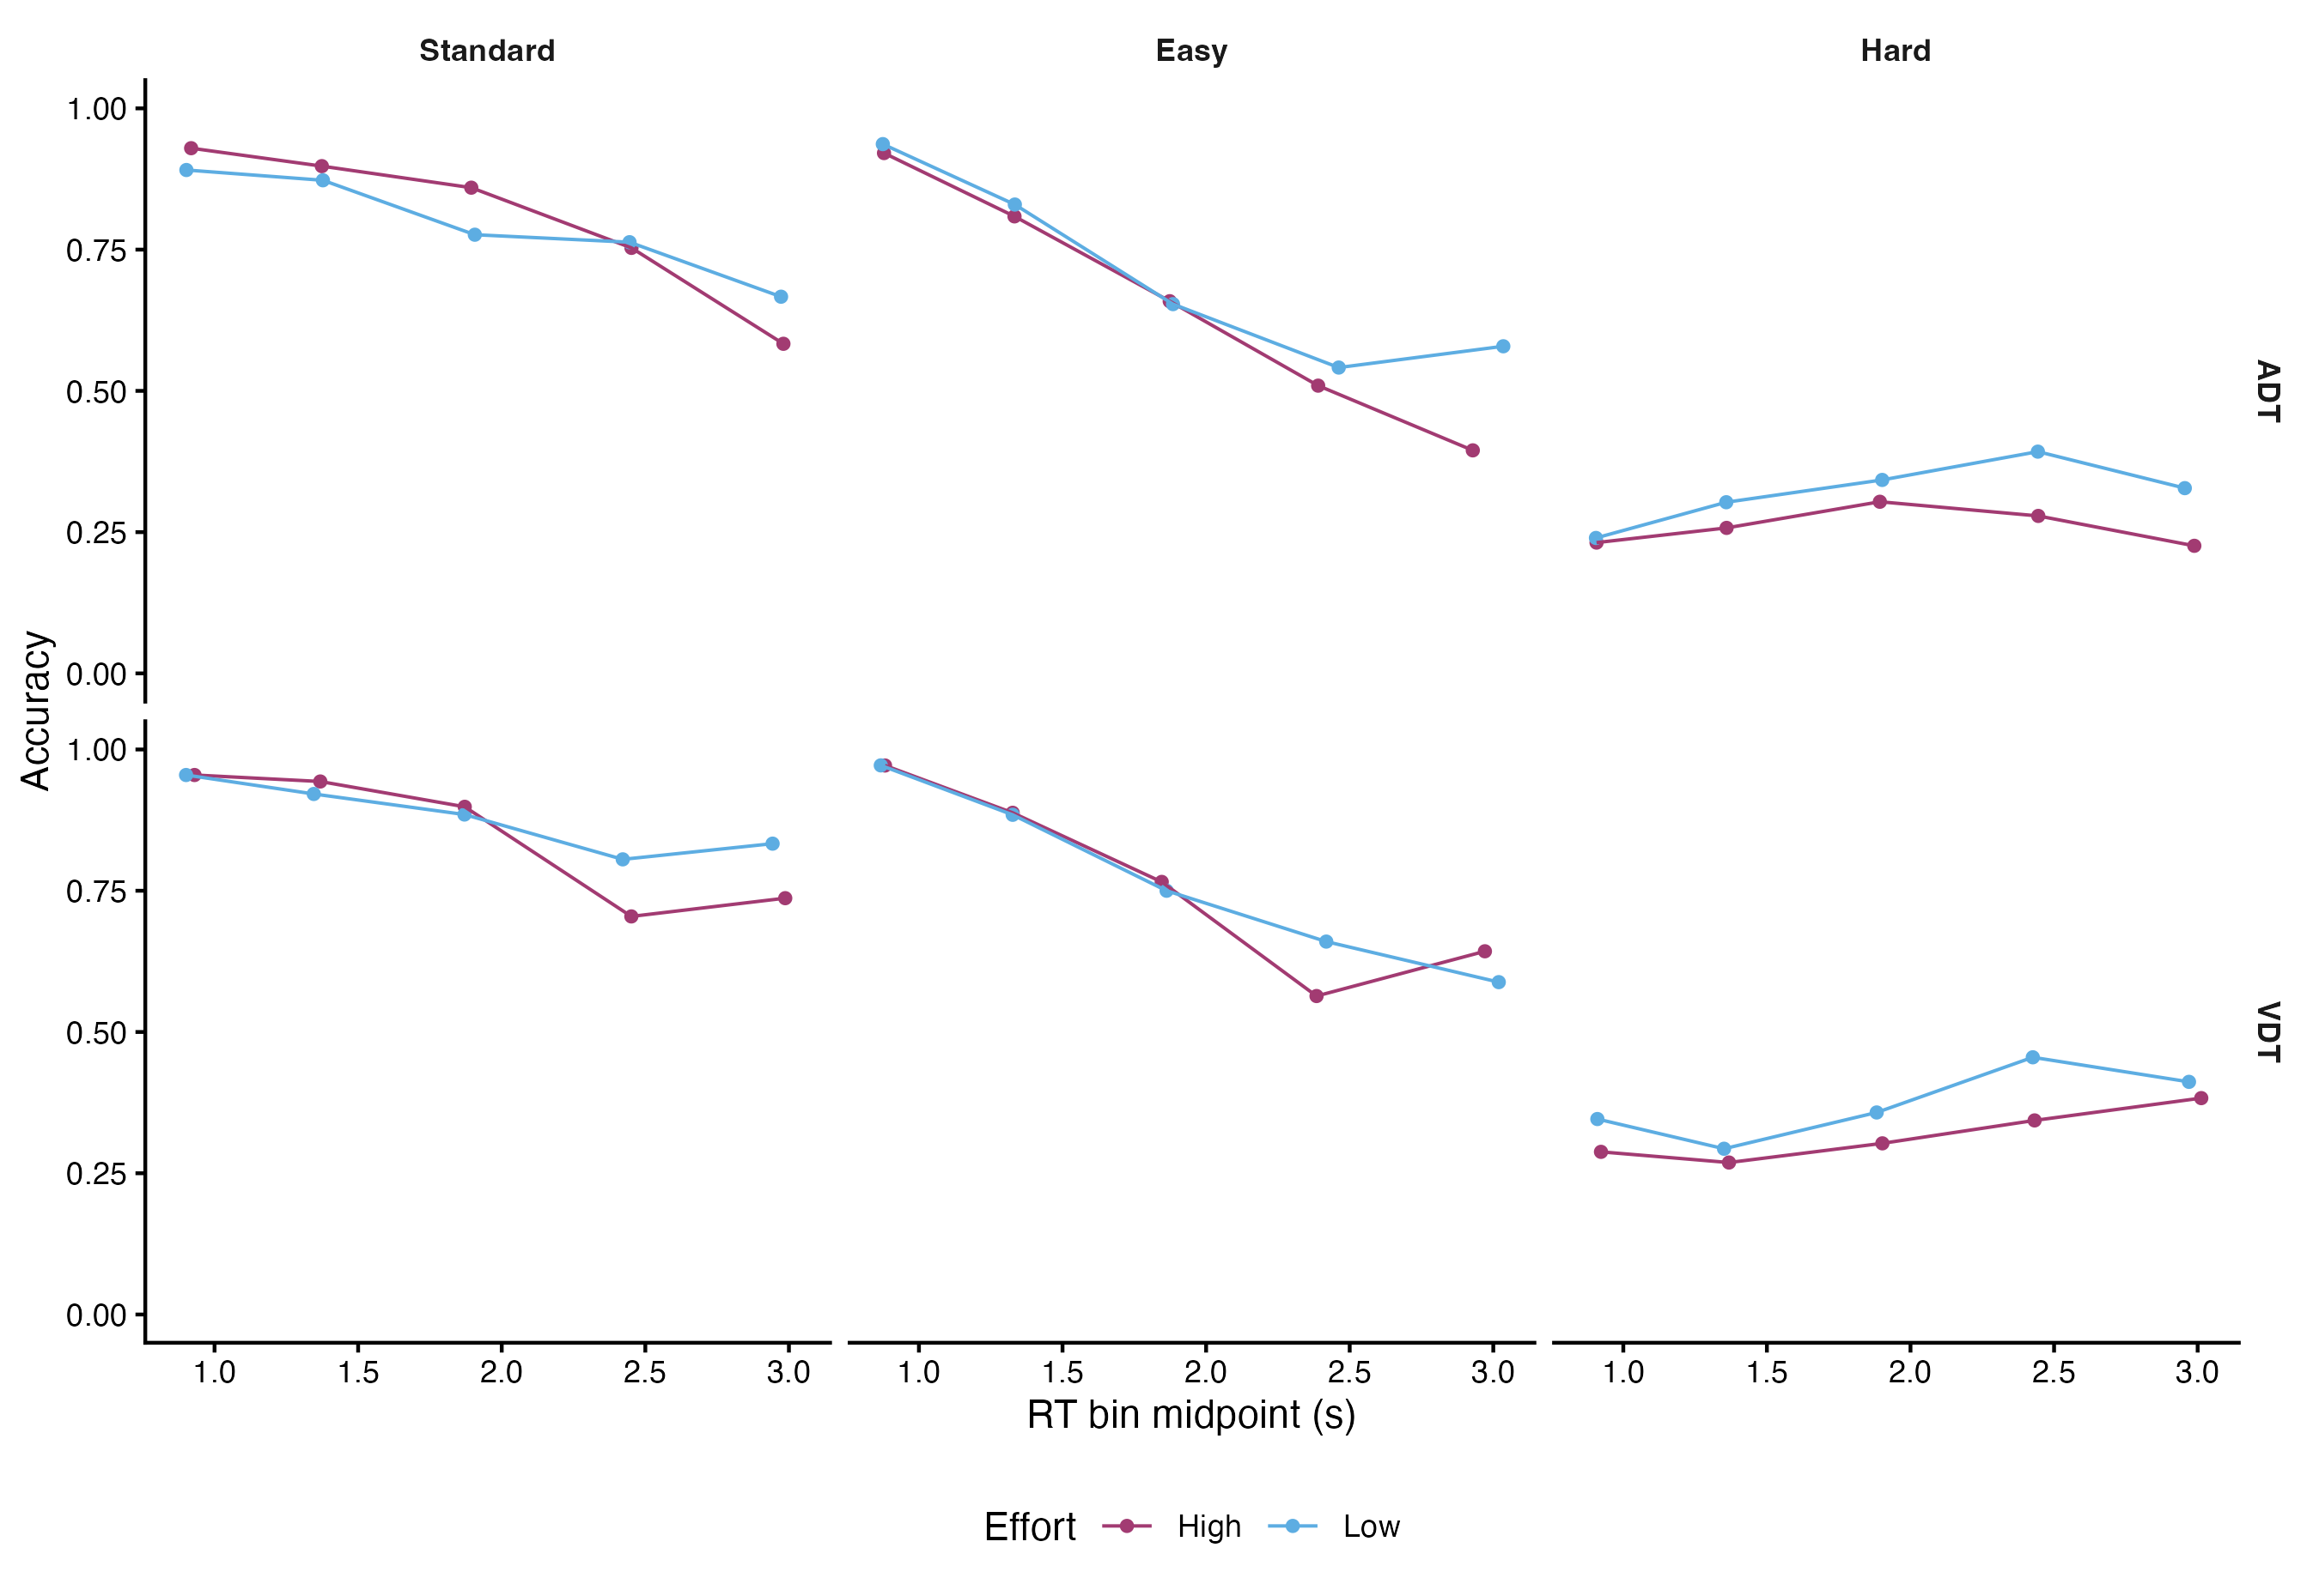
Figure S8: [CAPTION TO BE SUPPLIED]

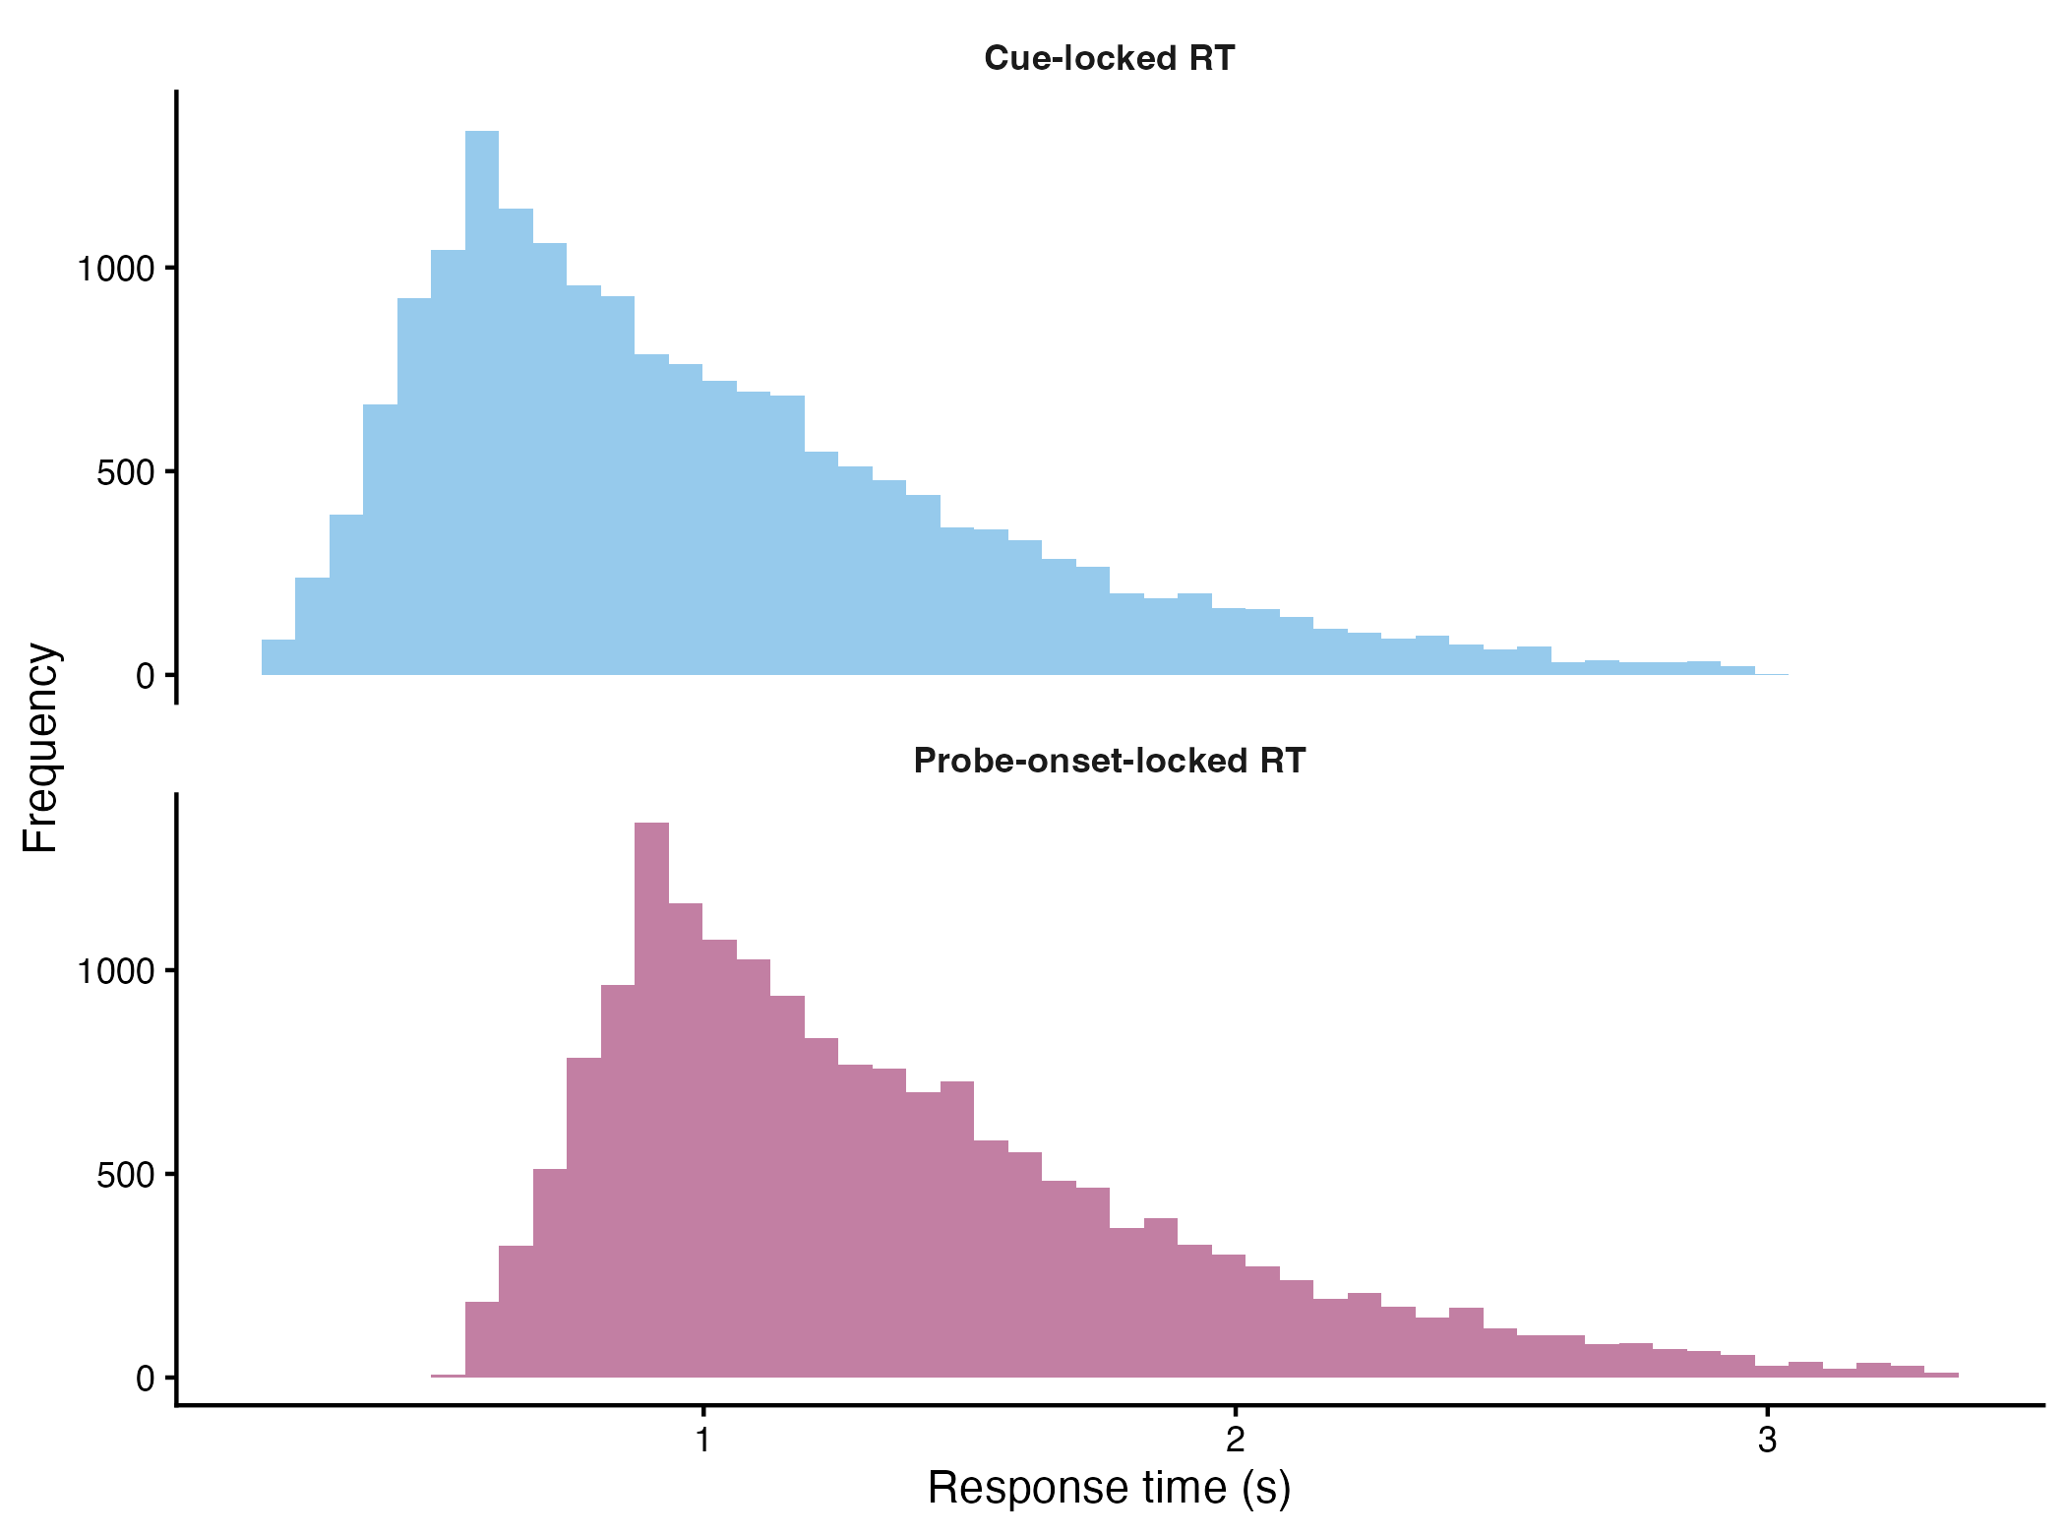
Figure S9: [CAPTION TO BE SUPPLIED]

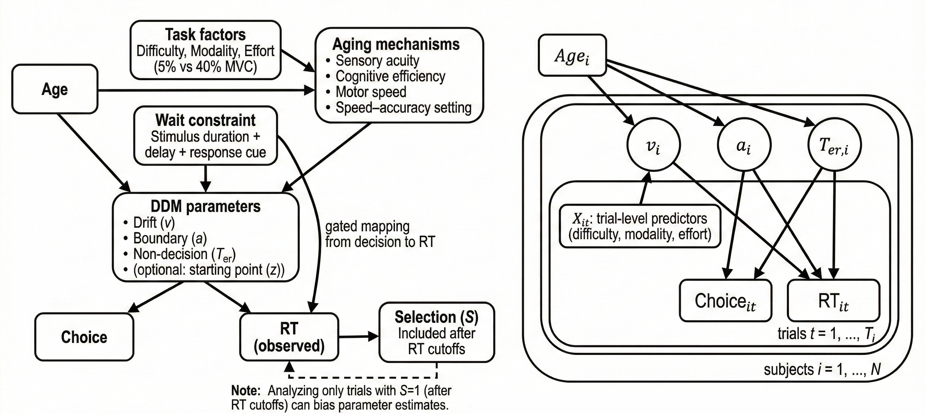
Figure S10: [CAPTION TO BE SUPPLIED]

S12 Analysis provenance (dissertation only)
[PROSE TO BE SUPPLIED: S12 Analysis provenance (dissertation only)] Resolves Lani comments: none. Inline value keys available for this section: none. Tables/figures in this section: none.

