MIPAC TVET 2026 • CIAST
LAYOUTLAB AR
A NOSS-Aligned Augmented Reality Trainer for Java Swing Interface Prototyping
Mohd Azlan bin Ab Aziz¹ | Hasnah binti Ngah²
Politeknik Mukah, Sarawak, Malaysia

Extended Abstract
Java Swing layout managers are difficult for novice learners because their rules remain invisible until code is compiled. LayoutLab AR is a browser-based augmented reality teaching aid aligned to IT-010-3:2016-C01, Application Prototype Development. Using a mobile device camera and an original tracked target, learners manipulate a virtual JFrame and complete three assessed BorderLayout missions. They place an application title in NORTH, test that CENTER absorbs remaining space during resizing, and diagnose why two buttons cannot independently occupy SOUTH before repairing the structure with a nested JPanel. Progress depends on touching the tracked 3D objects; conventional answer buttons cannot complete the assessment. The final AR state produces deterministic Java code showing the implemented prototype. The module integrates text, tracked 3D graphics, animation, spatial interaction and generated code. LayoutLab AR therefore makes AR essential to constructing, testing and repairing an application prototype rather than using it as a decorative visual overlay.
Keywords: augmented reality, BorderLayout, Java Swing, NOSS, prototype development, TVET

1. Problem and Objective
In BorderLayout, each region accepts one direct component and CENTER absorbs the remaining space. Learners commonly misread these rules, causing disappearing components and unpredictable resizing. The objective is to let learners construct, functionally test, diagnose and repair a Swing prototype through direct AR manipulation while producing auditable NOSS evidence.

2. AR Innovation and Assessed Flow
The camera recognises an original LayoutLab target and anchors a colour-coded 3D JFrame to it. Touch coordinates are raycast against mission-relevant meshes, making tracking, spatial anchoring and 3D interaction necessary for completion. BorderLayout is intentionally the assessed focus; FlowLayout and GridLayout remain enrichment content in the wider Playground.
Mission | AR task | Evidence
1 — Construct | Touch NORTH to place the application title. | Correct constraint and updated Java state.
2 — Test | Touch CENTER and observe the resize animation. | Verified dynamic layout behaviour.
3 — Diagnose and repair | Reveal the SOUTH collision and activate the JPanel repair. | Both buttons visible; score 3/3; nested-panel Java.
Why the AR is essential
The tracked object is the learning model, touch surface and assessment interface. The learner must act on the 3D regions to progress.

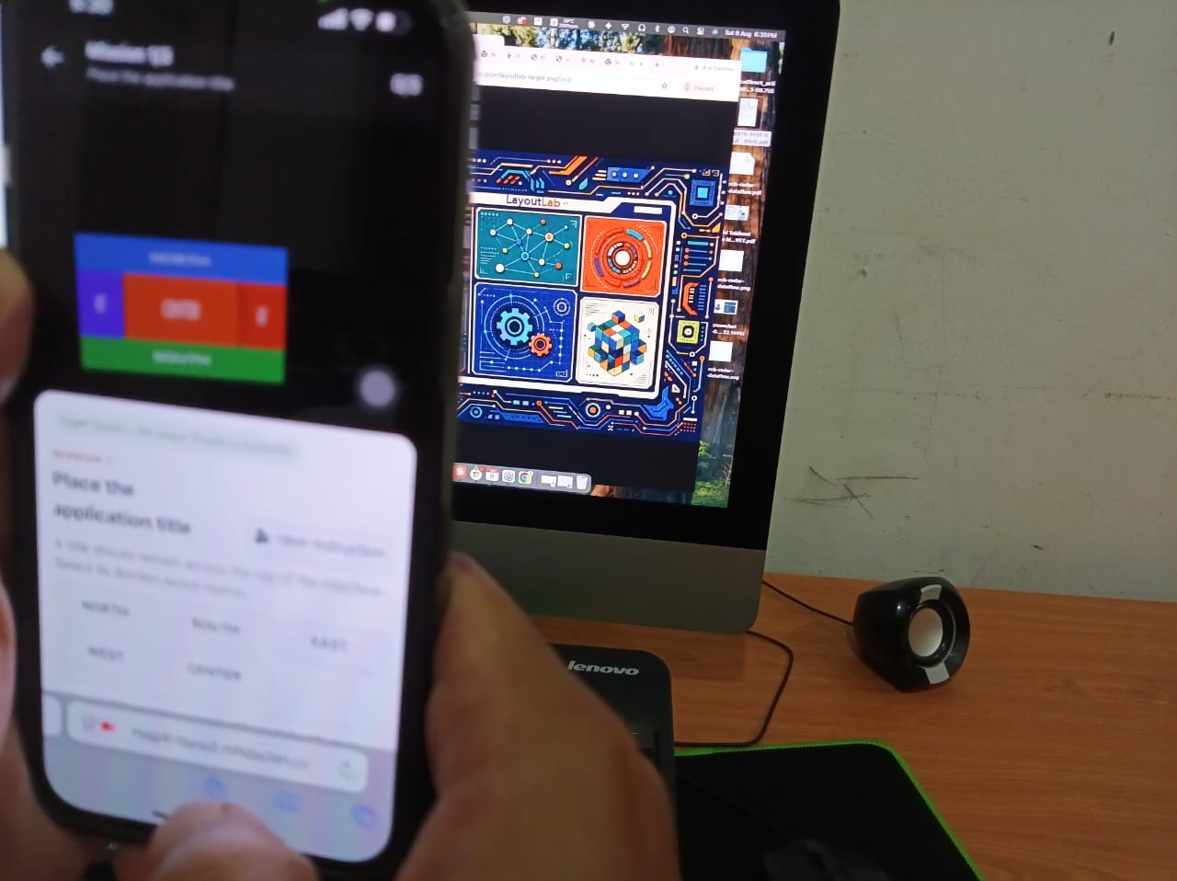  Figure 1. Target detected and 3D model anchored. | 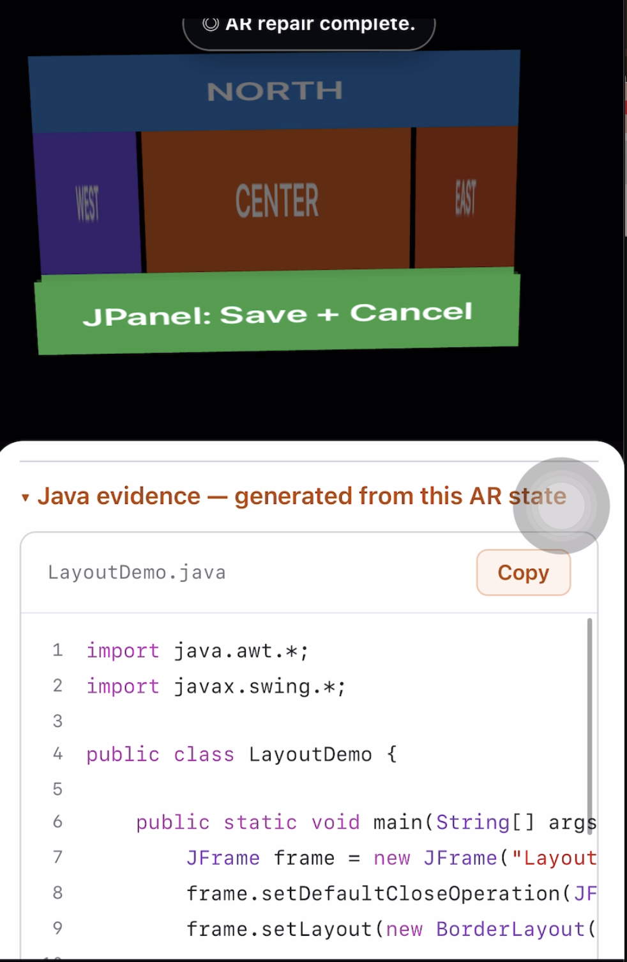  Figure 2. CENTER functionality test.

3. Media Elements
Several elements have defined learning functions: text communicates missions and rules; tracked 3D graphics expose the layout model; animation demonstrates resize and collision behaviour; direct touch assesses spatial decisions; and deterministic Java connects the AR prototype to implementation evidence.

4. Impact and Conclusion
LayoutLab AR shortens the distance between an abstract layout rule and its visible consequence. Learners construct a state, test behaviour, diagnose a failure, repair the structure and receive verifiable Java evidence. Lecturers gain a repeatable demonstrator aligned to a defined competency, while web deployment avoids native installation. The innovation is strongest when presented as a focused BorderLayout competency module: AR is the method of learning and assessment, and deterministic code—not generative AI—is the technical ground truth.

Declaration and Reference
The work is original and its evidence can be verified. Generative AI does not determine correctness, scoring or assessed Java output.
Keuning, H., Jeuring, J., & Heeren, B. (2018). Automated feedback generation for programming exercises. ACM TOCE, 19(1).

