LAYOUTLAB AR: A NOSS-ALIGNED TRAINER FOR JAVA SWING PROTOTYPING
Mohd Azlan bin Ab Aziz^{1*}, Hasnah binti Ngah²
¹ Department of Information and Communication Technology, Politeknik Mukah, Sarawak, Malaysia
² Department of Commerce, Politeknik Mukah, Sarawak, Malaysia

Extended Abstract
Java Swing layout rules are difficult for novice diploma students because their behaviour remains invisible until code is compiled. Students often respond by changing coordinates, recompiling, and guessing again. We consider that cycle pedagogically weak: it consumes lab time but does little to build a transferable mental model. LayoutLab AR is developed for DFP50463 Java Based Application Development runs in a browser, requires no installation, and available at https://magik-layout.mhdazlan.cc/. Using a mobile device and an original tracked target, learners manipulate a virtual JFrame through three JFrame layout missions. Also in the web app there are sections where students add Swing components to a live canvas, switch various layouts, resize the frame, and immediately observe faithful ports of the relevant JDK layout behaviour. The system generates deterministic, compile-able Java code for every action. A challenge area adds ten exercises in three modes: Parsons ordering, reflow prediction and reverse reconstruction
Keywords: assessment integrity, Java Swing, immersive teaching aid, spatial interaction, TVET
1. Background / Problem Statement
Students may reproduce Swing syntax without predicting resizing, region collisions or nested panels (Qian & Lehman, 2017). In the first evaluation, 81.9% of 11 Semester 5 students reported layout difficulty. Slides state the rules, while GUI builders often conceal them. The gap is an intervention that makes behaviour observable and requires learners to test and repair a prototype.
2. Innovation Objective
The objective is to enable learners to construct, functionally test, diagnose and repair a BorderLayout prototype in AR, then produce verifiable Java evidence aligned to the specified NOSS work activities.

3. Description of Innovation
LayoutLab AR uses image-based tracking to present an interactive 3D representation of a Java Swing interface within the learner’s physical environment. Learners complete a sequence of guided activities involving interface construction, behaviour testing, problem diagnosis and structural improvement. Direct interaction with the AR model is supported by immediate visual, audio and code-based feedback. Figure 1 illustrates the main stages of the learning experience, from target detection and prototype manipulation to task completion and generated Java evidence. BorderLayout provides the primary learning context, while the wider LayoutLab platform supports other layout managers for further exploration. Figure 1 records the tracked model, mission progress, repair and generated code. FlowLayout and GridLayout remain enrichment in the wider Playground; BorderLayout is the focused assessed competency.

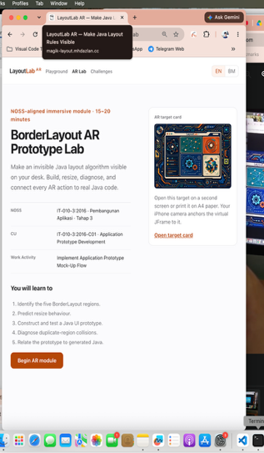 | 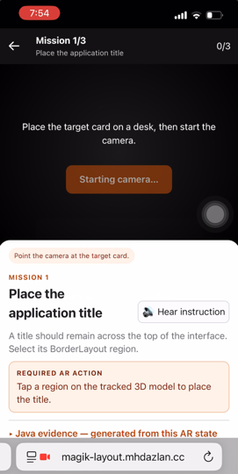 | 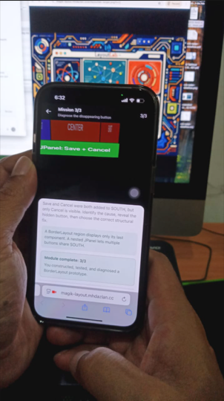 | 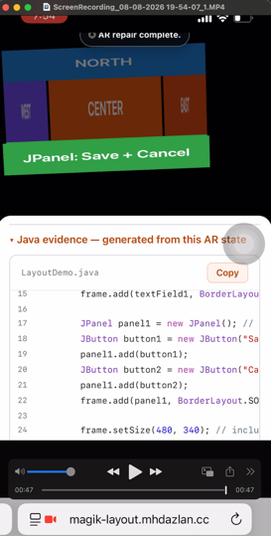

Figure 1. LayoutLab AR evidence sequence: tracking, construction, functionality testing and structural repair.

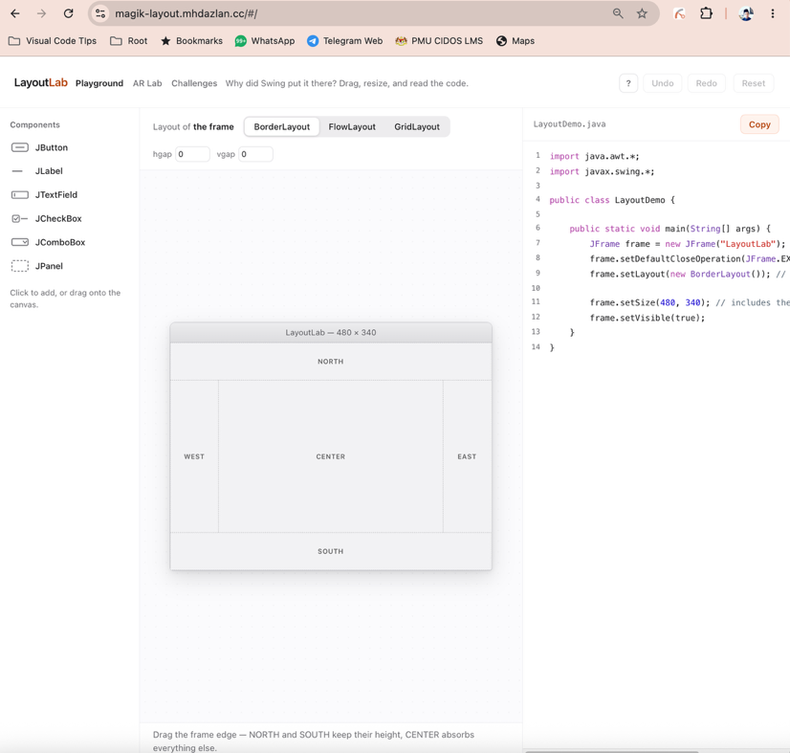

Figure 2. Playground section

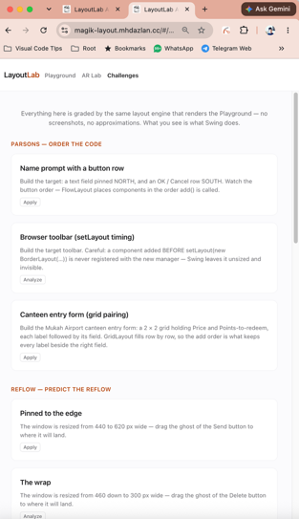 | 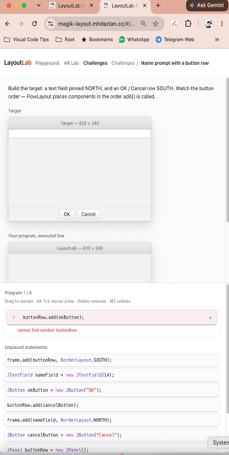 | 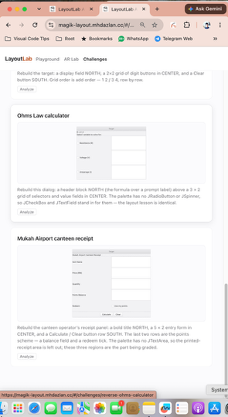 | 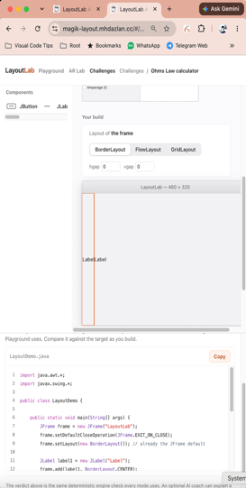

Figure 3. Challenge section

4. Methodology / Development Process
Development followed problem identification, needs analysis, design, implementation and validation. Feedback from 11 students prioritised visualisation, Java export and guidance; a second evaluation (n=6) informed onboarding and resizing feedback. The AR module uses React, Three.js and MindAR, connects to LayoutLab’s deterministic state and code-generation engines, and was tested through automated checks and iPhone 13 acceptance. The target uses an original asymmetric image. Generative AI is excluded from grading.
5. Innovation Value Proposition
Table 1. Innovation value proposition
Component | Description
Novelty | Tracked 3D prototype serves as model, touch surface and deterministic assessment.
Usefulness | Connects a layout rule to visible behaviour, repair and compilable Java evidence.
Replicability | Adaptable to other layout managers, courses and institutional challenge sets.
Cost Effectiveness | Secure browser delivery avoids native installation and licence costs.
Sustainability | Reusable deterministic engine and automated tests support maintenance.
Scalability | Potential expansion across polytechnics through additional NOSS-aligned modules.

6. Findings, Validation and Evidence of Effectiveness (Where Applicable)
Evidence is separated into formative platform feedback and AR technical acceptance to avoid overstating effectiveness. Table 2 summarises the current position.
Table 2. Formative and technical evidence
Evidence Item | Before / Baseline | After / Result | Interpretation
Learning need | 81.9% reported layout difficulty (n=11). | Three AR missions address placement, resize and nesting. | Strong need; AR learning gain not yet measured.
Visual understanding | 81.8% valued visual clarification (n=11). | All six later users reported placement or resizing ‘aha’ moments. | Supports the visual method, not causal AR impact.
Technical quality | Browser engine and prototype baseline. | 75 automated tests and strict production build pass. | Reproducible grading and code generation.
Device acceptance | AR required mobile production validation. | iPhone 13 verified HTTPS camera, tracking, touch, audio and 3/3 completion. | Ready for competition demonstration.
7. Impact of Innovation
Learners receive a construct-test-diagnose-repair sequence with code evidence. Lecturers gain a repeatable browser demonstrator without native installation. The immediate market is Malaysian polytechnic and vocational Java courses; institutional challenge packs offer future commercialisation potential. NOSS alignment supports competency-based TVET, while the architecture can scale to other layout managers and prototype tasks.
8. Conclusion
LayoutLab AR makes an invisible programming rule spatial, touchable and assessable. Its contribution is the complete evidence chain from AR action to tested behaviour, structural repair and deterministic Java. The module is technically ready for demonstration; the next step is a documented classroom pilot measuring completion time, errors and learning performance.
Declaration
The authors declare that:
- The work is original;
- All authors have contributed substantially;
- No plagiarism has occurred;
- AI-assisted content has been reviewed and validated by the authors; and
- All data are accurate and can be verified upon request.
AI-use disclosure
OpenAI Codex was used to assist software development and manuscript editing. The authors verified outputs against the source code, automated tests, device recordings, NOSS mapping and official template. AI does not determine learner scores or generate assessed Java output.
References
Keuning, H., Jeuring, J., & Heeren, B. (2018). A systematic literature review of automated feedback generation for programming exercises. ACM Transactions on Computing Education, 19(1), Article 3. https://doi.org/10.1145/3231711
Qian, Y., & Lehman, J. (2017). Students’ misconceptions and other difficulties in introductory programming: A literature review. ACM Transactions on Computing Education, 18(1), Article 1. https://doi.org/10.1145/3077618

