

**Lab Exercise -Signed Commits in Git and GitHub**

**Submitted by: Submitted to:**

Ajay kumar Dr. Hitesh Sharma  
500121875  
B-2 (Devops)

1. **Check for existing keys**

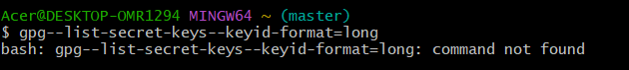

1. **If no key exists, generate a new one**
   * Select **RSA and RSA**
   * Key size: **4096**
   * Expiration: **0** (never) or a fixed date
   * Enter your **GitHub-registered name and email**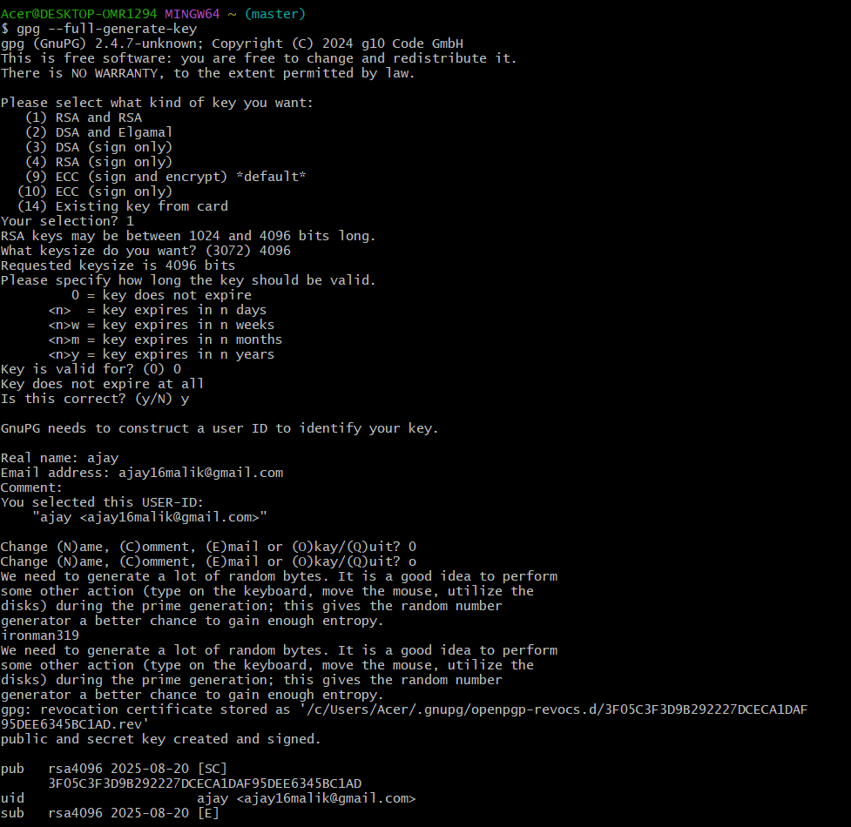

**Step 2 – Add GPG Key to GitHub**

1. **Export your public key:**

1. Copy the output.
2. Go to **GitHub → Settings → SSH and GPG Keys → New GPG Key**.

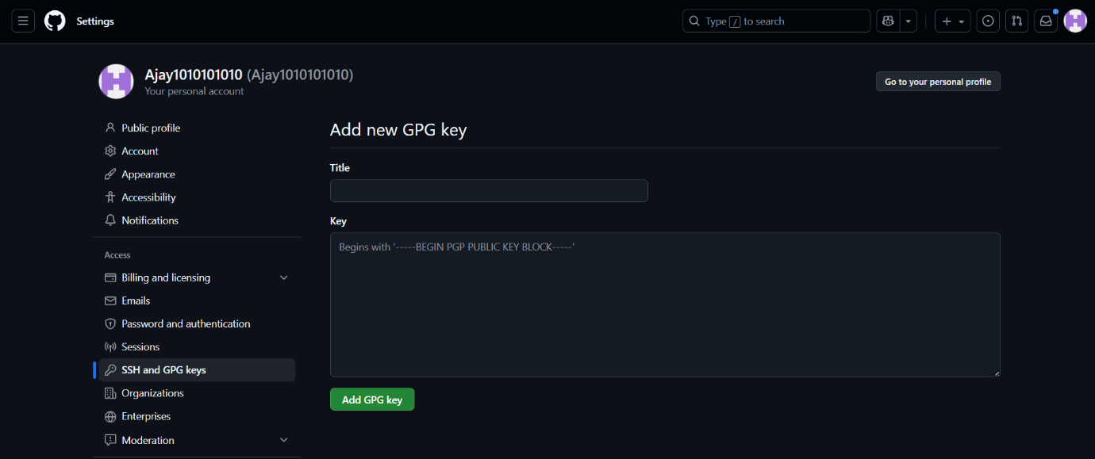

1. Paste your key and save.

**Step 3 – Configure Git for Signed Commits**

1. Tell Git which key to use:
2. Enable signing for all commits:

**Step 4 – Make a Signed Commit**

1. Clone your repo (or use an existing one):



1. Edit or create a file:

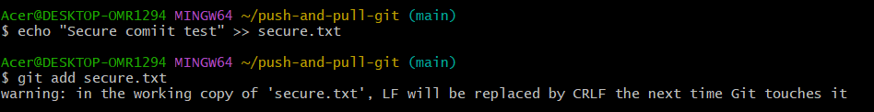

3.Commit with signing

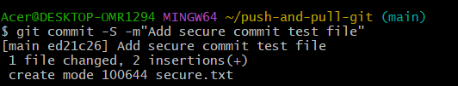

4.Enter your GPG passphrase when prompted.

**Step 5 – Push and Verify on GitHub**

1. Push the commit:

1. Go to your repository on GitHub → Click the commit → You should see a **green “Verified” badge**.

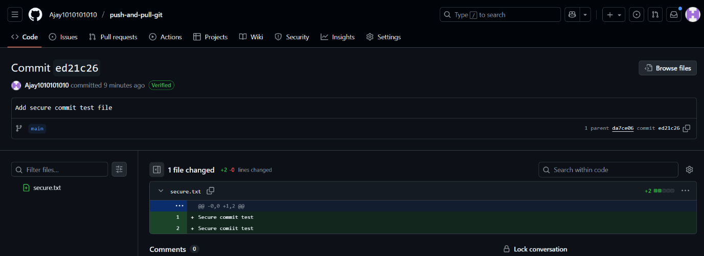

**Step 6 – Local Verification of Commit**

