**Experiment-1**

Aim:

* Learn how to use git revert to undo changes from specific commits.
* Practice handling merge conflicts during a revert.

Prerequisites:

* Install Git on your system.
* Set up a Git repository:

Steps:

1. Setup a Repository: -
2. 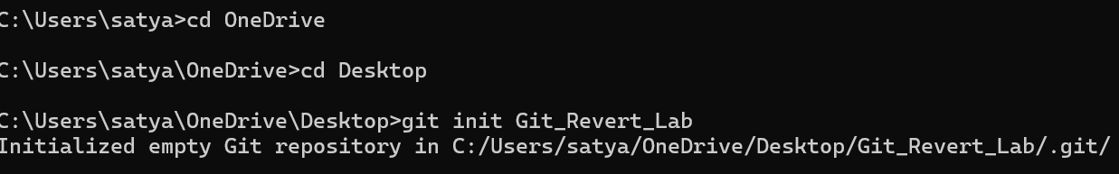Create a file:
3. Stage and commit the file:
4. 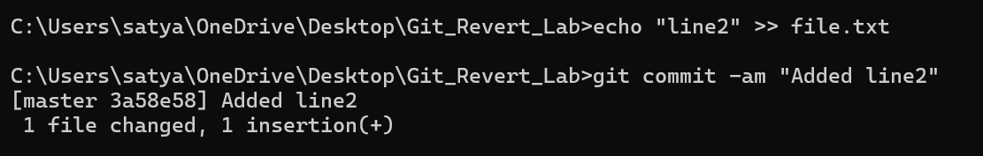Add more changes:
5. 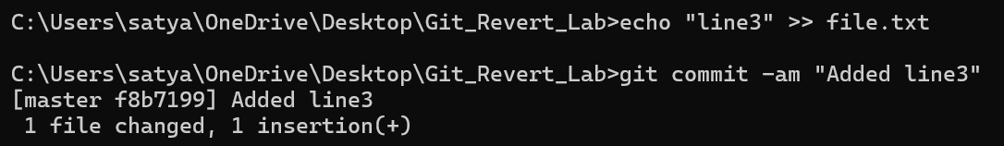Add another change:
6. Verify the commit history:
7. Revert the Last commit: -
8. Revert the most recent commit:



1. Verify the contents of file.txt:

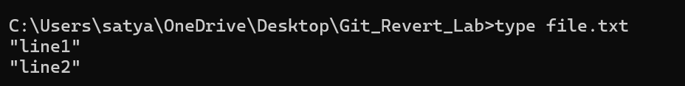

1. Check the commit history:

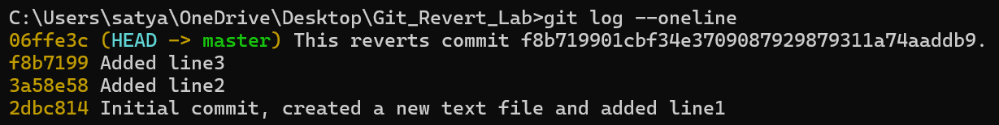

1. Handle merge conflict during commit: -
2. Modify file.txt:

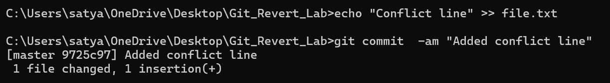

1. 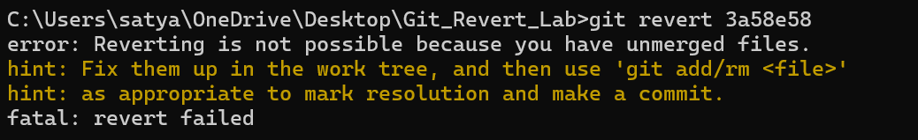Revert the second commit (8b2a1c1 again) to trigger a conflict:
2. Git will indicate a conflict. Resolve it:
   * Open file.txt and remove conflict markers.
   * 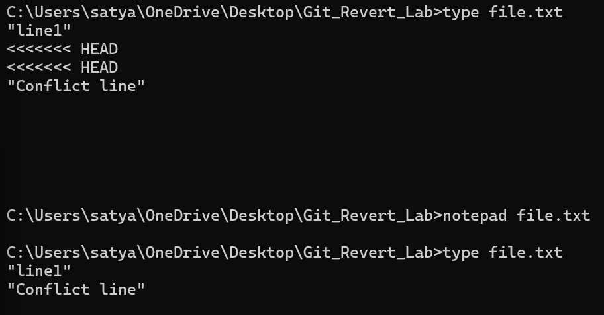Keep the desired lines.
3. Stage the resolved file:



1. 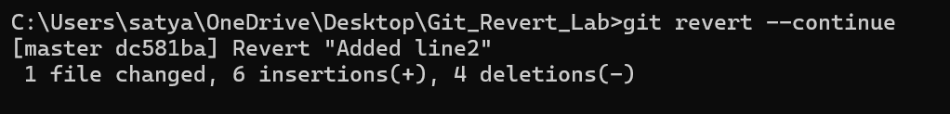Complete the revert:
2. Verify:

