**Lab Exercise 2- Working with Git Reset**

**Vansh Thakral(500125288)**

**Batch-1**

**Lab Exercise: Git Reset**

This lab exercise will guide you through the usage of the git reset command in various scenarios. The git reset command is used to undo changes in the Git history, working directory, or staging area. There are three main modes: **soft**, **mixed**, and **hard**.

**Objective**

* Learn how to use git reset to modify the commit history, unstage files, or discard changes.
* Understand the differences between --soft, --mixed, and --hard reset modes.

**Prerequisites**

1. Install Git on your system.
2. Set up a Git repository:

git init git-reset-lab

cd git-reset-lab

**Steps**

**1. Set Up the Repository**

1. Create and commit an initial file:

echo "Line 1" > file.txt

git add file.txt

git commit -m "Initial commit: Add Line 1"

1. Add a second change:

echo "Line 2" >> file.txt

git commit -am "Add Line 2"

1. Add a third change:

echo "Line 3" >> file.txt

git commit -am "Add Line 3"

1. Check the commit history:

git log --oneline

Output: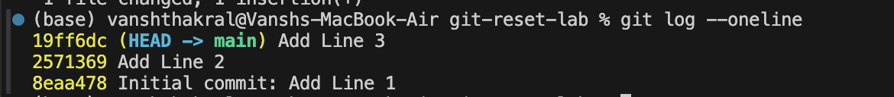

**2. Use git reset --soft**

This mode moves the HEAD pointer to an earlier commit but keeps the changes in the staging area.

1. Reset to the second commit:

git reset --soft HEAD~1

1. Check the commit history:

git log --oneline

Output:

1. Verify the staged changes:

git status

Output: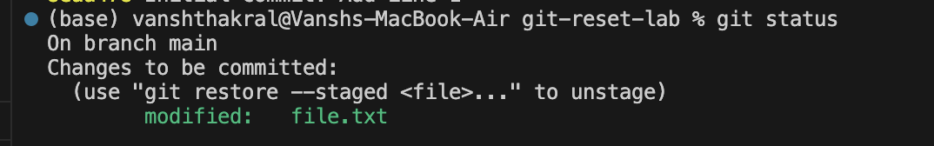

1. If needed, re-commit the changes:

git commit -m "Recommit Line 3"

**3. Use git reset --mixed**

This mode moves the HEAD pointer and unstages the changes but keeps them in the working directory.

1. Reset to the first commit:

git reset --mixed HEAD~1

1. Check the commit history:

git log --oneline

Output:

1. Verify the changes in the working directory:

git status

Output: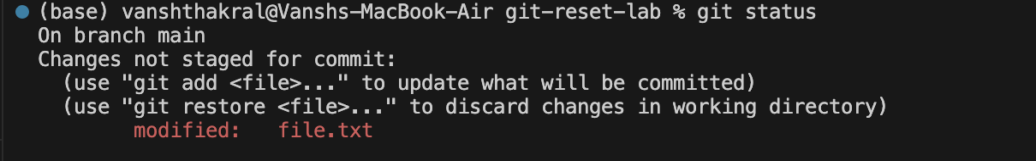

1. If needed, stage and re-commit:

git add file.txt

git commit -m "Recommit Line 2 and Line 3"

**4. Use git reset --hard**

This mode moves the HEAD pointer and discards all changes in the staging area and working directory.

1. Reset to the initial commit:

git reset --hard HEAD~1

1. Check the commit history:

git log --oneline

Output:

1. Verify the working directory: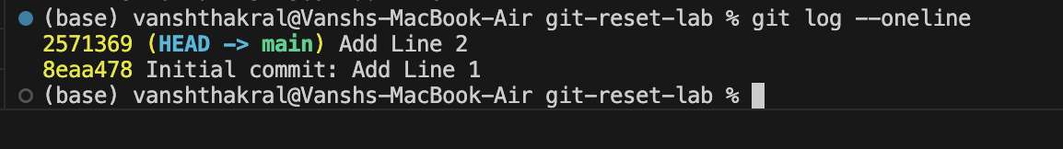

cat file.txt

Output:Screenshot 2025-08-13 at 11.44.43 PM.png

**5. Use git reset with a Commit Hash**

1. Add some changes for demonstration:

echo "Line 2" >> file.txt

git commit -am "Add Line 2"

echo "Line 3" >> file.txt

git commit -am "Add Line 3"

1. Get the commit hash for the initial commit:

git log --oneline

1. Reset to the initial commit using the hash:

git reset --hard <commit-hash>

1. Verify the working directory and commit history:

git log --oneline

cat file.txt

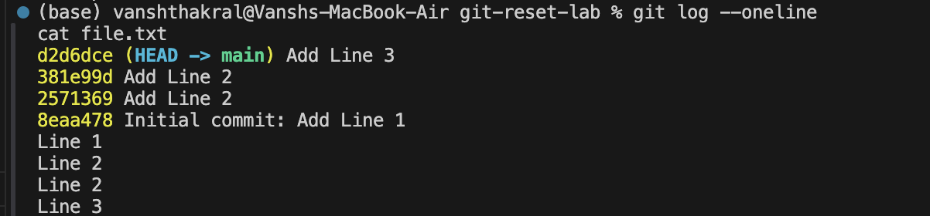

**Summary of Commands**

| **Mode** | **Effect** | **Command Example** |
| --- | --- | --- |
| --soft | Moves HEAD, keeps changes staged. | git reset --soft HEAD~1 |
| --mixed | Moves HEAD, unstages changes, keeps them in working dir. | git reset --mixed HEAD~1 |
| --hard | Moves HEAD, discards all changes in staging and working dir. | git reset --hard HEAD~1 |