**Lab Exercise – Install Terraform on Windows**

To find the latest version of Terraform for Windows:

1. Browse to the [Download Terraform](https://developer.hashicorp.com/terraform/downloads) page.

2. Select the Windows tab under the **Operating System**heading. The latest version is preselected.

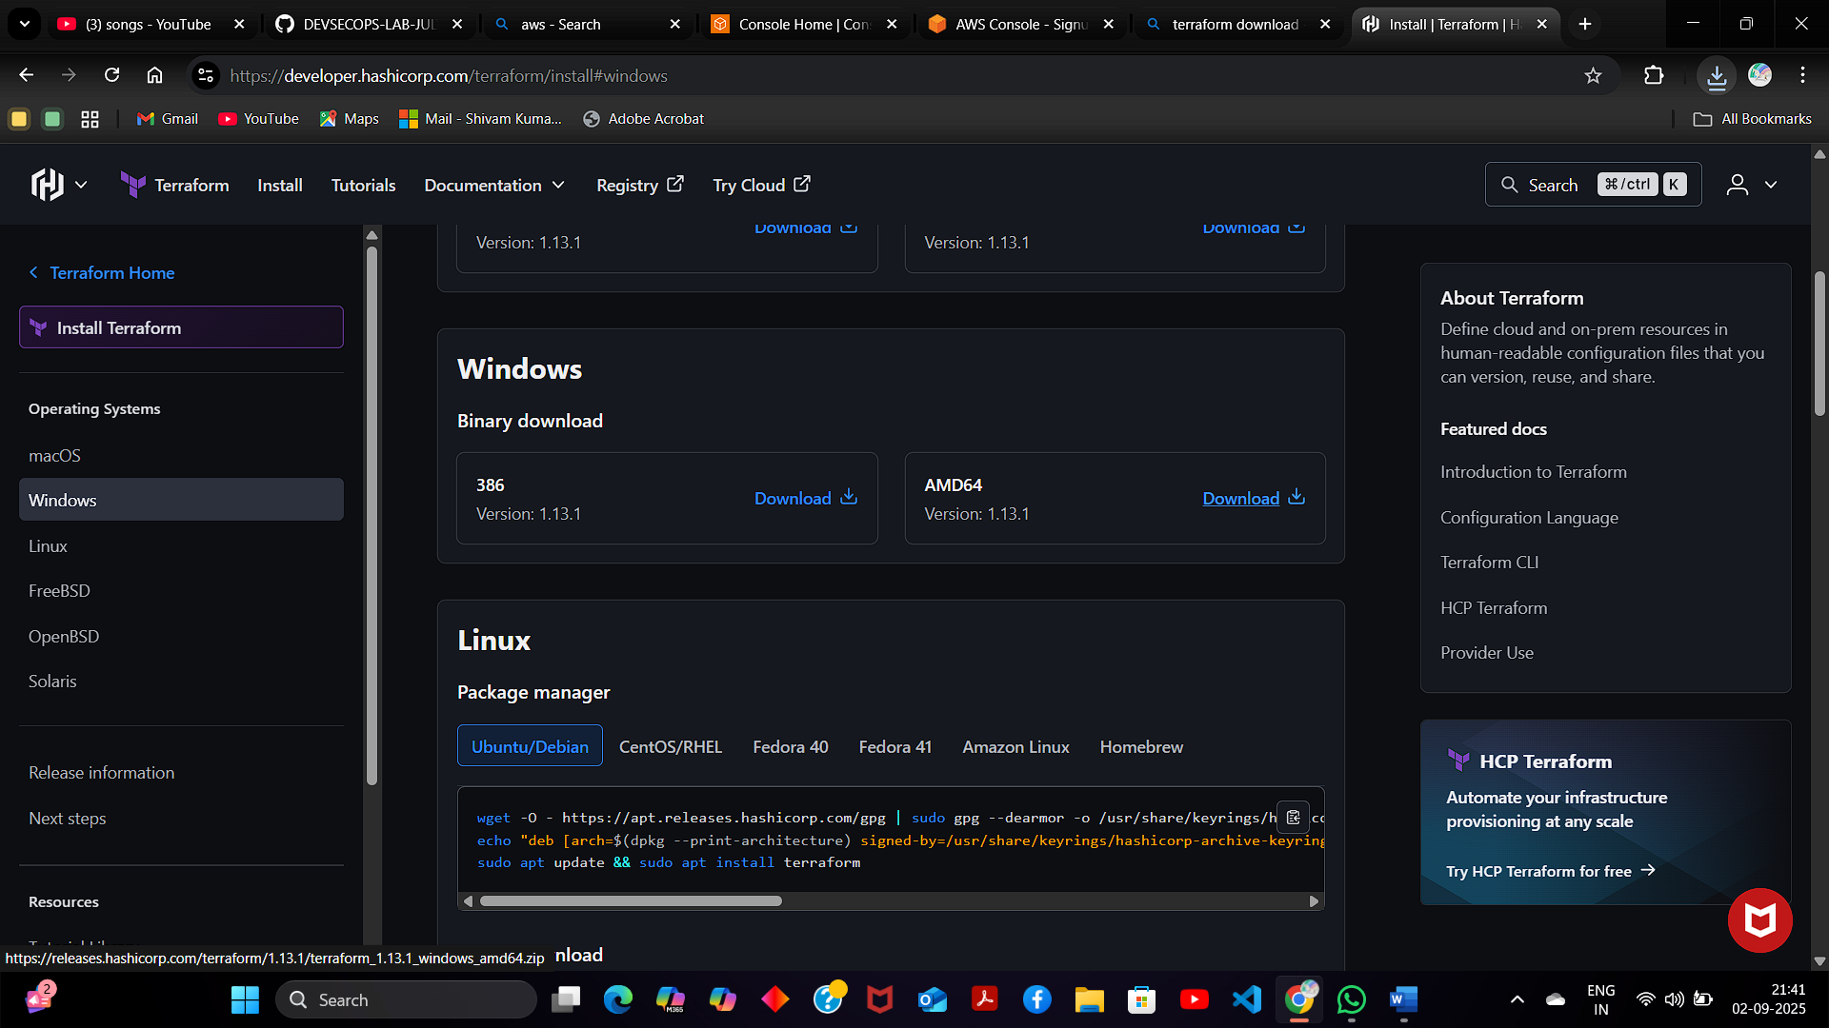

### Add Terraform Path to System Environment Variables

To add the Terraform executable to the system's global path:



1. Open the start menu, start typing environment and click **Edit system environment variables**. The System Properties window opens.

2. Click the **Environment Variables...**button

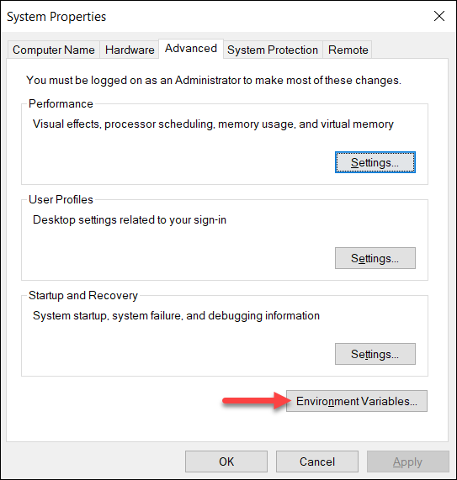



3. Select the **Path variable** in the System variables section to add terraform for all accounts. Alternatively, select **Path**in the **User variables** section to add terraform for the currently logged-in user only. Click **Edit**once you select a Path**.**

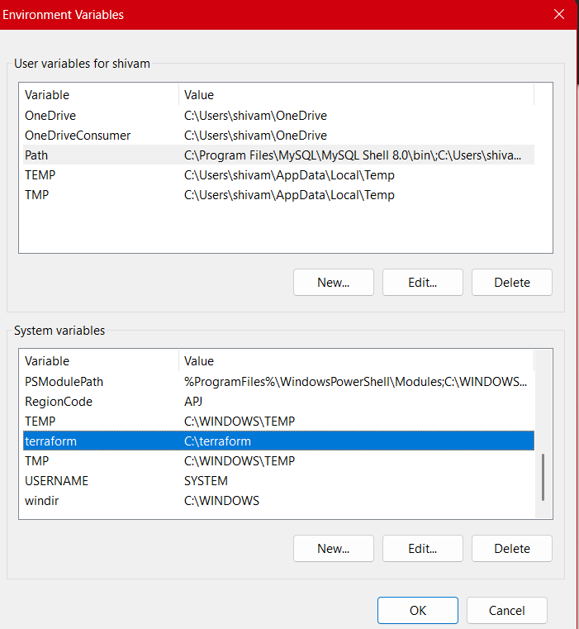

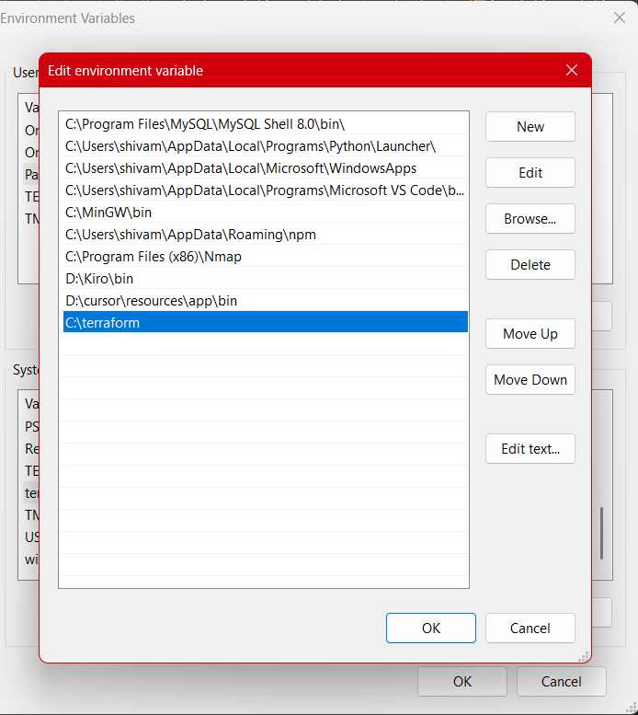

4. Click **New**in the edit window and enter the location of the Terraform folder.



5. Click **OK**on all windows to apply the changes.

### Verify Windows Terraform Installation

2. Enter the command to check the Terraform version: terraform -version

terraform -version

