**Lab Exercise 2– Terraform AWS Provider Configuration**

**Step 1: Create a New Directory:**

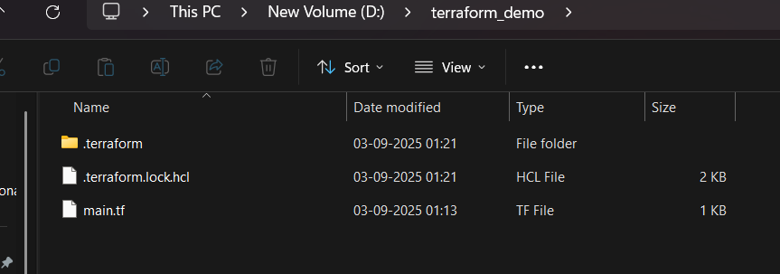

**Step 2: Create Terraform Configuration File (main.tf):**

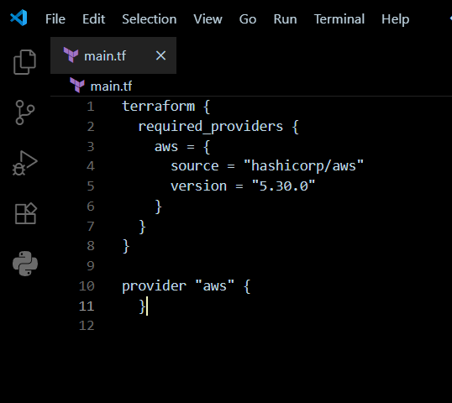

**Step 3: Initialize Terraform:**

