**Lab Exercise 3– Terraform IAM User Setting**

Create a new directory for your Terraform configuration and a file names main.tf

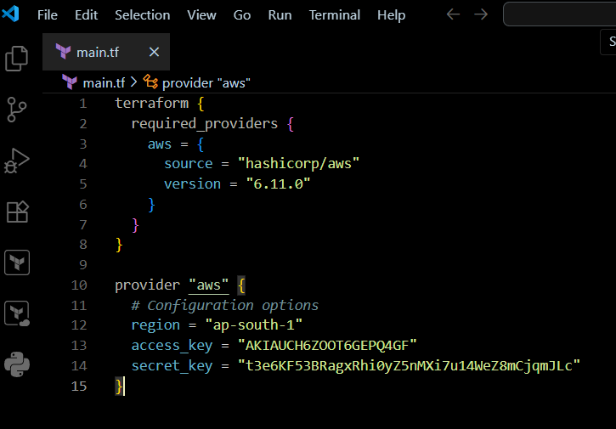This script defines an AWS provider and provisions an EC2 instance.

**Step 3: Initialize Terraform:**

