**Lab Exercise 4–Provisioning an EC2 Instance on AWS**

**“Terraform-Demo” and “main.tf”**

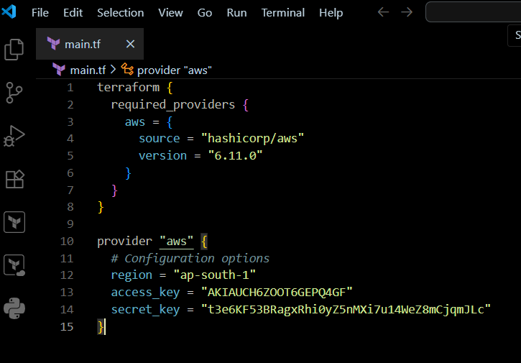

**Step 3: Initialize Terraform:**

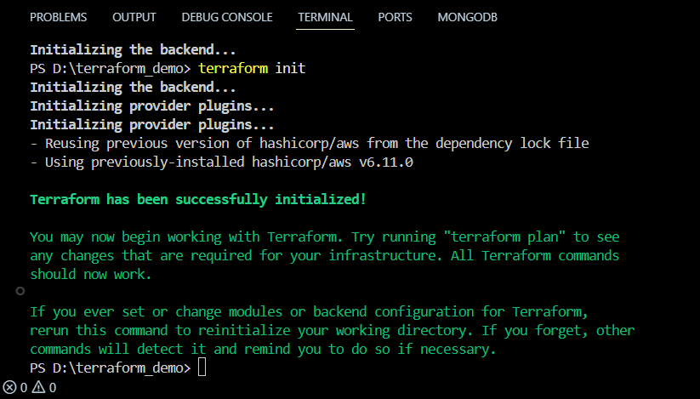

**Step 4: Create Terraform Configuration File for EC2 instance (instance.tf):**

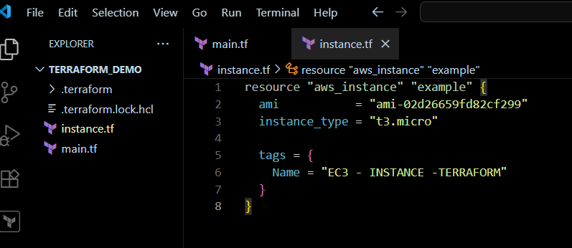

**Step 5: Review Plan:**

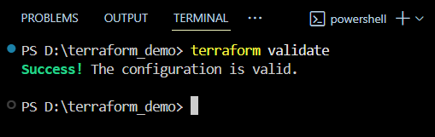

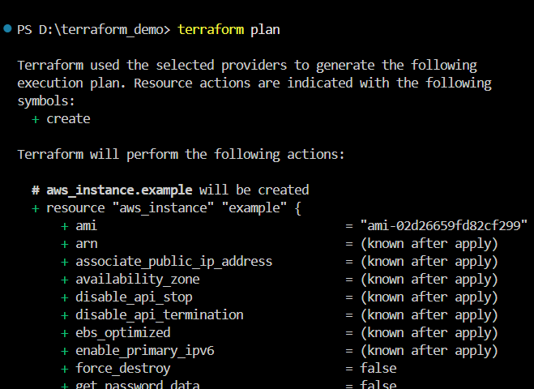

**Step 6: Apply Changes:**

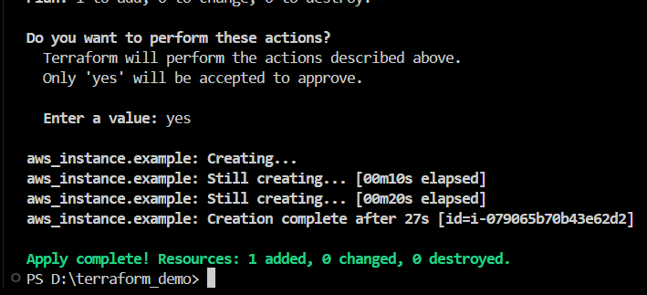

**Step 7: Verify Resources:**

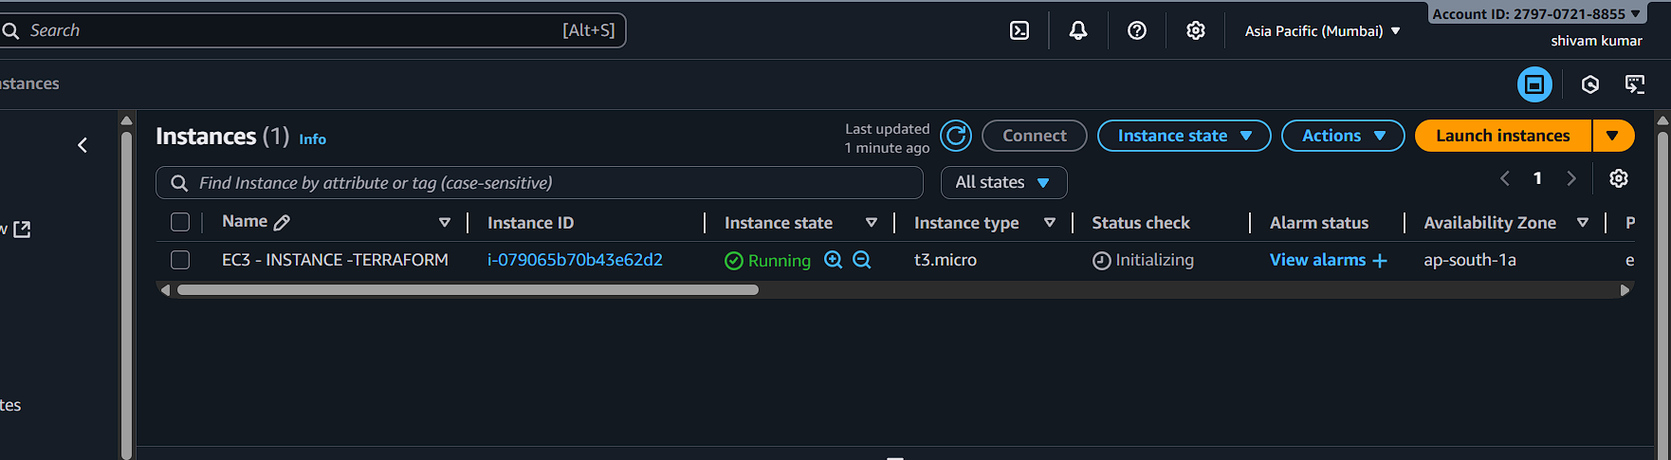**Step 8: Cleanup Resources:**

