**Lab Exercise 5–Provisioning an S3 Bucket on AWS**

**Create a file – bucket.tf**

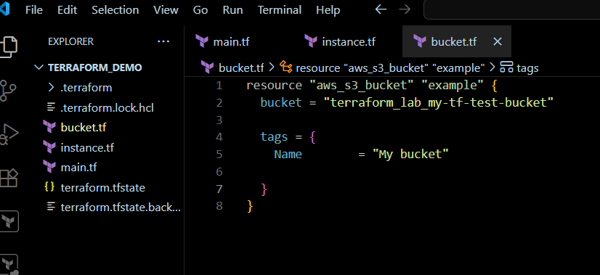

Validate the syntax ;

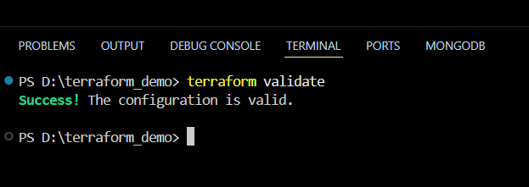

**This Creates a Terraform Configuration File for the S3 Bucket (s3.tf)**

**Step 5: Review the Plan:**

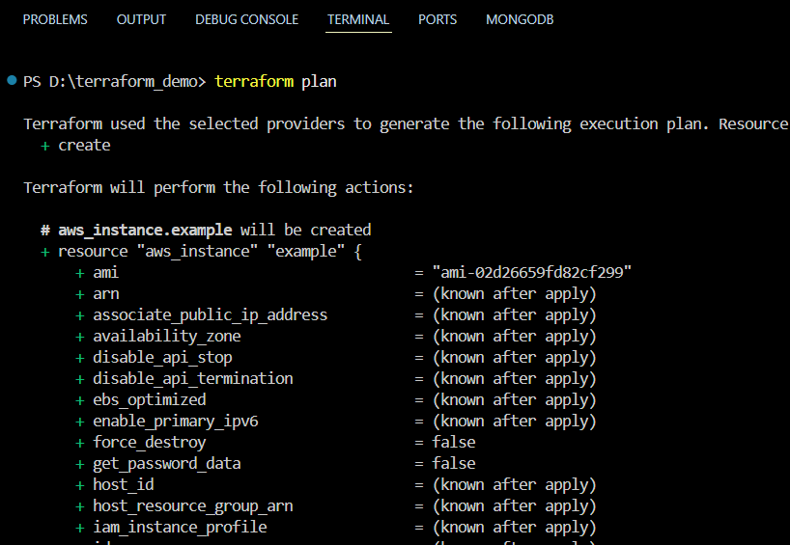 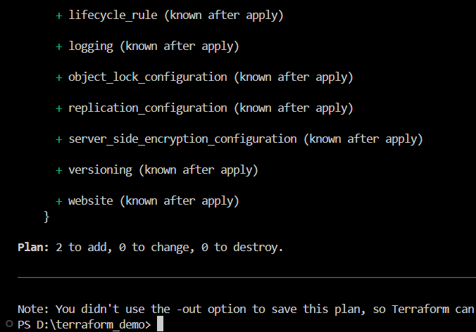

**Step 6: Apply the Changes:**

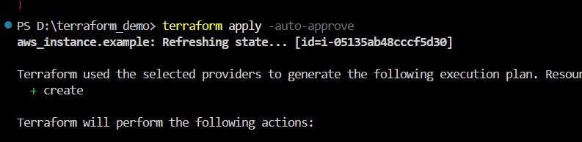

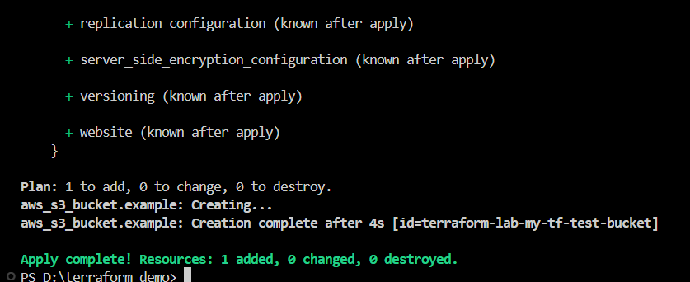

**Step 7: Verify Resources:**

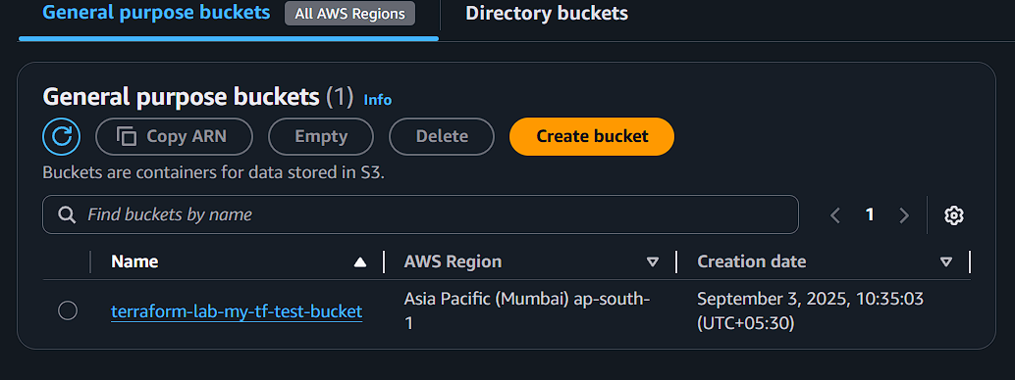

**Step 8: Cleanup Resources:**

