**Lab Exercise 7– Terraform Variables with Command Line Arguments**

**Create Terraform Configuration Files:**

# instance.tf

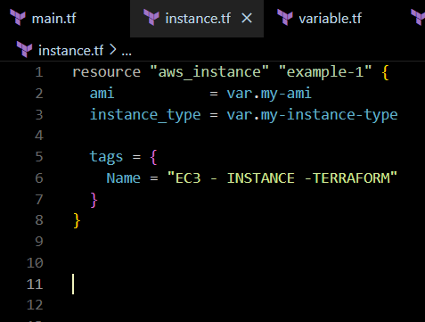

#variables.tf:

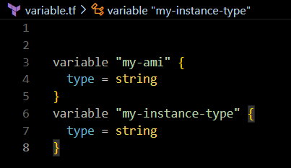

**Use Command Line Arguments:**

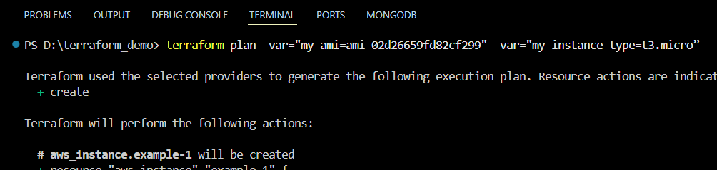

**Test and Verify:**

