**Lab Exercise 8– Terraform Multiple tfvars Files**

**# main.tf**

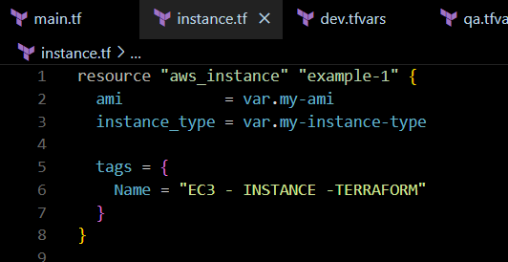

1. **Create Multiple tfvars Files:**

**# dev.tfvars**

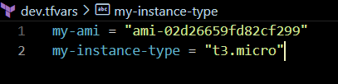

**#qa.tfvars**

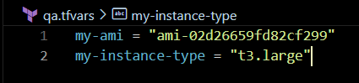

**# prod.tfvars**

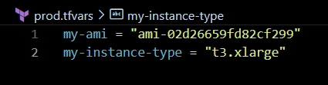

**Initialize and Apply for Dev Environment:**

