**Lab Exercise 1- Working with Git Revert**

**Lab Exercise: Git Revert**

1. Install Git on your system.
2. Set up a Git repository:

**Steps**

**1. Set Up the Repository**

1. Create a file:
2. Stage and commit the file:
3. Add more changes:
4. Add another change:
5. Verify the commit history:

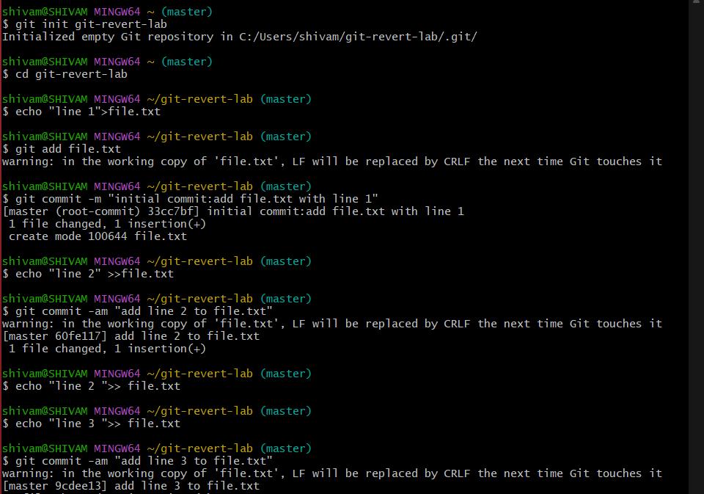

output:

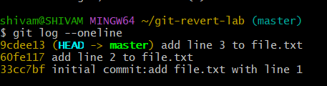

**2. Revert the Last Commit**

1. Revert the most recent commit:
2. Git will open a text editor for the commit message. Save and close the editor to complete the revert.
3. Verify the contents of file.txt:

Output:

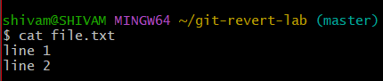

1. Check the commit history:

Example output:

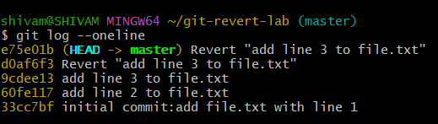

**3. Handle Merge Conflicts During Revert**

1. Modify file.txt:
2. Revert the second commit (8b2a1c1 again) to trigger a conflict:

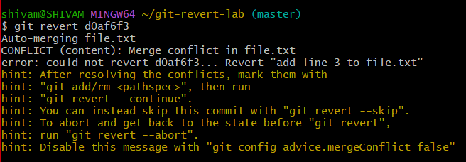

1. Git will indicate a conflict. Resolve it:
   * Open file.txt and remove conflict markers and Keep the desired lines.
2. Stage the resolved file:
3. Complete the revert:

