**Lab Exercise 3- Working with Git Rebase**

**Lab Exercise: Git Rebase**

**Step-by-Step Instructions**

**1. Set Up the Repository**

1. Create the main branch and make the initial commit:

git commit -m "Initial commit: Add Line 1 from main branch"

1. Create a new branch feature-branch:
2. Add a new line to file.txt in feature-branch:
3. Switch back to the main branch and add another line:

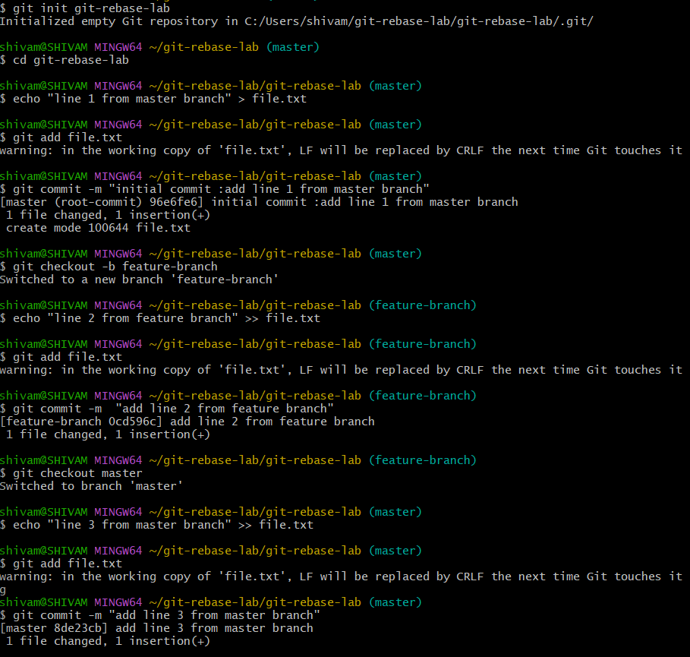

**2. Rebase feature-branch onto main**

1. Switch to feature-branch:
2. Rebase feature-branch onto main:
3. Git will replay the commit from feature-branch onto the main branch. Since there are no conflicts, the rebase completes automatically.

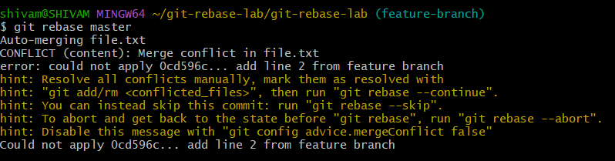

**3. Verify the Rebase**

1. View the commit history:

Example output:

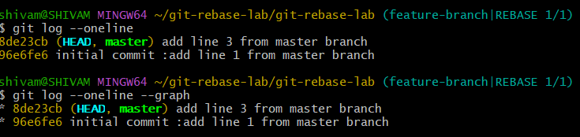

1. Check the contents of file.txt:

Output:

