**Lab Exercise 4- Signed Commits in Git and GitHub**

**Step 1 – Generate or Use an Existing GPG Key**

1. **Check for existing keys**

**If no key exists, generate a new one**

* + Select **RSA and RSA**
  + Key size: **4096**
  + Expiration: **0** (never) or a fixed date
  + Enter your **GitHub-registered name and email**

1. **Get your key ID**

Example output:

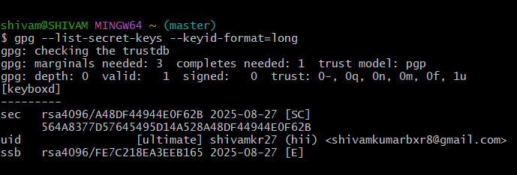

**Step 2 – Add GPG Key to GitHub**

1. Export your public key:
2. Copy the output.
3. Go to **GitHub → Settings → SSH and GPG Keys → New GPG Key**.
4. Paste your key and save.

**Step 3 – Configure Git for Signed Commits**

1. Tell Git which key to use:
2. Enable signing for all commits:

**Step 4 – Make a Signed Commit**

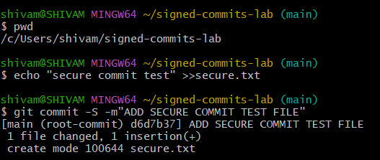

**Step 5 – Push and Verify on GitHub**

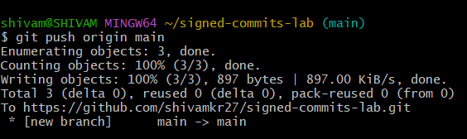

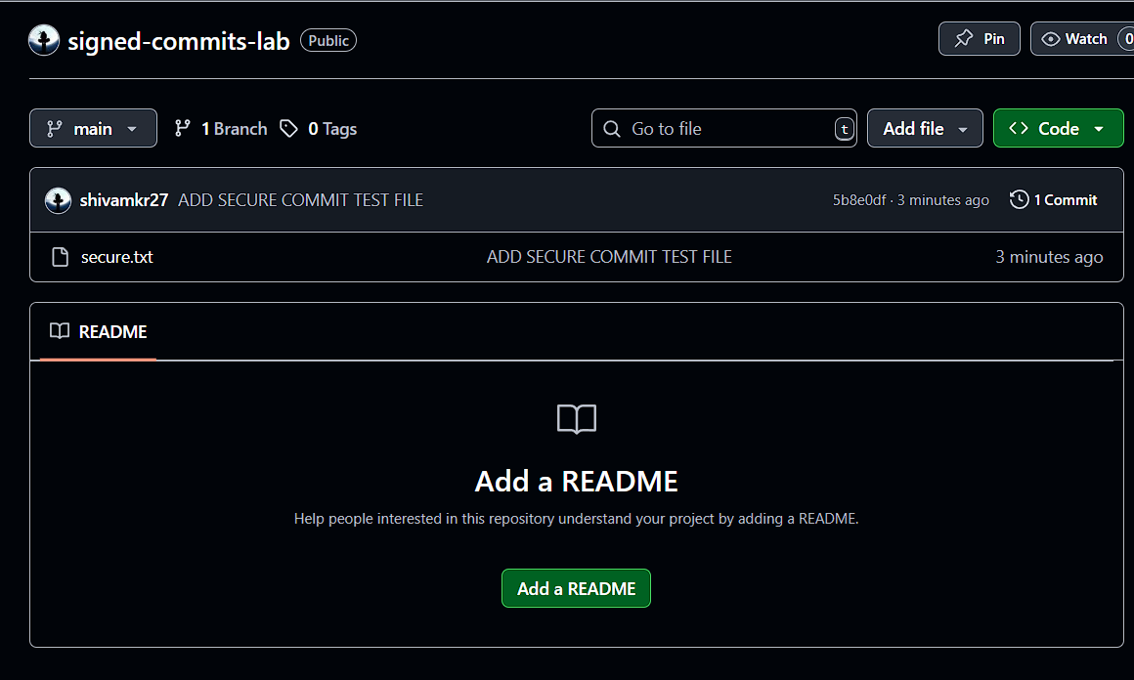

**Step 6 – Local Verification of Commit**

