**Lab Exercise 5- Generate and Use SSH Key with Git and GitHub**

**Objective:**  
To learn how to generate an SSH key, add it to GitHub, and use it to securely connect and push code without repeatedly entering a password.

**Step 1 – Check for Existing SSH Keys**

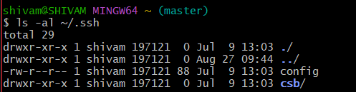

**Step 2 – Generate a New SSH Key**

* **-t rsa** → key type
* **-b 4096** → key length
* **-C** → comment (your GitHub email)

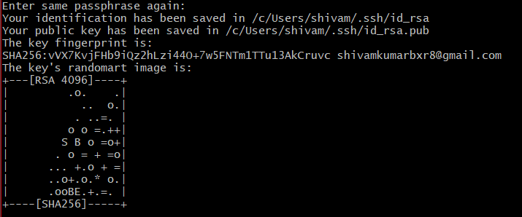

**Step 3 – Start the SSH Agent**

**Step 4 – Add SSH Key to the Agent**

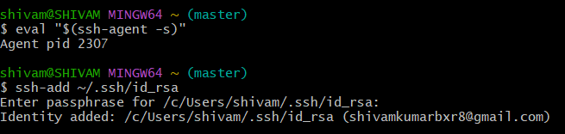

**Step 5 – Add SSH Key to GitHub**

1. Copy the public key:
2. Log in to GitHub → **Settings** → **SSH and GPG Keys** → **New SSH key**.

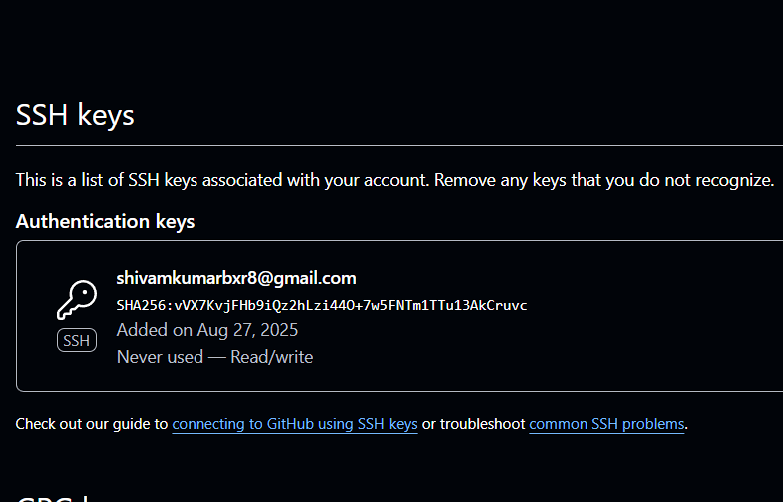

**Step 6 – Test SSH Connection**



**Step 7 – Use SSH to Clone a Repository**

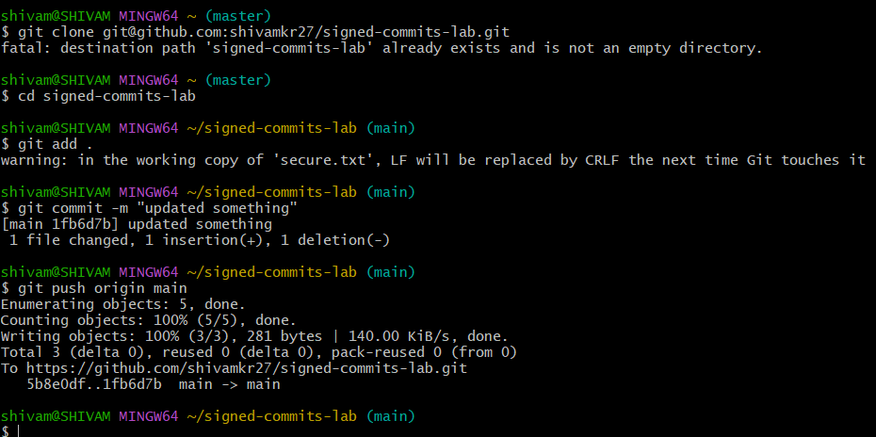

Now you can pull and push without entering your username/password.