**Lab Exercise 6.1**

**Managing Jenkins Freestyle Jobs**

**Step 1: Create a new Freestyle Job localhost:8080**

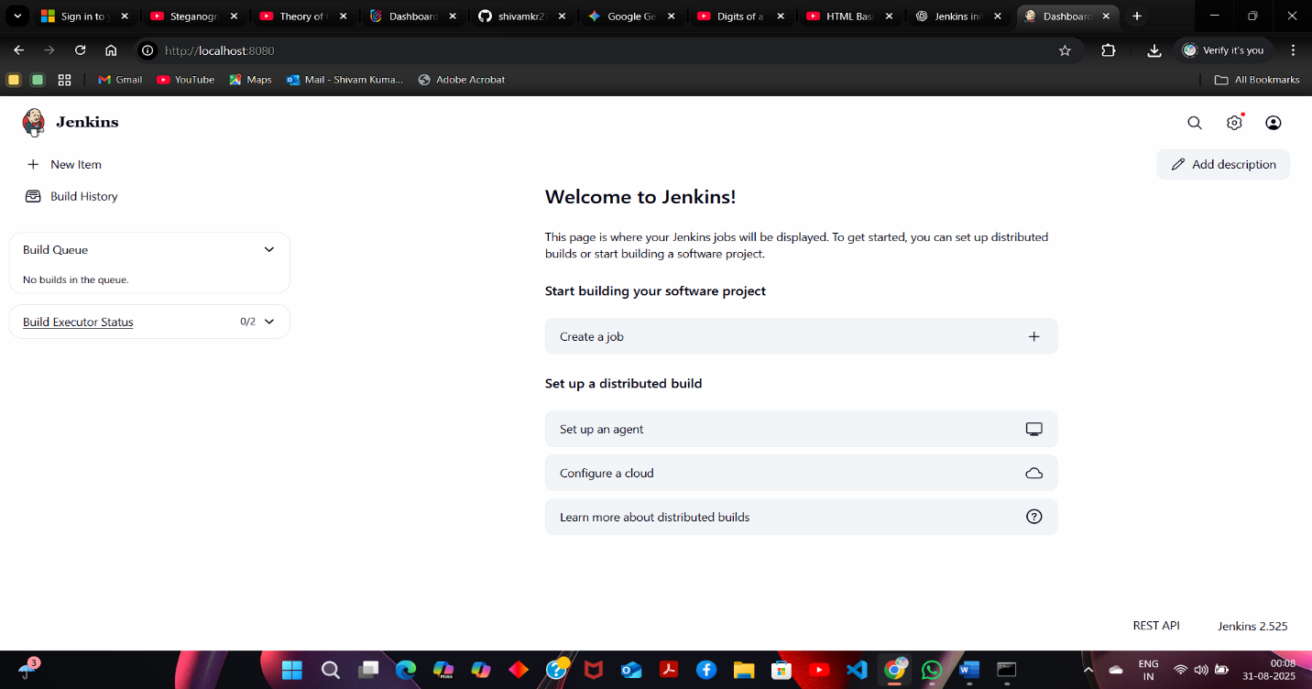

Enter a name for your project, select **Freestyle project** as the build job type

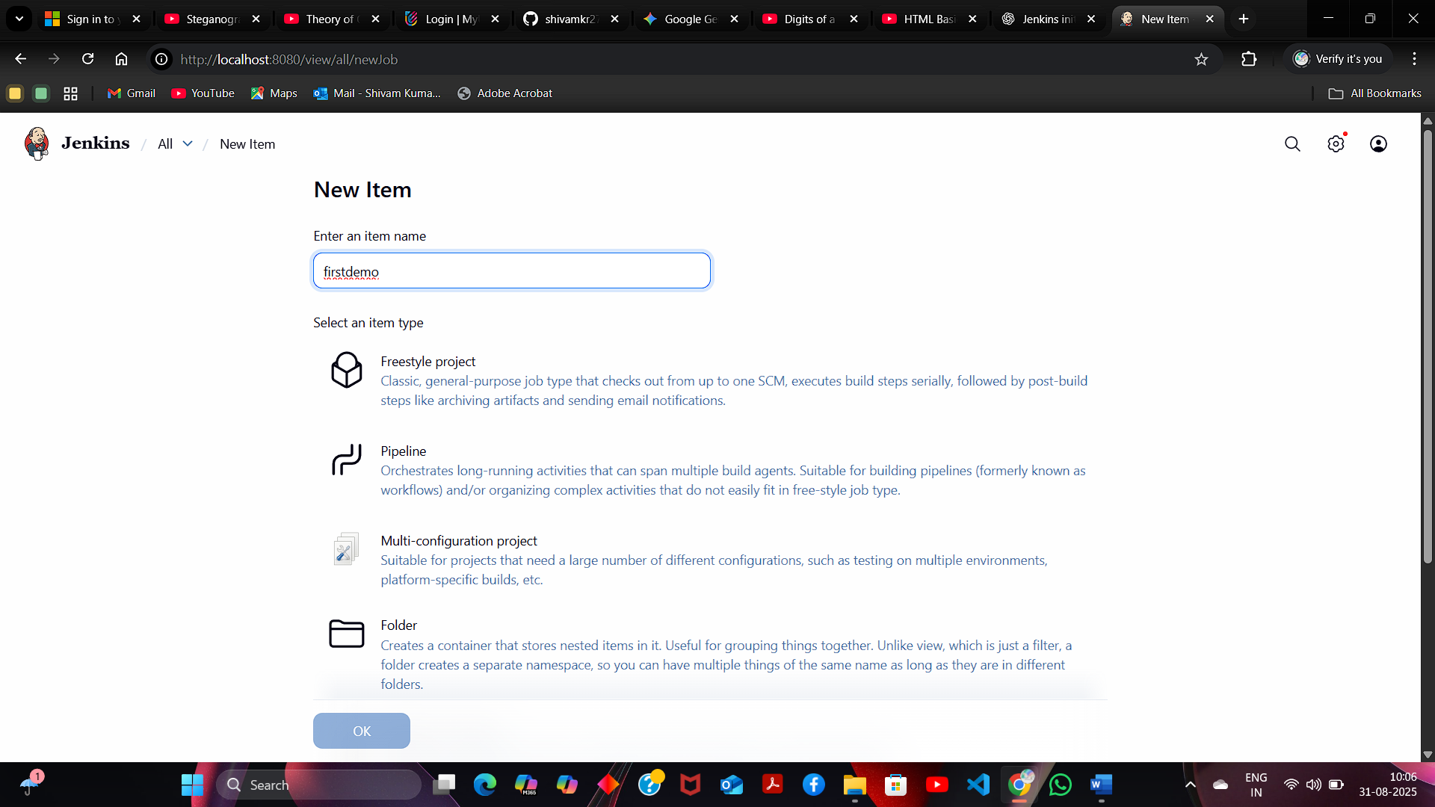

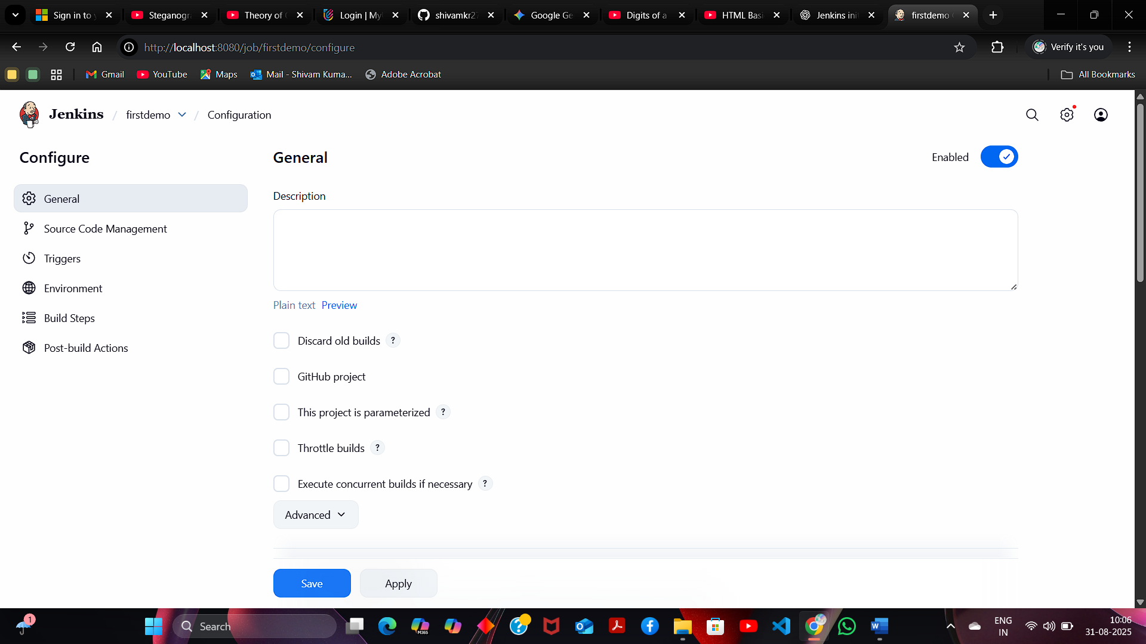

**Step 2: Rename and delete the Freestyle Job**

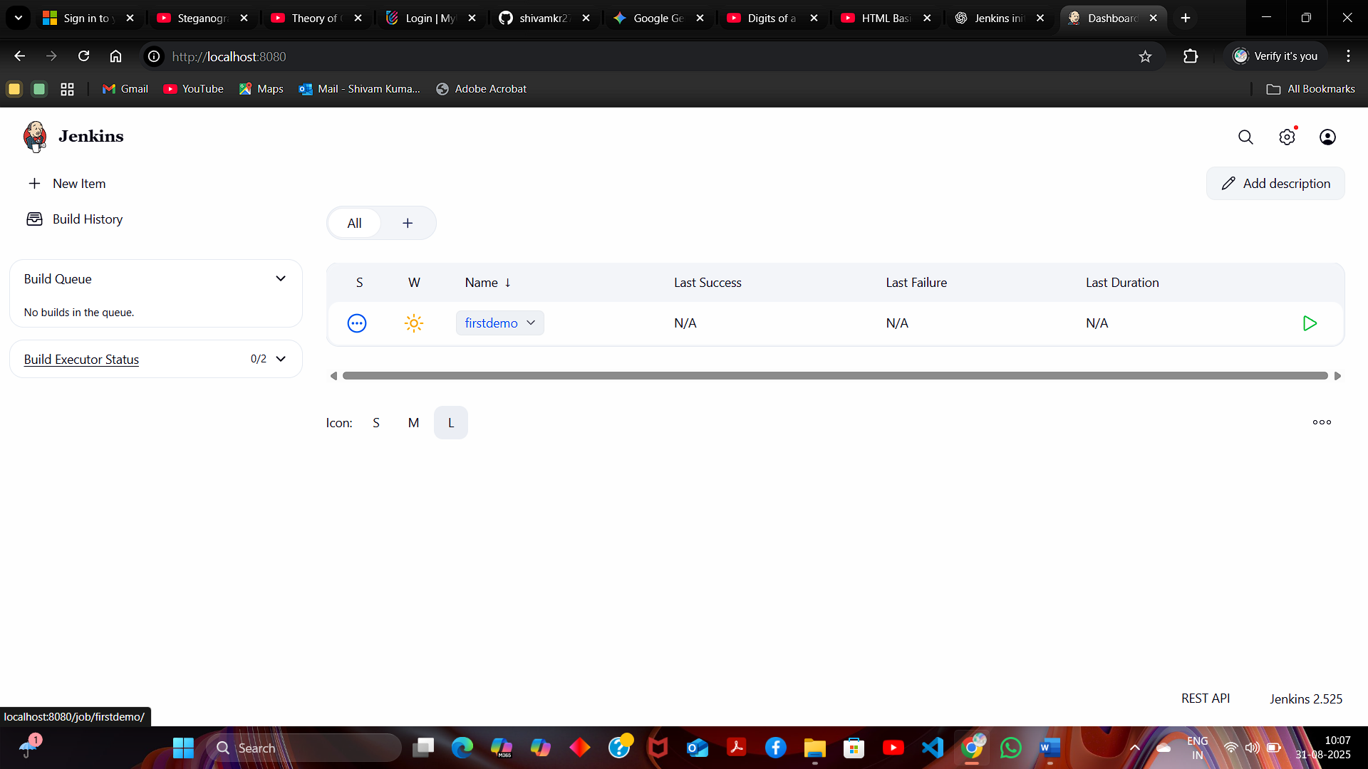

**Rename** the project

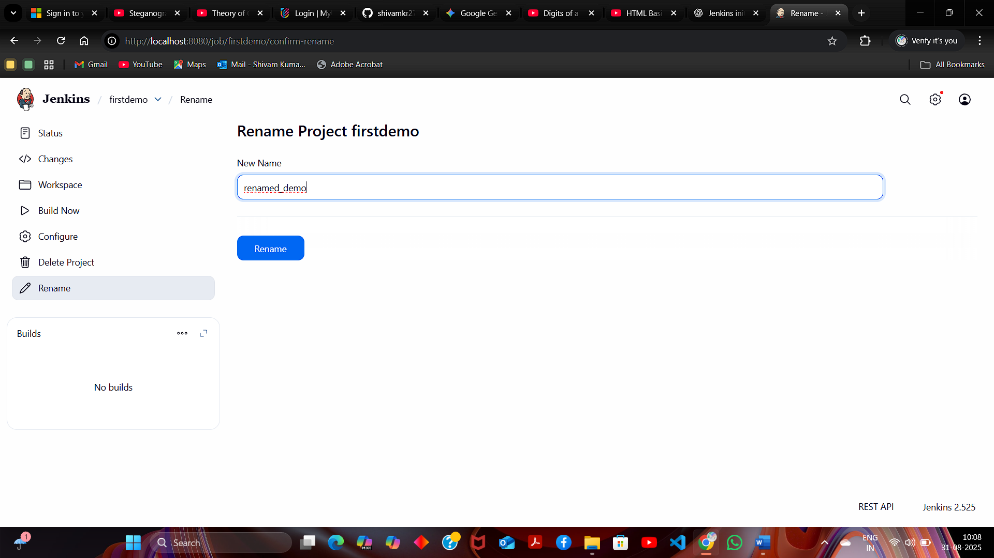

**Delete Project**

