**Lab Exercise 6.2**

**Creating a New Jenkins Job to Checkout Source Code**

1. Navigate to **localhost:8080** in your web browser, enter your credentials, and click on **Sign In**

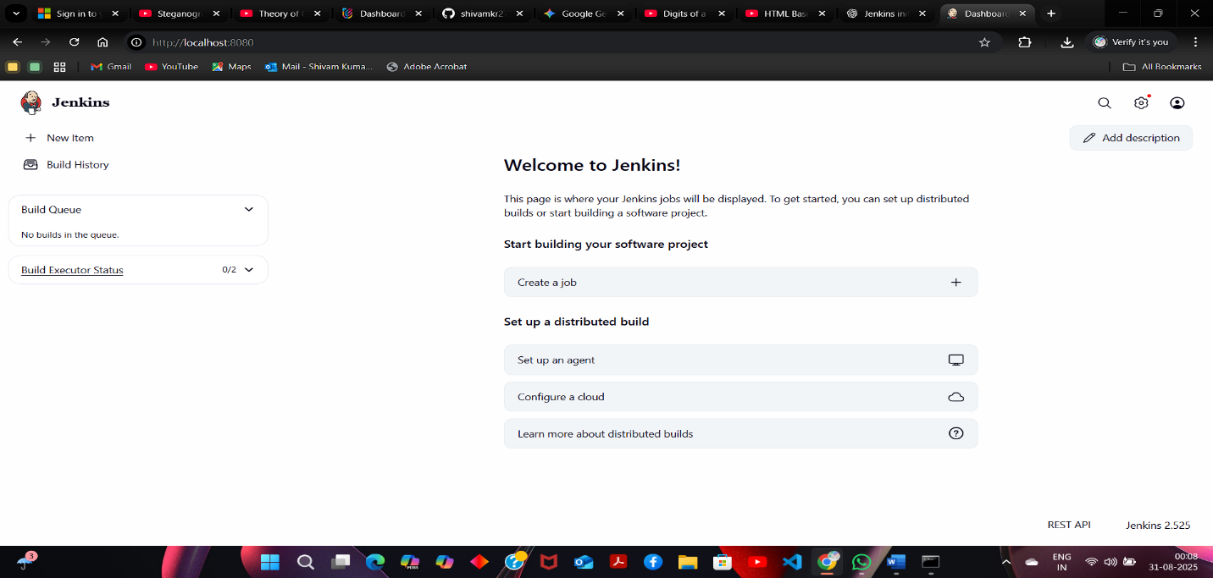

1. Provide custom job name inside the field **Enter an item name,** select the **Freestyle project** option,and click on the **OK** button to save the job

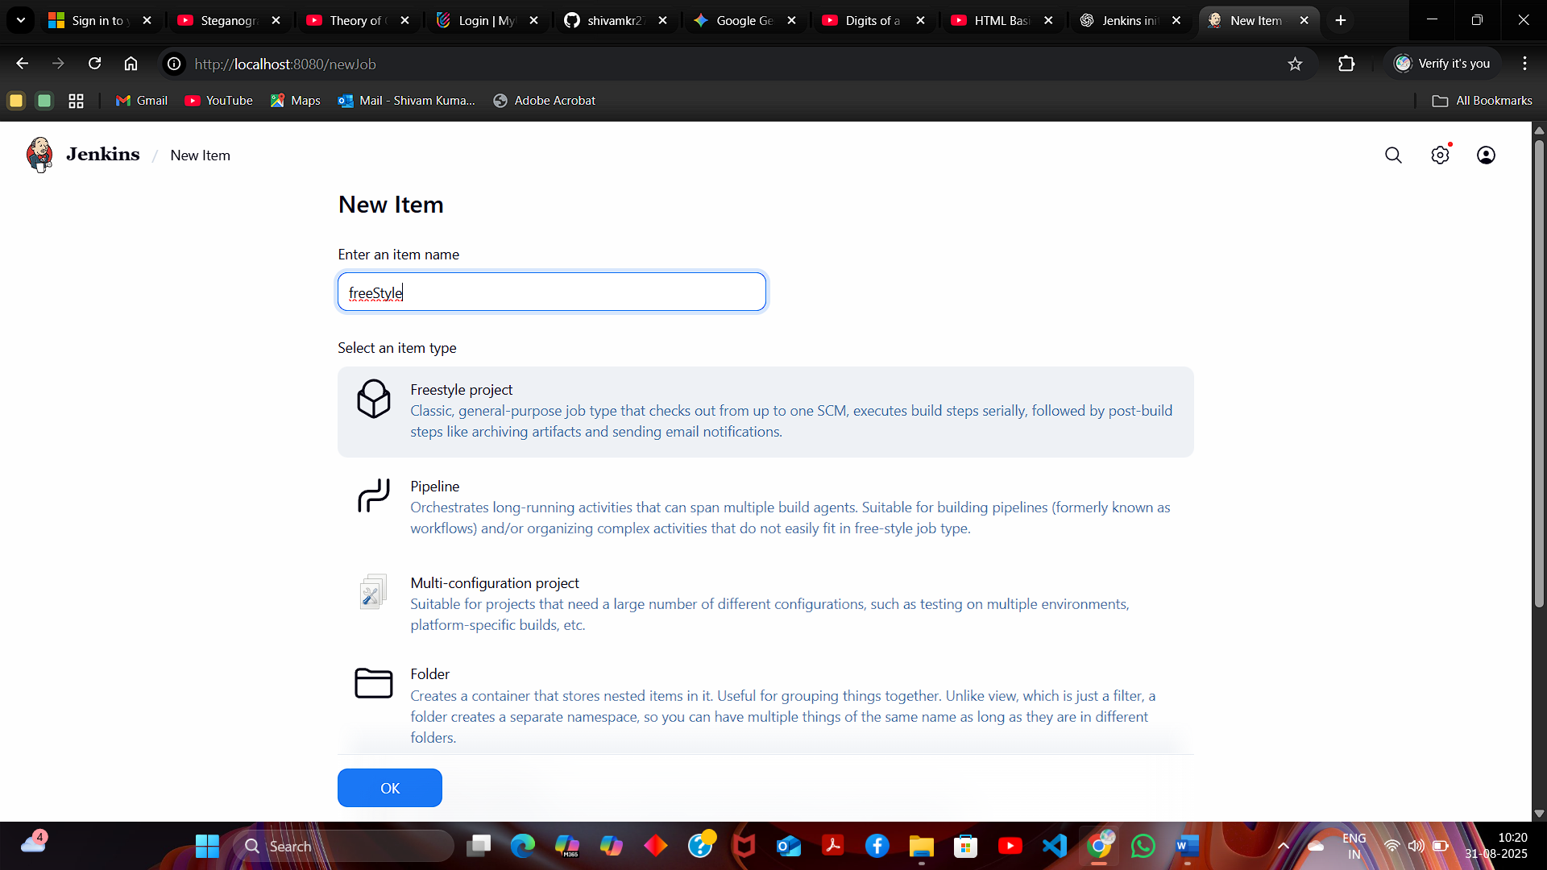

**Step 2: Configure source code management**

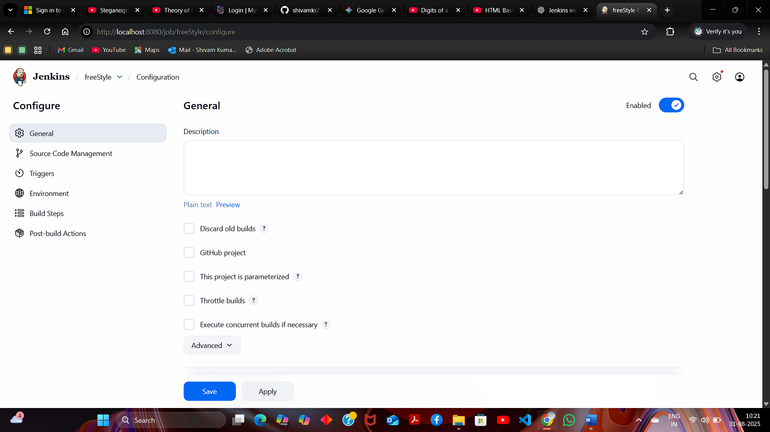

Navigate to the **Source Code Management** tab, provide Git repository configuration inside the **Repository URL** field, and click on the **Save** button

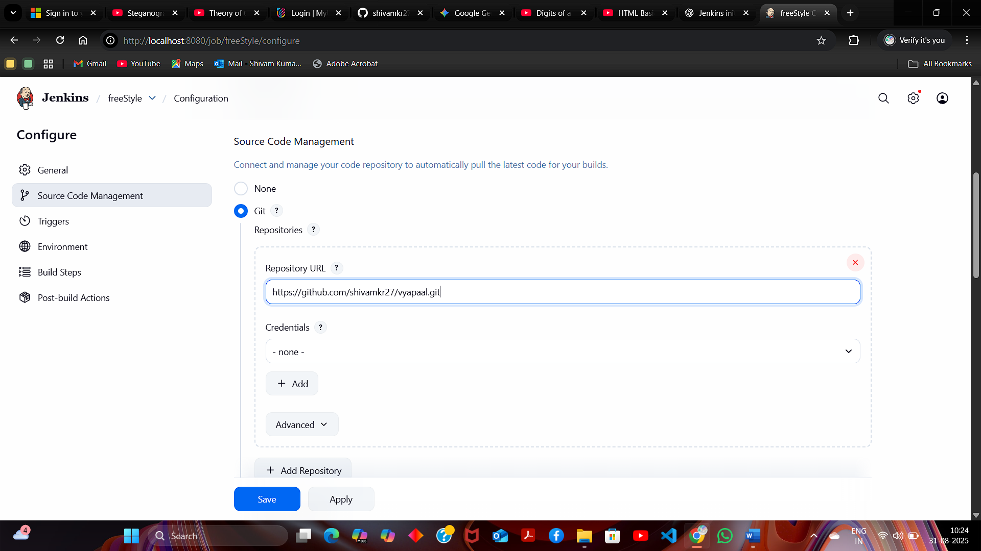

**Build Now** option to schedule a build

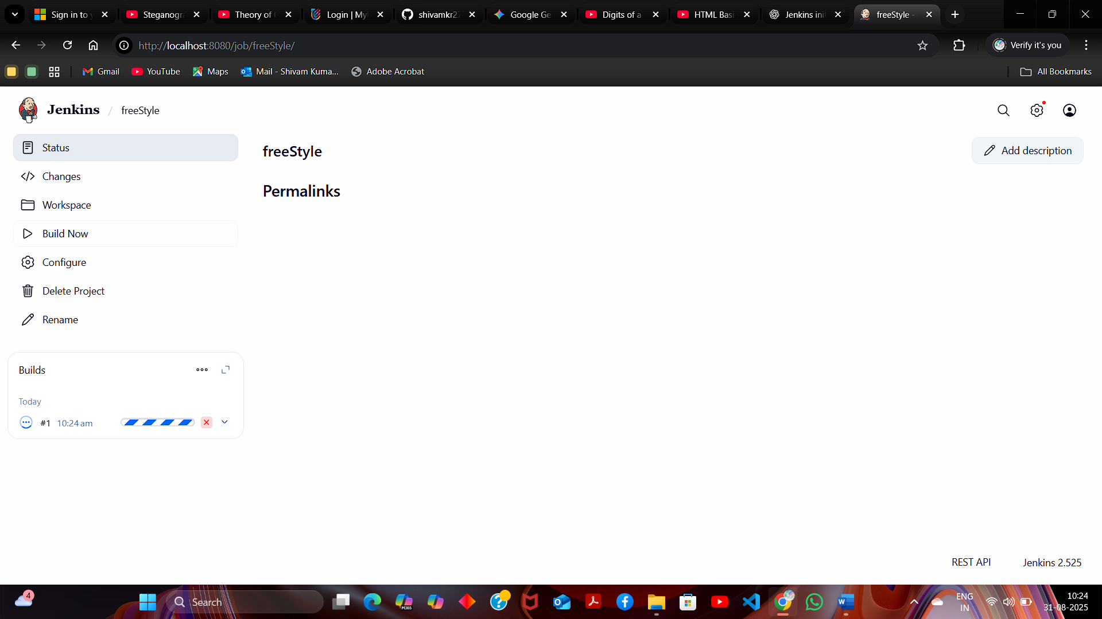

**Console Output** to check out the process during the build process

