**Lab Exercise 7**

**Integrating Maven with Jenkins**

Click on the **Manage Jenkins** option as shown in the screenshot below:

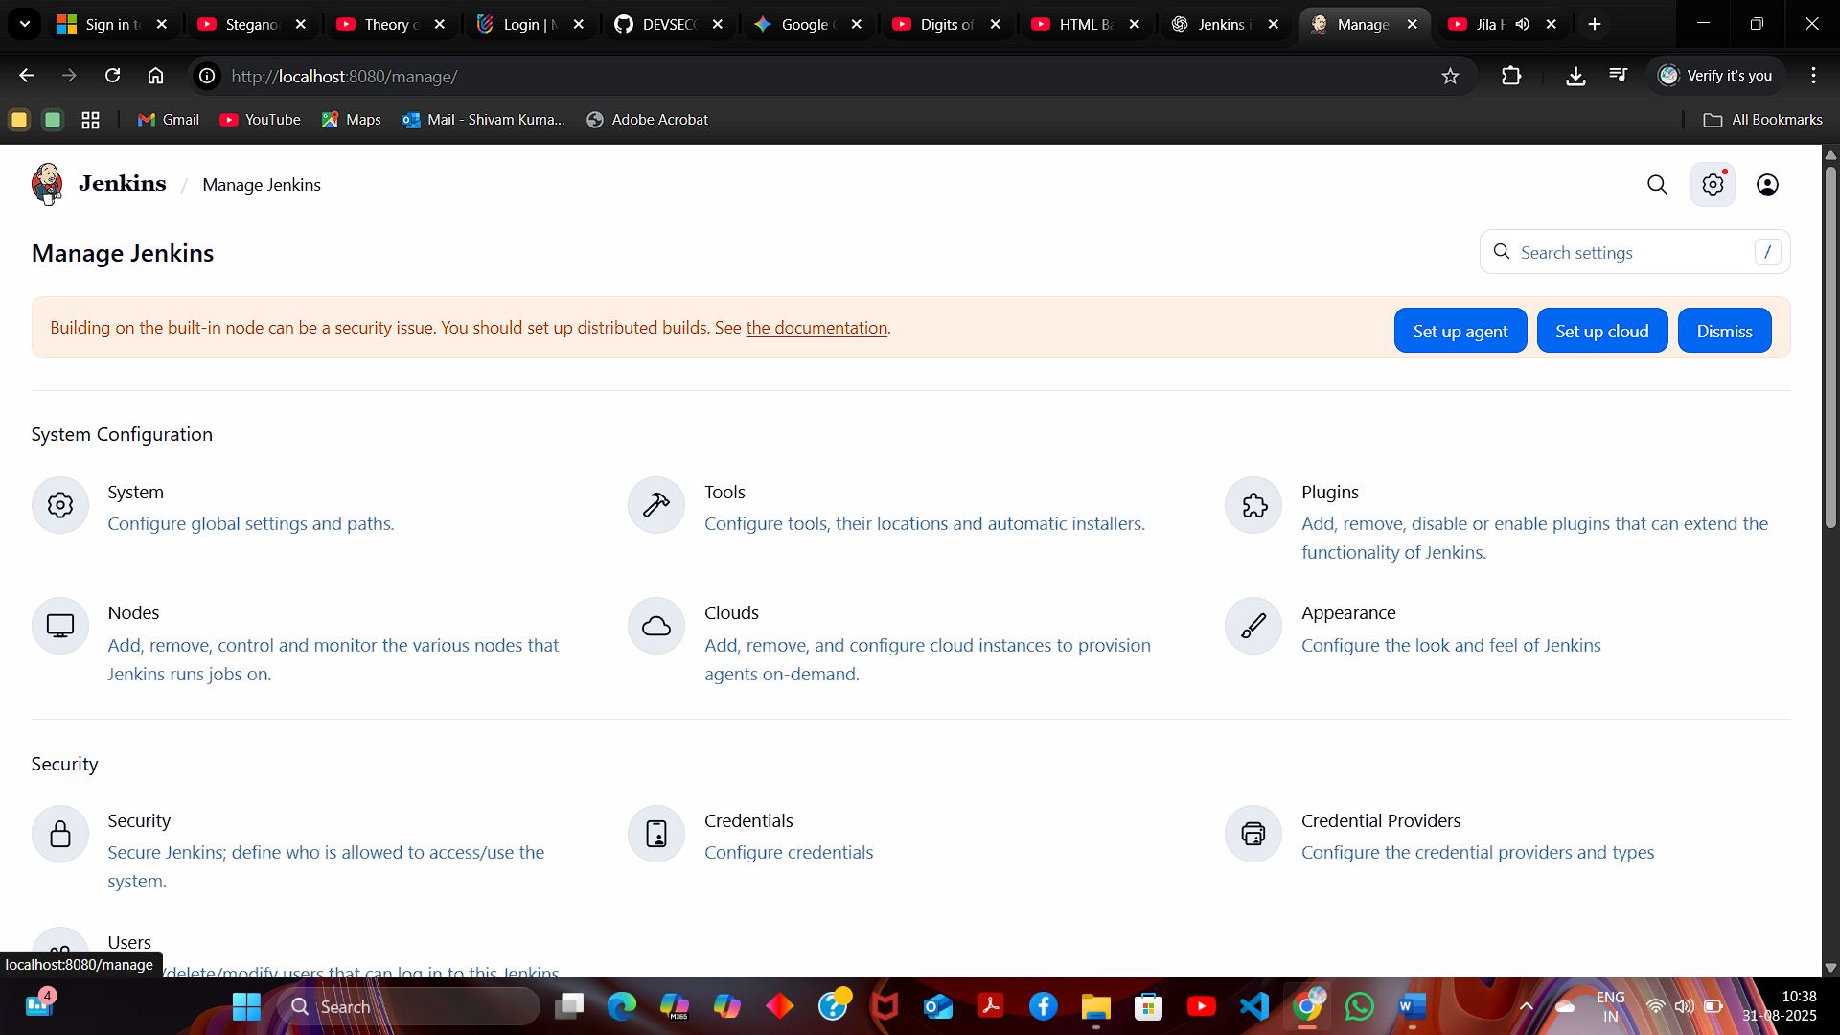

Click on the **Plugins** option as shown in the screenshot below:

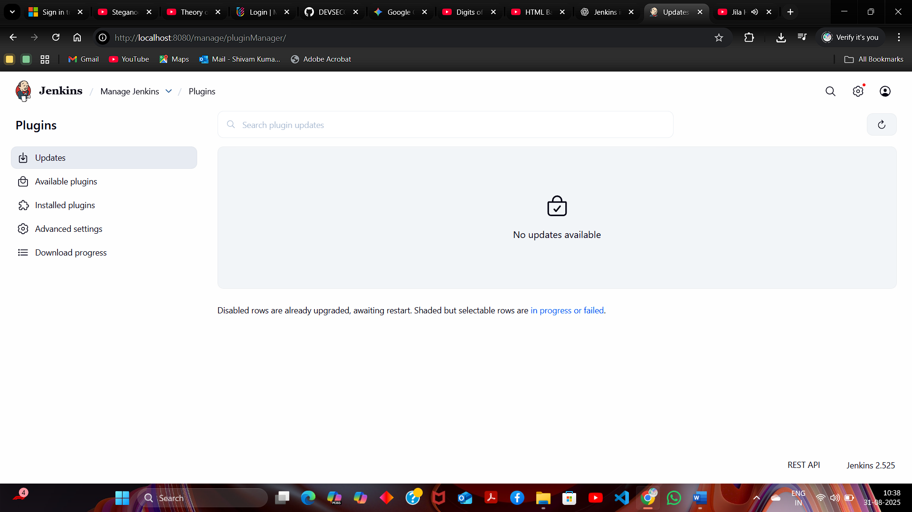

Click on **Installed plugins** to verify whether the **Maven Integration plugin** has been installed

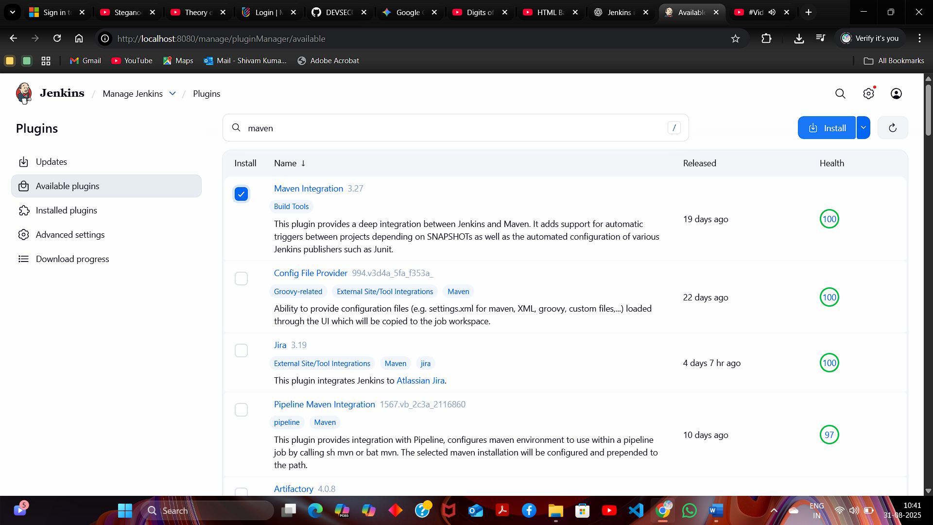

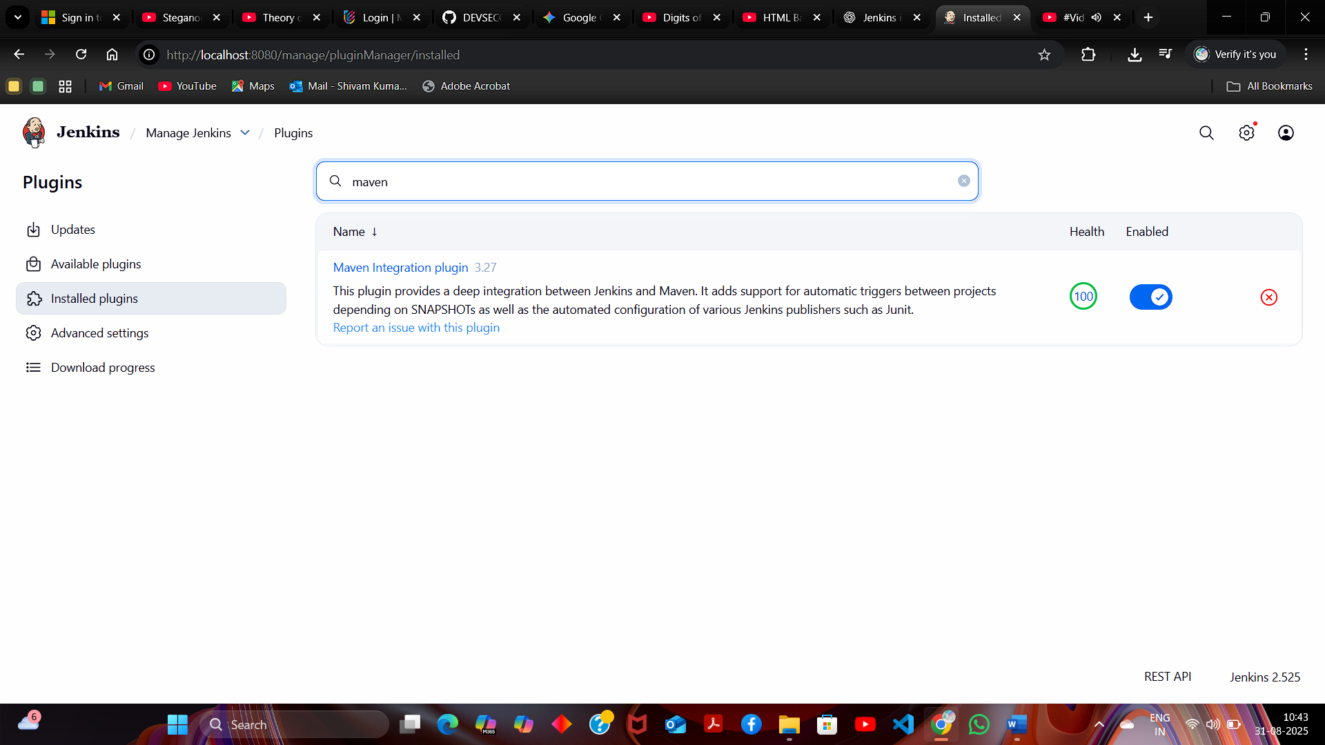

**Set up Global Tool Configuration**

1. Go to the Jenkins Dashboard, click on **Manage Jenkins**, and then select **Tools** from the list of options

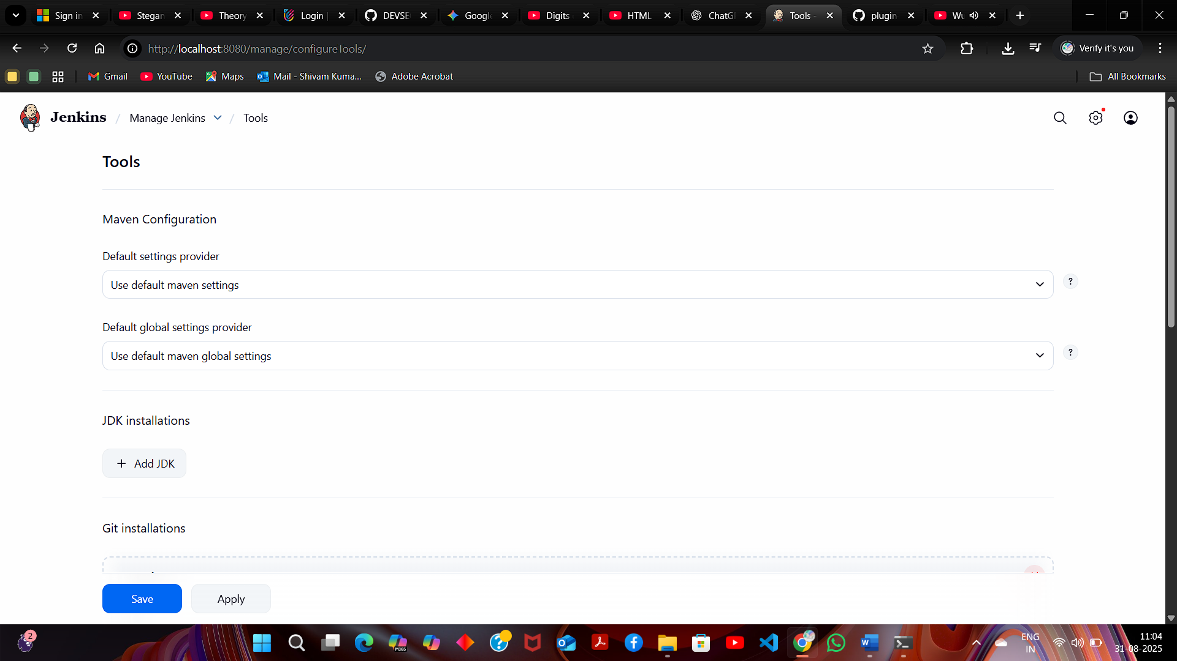

To configure Maven, click on the **Maven installations** button in the Maven section and enter a **Name** and **MAVEN_HOME** path

