**Lab Exercise 8**

**Setting up Maven Build Job in Jenkins**

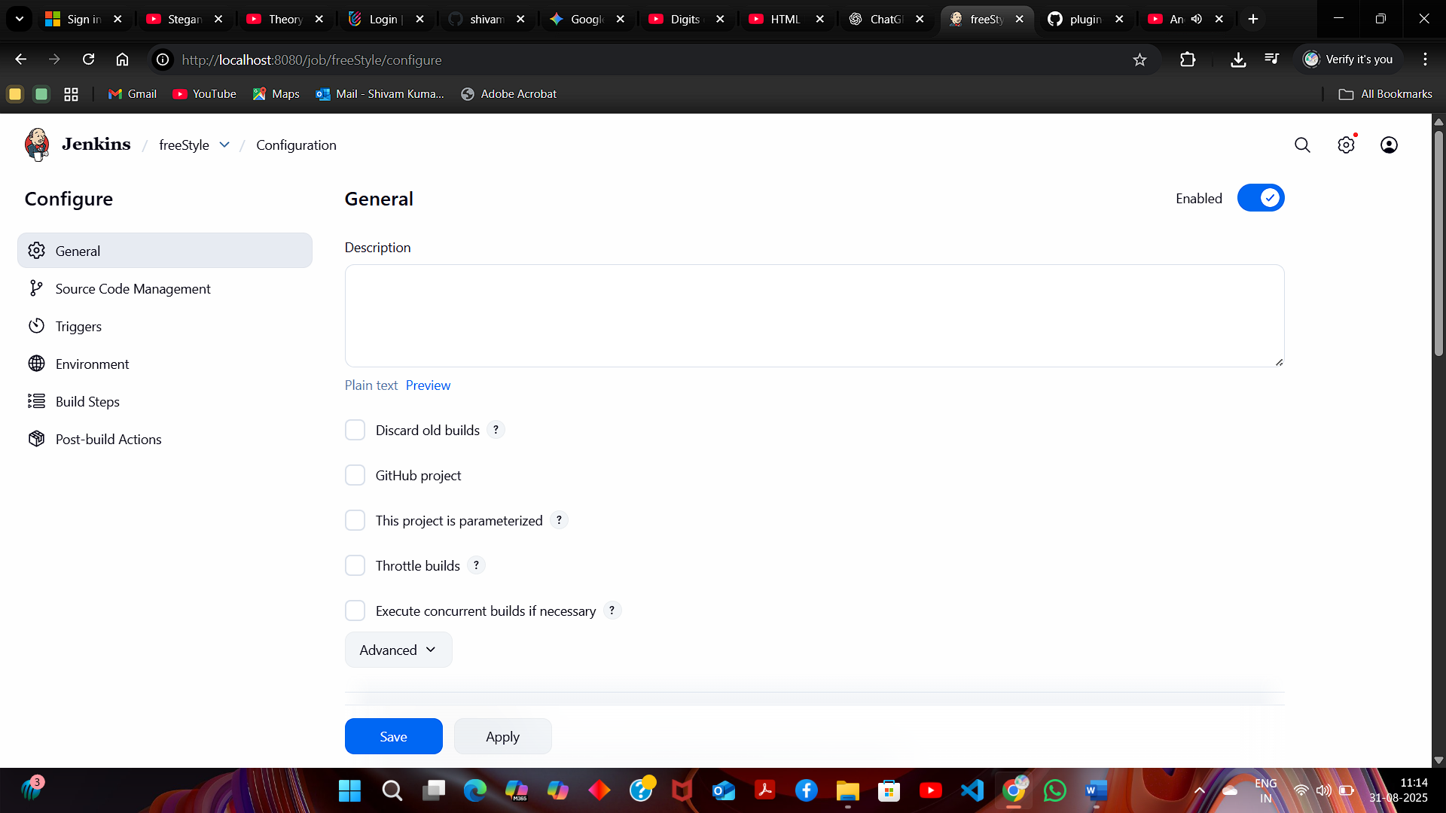

Now, in the Configure page, navigate to **Source Code Management** in the left navigation bar, select **Git**, and then provide the Git repository URL

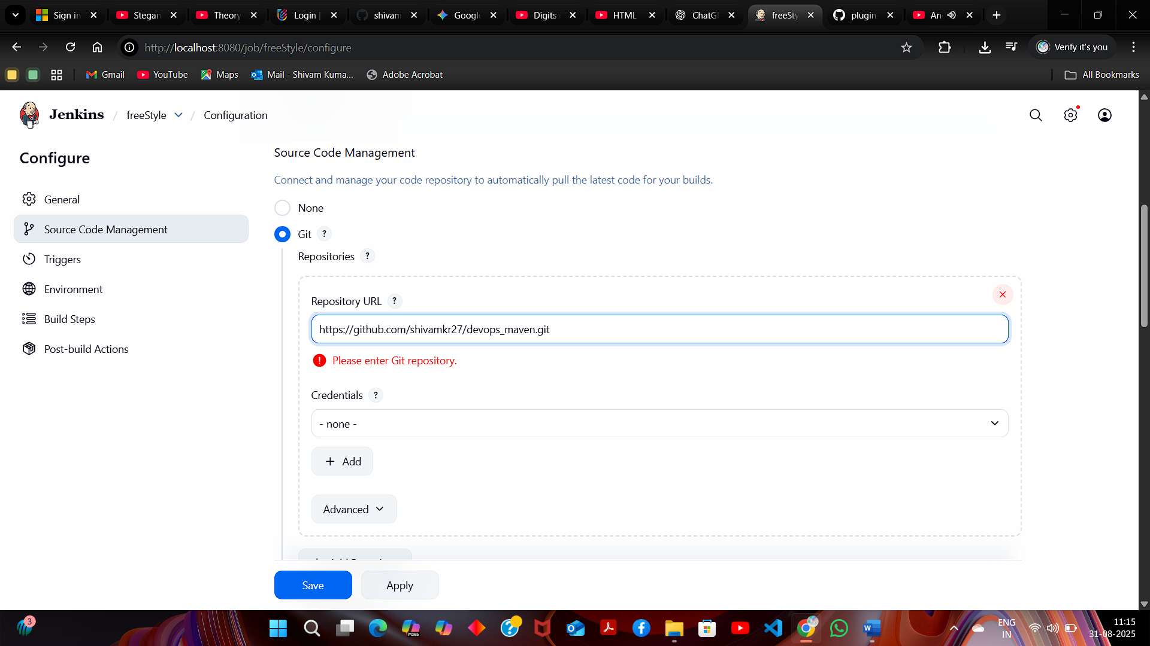

**Note:** Here, the repository URL is **https://github.com/shivamkr27/devops_maven.git.**

1. Now, navigate to **Build Steps**, click on **Add build step**, and then select the option **Invoke top-level Maven targets**

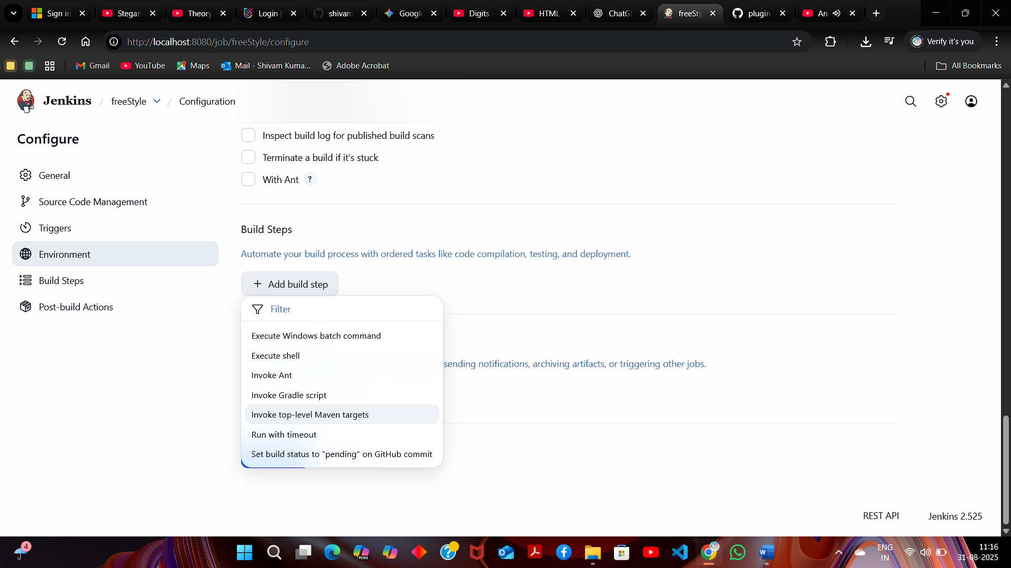

1. Provide clean install under **Goals** section and then click on **Save**

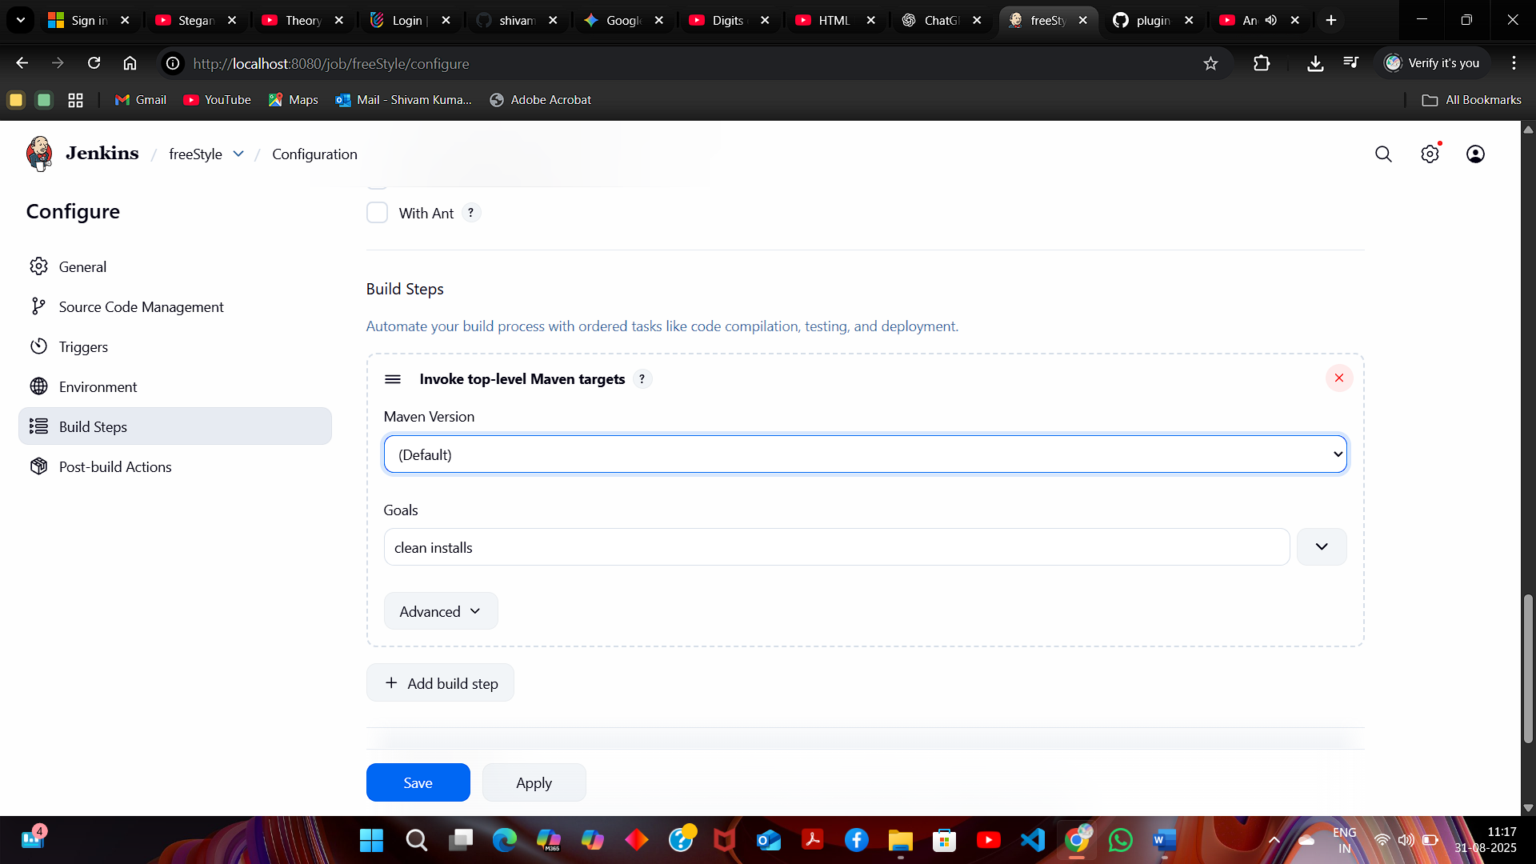

You will be navigated to the project after clicking on Save. Now, click on **Build Now** to initiate a new build, and the build logs will display the progress of the build process.

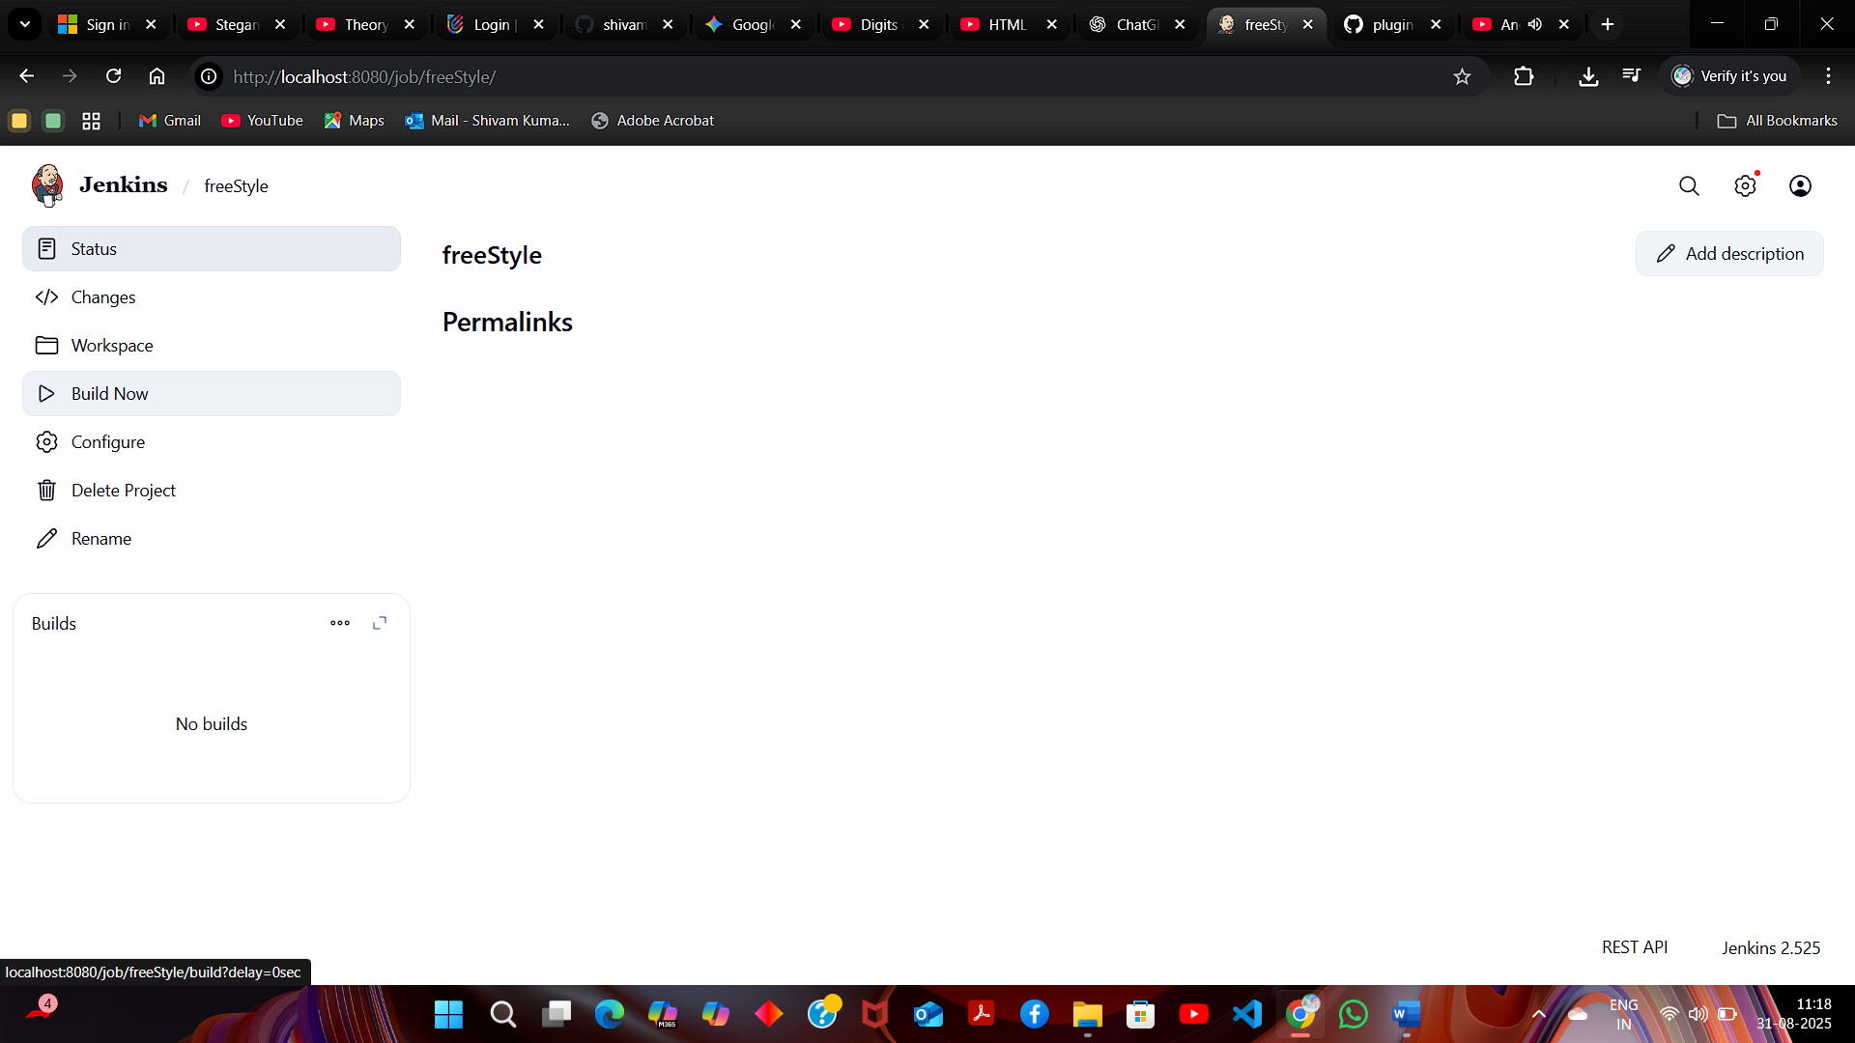

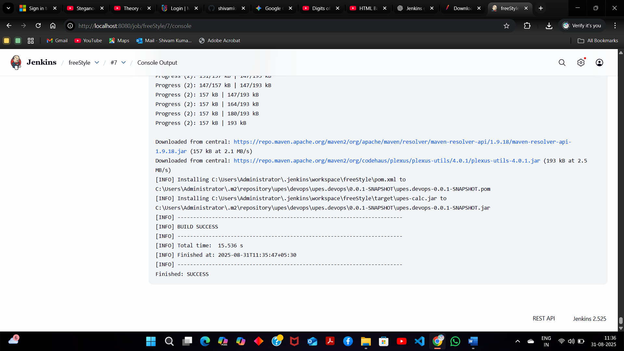

build is configured successfully