**Lab Exercise 9**

**Setting up Poll SCM Configuration in Jenkins**

Select the **Freestyle project** while creating a Jenkins job, provide a custom job name,

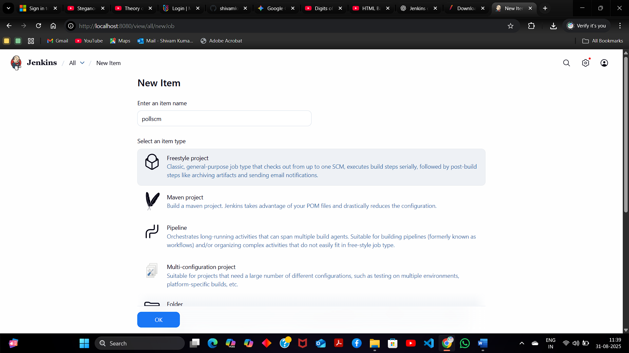

in the Configure page, navigate to **Source Code Management**, select **Git**, and then provide the Git repository URL

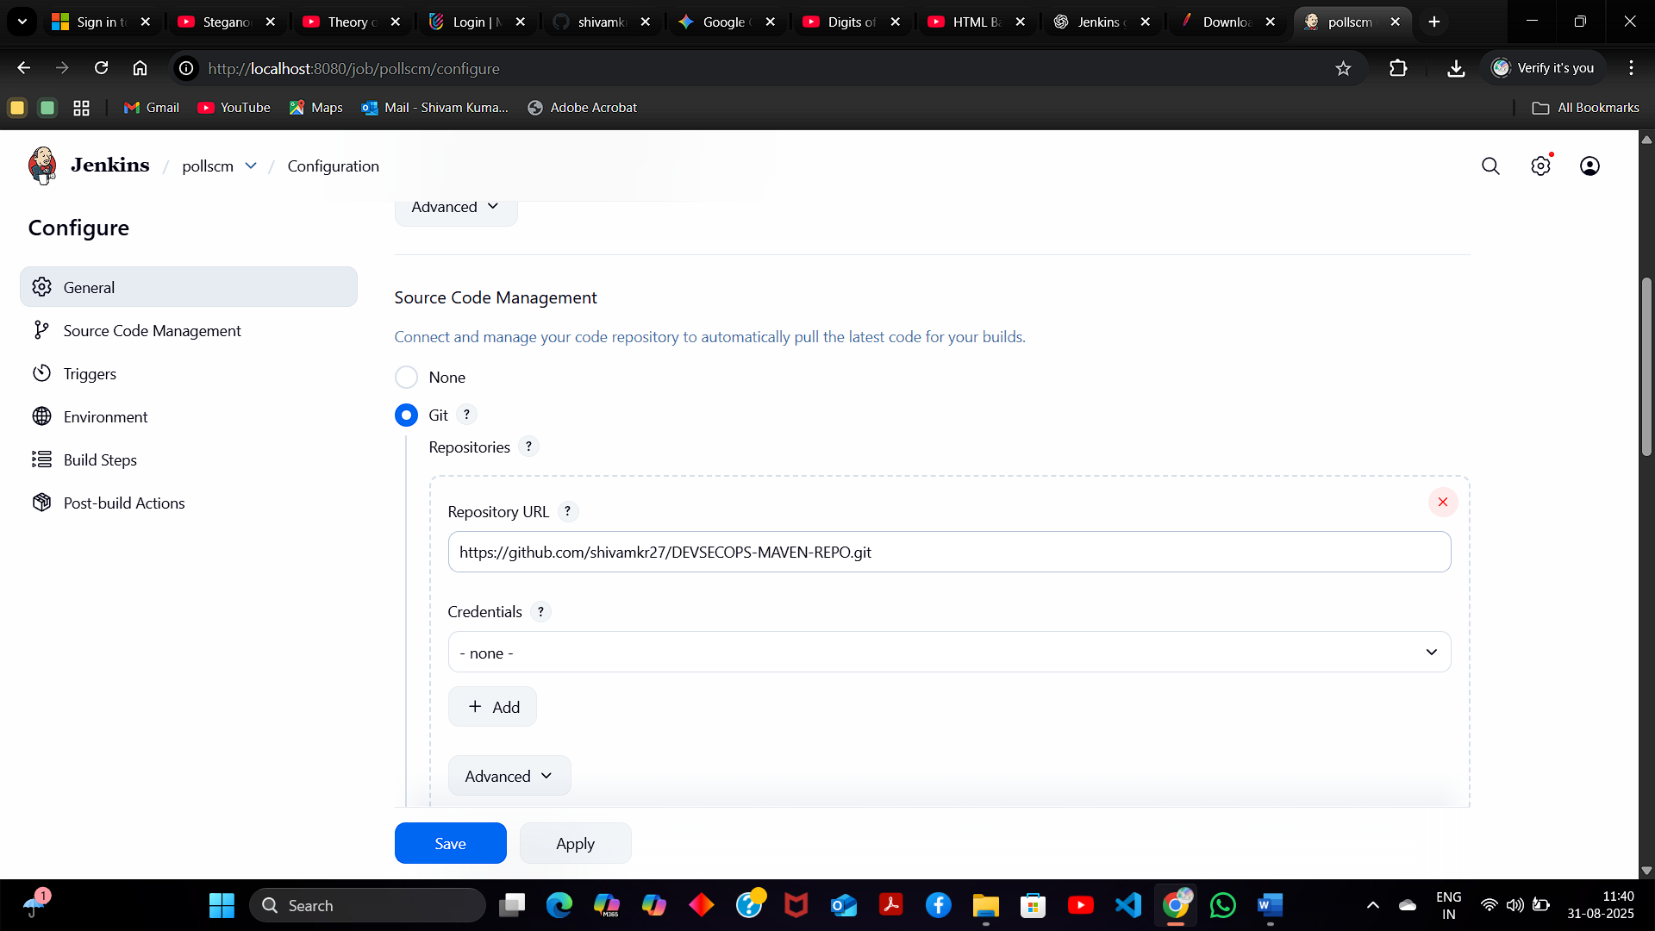

**Note:** Here, the repository URL is **https://github.com/shivamkr27/DEVSECOPS-MAVEN-REPO.git**

navigate to **Build Environment**, click on **Poll SCM**, provide **H/2\*\*\*\*** in **Schedule** section

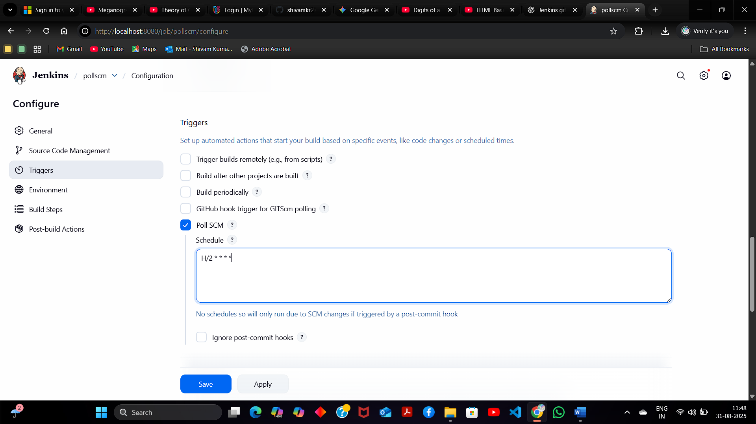

click on **Build Now** to configure a build,to view the successful build in the **Console output** .

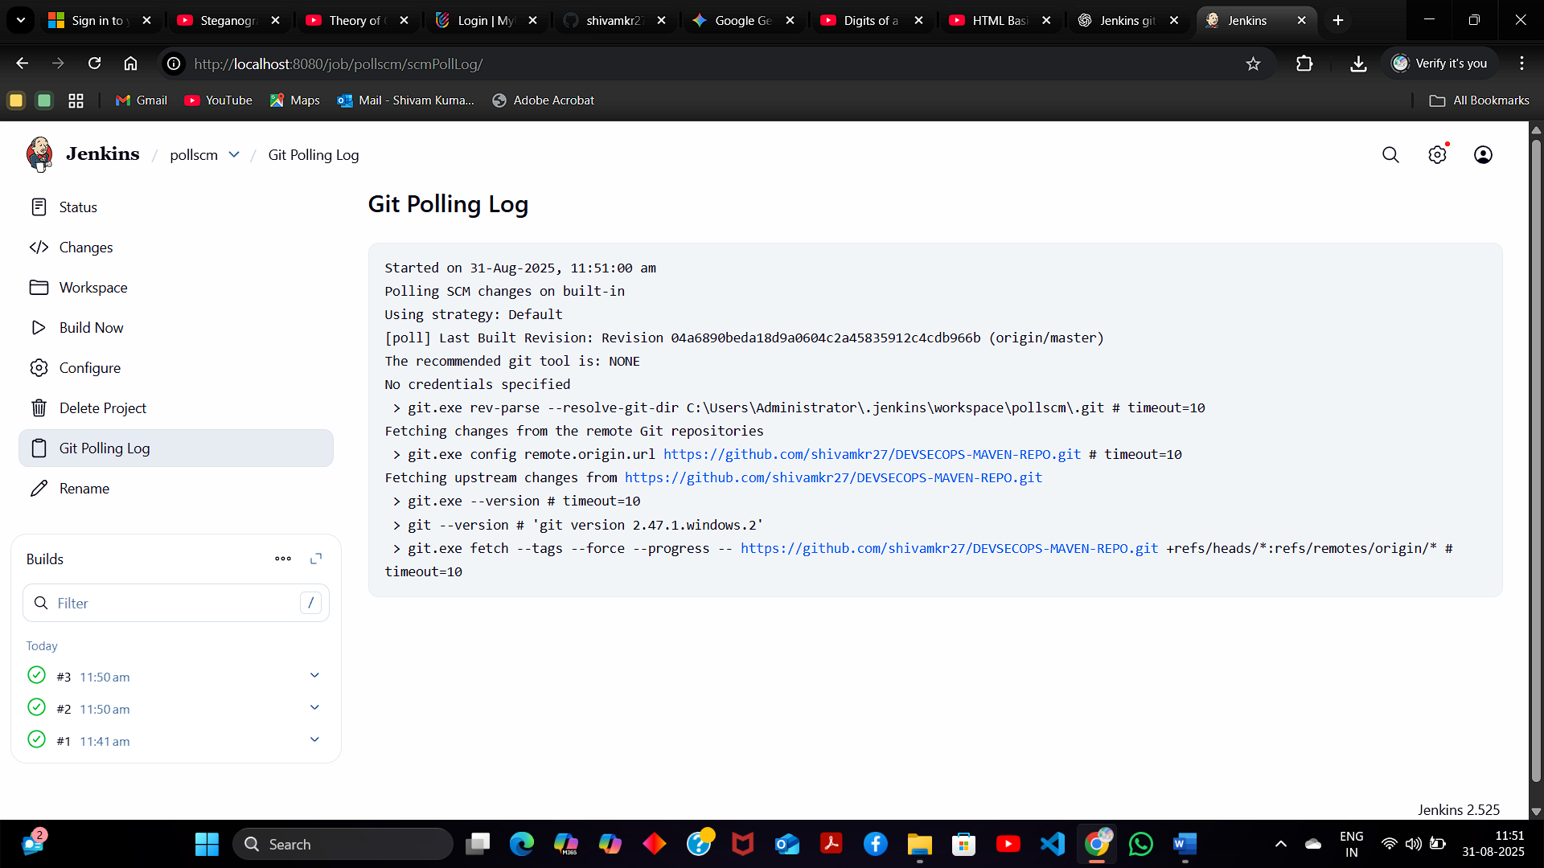

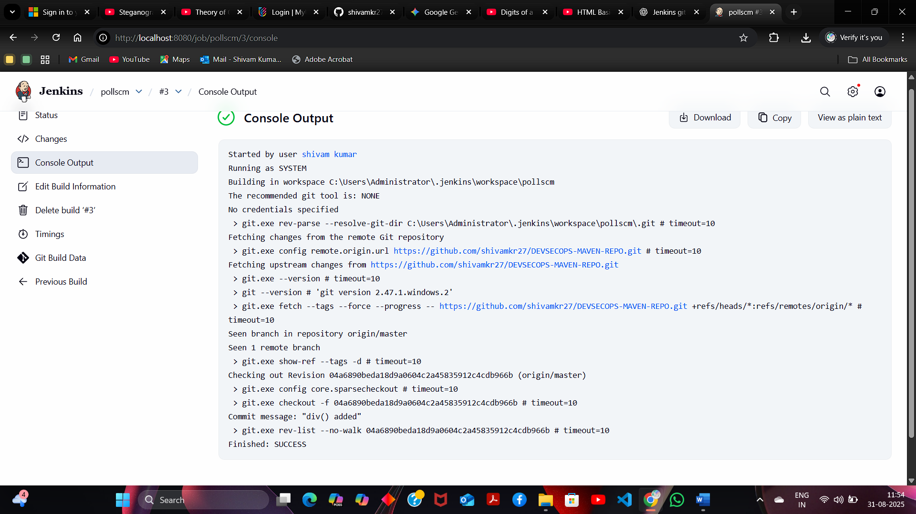

build is configured successfully.