Lab Exercise 22- Docker Image Vulnerability Scanning Using Trivy (Windows)
Step 1: Verify Docker Setup
Before using Trivy, make sure Docker is working correctly.
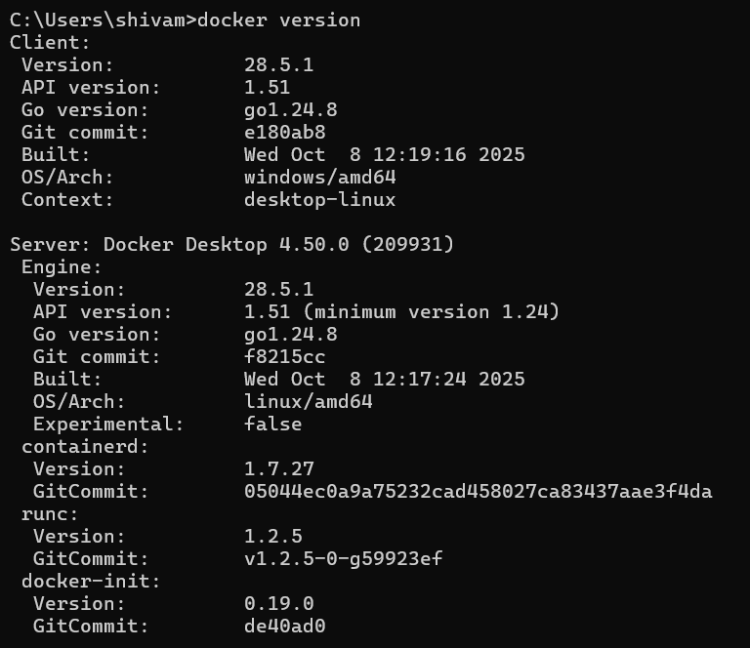

Expected Output:
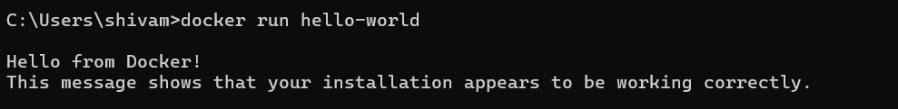
Step 2: Install Trivy on Windows
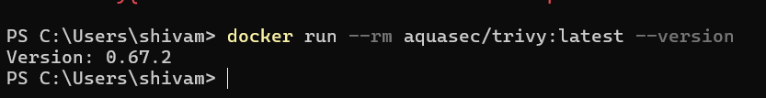Step 3: Pull a Docker Image
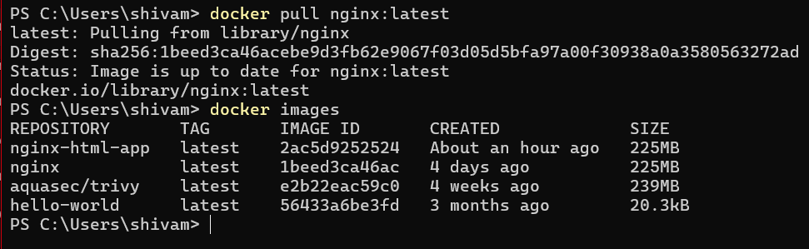Step 4: Scan Docker Image with Trivy
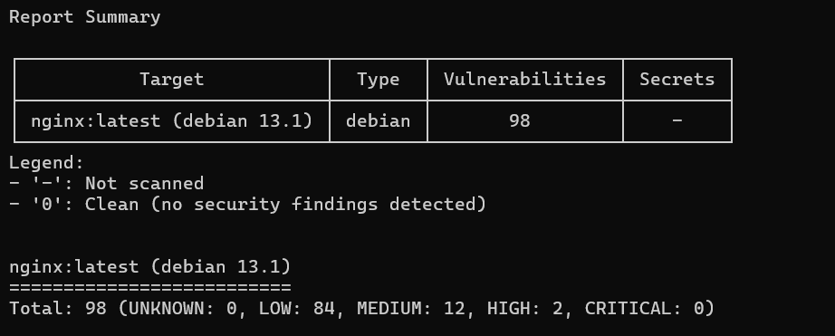Step 5: Save Report to a File
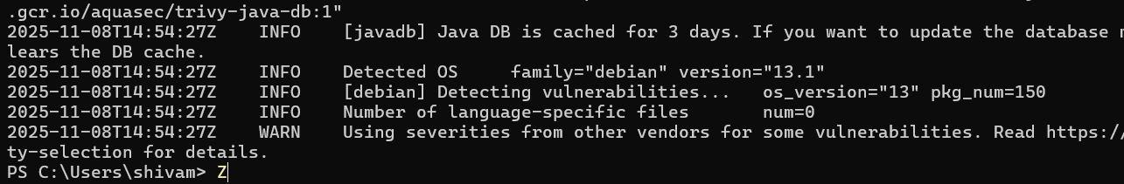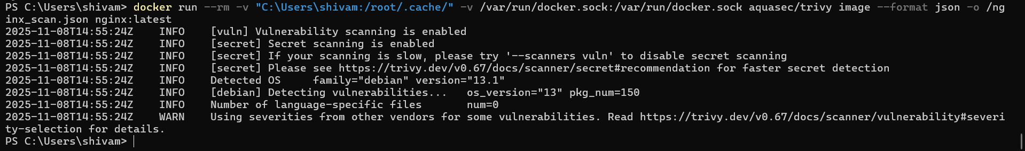Save as a text file: Save as a JSON report:
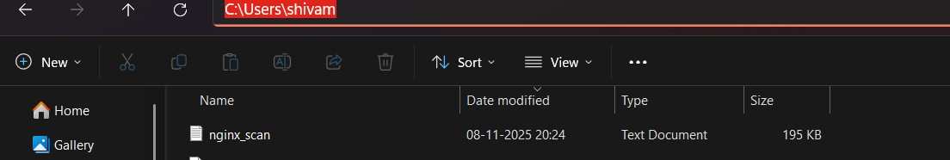

Step 6: Scan a Local Image
If you’ve built your own Docker image:
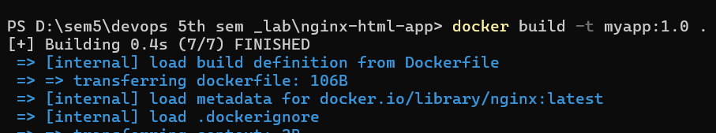
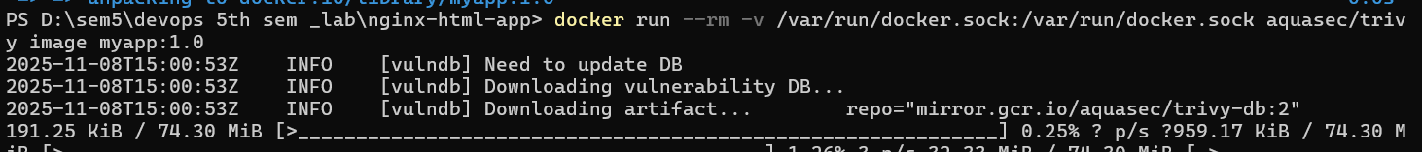

Step 7: Update Vulnerability Database
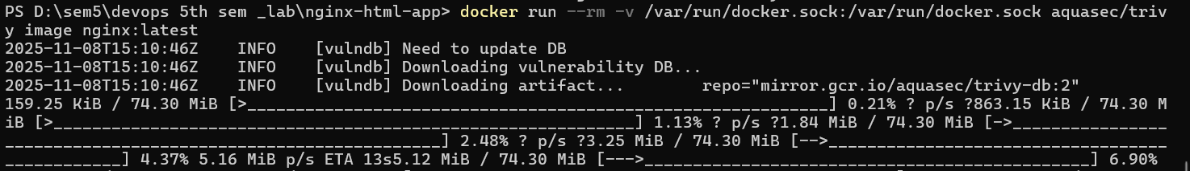

Step 8: Clean Up
Remove images (optional):
