Lab Exercise 22

Checking Vulnerabilities Using Trivy

Objective: To scan container images for vulnerabilities using Trivy to identify and mitigate security risks and ensure that containerized applications are secure

Alternate Installation Method: Trivy run via Docker container instead of direct Linux installation

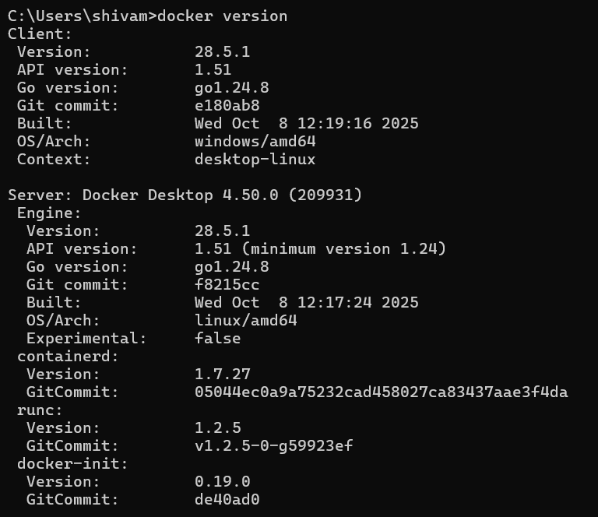

Step 1: Install Trivy

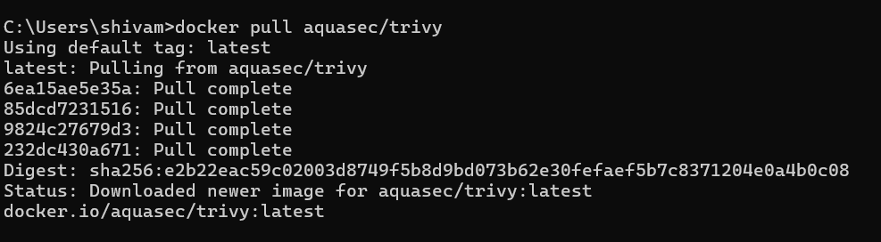

Step 2: Scan the vulnerabilities using Trivy

- Run the following command to scan the NGINX container image with Trivy for vulnerabilities and security issues:
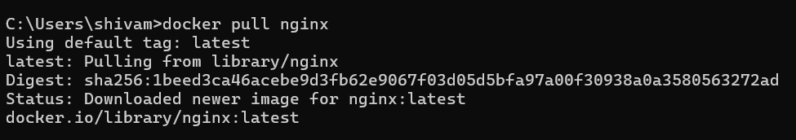

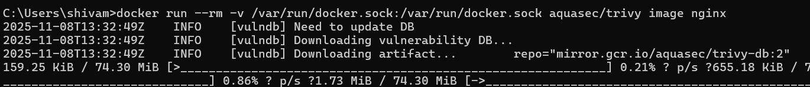

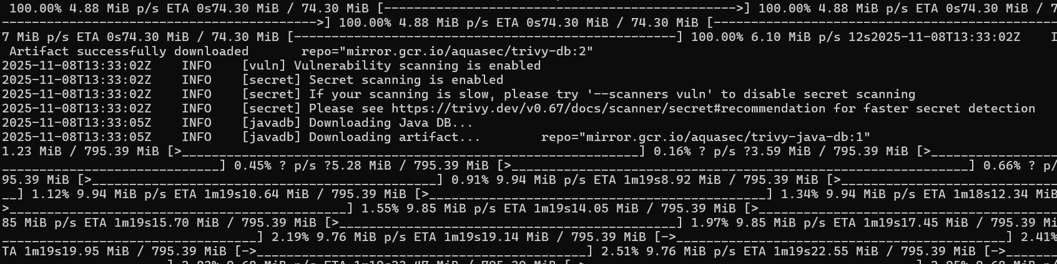

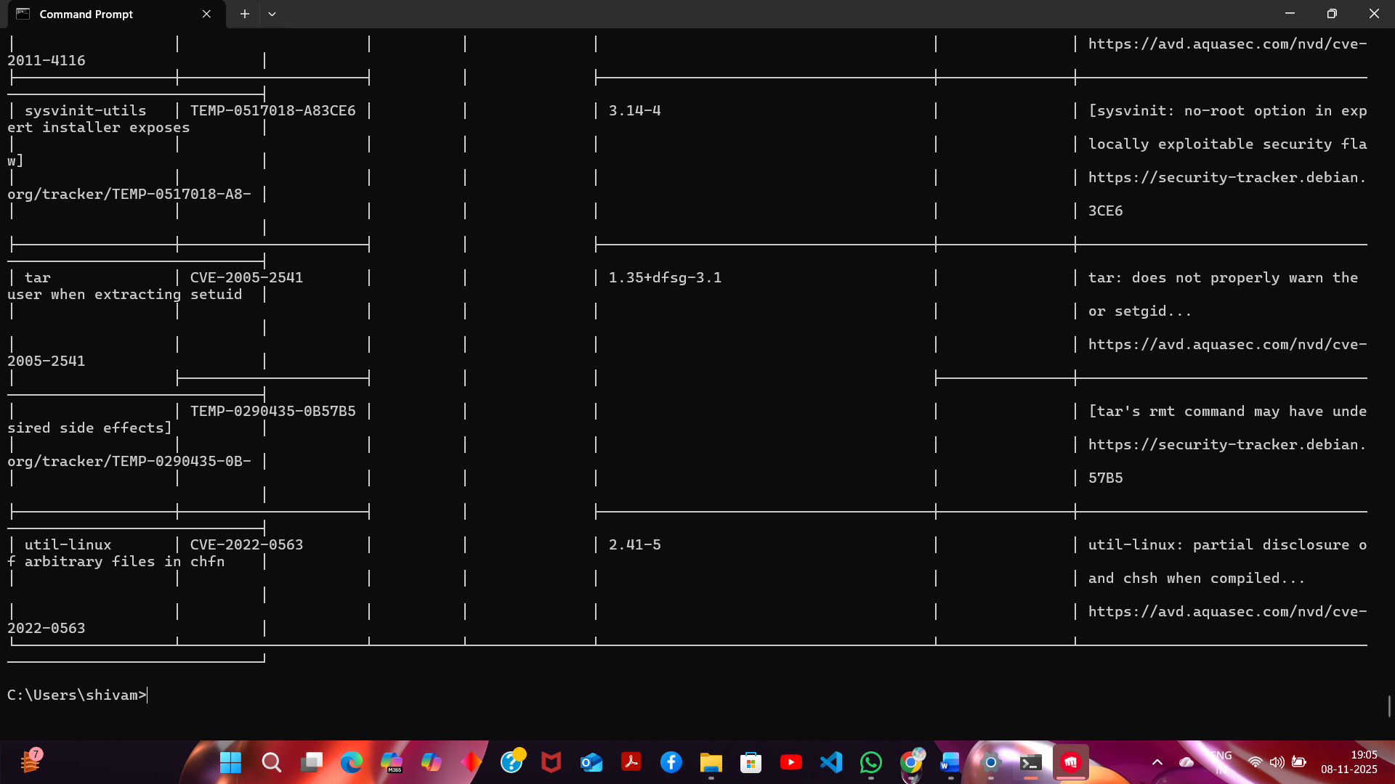
By following these steps, you have successfully scanned container images for vulnerabilities using Trivy to identify and mitigate security risks and ensure the security of containerized applications.

