Experiment-1
Aim:
- Learn how to use git revert to undo changes from specific commits.
- Practice handling merge conflicts during a revert.
Prerequisites:
- Install Git on your system.
- Set up a Git repository:
Steps:
- Setup a Repository: -
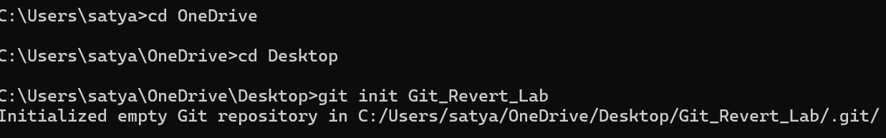
- Create a file:

- Stage and commit the file:

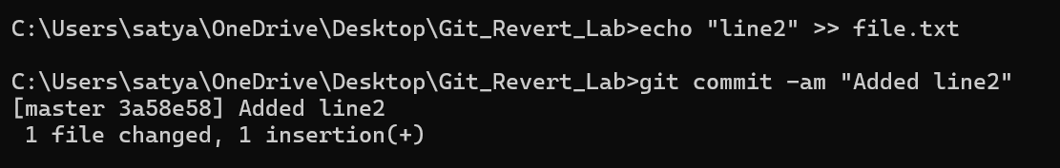
- Add more changes:

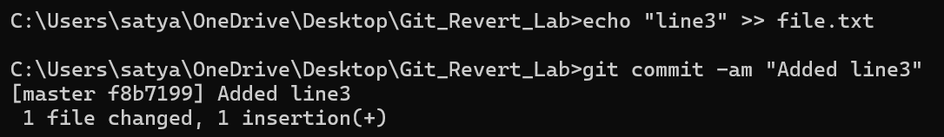
- Add another change:

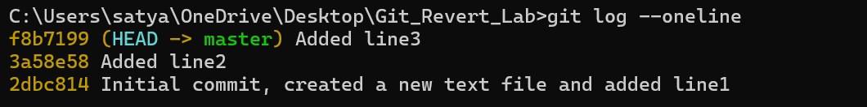
- Verify the commit history:

- Revert the Last commit: -
- Revert the most recent commit:

- Verify the contents of file.txt:
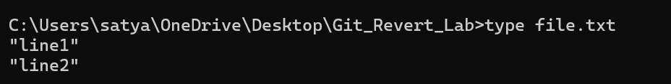

- Check the commit history:
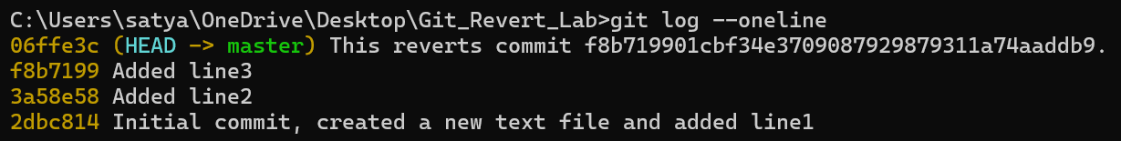

- Handle merge conflict during commit: -

- Modify file.txt:
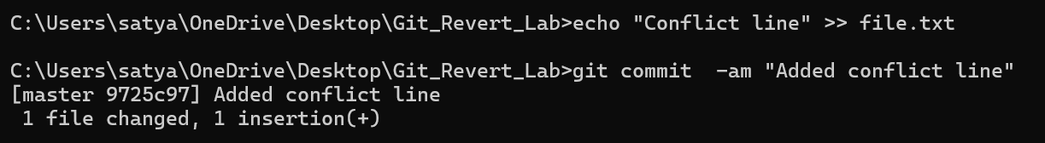
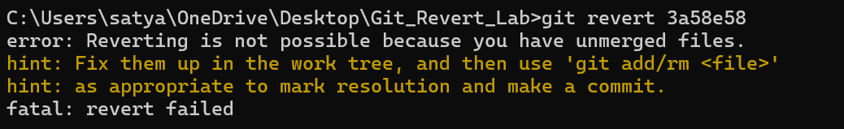
- Revert the second commit (8b2a1c1 again) to trigger a conflict:

- Git will indicate a conflict. Resolve it:
  - Open file.txt and remove conflict markers.
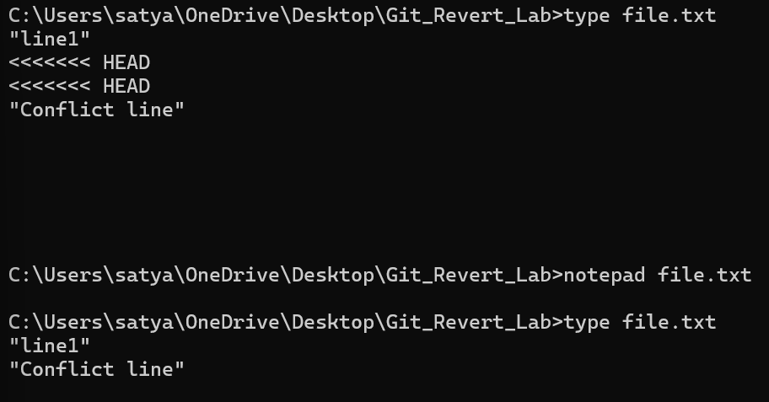
  - Keep the desired lines.

- Stage the resolved file:
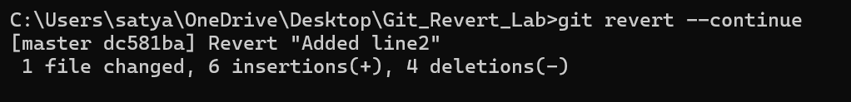
- Complete the revert:

- Verify:
