Lab Exercise 2- Working with Git Reset

Objective
- Learn how to use git reset to modify the commit history, unstage files, or discard changes.
- Understand the differences between --soft, --mixed, and --hard reset modes.

Prerequisites
- Install Git on your system.
- Set up a Git repository:
git init git-reset-lab
cd git-reset-lab

Steps
1. Set Up the Repository
- Create and commit an initial file:
echo "Line 1" > file.txt
git add file.txt
git commit -m "Initial commit: Add Line 1"
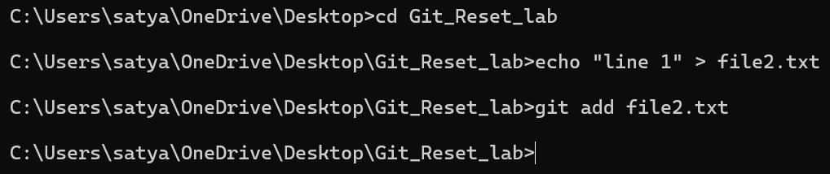

- Add a second change:
echo "Line 2" >> file.txt
git commit -am "Add Line 2"
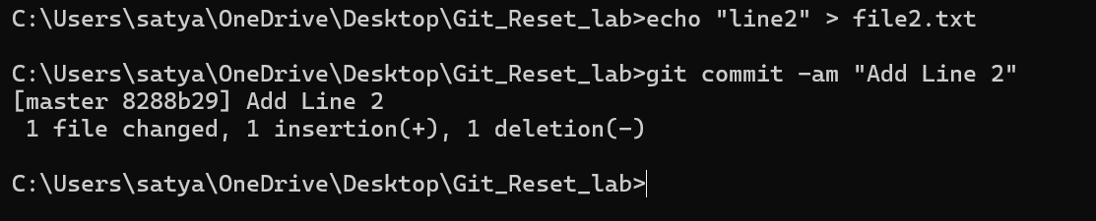
- Add a third change:
echo "Line 3" >> file.txt
git commit -am "Add Line 3"
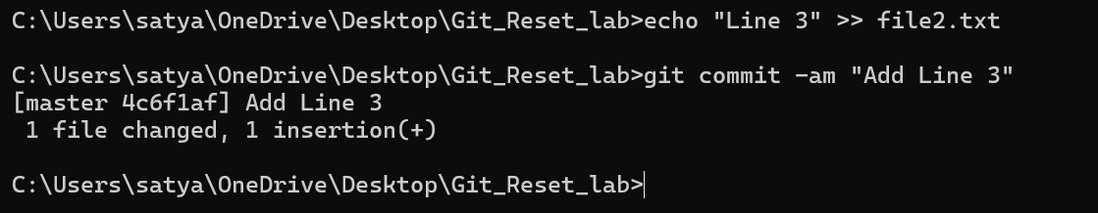
- Check the commit history:
git log –oneline
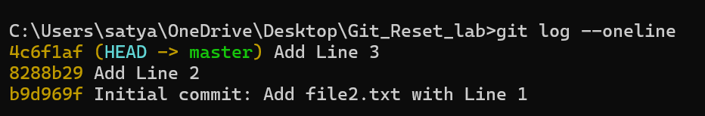

2. Use git reset --soft
This mode moves the HEAD pointer to an earlier commit but keeps the changes in the staging area.
- Reset to the second commit:
git reset --soft HEAD~1
- Check the commit history:
git log –oneline

Output:
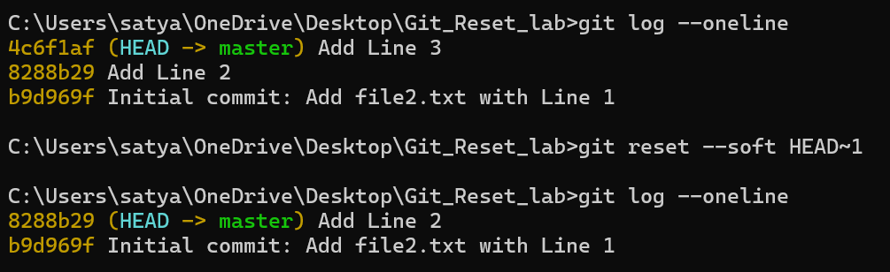

- Verify the staged changes:
git status

Output:
Changes to be committed:
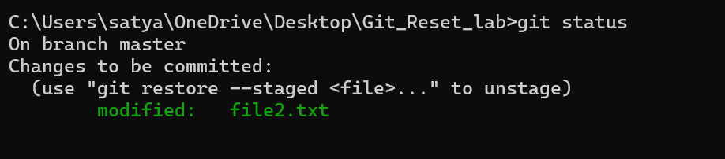
- If needed, re-commit the changes:
git commit -m "Recommit Line 3"
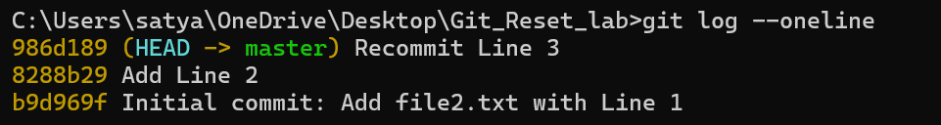

3. Use git reset --mixed
This mode moves the HEAD pointer and unstages the changes but keeps them in the working directory.
- Reset to the first commit:
git reset --mixed HEAD~1

- Check the commit history:
git log --oneline
Output:

- Verify the changes in the working directory:
git status
Output:
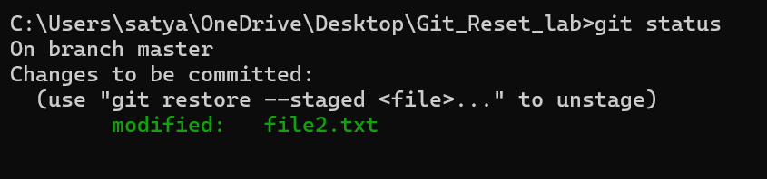
- If needed, stage and re-commit:
git add file.txt
git commit -m "Recommit Line 2 and Line 3"
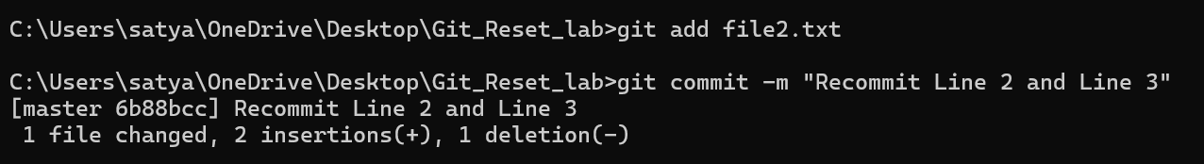

4. Use git reset --hard
This mode moves the HEAD pointer and discards all changes in the staging area and working directory.
- Reset to the initial commit:
git reset --hard HEAD~1
- Check the commit history:
git log –oneline
Output:
- Verify the working directory:
cat file.txt
Output:

5. Use git reset with a Commit Hash
- Add some changes for demonstration:
echo "Line 2" >> file.txt
git commit -am "Add Line 2"
echo "Line 3" >> file.txt
git commit -am "Add Line 3"
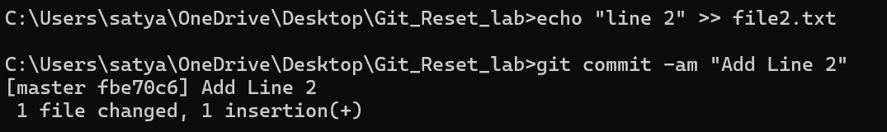
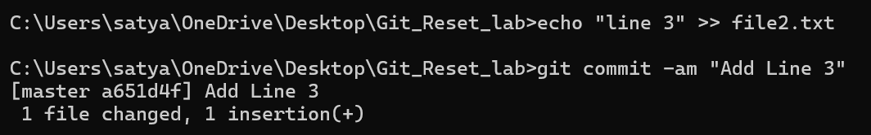

- Get the commit hash for the initial commit:
git log –oneline
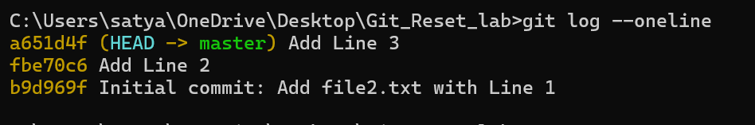
- Reset to the initial commit using the hash:
git reset --hard <commit-hash>
- Verify the working directory and commit history:
git log --oneline
cat file.txt
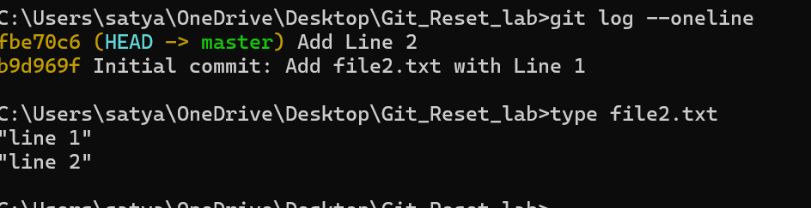

Summary of Commands
Mode | Effect | Command Example
--soft | Moves HEAD, keeps changes staged. | git reset --soft HEAD~1
--mixed | Moves HEAD, unstages changes, keeps them in working dir. | git reset --mixed HEAD~1
--hard | Moves HEAD, discards all changes in staging and working dir. | git reset --hard HEAD~1

