Lab Exercise 1- Working with Git Revert
Lab Exercise: Git Revert

- Install Git on your system.
- Set up a Git repository:
Steps
1. Set Up the Repository
- Create a file:
- Stage and commit the file:
- Add more changes:
- Add another change:
- Verify the commit history:
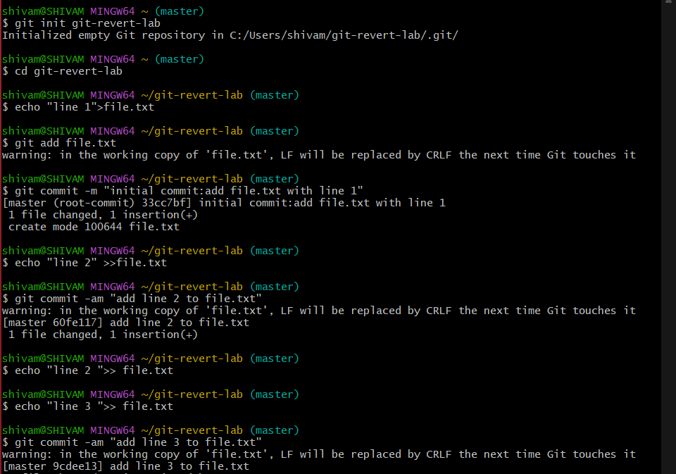

output:
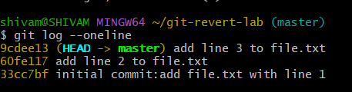

2. Revert the Last Commit
- Revert the most recent commit:
- Git will open a text editor for the commit message. Save and close the editor to complete the revert.
- Verify the contents of file.txt:
Output:
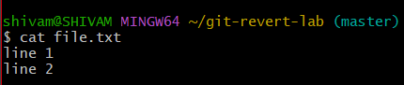

- Check the commit history:
Example output:
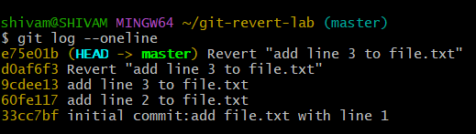

3. Handle Merge Conflicts During Revert
- Modify file.txt:
- Revert the second commit (8b2a1c1 again) to trigger a conflict:
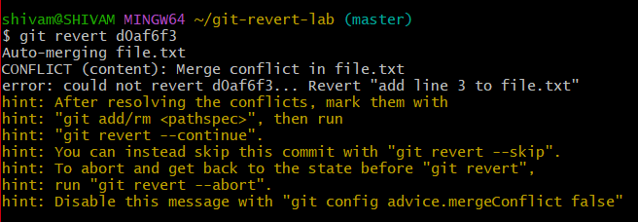
- Git will indicate a conflict. Resolve it:
  - Open file.txt and remove conflict markers and Keep the desired lines.
- Stage the resolved file:
- Complete the revert:

