Lab Exercise 2- Working with Git Reset

Prerequisites
- Install Git on your system.
- Set up a Git repository:

Steps
1. Set Up the Repository
- Create and commit an initial file:
- Add a second change:
- Add a third change:
- Check the commit history:
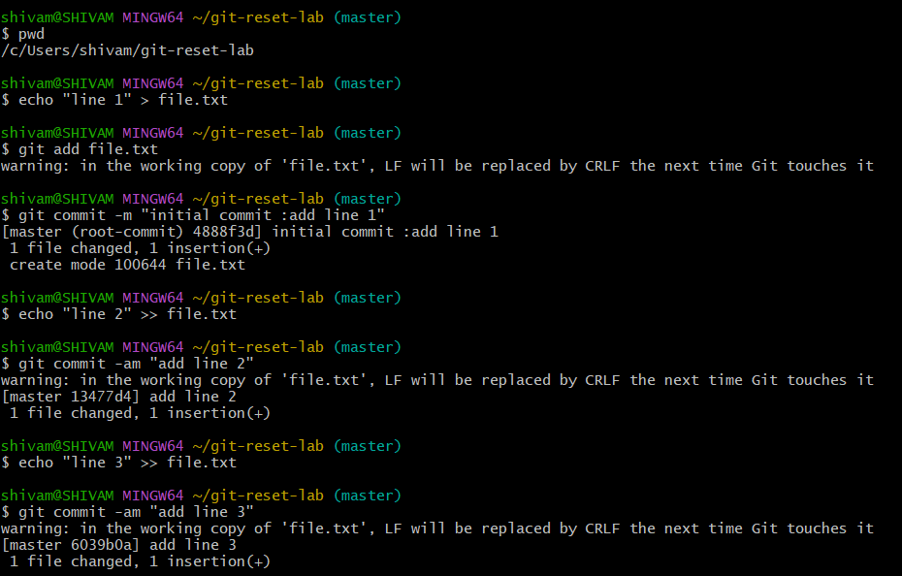
Example output:
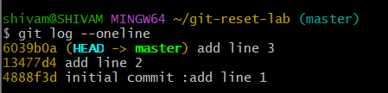

2. Use git reset --soft
This mode moves the HEAD pointer to an earlier commit but keeps the changes in the staging area.
- Reset to the second commit:
- Check the commit history:
Output:
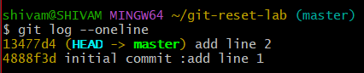
- Verify the staged changes:
Output:
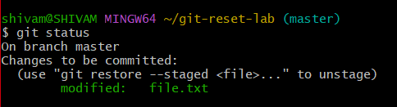
- If needed, re-commit the changes:
3. Use git reset --mixed
This mode moves the HEAD pointer and unstages the changes but keeps them in the working directory.
- Reset to the first commit:
- Check the commit history:
Output:
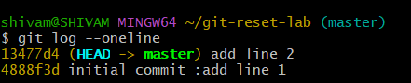

- Verify the changes in the working directory:
Output:
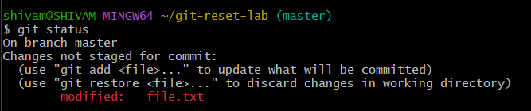
- If needed, stage and re-commit:
git add file.txt
git commit -m "Recommit Line 2 and Line 3"

4. Use git reset --hard
This mode moves the HEAD pointer and discards all changes in the staging area and working directory.
- Reset to the initial commit:
- Check the commit history:
Output:
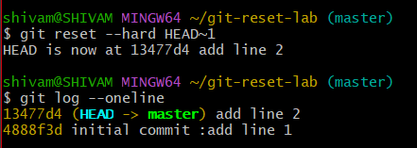
- Verify the working directory:
Output:
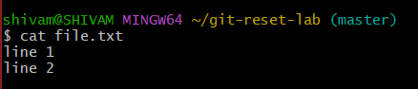

5. Use git reset with a Commit Hash
- Add some changes for demonstration:
- Get the commit hash for the initial commit:
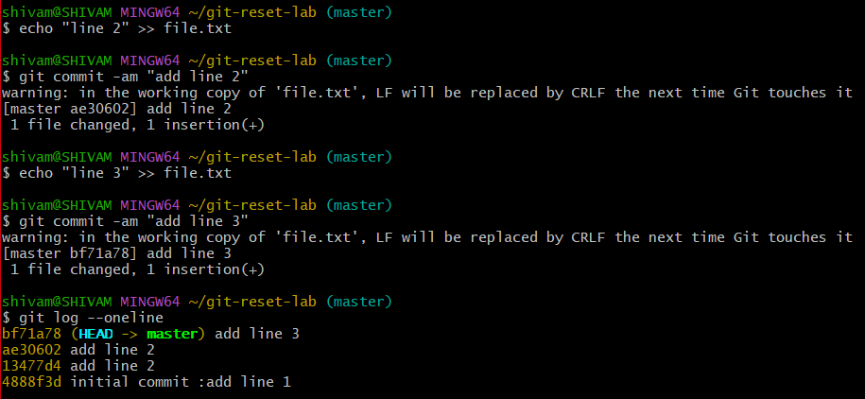
- Reset to the initial commit using the hash:
- Verify the working directory and commit history:
