Lab Exercise 3- Working with Git Rebase
Lab Exercise: Git Rebase
Step-by-Step Instructions
1. Set Up the Repository
- Create the main branch and make the initial commit:
git commit -m "Initial commit: Add Line 1 from main branch"
- Create a new branch feature-branch:
- Add a new line to file.txt in feature-branch:
- Switch back to the main branch and add another line:
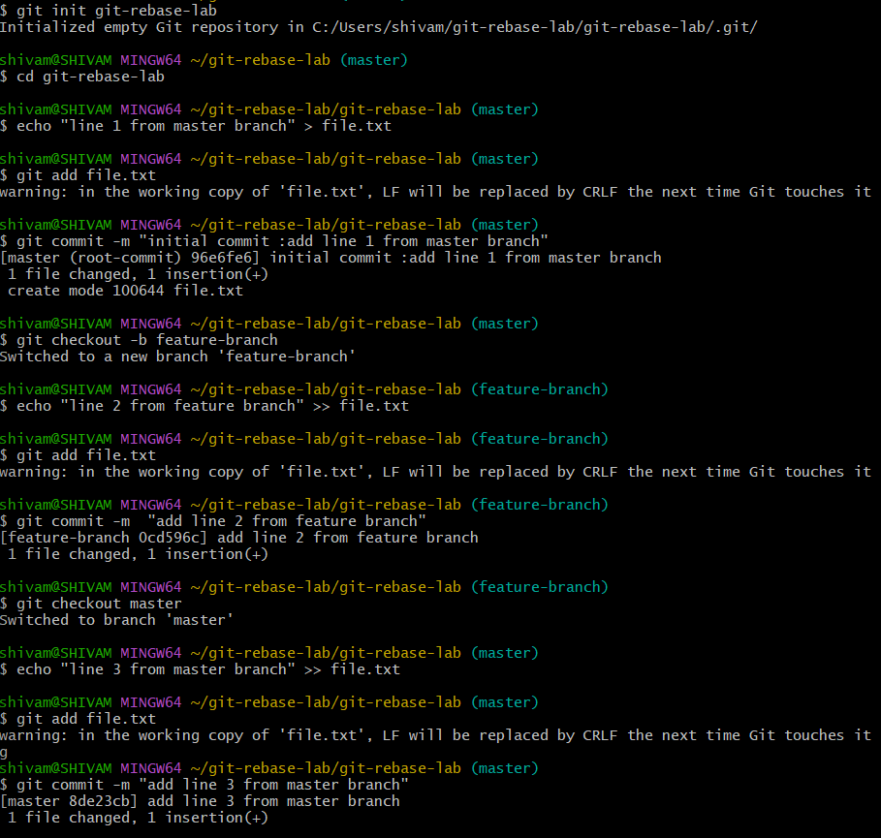

2. Rebase feature-branch onto main
- Switch to feature-branch:
- Rebase feature-branch onto main:
- Git will replay the commit from feature-branch onto the main branch. Since there are no conflicts, the rebase completes automatically.
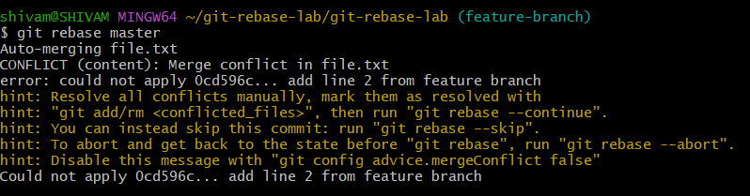

3. Verify the Rebase
- View the commit history:
Example output:
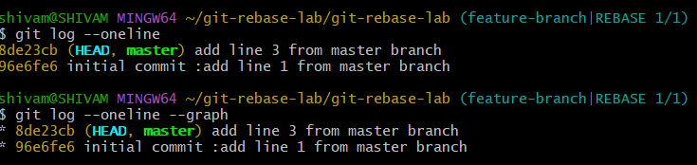
- Check the contents of file.txt:
Output:
